SuperMart_Db

Faith Mangope Technology and Leadership Institute
Introduction to T-SQL
Prepared by: Vezinduna Mbekezeli Ndlovu

Part 1 — Database Creation
Create the SuperMart_Db database with Customers and Orders tables, including primary keys, a foreign key, a CHECK constraint on order status, and NOT NULL rules (Phone is the only nullable column).
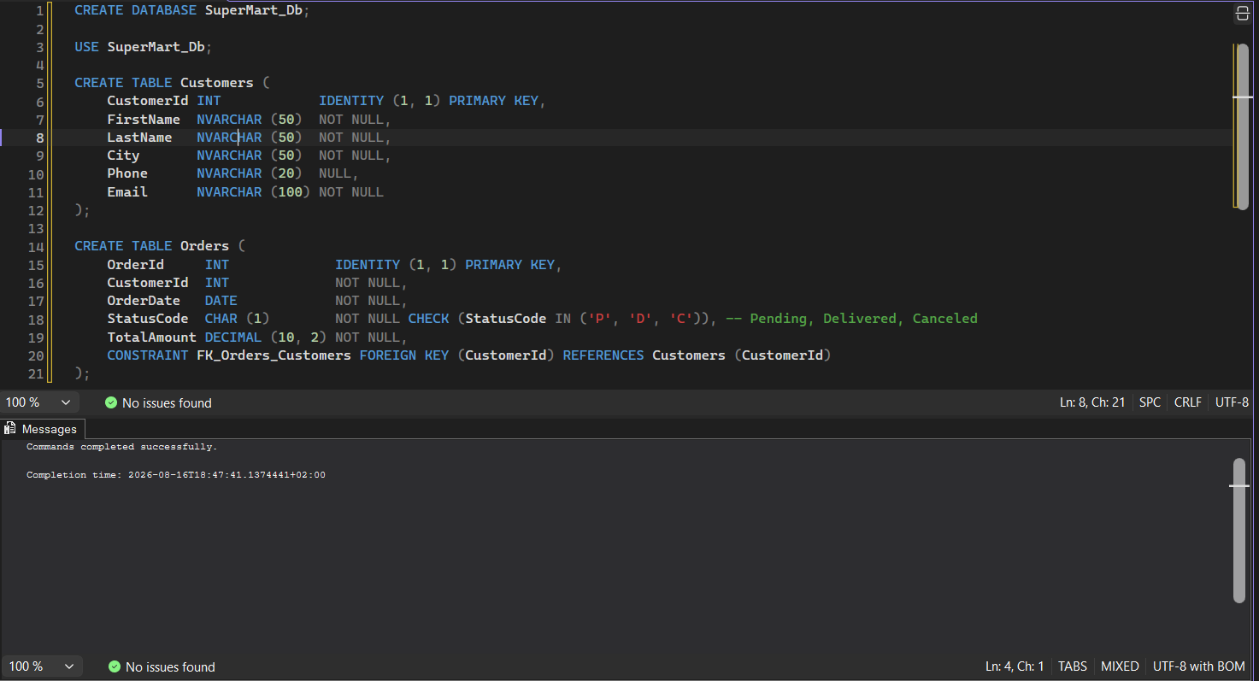

Part 2 — Populating the Database
Insert 7 customers (3 cities, some NULL phone numbers, 2 with no orders) and 10 orders (varied dates across 2026, amounts, and statuses).
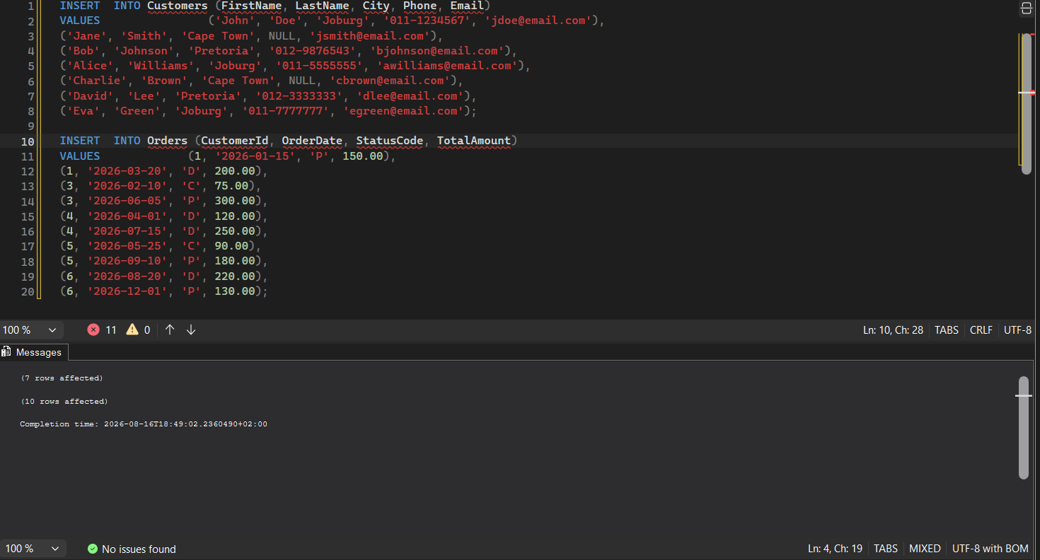

Part 3 — Basic Data Retrieval
Customer contact report: CustomerId, full name, Country, City, and Phone (NULLs replaced with 'No Phone Number' via COALESCE).
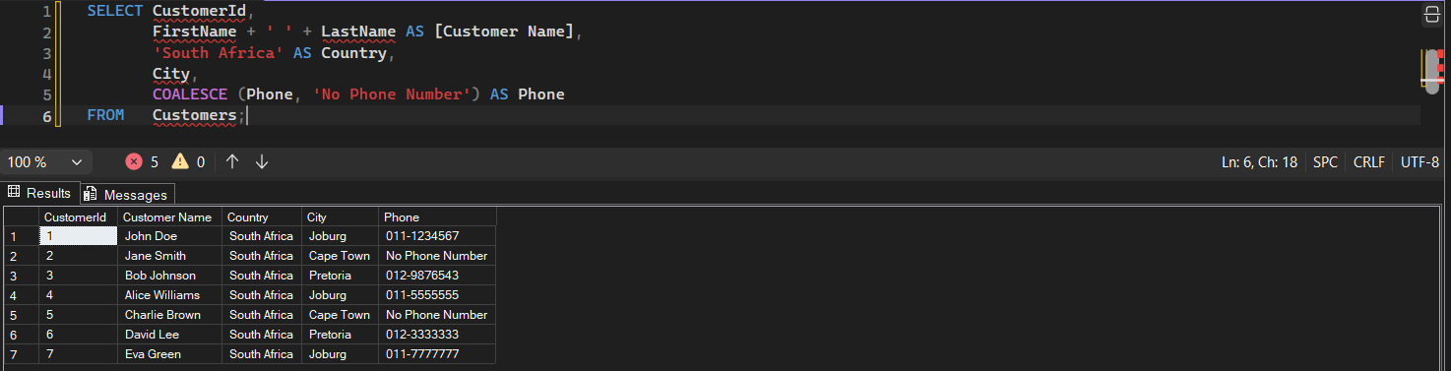

Part 4 — Filtering Data
A) Customers from Gauteng (Joburg, Pretoria) using IN.
B) Orders placed in Q1 2026 using BETWEEN.
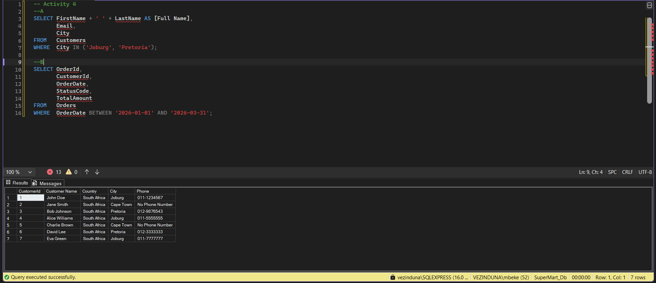

Part 5 — SQL Joins
Four reports over the same Customer Name / OrderId / OrderDate / TotalAmount shape: INNER JOIN (customers with orders), LEFT JOIN (all customers incl. those without orders), RIGHT JOIN (all orders incl. any without a matching customer), FULL JOIN (complete audit of both sides).
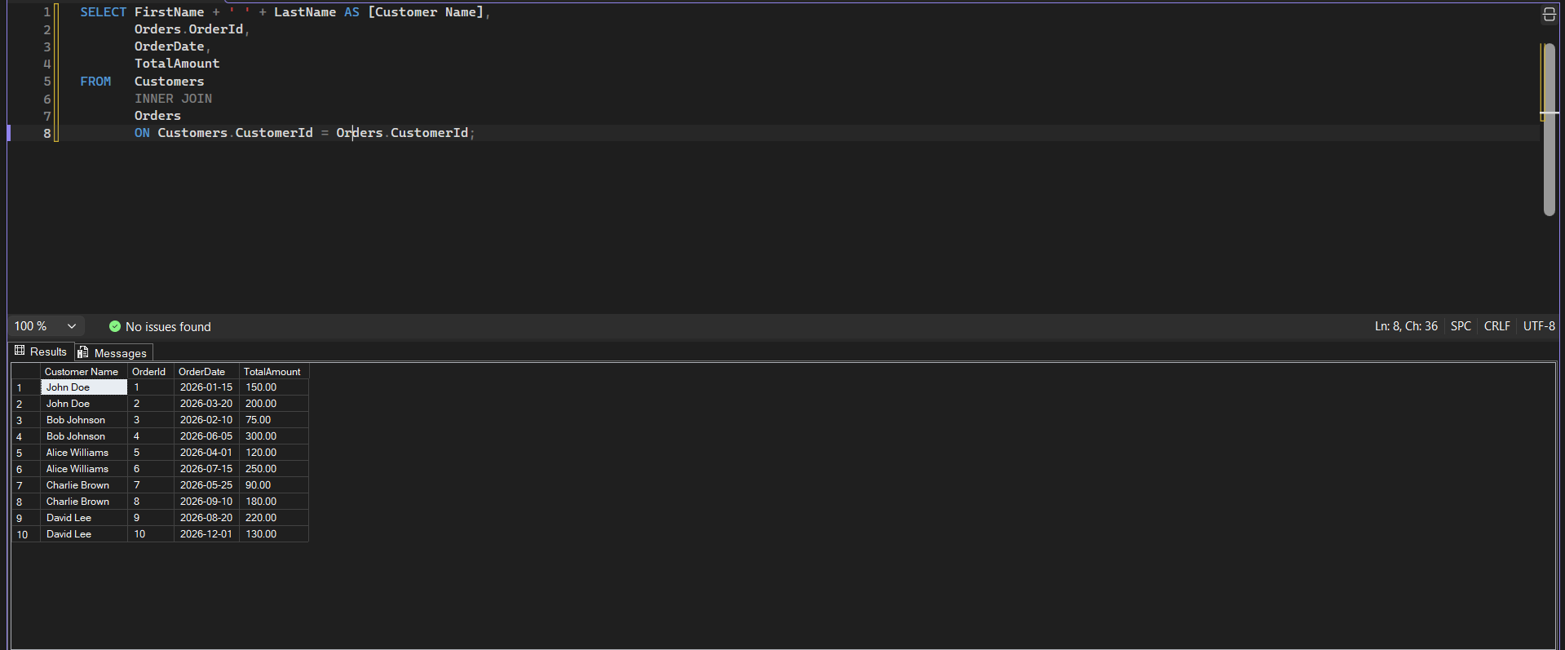
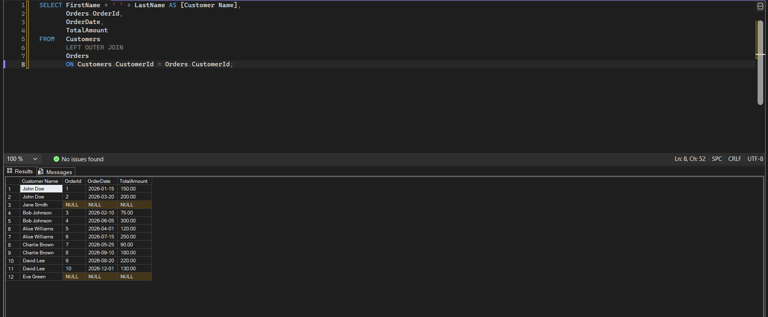
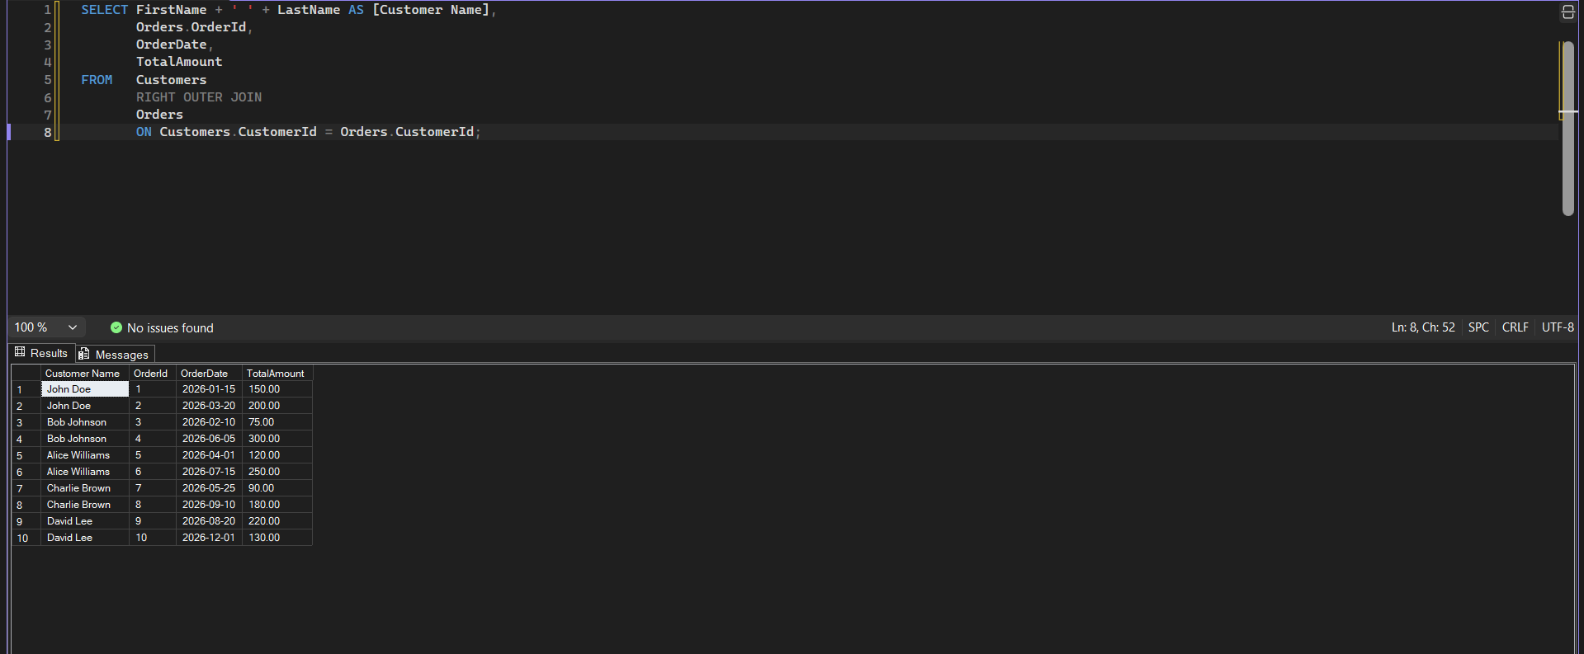
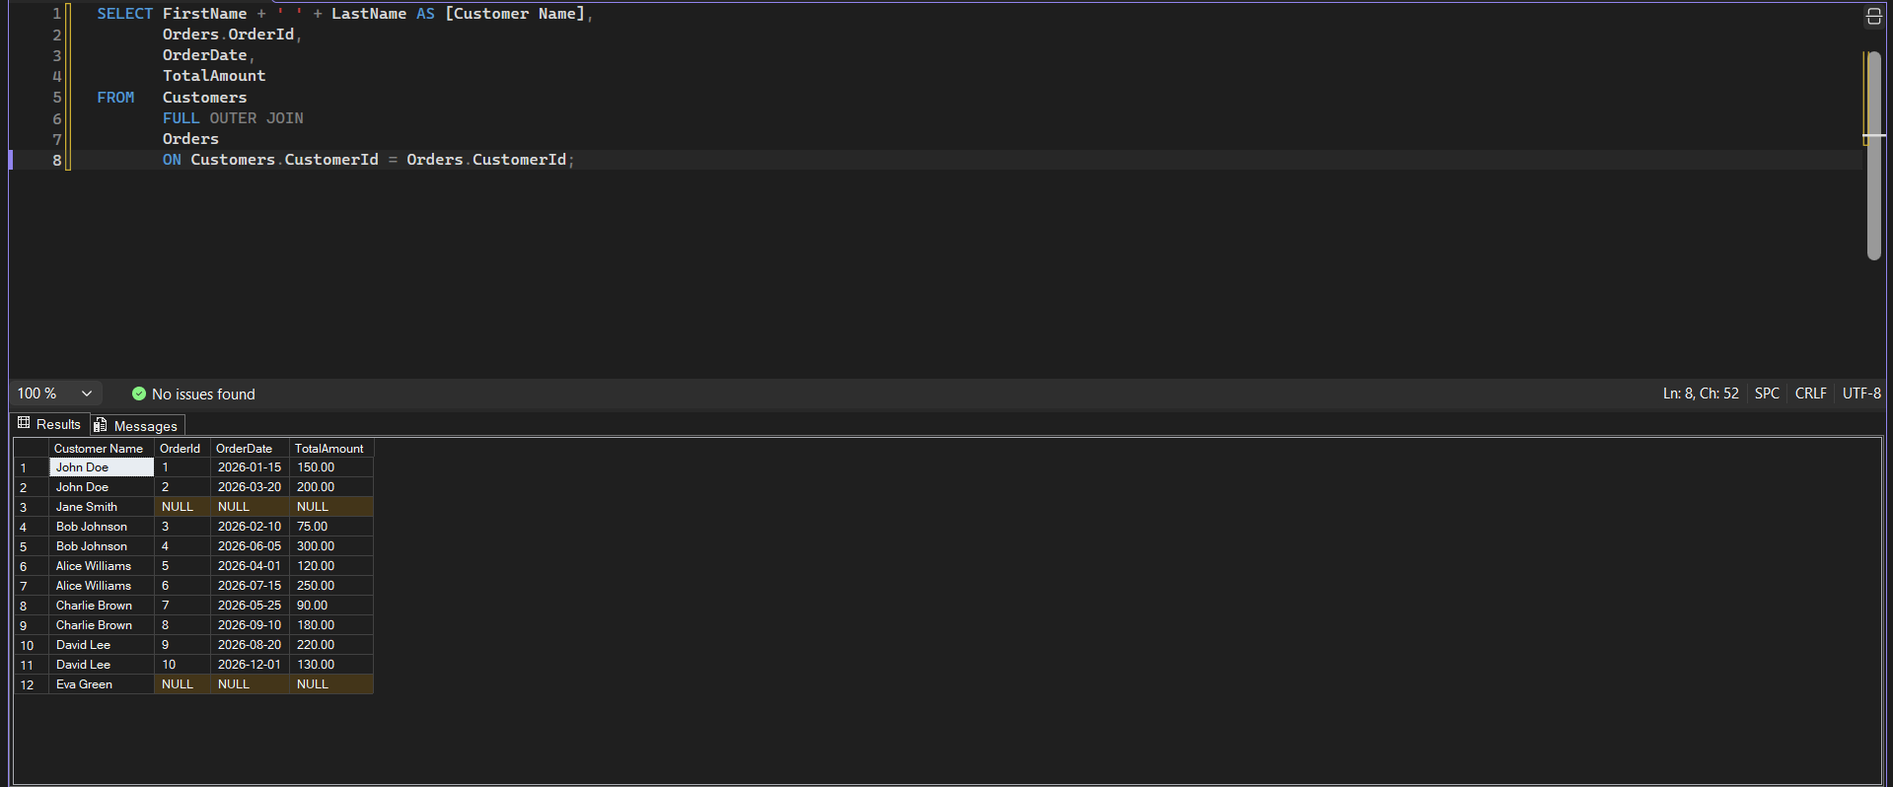

Part 6 — Sorting, Aggregation, Date & String Functions
Task 1: UPPER() name, LEN() of first name, sorted by first name. Task 2: customer count per city, sorted descending. Task 3: order count/AVG/MAX/MIN. Task 4: YEAR(), MONTH(), DATEDIFF() days since order, sorted by TotalAmount descending.
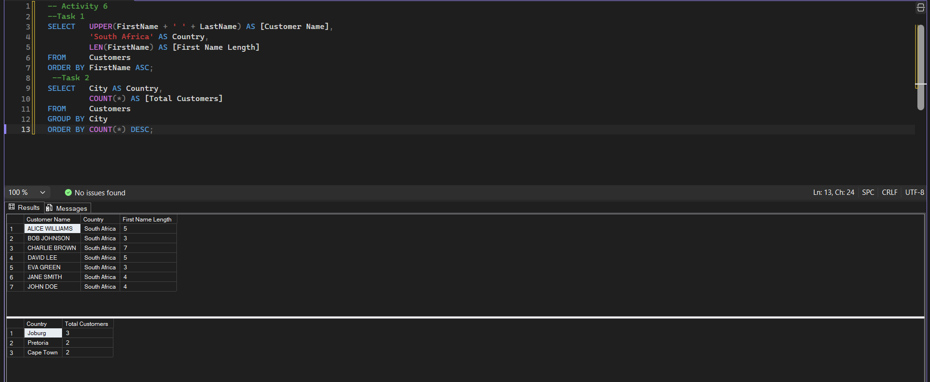
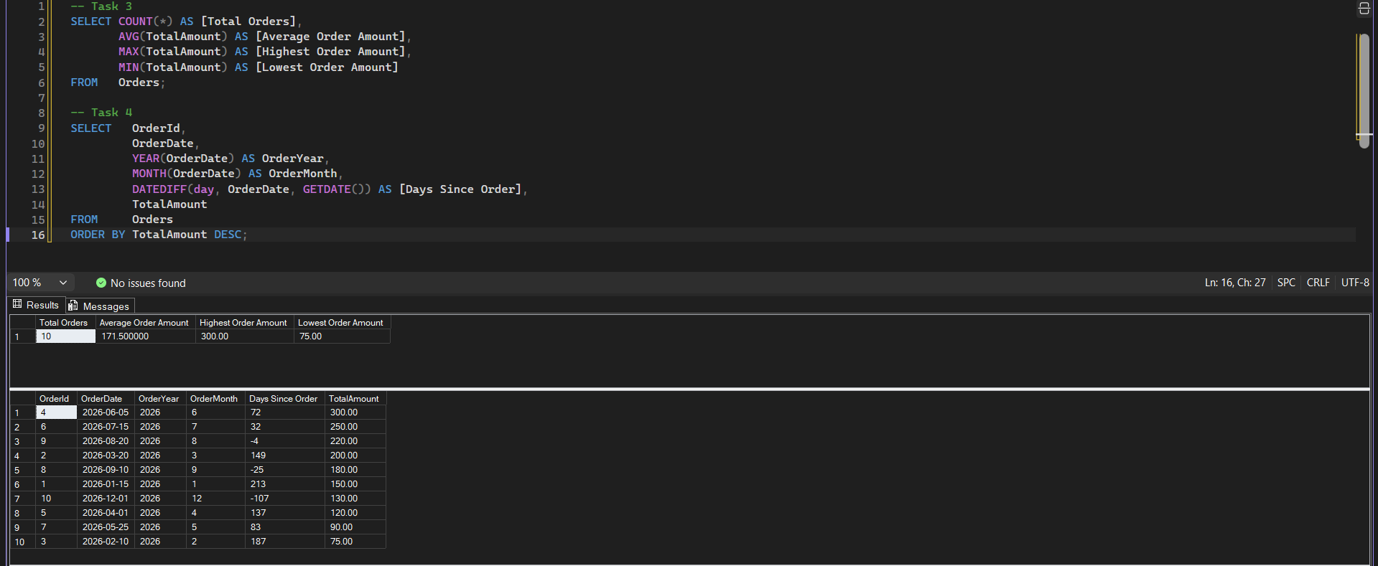

Part 7 — Subqueries (Section A)
Names of customers who have placed at least one order, written two ways: using IN and using EXISTS.
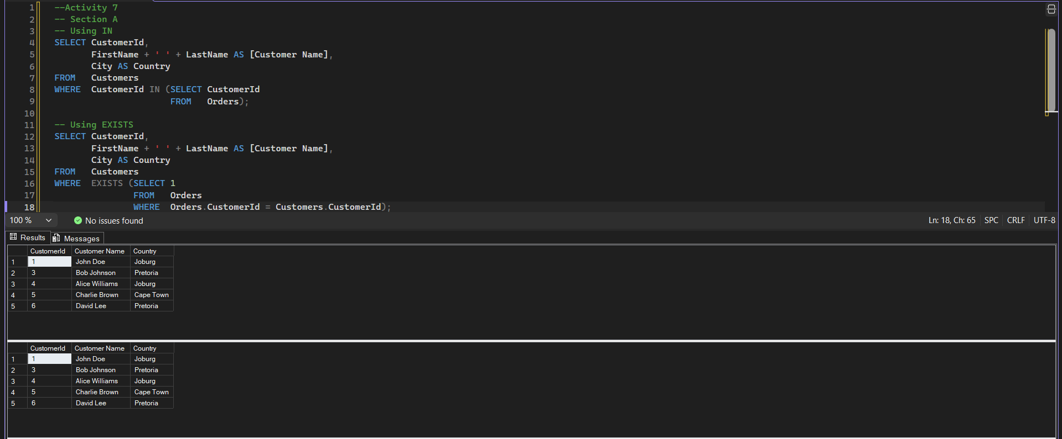
CustomerOrders (Section B.1)

A reusable view showing Customer Name, Order Date, and Total Amount for management reporting.
A Common Table Expression that counts orders per customer, then joined back to Customers so every customer appears (including those with zero orders).

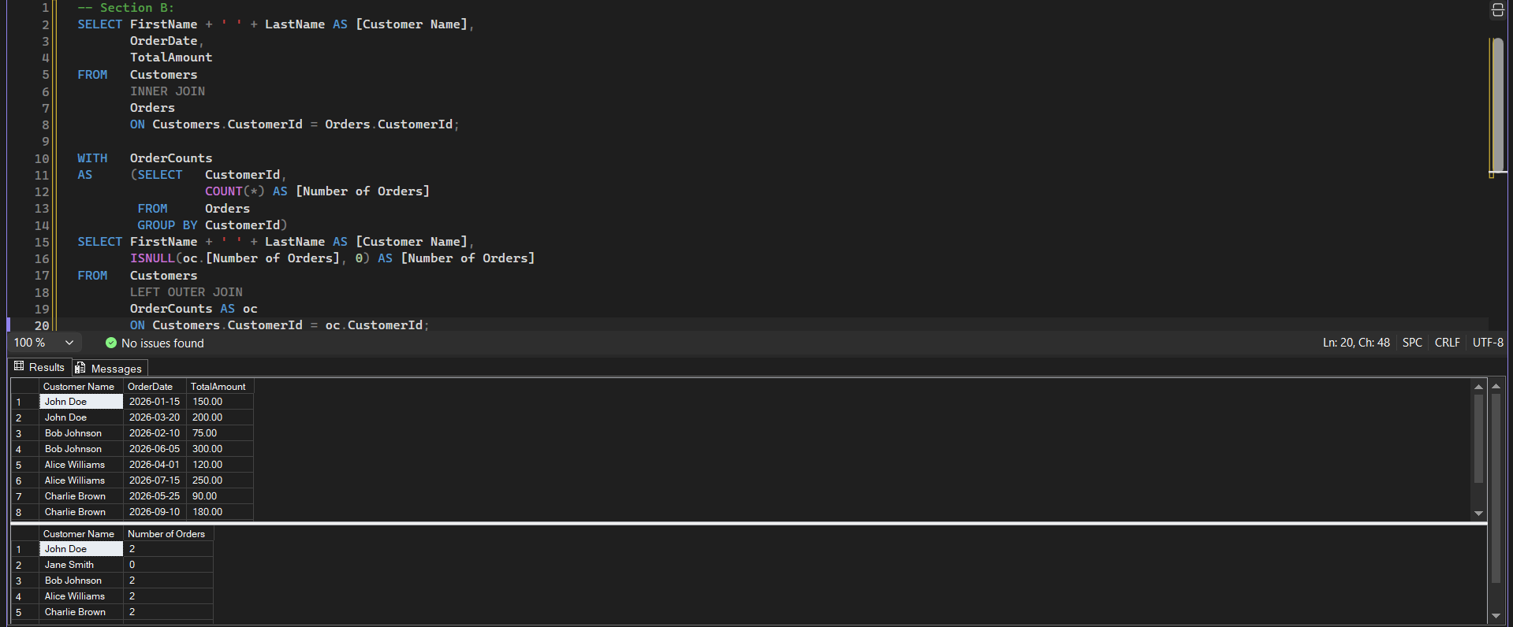

Stored Procedure: GetCustomerOrders (Section C)
A parameterised stored procedure that returns OrderId, OrderDate, OrderStatus, and TotalAmount for a given CustomerID, executed for CustomerID = 1.
