Exercise #3: UCX ping-pong Latency Benchmark

## Goal

The goal of this exercise is to learn how to measure latency, by writing a C/C++ benchmark application on top of UCP using RMA semantics (.i.e., ucp_put_nbx, ucp_get_nbx, and atomic operations).

## What do you need to measure?

You need to measure the latency between two machines, for exponential series of message sizes, ranging from 8 byte to 10MB. Latency is the time taken to transfer data from one machine to other for that message size.

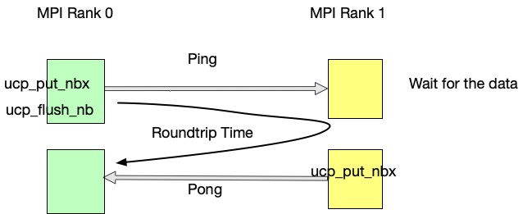

## How to measure latency?

In order to measure the latency, you need the same code acting both as server and a client. One instance of the code acts as a client (MPI Rank #0), and another instance acts as a server (MPI Rank #1). The client instance sends the message and server instance receives the message. The instance acting as a server after receiving the message, sends the response message. The client calculates the time taken to send and receive a response message. This time is the round-trip time. Given this is a round-trip, the latency is half of round-trip time.

## Setup & Submission

For this exercise you may use any lab machine (subject to change in the future).

You should submit an archive named “<id1>_<id2>.tgz”, containing a Makefile (calling “make” will build the code), building “pingpong” executables. Submission should include a report with short description of the implementation and the performance results.