**Report For Binary Search Tree**

09019204

曹邹颖

1. **Problem description / demand analysis问题描述**
2. Insert the following elements in a Binary Search Tree in the given order and draw the tree

12, 80, 65, 23, 72, 70, insert_root(47), 11, 87, 61, 54, 19, 44, 3, 27

1. What is the height of the constructed tree?
2. What is the average time (average path from the root) for accessing each element of the tree?
3. **Results and analysis结果和分析**

解：

1)

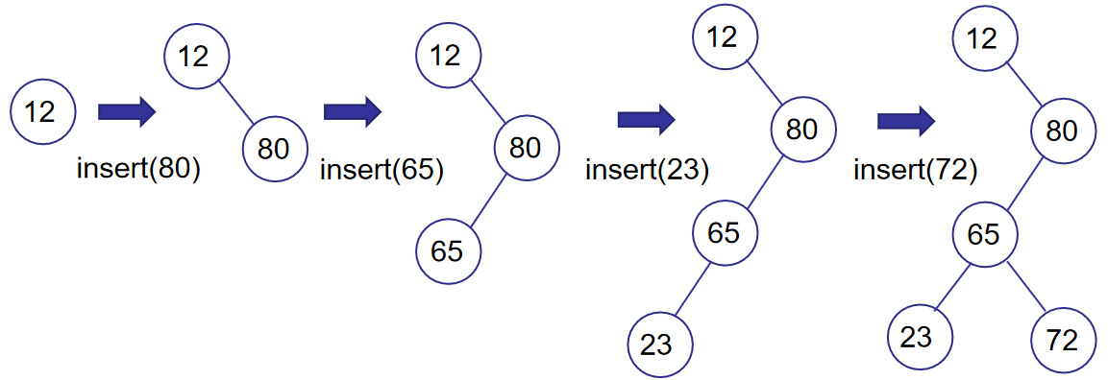

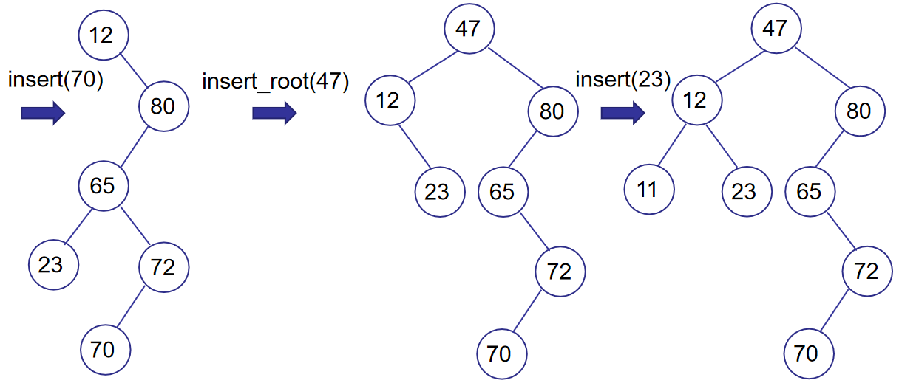

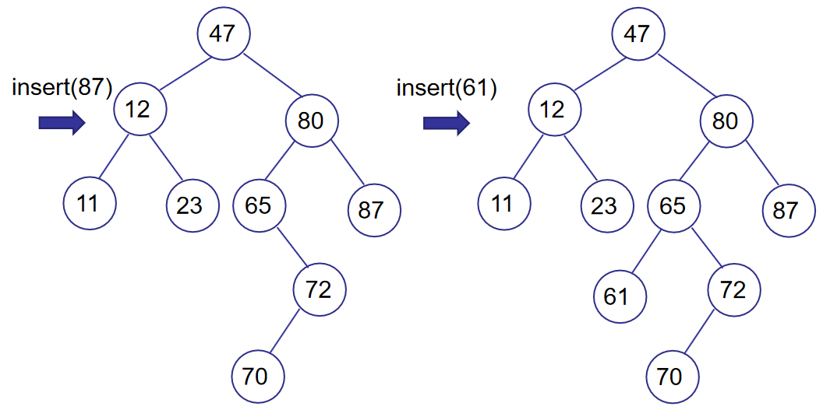

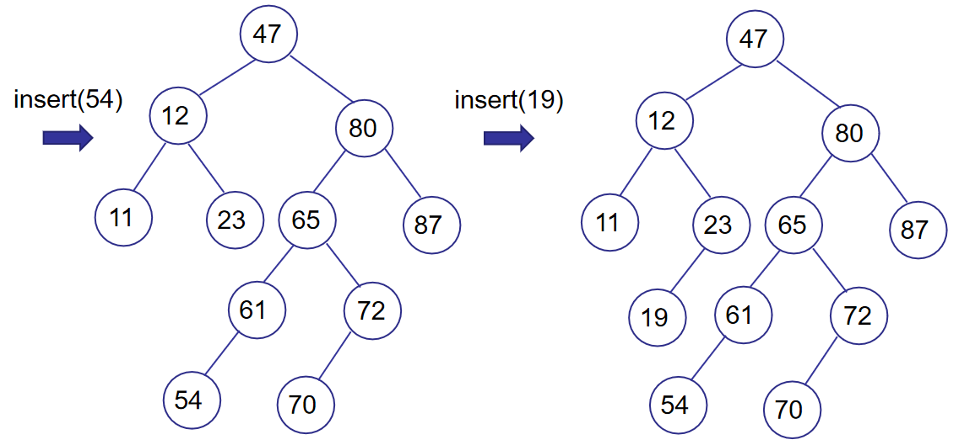

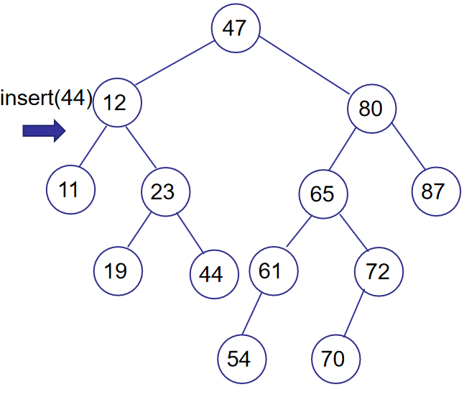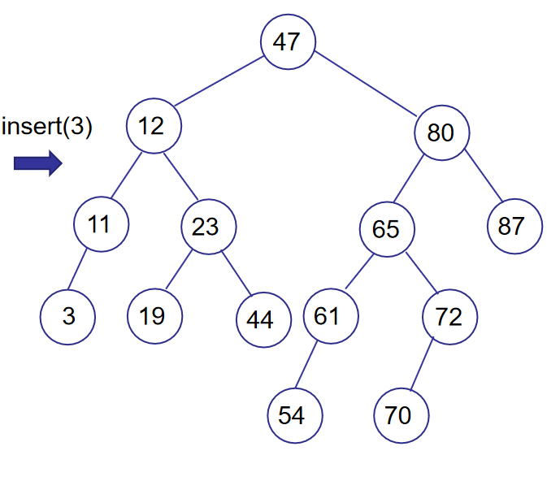

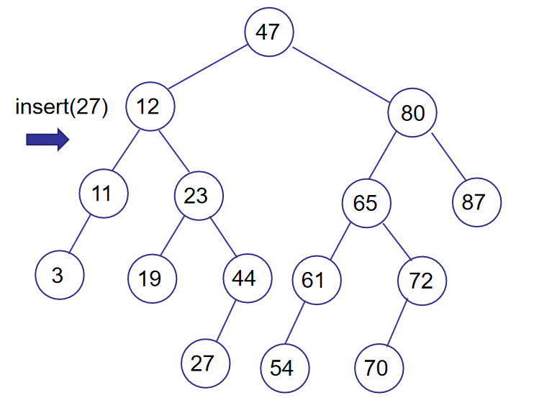

1. The height of the constructed tree is: 5
2. The average time (average path from the root) for accessing each element of the tree is:

$$\frac{0∗1+1∗2+2∗4+3∗5+4∗3}{15}=\frac{37}{15}≈2.467$$