**Report For Exercise Max Flow Problem**

09019204

曹邹颖

1. **Problem description / demand analysis问题描述**

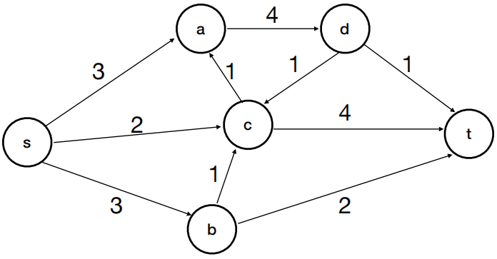

1. Give the order of the augmenting paths you are considering
2. Apply Edmonds-Karp algorithm and give the graph (current flow) at each step
3. **Results and analysis结果和分析**
4. 解：The order of the augmenting paths I am considering:

s-c-t

s-b-t

s-b-c-t

s-a-d-t

s-a-d-c-t

1. 解：

s-c-t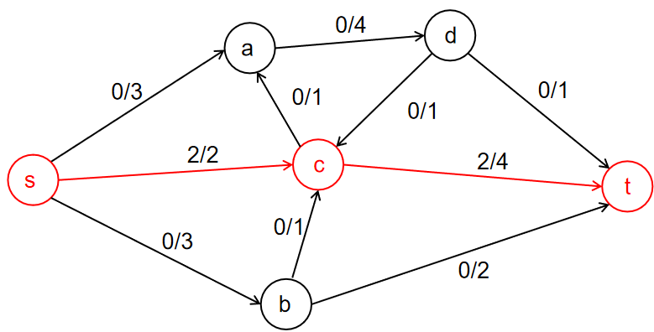

s-b-t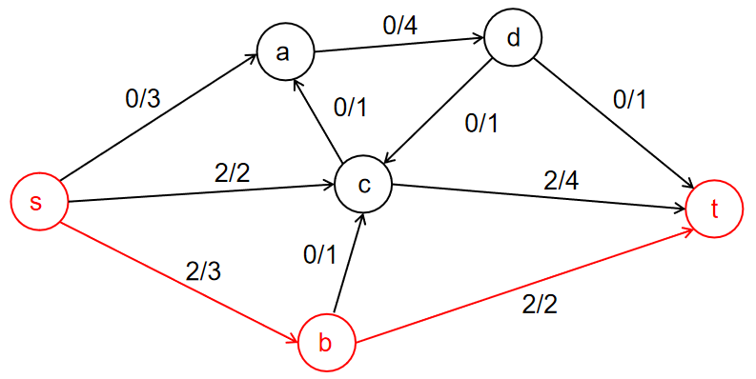

s-b-c-t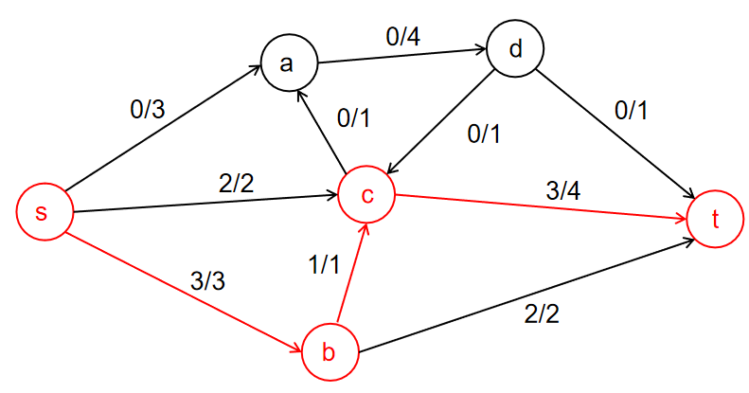

s-a-d-t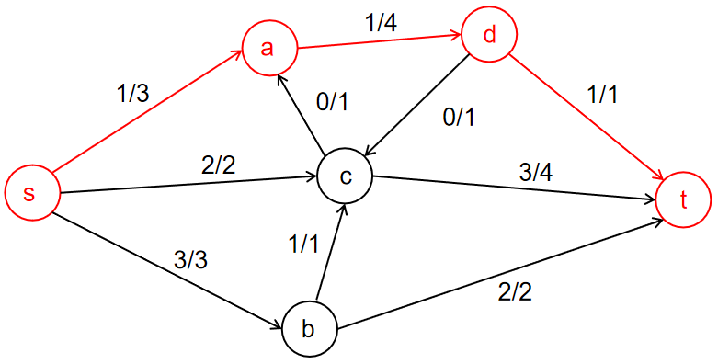

s-a-d-c-t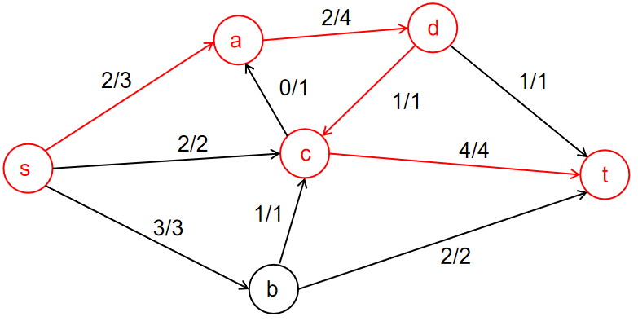

从而得到最大流结果：

