**Report For Exercise Huffman Encoding & Decoding**

09019204

曹邹颖

1. **Problem description / demand analysis问题描述**
2. **Huffman (encoding)**

①Encode the following text:

An illusory vision is a visionary illusion. Is it?

②Give the corresponding encoding table

③What is the average number of bits per character?

1. **Huffman (decoding)**

Decode the following:

11000111101011010111000001111101

The encoding table:

|  |  |
| --- | --- |
| Character | Code |
| ！ | 101 |
| A | 11 |
| B | 00 |
| C | 010 |
| D | 100 |
| R | 011 |

1. **Results and analysis结果和分析**
2. 解：

①Encode the following text:

An illusory vision is a visionary illusion. Is it?

Scan the text and count occurrence of all characters:

|  |  |  |  |  |  |  |  |  |  |  |  |  |  |  |  |
| --- | --- | --- | --- | --- | --- | --- | --- | --- | --- | --- | --- | --- | --- | --- | --- |
| A | n | i | l | u | s | o | r | y | v | a | I | t | “space” | . | ? |
| 1 | 4 | 9 | 4 | 2 | 6 | 4 | 2 | 2 | 2 | 2 | 1 | 1 | 8 | 1 | 1 |

Sort characters based on number of occurrences in text:

|  |  |  |  |  |  |  |  |  |  |  |  |  |  |  |  |
| --- | --- | --- | --- | --- | --- | --- | --- | --- | --- | --- | --- | --- | --- | --- | --- |
| A | I | t | . | ? | u | r | y | v | a | n | l | o | s | “space” | i |
| 1 | 1 | 1 | 1 | 1 | 2 | 2 | 2 | 2 | 2 | 4 | 4 | 4 | 6 | 8 | 9 |

Build Huffman code tree based on prioritized list:

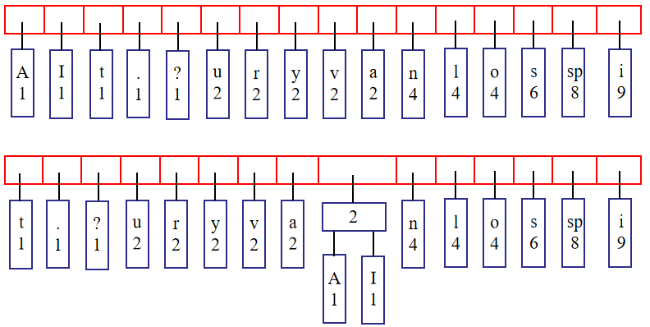

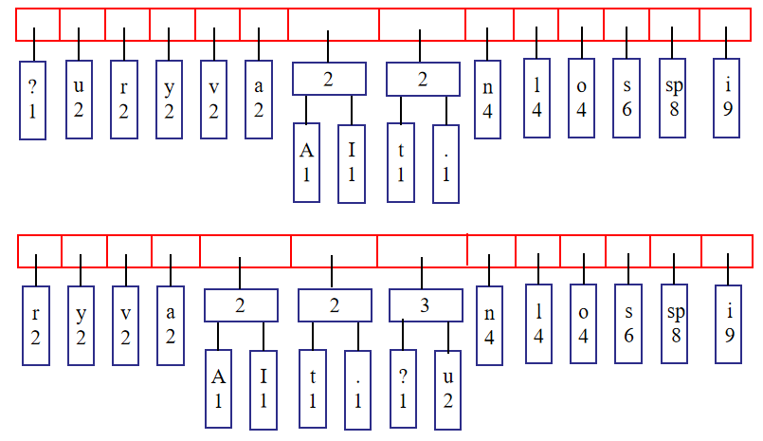

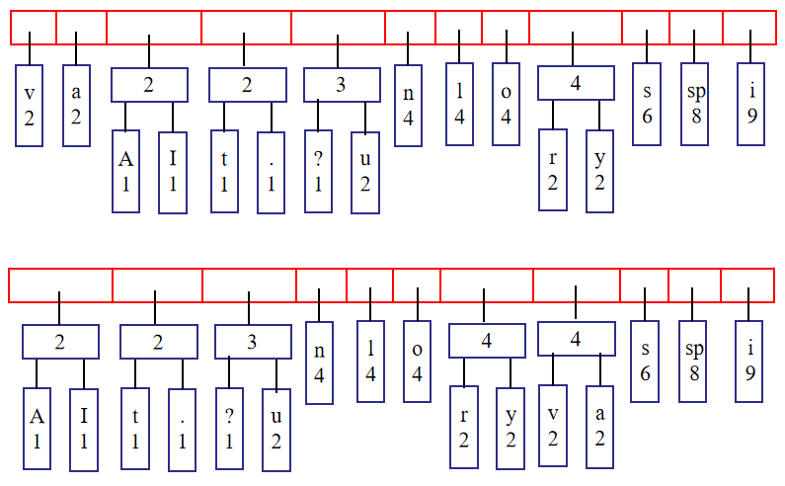

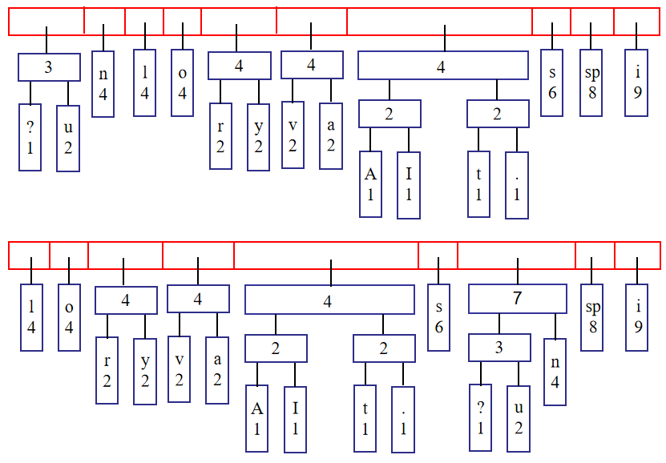

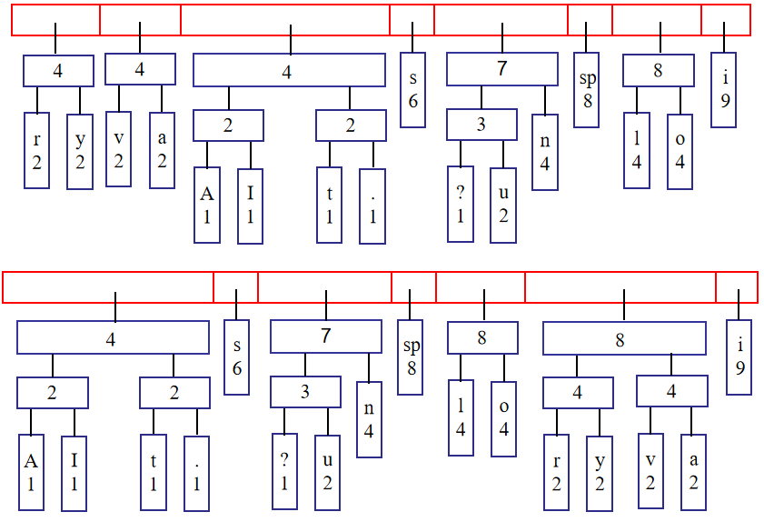

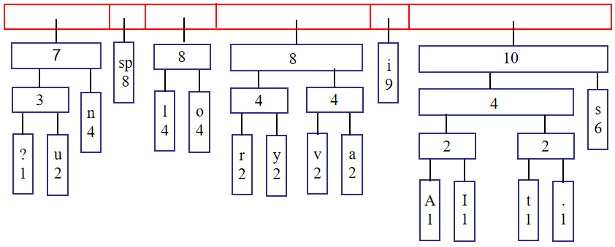

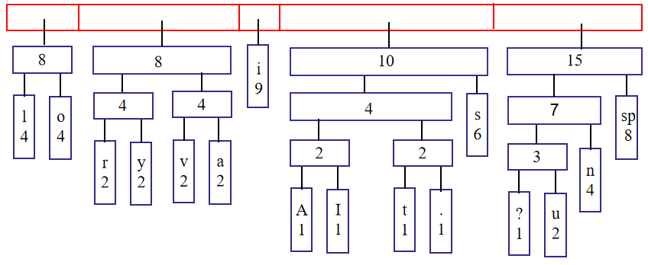

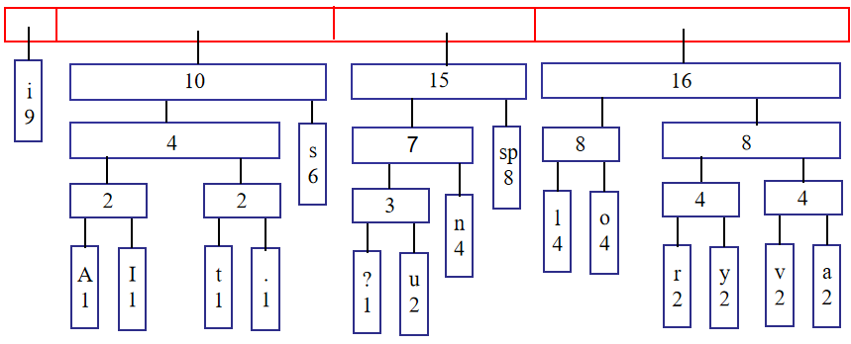

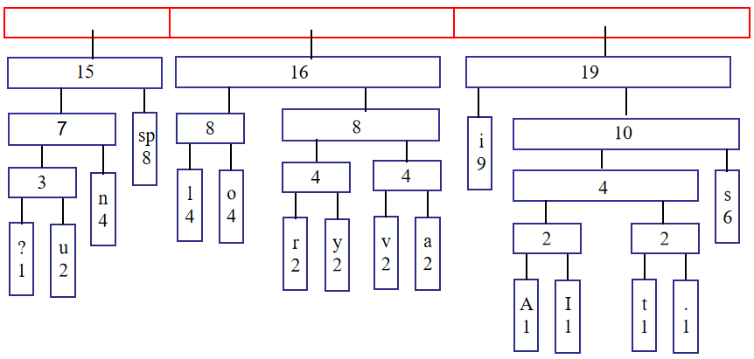

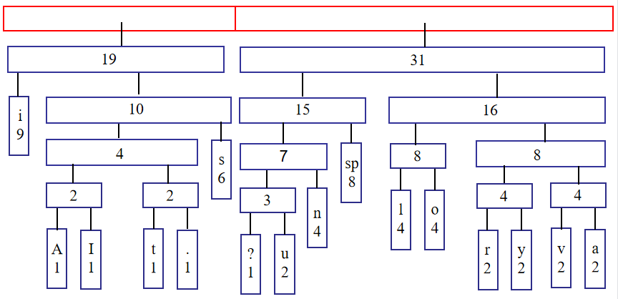

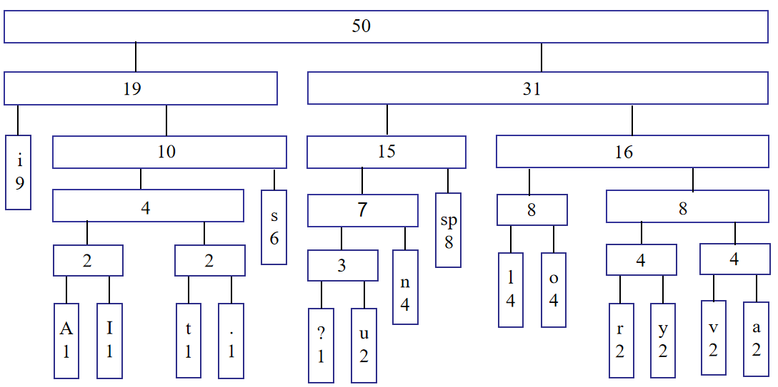

②Give the corresponding encoding table

|  |  |
| --- | --- |
| Character | Code |
| i | 00 |
| A | 01000 |
| I | 01001 |
| t | 01010 |
| . | 01011 |
| s | 011 |
| ? | 10000 |
| u | 10001 |
| n | 1001 |
| “space” | 101 |
| l | 1100 |
| o | 1101 |
| r | 11100 |
| y | 11101 |
| v | 11110 |
| a | 11111 |

the Huffman codes:

An illusory vision is a visionary illusion. Is it?

010001001101001100110010001011110111100111011011111000011001101100110100011101111111011111000011001101100111111111001110110100110011001000101100110110010101110101001011101000101010000

③What is the average number of bits per character?

183/50=3.66

1. 解：解码为ABRACACADBRA!。