仿真说明

目录

仿真说明 1

一、 Cpuclk 2

二、 Ifetch32 2

三、 Idecode32 3

1. Cpuclk
   1. 截图

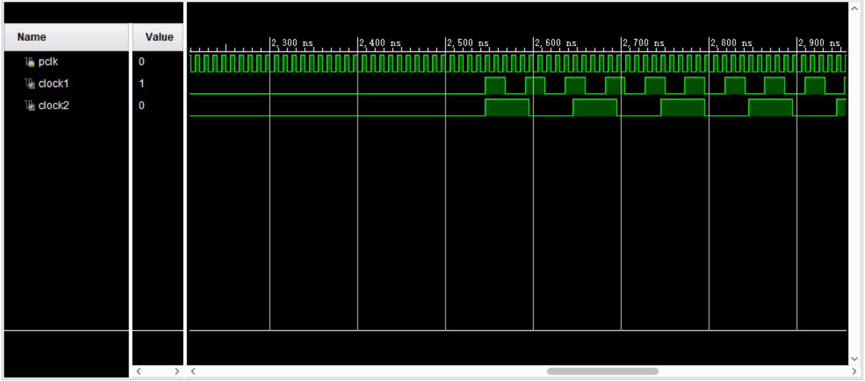

1. Ifetch32

2.1 Ifetch32-sim.asm

|  |
| --- |
| .DATA 0X0  .TEXT 0X0000  start:  add $1,$2,$3 # 00:$1=$2+$3=5  lop:  beq $12,$1,lop # 04:if $12=$1,jump lop,不分支  lop1:  sub $8,$8,$4 # 08:$8=$8-4  bne $8,$0,lop1 # 0c:if $8≠0,jump lop1  beq $1,$1,lop2 # 10:if $1=$1,jump lop2  nop # 14  nop # 18  lop2:  bgez $0,1 # 1c:if $zero≥0,jump PC+4+1<<2=24  jr $0 # 20:  blez $9,1 # 24:if $9<=0,jump PC+4+1<<2, 不分支  bgtz $9,1 # 28:if $9>0,jump PC+4+1<<2=30  j first # 2c:  bltz $12,1 # 30:if $12<0,jump PC+4+1<<2,不分支  bgezal $12,2 # 34:if $12≥0,jump PC+4+2<<2,PC=40  jal start # 38  nop # 3c  bltzal $9,3 # 40:if $9<0,jump PC+4+3<<2,不分支  j lop3 # 44:PC=50  nop # 48  nop # 4c  lop3:  jalr $30,$0 # 50:PC=0  first:  add $1,$3,$4 # 54:$1=$3+$4=7  #PC:  #00, 04, 08,0c,08,0c, 10,1c,24, 28,30, 34,40, 44, 50, 0  #00,00,04,04,08,0c,08,0c,08,10,1c,24,2c,28,30,38,34,40,50,44,48,50,54,0 |

2.2 截图

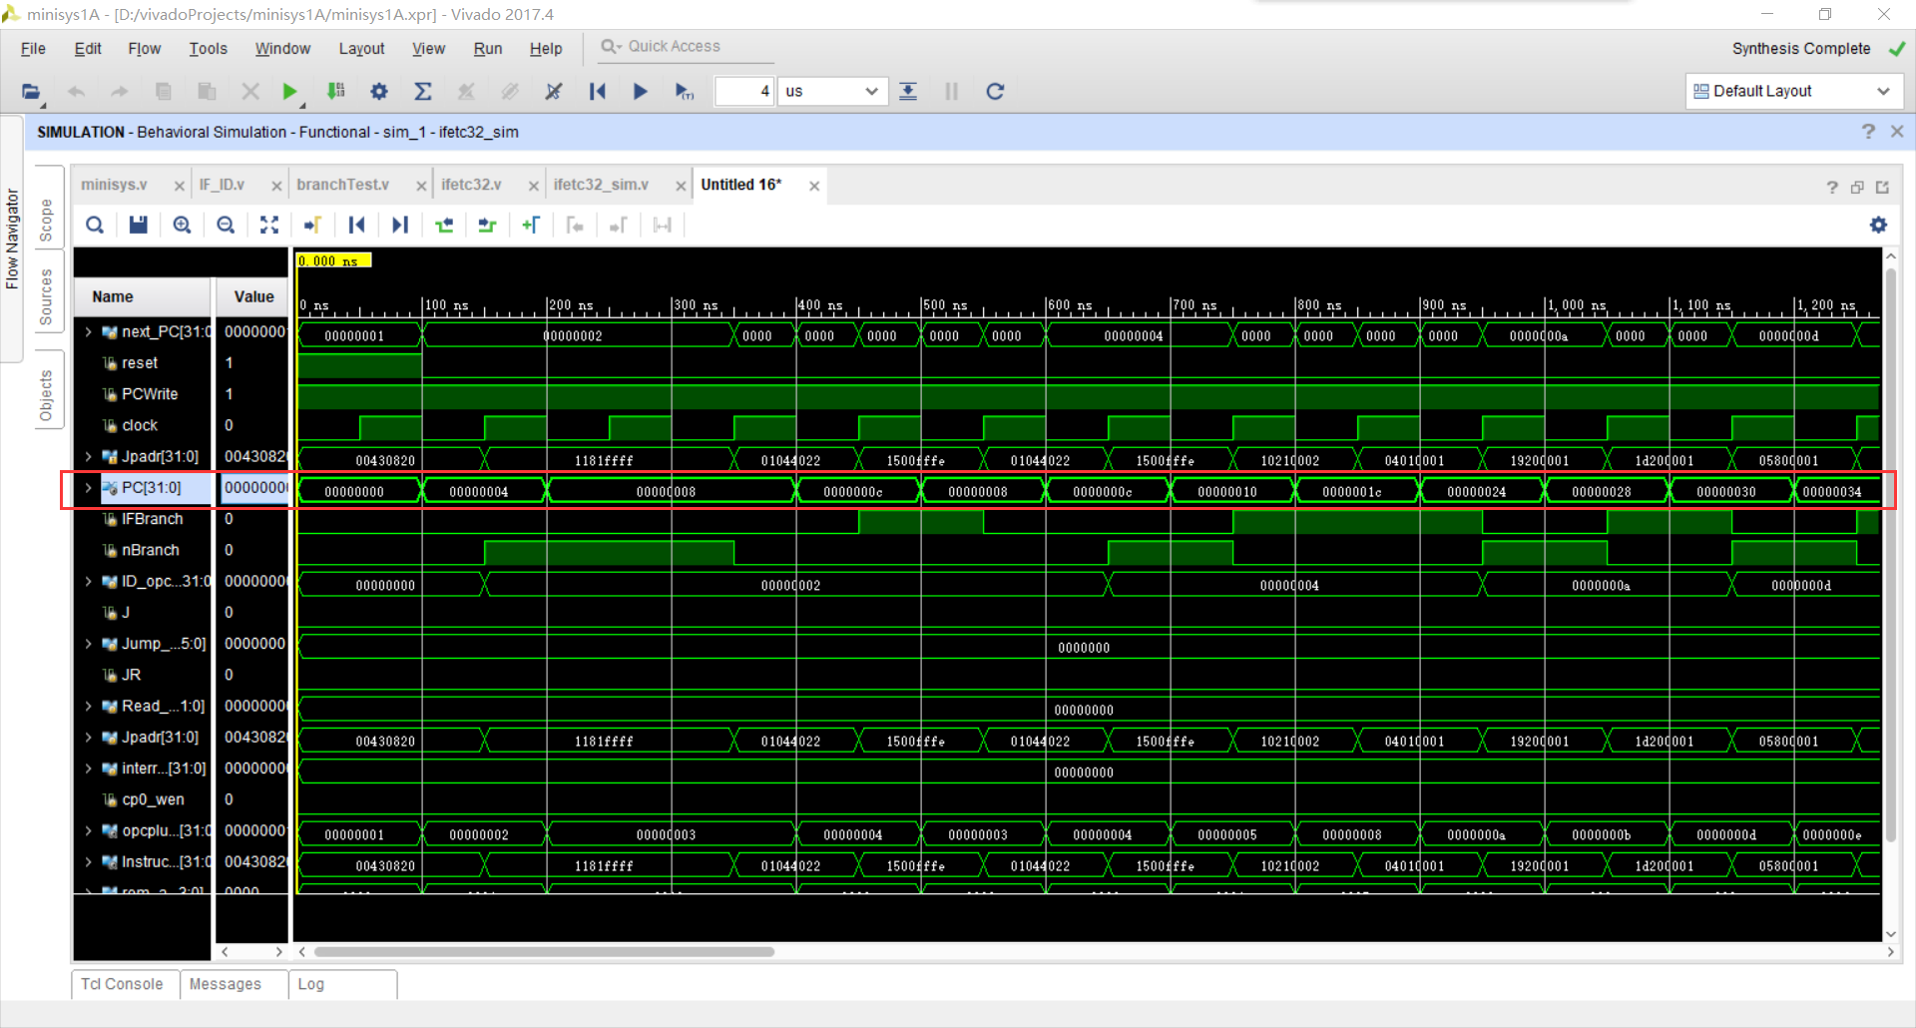

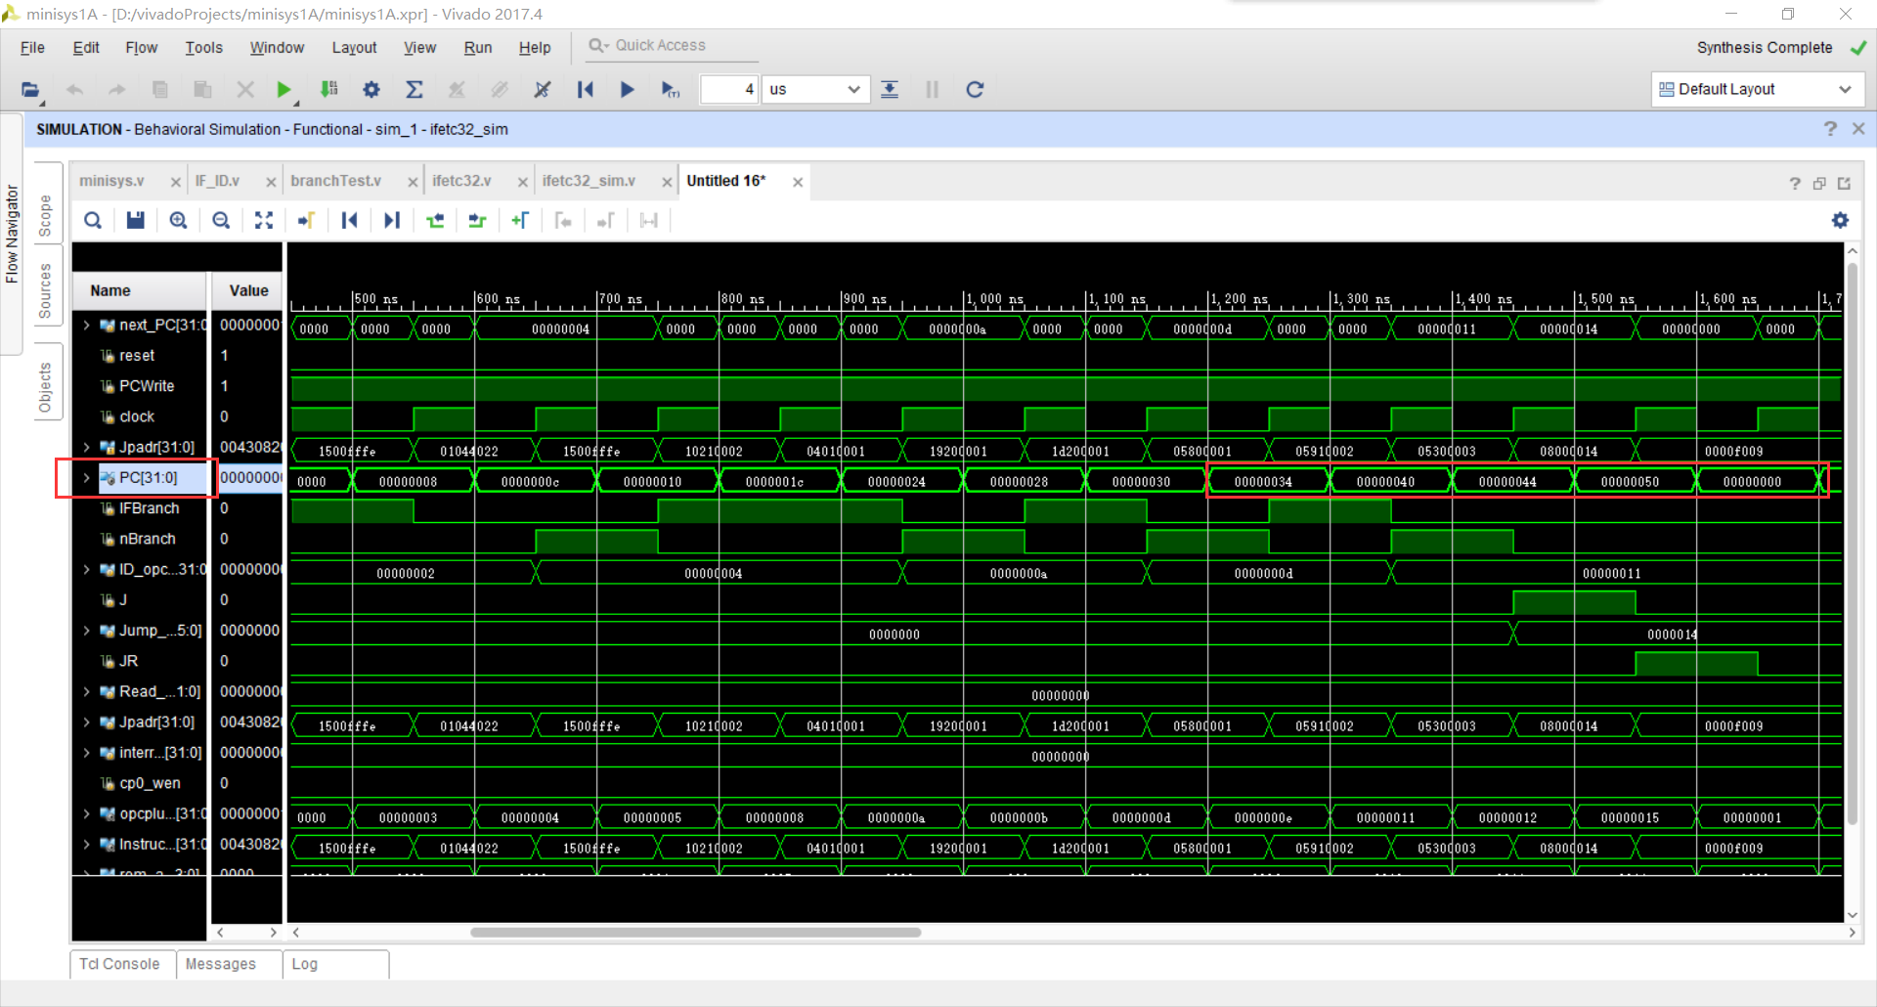

1. Idecode32

3.1 Idecode-sim.asm

|  |
| --- |
| .DATA 0X0  .TEXT 0X0000  start:  lui $8,0xffff # 00:$8=0xffff0000  addiu $9,$0,61 # 04:$9=61=111101=0x3d  add $10,$8,$9 # 08:$10=$8+$9=0xffff003d(负数)  jal lop1 # 0c:$31=(0c+4)>>2=10>>2=16>>2=4,PC=14  j start # 10  lop1:  bgezal $12,2 # 14:if $12≥0,$31=(14+4)>>2=18>>2=24>>2=6,jump PC+4+2<<2,PC=20  jal start # 18  nop # 1c  bltzal $0,3 # 20:if $9<0,jump PC+4+3<<2,不分支  lop2:  jalr $30,$0 # 24:$30=(24+4)>>2=28>>2=40>>2=10=a,PC=0  #PC:  #00,04,08,0c,14,20,24,0 |

3.2 截图

