Entityframework

Goto <https://www.nuget.org/packages/dotnet-ef/>

Copy

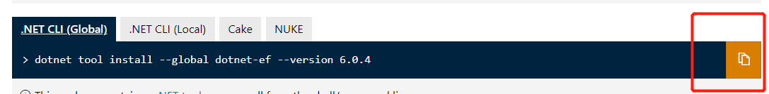

Run it in package manager console.

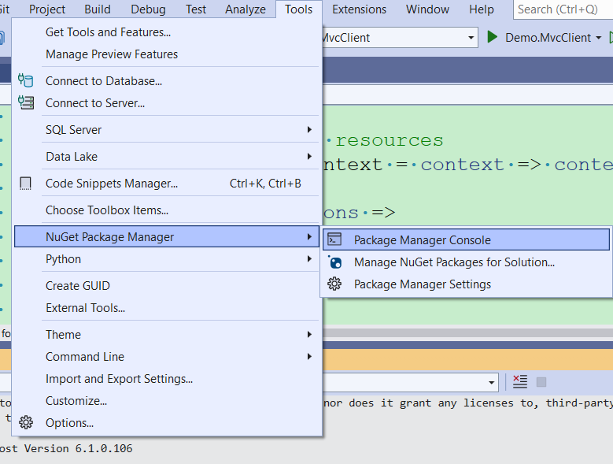

If you have older version, run dotnet tool update --global dotnet-ef

