Zoe Veale

CSE 461

Lab 2

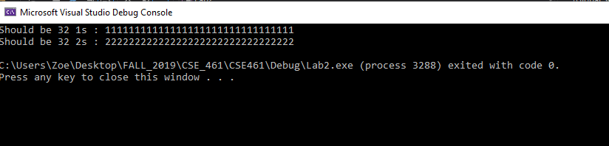

/*main.cpp*/

#include <iostream>

#include "sDisk.h"

int main(int argc, char* argv) {

Sdisk disk1("test1", 16, 32);

std::string block1, block2, block3, block4;

for (int i = 1; i <= 32; i++) block1 = block1 + "1";

for (int i = 1; i <= 32; i++) block2 = block2 + "2";

disk1.PutBlock(4, block1);

disk1.GetBlock(4, block3);

std::cout << "Should be 32 1s : ";

std::cout << block3 << std::endl;

disk1.PutBlock(8, block2);

disk1.GetBlock(8, block4);

std::cout << "Should be 32 2s : ";

std::cout << block4 << std::endl;;

return 0;

}

/*sDisk.h*/

#ifndef SDISK_H

#define SDISK_H

#include <string>

#include <fstream>

#include <cstdio>

class Sdisk {

public:

Sdisk(std::string diskname, int numberofblocks, int blocksize) :

diskname(diskname), numberofblocks(numberofblocks), blocksize(blocksize) {

if (!LoadDisk()) {

CreateDisk();

}

}

int GetBlock(int blocknumber, std::string& buffer) {

std::ifstream file(diskname.c_str(), std::fstream::binary || std::fstream::app);

file.seekg((__int64)blocknumber * (__int64)blocksize);

char* block = new char[blocksize + 1];

block[blocksize] = '\0';

file.read(block, blocksize);

buffer = std::string(block);

delete[] block;

if (!file.good())

return 0;

return 1;

}

int PutBlock(int blocknumber, std::string buffer) {

std::ofstream file(diskname.c_str(), std::fstream::binary || std::fstream::out);

file.seekp((__int64)blocknumber * (__int64)blocksize);

file.write(buffer.c_str(), blocksize);

if (!file.good())

return 0;

return 1;

}

int GetNumberOfBlocks() { return numberofblocks; }

int GetBlockSize() { return blocksize; }

private:

std::ifstream inFile;

std::string diskname; // file name of software-disk

int numberofblocks; // number of blocks on disk

int blocksize; // block size in bytes

bool LoadDisk() {

return inFile.is_open();

}

void CreateDisk() {

std::ofstream file(diskname.c_str(), std::fstream::binary);

std::string buffer(numberofblocks * blocksize, '#');

file.write(buffer.c_str(), (__int64)numberofblocks * (__int64)blocksize);

if (!file.good())

printf("File did not write!\n");

}

};

#endif // !SDISK_H