Zoe Veale

CSE 461

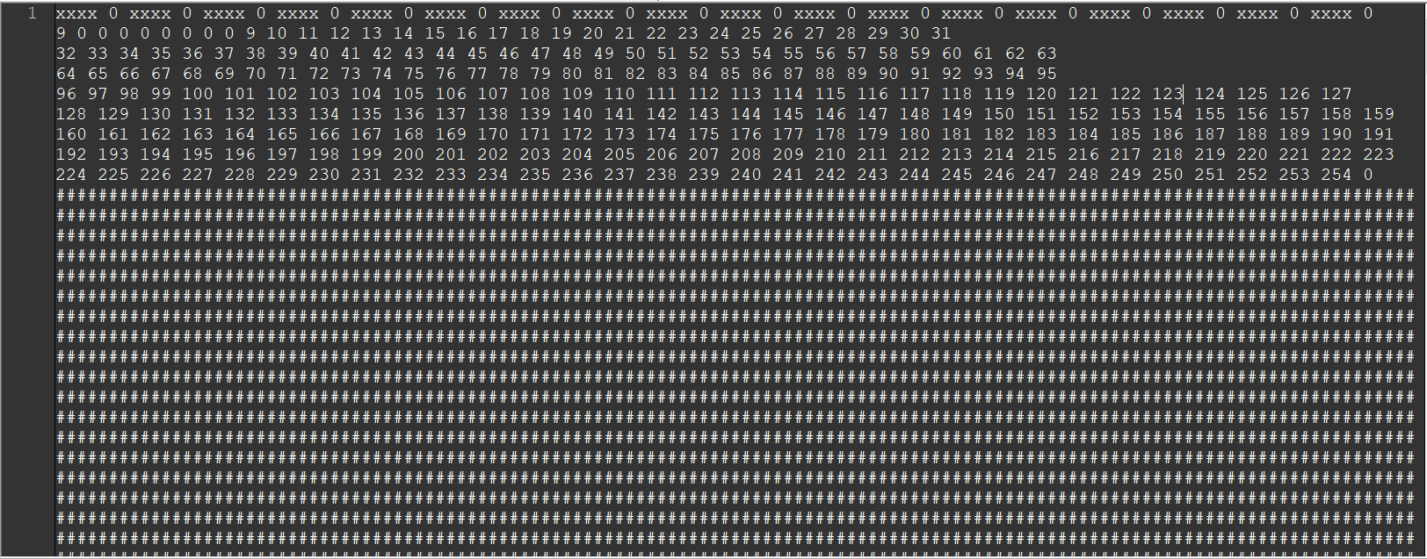Lab3

#include "fileSystem.h"

int main(int argc, char* argv) {

Sdisk diskA("diskA", 256, 128);

FileSystem test("diskA", 256, 128);

}

#ifndef FILESYSTEM_H

#define FILESYSTEM_H

#include <vector>

#include <sstream>

#include <iomanip>

#include "sDisk.h"

class FileSystem : public Sdisk {

public:

FileSystem(std::string diskname, int numberofblocks, int blocksize);

int FileSystemClose();

int FileSystemSynch();

int NewFile(std::string file);

int RemoveFile(std::string file);

int GetFirstBlock(std::string file);

int AddBlock(std::string file, std::string block);

int DeleteBlock(std::string file, int blocknumber);

int ReadBlock(std::string file, int blocknumber, std::string& buffer);

int WriteBlock(std::string file, int blocknumber, std::string buffer);

int NextBlock(std::string file, int blocknumber);

private:

const int FILE_ALLOCATION_SIZE = 4;

const int FILE_NAME_SIZE = 7;

const int FAT_MEMORY_POSITION = 1;

const int ROOT_MEMORY_POSITION = 0;

int rootSize; // maximum number of entries in ROOT

int fatSize; // number of blocks occupied by FAT

std::vector<std::string> filename; // filenames in ROOT

std::vector<int> firstBlock; // firstblocks in ROOT

std::vector<int> fat; // FAT

};

#endif // !FILESYSTEM_H

#include "fileSystem.h"

FileSystem::FileSystem(

std::string diskname, int numberofblocks, int blocksize) :

Sdisk(diskname, numberofblocks, blocksize),

rootSize(GetBlockSize() / FILE_NAME_SIZE),

fatSize(GetNumberOfBlocks()* FILE_ALLOCATION_SIZE / GetBlockSize()) {

std::string buffer;

GetBlock(1, buffer);

if (buffer[1] == '#') {

//new disk

for (int i = 0; i < rootSize; i++) {

//TODO:: preprocessor defines for no file and first block zero, NULL maybe

filename.push_back("xxxx");

firstBlock.push_back(0);

///

}

for (int i = 0; i < GetNumberOfBlocks(); i++) {

if (i < fatSize + FAT_MEMORY_POSITION) {

fat.push_back(0);

}

else {

fat.push_back(i);

}

}

//fat.resize(GetNumberOfBlocks(), -1);

fat[0] = fatSize + FAT_MEMORY_POSITION;

fat[GetNumberOfBlocks() - FAT_MEMORY_POSITION] = 0;

FileSystemSynch();

}

else {

//load disk

buffer.clear();

GetBlock(0, buffer);

std::stringstream diskData(buffer);

for (unsigned int i = 0; i < rootSize; i++) {

std::string name;

int blockNumber;

diskData >> name >> blockNumber;

filename.push_back(name);

firstBlock.push_back(blockNumber);

}

diskData.str("");

diskData.clear();

for (int i = FAT_MEMORY_POSITION; i < fatSize + FAT_MEMORY_POSITION; i++) {

GetBlock(i, buffer);

diskData.str(diskData.str() + buffer);

}

for (unsigned int i = 0; i < GetNumberOfBlocks(); i++) {

int blockNumber;

diskData >> blockNumber;

fat.push_back(blockNumber);

}

}

}

int FileSystem::FileSystemClose() {

FileSystemSynch();

return 1;

}

int FileSystem::FileSystemSynch() {

std::ostringstream rootStringStream;

for (int i = 0; i < filename.size(); i++) {

rootStringStream << filename[i] << " " << firstBlock[i] << " ";

}

for (int k = rootStringStream.tellp(); k < GetBlockSize(); k++) {

rootStringStream << " ";

}

PutBlock(ROOT_MEMORY_POSITION, rootStringStream.str());

std::ostringstream fileTableAllocationStringStream;

for (int i = 0; i < fatSize; i++) {

for (int k = GetBlockSize() * (i) / FILE_ALLOCATION_SIZE;

k < GetBlockSize() * (i + 1) / FILE_ALLOCATION_SIZE; k++) {

fileTableAllocationStringStream << fat[k] << " ";

}

for (int k = fileTableAllocationStringStream.tellp(); k < GetBlockSize(); k++) {

fileTableAllocationStringStream << " ";

}

PutBlock(FAT_MEMORY_POSITION + i, fileTableAllocationStringStream.str());

fileTableAllocationStringStream.str("");

fileTableAllocationStringStream.clear();

}

return 0;

}