Zowe: A Big Hit at the Poughkeepsie Client Experience Center zModernization Summit Event
By Daniel Jast(Daniel.Jast@ibm.com)

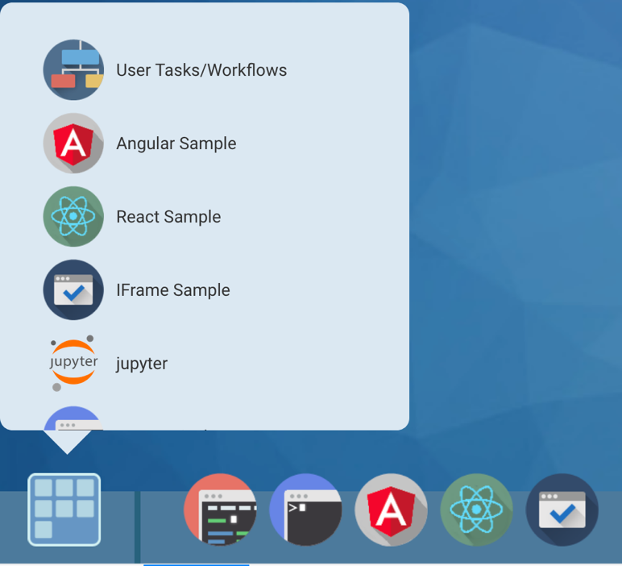
The Poughkeepsie Client Experience Center recently hosted the annual IBM Z Summit Program Technical training event titled, zModernization Summit Event. At the training event, we provided 20 of the new IBM Technical Sellers in Z with hands on training in some of the “modernizing” applications on Z. These technologies included CICS, DB2, z/OS Connect, z/OSMF Zowe, Spark, ICP, Docker and more. The week let participants take a cobol application running on z/OS, expose the applications services into APIs, and then create a containerized application with those APIs which was then deployed out to the IBM Cloud. The application that was being run was a stock trading application which allowed users to create an investment portfolio, add stocks to the portfolio, and so on. We then let users get a hands-on experience on the Zowe Desktop and CLI, seeing how easy and simple completing complex z/OS tasks can be for new users by utilizing Zowe.

On the Zowe Desktop, we had created an IFrame application that had the Jupyter Notebooks running right on the Zowe Desktop. Jupyter Notebooks are used to exploit Spark to analyze data sources of your choosing. We had the Jupyter Notebooks analyzing Investment portfolio data which the users had created unknowingly as they worked through the technical labs throughout the week of training.
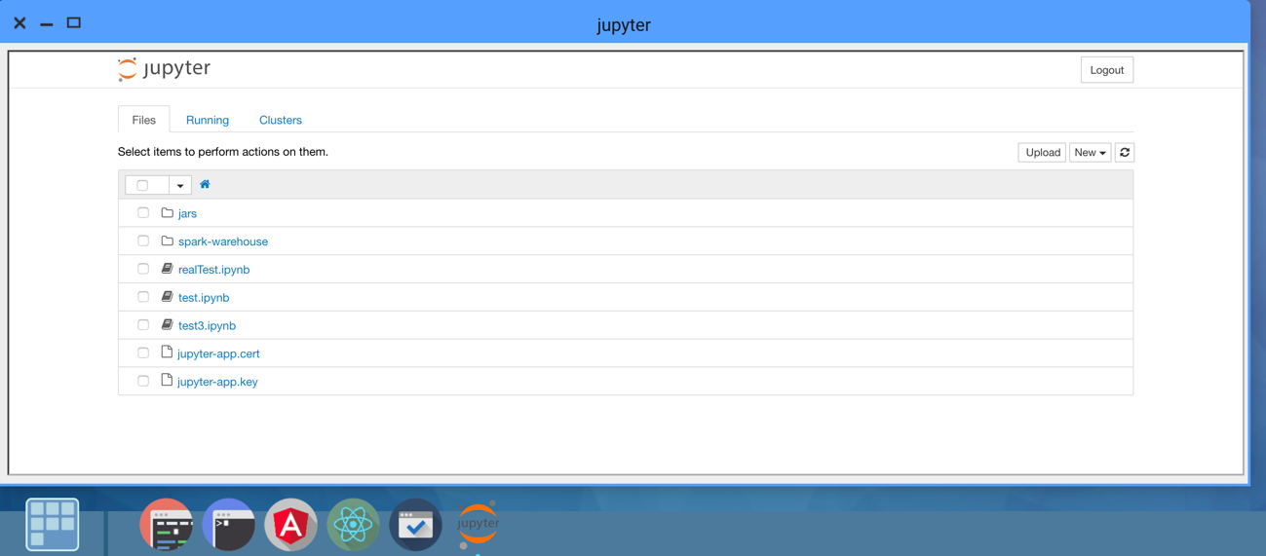
Training participants thoroughly enjoyed the Zowe and Jupyter Notebook piece. After getting previous training on “green screen” interfaces to z/OS, the Zowe Desktop and Zowe CLI were very well received. The audience was majority straight out of college, matching the target audience for the Zowe platform. When participants were asked what their highlights and key takeaways from the week of training were, some mentioned Zowe explicitly:

“Being able to learn more about Zowe and more innovative technologies integrated with Z.”

“Highlight: Zowe presentation!”

“My favorite (presentation) was the Zowe presentation”
“I think I really enjoyed learning about Zowe, and the hands on lab are super helpful in understanding!”

If you are looking to add Jupyter Notebooks to your Zowe Desktop, you can follow the github documentation posted here: https://github.com/zowe/jupyter-app
You can also follow the custom documentation written by the Client Experience Center’s Alex Lieberman(Alex.Lieberman1@ibm.com) and Dan Jast here: https://ibm.box.com/s/wo583vfw4klc2jg7l0zxo0k55yvw681b

If you would like to go through most of the Zowe Hands on Lab which event participants went through, you can request a demo from the Client Experience Center Demo Portal located here:
Zowe: Modern Z Systems Programming Demo: https://www.ibm.com/systems/clientcenterdemonstrations/faces/_rlvid.jsp?_rap=!viewDemo&demoId=3089&conversationContext=1&_rvip=/dcSearchDemonstrations.jsp
NOTE: If you are not an IBMer, you will not be able to participate in this demonstration without your IBM representatives help. You can contact Dan Jast for further information.

