**HALL EFFECT**

­­­Name-Surname: Zohra Shikhalizada

Date of the Experiment: 02.05.19

Report Submission Date: 09.05.19

Group Member: Rafet Kavak

**Introduction**

Materials can be differentiated according to their conductivity as conductors, semiconductors and insulators. Conductivity is one of the fundamental properties of materials that shows the allowance of the current pass through the material. Semiconductor has a conductivity between metals and insulators. While metals have a very high conductivity and insulators have lowest conductivity. One of the major factors determining conductivity is the band gap. It’s about the minimum energy that an electron requires to get excited and take place in conduction. The concept defining how quickly electron participates in conduction by moving through a metal or semiconductor in the presence of an electric field is called the electron mobility.

Conductivity of semiconductors can be changed by introducing impurities to it. The most widely used semiconductors are the 4th group elements such as Silicon and Germanium. These elements are doped with trivalent or pentavalent materials which results in change in conductivity and the number of charge carriers. When 4th group elements are doped with 5th group elements the additional electron of the pentavalent element contributes to conductivity increasing the number of electrons. Silicon resulting from pentavalent doping is called the n-type semiconductor and the number of negative charge carriers outnumber the positive ones. On the other hand, when we dope silicon with a lower group element, due to the lack of electron a hole is created in the lattice therefore an electron is easily accepted by a hole. This is called a p-type semiconductor and the main charge carriers of p-type semiconductors are holes[1].

The type of the semiconductors can be identified by the Hall effect which was discovered in 1879 by Edwin Hall[2]. He showed that when current passes through a conductor or a semiconductor in presence of a magnetic field a voltage difference is generated perpendicular to the direction of the current and the magnetic field. Charge carriers experience a magnetic force they are deflected to either side of the semiconductor which results in the Hall voltage. The polarity of the Hall voltage can be used to determine the sign of the charge carriers. As the Lorentz force acting on the carriers must be balanced by the electrostatic force, an expression for the Hall voltage can be derived.

$$qvB=qE_{H}$$

$$E_{H}=vB$$

$$V_{H}=E_{H}s=vBs$$

Where s is the width of the sample. Furthermore, since velocity of the carriers is related to current where A=sd is the cross sectional are of the sample and d is the thickness,

$$v=\frac{I}{nqA}$$

$$V_{H}=\frac{1}{nq}\frac{IB}{d}$$

RH=1/nq is called the Hall coefficient and it dependent of the material and temperature. Its sign gives the sign of the charge carriers.

The conductivity of materials also depend on the temperature and the energy gap which can be described as the following where $σ_{0}$ is conductivity at 0 Kelvin, k is the Boltzman’s constant, Eg is the energy gap and T is the temperature,

$$σ=σ_{0}exp(-\frac{E_{g}}{2kT})$$

Furthermore, we can describe the mobility which is defined as

$$μ=\frac{v}{E_{app}}=\frac{I}{nqA}\frac{l}{V_{app}}=\frac{l}{nqA}\frac{1}{R}$$

**Experimental Details**

The experimental setup includes Hall effect module, Hall probe, semiconductor, electromagnet, power supply, personal computer and a control computer which can be seen from the figure below. The power supply provides the necessary current to create the magnetic field for the electromagnet. The applied magnetic field is measured with the Hall probe. The values of current, Hall voltage, magnetic flux are measured by the help of the “Cobra 3 Basic Unit” interface on the personal computer.

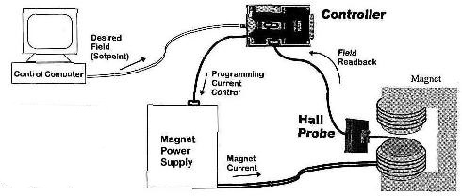

Figure 1. Experimental setup for Hall effect[3]

The experiment consists of 2 parts. In the first, part we keep the magnetic flux constant while changing the current with the increments of 10 and record the Hall voltage and the current values. For the second part, the current is kept constant while the magnetic flux density is decreased with the increments of 50 from 300 to zero.

**Measurement & Data Analysis**

*Data:*

|  |  |  |
| --- | --- | --- |
| Sample Current, Ip(mA) | Hall Voltage UH (mV) | Slope (mV/mA) |
| -30 | -62.5 | m=2.021 |
| -20 | -41.8 |
| -10 | -22 |
| 0 | -0.3 |
| 10 | 20.6 |
| 20 | 38.9 |
| 30 | 58.1 |

Table 1: Hall Voltage corresponding to Sample Current

Table 1 describes the relation between the current passing through the semiconductor and the Hall voltage created on it. We can see that the value of the Hall voltage is proportional to the sample current.

|  |  |  |
| --- | --- | --- |
| Flux density, B(mT) | Hall Voltage UH (mV) | Sample Voltage Up (mV) |
| 300 | 58.0 | 1.54 |
| 250 | 50.1 | 1.53 |
| 200 | 41.5 | 1.51 |
| 150 | 32.0 | 1.51 |
| 100 | 22.0 | 1.50 |
| 50 | 11.6 | 1.50 |
| 0.2 | 1.1 | 1.49 |

Table 2: Currents vs voltages in at constant intensity (aperture diameter 4mm) for different wavelengths

From Table 2 we can see the decrease in the Hall Voltage as the flux density decreases. We also observe a slight change in sample voltage even though sample current doesn’t change.

*Plots:*

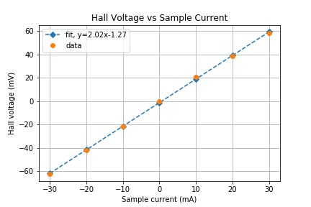

Figure 2. : Hall Voltage corresponding to Sample Current

Figure 2. corresponds to the Table 1 in Data part. The slope of the graph equals to 2.02 mV/mA

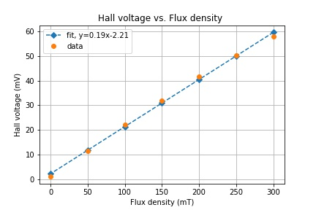

Figure 3. Plot of Hall voltage dependence on flux density

Figure 3 corresponds to the Table 2. The slope of the plot is 0.19 mV/mT.

*Calculations:*

$$V_{H}=\frac{1}{nq}\frac{IB}{d}$$

For the first part:

d=0.001 m, B=300 mT, q=1.602*10-19,

For the second part:

From the slope $\frac{V_{H}}{B}=0.19$

$$n=\frac{B}{V_{H}}\frac{I}{qd}=\frac{ 30mA}{0.191 mV/mT 1.602.{10}^{-19}C {10}^{-3}m}=9.85*{10}^{20}$$

$$R_{H}=\frac{1}{nq}=0.0063$$

**Results and Discussion**

*Comments:*

In the experiment we measured the Hall voltage of the sample and the number of the charge carriers. From the Table 1 and Figure 2 we observed that Hall Voltage was proportional to the current passing through the sample. From the sign of the RH it’s concluded that the Germanium used in the experiment is p-type. In the second part of the experiment, as we can see from the Figure 3, we observed an increase in the sample voltage while the current was held constant. It can be explained with magnetoresistance due to the fact that mean free path decreases with increasing magnetic field.

The Hall effect has many applications one of which is to determine if the given material is an insulator or a semiconductor. It is also used as a magnetometer which helps to determine the magnetic field present, in position sensing sensor, and so on.

*Errors:*

There’s a mild error in the value of Hall coefficient which can be due to the fact that the readings in the second part were not exactly as same as in the table. The magnetic flux was not constant and was constantly changing.

**Reference:**

[1] The website of Wikibooks, *“Semiconductor Electronics/Semiconductor/Doping”* (Accessed May 9, 2019)

[2] Wikipedia: The Free Encyclopedia,*” Hall effect”* (Accessed May 9, 2019)

[3] (2010).“The Photoelectric Effect” METU Department of Physics: Applied Modern Physics Laboratory Manual and Workbook. Ankara

1. <https://en.wikibooks.org/wiki/Semiconductor_Electronics/Semiconductor/Doping>
2. <https://en.wikipedia.org/wiki/Hall_effect#cite_note-1>
3. <https://www.vicontrols.com/g3magctl/g3magctl.htm>