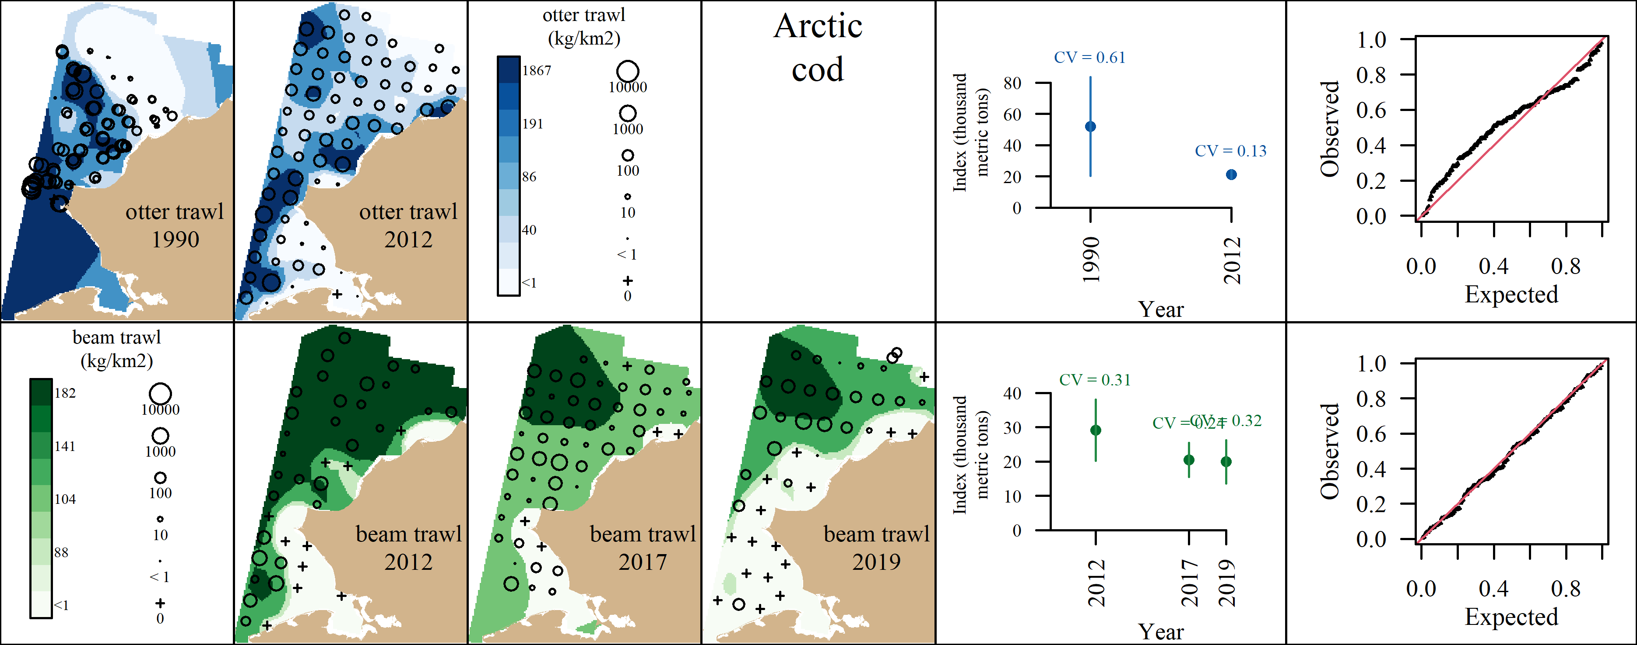 Appendix A1: VAST output for Arctic cod. A) Predicted density with observed densities superimposed, B) Abundance Indices with coefficients of variation, and C) QQ plot.

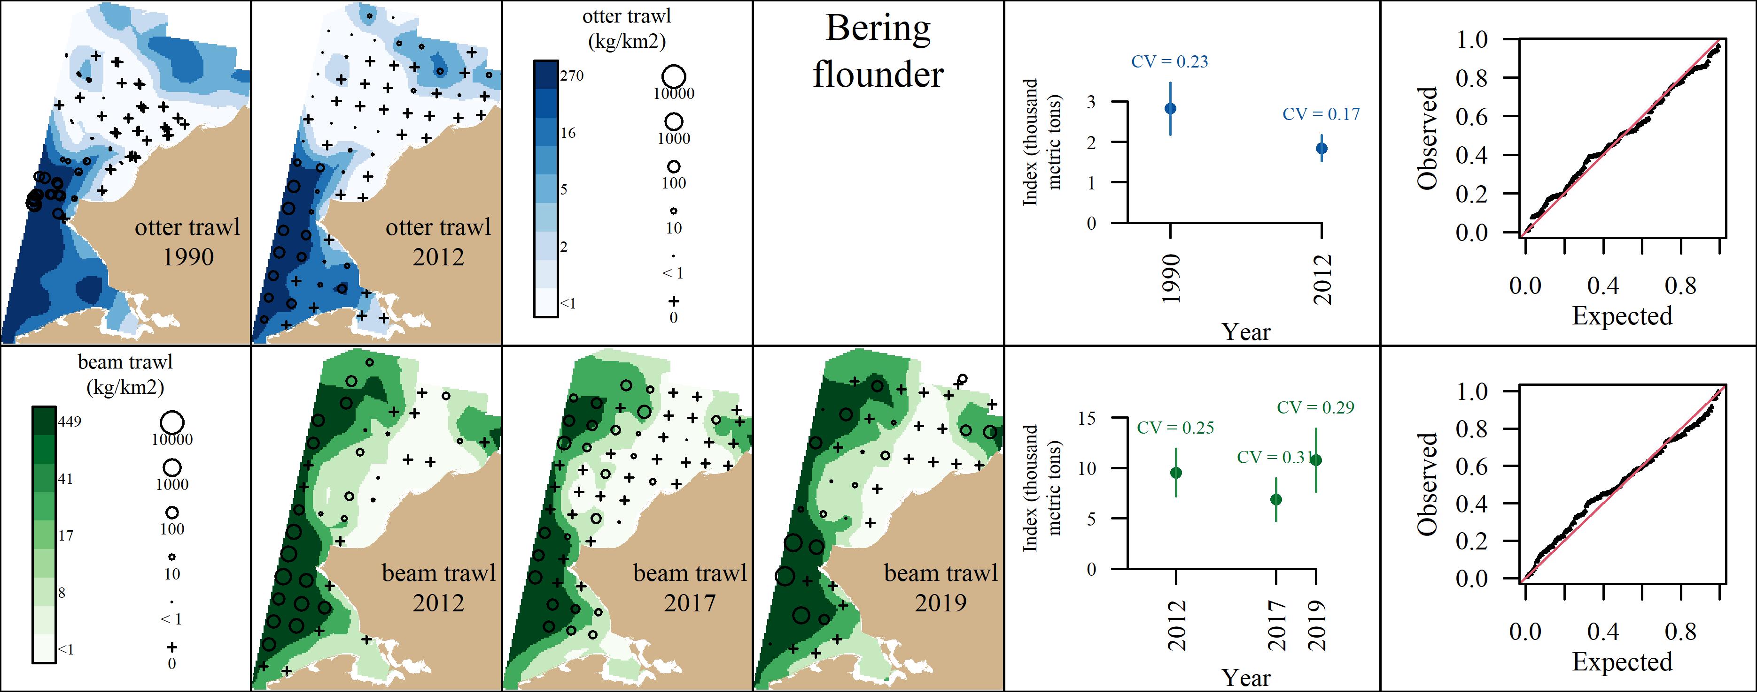 Appendix A2: VAST output for Bering flounder. A) Predicted density with observed densities superimposed, B) Abundance Indices with coefficients of variation, and C) QQ plot.

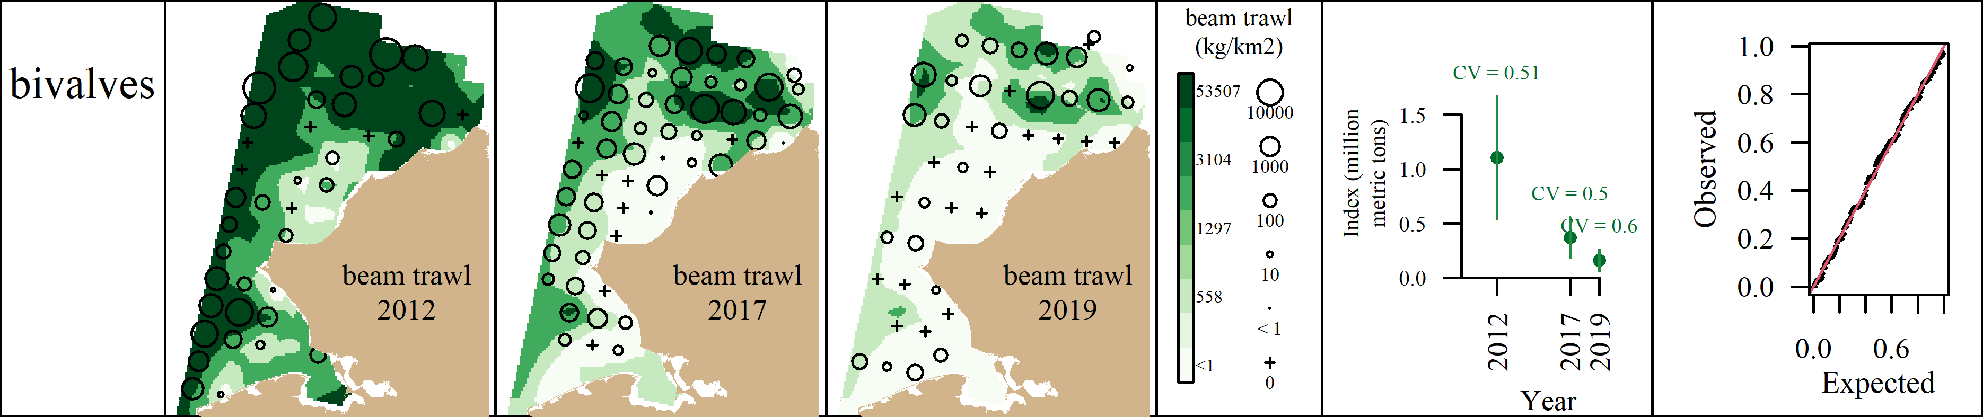 Appendix A3: VAST output for bivalves. A) Predicted density with observed densities superimposed, B) Abundance Indices with coefficients of variation, and C) QQ plot.

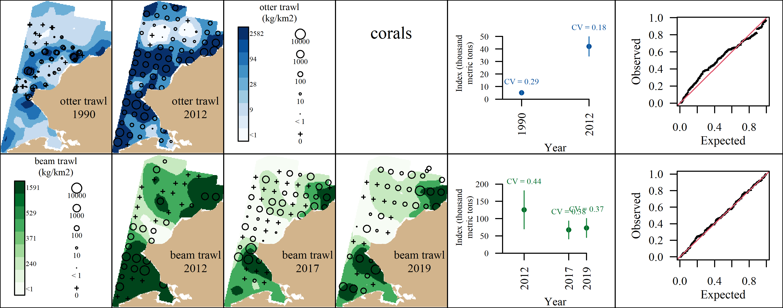 Appendix A4: VAST output for corals. A) Predicted density with observed densities superimposed, B) Abundance Indices with coefficients of variation, and C) QQ plot.

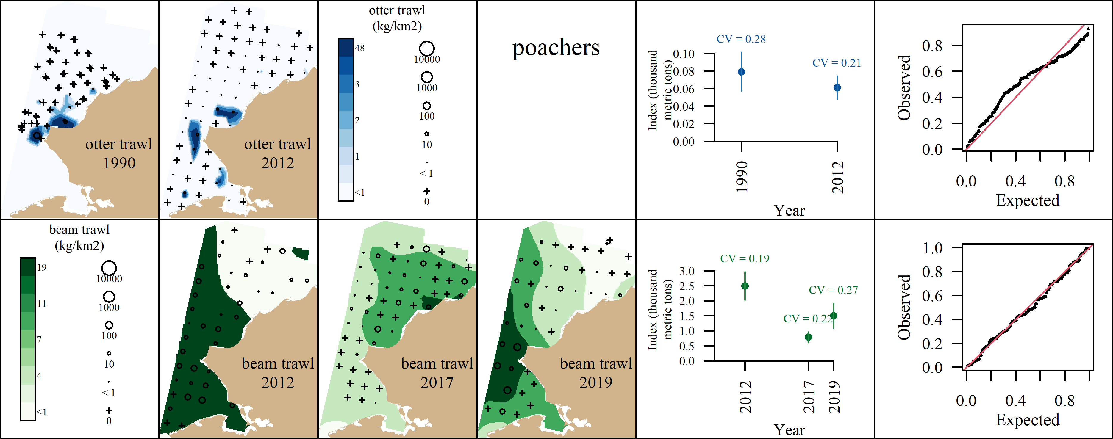 Appendix A5: VAST output for poachers. A) Predicted density with observed densities superimposed, B) Abundance Indices with coefficients of variation, and C) QQ plot.

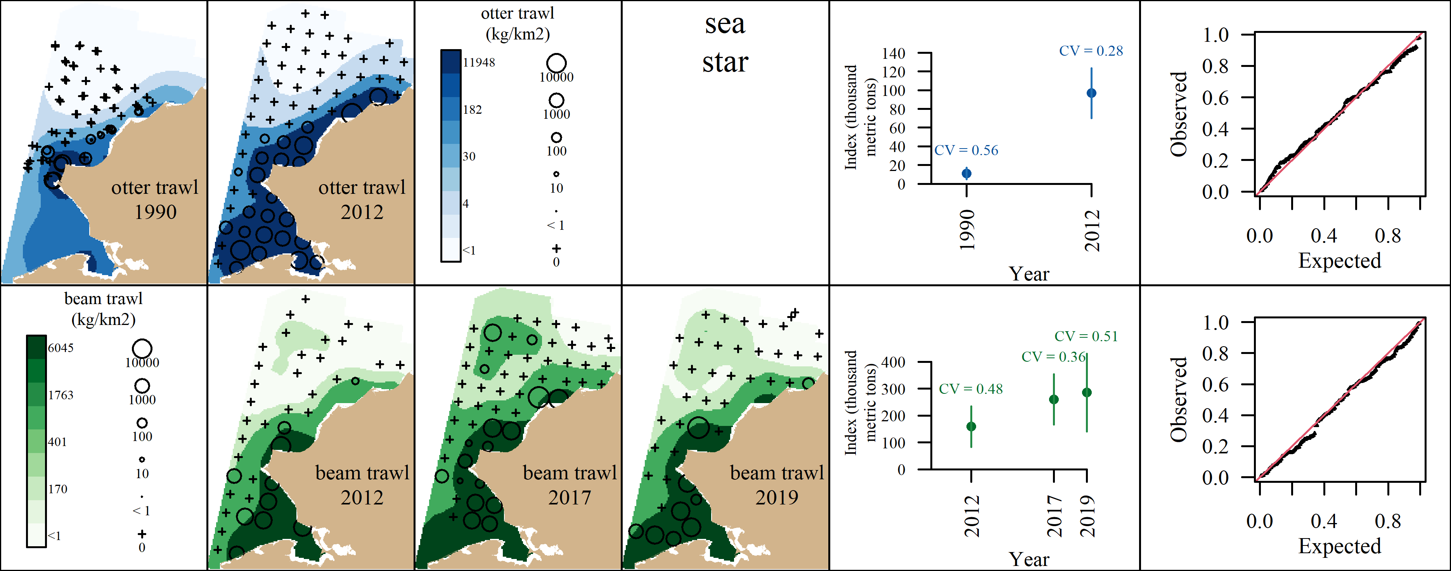 Appendix A6: VAST output for purple-orange sea star. A) Predicted density with observed densities superimposed, B) Abundance Indices with coefficients of variation, and C) QQ plot.

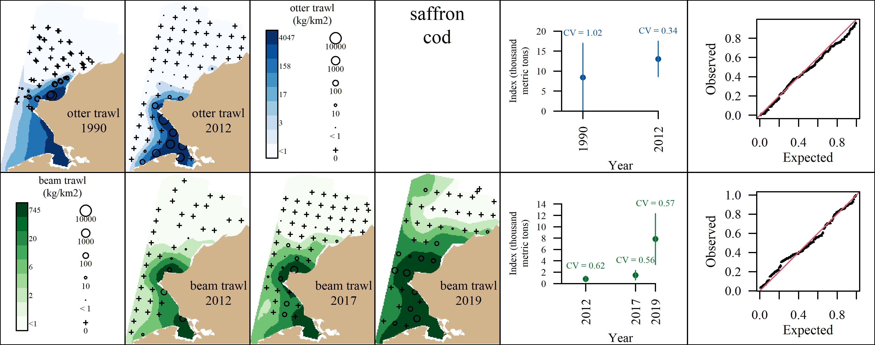 Appendix A7: VAST output for saffron cod. A) Predicted density with observed densities superimposed, B) Abundance Indices with coefficients of variation, and C) QQ plot.

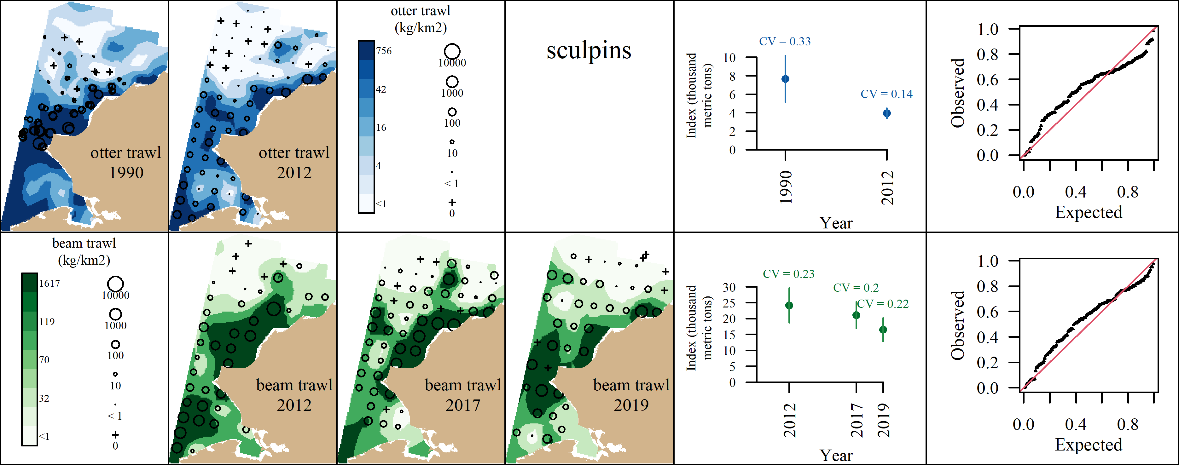 Appendix A8: VAST output for sculpins. A) Predicted density with observed densities superimposed, B) Abundance Indices with coefficients of variation, and C) QQ plot.

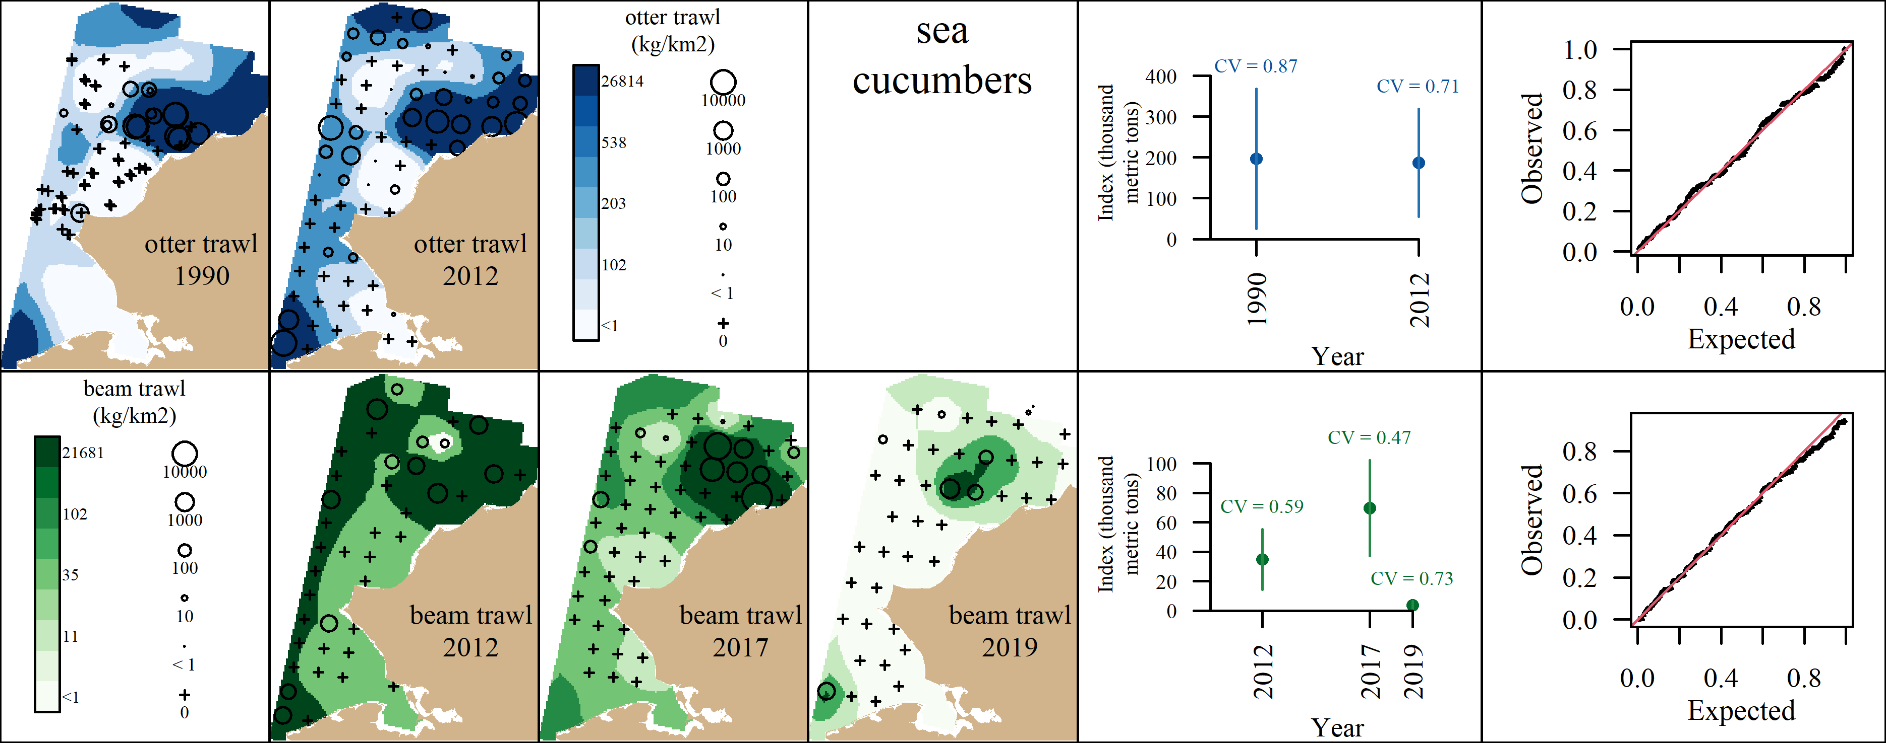 Appendix A9: VAST output for sea cucumbers. A) Predicted density with observed densities superimposed, B) Abundance Indices with coefficients of variation, and C) QQ plot.

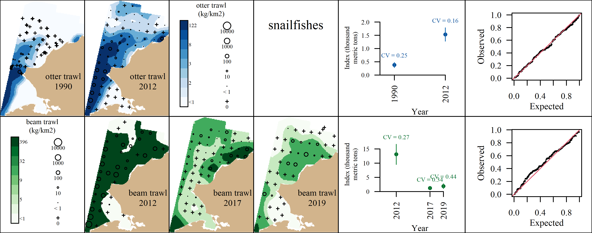 Appendix A10: VAST output for snailfishes. A) Predicted density with observed densities superimposed, B) Abundance Indices with coefficients of variation, and C) QQ plot.

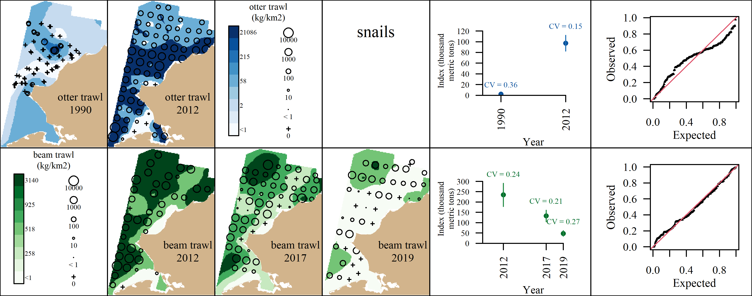 Appendix A11: VAST output for snails. A) Predicted density with observed densities superimposed, B) Abundance Indices with coefficients of variation, and C) QQ plot.

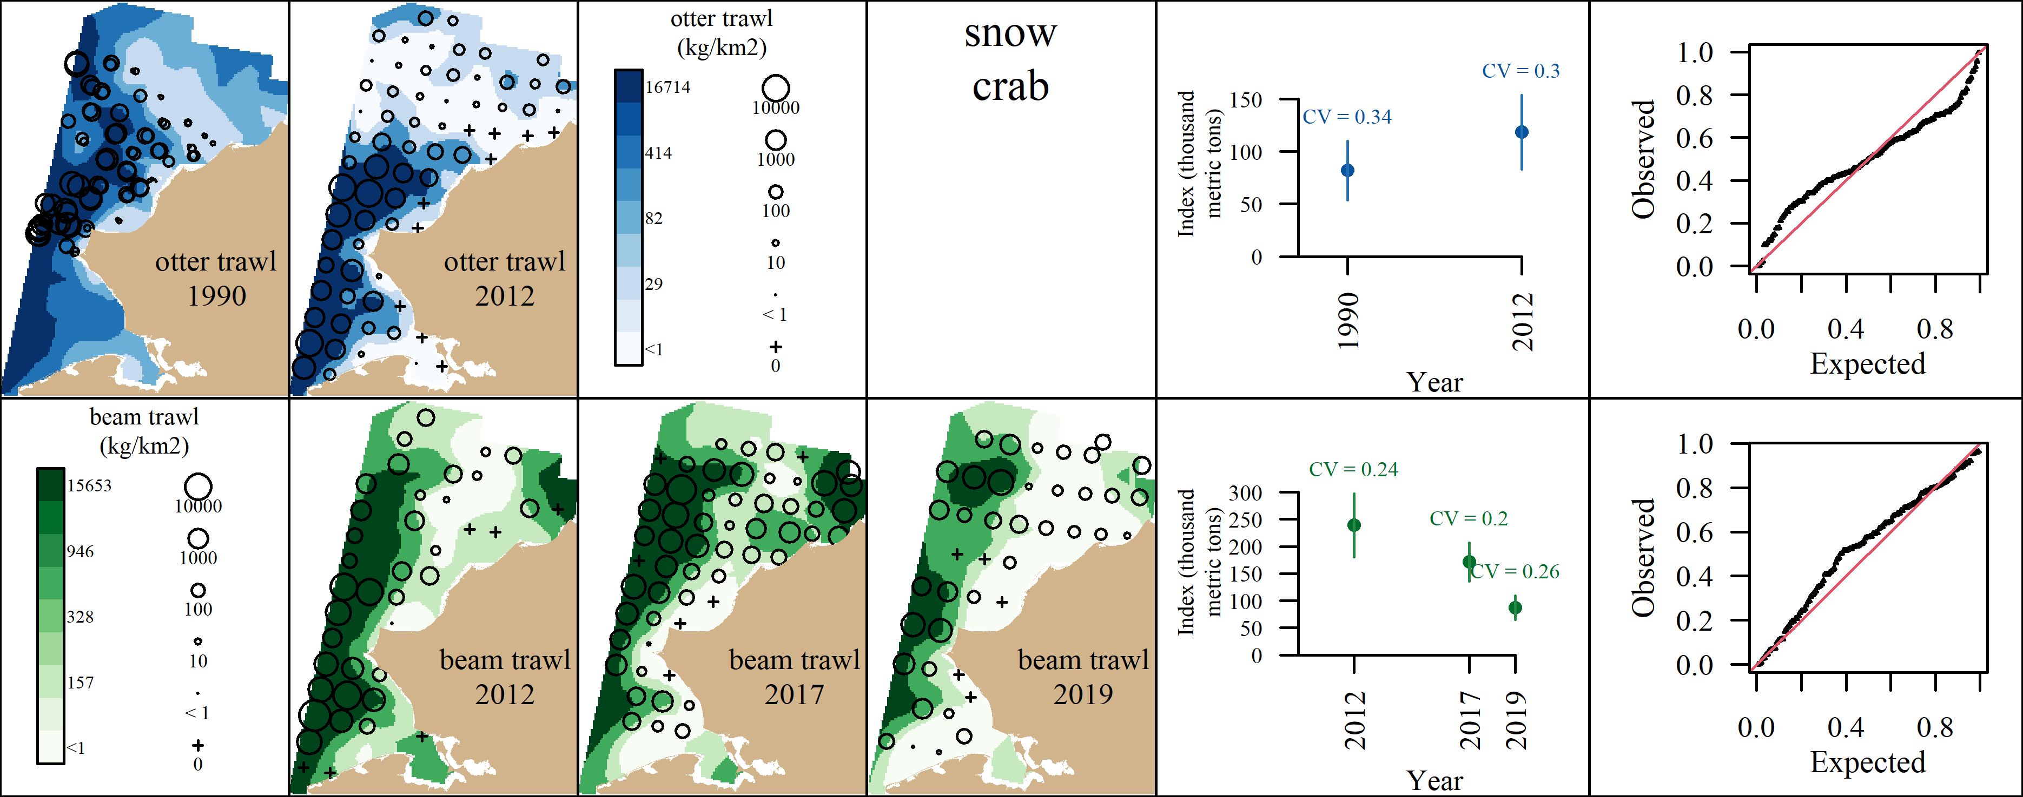 Appendix A12: VAST output for snow crab. A) Predicted density with observed densities superimposed, B) Abundance Indices with coefficients of variation, and C) QQ plot.

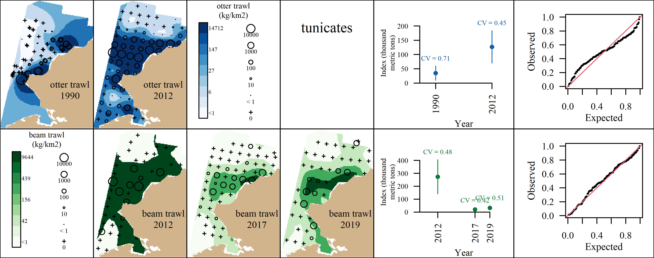 Appendix A13: VAST output for tunicates. A) Predicted density with observed densities superimposed, B) Abundance Indices with coefficients of variation, and C) QQ plot.

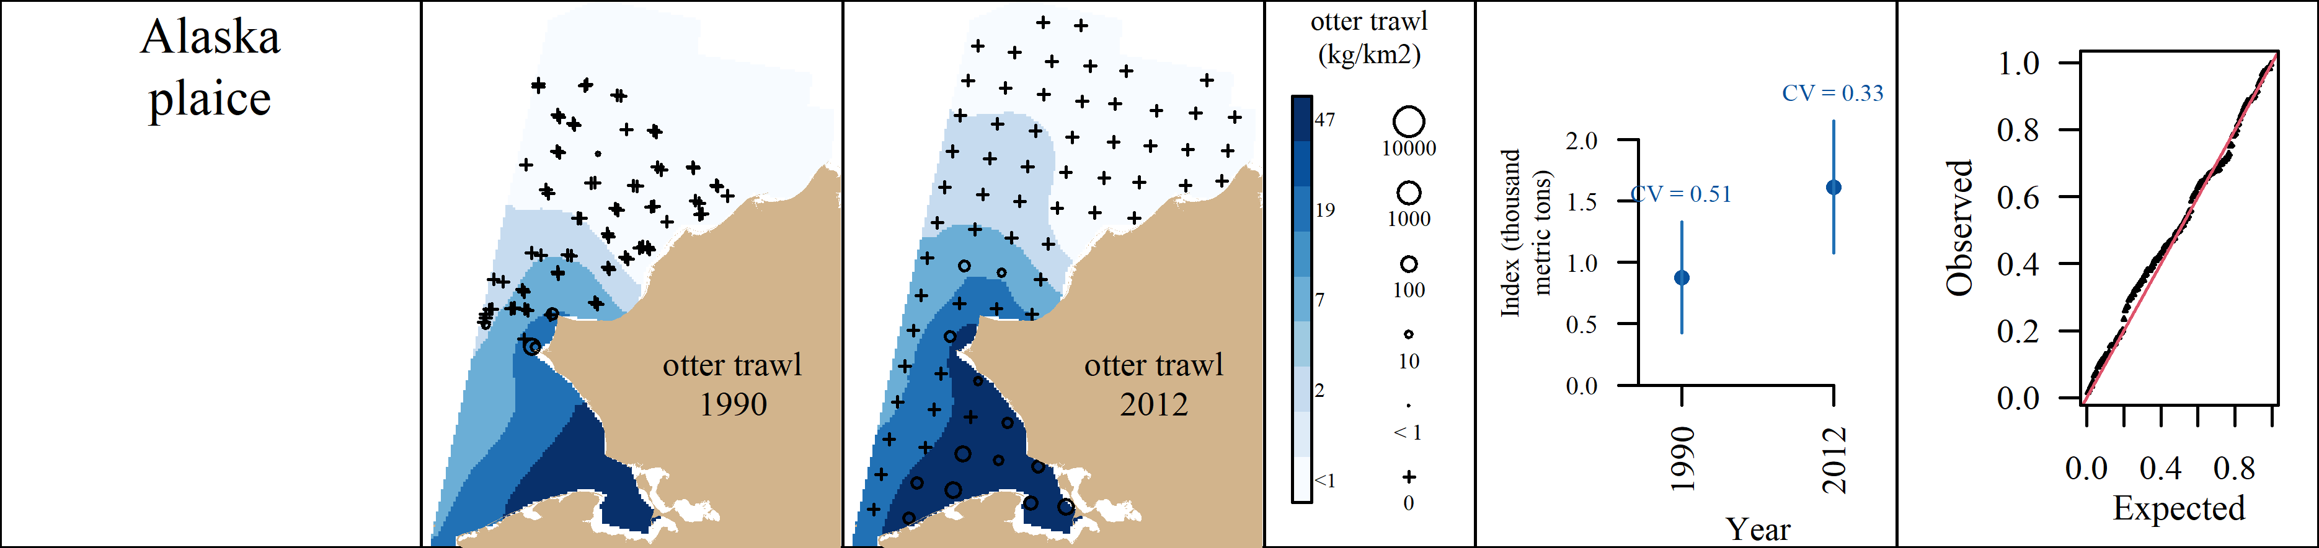 Appendix A14: VAST output for Alaska plaice. A) Predicted density with observed densities superimposed, B) Abundance Indices with coefficients of variation, and C) QQ plot.

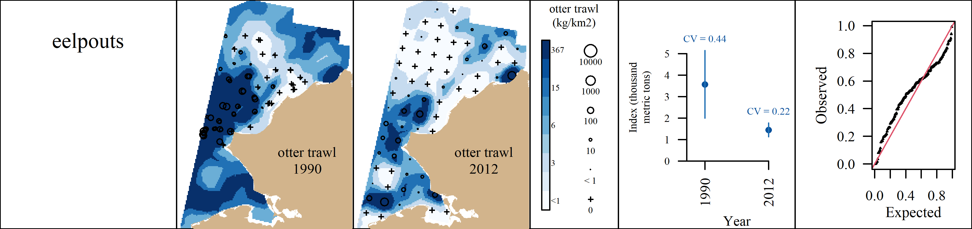 Appendix A15: VAST output for eelpouts. A) Predicted density with observed densities superimposed, B) Abundance Indices with coefficients of variation, and C) QQ plot.

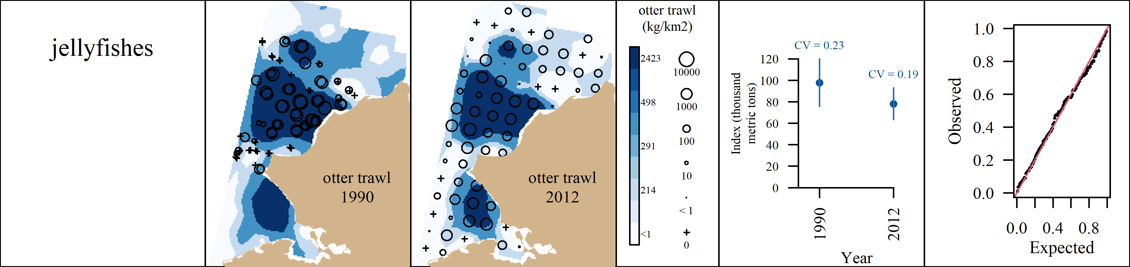 Appendix A16: VAST output for jellyfishes. A) Predicted density with observed densities superimposed, B) Abundance Indices with coefficients of variation, and C) QQ plot.

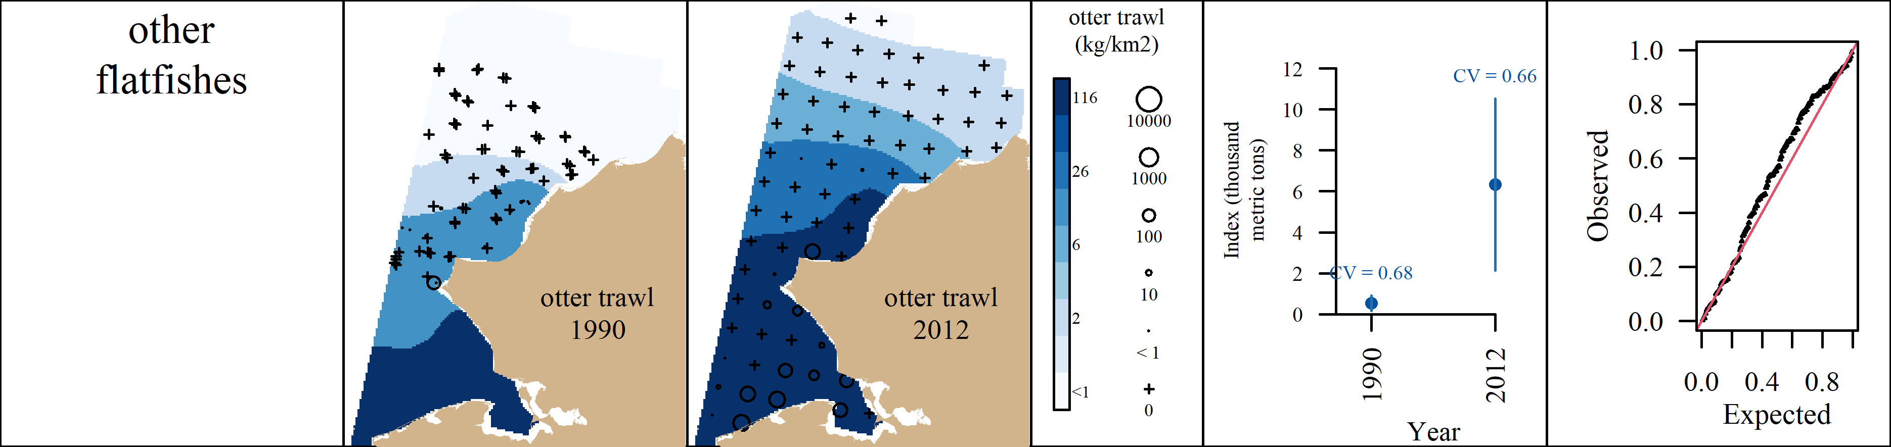 Appendix A17: VAST output for other flatfishes. A) Predicted density with observed densities superimposed, B) Abundance Indices with coefficients of variation, and C) QQ plot.

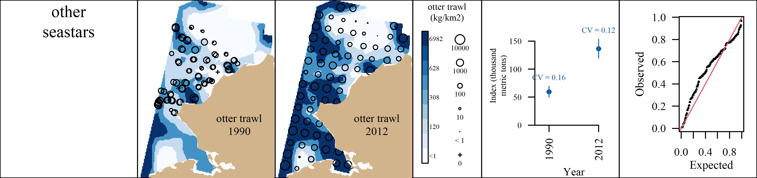 Appendix A18: VAST output for other seastars. A) Predicted density with observed densities superimposed, B) Abundance Indices with coefficients of variation, and C) QQ plot.

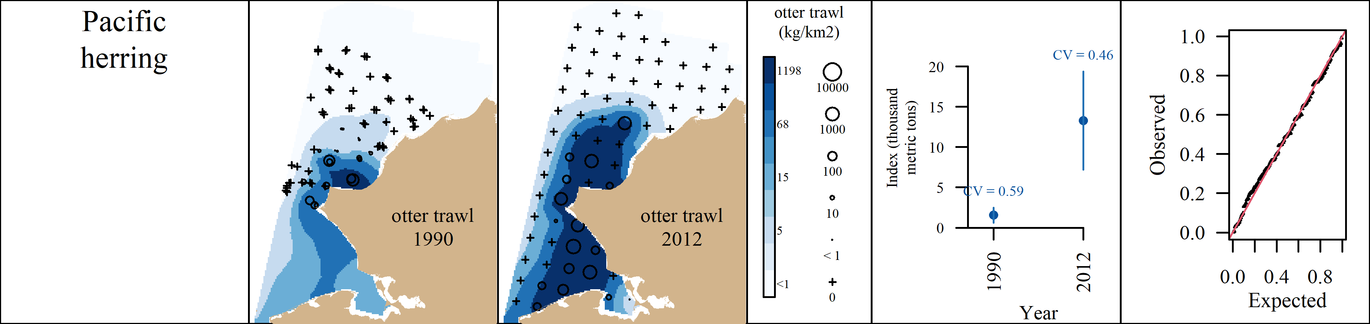 Appendix A19: VAST output for Pacific herring. A) Predicted density with observed densities superimposed, B) Abundance Indices with coefficients of variation, and C) QQ plot.

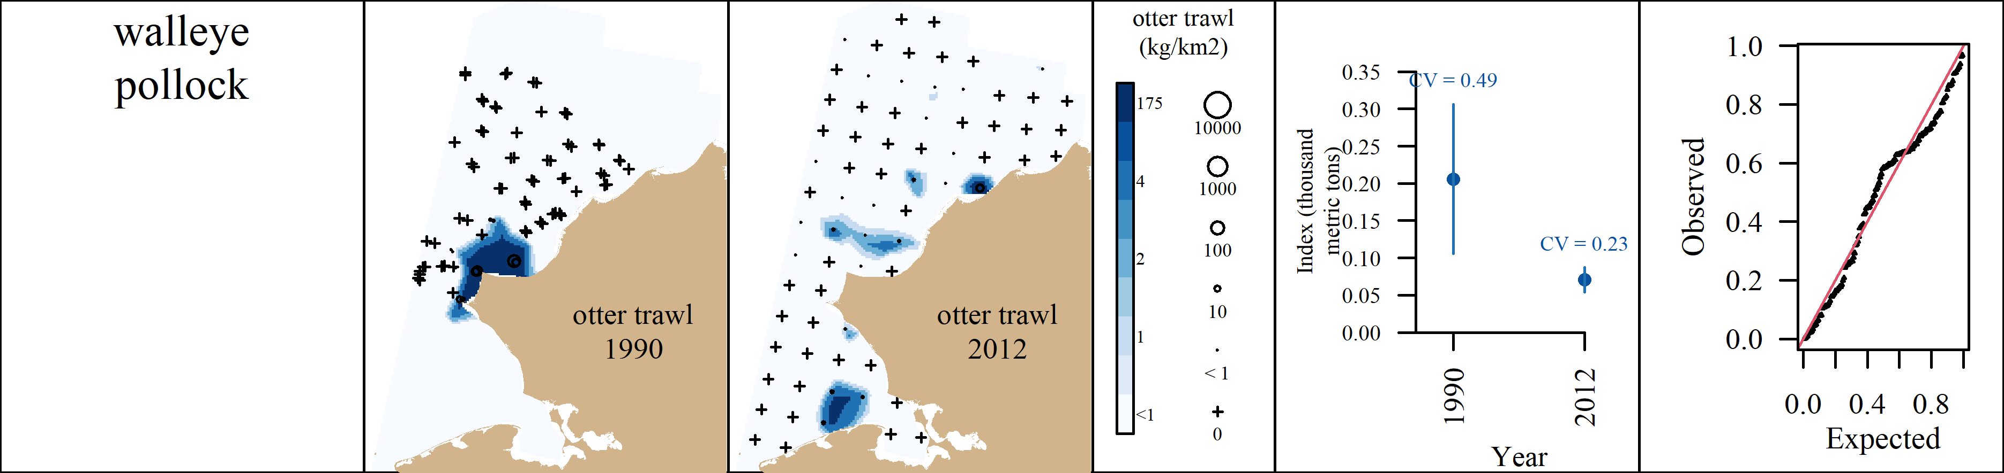 Appendix A20: VAST output for walleye pollock. A) Predicted density with observed densities superimposed, B) Abundance Indices with coefficients of variation, and C) QQ plot.

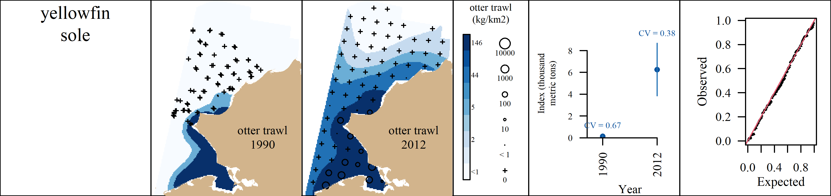 Appendix A21: VAST output for yellowfin sole. A) Predicted density with observed densities superimposed, B) Abundance Indices with coefficients of variation, and C) QQ plot.