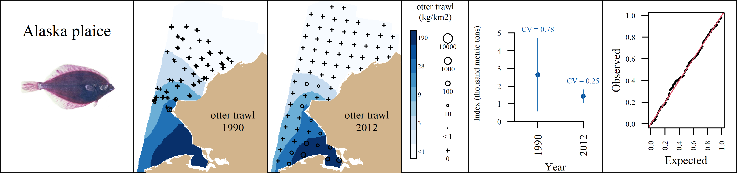 Appendix A1: VAST output for Alaska plaice (*Pleuronectes quadrituberculatus*) for the the otter trawl. From left to right, plots are generally formatted as: A) predicted density with observed densities superimposed, B) abundance indices with associated coefficients of variation, and C) QQ diagnostic plot.

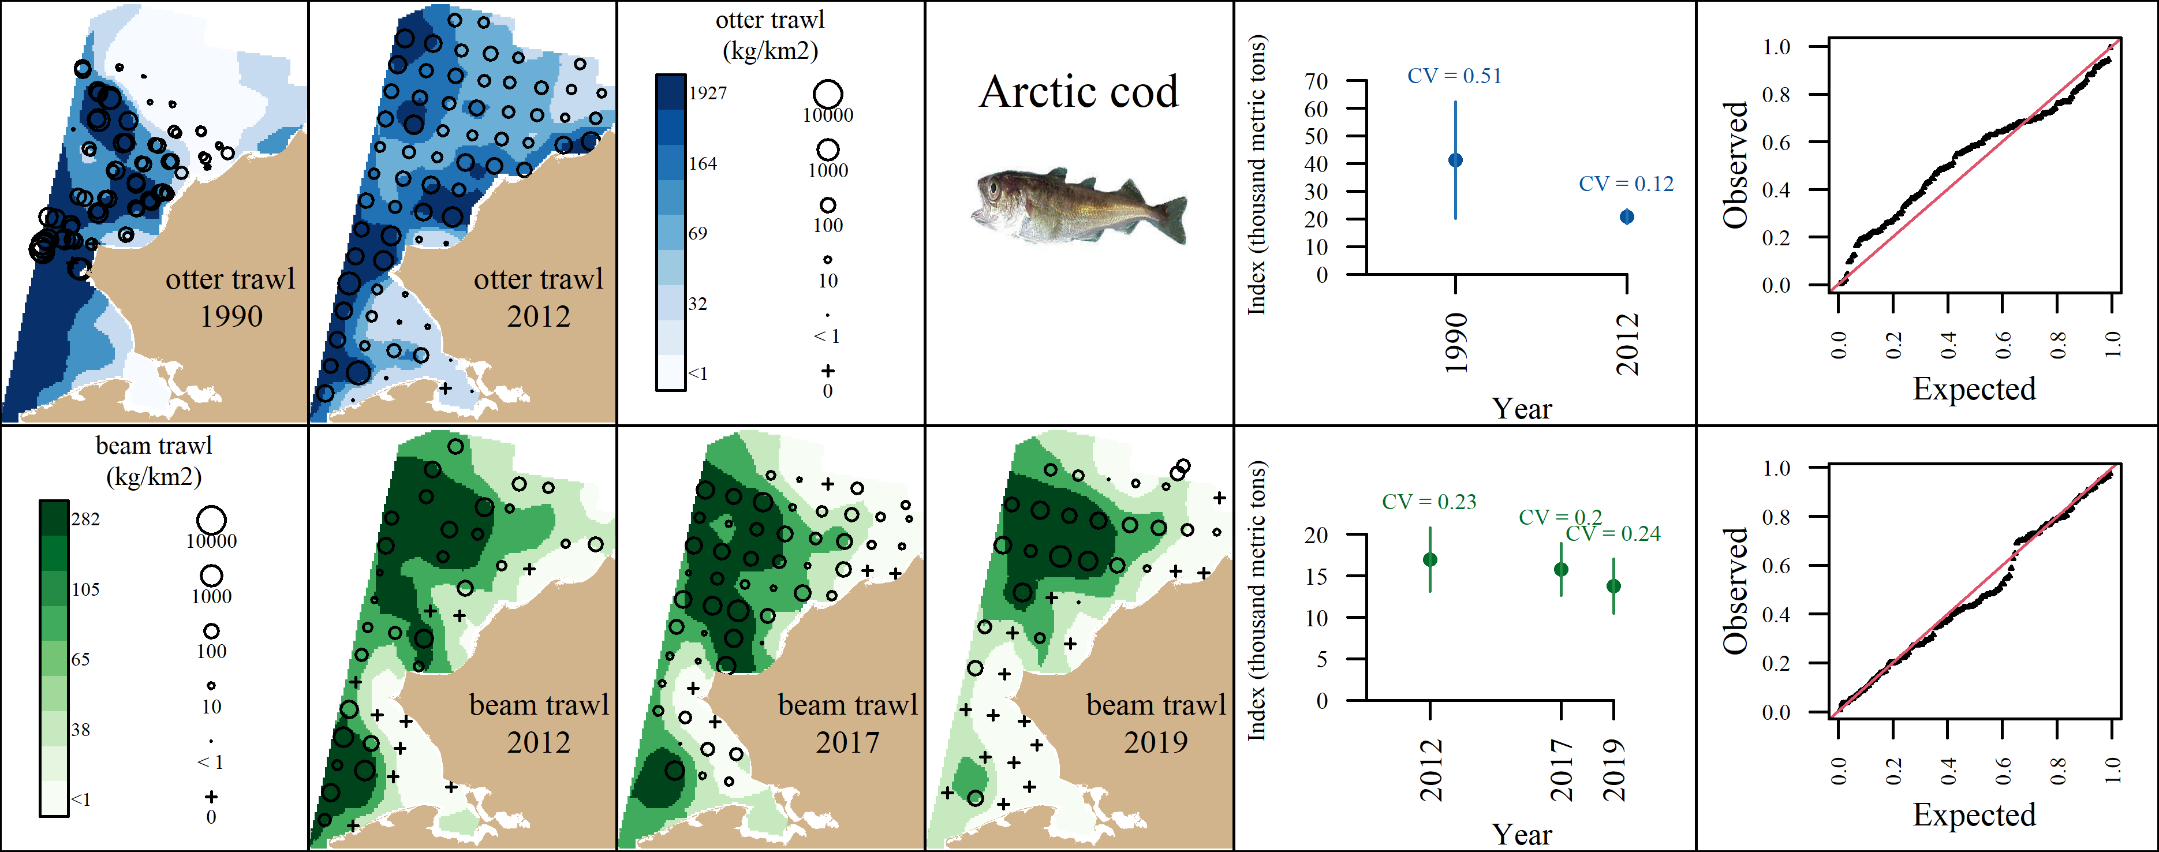 Appendix A2: VAST output for Arctic cod (*Boreogadus saida*) for the the otter trawl (top row) and the beam trawl (bottom row). From left to right, plots are generally formatted as: A) predicted density with observed densities superimposed, B) abundance indices with associated coefficients of variation, and C) QQ diagnostic plot.

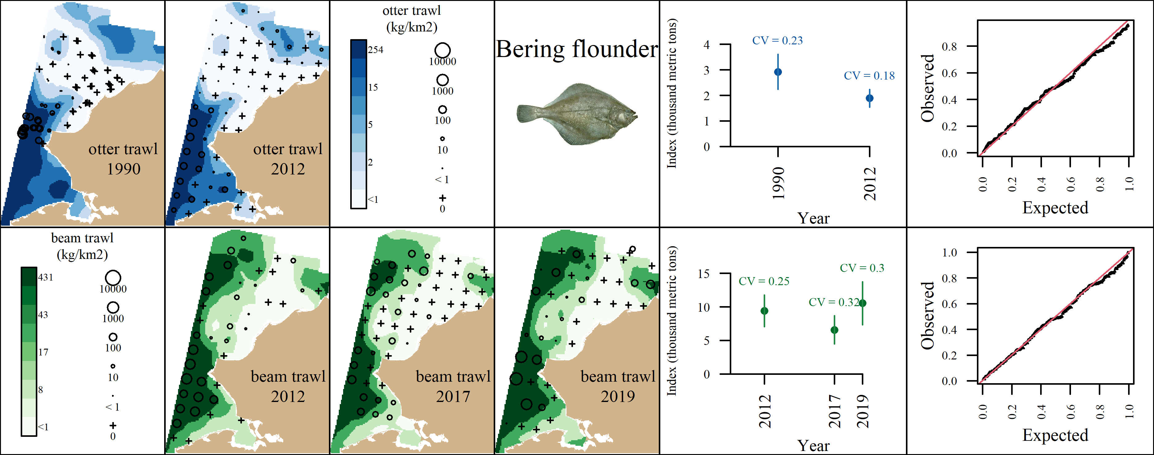 Appendix A3: VAST output for Bering flounder (*Hippoglossoides robustus*) for the the otter trawl (top row) and the beam trawl (bottom row). From left to right, plots are generally formatted as: A) predicted density with observed densities superimposed, B) abundance indices with associated coefficients of variation, and C) QQ diagnostic plot.

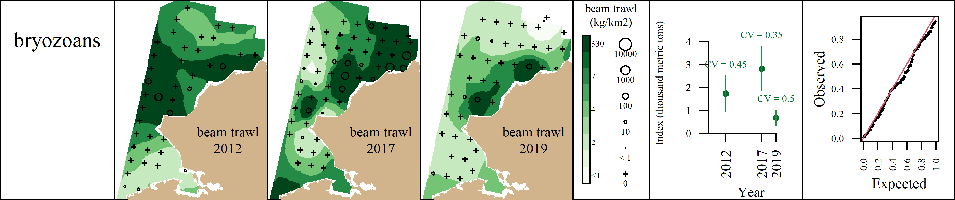 Appendix A4: VAST output for bryozoans (Phylum: Bryozoa) for the the beam trawl. From left to right, plots are generally formatted as: A) predicted density with observed densities superimposed, B) abundance indices with associated coefficients of variation, and C) QQ diagnostic plot.

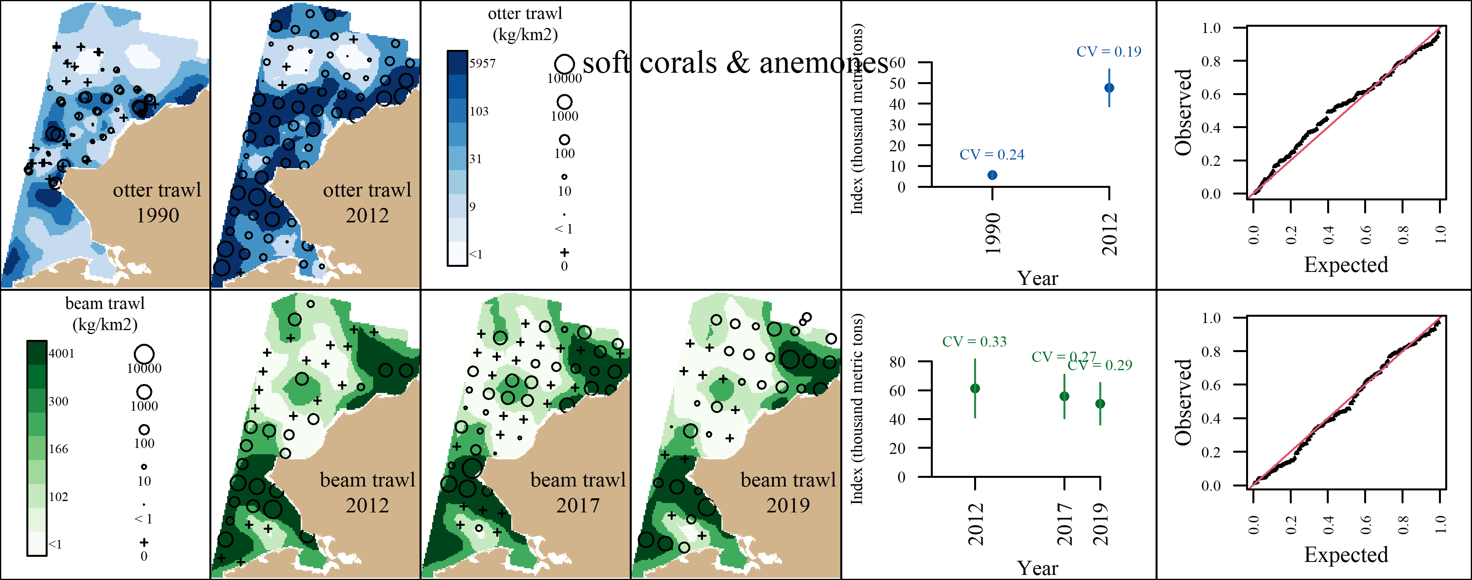 Appendix A5: VAST output for soft corals and sea anemones (Class: Anthozoa) for the the otter trawl (top row) and the beam trawl (bottom row). From left to right, plots are generally formatted as: A) predicted density with observed densities superimposed, B) abundance indices with associated coefficients of variation, and C) QQ diagnostic plot.

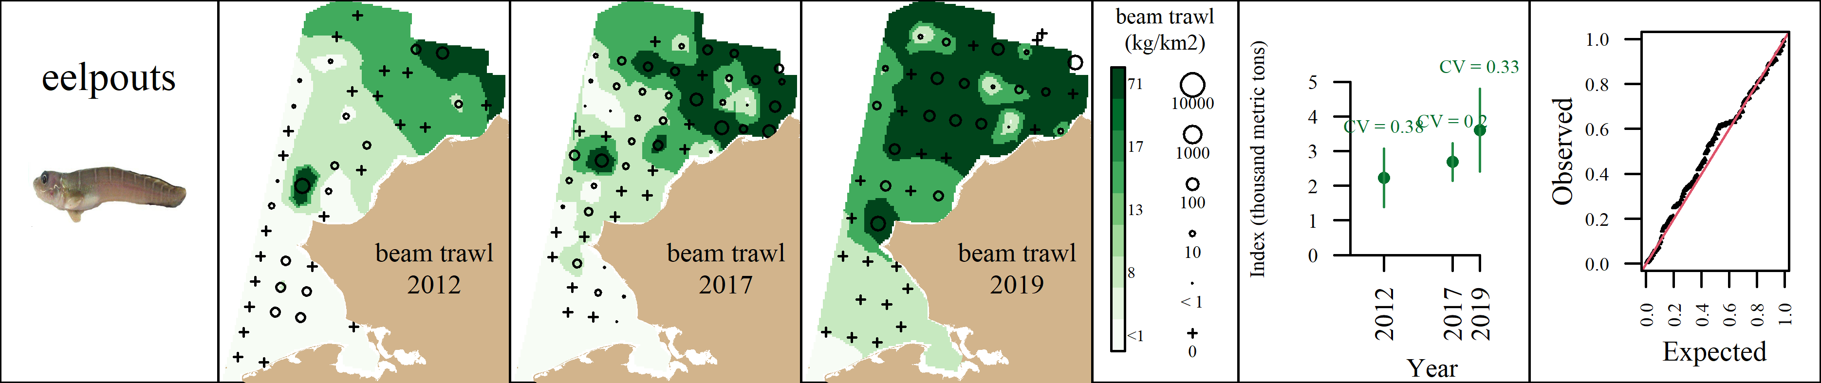 Appendix A6: VAST output for eelpouts (Family: Zoarchidae) for the the beam trawl. From left to right, plots are generally formatted as: A) predicted density with observed densities superimposed, B) abundance indices with associated coefficients of variation, and C) QQ diagnostic plot.

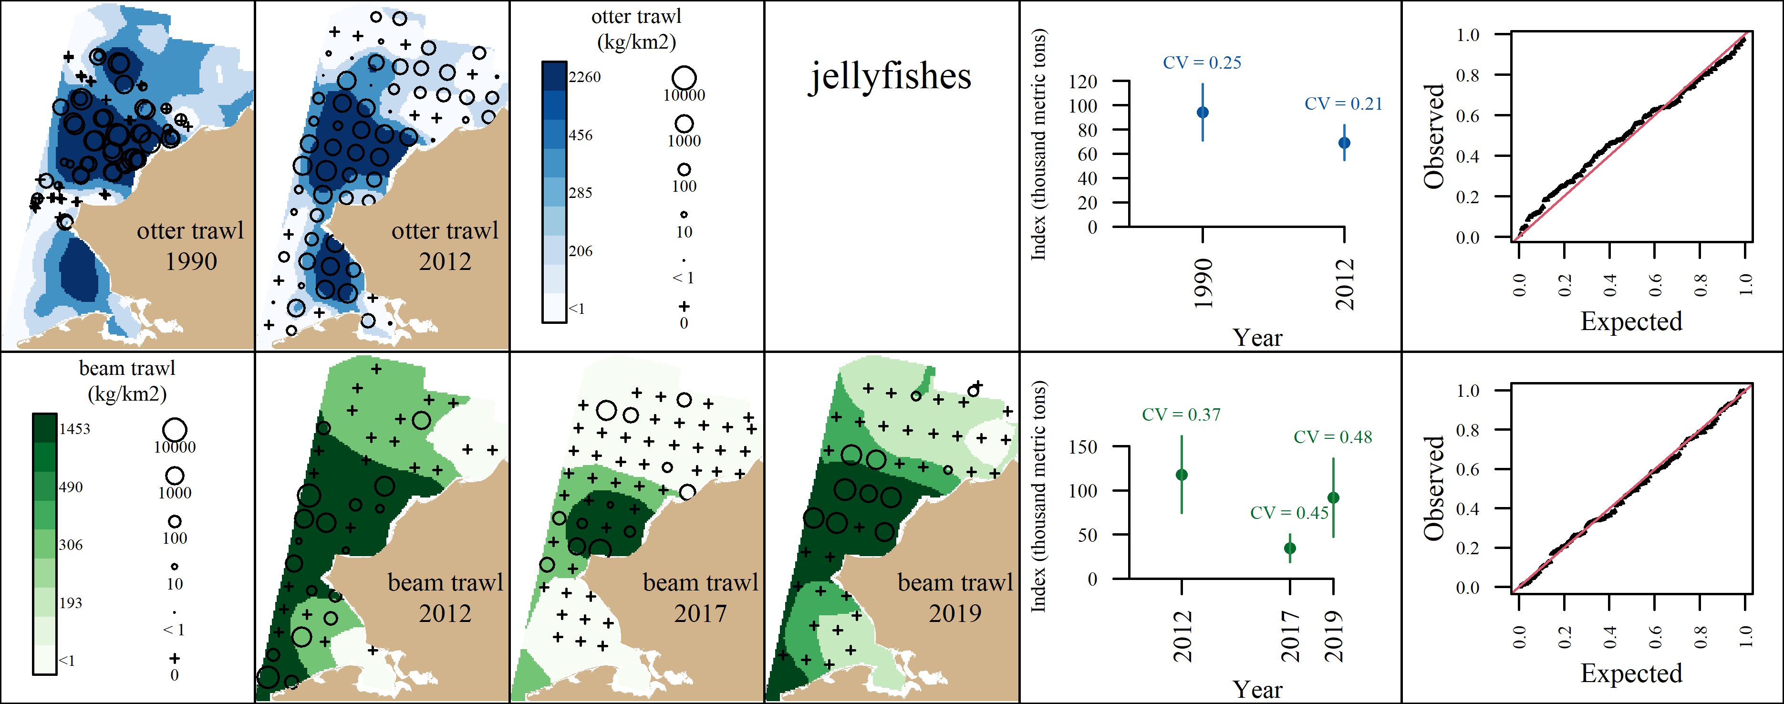 Appendix A7: VAST output for jellyfishes (Class: Scyphozoa) for the the otter trawl (top row) and the beam trawl (bottom row). From left to right, plots are generally formatted as: A) predicted density with observed densities superimposed, B) abundance indices with associated coefficients of variation, and C) QQ diagnostic plot.

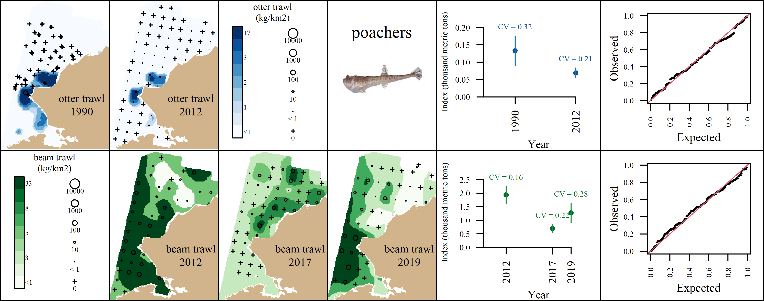 Appendix A8: VAST output for poachers (Family: Agonidae) for the the otter trawl (top row) and the beam trawl (bottom row). From left to right, plots are generally formatted as: A) predicted density with observed densities superimposed, B) abundance indices with associated coefficients of variation, and C) QQ diagnostic plot.

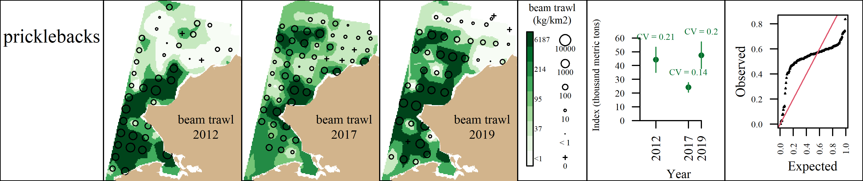 Appendix A9: VAST output for pricklebacks (Family: Stichaeidae) for the the beam trawl. From left to right, plots are generally formatted as: A) predicted density with observed densities superimposed, B) abundance indices with associated coefficients of variation, and C) QQ diagnostic plot.

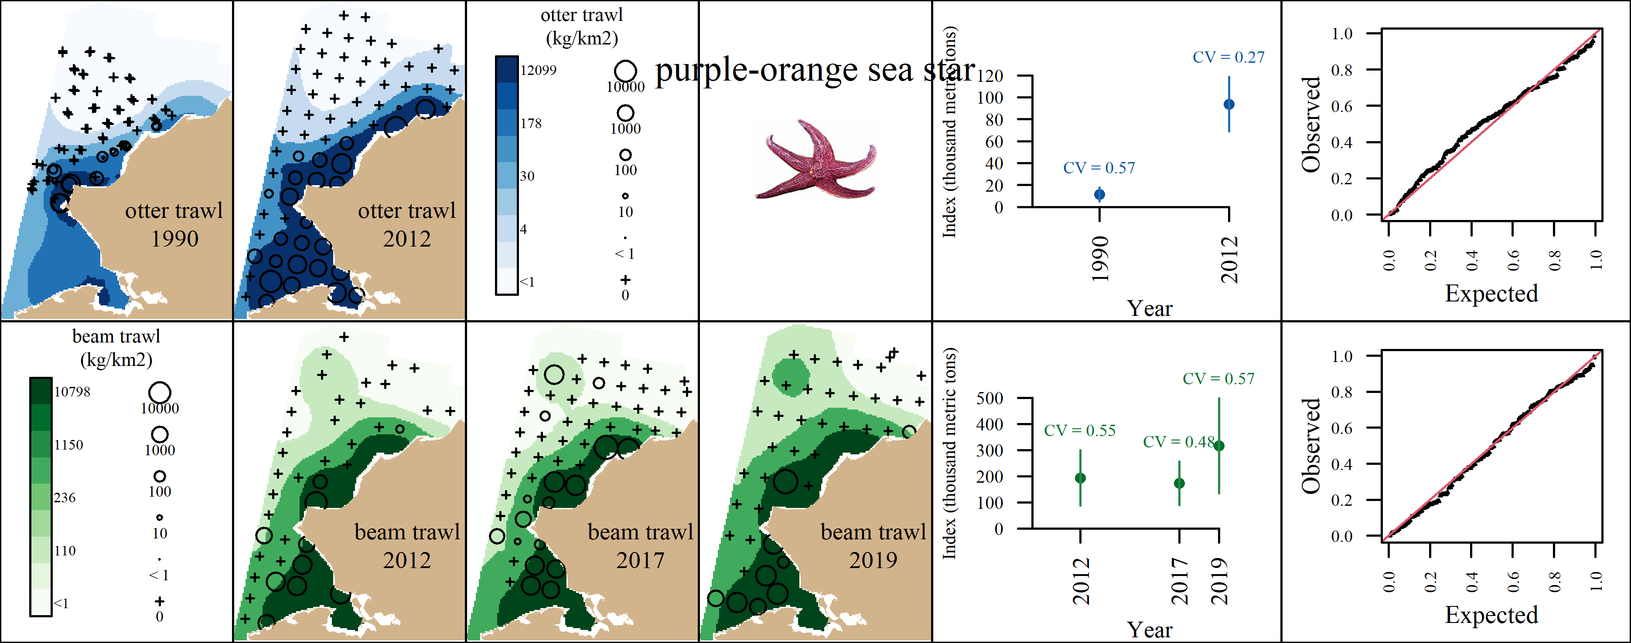 Appendix A10: VAST output for purple-orange sea star (*Asterias amurensis*) for the the otter trawl (top row) and the beam trawl (bottom row). From left to right, plots are generally formatted as: A) predicted density with observed densities superimposed, B) abundance indices with associated coefficients of variation, and C) QQ diagnostic plot.

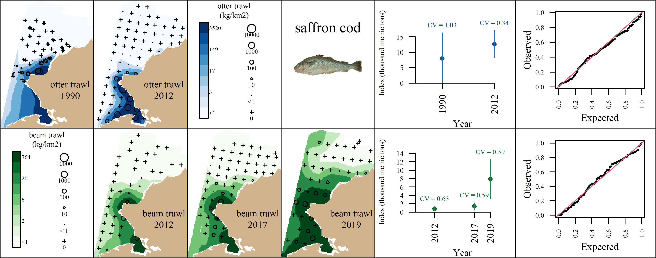 Appendix A11: VAST output for saffron cod (*Eleginus gracilis*) for the the otter trawl (top row) and the beam trawl (bottom row). From left to right, plots are generally formatted as: A) predicted density with observed densities superimposed, B) abundance indices with associated coefficients of variation, and C) QQ diagnostic plot.

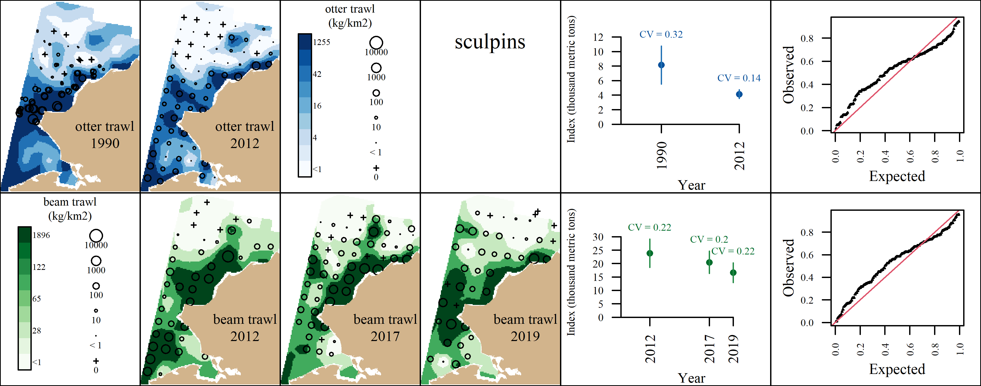 Appendix A12: VAST output for sculpins (Family: Cottidae) for the the otter trawl (top row) and the beam trawl (bottom row). From left to right, plots are generally formatted as: A) predicted density with observed densities superimposed, B) abundance indices with associated coefficients of variation, and C) QQ diagnostic plot.

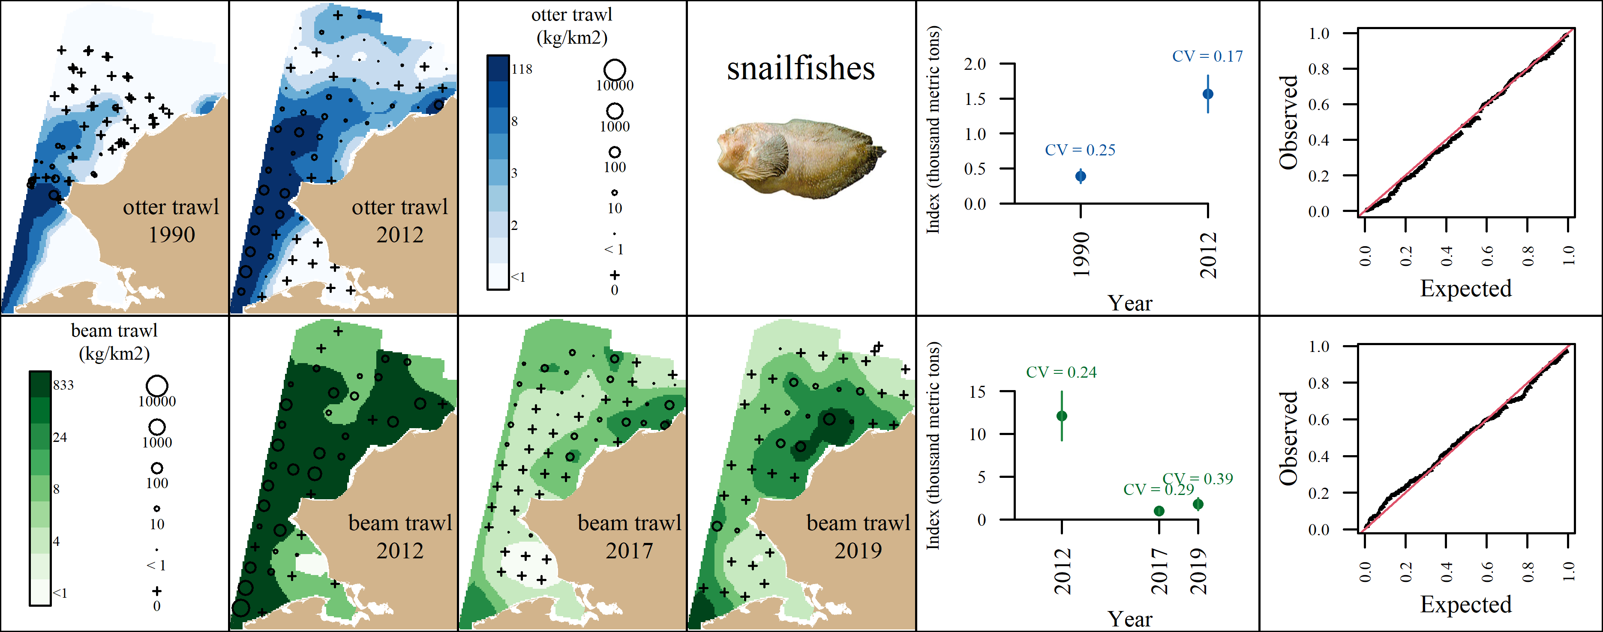 Appendix A13: VAST output for snailfishes (Family: Liparidae) for the the otter trawl (top row) and the beam trawl (bottom row). From left to right, plots are generally formatted as: A) predicted density with observed densities superimposed, B) abundance indices with associated coefficients of variation, and C) QQ diagnostic plot.

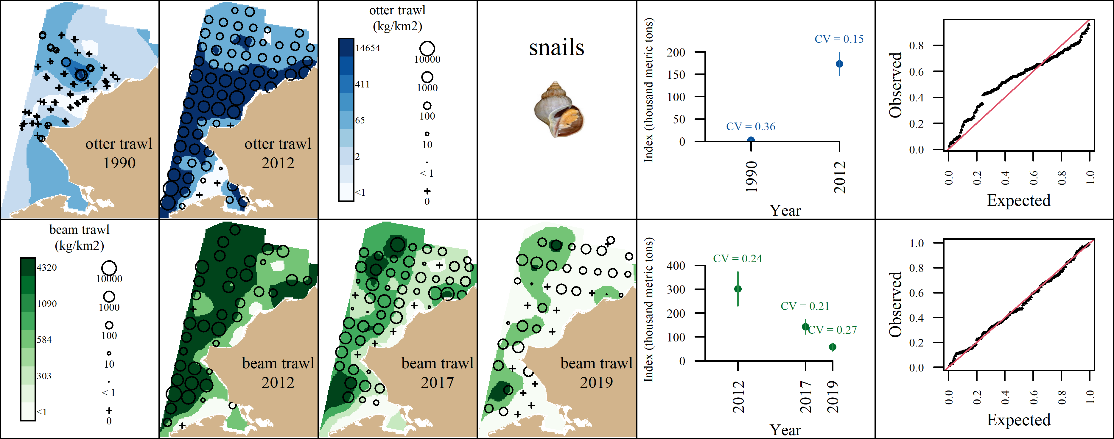 Appendix A14: VAST output for snails (Class: Gastropoda) for the the otter trawl (top row) and the beam trawl (bottom row). From left to right, plots are generally formatted as: A) predicted density with observed densities superimposed, B) abundance indices with associated coefficients of variation, and C) QQ diagnostic plot.

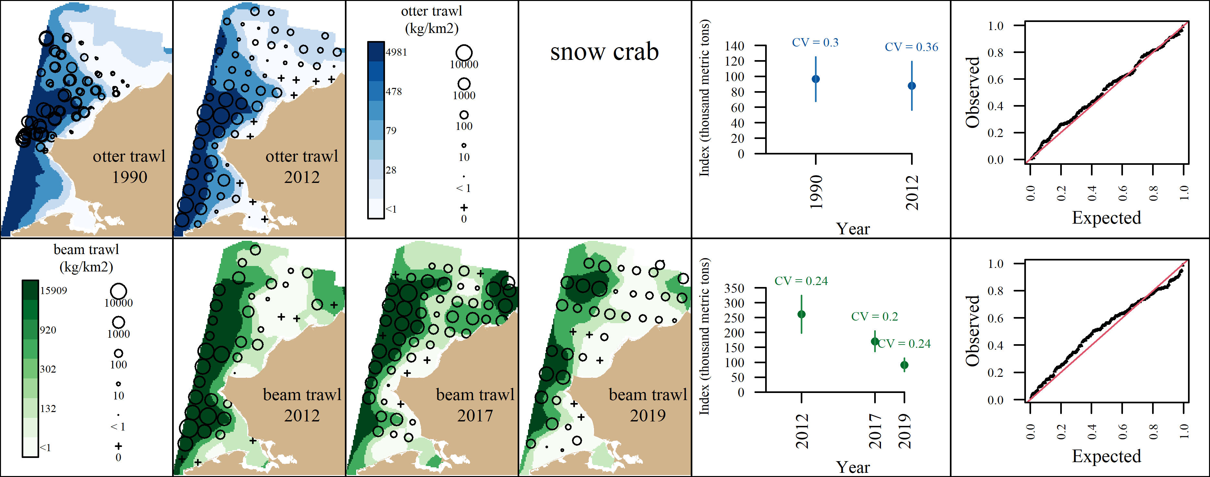 Appendix A15: VAST output for snow crab (*Chionoecetes opilio*) for the the otter trawl (top row) and the beam trawl (bottom row). From left to right, plots are generally formatted as: A) predicted density with observed densities superimposed, B) abundance indices with associated coefficients of variation, and C) QQ diagnostic plot.

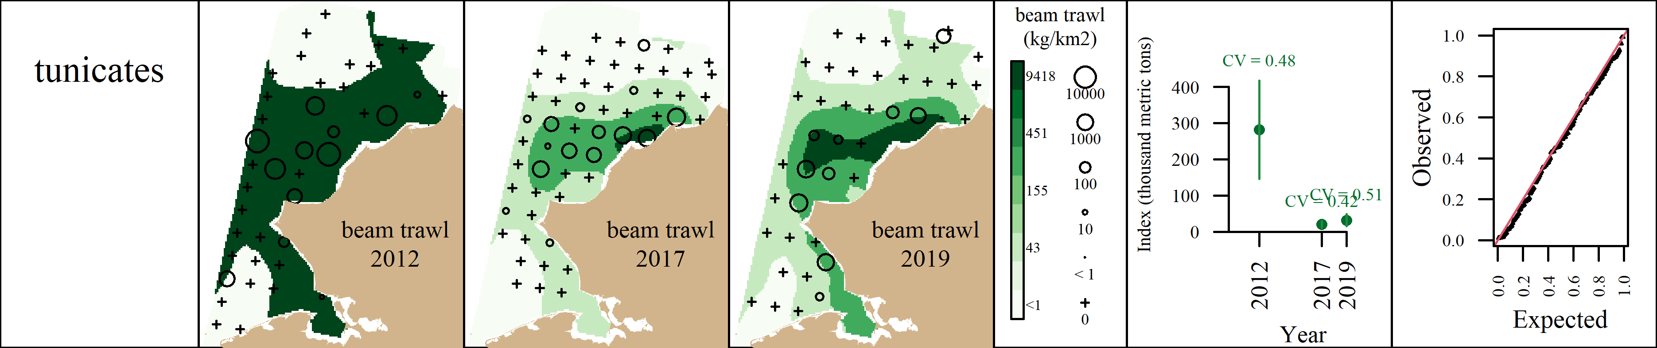 Appendix A16: VAST output for tunicates (Subphylum: Tunicata) for the the beam trawl. From left to right, plots are generally formatted as: A) predicted density with observed densities superimposed, B) abundance indices with associated coefficients of variation, and C) QQ diagnostic plot.

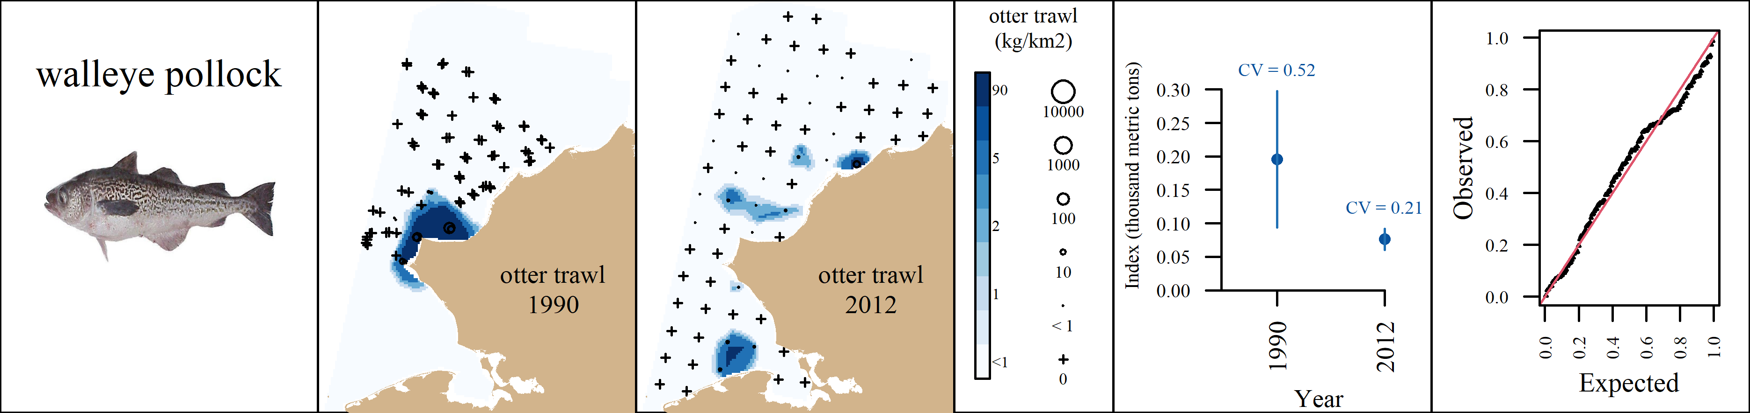 Appendix A17: VAST output for walleye pollock (*Gadus chalcogrammus*) for the the otter trawl. From left to right, plots are generally formatted as: A) predicted density with observed densities superimposed, B) abundance indices with associated coefficients of variation, and C) QQ diagnostic plot.

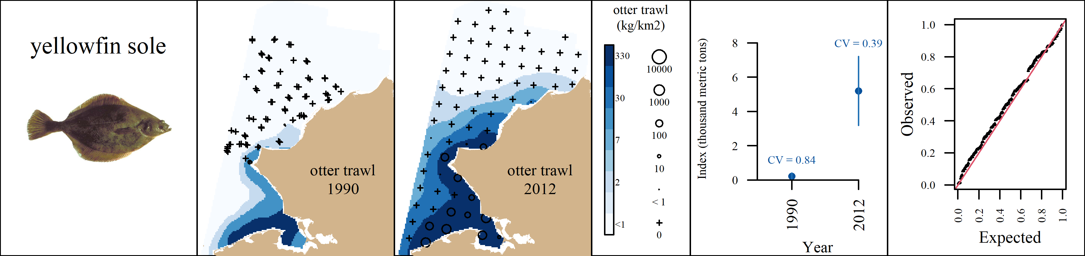 Appendix A18: VAST output for yellowfin sole (*Limanda aspera*) for the the otter trawl. From left to right, plots are generally formatted as: A) predicted density with observed densities superimposed, B) abundance indices with associated coefficients of variation, and C) QQ diagnostic plot.