BSCS FINAL PROJECT
Agile Software Design Specification

Desktop Automation using AI



Product Owner

Sadia Aslam

Presented by:
Group ID: S26CS089

Student Reg# Student Name
L1f22bscs0124 | Syed Muneeb Faraz
L1S23bscs0144 | Sania Amir
L1S23bscs0152 | Zoya Khalid

Faculty of Information Technology & Computer Science

University of Central Punjab

Agile Software Design Specification

SDS Phase II

Version 1

Product Owner

Sadia Aslam

Scrum Master

Syed Muneeb Faraz

Group S26CS089

Team
Member Name | Roles
Syed Muneeb Faraz | Computer vision module for screen element detection, Workflow management and task logging features, System integration, testing, debugging, and final improvements
Sania Amir | GUI interface and voice command input functionality, Speech-to-text conversion and natural language processing, Automation engine and multi-step workflow execution, Workflow management and task logging features
Zoya Khalid | GUI interface and voice command input functionality, Speech-to-text conversion and natural language processing, Automation engine and multi-step workflow execution, Workflow management and task logging features

Table of Contents
Table of Contents i
Revision History & Sprint Log ii
Previous Phases Feedback iii
Abstract 1
1. System Architecture 1
1.1 High-Level Architecture 1
1.2 Architecture Diagram 2
1.3 Component Overview 2
2. Mapping Design to User Stories 3
3. Detailed System Design 3
3.1 Module Decomposition 3
3.2 Data Flow Description 4
4. UML Diagrams 8
5. Database Design (ERD) 10
5.1 ER Diagram 10
5.2 Schema Tables 10
6. API Design 14
7. UI/UX Design (Prototypes) 15
8. Sprint-wise Design Evolution 27
9. Test Design 28
10. Design Quality Attributes 29
11. Deployment Considerations 30
12. Future Enhancements 31
13. Revised Project Plan 32
14. References 33
Appendix A: Glossary 34
Appendix B: IV & V Report 35

Revision History & Sprint Log
Version | Sprint | Date | Changes | Owner
v0.1 | Sprint 1 | June 2026 | GUI interface; design GUI | Sania Amir,  Zoya Khalid
v0.2 | Sprint 2 | June 2026 | Speech-to-text conversion and natural language processing; implement speech recognition; process natural language commands; test command interpretation accuracy | Sania Amir,  Zoya Khalid
v0.3 | Sprint 3 | July 2026 | Computer vision module for screen element detection; detect buttons and text fields; implement OCR and UI recognition; test screen detection across applications | Syed Muneeb Faraz
v0.4 | Sprint 4 | July 2026 | Automation engine and multi-step workflow execution; automate mouse and keyboard actions; execute workflows automatically; validate multi-step automation | Sania Amir,  Zoya Khalid
v0.5 | Sprint 5 | August2026 | Workflow management and task logging features; save workflows in database; implement workflow editing/deletion; generate execution logs | Syed Muneeb Faraz,  Sania Amir,  Zoya Khalid
v1.0 | Sprint 6 | August 2026 | System integration, testing, debugging, and final improvements; integrate all modules; perform testing and debugging; optimize system performance; prepare final documentation | Syed Muneeb Faraz

Previous Phases Feedback
Idea Defense Feedback (Screenshot)

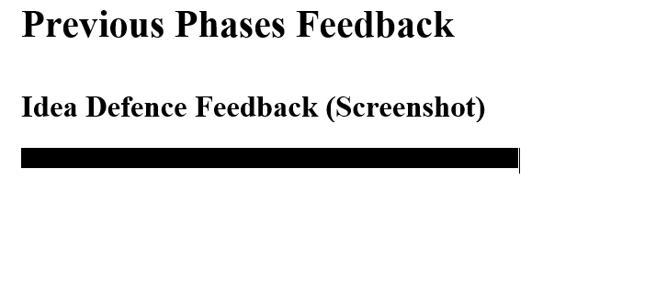

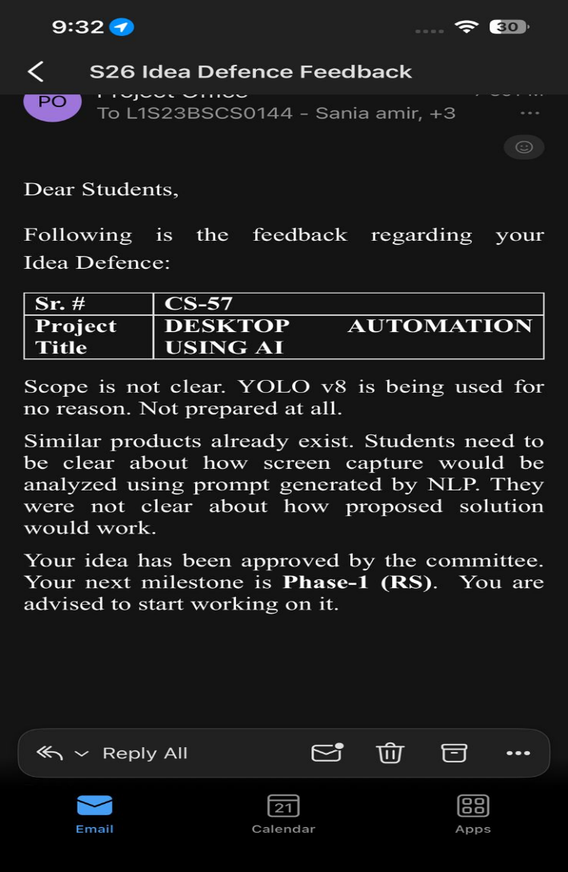

Abstract
Millions of students, freelancers, and office workers spend a lot of time doing the same things over and over on their computers, like opening programs, logging into portals, copying data, filling out forms, and switching between different software tools. Most of the time, these tasks are done by hand and need the user to pay attention all the time. This makes mistakes more likely and slows down productivity. There are automation tools available, but most of them need programming skills or advanced technical setup, which makes them hard for regular users to use. Current solutions also lack flexibility and cannot intelligently adapt to changes on the computer screen, which makes automation unreliable for everyday digital tasks.

This problem is significant because digital work is rapidly increasing as education and professional activities are becoming online. According to Pakistan Software Export Board (PSEB), more than 4 million freelancers and thousands of students depend on computers for repetitive work. If even 20% of these users perform daily repetitive workflows, the potential user base crosses 800,000 individuals. We calculated this market size by estimating 20% of the total population actively engaging in routine computer activities in educational and freelancing environments. Even saving 30 minutes daily per user can result in hundreds of productive hours annually across the country.
We selected this problem because we personally experienced repetitive tasks such as academic portal logins, form submissions, and document processing throughout university coursework. By addressing this issue, our objective is to reduce manual effort, help users save time, and minimize errors through intelligent automation. The expected result of this project is a desktop assistant capable of understanding natural language commands, detecting UI elements on screen, and performing common computer operations with minimal user input. This project will also allow us to learn and practically implement modern AI techniques that are highly relevant in current industry technologies.

System Architecture

High-Level Architecture
The architecture of the Desktop Automation Using AI system follows a Layered Architecture Style (specifically a 3-Tier Architecture). All layers reside and execute locally on the user's desktop machine without requiring initial cloud dependencies.

Justification for Choosing Layered Architecture:
- Separation of Concerns: It cleanly separates the user interface (Presentation Layer), the core AI processing modules (Logic Layer), and the local storage (Data Layer), making the codebase organized and easier to debug.
- Independent Module Development: This style perfectly aligns with our 16-week project schedule, allowing us to build the PyQt5 GUI (Weeks 1–3) independently before integrating the NLP and Computer Vision logic layers (Weeks 4–9).
- Local Processing Efficiency: Since the system captures the live desktop screen and executes rapid automation commands via PyAutoGUI, a local layered approach minimizes data latency and removes enterprise-level infrastructure costs.

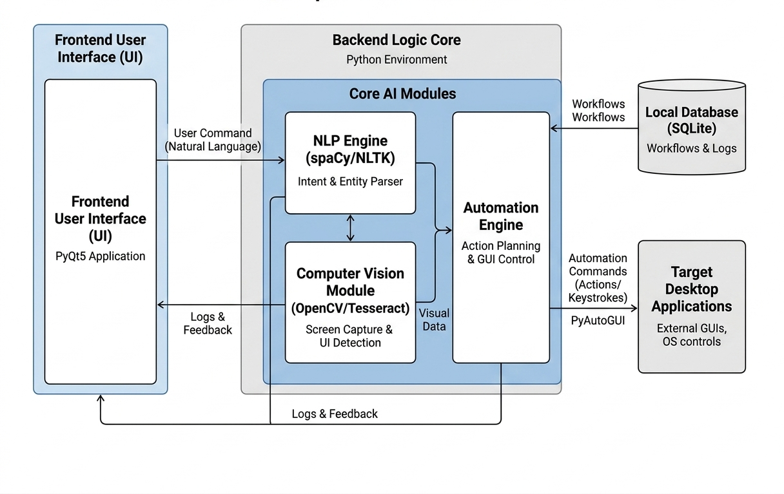
Architecture Diagram
Figure 1: Architectural Diagram

Component Overview
Based on the system architecture, here is the list of components and their primary responsibilities:
Table 1 Components Overview
Component | Responsibility
Frontend GUI (PyQt5) | Provides a clean desktop interface for users to input natural language commands, trigger automation tasks, and view real-time execution logs.
NLP Engine (spaCy / NLTK) | Parses the user's natural language input to identify the specific intent (action) and target application required for the workflow.
Computer Vision Module (OpenCV / Tesseract) | Captures the live screen layout and visually locates target UI elements like buttons, text boxes, and icons through template matching and text recognition.
Automation Engine (PyAutoGUI) | Takes the coordinates from the CV module and the intent from the NLP engine to programmatically execute mouse clicks, scrolling, and keyboard typing.
Local Database (SQLite) | Securely stores and manages pre-recorded user workflows, application preferences, and historical task execution logs.
Target Applications / OS | Serves as the external environment (such as Google Chrome or university portals) where the automation engine performs the scheduled digital actions.

Mapping Design to User Stories
Table 2 User Story Mapping

Story ID | Component | Description
US-01 | Frontend GUI (PyQt5) | Maps to PB-01. The PyQt5 desktop panel loads successfully, presenting a simple interface with visual panels for non-technical users.
US-02 | Voice Input Module (Microphone API) | Maps to PB-02. Connects the audio recording interface to capture user voice signals cleanly before processing.
US-03 | Speech Recognition Engine | Maps to PB-04. Converts recorded audio sequences into localized text blocks to prepare data for intent mapping.
US-04 | NLP Command Engine (spaCy / NLTK) | Maps to PB-05. Parses the text string using NLP models to extract core application intents (e.g., "Open") and entities (e.g., "Chrome").
US-05 | Computer Vision Module (OpenCV) | Maps to PB-07 & PB-09. Scans dynamic desktop environments to pinpoint the pixel coordinates (X, Y) of buttons, input fields, and icons.
US-06 | UI Text Recognition (Tesseract OCR) | Maps to PB-08. Reads text fields and text labels visible inside window areas to target form fields contextually.
US-07 | Automation Engine (PyAutoGUI) | Maps to PB-10 & PB-11. Programmatically controls physical mouse movements, clicks, and keyboard strings over target app areas.
US-08 | Sequential Action Planner | Maps to PB-12. Links multiple atomic tasks together to execute full multi-step logical workflows sequentially without crashing.
US-09 | Logging & Activity System (SQLite Logs) | Maps to PB-15 & PB-16. Automatically appends step-by-step performance logs, errors, and success histories onto the visible GUI log section.
US-10 | Local Database Layer (SQLite DB) | Maps to PB-17. Manages local relational storage for workflow profile registration, persistent custom settings, and history state updates.
US-11 | Core System Integration Architecture | Maps to PB-18. Connects the pipeline loops (GUI $\rightarrow$ NLP $\rightarrow$ CV $\rightarrow$ PyAutoGUI $\rightarrow$ Database) together for verified testing.

Detailed System Design

Module Decomposition

Authentication Module (User & Profile Management)
- receiveCommand(inputSignal): Captures raw text from the input line or voice stream entries from the user interface.
- loadProfile(userId): Verifies user identity tokens, loading local dashboard configurations and persistent custom application settings.
- saveProfile(profileData): Updates user preferences, account states, and security parameters securely into the local environment.

Data Processing Module (NLP & Computer Vision Pipeline)
- convertSpeechToText(audioData): Transcribes binary voice signals captured via Microphone API into clean localized text strings.
- parseIntent(rawText): Uses NLP tokenization rules to extract primary system actions (e.g., "click", "open").
- extractArguments(parsedText): Parses contextual target parameters, mapping targeted application entities like "Chrome" or window fields.
- captureScreen(): Grabs active frame buffers from the OS desktop environment to run visual analysis loops.
- locateUIElement(currentScreen): Runs template matching algorithms over frames to locate targeted button or icon coordinate blocks ($X, Y$).

API & Execution Layer (Automation & Storage Connectors)
- executeTask(intent, args): Interacts with backend sub-layers to route parsed intents to operational components.
- simulateClick(x, y) / simulateKeyPress(key): Directly references PyAutoGUI system wrappers to inject structural physical peripheral actions safely over screen bounds.
- createWorkflow(): Bundles serialized programmatic sub-steps into structured macro blocks for replay capabilities.
- storeExecutionDetails(): Logs state diagnostics, exceptions, execution duration metrics, and operational flags directly to SQLite data layers.

Data Flow Description

Table 3 Data Flow Description

Step | Stage | Data Movement
1 | Command Reception & Capture | User inputs voice command via microphone or types manual string  Receive Command (P1.1) captures the stream/text parameters $\rightarrow$ Routes binary signal patterns to the NLP processor context.
2 | Speech-to-Text & NLP Conversion | Process NLP (P1.2) translates audio bytes into localized string scripts $\rightarrow$ Mappings are passed to Identify Intent (P1.3) to isolate semantic action verbs $\rightarrow$ Extract Parameters (P1.4) parses argument configurations to formulate a structured automation task profile.
3 | Workflow Planning & Script Mapping | Mapped task packages hit Generate Workflow (P2.1) $\rightarrow$ Sequence actions array maps conditions via Automation Rules configuration stores $\rightarrow$ Checked steps pass to Validate Workflow (P2.3) to ensure data flow safety loops before triggering.
4 | Visual Detection (Computer Vision) | Validated script frames hit Send Action Plan (P2.4) $\rightarrow$ Triggers screen grab matrices over the Desktop OS environment $\rightarrow$ CV Engine (P3) runs OpenCV template configurations to match coordinates ($X, Y$) and labels through active text detection loops.
5 | Task Execution Logic | Extracted pixel coordinate bounds pass dynamically down into GUI Executor (P4) $\rightarrow$ Triggers PyAutoGUI runtime system wrappers to inject physical peripheral click behaviors, scrolling vectors, or keystroke lines safely back over target app boundaries.
6 | Session Monitoring & Persistence Logs | Operational exit frames and thread activities route back into Monitor and Logger (P6) $\rightarrow$ Execution metrics update onto the visible frontend dashboard panel $\rightarrow$ Structured operation metrics, failure stacks, and screenshot pointers write down into the persistent DS1: SQLite DB layer.

Context level DFD
At the context level, the system interacts with three external entities: the User, the Desktop OS, and the File System. The diagram below summarises these high-level flows
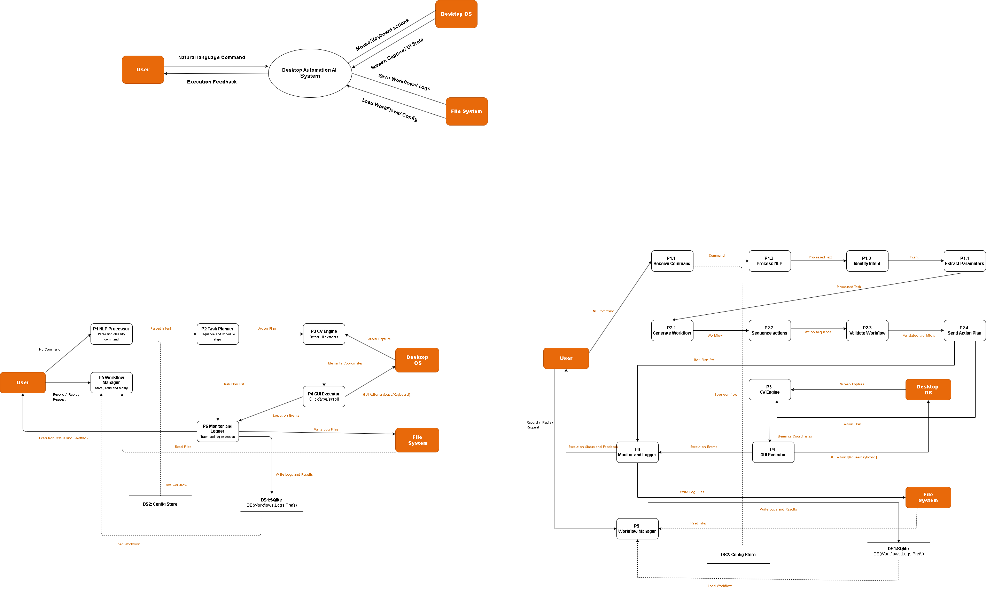
Figure 2: DFD level 0 diagram

DFD Level 01
DFD Level 1 expands the central process into six internal sub-processes: P1 NLP Processor, P2 Task Planner, P3 CV Engine, P4 GUI Executor, P5 Workflow Manager, and P6 Monitor & Logger. Two data stores are also shown: DS1 (SQLite DB) and DS2 (Config Store).

Figure 3: DFD level 1

DFD Level 02
DFD Level 2 zooms into P1 (NLP Processor) and P2 (Task Planner) from Level 1, decomposing each into four and three sub-processes respectively. The adjacent Level 1 processes (P3 CV Engine, P4 GUI Executor, P5 Workflow Manager, P6 Monitor & Logger) are shown as bordered reference boxes.

Figure 4: DFD level 2

UML Diagrams
Class Diagram
The class diagram defines the following core classes and their relationships:

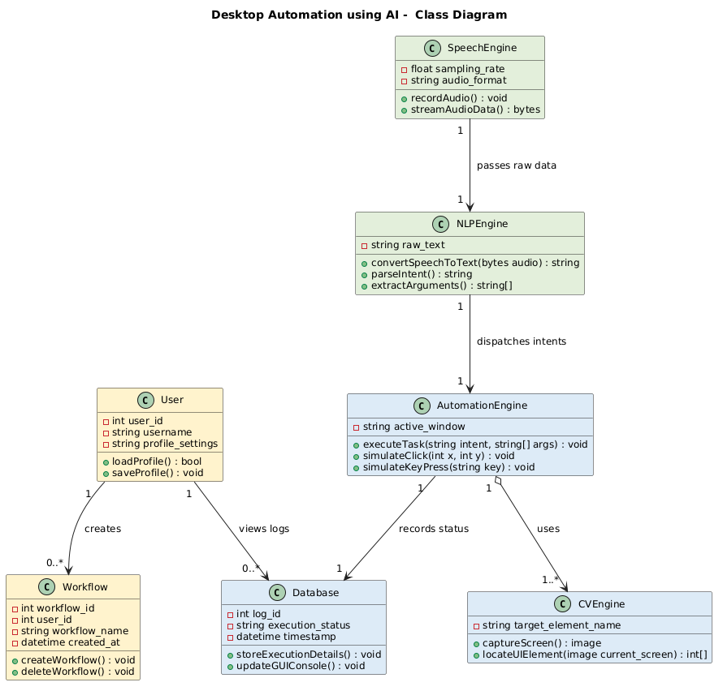
Figure 5: Class Diagram

Sequence Diagram

This diagram shows the step-by-step sequence of how our system processes a user's voice command. It models the complete flow starting from the GUI interface, converting audio to text, extracting the user's intent using NLP, finding screen coordinates via Computer Vision, and executing the final mouse/keyboard actions while saving logs in the local database.

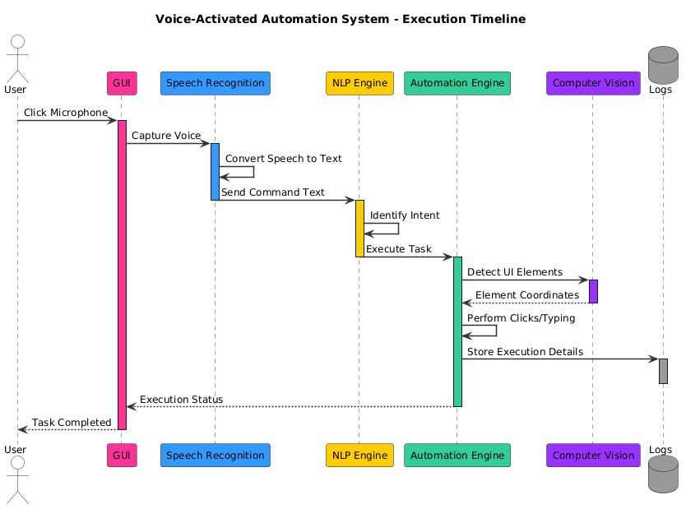

Figure 6:Sequence Diagram

Database Design (ERD)

ER Diagram
This ERD outlines the data relationships between Users, Workflows, Tasks, NLP Commands, and Execution Logs. It ensures referential integrity and helps track full history and screenshot references for all automated actions.

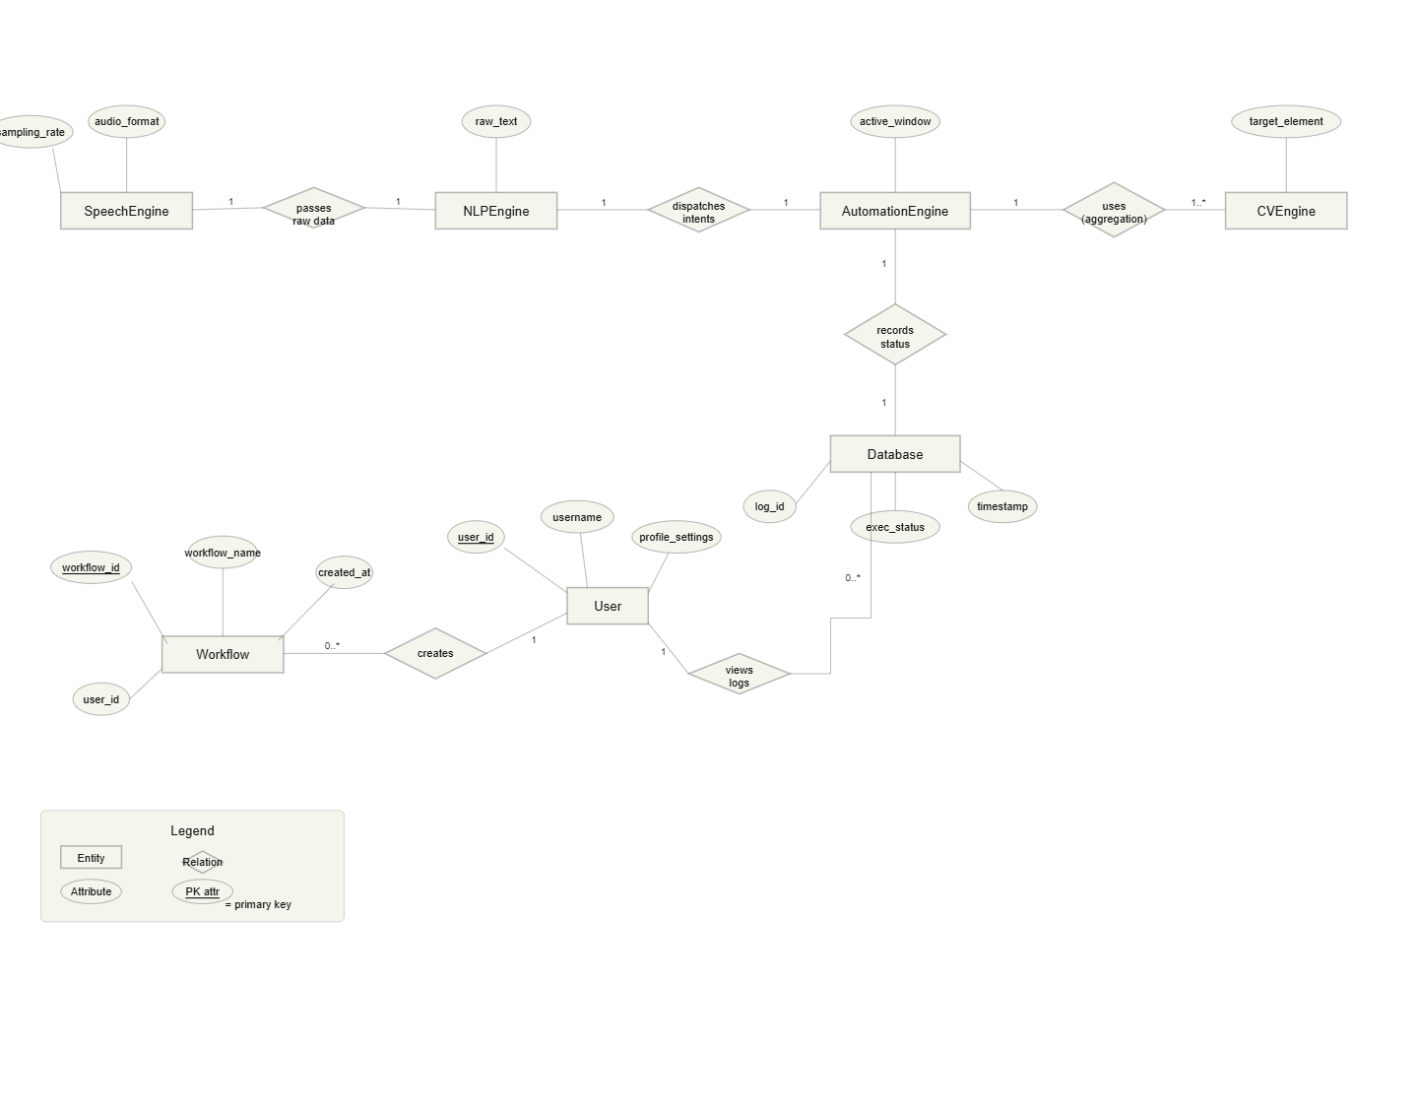
Figure 7: ERD

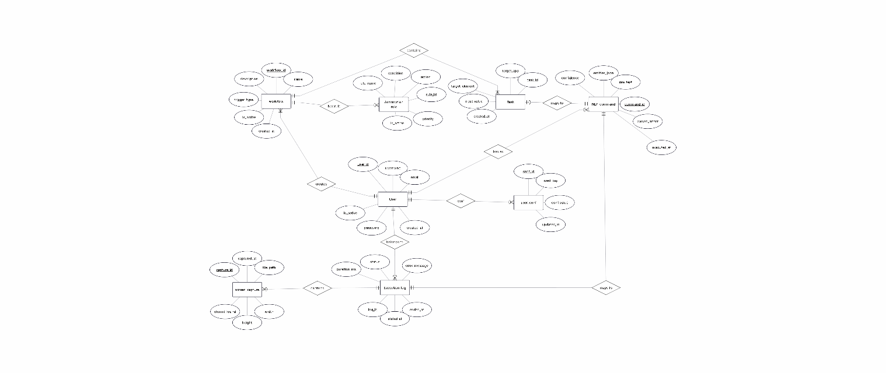

Schema Tables

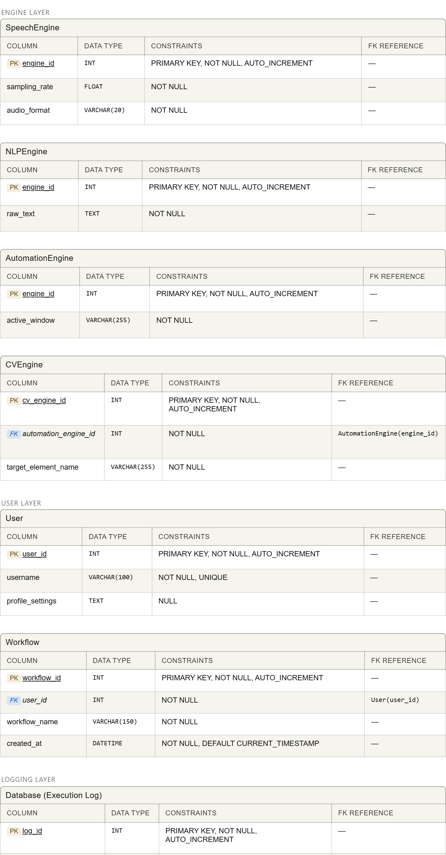

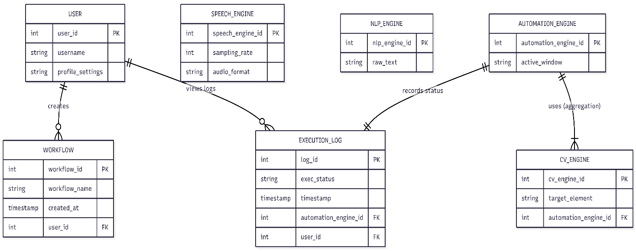
Figure 8: Relational Schema

API Design
Table 12 API Designing

Endpoint | Method | Input (Request Body) | Output (Response)
/api/auth/profile | GET | { "user_id": 1 } | { "status": "success", "username": "Zoya", "is_active": true }
/api/command/speech | POST | binary_audio_data (.wav) | { "status": "success", "transcribed_text": "open chrome and click login" }
/api/nlp/parse | POST | { "text": "open chrome" } | { "intent": "open_app", "target_app": "Chrome", "confidence": 0.96 }
/api/vision/detect | POST | { "target_element": "Login Button" } | { "element_found": true, "coordinates": { "x": 450, "y": 620 } }
/api/automation/execute | POST | { "action": "click", "x": 450, "y": 620 } | { "status": "completed", "execution_time": "150ms" }
/api/workflow/save | POST | { "workflow_name": "Portal Login", "tasks": [...] } | { "status": "saved", "workflow_id": 101, "created_at": "2026-06-07" }
/api/logs/store | POST | { "log_id": 501, "status": "Success", "duration_ms": 1200 } | { "status": "logged" }

UI/UX Design (Prototypes)

1.Wireframes:
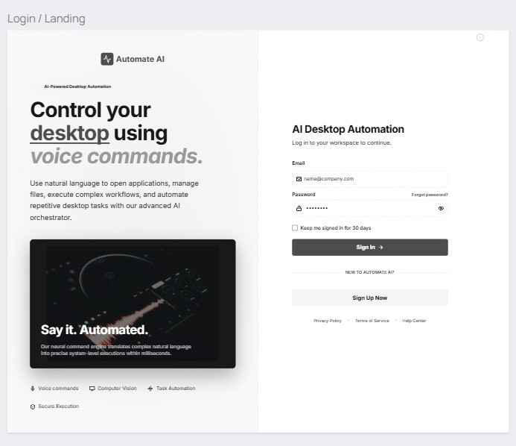
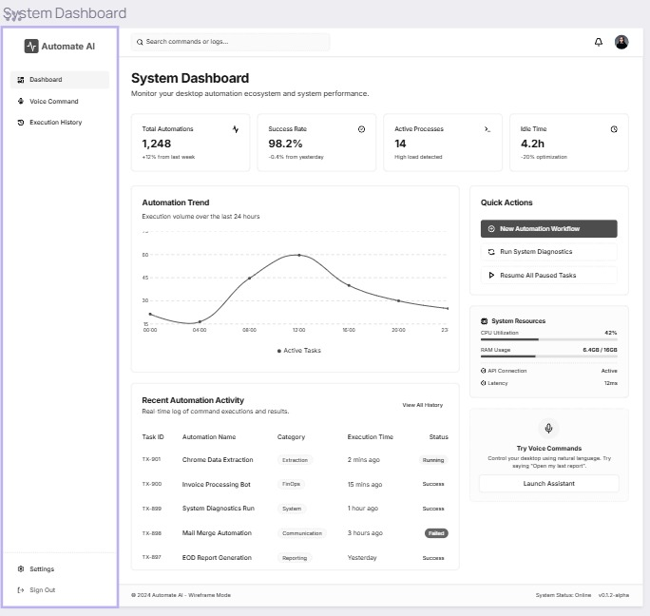

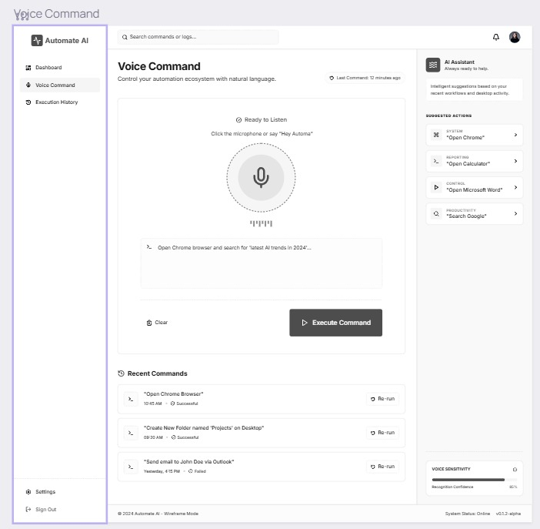

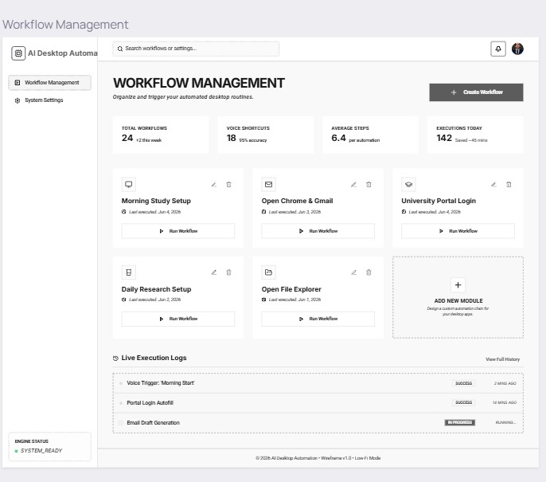
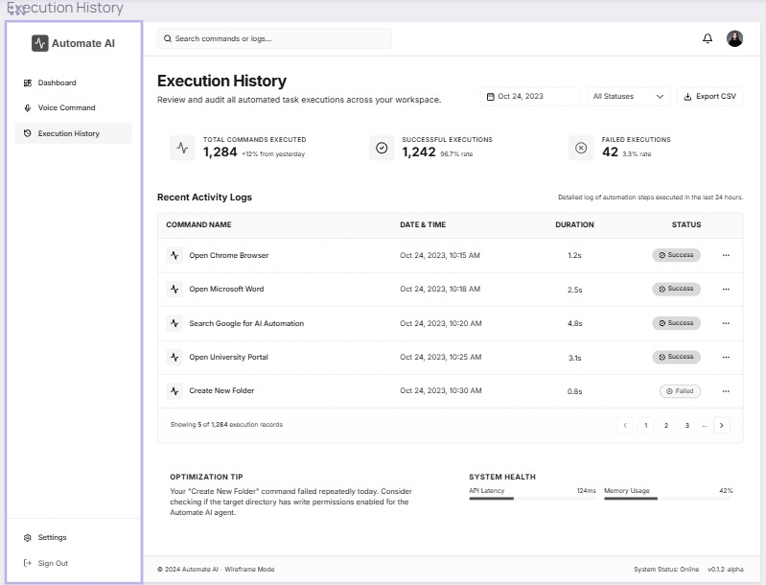
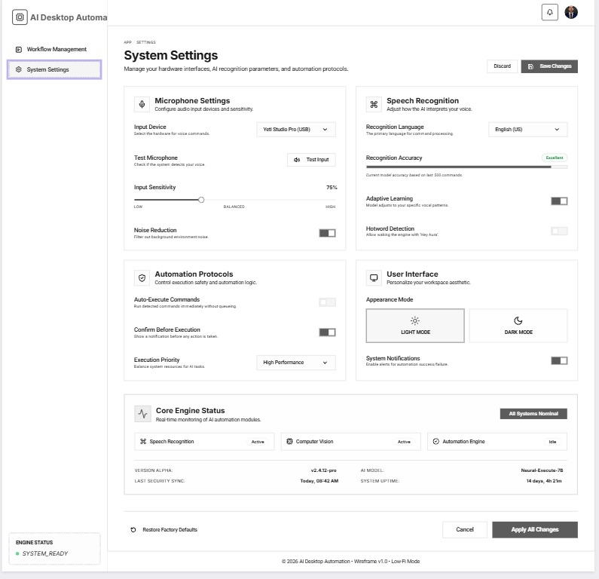

2. Navigation Flow:
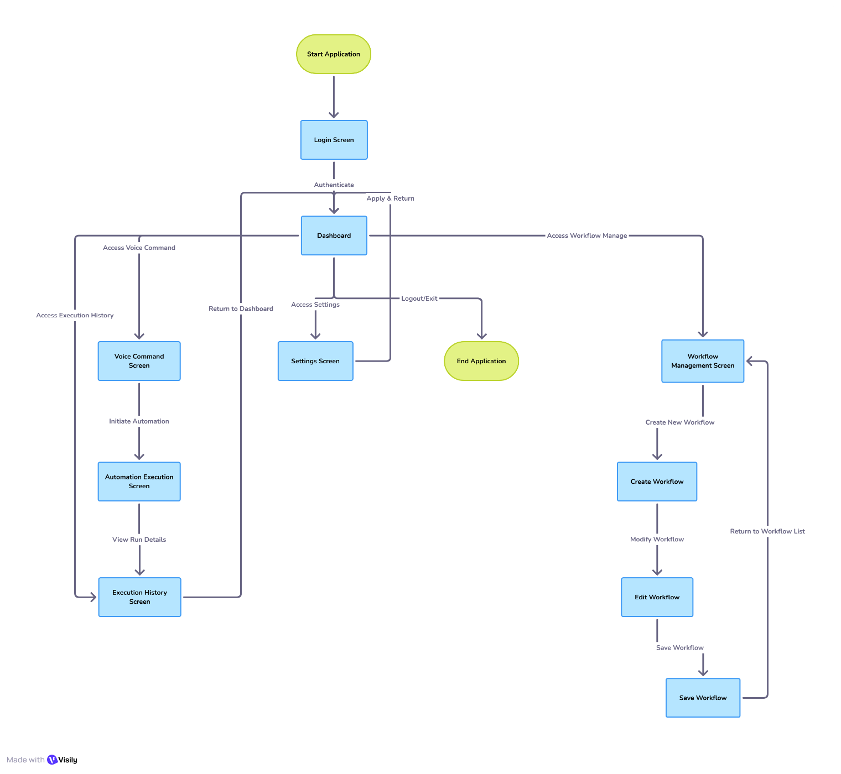

Figure 10: Navigation Flow

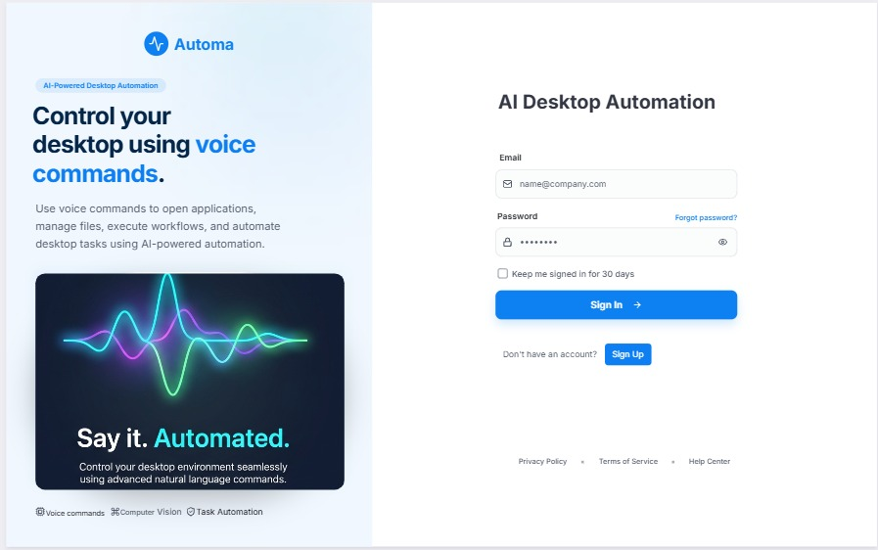
3. Screens:
Frontend Pages:
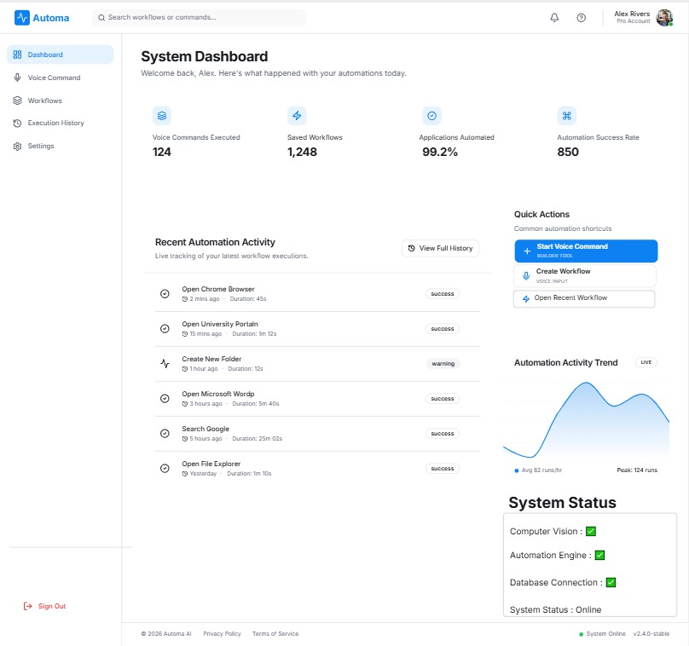

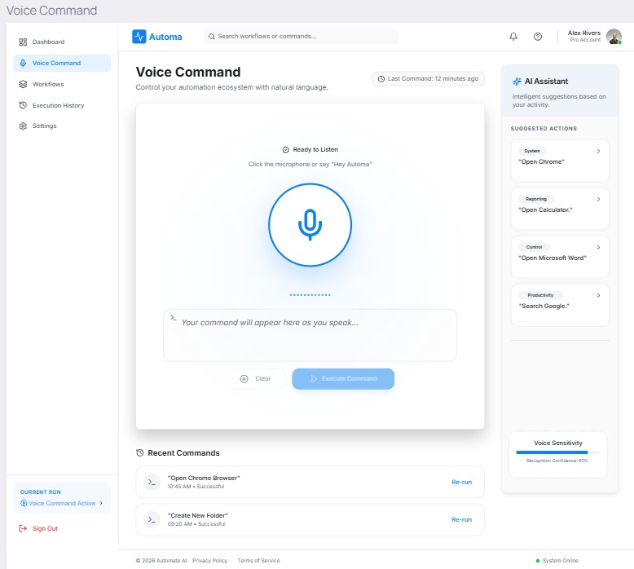
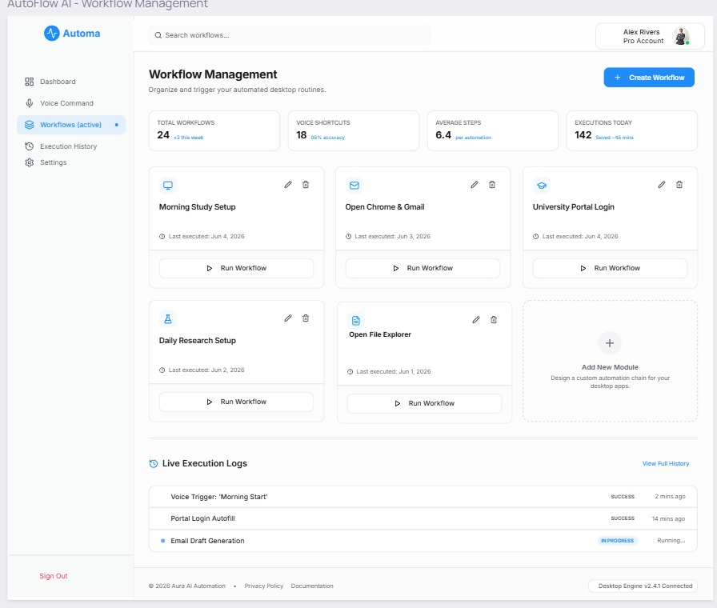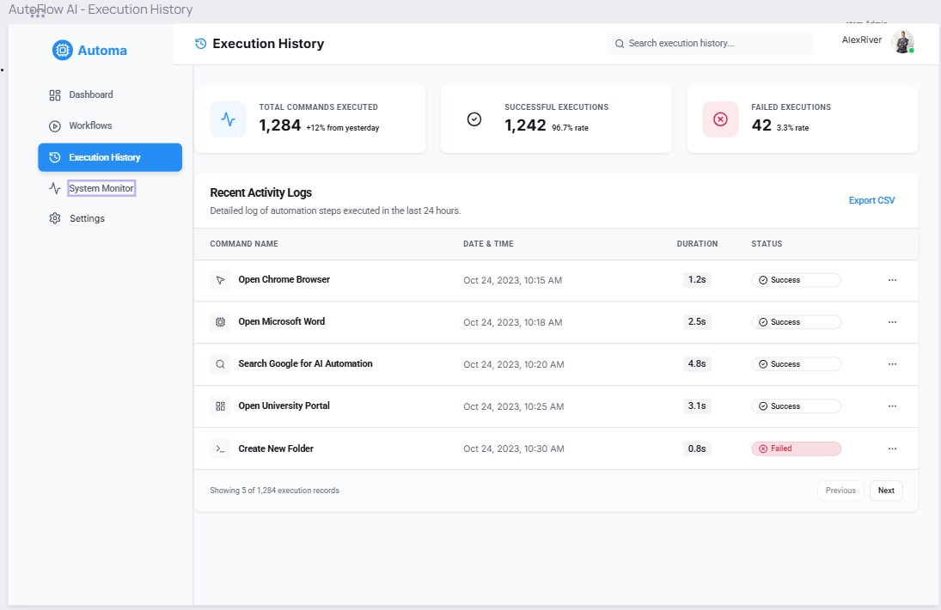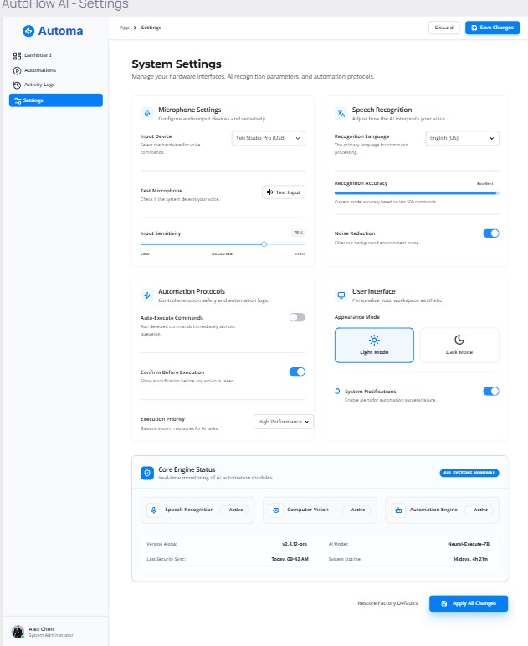

Sprint-wise Design Evolution

Table 13 Sprint Wise evolution

Sprint | Features Designed | Improvements
Sprint 1 | Frontend GUI Mockups & Design | Initial UI panel was created. Improved the layout by embedding a dedicated real-time console log pane in PyQt5 to show background automation steps explicitly.
Sprint 2 | Microphone API & Speech Transcription Engine | Realized raw background noise corrupted text conversion. Added an audio signal processing filter to clean input streams before routing to the transcription pipeline.
Sprint 3 | NLP Command Engine & Token Mapping | Designed core intent tracking logic. Realized complex user phrasing failed mapping, so we added an entities_json database field to catch dynamic custom parameter values safely.
Sprint 4 | Computer Vision Module (OpenCV & OCR) | Added dynamic coordinate tracking. Fixed template mismatching bugs after layout shifts by introducing screen matrix preprocessing filters.
Sprint 5 | PyAutoGUI Automation Engine Execution | Handled programmatic mouse operations and layout focus. Implemented forced structural delay timers between action strings to eliminate latency mismatch crashes.
Sprint 6 | SQLite Local Database Storage & History Layer | Designed data storage schemes. Solved concurrent file block exceptions during intensive data writing by creating isolated Execution log relational link states.

Test Design
Table 14 Test case
Test ID | Scenario | Expected Result
TC-01 | User launches the desktop client app. | The dashboard window displays with an "Idle/Ready" status label.
TC-02 | User says an ambiguous voice command. | System logs a warning: "Command not recognized. Please retry."
TC-03 | User speaks: "Open Chrome". | System translates speech to text and successfully extracts the launch intent.
TC-04 | System scans screen for a missing UI button. | Scanner checks layout coordinates, fails gracefully, and logs: "Element not found."
TC-05 | Automation engine runs click sequence step. | Mouse cursor jumps smoothly to mapped coordinates and executes the click.
TC-06 | Background task fails due to an unexpected timeout | System intercepts the error event and updates the GUI log text view in red color.
TC-07 | User clicks the "Save Workflow" action option. | Step strings are written safely into the local SQLite database file.

Design Quality Attributes

1. Scalability
- Client-Side Scalability: Direct localized execution removes resource strain from central server setups. 10,000+ simultaneous users can run their workflows locally without any performance degradation or server bottlenecks.
- Database Scaling: SQLite handles seamless transactional queries for massive workflow sets locally.
- Resource Management: Python script optimizations release screen matrix caches quickly to minimize high RAM usage on client environments.

2. Security
- Password Hashing: Implements strong encryption hashes (such as bcrypt or SHA-256 with salts) to protect credentials inside the local data store.
- Data Isolation: All user workflows, recorded path tokens, and application activity logs are restricted to the local device space.
- Safe System Controls: PyAutoGUI actions are constrained by fail-safe trigger boundaries to avoid endless UI loops or unsafe click sequences.

3. Maintainability
- Modular Code Separation: Strict division separates the Frontend GUI (PyQt5) from core processing blocks (NLP Engine, CV Engine).
- Standard Docstrings: Every method (e.g., parseIntent(), locateUIElement()) follows formal PEP 8 scripting guidelines. This makes it extremely easy for a new developer to read or modify code modules.
- Structured Error Catching: Isolated try-catch logs map failures cleanly to specific execution states instead of breaking the entire app.

Deployment Considerations

1. Hosting
- Platform: Native Desktop Deployment over host OS (Windows / macOS / Linux) for hardware input level control.
- Compute / API Server: Python runtime environment hosted on local client side to eliminate interface lag channels.
- Object / Artifact Storage: Local system files directory to hold reference crop clips, pattern matching masks, and window states.

2. Database
- Engine: SQLite 3 embedded relational database setup directly inside the Python desktop runtime bundle.
- Configuration: Serverless execution layer requiring zero external engine installations or active port configuration binds.
- Data Schemes: Native table scripts tracking user profile entities, structural macro tokens, and background activity runs.

3. Version Control & CI/CD
- Repository: GitHub (private platform tracking repository); core feature-branch pipeline logic with enforced PR tracking.
- Branching Strategy: GitFlow scheme separating active development timelines (develop) safely from release paths (main).
- Testing Iterations: Isolated local test suites checking automation code steps and layout
tracking modules before merging code.

Future Enhancements
Table 15 Future Enhancements

Enhancement | Description | Target Version
Object Detection Pipeline | Re-evaluate and integrate lightweight custom YOLOv8/v10 neural networks for advanced dynamic layout tracking. | v2.0
Cross-Platform Compatibility | Port local runtime configurations natively to Linux and macOS architectures, replacing Windows-specific API bindings. | v2.0
Cloud Workflow Sync | Migrate stored SQLite sequences to a centralized cloud database for synchronized profile backups. | v2.0
Advanced LLM Parsing | Replace basic localized rule matchers with an embedded LLM pipeline to process highly complex multi-turn voice logic inputs. | v3.0
Adaptive Layout Handling | Implement unsupervised graph neural networks to intelligently map UI controls after deep software version upgrades. | v3.0
Macro Marketplace Hub | Launch a sharing portal where users can safely exchange, download, and catalog community-vetted task automation routines. | v2.0
Enterprise RPA Export | Implement native exporter plugins to convert Python automation files directly into enterprise-grade formats (e.g., UiPath workflows). | v2.5

Revised Project Plan
The revised Gantt chart below reflects all project phases from June to September 2026. A live, interactive progress tracker is maintained on Jira Scrum Boards by Group S26CS089.

Figure 2: Gantt Chart

References
• Lasecki, W. S., et al. (2012). "Intelligent user interfaces for non-technical users." ACM Transactions on Computer-Human Interaction, 19(3).
• Avasarala, V., et al. (2019). "RPA tools: Challenges and opportunities." Journal of Robotics and Automation, 14(1), 50-65.
• Kumar, S., et al. (2020). "Natural language processing for intelligent automation systems." AI in Automation Review, 25(2), 99-112.
• Sarma, A. K., & Narayana, M. (2017). "Automating repetitive tasks in the office environment." Computers in the Office Environment, 30(4), 102-115.
• Brady, M., et al. (2018). "Time and task management in professional settings." Journal of Office Productivity, 45(2), 50-60.
• Brown, J., & Wilson, T. (2016). "Addressing the errors in manual workflows." Human-Computer Interaction Journal, 34(1), 18-29.
• Sutherland, W., et al. (2018). "Robotic Process Automation: A business transformation tool." Journal of Business Innovation, 40(1), 1-10.
• Reddy, P., et al. (2020). "Leveraging AI for desktop automation: The future of personal assistants." AI Systems and Tools Journal, 15(3), 77-90.
• Speech Recognition Library, Speech Recognition 3.10 Documentation, PyPI, 2023. [Online]. Available: https://pypi.org/project/SpeechRecognition/
• SQLite Development Team, SQLite Documentation, 2023. [Online]. Available: https://www.sqlite.org/docs.html
• PyAutoGUI Development Team, PyAutoGUI Documentation, 2023. [Online]. Available: https://pyautogui.readthedocs.io/en/latest/

Appendix A: Glossary
TERM | Description
AI | Artificial Intelligence: Logic used to interpret spoken commands and map screen layouts.
NLP | Natural Language Processing: System layer that analyzes text to find user intent and arguments.
GUI | Graphical User Interface: The desktop layout built using PyQt5 for menus, buttons, and logs.
OCR | Optical Character Recognition: Technology used to read text characters directly off the screen view.
Speech Recognition | Speech-to-Text: Converts microphone audio inputs into clean text strings.
Computer Vision | Visual Layout Processing: Scans screenshots using OpenCV to find target element locations.
Workflow | Macro Automation Sequence: A saved series of desktop tasks executed in chronological order.
Automation Engine | OS Execution Layer: Simulates native system movements like mouse clicks and keystrokes.
User Intent | Parsed Operational Directive: The specific action identified from a command (e.g., Launch_App).
Execution Log | Runtime Activity Stream: A chronological record of system operations, errors, and timestamps.
SQLite | Local Database: A serverless, embedded file database used to store settings and workflows locally.
PyAutoGUI | Input Simulation Library: Python library used to program mouse clicks and keyboard typing.
OpenCV | Vision Computing Core: Library used to handle image matching and coordinate calculations.
DS | Software Design Specification: The technical blueprint document compiled for Phase II grading.
UML | Unified Modeling Language: Standard visual notation rules used to draw structural class diagrams.

Appendix B: IV & V Report
(Independent verification & validation)
IV & V Resource

Name Signature

S# | Defect Description | Origin Stage | Status | Fix Time
 |  |  |  | Hours | Minutes
1
2
3
…
Table 1: List of non-trivial defects

Semester wise SDP Meeting Report

Group ID | Student Roll Number | Student Name and Signatures | Advisor
S26CS089 | L123BSCS0152 | Zoya Khalid | Mam Sadia Aslam
S26CS089 | L1S23BSCS0144 | Sania Amir | Mam Sadia Aslam
S26CS089 | L1S22BSCS0297 | Syed Muneeb Faraz | Mam Sadia Aslam

Sr. | Date | Status (Student 1) | Status (Student 2) | Status (Student 3) | Agenda Items | Notes
1 | 12-05-2026 | P | P | P | P | Finalized architectural layout, PyQt5 UI mockups, and cross-module DFD connections.
2 | 19-05-2026 | P | P | P | P | Approved local audio stream filtering and speech recognition pipeline mapping rules.
3 | 26-05-2026 | P | P | P | P | Validated NLP command parsing layers, token dictionary tracking, and intent matching states.
4 | 02-06-2026 | P | P | P | P | Reviewed OpenCV screen matrix configuration, layout threshold masks, and OCR character readers.
8 | 05-06-2026 | P | P | P | P | Conducted full system interface evaluations, defect identification iterations, and final documentation audits

Date: 10-06-2026 Advisor's Signatures: _______________________________

