The University of Azad Jammu &Kashmir, Muzaffarabad

Name: Zoya Mazhar
Rollno: 2024-SE-26
REPORT
Lab1(Digital image processing)

Department of Software Engineering
Anaconda (jupiter notebook for python)
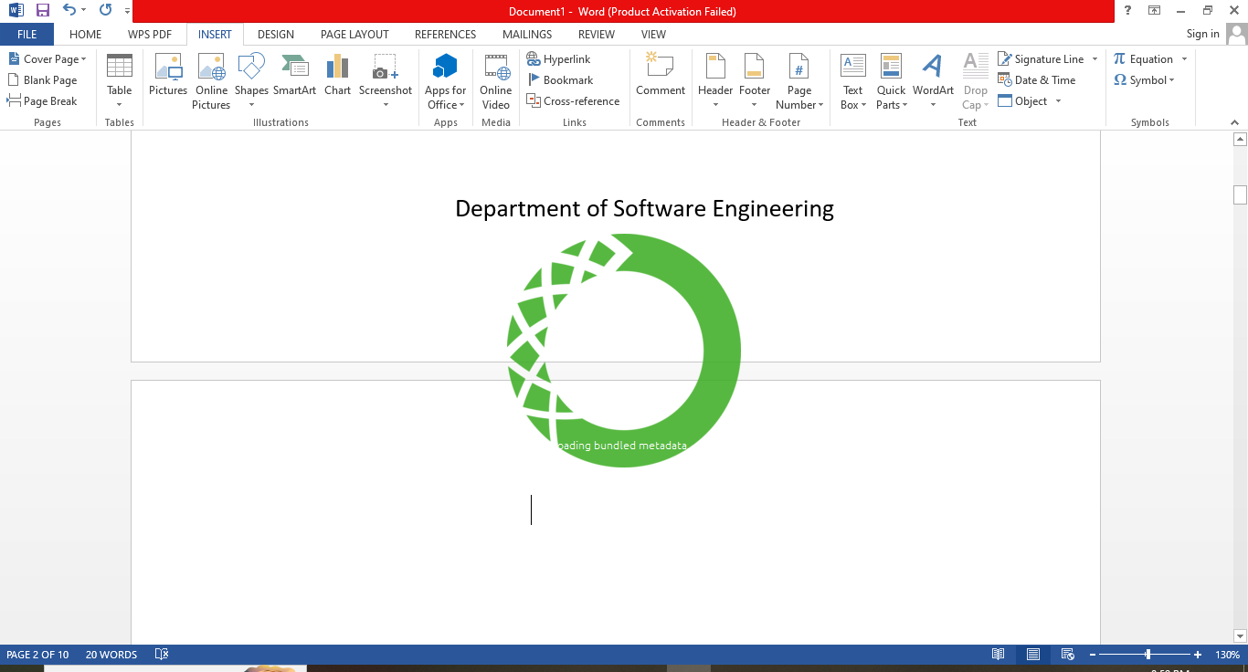

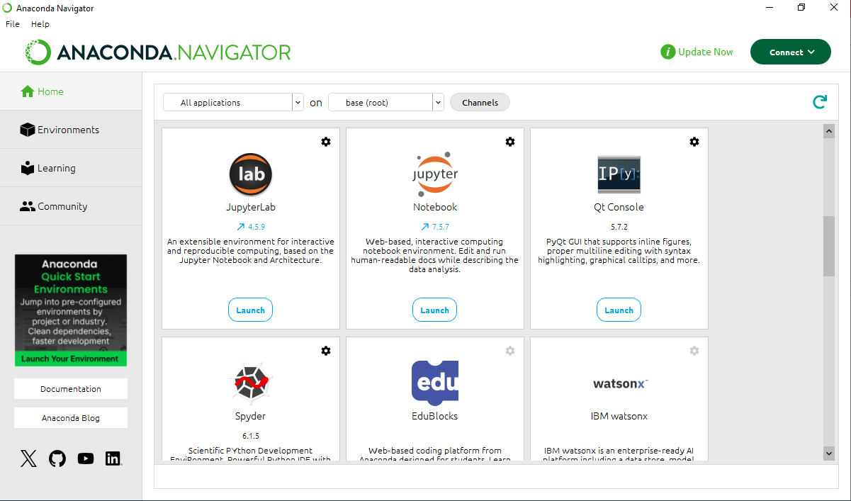
Hello:
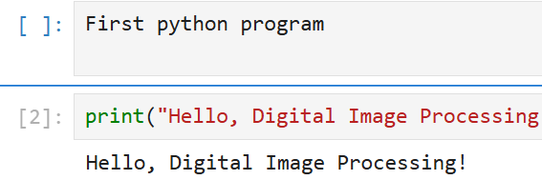
Basic Exercise:
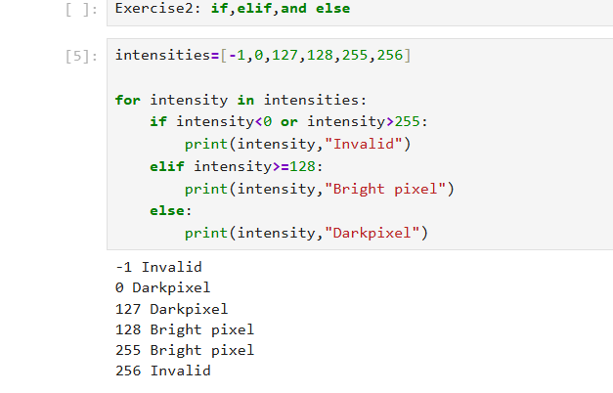
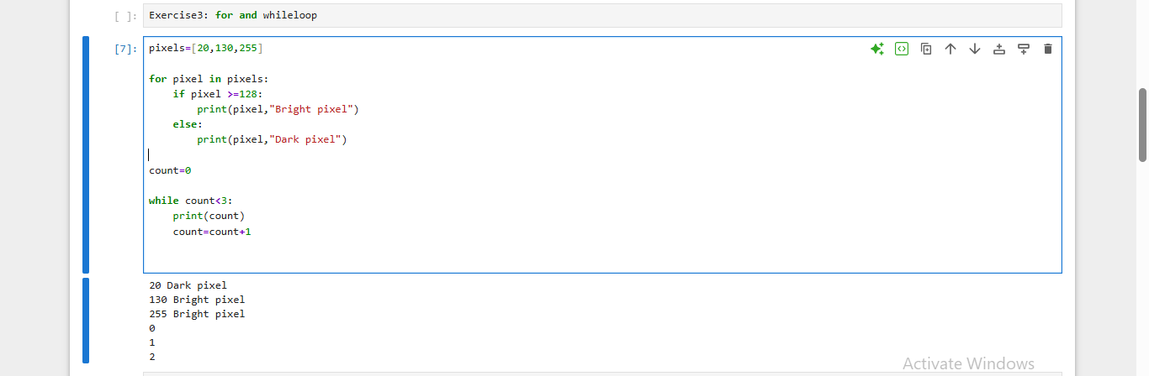
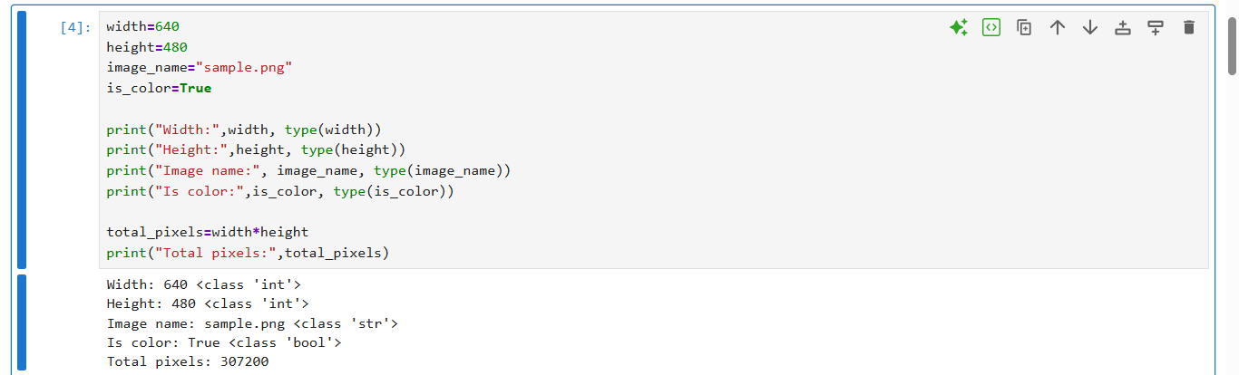
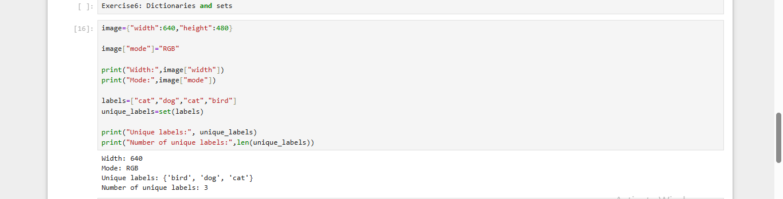

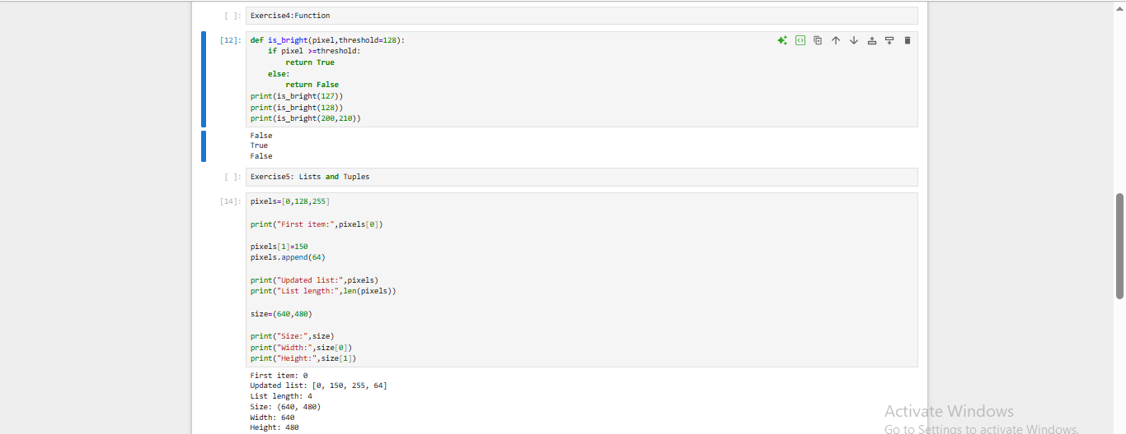
Successful import run:
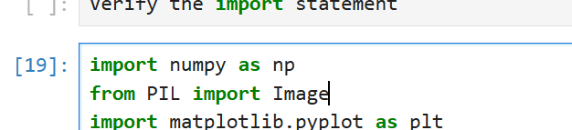
Install package detail:
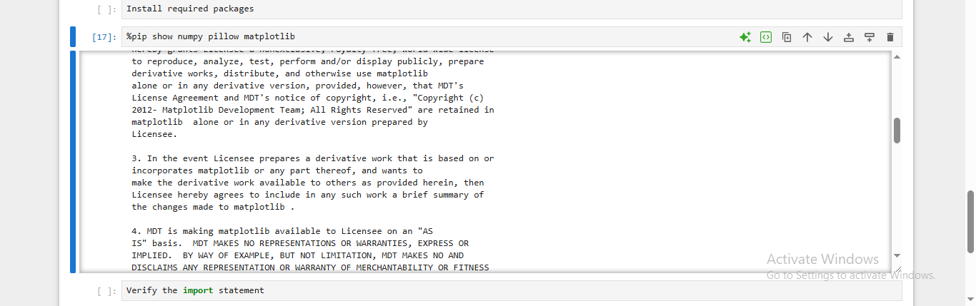

Python versus pip:
Python is a programming language. Pip is a tool used to install python package
Import statements:
Let us use code from other package. Numpy supports numerical calculation, Pillow provides image processing tools, and Matplotlib creates graphs and plots.

