The University of Azad Jammu and Kashmir


Digital Image Processing Lab — Lab Report
Lab Task # 02 — Digital Images, Pixels, Color, and Basic Transformations
Lab Instructor: Engr. Fahad Nisar
Semester: Fifth
Session: 2024-28 (SE)

Name: Zoya Mazhar
Roll Number: 2024-SE-26
Submission Date: 29-oct-26

Department of Software Engineering

1. Objective
The objective of this lab is to use NumPy, OpenCV (cv2) and Matplotlib to load, inspect, display, analyze, transform and save digital images, while correctly handling pixel coordinates, color channels, histograms, resolution and bit depth. After completing this lab I am able to:
- create an isolated Python virtual environment and install the required libraries in it;

- load a real color image with cv.imread() and read its shape and data type;
- inspect individual pixels using [row, column] indexing and find global and per-channel min/max values;
- convert between BGR and RGB, separate the red, green and blue channels, and convert a pixel value to HEX;
- crop an exact region, resize it, save it with cv.imwrite() and verify the save;
- compute and interpret a 256-bin grayscale histogram;
- quantize an 8-bit gradient to 1-bit, 2-bit and 4-bit levels and explain the difference between resolution and bit depth.

2. Tools and Requirements
- Language: Python 3 (run from the activated virtual environment).
- Editor: Jupyter notebook, opened on the project folder dip-lab-02.
- Libraries: numpy, opencv-python and matplotlib, installed inside .venv with pip.
- Image: One personally selected color JPG/PNG image of at least 300 × 300 pixel.

3. Step 1 — Creating the Project and Virtual Environment

3.1 What this step does
A virtual environment keeps this lab’s packages isolated from the system Python. I created the project folder, opened it in jupyter created the environment with the venv module, activated it, and installed the three required libraries inside it.
.

4. Step 2 — Loading the Image

4.1 What this step does
I placed my own image inside dip-lab-02 and created lab02.py. OpenCV loads the file in BGR channel order; if the path is wrong cv.imread() silently returns None, so the script raises FileNotFoundError to fail loudly. The shape (height, width, channels) and data type (uint8) are then printed.

4.2 Code (start of lab02.py)
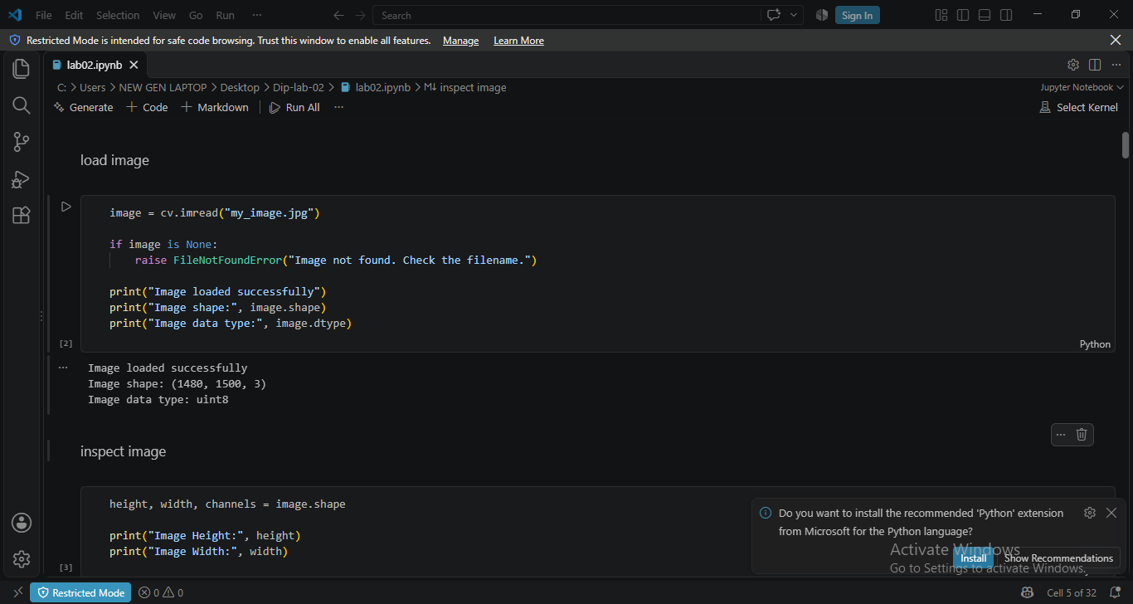

5. Step 3 — Inspecting the Image

5.1 What this step does
Images are indexed as img[row, column] — rows come first. The top-left pixel is img[0, 0] and the center pixel is img[h // 2, w // 2]. Each printed pixel shows three values in BGR order. I also printed the global minimum/maximum over the whole array and the minimum/maximum of each channel separately, so the full intensity range of the image is known. Every printed line carries a clear label.

5.2 Code (added to lab02.py)
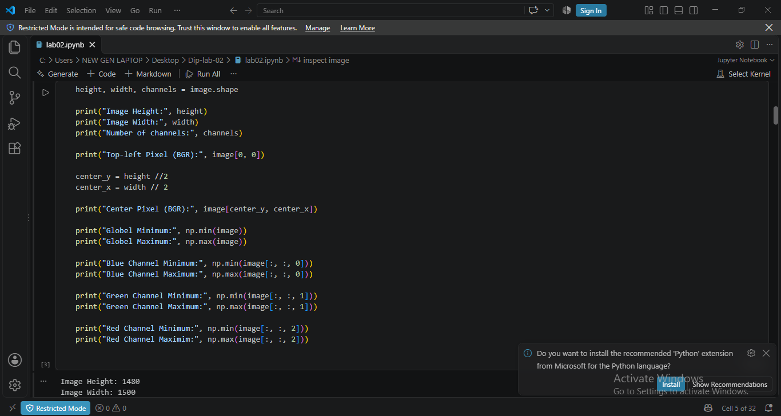
.

6. Step 4 — Color Conversion and Channel Separation

6.1 What this step does
OpenCV stores images as BGR while Matplotlib expects RGB, so the image is converted with cv.cvtColor before display — otherwise red and blue are swapped. I created a grayscale version with cv.COLOR_BGR2GRAY, separated the three channels with cv.split, and built a 2 × 3 figure showing: the RGB image, the red channel, the green channel, the blue channel, the grayscale image, and the unconverted BGR image. Individual channels and the grayscale view use the gray colormap (a single channel is just intensity), every panel has a title, and the axes are hidden. Finally the center pixel’s RGB value is converted to HEX and printed.

6.2 Code (added to lab02.py)
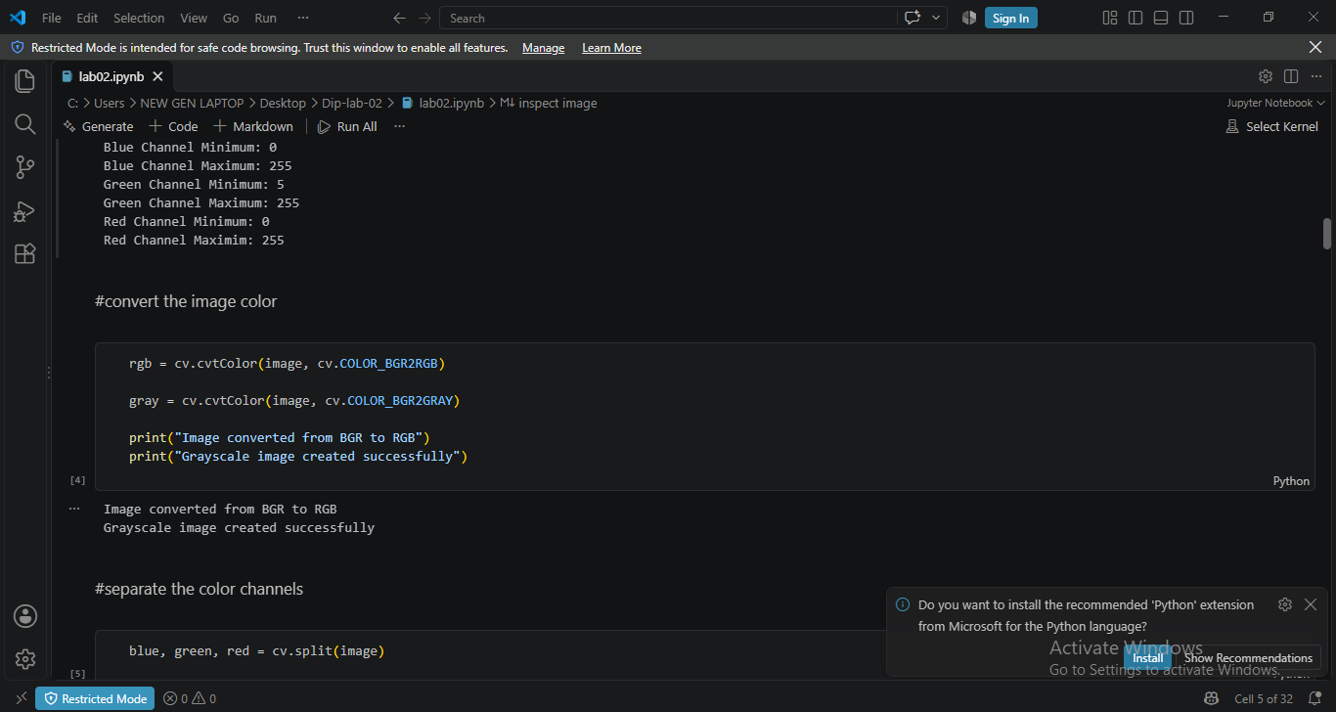

7. Step 5 — Cropping, Resizing and Saving

7.1 What this step does
Cropping in NumPy is pure slicing: image[y_start:y_end, x_start:x_end] — rows first, columns second. I computed a centered start so the crop is exactly 100 × 100 pixels, printed its shape, then resized it to 200 × 200 with cv.resize(). The original image, the crop and the resized crop are shown side by side. Because cv.imwrite() expects BGR, the resized RGB image is converted back with cv.COLOR_RGB2BGR before saving as resized_crop.png, and the Boolean result of imwrite is printed to prove the file was saved.

7.2 Code (added to lab02.py)
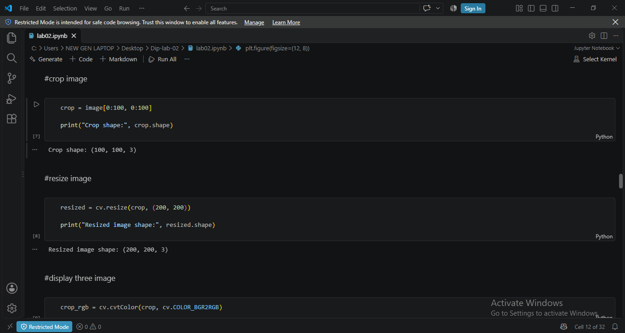

8. Step 6 — Creating the Grayscale Histogram

8.1 What this step does
The grayscale image is flattened into one long list of intensity values and plotted as a 256-bin histogram over the range 0–256, so every possible 8-bit value has its own bar. The plot has a title and labeled axes and is saved as grayscale_histogram.png. Reading the histogram tells me whether my image is mainly dark, bright or balanced.

8.2 Code (added to lab02.py)
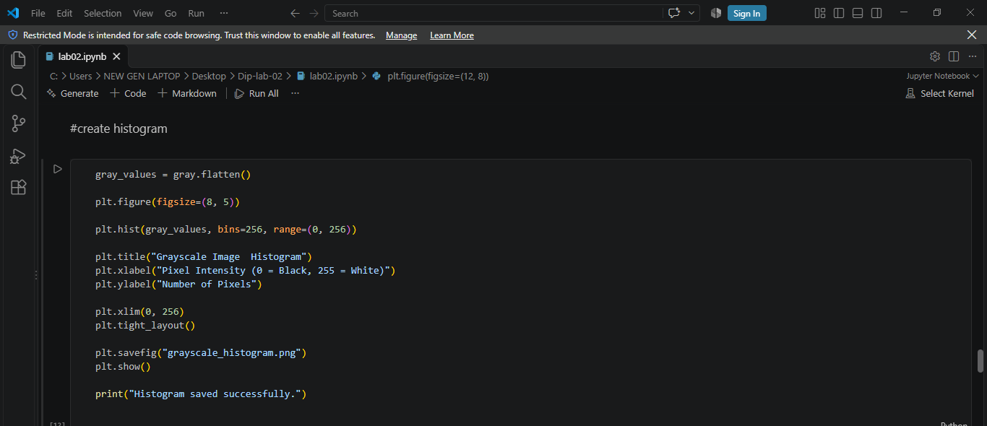
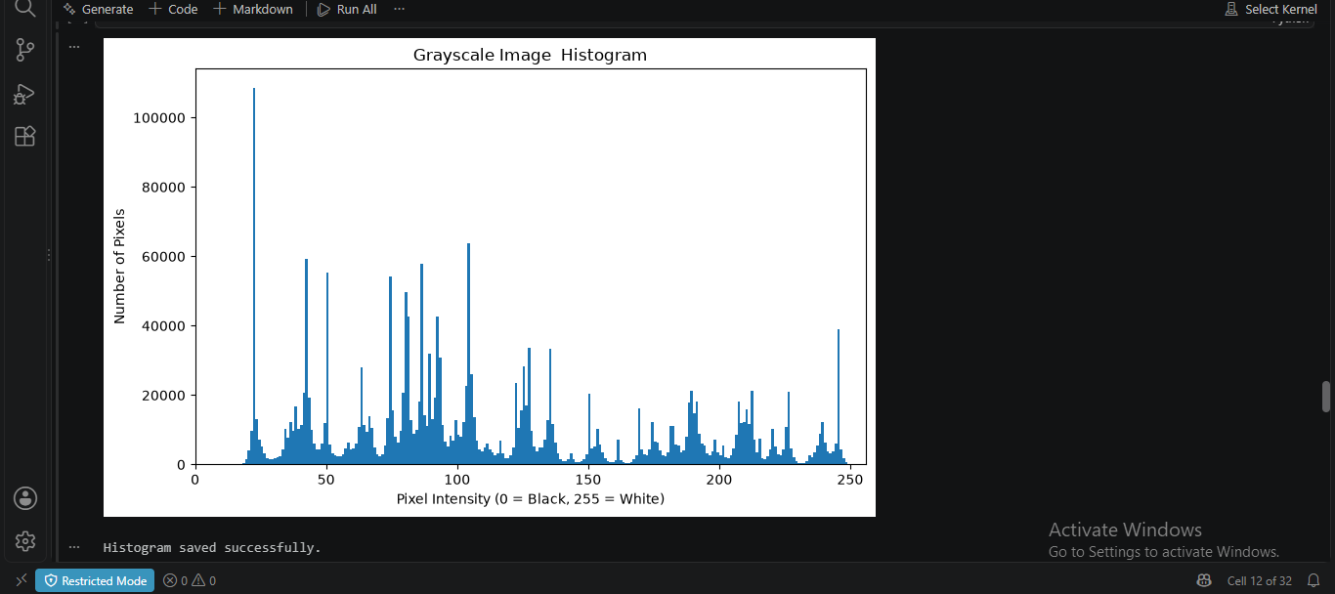

9. Step 7 — Demonstrating Bit Depth

9.1 What this step does
An 8-bit horizontal gradient from 0 to 255 was created with NumPy and quantized to 1-bit (2 levels), 2-bit (4 levels) and 4-bit (16 levels). Quantization maps each original value to the nearest allowed level, e.g. for n levels: q = round(value / 255 × (n − 1)) × (255 ÷ (n − 1)). All four gradients are shown in one figure and their unique-value counts are printed — 256, 2, 4 and 16 — which proves how many intensity levels each bit depth can store.

9.2 Code

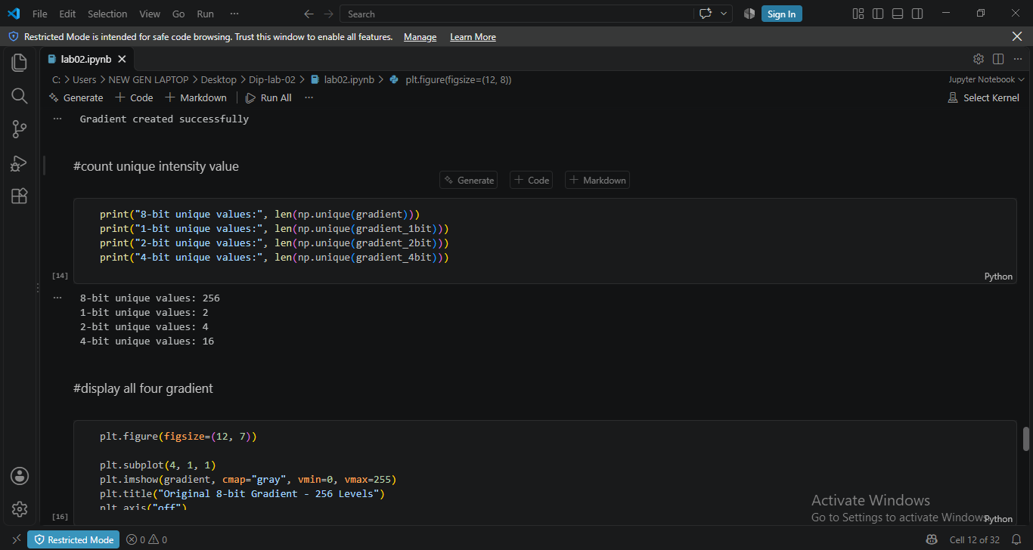
As expected, the 8-bit gradient is perfectly smooth, while the 1-bit version collapses to pure black and white, the 2-bit version to four visible bands and the 4-bit version to sixteen bands. Fewer bits mean fewer intensity levels, which appears as contour-like banding in smooth areas.

11. Written Explanations

11.1 BGR versus RGB
BGR and RGB describe the same three color channels in a different byte order. OpenCV was built when many early cameras and Windows bitmaps stored pixels as Blue-Green-Red, so cv.imread() still returns arrays in BGR order for backward compatibility. Matplotlib’s imshow() has no way of knowing this and assumes RGB, so if BGR data is displayed directly, the red and blue channels are swapped: blue skies look orange, and greens stay roughly correct because green sits in the middle in both orders. That is exactly what the last panel of Figure 5 shows. The fix is one line — cv.cvtColor(img, cv.COLOR_BGR2RGB) — before any Matplotlib display, and converting back with cv.COLOR_RGB2BGR before cv.imwrite(), because imwrite also expects BGR.

11.2 Resolution versus bit depth
Resolution is a spatial property: it is the number of pixels an image has (width × height, e.g. 300 × 300 or 1920 × 1080). Higher resolution means smaller, more numerous pixels, so finer spatial detail — text is sharper, edges are smoother. Bit depth is a color-precision property: it is how many bits each pixel (or channel) uses, which fixes the number of intensity levels (1-bit → 2 levels, 2-bit → 4, 4-bit → 16, 8-bit → 256). Higher bit depth means smoother tonal transitions; too little bit depth shows banding, as Figure 10 demonstrates. In short: resolution is about how many pixels you have, bit depth is about how many shades each pixel can be. A tiny image can be 8-bit and a huge image can be 1-bit — the two properties are independent.

11.3 What a histogram shows and what it does not show
A histogram is the frequency distribution of pixel intensities: for every value 0–255 it counts how many pixels in the image have that intensity. It therefore reveals the exposure and contrast of an image — whether it is dark (bars crowded near 0), bright (crowded near 255) or balanced (spread across the range), and whether values are clipped at either end. A per-channel histogram can even expose a color cast. What it does not show is space: the histogram throws away all pixel positions, so it says nothing about where an object is, what the image depicts, or the shape and edges it contains. Two completely different pictures with the same gray-level distribution produce identical histograms — which is why the histogram is a global statistical summary, not a description of image content.

12. Conclusion
In this lab I set up an isolated Python environment and used NumPy, OpenCV and Matplotlib to complete the full image-processing workflow: loading a real color image, inspecting its pixels and channel statistics, displaying BGR/RGB differences correctly, separating channels, converting a pixel to HEX, cropping, resizing and saving, building and interpreting a grayscale histogram, and demonstrating how bit depth controls the number of intensity levels. The key lessons were that images are just NumPy arrays indexed as [row, column], that OpenCV’s BGR order must be converted before Matplotlib display, and that resolution and bit depth are independent properties that both affect image quality in different ways.

