SDC Internship
Week 4 Individual Task
Specialist Advanced Build

Mobile App Security Review with MobSF on an Intentionally Vulnerable App for a Multi-Branch Bottled Water Company
Prepared by: Group 12 (Red teaming) Member 3 (Zoya Zia)
Target: InsecureBankv2 (com.android.insecurebankv2), an intentionally vulnerable Android training app
Tools used: MobSF v4.5.4 (static analysis), manual manifest, permission and source review, Android Studio emulator (Pixel 6, Android 13 / API 33) and adb (dynamic analysis)
Report status: Static analysis, manual code review and emulator based dynamic checks are complete. Twelve findings are recorded. Every finding states how far it was validated: some were confirmed in the emulator, and others rest on code and manifest evidence only because the lab backend server could not be run.

Summary
I reviewed InsecureBankv2 as the mobile product of a fictional Multi-Branch Bottled Water Company. I started with MobSF static analysis (security score 28/100, 13 manifest entries: 6 High, 7 Warning). MobSF's Code Analysis table came back empty, so I also read the manifest and eight source files by hand. That manual review found most of the findings, including the hardcoded encryption key, plain HTTP and the SMS receiver.
I then ran the app in an Android 13 emulator and tested what could be tested without the lab backend: storage, exported activities, the content provider, permissions and the login request. I used adb directly instead of MobSF's dynamic mode because MobSF ran in Docker and the emulator ran on the host. Twelve findings are recorded. Four were confirmed in the emulator (F5, F6, F8, F12), and the plain-HTTP login request (F2) was also observed using a small local listener.
The main limit is that the Python 2 backend was not running, so a successful login and the logging check could not be tested. I kept "not validated" and "potential" labels instead of overstating those findings.

1. Scope & Authorization
This review treats InsecureBankv2 as a stand-in for the mobile product of a fictional Multi-Branch Bottled Water Company. Its login, account statement, transfer and password-change screens correspond to a customer app that handles sign in, billing statements, payments and account security across branches. This mapping is an assumption made for the exercise.
Target: the InsecureBankv2 APK (MD5 5ee4829065640f9c936ac861d1650ffc as reported by MobSF), obtained from the project's official repository.
In scope: static analysis of the APK with MobSF, manual review of the manifest and permissions, manual review of the decompiled Java source, and dynamic checks of storage, logging and exported components in an Android emulator.
Out of scope: any real organisation, the app's backend server code, interception of real server traffic, other apps or devices and denial-of-service testing.
Authorization: InsecureBankv2 is a deliberately vulnerable training application. All testing was done on my own machine and inside an emulator. No real company, customer or branch data is involved.
Note on timing: this scope statement was written after the static scan had started and before any dynamic testing.

2. Objective
The goal of this task is to review an intentionally vulnerable Android app using the OWASP MASTG approach: find issues with MobSF static analysis and manual review, validate them in an emulator, map each finding to an OWASP MASVS category, rate its severity, and write developer ready fixes for the top five findings. The task also uses a new skill, mobile app security testing, with a new tool (MobSF with an Android emulator) and a new kind of target (a mobile app).

3. Plan and Measurable Target
- Scope: review InsecureBankv2 as the mobile app of a fictional Multi-Branch Bottled Water Company.
- Static analysis: scan the APK with MobSF in Docker and read the manifest, permissions and decompiled source by hand.
- Dynamic analysis: run the app in an Android 13 emulator and check storage, logs, exported components and network behaviour.
- Map every finding to an OWASP MASVS category, rate severity, and write developer-ready fixes for the top five.
- Target: at least 5 findings, each backed by a screenshot, command output or code reference as evidence.
Result: target met. Twelve findings are recorded. All twelve have code, manifest or tool evidence, and seven also have emulator evidence (F2, F5, F6, F8, F10, F11, F12) as screenshots or command output in Section 7.

4. Background: OWASP MASTG and MASVS
The OWASP Mobile Application Security Testing Guide (MASTG) describes how to test mobile apps, and the Mobile Application Security Verification Standard (MASVS) groups requirements into categories. This report uses these MASVS category names: STORAGE, CRYPTO, AUTH, NETWORK, PLATFORM, CODE, RESILIENCE and PRIVACY. Findings are mapped by category; individual control IDs are not cited.
Static analysis inspects the APK without running it (manifest, permissions, decompiled code). Dynamic analysis runs the app in an emulator and observes what it stores, logs and sends. Neither alone is enough: static analysis shows what the code can do, and dynamic analysis shows what actually happens.

5. Methodology

5.1 Lab setup
MobSF v4.5.4 runs in a Docker container on my Windows laptop (localhost:8000). The InsecureBankv2 APK was uploaded to MobSF for static analysis, and the decompiled Java source was reviewed in MobSF's Java Source viewer.
For dynamic checks I installed Android Studio and created a Pixel 6 virtual device (Android 13, API 33, Google APIs image, x86_64, 2 GB RAM). The APK was installed with adb:
C:\> adb install InsecureBankv2.apk
Performing Streamed Install
Success
Command output 1. Installing the APK in the emulator.

5.2 Static analysis with MobSF
MobSF parsed the APK, decompiled it, and analysed the manifest, certificate and permissions. Key numbers from the scan:
Item | Result
MobSF security score | 28/100
Manifest analysis | 13 entries: 6 High, 7 Warning
Exported components | Activities 4 of 10, receivers 1 of 2, providers 1 of 1, services 0 of 0
SDK levels | minSdk 15 (Android 4.0.3-4.0.4), targetSdk 22
Signing | v1 scheme only (v2, v3 and v4 false); MobSF flags Janus as High
Code Analysis table | Empty (no data), although the Java source decompiled successfully

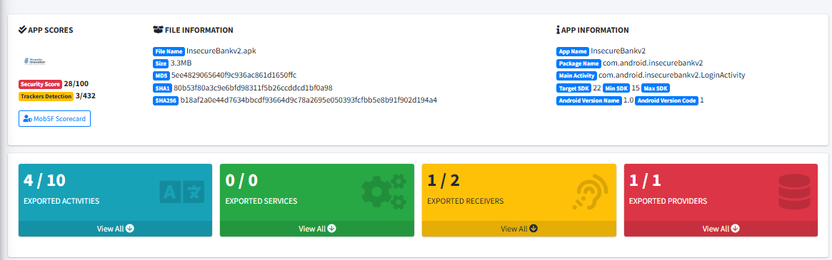
Figure A. MobSF static analysis overview: score 28/100, exported components, app and file information.

5.3 Manual review of manifest and permissions
I read the AndroidManifest.xml directly. Six components are exported: the activities PostLogin, DoTransfer, ViewStatement and ChangePassword, the content provider TrackUserContentProvider, and the receiver MyBroadCastReceiver (action "theBroadcast"). DoLogin, FilePrefActivity and WrongLogin are not exported. The application tag sets debuggable and allowBackup to true.
The manifest declares 12 permissions: INTERNET, WRITE_EXTERNAL_STORAGE, SEND_SMS, USE_CREDENTIALS, GET_ACCOUNTS, READ_PROFILE, READ_CONTACTS, READ_PHONE_STATE, READ_EXTERNAL_STORAGE (maxSdkVersion 18), READ_CALL_LOG, ACCESS_NETWORK_STATE and ACCESS_COARSE_LOCATION.

5.4 Manual review of the source
Files read in full: TrackUserContentProvider, DoLogin, WrongLogin, CryptoClass, LoginActivity, ChangePassword, PostLogin and MyBroadCastReceiver. Not reviewed: FilePrefActivity, DoTransfer, ViewStatement and MyWebViewClient.

5.5 Dynamic analysis in the emulator
Checks performed: first-launch behaviour and permission screen; private storage read with run-as (shared_prefs and databases); a logcat capture during a login attempt; direct launch of exported activities with am start; a query of the content provider with content query; and the login request, observed with a small local Python listener on port 8888 (a stub, not the real backend).
Checks not performed: a successful login, capture of real server traffic, triggering the broadcast receiver, launching DoTransfer and ViewStatement, and testing allowBackup. The lab backend server (Python 2) was not set up, so login did not succeed.

6. Findings Summary
Severity is my proposed rating for this lab context, based on likelihood and impact. It is not MobSF's rating.
ID | Finding | MASVS category | Severity | Validation status
F1 | Saved credentials can be recovered (hardcoded AES key, fixed IV) | CRYPTO, STORAGE | High | Code confirmed; not validated in the emulator
F2 | Login and password change sent over plain HTTP | NETWORK | High | Code confirmed; login request seen in cleartext against a local stub listener
F3 | Passwords and personal data written to logs | STORAGE | Medium | Code confirmed; not validated
F4 | Exported receiver sends the stored password by SMS to a number from the Intent | PLATFORM | High | Code and manifest confirmed; not triggered
F5 | Post-login screens exported, with no authentication check | PLATFORM, AUTH | High | Confirmed in emulator for PostLogin and ChangePassword
F6 | Exported content provider with no permission | PLATFORM | Medium | Reachability confirmed; table was empty
F7 | Password change sends no old password or token | AUTH | Medium (potential) | Client code only; server not reviewed
F8 | App configuration weaknesses (debuggable, allowBackup, old SDK, StrandHogg, v1 signing) | CODE, RESILIENCE | Medium | debuggable confirmed in emulator; rest from manifest and certificate
F9 | Separate developer login path (devadmin) | AUTH | Low (potential) | Client code only; server not reviewed
F10 | Broad permissions beyond what the reviewed code uses | PRIVACY | Low | Manifest confirmed; permission screen seen in emulator
F11 | Root check only shows a label; app has anti-emulator checks | RESILIENCE | Informational | Code and APKiD confirmed; label seen in emulator
F12 | Server IP and port stored in plain text | STORAGE | Low | Confirmed in emulator

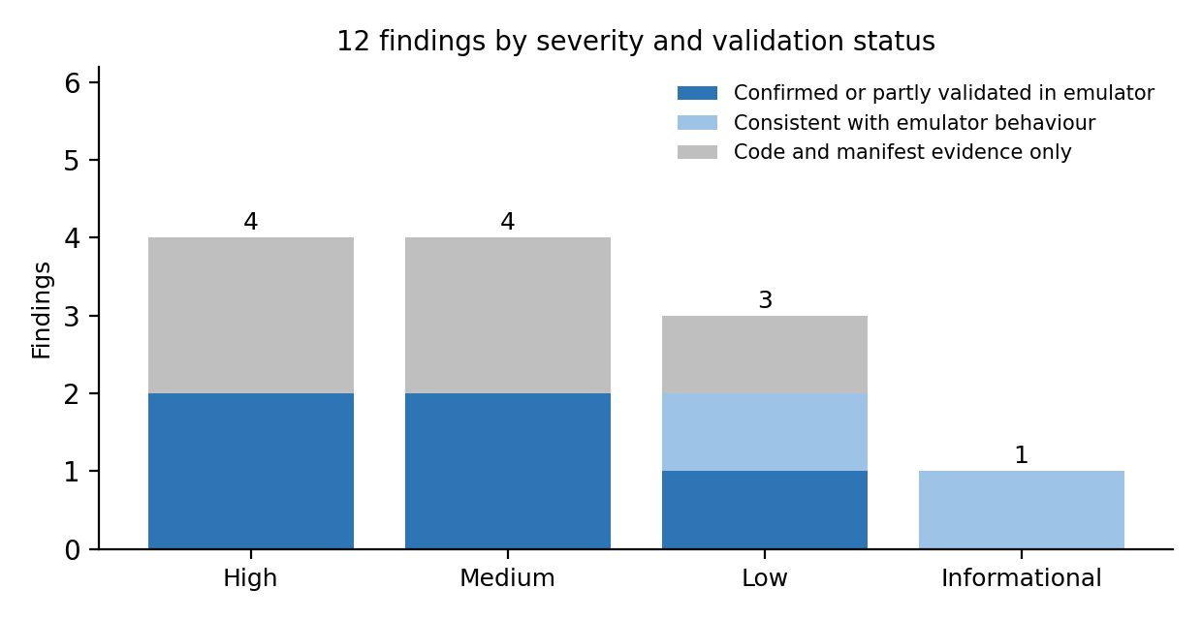
Figure 1. Findings by severity and validation status.

7. Detailed Findings

F1. Saved credentials can be recovered (High, CRYPTO / STORAGE)
Evidence: CryptoClass.java contains the key as a string constant ("This is the super secret key 123") and an IV of 16 zero bytes, used with AES/CBC/PKCS5Padding. DoLogin.saveCreds() stores the username as Base64 and the password encrypted with this class in the "mySharedPreferences" file. LoginActivity.fillData() reads them back, decrypts the password and writes it into the password field in plain text. The manifest sets allowBackup="true".
Impact: The key ships inside every copy of the APK, so anyone who obtains the saved preferences file can recover the password. Base64 is an encoding, not encryption. The fixed IV also means the same password always produces the same ciphertext.
Proposed severity: High, because user credentials are the most sensitive data in a customer app and the key is public to anyone with the APK.
Validation: Code confirmed. In the emulator, run-as showed only one preferences file (Command output 4). "mySharedPreferences", where saveCreds() writes, did not exist, because login never succeeded, so the stored value could not be extracted. Not validated dynamically.

F2. Login and password change sent over plain HTTP (High, NETWORK)
Evidence: DoLogin.java and ChangePassword.java both set protocol = "http://" and build the request URL from it. The login request sends username and password, and the change-password request sends username and the new password. MobSF's Network Security table returned no entries, which I do not treat as evidence either way.
Emulator result: I ran a small local listener on port 8888 (a Python stub, not the real backend), kept the app's server settings at 10.0.2.2:8888 and pressed Login. The app sent POST /login over plain HTTP with the username and password in the request body, URL-encoded and not encrypted (Command output 2). The values printed are the ones typed into the app.
C:\> python listener.py
--- POST /login
Body: username=jack&password=jack%40123%24%0A%0A%0A%0A%0A
--- POST /login
Body: username=jack&password=jack%40123%24%0A%0A%0A%0A%0A
--- POST /login
Body: username=jack&password=jack%40%2123%24
Command output 2. Login requests received by the local listener. %40, %24 and %21 are URL encodings of @, $ and !.
Impact: Anyone who can observe the network path can read the credentials and the new password.
Proposed severity: High, because the data is credentials and no transport encryption is used.
Validation: Code confirmed, and the cleartext login request was observed. The real login result and the password-change request were not tested because the backend was not running. Partly validated dynamically.

F3. Passwords and personal data written to logs (Medium, STORAGE)
Evidence: DoLogin.java calls Log.d("Successful Login:", ", account=" + username + ":" + password). ChangePassword.java prints the username and the phone number with System.out.println. MyBroadCastReceiver.java prints the phone number and a message containing both the old and the new password.
Impact: Plain-text passwords in device logs can be read by anyone with log access.
Proposed severity: Medium. Reading logs generally needs USB debugging or an older Android version, but the data is plain-text passwords.
Validation: Code confirmed. A logcat capture was taken during a failed login attempt but was only partly searched, and the Log.d line above sits on the successful-login path, which was never reached. Not validated dynamically.

F4. Exported receiver sends the stored password by SMS (High, PLATFORM)
Evidence: The manifest declares MyBroadCastReceiver with exported="true" and the action "theBroadcast", with no permission. onReceive() reads "phonenumber" and "newpass" from the Intent without checking the sender, opens the saved preferences, decrypts the stored password with CryptoClass, and sends an SMS "Updated Password from: [old password] to: [new password]" to the number from the Intent through SmsManager. The app declares SEND_SMS and READ_PHONE_STATE. ChangePassword.java also broadcasts the new password in plain text with the same action.
Impact: If another app on the device sends this broadcast with its own phone number, the saved password could be sent to that number without any action from the user.
Preconditions: the user has logged in before (so credentials are saved), and a malicious app or adb access exists on the device.
Proposed severity: High, because the impact is disclosure of a stored password with no user interaction once the preconditions hold.
Validation: Code and manifest confirmed. The receiver was not triggered in the emulator, and it needs saved credentials, which were never created.

F5. Post-login screens exported, with no authentication check (High, PLATFORM / AUTH)
Evidence: The manifest exports PostLogin, DoTransfer, ViewStatement and ChangePassword. PostLogin.onCreate() reads "uname" from the Intent and shows the screen. It contains no login or session check. The real login check happens in DoLogin, after which PostLogin is started. ChangePassword and ViewStatement also take their username from an Intent extra.
Emulator result: Without logging in, these commands were run from the command line:
C:\> adb shell am start -n com.android.insecurebankv2/.PostLogin
C:\> adb shell am start -n com.android.insecurebankv2/.ChangePassword

PostLogin opened with its Transfer, View Statement and Change Password buttons, and ChangePassword opened with its Username and New Password fields (Figure 2). DoTransfer and ViewStatement were not launched.
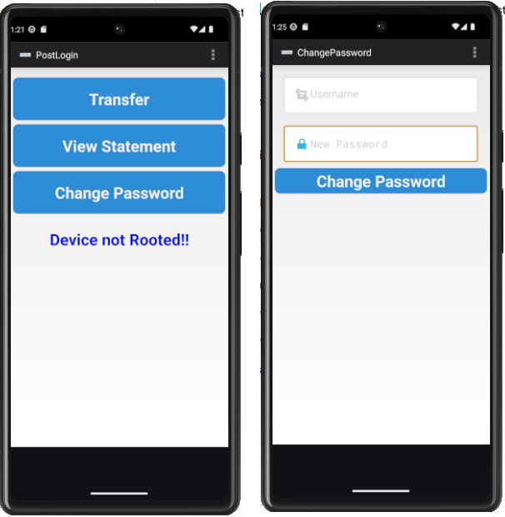
Figure 2. PostLogin (left) and ChangePassword (right) opened with adb, without logging in.
Impact: Another app or adb user can open these screens directly and skip the login screen. Whether the actions behind them work without the backend was not tested, so the impact on data is not shown.
Proposed severity: High. Access control on the screens is confirmed bypassed for two of the four exported activities.

F6. Exported content provider with no permission (Medium, PLATFORM)
Evidence: TrackUserContentProvider is exported in the manifest, and its query, insert, update and delete methods run directly on the database with no permission or caller check. DoLogin.trackUserLogins() inserts the username of each successful login into it.
Emulator result: The provider was queried from the command line. There was no permission error, so the provider answers callers outside the app, but the table was empty because no login had succeeded.
C:\> adb shell content query --uri content://com.android.insecurebankv2.TrackUserContentProvider/trackerusers
No result found.
Command output 3. Content provider queried without any permission.
Impact: Other apps could read, change or delete the stored login usernames once users have logged in.
Proposed severity: Medium. The data seen in code is usernames only. Reachability confirmed; data exposure not shown.

F7. Password change sends no old password or token (Medium, potential, AUTH)
Evidence: ChangePassword.java posts only "username" and "newpassword" to /changepassword. The password complexity pattern is checked in the app only.
Impact: If the server accepts such a request, passwords could be changed without proving the old one. Whether the server checks anything is not known.
Proposed severity: Medium (potential). It could rise if the server is shown to accept the request.
Validation: Client code only. The ChangePassword screen opened without login (F5), but no password change was sent. Not validated.

F8. App configuration weaknesses (Medium, CODE / RESILIENCE)
Evidence: Manifest: android:debuggable="true" and android:allowBackup="true"; minSdk 15 and targetSdk 22. MobSF flags StrandHogg 2.0 on PostLogin, DoTransfer, ViewStatement and ChangePassword. The app is signed with the v1 scheme only, which MobSF flags as Janus on Android 5.0-8.0.
Emulator result: run-as com.android.insecurebankv2 worked from the command line (Command output 4), which is only possible for a debuggable app. On launch the emulator also showed a warning that the app was built for an older version of Android (Figure 3). allowBackup, StrandHogg and Janus were not tested dynamically.
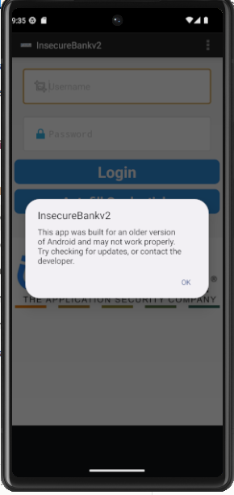
Figure 3. Launch warning: the app was built for an older version of Android.
Impact: A debuggable build lets a debugger attach and lets anyone with adb read the app's private data, allowBackup lets app data be copied through adb, and the old SDK levels allow installation on unpatched Android versions.
Proposed severity: Medium as a group. MobSF rates several of these High, but exploiting them needs device access, a malicious app, or an old Android version (Janus does not affect Android 13). debuggable confirmed.

F9. Separate developer login path (Low, potential, AUTH)
Evidence: In DoLogin.java, if the username equals "devadmin" the request goes to /devlogin instead of /login.
Impact: A separate developer login route can be a backdoor, depending on what the server does with it, which is unknown.
Validation: Client code only. The server was not reviewed. Not validated.

F10. Broad permissions (Low, PRIVACY)
Evidence: The manifest requests READ_CONTACTS, READ_CALL_LOG, GET_ACCOUNTS, READ_PROFILE, USE_CREDENTIALS and ACCESS_COARSE_LOCATION. In the files reviewed, only SEND_SMS and READ_PHONE_STATE are visibly used. At first launch in the emulator, the app showed a permission screen asking for access to files, SMS, contacts, phone, call logs, location, notifications, photos and music (Figure 4).
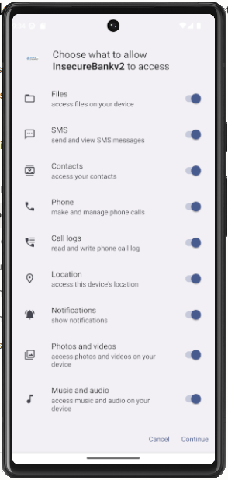
Figure 4. Permission screen shown at first launch.
Impact: Unused dangerous permissions increase what a compromised app could access. Four source files were not reviewed, so this is not a claim that the permissions are unused.

F11. Weak root check and anti-emulator checks (Informational, RESILIENCE)
Evidence: PostLogin.showRootStatus() looks for Superuser.apk and su, but only changes a label ("Rooted Device!!"); the app keeps working. The APKiD section of the MobSF report lists Anti-VM checks on Build.MODEL, MANUFACTURER and PRODUCT. In the emulator the app showed "Device not Rooted!!" and ran normally (Figure 2).
Impact: Root detection that does not act protects nothing. The anti-emulator checks did not stop the app from running on the emulator, so they did not block testing.

F12. Server IP and port stored in plain text (Low, STORAGE)
Evidence: The first launch shows a server setup screen (Server IP 10.0.2.2, Server Port 8888), shown in Figure 5. In the emulator, the preferences file could be read with run-as and holds serverip and serverport as readable XML.
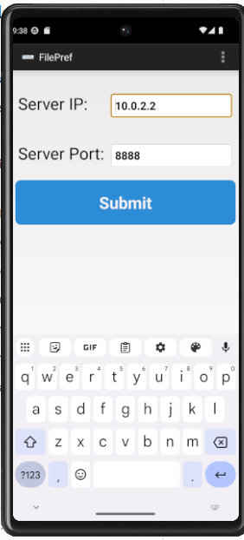
Figure 5. Server setup screen (FilePref) shown at first launch.
C:\> adb shell run-as com.android.insecurebankv2 ls shared_prefs
com.android.insecurebankv2_preferences.xml

C:\> adb shell run-as com.android.insecurebankv2 cat shared_prefs/com.android.insecurebankv2_preferences.xml
<?xml version='1.0' encoding='utf-8' standalone='yes' ?>
<map>
<string name="serverport">8888</string>
<string name="serverip">10.0.2.2</string>
</map>
Command output 4. Private app storage read through run-as.
The app's database is also a plain SQLite file. Its only table, names (columns id and name), was empty, so no sensitive data was found there.
C:\> adb shell run-as com.android.insecurebankv2 ls databases
mydb
mydb-journal

C:\> adb shell "run-as com.android.insecurebankv2 sqlite3 databases/mydb '.schema names'"
CREATE TABLE names (id INTEGER PRIMARY KEY AUTOINCREMENT, name TEXT NOT NULL);

C:\> adb shell "run-as com.android.insecurebankv2 sqlite3 databases/mydb 'SELECT * FROM names;'"
(no rows returned)
Command output 5. Database file and the empty names table.
Impact: This is configuration, not credentials, so the impact is low. It shows that the app keeps local data unencrypted and readable through adb on a debuggable app.
Proposed severity: Low. Confirmed in emulator.

8. Tool Output Review
Not every item in the tool output or source became a finding. Items reviewed and not reported:
- WrongLogin.java only shows a generic "Invalid Credentials" message and returns to the login screen. No data is stored or sent.
- LoginActivity.createUser() only shows a "Work-In-Progress" message.
- LoginActivity passes credentials to DoLogin through an Intent. DoLogin is not exported, so this is internal to the app.
- MobSF's "Abused Permissions 7/25" figure is a statistic, not a finding.
- The names table in the app database was empty and the content provider returned no rows, so neither is reported as a data leak.
Limits of the tool seen in this scan:
- MobSF's Code Analysis, File Analysis and Binary Analysis tables were empty although the app contains hardcoded keys and logging calls found by manual review. An empty table was therefore not treated as proof that the code is clean.
- MobSF's permission table lists 9 permissions while the manifest declares 12. READ_PHONE_STATE, READ_EXTERNAL_STORAGE and READ_CALL_LOG are missing from it and are written with the android:uses-permission tag.
- MobSF rated Janus as High, but it only affects Android 5.0 to 8.0, so I rated it lower inside F8 for an Android 13 device.
Static analysis and manual review found different things: MobSF reported the manifest-level issues quickly, while the credential, logging, cleartext and SMS problems came from reading the source. The emulator then confirmed the access-control and configuration issues.

9. Recommended Fixes (Top 5 Findings)
The top five are chosen by severity and by how directly a developer can act on them: F1, F2, F4, F5 and F3.
ID | Developer-ready fix
F1 | Stop storing the password on the device; keep a short-lived session token instead. If a secret must be stored, keep the key in the Android Keystore (not in code), use a new random IV for every encryption with AES-GCM, and set android:allowBackup="false".
F2 | Use HTTPS for every request and set a network security configuration that disallows cleartext traffic. Do not send credentials over http.
F4 | Remove the SMS that contains passwords. Set android:exported="false" on MyBroadCastReceiver, or protect it with a signature-level permission. Use an explicit in-app call instead of a broadcast for the password-change flow, and never put a password in an Intent.
F5 | Set android:exported="false" on PostLogin, DoTransfer, ViewStatement and ChangePassword. Check for a valid authenticated session at the start of each screen, and take the user identity from the session, not from an Intent extra.
F3 | Remove Log.d and System.out calls that print credentials or phone numbers, and strip log calls from release builds with R8 or ProGuard rules.

Examples for the most important fixes:
<!-- F5 and F4: AndroidManifest.xml -->
<activity android:name=".PostLogin" android:exported="false" />
<activity android:name=".ChangePassword" android:exported="false" />
<receiver android:name=".MyBroadCastReceiver" android:exported="false" />

<!-- F1: stop backups of app data -->
<application android:allowBackup="false" ... >

<!-- F2: network_security_config.xml -->
<network-security-config>
<base-config cleartextTrafficPermitted="false" />
</network-security-config>

// F5: first lines of PostLogin.onCreate()
if (!SessionManager.isLoggedIn(this)) {
startActivity(new Intent(this, LoginActivity.class));
finish();
return;
}

# F3: proguard-rules.pro, remove log calls from release builds
-assumenosideeffects class android.util.Log { *; }

Other findings: set exported="false" on the content provider or protect it with a signature-level permission (F6); require the old password and a server-side session on /changepassword, with the complexity check also on the server (F7); build release versions with debuggable="false", a higher minSdk and targetSdk, and v2 or later signing (F8); remove the devadmin route from release builds (F9); request only the permissions the app uses, and ask for each when it is needed (F10); make the root check act on its result or remove it (F11); and do not keep configuration in plain preferences on a debuggable build (F12).

10. Risk Log
Risk | Likelihood | Impact | Mitigation | What actually happened
The emulator will not run or is too slow on my laptop (virtualization or memory) | Medium | High | Check virtualization and RAM before installing. Use an Android Studio virtual device with a Google APIs image, and if that fails try another emulator such as Genymotion. | Virtualization worked. The laptop has 7.4 GB RAM, so the emulator was slow and showed repeated "System UI isn't responding" dialogs. The first start also failed because the C: drive was full (a 0-byte emulator.exe and a "not enough space for userdata partition" error). Fixed by freeing disk space, reinstalling the emulator package and reducing the virtual device storage.
The app detects the emulator (anti-VM checks) and behaves differently or exits | Medium | Medium | Record exactly how it behaves. For findings that cannot be validated, rely on code and manifest evidence and mark them as not dynamically validated. | Did not occur. The app ran normally on the emulator.
MobSF in Docker cannot be connected to an emulator running on the host | Medium | Medium | Use MobSF for static analysis only and do the dynamic checks with adb directly. | Avoided. Dynamic checks were done with adb (run-as, am start, content query, logcat).
MobSF misses issues (empty Code Analysis table, incomplete permission list) | High (already happened) | Medium | Treat tool output as a starting point. Review the manifest and source manually and cross-check the tool against them. | Occurred. Manual review found F1 to F4 and F7 to F9, which the tool did not report.
The lab backend server (Python 2) does not run, which blocks login-dependent tests | Medium | High | Run the lab server in an isolated environment. If it cannot run, test only what does not need a login and mark the rest as validated by code only. | Occurred. The backend was not set up, so F1, F3, F4, F7 and F9 were not validated in the emulator. A local stub listener on port 8888 was used to observe the login request (F2).
Findings are overstated because they are based on code only | Medium | High | Label every finding with its validation status, call it confirmed only with emulator evidence, and keep "potential" where the server was not reviewed. | Managed. Section 6 states the validation status of every finding.
Time pressure from other pending deliverables | Medium | Medium | Timebox each phase and finish validation of the top five findings first. | Partly occurred. Emulator setup took longer than planned (disk space, slow boot), so time went to the findings that could be validated without the backend.

11. Problems Found and Fixed
- Emulator would not start (disk full). The C: drive ran out of space, which left a 0-byte emulator.exe and caused a "not enough space to create userdata partition" error. I freed disk space, reinstalled the Android Emulator package from the SDK Manager and reduced the virtual device storage.
- API 30 image not available. The system image I planned to use was not in the image list, so I used API 33 (Android 13, Google APIs).
- APK install failed with a NullPointerException. The emulator had not finished booting. Waiting until sys.boot_completed returned 1 fixed it, and the install then returned Success.
- sqlite3 query failed with "incomplete input". Windows quoting broke the query. Wrapping the whole command in double quotes with the query in single quotes fixed it.
- Slow emulator on 7.4 GB RAM. "System UI isn't responding" dialogs kept appearing. I clicked Wait and continued with adb, which does not need the UI.
- Login could not be made to work. The Python 2 backend was not set up. This was not fixed. I used a small local listener to observe the login request, and recorded the rest as a limitation.

12. Limitations and Next Steps
- The backend server was not set up, so a successful login was never reached. Credential storage after login, the "Auto Fill Credentials" button, the real login response, end-to-end password change and capture of real server traffic were not tested. F1, F3, F4, F7 and F9 rest on code and manifest evidence only.
- F2 is supported by a login request captured against a local stub listener, not against the real server.
- The server was not reviewed, so F5 (actions behind the screens), F7 and F9 depend on server behaviour that is unknown.
- Only PostLogin and ChangePassword were launched from outside the app. DoTransfer and ViewStatement were not launched, and the broadcast receiver was not triggered.
- The content provider and the names table were empty, so data exposure was not shown, only that access was open.
- A logcat capture was taken but only partly searched.
- FilePrefActivity, DoTransfer, ViewStatement and MyWebViewClient were not reviewed in source and may contain further findings.
- The MobSF Code Analysis table was empty, so static results rely partly on manual review.
- The emulator ran on a laptop with 7.4 GB RAM and was slow. Severity ratings are my proposals for this lab context.
With more time I would: run the InsecureBankv2 backend in an isolated Python 2 container so login works, then validate F1, F3, F4 and F7; capture the real login traffic with a proxy instead of a stub listener; launch DoTransfer and ViewStatement, trigger the broadcast receiver, and review the four unread source files.

13. Conclusion
Static analysis, manual code review and emulator checks of InsecureBankv2 produced twelve findings. Four are rated High: the recoverable saved credentials (F1), plain HTTP for login and password change (F2), an exported receiver that can send the stored password by SMS (F4), and post-login screens that do not check authentication (F5). Of these, F5 was confirmed in the emulator without the backend: PostLogin and ChangePassword opened without logging in. The login request was also observed in cleartext using a local listener, which supports F2. The emulator also confirmed that the app is debuggable (F8), that the content provider answers outside callers (F6), and that server configuration is stored in plain text (F12).
MobSF reported the manifest-level issues, and manual review found the code-level ones that the tool missed. The main gap is that a successful login could not be tested because the lab backend was not running, so F1, F3, F4 and F7 are not validated in the emulator.

14. AI Assistance Disclosure
Claude (Anthropic) was used as a learning aid in this task to explain MobSF and MASVS concepts, help set up the lab and the emulator, help read the decompiled code, MobSF output and adb results, and help structure this report. The source code and manifest were read from MobSF by the author, and the emulator commands were run by the author. Items marked as not validated have not been reproduced in an emulator, and severity ratings are proposals to be reviewed by the author.
AI suggestions I corrected or rejected:
- Claude suggested an API 30 emulator image, which was not available in my SDK list, so I used API 33.
- Claude guessed that an API 31 image was a preview build because of a license prompt. This was not verified, so I did not rely on it.
- Claude's first sqlite3 command failed because of Windows quoting, and I used the corrected form.
- Claude expected some data to be saved even without a successful login. In the emulator only the server settings were saved, so I reported exactly that.
What I learned: how MobSF static results differ from manual review, how to use adb (run-as, am start, content query) to test a debuggable app, and how to label findings by how well they were validated.

