CAPS LOCK

Documentation

Contents

1. Theme 3
2. Summary 3

2.1. Stages of realization 3

2.1.1. Team configuration 3

2.1.2. Study the topic and discuss ideas 3

2.1.3. Project work 4

2.1.3.1. Diagram 4

2.1.3.2. Most important functions 4

2.1.4. Presentation 5

2.2. Difficulties 5

2.3.Conclusion 5

# Theme

The team of our project is team configuration.

# Summary

Our project aims with easy for the user interface to group 4 classmates from different grades together for future projects.

## Stages of realization

### Team configuration

* Jacqueline Yordanova [zoyordanova@codingburgas.bg](mailto:zoyordanova@codingburgas.bg)
* Ilian Iliev [idiliev18@codingburgas.bg](mailto:idiliev18@codingburgas.bg)
* Stanislava Andonova [srandonova18@codingburgas.bg](mailto:srandonova18@codingburgas.bg)
* Dimitar Kalayonav [dekaloyanov18@codingburgas.bg](mailto:dekaloyanov18@codingburgas.bg)

For the greatest efficiency in the process of work, our team is composed of participants with different abilities. Everyone takes care of a different part of the project development:

* ***Scrum trainer*** - takes care of the organization and documentation in the team, attends the meetings, but does not work on the code
* ***Back-end developer*** - deals with the logical part of the program, the various functions, the data processing
* ***Front-end developer*** - its work is related to the interface of the program, the way the menu is displayed, the result after the execution of any of the functions, etc.
* ***QA Engineer*** - review quality specifications and technical design documents to provide timely and meaningful feedback and creates detailed, comprehensive and well-structured test plans and test cases

### Study the topic and discuss ideas

In order to prepare the most useful program possible, we decided to make a tаble in Excel to see visually the tаsk.

### Project work

Everyone took on their tasks and we had periodic meetings at Discord, during which we discussed how the work process was going, various problems we encountered and looked for ways to solve them.

#### Diagram

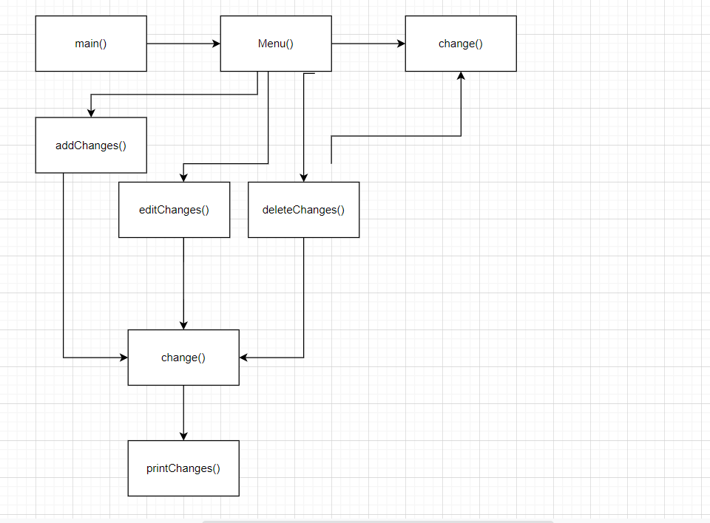

#### Most important functions

|  |  |  |  |
| --- | --- | --- | --- |
| Function name | Usage | Arguments | Return type |
| isEmailValid | checks if the email is valid | std::string email | bool, because checks if it is correct or not |
| showMainMenuHeading | Displays main menu graphic | - | void, because it is not needed |
| showStudentAddMenu | Displays add student menu | - | void, because it is not needed |
| initializeEditMenuOptions | Gives options to the user to edit | - | vector, because of the variable |
| editFirstNameMenu | Gives you right to edit the name | Int& id0 | void, because it is not needed |
| showEditMenuTeacher | displays the teacher edit menu | - | void, because it is not needed |
| deleteTeacherMenu | Deletes teacher’s menu | - | void, because it is not needed |
| handleUserChoiceStatus | Asks the user about the status of the team | vector<MENU_OPTION_STATUS>& options | void, because it is not needed |
| STUDENT_SERVICE::open | Opens the file with the students | const char* fileName | bool, because checks if it is correct or not |
| TEACHER_SERVICE::close | Closes the teacher’s file | - | void, because it is not needed |
| TEAM_SERVICE::add | Adds the teams’ file | TEAM team | bool, because checks if it is correct or not |

### Presentation

The last stage of project development is its protection.

## Difficulties

During the development of the project we did not encounter many problems. The exception is the easy-to-read interface of the result after performing the functions and of course the time.

## Conclusion

We have created a program that aims to help the user to distribute 4 students from different classes with 4 different roles and one teacher – mentor.