***Project Management***

**1-Project charter :**

1.1_Project name: "Safary"

1.2_Project sponsors:

1_Mr/Ahmed Mostafa . phone num/01012345678

2_Mr/Mohammad Ahmed. Gmail/moahmed23@gmail.com

1.3_Project manager:

Rehab Walid. phone num/01234567890

1.4_Project Team : Rahma Bahaa El-Deen , Zainab Ahmed , Zainab Hamada , Demyana Fayek, Rawan Mohammed .

1.5_Purpose of project: An application you can book a room at any hotel from it.

1.6_Business case for the project: booking hotels is very hard and need alot of time, so this application will facilitate that.

1.7_Key deliverables of the project: software and hardware.

1.8_General statement about how the team will approach the work : we will contact through WhatsApp, GitHab and Gmail. we will use application atom for coding with HTML and ide for javascript. An application for css.and eclipse for java. An application for PHP.

1.9_Basic timeline of when the project milestones will be reached:

1.9.1_project initiation:1/11/2021

1.9.2_planning:8/2/2022

1.9.3_prject charter:10/11/2021

1.9.4_project scope:16/11/2021

1.9.5_prototype:15/2/2022

1.9.6_executing:8/7/2022

1.9.7_controlling:8/10/2022

1.9.8_closing:25/11/2022

1.9.9_deadline:1/12/2022

1.10_Project resources, budget, staff, and vendors:

staff:

1_ Rehab Walid

2_Rahma Bahaa

3_Zeinab Ahmed

4_Zeinab Hamada

5_Dimiana Fayek

6_ Rawan Mohammed

1.11_ Summary budget: minimum cost: 1 million pound maximum cost: 5 millions pound.

1.12_ High-level risks: Any defect in the program can be a great risk to the project manager and employees, so we must be more precise in each of the steps because that project is not related to one person, but rather to several people.

**2-Project Scope :**

*2.1_Product scope description:*

Our goal in this project is to make an application that contains complete information about all hotels in Egypt through which the customer can book the suitable hotel at the suitable price for him in the place he wants to go to, and also a bus will be booked for him equipped with the latest capabilities, and in the end we ask the The customer has his opinion of the hotel in which he stayed, and we record his opinion in the application.

In this application, html, css and java will be used.

The customer will be able to use this application by downloading it, choosing the governorate in which he resides, as well as the governorate he wants to go to, registering the appropriate price for him, and recording the number of days of his stay in the hotel, and thus a room will be reserved for him in the hotel of his choice, as well as the bus ticket.

*2.2_Product Acceptance Criteria:*

What distinguishes this site from others is that it includes the entire trip for you, as it provides you with the bus to transport you from the place where it is located to our hotel. It also includes an assessment at the end of your stay to know the advantages that you want to enjoy.

*2.3_ Project deliverables :*

Project deliverable represented in document that contain the plan is to create an application for the ability to book hotels in an easy and convenient way for the customer In this report, we will mention project scope description, product acceptance crieria, project exclusions, project constraints.

*2.4_Project exception:*

_If the person who made the reservation wants to cancel his flight after confirming it within 24 hours, the hotel is not responsible for that and is not entitled to a refund of the reservation again.

_If a tourist attacks a person without referring to hotel security, it may result in a fine or the cancellation of their trip without end.

*2.5_project limitations:*

-The project will not take more than 1 year.

-The cost will not exceed 5 millions.

-The scope of the project takes 2 or 3 weeks.

-Determining product acceptance criteria takes months at most

-Project deliverables will take two weeks.

-Determining project exceptions will take 20 days at most.

-Determining project constraints will take 25 days.

**3-WBS :**

3.1_ Planning Task

3.1.1_ team manage

3.1.2_task assignment

3.2_ Coding

3.2.1_DB

3.2.1.1_table

3.2.1.2_ relationship

3.2.2_ Front End

3.2.2.1_ photoshop and logo

3.2.2.2_ coding / building templates

3.2.3_ Back End

3.2.3.1_ Build Admin Panel

3.2.3.2_ Build Wepsite

3.2.3.3_ Build Mopile App

3.3_ Testing / Controlling

3.3.1_ Test DB

3.3.2_ Test Admin Panel Function

3.3.3_ Test Website Function

3.3.4_ Test Mopile App Function

3.4_ Push on server

3.4.1_ upload all file online

3.5_ Adverting

3.5.1_ TV ads

3.5.2_ Online ads

**4-WBS Dictionary :**



**5-Responsibilities Matrix :**

|  |  |  |  |  |  |  |  |
| --- | --- | --- | --- | --- | --- | --- | --- |
| ***Project Tasks*** | Project Manager | Senior Analyst | Head of Design | Sales Director | Sponser | Devolopment | Test |
| Execution | **R** | **C** | **S** | **N** | **N** | **R** | **S** |
| Strategic Framework | **R** | **R** | **C** | **A** | **N** | **R** | **A** |
| Risk Factors | **S** | **R** |  | **N** | **C** | **R** | **R** |
| Design Wireframe | **C** | **C** | **R** |  | **N** | **S** | **A** |
| User Journey | **C** | **S** |  | **R** |  | **S** | **R** |
| Evaluation Framework | **R** | **N** |  | **C** | **S** | **C** | **R** |
| Delivery Roadmap | **R** |  | **R** |  | **N** | **C** | **C** |
| Reviews | **R** | **R** | **N** | **C** | **N** | **N** | **R** |
| Test | **R** | **C** |  | **R** | **S** | **C** | **R** |

1. Responsible **( R** **)**
2. Support **( S )**
3. Consult **( C )**
4. Notification **( N )**
5. Approval **( A )**

**6_Network:**



**7-Resources:**





**8_Budget:**

Cost by 5 weeks

|  |  |  |  |  |  |  |  |  |  |
| --- | --- | --- | --- | --- | --- | --- | --- | --- | --- |
| A | 50 |  |  |  |  |  |  |  |  |
| B |  | 18 | 22 |  |  |  |  |  |  |
| C |  | 21 | 16 |  |  |  |  |  |  |
| D |  |  |  | 20 |  |  |  |  |  |
| E |  |  |  | 29 | 22 |  |  |  |  |
| F |  |  |  |  |  | 24 |  |  |  |
| G |  |  |  |  |  |  | 35 |  |  |
| H |  |  |  |  |  |  |  | 30 | 22 |

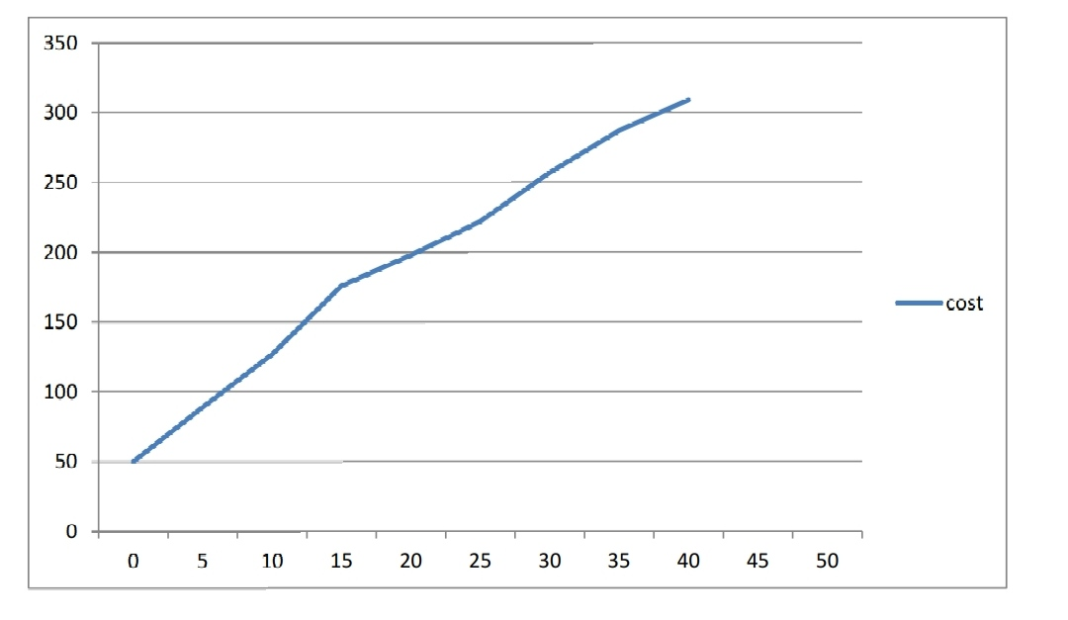



**9_Risk:**

Dangers we may face in project management and how to deal with them:

* Change in the definition or identification of the project.

The project and its principles must be defined before starting work, and it must be approved by the project owners, project sponsor and customers

There is no clear quality plan

The plan should communicate the project manager's desire and explain the processes that will be used in the project, how the project will be implemented, how you will control the project and how you will close it

* Blurred project boundaries or disappointing performance by implementing contractors or designers

The project scope statement should define the project boundaries to make clear what will not be included in the project deliverables. It is important to define what is excluded so that there is no confusion when the project manager wants to close the project and the project clients expect more deliverables.

* Inaccuracy or incompleteness of various time estimates for parts of the project

The time period for work on the project must be accurately divided, specifying the start and end time of the project and the time period that will be required for each stage of the project

* Unavailability of necessary materials

It is important to determine what resources we will need, how we will provide them and whether the budget will allow before starting work

-------------------------------------------------------------

How will I monitor my project

I must follow up with the employees how the work is going and whether it is going within the set plan and monitor the time period and budget set before and whether the project outputs are in line with the desired specifications.