**BAIT 518 Data Visualization**

**Project Report**

**Professor: Dr. Chunhua Wu**

**TA: Xilin Song**

**BA1 - Team B**

**October 27th, 2023**

Sergio Chamba Aguas - 79795549

Xinge (Alisa) Wu - 33633223

Young Ji Tuen - 77199693

Yuehan Wang - 21233218

Zixuan (Coco) Zhang - 14984785

**ChatGPT**

# **1. Background**

In today’s world, society is seeing the detrimental impact of global warming. Countries have acknowledged the urgent need to take immediate action to reduce the impact of climate change and build a cleaner world. Cars emit a significant amount of greenhouse gasses, such as carbon dioxide, that contribute to global warming and climate change. It is important to gather insights to thoroughly understand how car emissions negatively affect the environment and take corresponding actions to resolve this environmental challenge.

It is evident that leadership believes in the need for a movement towards more environmentally friendly transportation. For example, the US (United States) Government is encouraging manufacturers to transition to electric vehicles (EVs) by 2035. The expectation is that by 2030, 50% of cars sold need to be electric (The White House, 2023), by 2032 67% (Duffy, 2023), and 100% by 2035 (Romaine, 2021).

However, there remains some hesitancy among the general public to make this transition towards EVs. Concerns regarding lack of charging infrastructure and the limited fuel efficiency and range of EVs are among the top reasons US vehicle consumers cite for not considering an EV (Crownhard, 2022).

There is comprehensive data available on the energy consumption of vehicle types, and this information could provide US consumers meaningful insights into the benefits of purchasing an EV. Indeed, US vehicle consumers have a vested interest in making more environmentally conscious choices in their next vehicle purchase.

# **2. Goal**

The goal of this project is to illustrate the relative fuel efficiency of EVs compared to gas-powered cars, as well as to demonstrate the improvements in EV range over time. Finally, it aims to present actionable insights to US vehicle consumers by comparing EV characteristics, and thus help them choose the best EVs for their needs.

**3. Potential impact**

The data presented in this report may empower US vehicle consumers to make informed decisions regarding their next vehicle purchase. They can choose the appropriate type of vehicle whilst weighing the important factors of vehicle fuel efficiency, range, and environmental impact.

**4. Data**

**4.1. Data Source**

We conducted research on this topic and found a suitable dataset on Kaggle from the US Department of Energy. This dataset includes vehicle fuel economy data of vehicles released in the US from 1985 to 2023. Our data source is linked here: [🚙 Vehicle MPG (1984-2023)](https://www.kaggle.com/datasets/mexwell/vehicle-mpg-1984-2023) (Kaggle, 2023).

**4.2. Key metrics**

To achieve our goals, we selected the following variables to act as our key metrics:

1. Model year: the year in which each car model was released.
2. Fuel type: whether the car is fuelled by gas, electricity, or both
3. Vehicle class: which class of vehicle the car belongs to
4. Combined Miles per Gallon (MPG): a measure of fuel efficiency

# **5. Visualizations**

# **5.1. Fuel efficiency of vehicles by fuel type**

For our first visualization, we wanted to have a broad view of our data and, at the same time, provide justification as to why we decided to focus on EVs. To do this, we first needed two additional variables: (1) car fuel category, and (2) aggregated MPG or equivalent.

The original dataset distinguished between different fuel types based on their first fuel type, second fuel type, engine description and/or model type. To categorize cars based on their fuel type into the three categories of ‘Electric’, ‘Hybrid’, and ‘Gas Only’, we used the following code to create the ‘Car Fuel Category’ variable:

1. Car Fuel Category:

*IF [Fuel Type 1] == 'Electricity' THEN 'Electric'*

*ELSEIF [Fuel Type 2] == 'Electricity' OR*

*CONTAINS([Engine Description],'Hybrid') OR*

*CONTAINS([Model], 'Hybrid') THEN 'Hybrid'*

*ELSE 'Gas Only'*

*END*

Then, we decided to create the variable: ‘Aggregated MPG or Equivalent’ in order to have a common metric to compare the fuel efficiency across fuel categories. The original dataset had more granular information which we simplified into one variable using the following code:

1. Aggregated MPG or Equivalent:

*IF [Fuel Type 1] == 'Electricity' THEN [Combined MPG (Fuel Type 1)]*

*ELSEIF [Fuel Type 1] != 'Electricity' AND IFNULL([Fuel Type 2], 'NA') == 'NA' THEN [Combined MPG (Fuel Type 1)]*

*ELSE ([Combined MPG (Fuel Type 1)] + [Combined MPG (Fuel Type 2)])/2*

*END*

Finally, we chose to use a scatter plot to visually represent the different groups and their change in fuel efficiency over time.

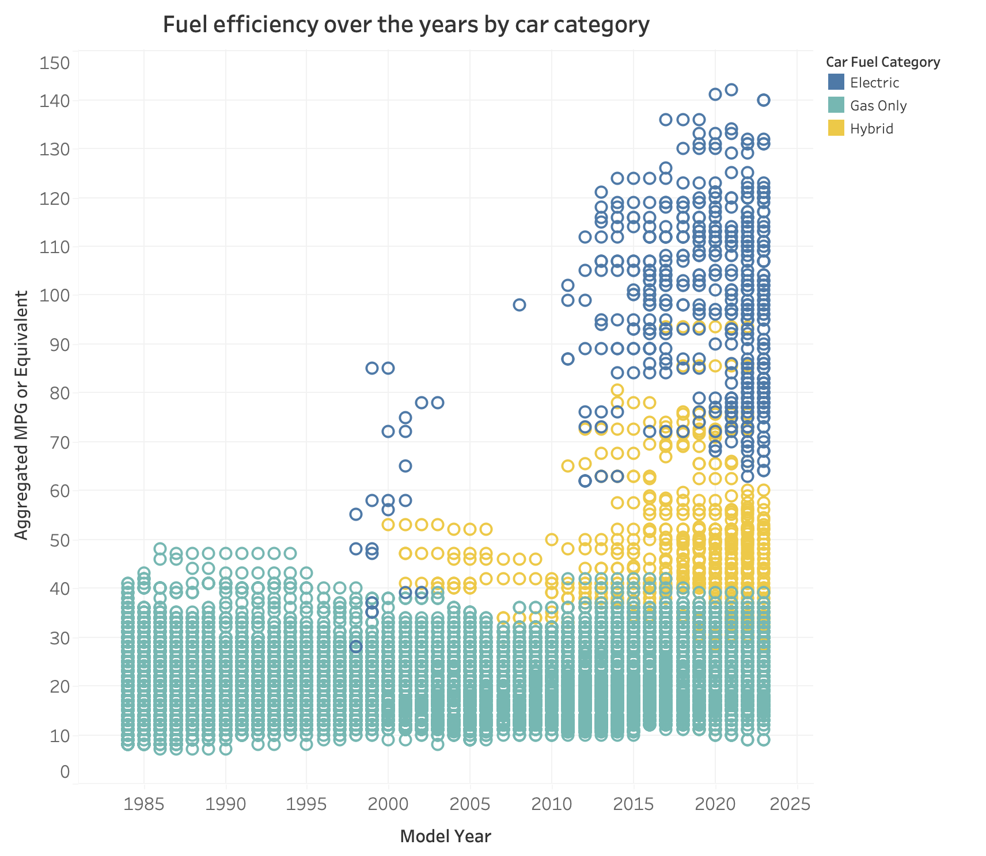

From the visualization above, we can conclude that there is a stark difference in fuel efficiency by fuel type. Specifically, EVs were revealed to have a much better fuel efficiency than gas-powered or hybrid cars. Furthermore, the fuel efficiency of EVs seemed to improve at a greater rate than gas-powered or hybrid cars. Thus, we decided to bring our focus to electric cars.

In the next three visualizations, we sought to illustrate the evolution of average EV range, as well as the fuel efficiency and range by EV class. With these visualizations, we aimed to provide users with a broader understanding of the impact they can have on the environment and the savings they can achieve by acquiring an electric vehicle.

# **5.2. Range of EVs over time**

With the understanding that US consumers have expressed concerns regarding the limited range of EVs, we chose to illustrate the changes in EV range over time. In addition, we wished to provide a forecast of the change in range for the next 5 years.

In order to do so, we filtered the data to include only purely EVs, before charting the average range of vehicles by model year. Finally, we added a forecast line with 95% confidence intervals to reveal the predicted trend in the next five years.

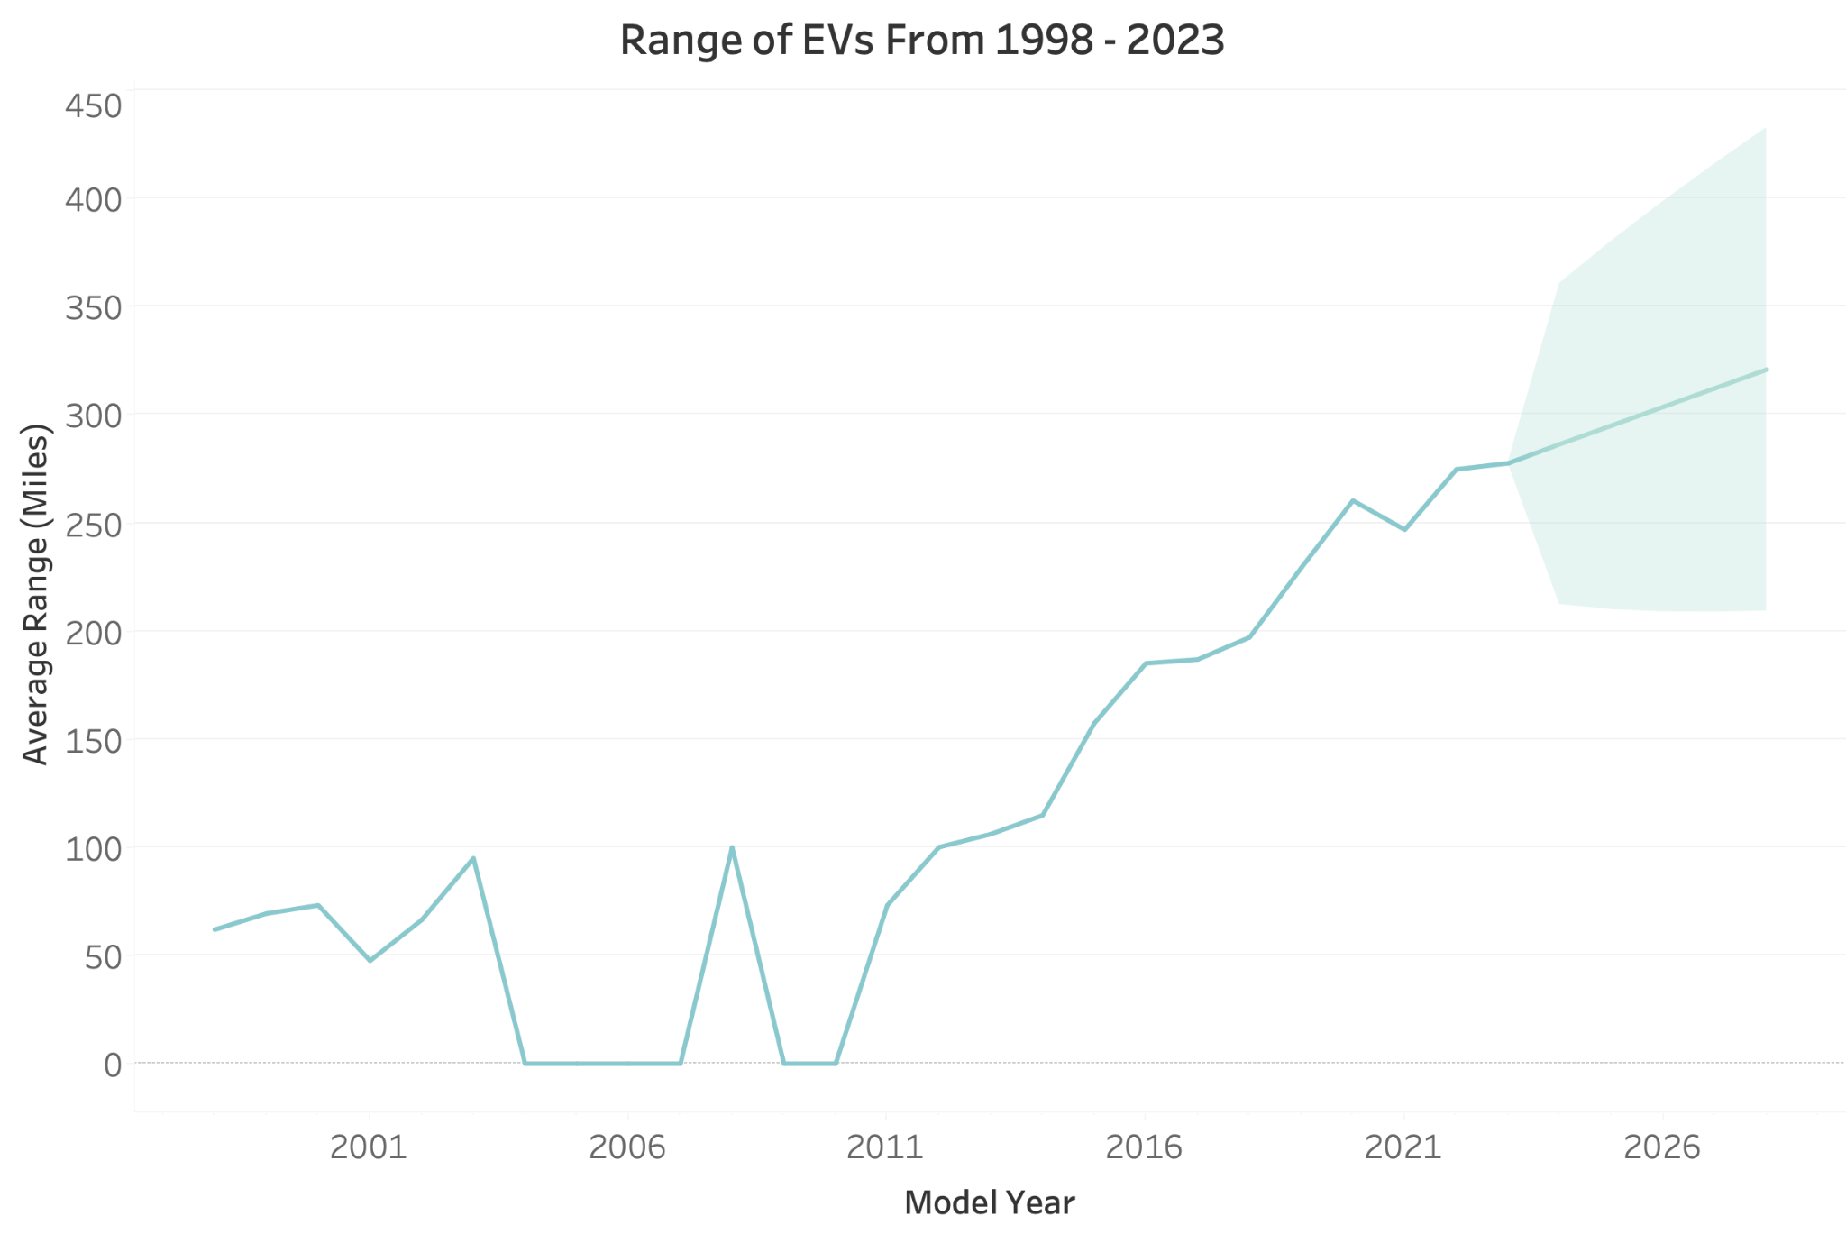

The visualization above demonstrates an overall increase in EV range from 1998, when the first EV was released, to 2023. This overall trend in range may be due to the rapid developments in EV battery technology in recent years (Davey, 2023). There are two periods — 2004 to 2007 and 2009 to 2010 — where the average range of EVs drops to zero, indicative of a lack of EVs released during those two periods.

Additional forecasting analysis reveals a continuous growth in range over the next five years. Coupled with expanding efforts by the US government to improve chagrin infrastructure across the country, EV drivers may quickly be able to drive even longer distances with less battery.

# **5.3. Fuel efficiency and range of EVs by vehicle class**

Now that consumers have gained insight into the relative fuel economy and range of EVs over time, they may be interested in making a decision on which EV class to purchase. Thus, the next question we sought to answer was: what has the fuel efficiency and range of each EV class been over time?

After filtering for data from the last five years (2018 to 2023), we merged similar categories into nine groups to facilitate a comparison of the average MPG equivalent across different EV classes.

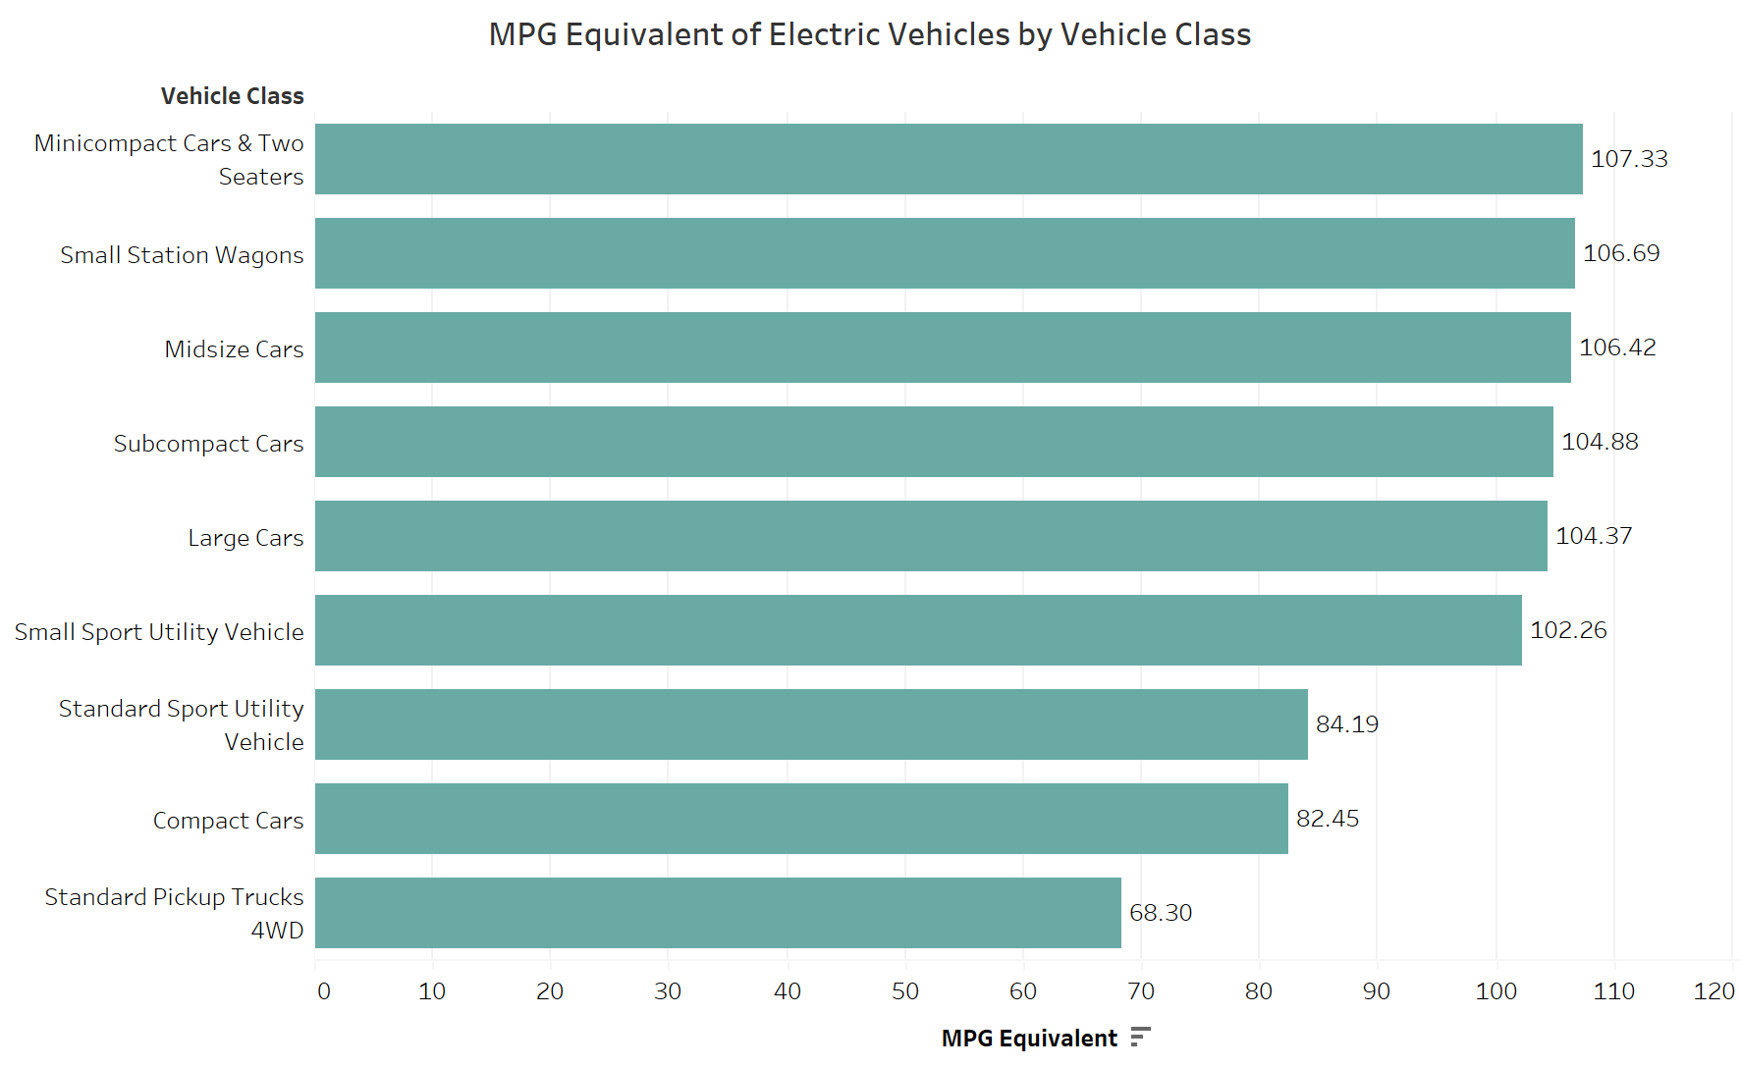

This visualization provides a clear comparison of the MPG equivalent across different electric vehicle classes. It is evident from this chart that midsize cars outperform other categories in terms of fuel efficiency within the realm of electric vehicles, while standard pickup trucks lag behind in efficiency. Generally speaking, smaller and lighter EVs have better fuel efficiency than larger and heavier ones.

Contrary to fuel efficiency, range is generally greater in larger vehicles, with large cars having the greatest range among all EV classes. This may be due to larger cars having a greater capacity to store more fuel than smaller cars.

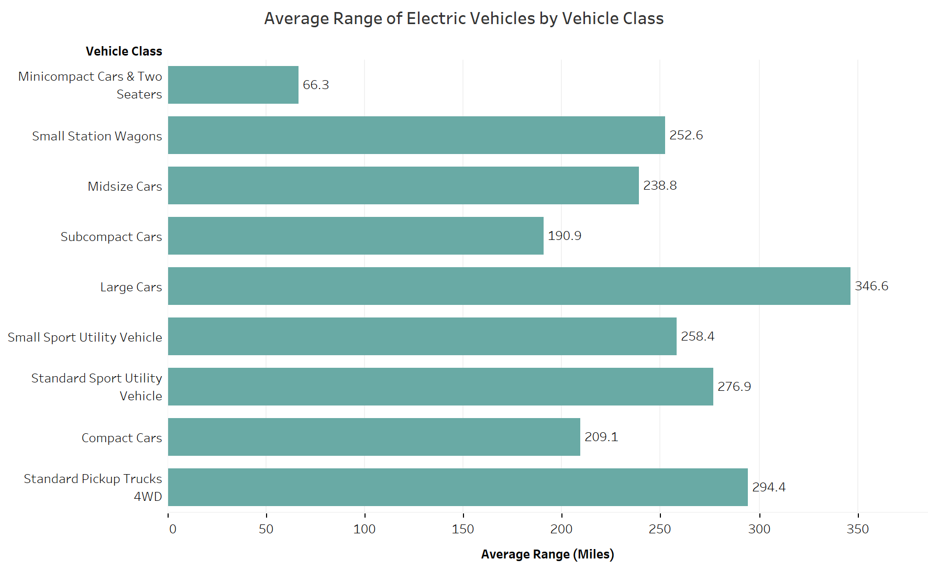

Even though minicompact cars and two-seaters are very fuel efficient, many potential buyers are concerned about their limited range. On the other hand, while standard pickup trucks might have a longer range, they may not be as fuel efficient. Choosing a mid-sized car might be a balanced option for consumers who do not want to compromise too much on either fuel efficiency or range.

All in all, understanding these comparisons can help consumers make informed decisions about which vehicle class best suits their lifestyle, budget, and commitment to environmental sustainability.

# **6. Conclusions and recommendations**

From the aforementioned findings, we recommend that individuals consider purchasing new electric vehicles. These vehicles offer better fuel efficiency than gasoline-powered or hybrid cars, as measured by a higher average fuel efficiency. This may ultimately result in significant cost savings in comparable situations. Moreover, reduced annual petroleum consumption contributes to more efficient environmental protection. This has resulted in the government’s commitment to developing charging infrastructure in both urban and rural areas (Loveday, 2023).

In addition, in the United States, several states provide incentives to promote EV adoption (Plug in America, 2023). For example, in Arizona, specific all-electric and plug-in hybrid vehicles qualify for a federal tax credit ranging from $3,700 to $7,500 (US Department of Energy, 2023). These incentives underscore the government's commitment to environmental sustainability and make EVs financially appealing to consumers.

Furthermore, the range of EVs has demonstrated significant increases over the years. This suggests that consumers will be able to travel for longer distances with less battery, especially in a smaller and lighter EV, which has better fuel efficiency than larger and heavier ones. Ultimately, the choice of EV class will depend on consumers’ lifestyle, budget, and commitment to environmental sustainability.

Overall, EVs are gaining traction in the automotive market due to their smaller environmental footprint and relative fuel efficiency. We anticipate a growing number of individuals opting for EVs, driven by both economic and environmental benefits recognized by consumers and governments worldwide.

**7. References**

ChatGPT. (2023, October 23). Help me create a logo of vehicle fuel. [Response to user question].

Retrieved from <https://chat.openai.com/>

The White House. (2023, April 17). *Fact sheet: Biden-Harris administration announces new*

*private and public sector investments for affordable electric vehicles.* The White House. <https://www.whitehouse.gov/briefing-room/statements-releases/2023/04/17/fact-sheet-biden-harris-administration-announces-new-private-and-public-sector-investments-for-affordable-electric-vehicles/>

Duffy, C. (2023, August 31). *Auto industry’s switch to EVs gets $12 billion in loans and*

*grants from the US energy department.* CNN Business.

[https://www.cnn.com/2023/08/31/cars/biden-evs-usde-billion-manufacturing/index.html#](https://www.cnn.com/2023/08/31/cars/biden-evs-usde-billion-manufacturing/index.html#:~:text=The%20funding%20pledge%20comes%20after%20the%20Biden%20administration,cars%20sold%20in%20the%20United%20States%20by%202032.)

[:~:text=The%20funding%20pledge%20comes%20after%20the%20Biden%20administrat](https://www.cnn.com/2023/08/31/cars/biden-evs-usde-billion-manufacturing/index.html#:~:text=The%20funding%20pledge%20comes%20after%20the%20Biden%20administration,cars%20sold%20in%20the%20United%20States%20by%202032.)

[ion,cars%20sold%20in%20the%20United%20States%20by%202032.](https://www.cnn.com/2023/08/31/cars/biden-evs-usde-billion-manufacturing/index.html#:~:text=The%20funding%20pledge%20comes%20after%20the%20Biden%20administration,cars%20sold%20in%20the%20United%20States%20by%202032.)

Romaine, J. (2021, April 15). *All new US vehicles could be required to be electric by 2035,*

*new study says.* The Hill. <https://thehill.com/changing-america/sustainability/energy/548394-all-new-us-vehicles-could-be-required-to-be-electric/#:~:text=1%20A%20new%20study%20by%20University%20of%20California%2C,to%20it%20as%20the%20primary%20use%20of%20transportation.>

Crownhard, C. (2022, December 22). *Why EVs won’t replace hybrid cars anytime soon*. Climate Change

and Energy.

[https://www.technologyreview.com/2022/12/22/1065830/why-evs-wont-replace-hybrid-cars-anyti](https://www.technologyreview.com/2022/12/22/1065830/why-evs-wont-replace-hybrid-cars-anytime-soon/)

[me-soon/](https://www.technologyreview.com/2022/12/22/1065830/why-evs-wont-replace-hybrid-cars-anytime-soon/)

Davey, R. (2023, January 30). *New developments in electric vehicle battery technology.* AZO CleanTech.

<https://www.azocleantech.com/article.aspx?ArticleID=1651>

US Department of Energy (2023, October). *Alternative fuel data center.* Energy Efficiency and

Renewable Energy. <https://afdc.energy.gov/vehicles/electric.html>

Loveday, S. (2023, January)*. A Comprehensive Guide to U.S. EV Charging Networks.* US News.

<https://cars.usnews.com/cars-trucks/advice/ev-charging-stations>

Plug in America (2023, May). *The EV Support Program gives current and prospective electric vehicle*

*drivers the support they need.* Plug in America.

<https://pluginamerica.org/learn/ev-support-program/>