

Temple University

College of Engineering

Bioengineering

Solutions
With all the earlier sections revised (depending on 1st paper notes and advisor notes) // dimensions are not changed yet
Partial Gravity Bioreactor
Presented By: Team #13
Dmitry M Hackel | Irene Bui
Jake Fisher | Zenub Abouzid

Supervised By:
Dr. Yah-el Har-el & Dr. Peter Lelkes
09 – 14 – 2025
Acknowledgment

We want to extend our most profound appreciation to the following individuals and organizations who have contributed to the completion of this project:

- Dr. Yar-el Har-el, for providing guidance and feedback throughout the course of this project through her professor and advisor roles.

- Dr. Peter Lelkes, a subject matter expert and our advisor, for providing valuable information and resources for our research.

- Dr. Jonathan Gerstenhaber, for providing valuable information, previous prototypes, and ideas that paved the way for the prototype.

- Brian Amin and Matthew Short, a previous team who completed a similar topic, for giving us the time to explain their prototype in more depth.

- Temple University, for providing access to their machines, labs, and space.

Additionally, we would like to express our gratitude to all those who have supported us in ways both seen and unseen. Without your contributions and presence, this project would not have been possible.

Thank you.

Abstract

The progress of human exploration to space, the Moon, and Mars is not considered safe because of the limited understanding of how partial gravity impacts human cells. This issue has not been fully addressed due to cost limitations and the difficulty of accurately simulating partial gravity on Earth. This project focused on developing a validated prototype for a partial gravity bioreactor. By successfully simulating the mathematical model and conducting tests to visually validate the prototype, the accuracy between the models can be determined.

Table of Contents
List of Acronyms/Abbreviations V
List of Figures I
List of Tables II
1. Problem Statement 1
1.1 Overall Objective 1
1.2 Background 2
1.3 Needs Statement 6
1.4 Implications of Project Success 6
2. Design Criteria 8
2.1 Non-Negotiable Criteria 8
2.2 Negotiable Criteria 10
3. Solutions 11
3.1 Solution A: Inclined Plane (Dual Motors) 11
3.2 Solution B: Random Positioning Machine 13
3.3 Solution C: Inclined Plane (Single Motor) 14
3.4 Decision Matrix 15
4. References 17
5. Supplementary Data 24
6. Supplementary Data References 27

List of Acronyms/Abbreviations

MOND | Modified Newtonian Dynamics
ACME | Advanced Combustion via Microgravity Experiments
NASA | The National Aeronautics and Space Administration
ISS | International Space Station
$0G$ | Zero Gravity
$$µG$$ | Microgravity
$$\frac{1}{6}G$$ | Lunar Gravity
$$\frac{3}{8}G$$ | Martian Gravity
$$1G$$ | Earth Gravity
RWV | Rotating Wall Vessel
UNSDG | United Nations Sustainable Development Goals
SDG | Sustainable Development Goals
DGD | Degree of Gravity Dispersion

List of Figures

Figure 1: Experimental Design for Simulated Partial Gravity Apparatus for Rats 3
Figure 2: Basic Bioreactor 4
Figure 3: 3D Clinostat 5
Figure 4: Partial Gravity Bioreactor 6
Figure 5: Inclined Plane Bioreactor with Dual Motors 12
Figure 6: Rough Sketch of Inclined Plane with Dual Motors 12
Figure 7: RPM-2.0 AIRBUS 13
Figure 8: Rough Sketch of RPM 14
Figure 9: Rough Sketch of Inclined Plane with Single Motor 15

List of Tables

Table 1: Non-Negotiable Needs 9
Table 2: Negotiable Needs 10

Problem Statement

Overall Objective

Since the 1960s, space exploration has yielded intriguing discoveries that continue to unfold over time. Yuri Gagarin became the first human in space in 1961, paving the way for thousands of astronauts and cosmonauts to follow him as the years passed [1]. Various theories have been proposed based on space, including the Croatian Barrel Theory, which explains how the solar system, stars, and other celestial bodies formed [2][3]. In 2002, research refuted the theory that gravity alone governs the universe, as it could not explain specific astronomical observations [4]. Sanders and McGaugh modified Newtonian gravity as an alternative to cosmic dark matter, known as Modified Newtonian Dynamics (MOND), correlating a relationship between the acceleration from Newtonian gravity and the observed acceleration at any radius in a galaxy [5][6].

Exploring space not only reveals discoveries beyond our planet, but it also uncovers truths that enhance and govern our lives. Advanced Combustion via Microgravity Experiments (ACME) investigates fuel efficiency and pollutant production in combustion under microgravity conditions on Earth [7]. One of their investigations, Flame Design, studied the quantity of soot produced under different flame conditions [7]. Such a discovery could lead to more efficient combustion, reducing pollution on Earth [7]. In the ongoing Moon exploration, researchers found that the Moon's gravity affects Earth’s tides, plant growth, animal behavior, and agricultural practices [8]. Moreover, models have shown that the Earth-Moon coupled magnetospheres provide a buffer against the solar wind, allowing for a reduction in Earth’s atmospheric loss to space [9]. The National Aeronautics and Space Administration (NASA) has been exploring Mars for over sixty years to decide whether it is or was a habitable world [10]. Since Mars is the most similar planet to Earth in the Solar System, understanding its surface and evolution is crucial for preparing for future human exploration [11]. With evidence suggesting that Mars was once full of water, warmer, and had a thicker atmosphere, it is highly likely that Mars could be a habitable environment [11].

Traveling beyond Earth’s atmosphere to investigate potential extraterrestrial life entails considerable risks and substantial financial investment. Considering that human physiology is heavily dependent on gravity, any significant fluctuations in gravitational force may lead to serious health issues [12]. Gravity, as a vector quantity, influences all objects by determining their weight relative to their mass [13]. Biological organisms respond to environmental stimuli—including gravity—by developing unique morphological traits, physiological characteristics, behaviors, and habitat preferences [13]. The sensitivity of organisms to changes in gravity increases with their size and mass, with single cells enduring exposures up to 10⁵G and humans tolerating gravitational forces of 4-5G [13]. At the cellular level, cells comprise organelles, each with mass and thus subject to gravitational forces [14]. Variations in gravitational vectors could disrupt cellular homeostasis, affecting structural integrity, composition, and orientation, such as the cytoskeleton, which maintains cellular shape [14]. Additionally, numerous studies have documented genes exhibiting sensitivity to gravity alterations, including modifications in cytoskeletal gene expression pathways and gene inhibition following microgravity exposure [15][16]. In the absence of gravity, cellular growth pathways shift, and metabolic processes adapt due to changes in reactive oxygen species levels [17][18]. Furthermore, cellular adaptation to gravity is vital for tissue adaptation, with bones containing osteocytes that sense and respond to varying gravitational loads [13].

Such cellular changes impact the entire human system. Astronauts exposed to microgravity undergo physiological deconditioning in systems sensitive to mechanical loading, including the cardiovascular, pulmonary, and musculoskeletal systems [19]. To mitigate these effects, International Space Station (ISS) crew members engage in rigorous exercise; however, despite extensive physical activity, astronauts still return from their six-month ISS missions exhibiting decreased calf muscle volume and strength, loss of bone mineral density, and reduced peak oxygen uptake [20][21][22][23].

Given that, it is highly unethical to send people into space without understanding the effects of gravitational changes on the body. This paper discusses a validated proposed prototype of a device that cultures cells under the influence of partial gravity and microgravity, enabling the correlation of specific cell behaviors with gravitational differences.

Background

Understanding the effects of partial gravity on humans is less extensively studied due to the high costs associated with conducting tests in partial or microgravity environments. Between 1960 and 1973, the research experience and studies gained during the Apollo missions—focused on lunar exploration—provided valuable insights into the diverse effects of partial gravity on the human musculoskeletal, cardiovascular, and respiratory systems, employing either microgravity or Earth’s gravity as controls [24][25]. However, the Apollo missions cost approximately $25.4 billion in 1969, equivalent to roughly $217 billion in 2024 [26]. Following these missions, despite the lack of subsequent lunar landings, the failures in early missions facilitated advancements in spacecraft design, including the incorporation of additional protective layers and the development of new, safer materials, alongside the integration of computer systems for troubleshooting purposes [27]. In 2019, the health impacts of a year-long space mission were examined at the molecular and psychological levels by comparing the DNA sequences of twin brothers—Mark and Scott Kelly—with Mark Kelly remaining on Earth, serving as the control, and Scott Kelly participating in spaceflight [28][29]. The study revealed that extensive multisystem and gene expression changes occur during spaceflight [28]. Astronauts may face risks including mitochondrial dysfunction, immunological stress, vascular modifications, fluid shifts, and cognitive performance decline, along with alterations in telomere length, gene regulation, and genome integrity [28].

Given the expenses and decommissioning of the ISS, researchers endeavored to replicate partial gravity conditions on Earth, such as employing a pulley-spring system to simulate partial gravity for rodents (refer to Figure 1) [23][30]. However, a limitation of the apparatus was that only the tail was suspended rather than the entire body, resulting in a weight shift within the rodent’s body and thus failing to provide a truly accurate simulation [30].

Figure 1: Experimental Design for Simulated Partial Gravity Apparatus for Rats

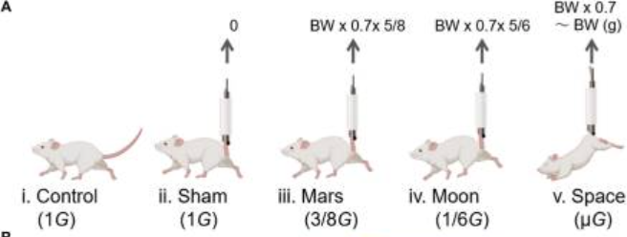

Figure 1 shows the groups of experimental rats with the Control group ($1G$) (i); the sham group with SA ($1G$) (ii); the Mars group ($\frac{3}{8}G$) (iii); the Moon group ($\frac{1}{6}G$) (iv); and the interplanetary space ($µG$) group (v) [18].

The effects of gravity on an object may manifest as either displacement or deformation [31]. Microgravity creates distinctive environments conducive to cell growth, whereas partial gravity (such as on the Moon and Mars) may yield markedly different effects [32]. To comprehensively understand the concepts related to partial gravity apparatuses, it is imperative to distinguish between zero gravity, gravity, microgravity, and partial gravity. Gravity is an abstract phenomenon that can be quantified; however, its fundamental cause remains unknown [33]. The gravitational constant is not a force or acceleration but is employed as a scaling factor in Newton's Law of Gravitation, as demonstrated in Equation 1 [33][34].

Equation 1: Gravitational Force Equation
$$F=\frac{Gm_{1}m_{2}}{r^{2}}$$
$F$ is the magnitude of the gravitational force acting between masses $m_{1}$ and $m_{2}$separated by distance [33]. $G$ is a universal constant with a value of $6.67384*{10}^{-11} \frac{m^{3}}{\frac{s^{2}}{kg}}$ [34].

Zero gravity ($0G$) describes a condition where there is an absence of gravitational force exerted on an object, which occurs either due to its infinite distance from any other gravitational body or when the net sum of all forces acting upon it equals zero [35]. Microgravity ($μG$) pertains to a state in which the net gravitational force exerted on an object is minimal, typically within the range of ${10}^{-4}$ to ${10}^{-6}G$ [36]. Although the object remains influenced by gravitational forces, it undergoes continuous free fall [36]. This perpetual free fall occurs when the object falls at a constant velocity but does not contact a surface [36]. As a result, the difference between the initial and final velocities manifests as a constant acceleration ($g$) [36]. Partial gravity refers to a gravitational force that is diminished but not absent compared to Earth's gravitational acceleration, such as on the Moon, where gravity is approximately $\frac{1}{6}G$, on Mars $\frac{3}{8}G$, and on Earth$1G$ [29]. On Earth, the simulation of partial gravity can be achieved through techniques such as centrifugation, parabolic flight, or modified rotation devices that generate acceleration less than $1g$ [37].

To investigate gravitational effects, cell culturing is regarded as the most efficacious method, with bioreactors serving as the optimal apparatus, given their ability to supply controlled nutrients and biomimetic stimuli for cellular growth [38]. A bioreactor is defined as a vessel in which a chemical process involving organisms or biochemically active substances derived from such organisms is conducted, or a system designed for cell cultivation, first developed in 1964 (refer to Figure 2) [39].

Figure 2: Basic Bioreactor
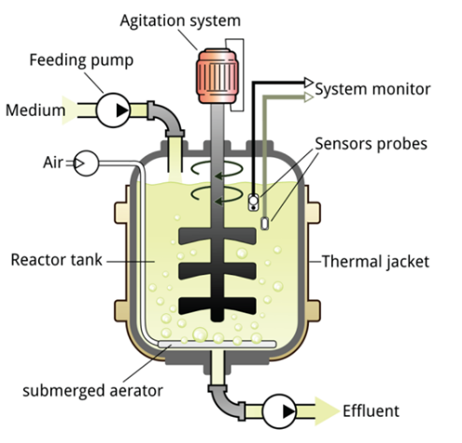
Figure 2 shows the basic bioreactor components. It includes a feeding pump, air, medium, agitation system, reactor tank, and other elements to ensure an automated culturing system [39].

Previous bioreactors were designed as ground-based systems to mimic aspects of weightlessness or reduced gravity experienced by biological organisms in space. Recognizing this potential, in the mid-1980s, NASA researchers at Johnson Space Center needed to develop a way to study the effects of microgravity on human tissues as the shuttle fleet was grounded after the Challenger disaster [40]. They invented a rotating bioreactor to address the challenge of treating injured astronauts in space and to simulate weightlessness on Earth [40]. In $μG$, the bioreactor allows cells to grow in three-dimensional tissue structures that closely resemble natural development, aiding advances in medicine both on Earth and in space [40]. In 2002, Houston-based Regenetech Inc. licensed NASA bioreactor technology and patents that can expand adult stem cells (from blood to bone marrow) by 50-200 times in less than a week, providing safer, faster, and more affordable cell sources for therapies [40].

Partial gravity bioreactors, although not extensively studied, have been previously examined. Research dating back to the 1900s has investigated the effects of clinostats, or rotating wall vessels, on biological samples [41]. Clinostats were invented by Julius Sachs, who rotated growing plants around their growth axis [41]. These devices exist in one-dimensional (1-D) or two-dimensional (2-D) forms, depending on the dimensions of the rotated axial line or the entire experimental area [42]. Subsequently, enhancements to the clinostat with two axes led to the development of three-dimensional (3-D) clinostats, known as the Random Positioning Machine (RPM) (refer to Figure 3) [42][43].

Figure 3: 3D Clinostat

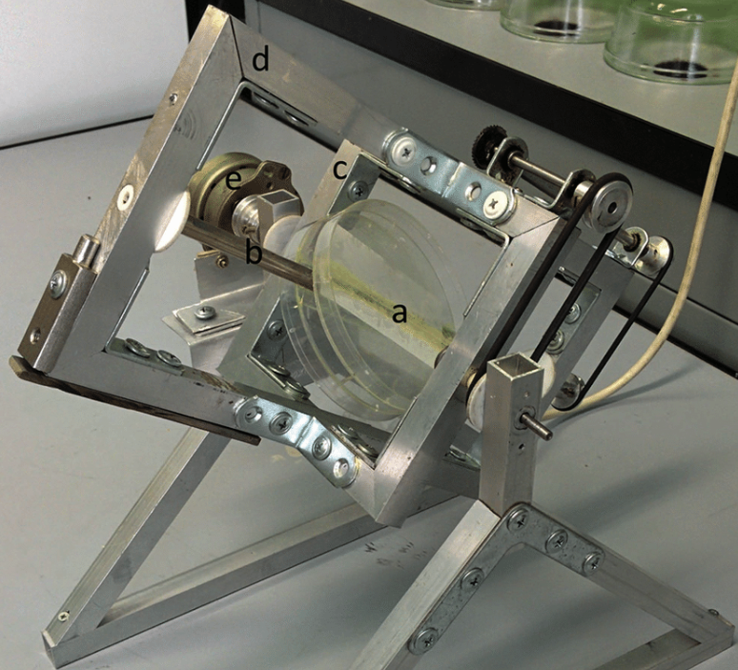

Figure 3 depicts a three-dimensional clinostat employed to investigate the effects of microgravity on seed germination: a, insert for Petri dishes; b, rotating shaft; c, inner frame; d, outer rotating frame; e, motor [43].

Numerous early-stage partial gravity bioreactors have been investigated using plant species capable of continuous growth under Earth's gravitational forces [44]. Initial implementations included clinostats, which maintain a constant rotation of a sample to effectively average the gravitational vector to near zero [41]. This form of a partial gravity bioreactor does not fully replicate “true” microgravity, as cells continue to experience mechanical stimulation and gradients that differ from actual microgravity conditions [41]. Subsequently, rotating wall vessel (RWV) bioreactors were introduced as a specialized variant of clinostats [41]. RWVs are fluid-filled cylinders containing cells, designed to create a low-shear, controlled environment conducive to cellular differentiation in three-dimensional space [45]. By rotating at a terminal velocity, RWVs facilitate proper nutrient delivery to the tissue culture, thus promoting healthy tissue and cell growth [45]. In 2018, a previous senior design team utilized the stability of RWVs for cell culturing while incorporating the partial gravity factor using an inclined plane to partially cancel the gravitational vector, allowing cells to experience a form of partial gravity (refer to Figure 4).

Figure 4: Partial Gravity Bioreactor

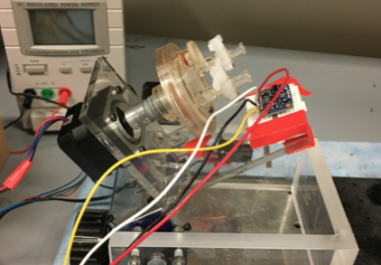

Figure 4 depicts the prototype of a partial gravity bioreactor, designed by an earlier senior design team. It comprises a Rotating Wall Vessel (RWV) affixed to an inclined plane that simulates partial gravity.

Needs Statement

Building a partial gravity cell culturing prototype would enable the study of the relationship between cell properties and different gravitational environments, therefore allowing for correlation between gravitational differences and cell properties.

Implications of Project Success

In the event of the prototype's success, both terrestrial and extraterrestrial life would benefit significantly. Comprehending the effects of varying gravitational conditions on cellular behavior would facilitate more precise conclusions regarding human space exploration. Such findings would underpin the development of solutions aimed at safeguarding human safety beyond Earth. Facilitating human travel to outer space, including destinations such as Mars and the Moon, enhances our knowledge of extraterrestrial regions and addresses fundamental questions concerning alien life forms. Additionally, this research has the potential to identify new planets or locations in space where humans might establish a new life.

The success of the prototype closely correlates with several United Nations Sustainable Development Goals (UNSDGs) [46]. SDG 3: Good Health and Well-being is supported, as the device facilitates controlled studies on how partial gravity influences cellular development, physiology, and long-term health in space [47]. By understanding these effects, the prototype can inform the design of countermeasures, treatments, and potentially therapeutic approaches for conditions such as bone loss and muscle atrophy, which are of critical concern for astronauts [28]. Accordingly, the prototype would contribute to ensuring healthy lives for humans [47]. Furthermore, the prototype advances SDG 12: Responsible Consumption and Production through the implementation of a closed-loop biological system, an approach essential for sustainable space habitats and beneficial for the efficient utilization of resources on Earth [48]. The use of a bioreactor enhances system control in cultivating cells, enabling accurate, real-time monitoring, early problem detection, reproducibility, and cost efficiency [49]. In this context, SDG 13: Climate Action is addressed by demonstrating how biological systems adapt to extreme and changing environments, thereby informing strategies for ecosystems on Earth [50]. Lastly, SDG 9: Industry, Innovation, and Infrastructure is pertinent, as the development of the prototype signifies an innovative research platform that represents the convergence of biotechnology and space technology [51].

Design Criteria
To guarantee the feasibility of the prototype, the design criteria are classified as either non-negotiable (mandatory) (refer to Table 1) or negotiable (desirable) (refer to Table 2). However, owing to the complexity of the project, these criteria are divided into two primary domains: partial gravity and the prototype.

Non-Negotiable Criteria

Four criteria must be satisfied to deem the partial gravity component in the project successful: gravitational type, simulation, visual validation, and movement.

Gravitational Type: With NASA deorbiting the ISS, the ability to conduct experiments in the unique microgravity laboratories would be impossible [52]. Therefore, gravitational experiments conducted on Earth should encompass the primary missions previously planned. According to NASA, traveling to the lunar surface and around the Moon would facilitate scientific discoveries that prepare humans for subsequent exploration, including Mars [53]. As the Moon and Earth represent the two most significant gravitational environments, lunar gravity ($\frac{1}{6}G$) and Martian gravity ($\frac{3}{8}G$) warrant careful consideration [54]. To obtain more accurate data, Earth’s gravity ($1G$) and microgravity ($μG$) should also be included to ensure that the same cells are subjected to all gravity levels and to serve as references for previous experiments [54][55].

Movement: To cultivate cells effectively, the partial gravity method should not present any issues for cell culture practices. Given the high sensitivity of cells to their environment, the technique employed to simulate partial gravity must prevent excessive vibrations or inconsistent cell motion [56]. To accomplish this, the procedure for attaining different gravitational levels should function smoothly, enable cells to undergo free fall, and simultaneously minimize shear stress on the cells, maintaining these conditions continuously.

Simulation: The partial gravity effect on cells has not yet been observed or tested. However, visualizing gravity is not applicable, since gravity is a theory [57]. Utilizing mathematics, fluid mechanics, and particle mechanics, a mathematical model should be developed for partial gravity.

Validation: Since models are simplified representations of the systems studied, models, to a degree, are all incorrect at least in some details [58]. Therefore, visualizing the specimen would provide further insight into the accuracy of the model and constitutes a form of validation. It is necessary to visualize the specimen under different gravitational levels to ensure the model's accuracy.

Three criteria should be met to consider the prototype successful: size, material, and specimen culturing stability.

Size: Since the prototype's placement may be limited to the incubator, its overall dimensions are also constrained. The Nuaire NU-5810E incubator is considered the most suitable and effective location based on previous designs because it operates at 37°C with 98% humidity [59]. The maximum size of the prototype is limited by the incubator's internal capacity, which measures $21 × 20 × 20.8 in$.

Material: Given the potential placement of the prototype within an incubator, the selected materials must endure both room temperature and 37°C, in addition to 98% humidity [59]. Furthermore, the prototype is anticipated to maintain stability for at least four months.

Stability of the Specimen Culturing Component: Considering that the prototype integrates the cell culturing component and motion system responsible for partial gravity simulation, it is imperative that the attachment of the cell culturing component to the prototype's framework is secure to ensure precise results, given the sensitivity of cells to their environment [56]. Throughout any movement induced by the partial gravity simulation, the cell culturing section must remain stable; that is, it should neither wobble nor detach.

Table 1: Non-Negotiable Needs

Priority | Requirement | Metric | Target Values/ Range or Pass/Fail | Justification
Non-negotiable | Gravitational Type | Partial Gravity and Controls | Range: $μG$to 1$G$  Lunar gravity ($\frac{1}{6}G$)  Martian gravity ($\frac{3}{8}G$)  Earth’s gravity ($1G$)  Microgravity ($μG$)  [54][55] | NASA’s Goals [53]
Non-negotiable | Partial Gravity Movement Causes Steady Flow | Partial Gravity Accuracy | Pass/ Fail Using Model and Visuals | Inaccuracy of data due to cell sensitivity [56]
Non-negotiable | Simulation | Mathematical Model | Pass/ Fail | Accuracy and Validation
Non-negotiable | Validation | Visual | Pass/ Fail | Accuracy and Validation of Model [58]
Non-negotiable | Size | Dimensions | $$21 × 20 × 20.8 in$$ | Nuaire NU-5810E Incubator Restricted Area [65]
Non-negotiable | Material | Strength and Durability | Pass/ Fail to withstand room temperature and 37°C, along with 98% humidity  [59] | Project Duration
Non-negotiable | Cell Culturing Component Stability | Stability | Pass/ Fail of component wobbling/detachment | Inaccuracy of data due to cell sensitivity [56]
Table 1 delineates the seven non-negotiable criteria essential for the validation of the prototype. Regarding partial gravity, the requirements encompass gravitational type, simulation, partial gravity movement, and verification processes. Concerning the prototype, the criteria related to the base and partial gravity—such as size, material, and the stability of cell culturing components—are considered fundamental. Additionally, the metric, target range, and justification for each criterion are systematically provided.

Negotiable Criteria

Regarding the negotiable criteria, four factors have the potential to enhance the prototype if they are duly implemented. Firstly, the integration of an automated imaging system for cellular analysis would enable users to evaluate the cell culture comprehensively and acquire more profound insights into cellular interactions across various temporal stages. Secondly, the advancement of mathematical models into computational simulations would facilitate a more detailed understanding of the fluid dynamics affecting the cells. Thirdly, incorporating a broader spectrum of gravitational conditions would allow for a more precise simulation of human body movements, from Earth to extraterrestrial environments. Lastly, cultivating the cells would ensure that the prototype is suitable for cell culturing, with a cell viability exceeding 80%, in accordance with ASTM F2739-19 [60][61].

Table 2: Negotiable Needs

Priority | Requirement | Metric | Target Values/ Range or Pass/Fail | Justification
Negotiable | Automated Imaging System | Data Tracking | > 30 FPS | To record the cell’s activity during culturing
Negotiable | Computational Models | Modeling Accuracy | Pass/ Fail | To have a more sophisticated model for partial gravity
Negotiable | Broader  Range of Gravitation | Partial Gravity and Controls | More than three partial gravities achieved | To include minimal gravitational changes during spaceflight
Negotiable | Cell Culturing | Validation | Cell Viability >80% [60] | ASTM F2739-19 [61]

Table 2 delineates the four negotiable criteria for the enhancement of the prototype. These criteria encompass an automated imaging system, the development of computational models, an expanded gravitational environment, and cell culturing. The table supplies the metric, target range, and justification for each criterion.

Solutions
The project concentrates on validating partial gravity, which involves ensuring that the tested specimen experiences the intended level of partial gravity. Cell culturing methodologies will not be addressed. To eliminate any effects attributable to cell culturing, the same culturing component will be employed across all proposed solutions.

Bioreactors are the predominant method utilized in cell cultivation due to their capability to sustain biologically active environments and to regulate parameters such as pH, temperature, oxygen tension, media perfusion rate, as well as their capacity to apply external stimuli [62]. Various types of bioreactors exist, including wave motion, stirred tank, and rotating wall vessels (refer to Supplementary Table S 1) [63]. Since cells are susceptible to mechanical stresses such as shear forces and microfluidic flow, which may result in cellular structural failure and reduced viability, the selection of a bioreactor should be based on its ability to exert minimal shear stress on the cells [64]. Cells cultured in microgravity and ground-based microgravity analogs present a low-shear stress environment suitable for cell cultivation [65]. Although rotating wall vessels (RWVs) are effective at small volumes (<10L), they are capable of simulating microgravity with low turbulence and minimal impact [63].

Given the bioreactor employed for cell cultivation, three potential solutions for addressing partial gravity are examined.

Solution A: Inclined Plane (Dual Motors)

The proposed solution entails the enhancement of an existing design through the development of the partial gravity prototype using an RWV on an inclined plane, equipped with a dual-motor system (refer to Figure 5). The use of the inclined plane was previously studied and found to be a successful simulation of lunar gravity [66]. The design consists of three components: a foundational structure, a component that securely holds the bioreactor along with the motor responsible for generating rotational force, and a final system designed to adjust the angle of the motor and bioreactor to simulate partial gravity.

The base will be constructed as a rectangular structure capable of supporting the bioreactor assembly with stability and durability. The main section of the RWV will include a motor attached to the bioreactor to enable rotation, and this assembly will be mounted to the system that adjusts the bioreactor's angle. Next, a camera will be mounted on the same part of the device to accurately simulate the bioreactor's angle and allow monitoring of the cells during their rotation within the RWV. For the final part, a secondary motor capable of adjusting to various angles will be used, and it will have an attachment to the bioreactor system. The secondary motor should be able to set angle variations at least at four different positions to mimic the following gravitational conditions: $1G$, $\frac{3}{8}G$, $\frac{1}{6}G$, and $µG$. The rough sketch of the proposed solution is seen in Figure 6.

These improvements to the current designs enhance the ability to validate the actual generation of partial gravities. The addition of a camera will enable real-time, accurate observation of cell reactions. Furthermore, this design provides a means for validation through modeling and mathematical analysis to confirm that this configuration produces the desired partial gravity effect for RWV.

Figure 5: Inclined Plane Bioreactor with Dual Motors

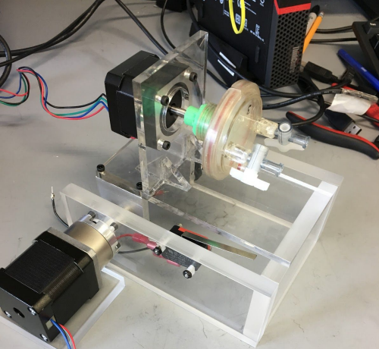

Figure 5 depicts the inclined plane bioreactor, designed by the previous senior design team, is displayed. Utilizing two motors and an inclined plane, the previous team simulated partial gravity.

Figure 6: Rough Sketch of Inclined Plane with Dual Motors
I.  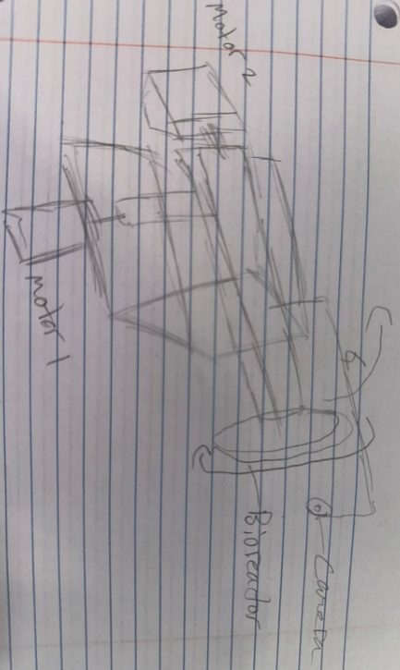 | II.  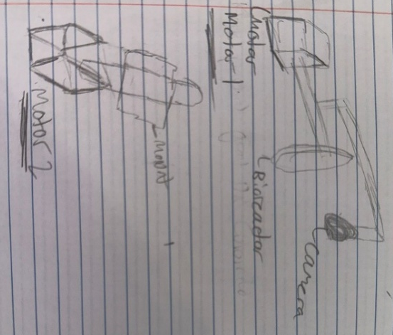

Figure 6 depicts the preliminary design of Solution A, which involves an inclined plane equipped with a dual motor system. The figure on the left (I) provides a schematic overview of the prototype configuration, featuring two motors: Motor 1, responsible for adjusting the incline, and Motor 2, designated for rotating the bioreactor. The figure on the right (II) presents a detailed, close-up view of the motor independently.

Solution B: Random Positioning Machine

This solution represents a differential construction of a three-dimensional clinostat featuring two independently rotating frames, mounted at perpendicular angles to each other [35]. Both frames operate at separate or constant speeds and directions to create a randomized positioning environment [67]. When the movement is genuinely random with zero eccentricity, it enables complete randomization conducive to establishing a microgravity environment [67]. Theoretically, variations in eccentricity and orientation distribution across a spheroid can yield a partial gravity environment akin to the forces experienced on the Moon or Mars [68].

Nonetheless, NASA does not employ random positioning machines to generate partial gravity environments. Instead, theoretical models have been developed to simulate planetary hypo-gravity (for Earth and Mars) via independently rotating frames, which disperse the gravitational vector rather than eliminate it [69]. To emulate these gravitational forces on biological specimens, a new parameter termed the "degree of gravity dispersion" (DGD) was introduced [69]. This approach involves novel angular velocity control methods, including linear sawtooth and parabolic sawtooth patterns, designed to prevent trajectory repetition from producing uniform gravitational forces on the bioreactor [69]. While this has been mathematically validated, its practical application and efficacy in cell culture remain to be thoroughly examined [69].

The RPM-2.0 AIRBUS indeed provides micro- and partial gravity environments for industrial purposes; however, although it states the capacity to simulate partial gravity, it has only been documented to test such environments on biological plant cells (refer to Figure 7) [70]. The proposed solution should include the same aspects of the RPM with different parameters in rotation to mimic the following gravitational conditions: $1G$, $\frac{3}{8}G$, $\frac{1}{6}G$, and $µG$ (refer to Figure 8).

Figure 7: RPM-2.0 AIRBUS
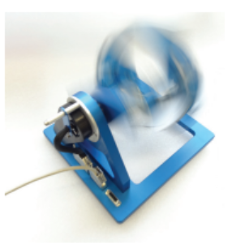
Figure 7 illustrates the RPM-2.0 Airbus model rotating along two axes.

Figure 8: Rough Sketch of RPM

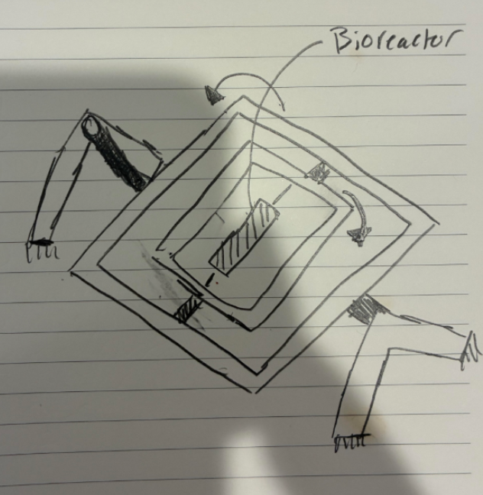

Figure 8 represents the preliminary sketch for the RPM. The bioreactor is centrally positioned and connected to the initial set of rotational axes via a rod. These two axes rotate to eliminate gravitational vectors.

Solution C: Inclined Plane (Single Motor)

This proposed solution delineates the utilization of an inclined plane single motor bioreactor, equipped with an integrated webcam monitoring system, as an innovative approach for enhancing the efficiency of cell culture processes. The system is engineered to optimize mixing, oxygen transfer, and gentle agitation—all vital for the proliferation of cells in suspension under partial gravity conditions. These hydrodynamic parameters can be quantitatively characterized using the specific power input (P/V), which correlates motor power with culture volume and serves as an essential metric to ensure proper mixing while preventing excessive shear forces. By maintaining P/V within the ranges established for mammalian and microbial culture systems, the design endeavors to balance nutrient and gas transfer requirements with the safeguarding of sensitive cell cultures [72].

Environmental control is managed via two strategies. The primary method involves operating within a standard CO₂ incubator, utilizing its inherent regulation of temperature, humidity, and gas composition [61]. Culture conditions can be monitored using sterilizable or optical sensors for temperature, pH, and dissolved oxygen, with all data and imaging consistently logged through a microcontroller.

For real-time visualization, the system will incorporate a webcam with adjustable focus and LED illumination to ensure uniform brightfield imaging. To maintain consistent image quality during bioreactor operation, the webcam shall be mounted directly onto the rotating vessel assembly, thereby following the vessel’s motion and changes in orientation. This methodology guarantees that the camera sustains a constant field of view relative to the culture. The camera is affixed using a gimbal-like system, which permits the lens to remain aligned with the observation window throughout the entire range of vessel motion.

The control of the bioreactor is overseen by a microcontroller platform, such as Arduino, which regulates motor speed, acquires sensor data, and operates the camera. Data logging facilitates the export of sensor readings and image sequences for subsequent analysis. Safety features comprise over-current protection, temperature cutoffs, and emergency stop mechanisms to ensure the safety of both the vessel and the cultural contents.

The operation of rotation and tilt utilizing a single motor can effectively facilitate controlled vessel rotation; however, it demonstrates limited flexibility in adjusting the vessel's angle. In the simplest configuration, the motor drives the vessel at a fixed RPM while the axis of rotation remains stationary, with the angle relative to gravity mechanically pre-set on the mounting frame. This configuration indicates that the speed and angle cannot be adjusted simultaneously, as the motor can execute only one function at a time. More sophisticated systems, such as differential gears, could be implemented; nonetheless, these systems introduce additional mechanical complexity, thereby reducing overall efficiency [72]. A rough sketch of the solution is seen in Figure 9.

Figure 9: Rough Sketch of Inclined Plane with Single Motor

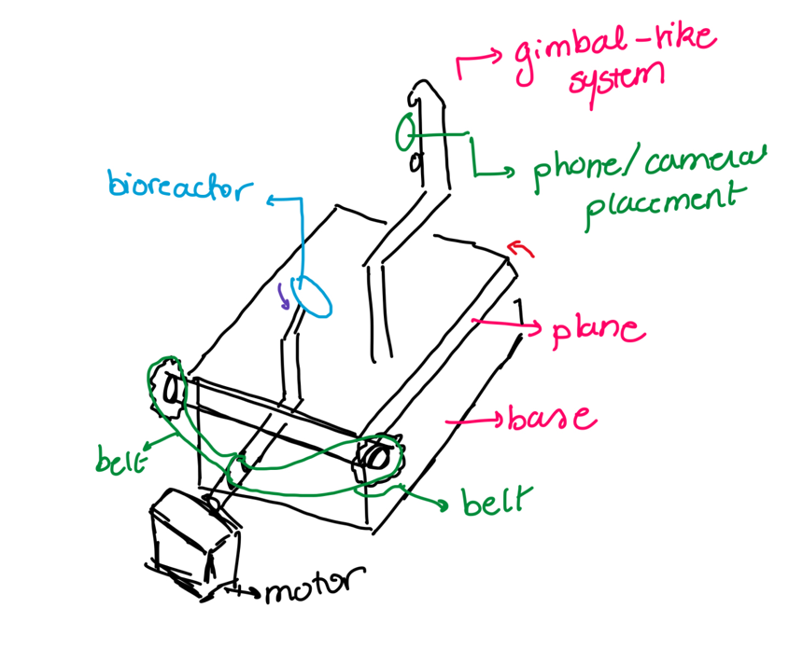
Figure 9 illustrates the preliminary sketch for the single-motor inclined plane. The bioreactor is connected to the motor via a tube, and an additional connection between the motor and the rod for the incline is facilitated through belts on gears.

Decision Matrix

Choosing the right approach for the partial gravity bioreactor involves considering several factors, like design time, cost, feasibility, and cell viability. Since each of the three options has its own pros and cons, a weighted comparison is essential to identify the best solution. A prioritization (weighted decision) matrix is used to evaluate the options based on the predefined criteria [73].

The three distinct options under comparison include the inclined plane design with dual motor (designated as Solution A), the random positioning machine (designated as Solution B), and the inclined plane design with a single motor (designated as Solution C).

The initial criteria to consider are the non-negotiable criteria. The primary criterion is the gravitational type (refer to Table 1). Since the main objective is to attain $\frac{1}{6}G$, $\frac{3}{8}G$, $1G$, and $μG$ to verify the locations' gravitational properties that NASA is reluctant to explore, the gravitational type criterion is assigned a weight of 5 points [54][55]. As this criterion necessitates simulations and theoretical applications, including fluid dynamics and additional disciplines, the ranking is based on whether such gravitational values have been tested in other experiments or through direct mathematical computations. A rank of 1 indicates minimal or no citations, whereas a rank of 3 signifies a higher citation count. The ranking process is conducted for each of the gravitational targets.

The second criterion pertains to simulation (refer to Table 1). With gravity, validation is predicated on mathematical principles and their influence on an object, given that gravity is a theoretical framework [57]. In this context, the essential criterion stipulates that the method's partial simulation of gravity does not increase shear forces nor interfere with fluid flow, which cannot be validated without simulation. Consequently, the mathematical simulation criterion is given 4 points. The ranking of this criterion is determined by its complexity, with 1 indicating the most complex and 3 the least complex.

The third criterion is visual validation (refer to Table 1). To confirm that the mathematical simulation accurately represents the system, the visual validation is assigned a weight of 3. The ranking of this criterion depends on the quality of specimen visualization, with 1 indicating difficulty in visualizing the specimen and 3 indicating clear visualization.

The fourth criterion pertains to dimensions (refer to Table 1). When the device is positioned within the incubator, its size is constrained by the dimensions of $21 × 20 × 20.8 in$. Nevertheless, because the design is heavily dependent on the type of bioreactor employed, and considering the restriction on dimension ranking, a score of 2 points is awarded. Consequently, this criterion is evaluated based on the probability of space utilization, with a ranking of 1 indicating significant spatial occupation and a ranking of 3 indicating minimal space consumption.

The final criterion pertains to the design timeline. Given that the project is mandated to be finalized within three months, the proposed solution must be completed within this timeframe. Nonetheless, due to the dependency of materials used in the device on the procurement schedule and supply arrivals, this criterion is assigned a weight of 2 points. The ranking for this criterion is determined by the ease with which the project can be replicated, with a score of 1 indicating a prolonged or unprecedented process, and a score of 3 signifying a swift completion. With the criteria established, the decision matrix is identified (refer to Supplementary Table S 2).

References
- “April 1961 - First Human Entered Space - NASA,” NASA. Available: https://www.nasa.gov/image-article/april-1961-first-human-entered-space/
- “Croatian Barrel Theory,” Google Books. Available: https://books.google.com/books?hl=en&lr=&id=6fpgEQAAQBAJ&oi=fnd&pg=PR3&dq=why+are+the+rings+around+the+planets+for&ots=6NYg8vGXx7&sig=fDnYWiJSO_0-C7OTs6DVDOnjzG8#v=onepage&q=why%20are%20the%20rings%20around%20the%20planets%20for&f=false
- “Croatian Barrel Theory | Miro (Mike) Laus,” Mike Laus. Available: https://www.miromikelaus.com/#:~:text=Grounded%20in%20Laus%E2%80%99s%20cultural%20heritage%2C%20the%20Croatian%20Barrel,system%2C%20with%20celestial%20bodies%20emerging%20at%20varying%20times.
- A. May, “10 Wild Theories About the Universe,” Live Science, Jul. 16, 2021. Available: https://www.livescience.com/strange-theories-about-the-universe.html
- R. H. Sanders and S. S. McGaugh, “Modified Newtonian Dynamics as an Alternative to Dark Matter,” Annual Review of Astronomy and Astrophysics, vol. 40, no. 1, pp. 263–317, Sep. 2002, doi: 10.1146/annurev.astro.40.060401.093923. Available: https://doi.org/10.1146/annurev.astro.40.060401.093923
- B. Famaey and A. Durakovic, “Modified Newtonian Dynamics (MOND),” arXiv.org, Jan. 28, 2025. Available: https://arxiv.org/abs/2501.17006
- NASA, “Studying Combustion and Fire Safety - NASA,” NASA, Mar. 07, 2024. Available: https://www.nasa.gov/missions/station/iss-research/studying-combustion-and-fire-safety/
- Gullari, Jeevan Kumar. (2025). The Impact of Moon Phases on Earth, Plants, and Humans: A Comprehensive Study from Project Alpha. 10.13140/RG.2.2.12235.71203. Available: https://papers.ssrn.com/sol3/papers.cfm?abstract_id=5090101
- J. Green, D. Draper, S. Boardsen, and C. Dong, “When the Moon Had a Magnetosphere,” Science Advances, vol. 6, no. 42, Oct. 2020, doi: 10.1126/sciadv.abc0865. Available: https://pmc.ncbi.nlm.nih.gov/articles/PMC10763664/
- A. Cermak, “Mars Exploration - NASA Science,” NASA Science, Aug. 01, 2025. Available: https://science.nasa.gov/planetary-science/programs/mars-exploration/
- “Why Go to Mars?” Available: https://www.esa.int/Science_Exploration/Human_and_Robotic_Exploration/Exploration/Why_go_to_Mars#:~:text=The%20scientific%20reasons%20for%20going%20to%20Mars%20can,beyond%20Earth%20is%20a%20fundamental%20question%20of%20humankind.
- J. T. Fisher, U. Ciuha, P. Denise, A. C. McDonnell, H. Normand, and I. B. Mekjavic, “The Combined Effects of Artificial Gravity, Temperature, and Hypoxia on Haemodynamic Responses and Limb Blood Flow,” European Journal of Applied Physiology, Apr. 2025, doi: 10.1007/s00421-025-05773-7. Available: https://doi.org/10.1007/s00421-025-05773-7
- S. A. Narayanan, “Gravity’s Effect on Biology,” Frontiers in Physiology, vol. 14, Jul. 2023, doi: 10.3389/fphys.2023.1199175. Available: https://pmc.ncbi.nlm.nih.gov/articles/PMC10351380/
- E. R. Morey-Holton, “The Impact of Gravity on Life,” in Elsevier eBooks, 2003, pp. 143–159. doi: 10.1016/b978-012598655-7/50036-7. Available: https://www.sciencedirect.com/science/article/pii/B9780125986557500367?via%3Dihub
- M. L. Lewis et al., “cDNA Microarray Reveals Altered Cytoskeletal Gene Expression in Space‐Flown Leukemic T Lymphocytes (Jurkat),” The FASEB Journal, vol. 15, no. 10, pp. 1783–1785, Jun. 2001, doi: 10.1096/fj.00-0820fje. Available: https://pubmed.ncbi.nlm.nih.gov/11481229/
- N. E. Ward, N. R. Pellis, S. A. Risin, and D. Risin, “Gene Expression Alterations in Activated Human T-cells Induced by Modeled Microgravity,” Journal of Cellular Biochemistry, vol. 99, no. 4, pp. 1187–1202, Jan. 2006, doi: 10.1002/jcb.20988. Available: https://pubmed.ncbi.nlm.nih.gov/16795038/
- T. T. Chang et al., “The Rel/NF-κB Pathway and Transcription of Immediate Early Genes in T Cell Activation Are Inhibited by Microgravity,” Journal of Leukocyte Biology, vol. 92, no. 6, pp. 1133–1145, Jul. 2012, doi: 10.1189/jlb.0312157. Available: https://pubmed.ncbi.nlm.nih.gov/22750545/
- S. Tauber, S. Christoffel, C. S. Thiel, and O. Ullrich, “Transcriptional Homeostasis of Oxidative Stress-Related Pathways in Altered Gravity,” International Journal of Molecular Sciences, vol. 19, no. 9, p. 2814, Sep. 2018, doi: 10.3390/ijms19092814. Available: https://pubmed.ncbi.nlm.nih.gov/30231541/
- E. S. Baker, M. R. Barratt, C. F. Sams, and M. L. Wear, “Human Response to Space Flight,” in Springer eBooks, 2019, pp. 367–411. doi: 10.1007/978-1-4939-9889-0_12. Available: https://doi.org/10.1007/978-1-4939-9889-0_12
- S. Trappe et al., “Exercise in Space: Human Skeletal Muscle After 6 Months Aboard the International Space Station,” Journal of Applied Physiology, vol. 106, no. 4, pp. 1159–1168, Jan. 2009, doi: 10.1152/japplphysiol.91578.2008. Available: https://doi.org/10.1152/japplphysiol.91578.2008
- A. D. Moore, M. E. Downs, S. M. C. Lee, A. H. Feiveson, P. Knudsen, and L. Ploutz-Snyder, “Peak Exercise Oxygen Uptake During and Following Long-Duration Spaceflight,” Journal of Applied Physiology, vol. 117, no. 3, pp. 231–238, Jun. 2014, doi: 10.1152/japplphysiol.01251.2013. Available: https://doi.org/10.1152/japplphysiol.01251.2013
- J. D. Sibonga, E. R. Spector, S. L. Johnston, and W. J. Tarver, “Evaluating Bone Loss in ISS Astronauts,” Aerospace Medicine and Human Performance, vol. 86, no. 12:Supplement, pp. A38–A44, Nov. 2015, doi: 10.3357/amhp.ec06.2015. Available: https://pubmed.ncbi.nlm.nih.gov/26630194/
- C. Richter, B. Braunstein, A. Winnard, M. Nasser, and T. Weber, “Human Biomechanical and Cardiopulmonary Responses to Partial Gravity – a systematic review,” Frontiers in Physiology, vol. 8, Aug. 2017, doi: 10.3389/fphys.2017.00583. Available: https://doi.org/10.3389/fphys.2017.00583
- NASA, “Apollo 15: Mission Details - NASA,” NASA, Sep. 29, 2023. Available: https://www.nasa.gov/missions/apollo/apollo-15-mission-details/
- C. Richter, B. Braunstein, A. Winnard, M. Nasser, and T. Weber, “Human Biomechanical and Cardiopulmonary Responses to Partial Gravity – a systematic review,” Frontiers in Physiology, vol. 8, Aug. 2017, doi: 10.3389/fphys.2017.00583. Available: https://doi.org/10.3389/fphys.2017.00583
- Apollo11Space, “Apollo Program Costs (New Data 1969 vs 2024),” Apollo11Space, Mar. 17, 2024. Available: https://apollo11space.com/apollo-program-costs-new-data-1969-vs-2024/
- Apollo11Space, “Apollo Program Failures and Lessons Learned: NASA’s Journey to the Moon,” Apollo11Space, Aug. 18, 2024. Available: https://apollo11space.com/apollo-program-failures-and-lessons-learned-nasas-journey-to-the-moon/
- F. E. Garrett-Bakelman et al., “The NASA Twins Study: A Multidimensional Analysis of a Year-Long Human Spaceflight,” Science, vol. 364, no. 6436, Apr. 2019, doi: 10.1126/science.aau8650. Available: https://doi.org/10.1126/science.aau8650
- “Twins Study - NASA,” NASA. Available: https://www.nasa.gov/humans-in-space/twins-study/
- S. Zhang, T. Adachi, S. Zhang, Y. Yoshida, and A. Takahashi, “A New Type of Simulated Partial Gravity Apparatus for Rats Based on a Pully-Spring System,” Frontiers in Cell and Developmental Biology, vol. 10, Aug. 2022, doi: 10.3389/fcell.2022.965656. Available: https://pmc.ncbi.nlm.nih.gov/articles/PMC9472129/
- M. Stephenson and W. Grayson, “Recent Advances in Bioreactors for Cell-Based Therapies,” F1000Research, vol. 7, p. 517, Apr. 2018, doi: 10.12688/f1000research.12533.1. Available: https://pmc.ncbi.nlm.nih.gov/articles/PMC5931275/
- “NASA Bioreactors Advance Disease Treatments | NASA Spinoff.” Available: https://spinoff.nasa.gov/Spinoff2009/hm_3.html
- J. Wong, “Cells in Space,” Nature Medicine, vol. 3, no. 3, p. 259, Mar. 1997, doi: 10.1038/nm0397-259b. Available: https://www.nature.com/articles/nm0397-259b
- The Editors of Encyclopaedia Britannica, “Physical Constant | Definition, Examples & Units,” Encyclopedia Britannica, Jul. 20, 1998. Available: https://www.britannica.com/science/physical-constant
- Hasenstein, K. H., & Van Loon, J. J. W. A. (2022). Clinostats and Other Rotating Systems—Design, Function, and Limitations. In River Publishers eBooks (pp. 147–156). https://doi.org/10.1201/9781003338277-17
- “Zero Gravity Noun - Definition, Pictures, Pronunciation and Usage Notes | Oxford Advanced Learner’s Dictionary at OxfordLearnersDictionaries.com.” Available: https://www.oxfordlearnersdictionaries.com/definition/english/zero-gravity
- Cook, A. H, Nordtvedt, K. L, Faller, and J. E, “Gravity | Definition, Physics, & Facts,” Encyclopedia Britannica, Aug. 13, 2025. Available: https://www.britannica.com/science/gravity-physics/Newtons-law-of-gravity
- J. Sánchez-Haro, I. Lombillo, and G. Capellán, “Simplified Model to Consider Influence of Gravity on Impacts on Structures: Experimental and Numerical Validation,” International Journal of Impact Engineering, vol. 173, p. 104474, Dec. 2022, doi: 10.1016/j.ijimpeng.2022.104474. Available: https://www.sciencedirect.com/science/article/pii/S0734743X22003141
- D. R. Morrison, ed., “Space Bioreactor Science Workshop”, Johnson Space Center, Houston, TX; National Aeronautics and Space Administration, Washington, D.C., NASA CP-2485, Aug. 1985. Available: https://archive.org/download/Bioreactor01/bioreactor%2001.pdf.
- NASA, “What is Microgravity? - NASA,” NASA, Jul. 25, 2023. Available: https://www.nasa.gov/centers-and-facilities/glenn/what-is-microgravity/
- A. Manzano et al., “Novel, Moon and Mars, Partial Gravity Simulation Paradigms and Their Effects on the Balance Between Cell Growth and Cell Proliferation During Early Plant Development,” Npj Microgravity, vol. 4, no. 1, Mar. 2018, doi: 10.1038/s41526-018-0041-4. Available: https://www.nature.com/articles/s41526-018-0041-4
- R. S. Thombre, K. Kaur, S. S. Jagtap, J. Dixit, and P. V. Vaishampayan, “Microbial Life in Space,” in New Frontiers in Astrobiology, Elsevier, 2022, pp. 135–166. [Online]. Available: https://www.sciencedirect.com/science/article/abs/pii/B9780128241622000130
- V. Chantseva, T. Bilova, G. Smolikova, A. Frolov, and S. Medvedev, “3D-Clinorotation Induces Specific Alterations in Metabolite Profiles of Germinating Brassica Napus L. Seeds,” Biological Communications, vol. 64, no. 1, pp. 55–74, Jan. 2019, doi: 10.21638/spbu03.2019.107. Available: https://www.researchgate.net/publication/333850184_3D-clinorotation_induces_specific_alterations_in_metabolite_profiles_of_germinating_Brassica_napus_L_seeds
- F. J. Medina, A. Manzano, A. Villacampa, M. Ciska, and R. Herranz, “Understanding Reduced Gravity Effects on Early Plant Development Before Attempting Life-Support Farming in the Moon and Mars,” Frontiers in Astronomy and Space Sciences, vol. 8, Sep. 2021, doi: 10.3389/fspas.2021.729154. Available: https://www.researchgate.net/publication/354358925_Understanding_Reduced_Gravity_Effects_on_Early_Plant_Development_Before_Attempting_Life-Support_Farming_in_the_Moon_and_Mars
- B. R. Unsworth and P. I. Lelkes, “Growing Tissues in Microgravity,” Nature Medicine, vol. 4, no. 8, pp. 901–907, Aug. 1998, doi: 10.1038/nm0898-901. Available: https://www.nature.com/articles/nm0898-901
- “United Nations Sustainable Development Goals (SDGs),” UN Regional Information Centre for Western Europe, UNRIC. Available: https://unric.org/en/united-nations-sustainable-development-goals/
- “Goal 3 | Good Health and Well-Being.” Available: https://sdgs.un.org/goals/goal3
- “Goal 12 | Responsible Consumption and Production.” Available: https://sdgs.un.org/goals/goal12
- F. Palladino et al., “Bioreactors: Applications and Innovations For A Sustainable And Healthy Future—A Critical Review,” Applied Sciences, vol. 14, no. 20, p. 9346, Oct. 2024, doi: 10.3390/app14209346. Available: https://www.researchgate.net/publication/384925238_Bioreactors_Applications_and_Innovations_for_a_Sustainable_and_Healthy_Future-A_Critical_Review
- “Goal 13 | Climate Action.” Available: https://sdgs.un.org/goals/goal13
- “Goal 9 | Industry, Innovation, and Infrastructure.” Available: https://sdgs.un.org/goals/goal9
- “FAQs : The International Space Station Transition Plan - NASA,” NASA. Available: https://www.nasa.gov/faqs-the-international-space-station-transition-plan/#q3
- “Destinations - NASA,” NASA. Available: https://www.nasa.gov/humans-in-space/destinations/
- J. Swanenburg, C. A. Easthope, A. Meinke, A. Langenfeld, D. A. Green, and P. Schweinhardt, “Lunar and Mars Gravity Induce Similar Changes in Spinal Motor Control as Microgravity,” Frontiers in Physiology, vol. 14, Jul. 2023, doi: 10.3389/fphys.2023.1196929. Available: https://pmc.ncbi.nlm.nih.gov/articles/PMC10411353/
- Harland and D. M, “Microgravity | Space Exploration, Astronauts & Zero-Gravity,” Encyclopedia Britannica, Nov. 19, 2007. Available: https://www.britannica.com/science/microgravity
- “Scientists Create Model to Measure How Cells Sense Their Surroundings,” ScienceDaily, Mar. 20, 2020. Available: https://www.sciencedaily.com/releases/2020/03/200326144348.htm
- “Gravity: It’s Only a Theory | National Center for Science Education.” Available: https://ncse.ngo/gravity-its-only-theory
- J. Berro, “‘Essentially, All Models Are Wrong, But Some Are Useful’—A Cross-Disciplinary Agenda for Building Useful Models in Cell Biology and Biophysics,” Biophysical Reviews, vol. 10, no. 6, pp. 1637–1647, Nov. 2018, doi: 10.1007/s12551-018-0478-4. Available: https://pmc.ncbi.nlm.nih.gov/articles/PMC6297095/
- Nuaire, “NU-5810 High Heat Decontamination CO2 incubator,” www.nuaire.com. Available: https://www.nuaire.com/products/co2-incubators/direct-heat/in-vitrocell-nu-5810-direct-heat-decon-co2-incubator
- C.-P. Segeritz and L. Vallier, “Cell Culture,” in Elsevier eBooks, 2017, pp. 151–172. doi: 10.1016/b978-0-12-803077-6.00009-6. Available: https://www.sciencedirect.com/science/article/pii/B9780128030776000096
- Standard Guide for Quantifying Cell Viability and Related Attributes within Biomaterial Scaffolds,” ASTM F2739-19, ASTM International, 2019. Available: https://compass.astm.org/document/?contentCode=ASTM%7CF2739-19%7Cen-US&proxycl=https%3A%2F%2Fsecure.astm.org&fromLogin=true
- A. Simonyan and N. Sarvazyan, “Bioreactors,” in Learning materials in biosciences, 2020, pp. 127–136. doi: 10.1007/978-3-030-39698-5_11. Available: https://doi.org/10.1007/978-3-030-39698-5_11
- M. Stephenson and W. Grayson, “Recent Advances in Bioreactors for Cell-Based Therapies,” F1000Research, vol. 7, p. 517, Apr. 2018, doi: 10.12688/f1000research.12533.1. Available: https://pmc.ncbi.nlm.nih.gov/articles/PMC5931275/
- Fern J. Armistead, Julia Gala De Pablo, Hermes Gadêlha, Sally A. Peyman, Stephen D. Evans, “Cells Under Stress: An Inertial-Shear Microfluidic Determination of Cell Behavior,” Biophysical Journal, vol. 116, issue 6, pgs. 1127-1135, 2019, ISSN 0006 3495. Available: https://doi.org/10.1016/j.bpj.2019.01.034
- C. A. Nickerson, C. M. Ott, J. W. Wilson, R. Ramamurthy, and D. L. Pierson, “Microbial Responses to Microgravity and Other Low-Shear Environments,” Microbiology and Molecular Biology Reviews, vol. 68, no. 2, pp. 345–361, Jun. 2004, doi: 10.1128/mmbr.68.2.345-361.2004. Available: https://pmc.ncbi.nlm.nih.gov/articles/PMC419922/
- P. R. Cavanagh et al., “A Novel Lunar Bed Rest Analogue,” Aviation Space and Environmental Medicine, vol. 84, no. 11, pp. 1191–1195, Oct. 2013, doi: 10.3357/asem.3472.2013. Available: https://pubmed.ncbi.nlm.nih.gov/24279234/
- Zhu W, Obara H. Flow structure of okra mucilage in rotating wall vessel system. Heliyon. 2024 Aug 21;10(16):e36149. doi: 10.1016/j.heliyon.2024.e36149. PMID: 39262968; PMCID: PMC11388502.
- S. L. Wuest, S. Richard, S. Kopp, D. Grimm, and M. Egli, “Simulated Microgravity: Critical Review on The Use of Random Positioning Machines for Mammalian Cell Culture,” BioMed Research International, vol. 2015, pp. 1–8, Jan. 2015, doi: 10.1155/2015/971474. Available: https://doi.org/10.1155/2015/971474
- A. Scheuer, G. Grégoire, E. Abisset-Chavanne, F. Chinesta, and R. Keunings, “Modelling the Effect of Particle Inertia on the Orientation Kinematics of Fibres and Spheroids Immersed in a Simple Shear Flow,” Computers & Mathematics With Applications, vol. 79, no. 3, pp. 539–554, Jan. 2019, doi: 10.1016/j.camwa.2018.12.039. Available: https://www.sciencedirect.com/science/article/pii/S0898122118307375
- T. Y. Kim, “Theoretical Study on Microgravity and Hypogravity Simulated by Random Positioning Machine,” Acta Astronautica, vol. 177, pp. 684–696, Aug. 2020, doi: 10.1016/j.actaastro.2020.07.047. Available: https://www.sciencedirect.com/science/article/abs/pii/S0094576520304744
- “RPM 2.0 - Airbus Defence & Space Dutch Technology,” Airbus Defence & Space Dutch Technology, Nov. 23, 2021. Available: https://airbusdefenceandspacenetherlands.nl/products/rpm-2-0/
- A. W. Nienow, B. Isailovic, and T. A. Barrett, “Design and Performance of Single-Use, Stirred-Tank bioreactors,” Jan. 30, 2024. Available: https://www.bioprocessintl.com/single-use/design-and-performance-of-single-use-stirred-tank-bioreactors
- M. Scholz, “Weighted Decision Matrix: A Tool for Pro-Level Prioritization,” airfocus, Jun. 26, 2025. Available: https://airfocus.com/blog/weighted-decision-matrix-prioritization/

Supplementary Data

Supplementary Table S 1: Bioreactor Systems for Cell Expansion

Bioreactor type | Commercial examples | Parameter ranges | Advantages/limitations | Example case studies | References
Rocking bed (wave  motion) | • WAVE (GE Healthcare)  • Finesse (Thermo Fisher)  • Biostat (Sartorius) | • Size (1–500 L)  • Rocking angle: 5–35°  • Rotation speed: 10–35 rpm | Advantages:  • Versatile single-use bags  Limitations:  • Limited scale-up potential | • Cell type: hMSCs  • Method: microcarrier culture  • Culture time: 7 days  • Fold expansion: 0.7–14.5  • Metrics: viability, tri-lineage  differentiation, aggregate size | [1]
Stirred tank | • Mobius (EMD Millipore)  • Finesse (Thermo Fisher) | • Size (100 mL–1,000 L)  • Impeller power/speed:  variable during culture period  • Impeller design: updraft or  downdraft, single or multiple | Advantages:  • Functional at-large volumes:  >50 L  Limitations:  • Shear forces may impact  cell viability/differentiation | • Cell type: hMSCs, hASCs,  hiPSCs, and murine ovary cell  cells  • Method: aggregates, microcarriers,  and single-cell suspensions  • Culture time: 11–17 days  • Fold expansion: 25.7–43  • Metrics: viability, aggregate size,  and differentiation capacity | [3][4][5][6]
Rotating wall  vessels | RCCMAX (Synthecon) | • Size (100 mL–10 L)  • Rotational speed: 5–20 rpm  • Continuous medium  recirculation or closed  batch system | Advantages:  • Low turbulence  • Can simulate microgravity  Limitations:  • Effective only at small  volumes: <10 L | • Cell type: hMSCs  • Method: scaffolds  • Culture time: 21 days  • Fold expansion: ~39  • Metrics: viability, surface marker  expression, and differentiation | [7]
Perfusion  bioreactor | • FiberCell (FiberCell Systems)  • Quantum Cell Expansion (Terumo BCT) | • Size (100 mL–5 L)  • Perfusion: direct (for  example, through  scaffolds) or indirect  (hollow-fiber, encapsulated  cells) | Advantages:  • Limited turbulence  • Can be automated  • Compact  Limitations:  • Shear forces may impact  cell viability/differentiation | • Cell type: hMSCs  • Method: encapsulation  • Culture time: 21 days  • Fold expansion: not applicable  • Metrics: viability and differentiation | [8][9]
Isolation/expansion  automated systems | • G-Rex (Wilson Wolf)  • CliniMACs Prodigy (Miltenyi Biotec) | • Size (100 mL)  • Degree of automation | Advantages:  • Versatile single-use bags  • Automated cell isolation,  manipulation, and expansion  • GMP-compliant  Limitations:  • Primarily T-cell expansion | • Cell type: human lymphocytes  • Method: suspension culture  • Culture time: 8–14 days  • Fold expansion: 32–63  • Metrics: viability and cell marker  evaluation | [10][11]

GMP, good manufacturing practices; hASC, human adipose-derived stem cell; hiPSC, human induced pluripotent stem cell; hMSC, human mesenchymal stem cell.
Supplementary Table S 1 shows a summary of the different types of bioreactors for cell expansion. It includes their commercial examples, parameter ranges, advantages/ limitations, and example case studies [2].

Supplementary Table S 2: Decision Matrix

Criteria | Weight | Inclined Plane with Dual Motor |  | Random Positioning Machine |  | Inclined Plane with One Motor
Criteria | Weight | Rating | Weighted Score | Rating | Weighted Score | Rating | Weighted Score
Lunar's Gravity | 5 |  | 0 |  | 0 |  | 0
Moon's Gravity | 5 |  | 0 |  | 0 |  | 0
Microgravity | 5 |  | 0 |  | 0 |  | 0
Earth's Gravity | 5 |  | 0 |  | 0 |  | 0
Mathematical Simulation | 4 |  | 0 |  | 0 |  | 0
Visual Validation | 3 |  | 0 |  | 0 |  | 0
Dimensions | 2 |  | 0 |  | 0 |  | 0
Design Time | 2 |  | 0 |  | 0 |  | 0
Total Score

Supplementary Table S 2 presents the decision matrix utilized to determine the proposed solution. The five criteria encompass gravitational types, mathematical simulation, visual validation, dimensions, and design time.

Supplementary Data References
- A. Shekaran et al., “Biodegradable ECM-coated PCL Microcarriers Support Scalable Human Early MSC Expansion and In Vivo Bone Formation,” Cytotherapy, vol. 18, no. 10, pp. 1332–1344, Aug. 2016, doi: 10.1016/j.jcyt.2016.06.016. Available: https://pubmed.ncbi.nlm.nih.gov/27503763/
- M. Stephenson and W. Grayson, “Recent Advances in Bioreactors for Cell-Based Therapies,” F1000Research, vol. 7, p. 517, Apr. 2018, doi: 10.12688/f1000research.12533.1. Available: https://pmc.ncbi.nlm.nih.gov/articles/PMC5931275/
- Tanja A. Grein, Jasmin Leber, Miriam Blumenstock, Florian Petry, Tobias Weidner, Denise Salzig, Peter Czermak, "Multiphase Mixing Characteristics in a Microcarrier-Based Stirred Tank Bioreactor Suitable for Human Mesenchymal Stem Cell Expansion", Process Biochemistry,vol. 51, issue 9,pgs 1109-1119,2016,ISSN 1359-5113. Available: https://doi.org/10.1016/j.procbio.2016.05.010
- D. C. Surrao et al., “Large‐Scale Expansion of Human Skin‐Derived Precursor Cells (hSKPs) in Stirred Suspension Bioreactors,” Biotechnology and Bioengineering, vol. 113, no. 12, pp. 2725–2738, Jun. 2016, doi: 10.1002/bit.26040. Available: https://pubmed.ncbi.nlm.nih.gov/27345530/
- T. Lawson et al., “Process Development for Expansion of Human Mesenchymal Stromal Cells in a 50L Single-Use Stirred Tank Bioreactor,” Biochemical Engineering Journal, vol. 120, pp. 49–62, Nov. 2016, doi: 10.1016/j.bej.2016.11.020. Available: https://www.sciencedirect.com/science/article/pii/S1369703X16303266
- S. Markert and K. Joeris, “Establishment of a Fully Automated Microtiter Plate‐Based System for Suspension Cell Culture and its Application for Enhanced Process Optimization,” Biotechnology and Bioengineering, vol. 114, no. 1, pp. 113–121, Jul. 2016, doi: 10.1002/bit.26044. Available: https://pubmed.ncbi.nlm.nih.gov/27399304/
- M. C. Varley, A. E. Markaki, and R. A. Brooks, “Effect of rotation on scaffold motion and cell growth in rotating bioreactors,” Tissue Engineering Part A, vol. 23, no. 11–12, pp. 522–534, Jan. 2017, doi: 10.1089/ten.tea.2016.0357. Available: https://pubmed.ncbi.nlm.nih.gov/28125920/
- B. B. Nguyen, H. Ko, and J. P. Fisher, “Tunable Osteogenic Differentiation of hMPCs in Tubular Perfusion System Bioreactor,” Biotechnology and Bioengineering, vol. 113, no. 8, pp. 1805–1813, Jan. 2016, doi: 10.1002/bit.25929. Available: https://pubmed.ncbi.nlm.nih.gov/26724678/
- O. Ball, B.-N. B. Nguyen, J. K. Placone, and J. P. Fisher, “3D printed vascular networks enhance viability in High-Volume perfusion bioreactor,” Annals of Biomedical Engineering, vol. 44, no. 12, pp. 3435–3445, Jun. 2016, doi: 10.1007/s10439-016-1662-y. Available: https://pubmed.ncbi.nlm.nih.gov/27272210/
- U. Mock et al., “Automated Manufacturing of Chimeric Antigen Receptor T Cells for Adoptive Immunotherapy Using CliniMACS Prodigy,” Cytotherapy, vol. 18, no. 8, pp. 1002–1011, Jul. 2016, doi: 10.1016/j.jcyt.2016.05.009. Available: https://pubmed.ncbi.nlm.nih.gov/27378344/
- C. Priesner et al., “Automated Enrichment, Transduction, and Expansion of Clinical-Scale CD62L+ T cells for Manufacturing of Gene Therapy Medicinal Products,” Human Gene Therapy, vol. 27, no. 10, pp. 860–869, Aug. 2016, doi: 10.1089/hum.2016.091. Available: https://pubmed.ncbi.nlm.nih.gov/27562135/

