CST-239 Activity 7 Guide

(src and docs not required as deliverables)

Zachary Pahl

4/24/2022

Part1

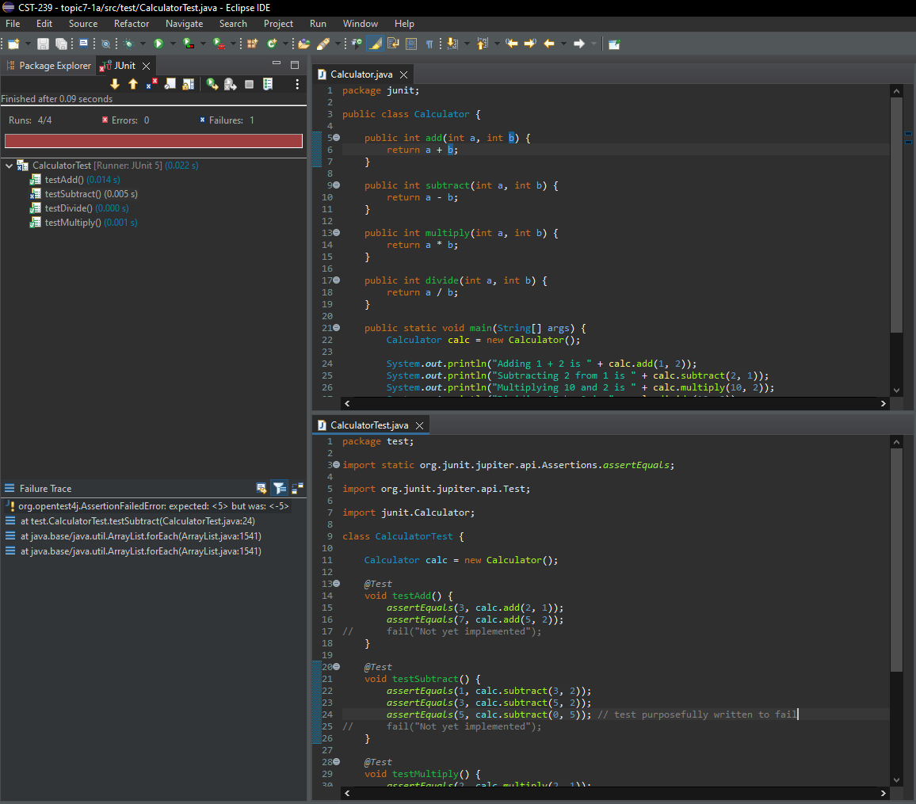

Part1b

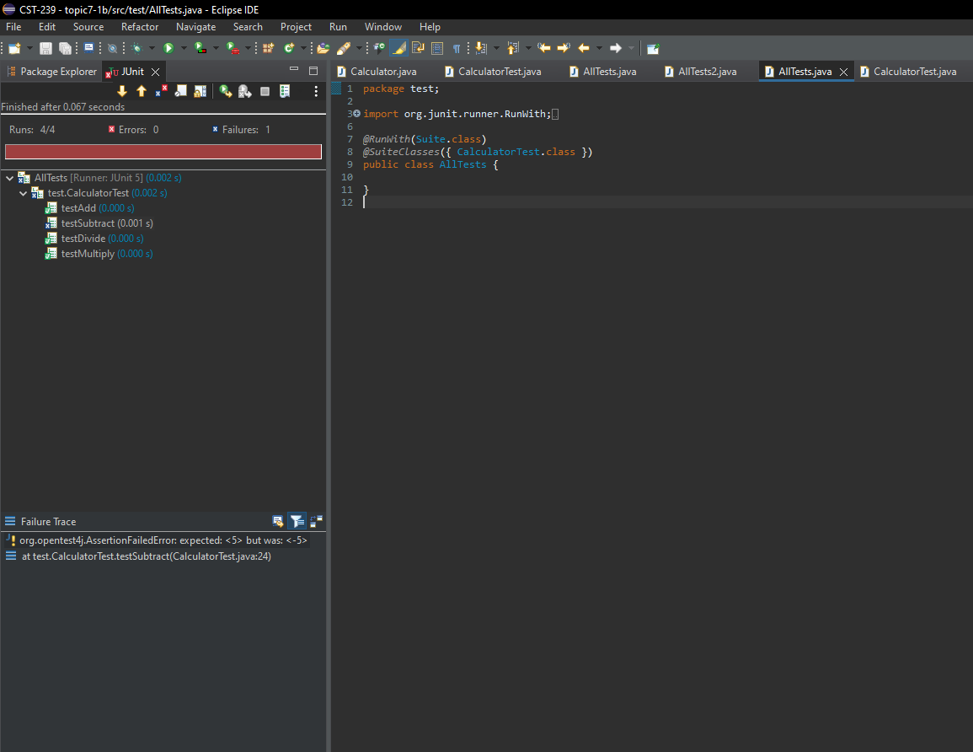

I wrote one test suite, and the CalculatorTest.java class that tests all 4 methods in the Calculator.java class: addition, subtraction, multiplication, and division. The error conditions needing to be tested are if the arithmetic is done as it’s supposed to be done by the calculator. For testing integer division, it’s very important to test that it returns an integer correctly as well as that it throws an error if dividing by zero.

This part of the activity is a demonstration of white box testing as we are aware of the internal workings of the code we are testing. Black box testing refers to when the tester is not familiar with the internal structure of the program being tested.

Testing suites are used when one wants to bundle and run multiple unit test cases and run them together, just as the name implies. A Test Suite runs a “suite” of tests.

Part2

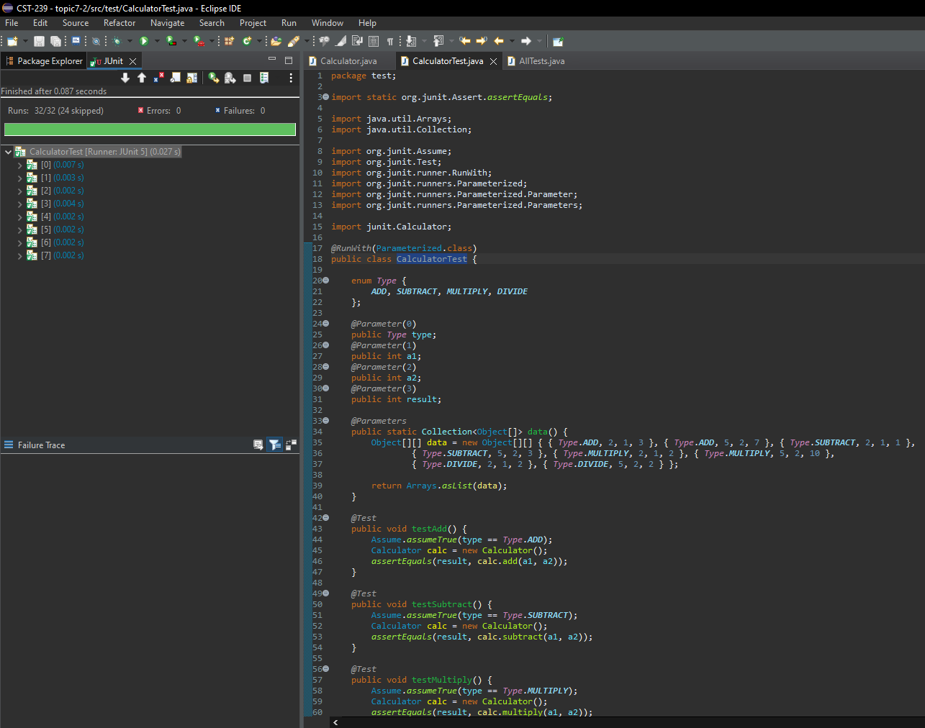

Parameterized Tests improved the testing because each @Test is written in a more generally way, I was able to simply create an object[][] with the specific numbers to run tests with. This cleans up the code of each @Test.

Part3

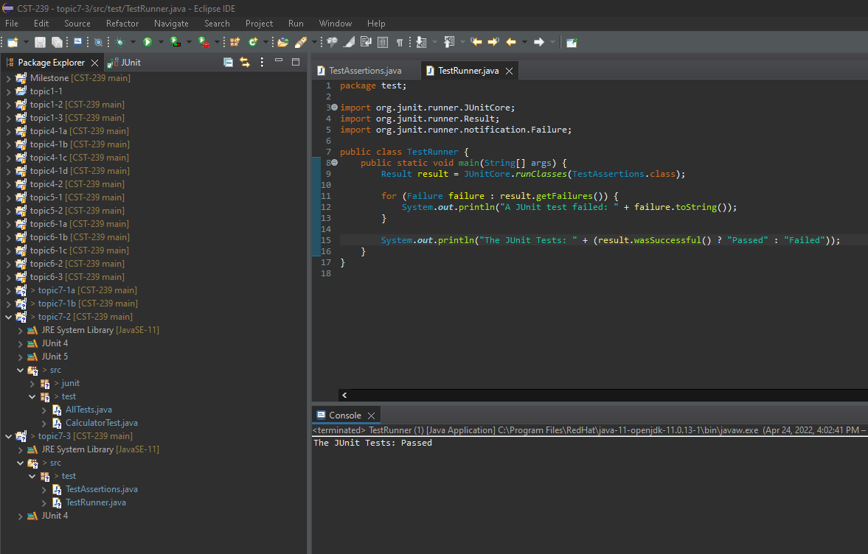

The challenge to making tests for all error conditions and exceptions in code is that we often don’t know what we don’t know. With experience, we will surely start to see ahead of time what type of errors are best to write tests for; until then, we have to use our current coding logic and knowledge to do our best to intuit where and when it’s most appropriate to write tests.

To test if an exception will be thrown in code, simply add @Test(expected = Exception.class) at the @Test annotation for the test. Now that test will pass if and only if that exception is thrown (see screenshots below).

Additionally, there’s an assertion “assertThrows(Exception.class, lambda expression that should throw expected exceptions)” that can be used for more fine tuned control of testing for exception being thrown within a test (see also <https://www.baeldung.com/junit-assert-exception>).

