Project Report on

Social Media Sentiment Analysis
Presented by
Zeel Panchal



Bhavya Gajjar Sagar Khatri
Project Guide Company Head

Acknowledgment

I express my sincere gratitude to Mr. Bhavya Gajjar, my project guide, for his continuous support, valuable guidance, and insightful feedback throughout the development of this project. His expertise and encouragement have been instrumental in shaping the direction and successful completion of this work.
I would also like to extend my heartfelt thanks to Mr. Sagar Khatri, the Company Head of BrainyBeam Technologies Pvt. Ltd., for providing the opportunity, resources, and professional environment necessary to undertake and complete this project. His leadership and mentorship have greatly contributed to my learning experience.
I am thankful to the entire team at BrainyBeam Technologies Pvt. Ltd. for their cooperation, technical assistance, and motivation during various stages of this project.

INDEX

Abstract 4
Chapter 1: INTRODUCTION 5
1.1Motivation 5
1.2 Need 6
1.3 Organization of Report 7
Chapter 2: PROPOSED SYSTEM AND ANALYSIS AND DESIGN 8
2.1 Problem Statement 8
2.2 Features 9
2.3 Scope 10
2.4 Methodology 11
2.4 Objective 12
Chapter 3:SPECIFICATIONS 13
3.1 Requirement Specification 13
3.2 Software and Hardware Requirements 15
Chapter 4: SYSTEM ARCHITECTURE 17
4.1 Proposed System Architecture 17
4.2 Modules 19
4.3 UML Diagram 20
Chapter 5: IMPLEMENTATIONS 21
5.1 Data Collection Implementation 22
5.2 Preprocessing Implementation 22
5.3 Sentiment Analysis Implementation 22
5.4 Machine Learning Model Implementation 22
5.5 Dashboard Implementation 22
5.6 Output Generation 22
Chapter 6: CONCLUSION AND FUTURE SCOPE 24
6.1 Conclusion 26
6.2 Challenges and Solutions in Future Implementations 26
6.3 Future Scope 27

Abstract

This project presents an end-to-end sentiment analysis system designed to evaluate public opinion on AI-generated influencers using Reddit data. The system automates the complete workflow, beginning with data collection through the PRAW API, followed by comprehensive preprocessing techniques to clean and standardize textual content. Sentiment classification is performed using both rule-based methods (VADER) and multiple machine-learning models built on TF-IDF features, enabling accurate categorization of posts into positive, negative, and neutral sentiments.
An interactive Streamlit dashboard serves as the user interface, allowing real-time exploration of sentiment trends, model performance, and Reddit comment analysis. The dashboard also supports multi-format data export for further research and reporting. The modular architecture ensures scalability, maintainability, and efficient processing of large datasets.
The results demonstrate the effectiveness of combining natural language processing, machine learning, and visualization tools to analyse online discussions. This system provides valuable insights into user perceptions of AI influencers and can be extended to other domains for broader sentiment analysis applications.

Chapter 1: INTRODUCTION

In a world where digital conversations move faster than monsoon clouds, understanding people's feelings has become just as important as understanding their words. Social platforms like Reddit have changed into modern public squares, raw, unfiltered, and endlessly expressive. Within these vast online communities, discussions about AI-generated influencers like Lil Miquela and Imma have ignited new waves of curiosity, scepticism, and debate.
This project enters that realm with a clear purpose: to gather Reddit posts about AI influencers, clean and process the text, apply both rule-based and machine-learning sentiment analysis, and share the insights through an interactive dashboard.
The work combines traditional principles like structured data collection, careful preprocessing, and statistical modelling with modern tools such as TF-IDF pipelines, high-dimensional classifiers, and real-time analysis powered by APIs. At the centre of it lies a simple question humans have been asking for ages: What do people think? We are answering it using algorithms now.
To make the analysis easy to understand, the final product is presented in a Streamlit dashboard. This interface lets users explore sentiment trends, compare models, and even conduct live comment analysis on any Reddit post. In a digital landscape overflowing with text, this project aims to bring clarity, pattern, and some poetic order to the chaos.

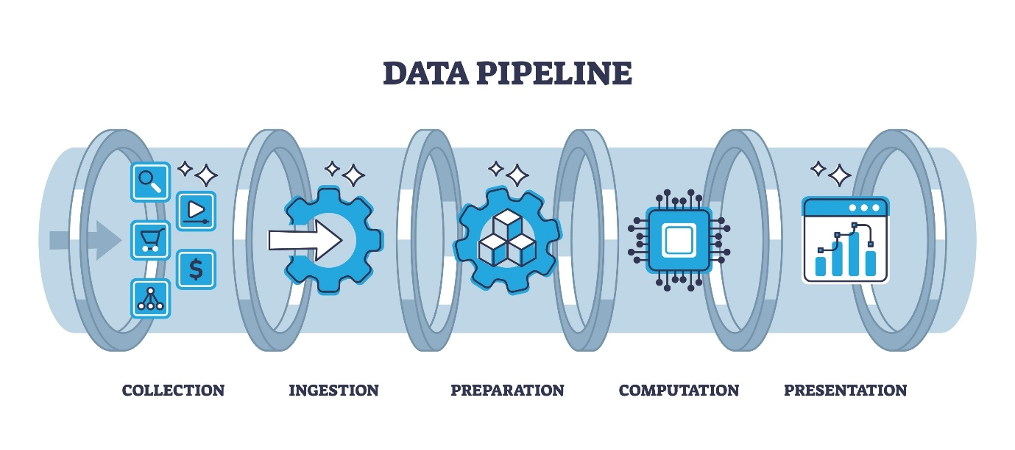

1.1Motivation
Rapid developments in artificial intelligence for content creation, particularly for social media, have formed a new class of digital entities: AI influencers. These digital personas, from examples like Lil Miquela and Imma, are becoming increasingly popular and generating discussions around authenticity, ethics, user perception and of course, the ever-fuzzy lines between the human and algorithmic entities.
Reddit, which offers open conversations and highly-engaged communities, is ideal for assessing public responses toward new technology. However, with a relatively massive volume of posts and an unstructured data format, much analysis requires a human to sift and analyze each participant comment, which can be ineffective or impractical.
This project was initiated because of the need for assessing public sentiment toward AI influencers in a structured, systematic way using both scalable efforts and data-driven approaches. Using a collection of Reddit posts, we will conduct a number of standard preprocessing techniques, and then perform both rule-based and ML sentiment analysis on social community reactions to participants toward AI influencers. The goal is to provide reporting on data-driven assessment of the public sentiment of AI influencers objectively.
The end result will be an interactive data dashboard or analytics tool that enables exploration of sentiment trends, comparison of model performance, and real-time comment analysis. In total, the work is intended to support researchers, practitioners, marketers, and other stakeholder interest in examining what online communities think and feel about AI influencers for purposes of discussing acceptability toward new technology in wider discussions on technology use and digital culture.

1.2 Need
As AI-generated influencers become more prevalent and people engage more with virtual personalities, there's an increasing need for structured ways to assess how audiences react to these new technologies. While conversations on social media can offer valuable insights into public opinion, the lack of systematic analysis often results in incomplete or skewed conclusions.
Here’s what we clearly need:
- Reliable sentiment measurement: Online opinions are varied, ever-changing, and often chaotic. We need a solid analytical framework to accurately pinpoint whether attitudes are positive, negative, or neutral.
- Automated large-scale analysis: Going through thousands of Reddit posts by hand is just not feasible. By automating data collection, preprocessing, and classification, we can conduct scalable analyses with much less human effort.
- Model comparison for performance validation: Different machine-learning algorithms respond differently to complex text data. A platform that facilitates training, evaluating, and comparing these models will help us choose the most effective methods.
- Interactive visualization for interpretation: Stakeholders require user-friendly tools to delve into sentiment trends, posting behaviours, and community reactions. Visual dashboards can turn raw data into valuable insights.
- Real-time analysis capabilities: Since online discussions evolve quickly, we need systems that can analyse live content—like comments on new Reddit posts—to keep up with shifting sentiments.
This project aims to meet these needs by combining automated data collection, advanced preprocessing, sentiment analysis, model evaluation, and interactive visualization into one comprehensive framework.

1.3 Organization of Report
This report is structured into six chapters, each addressing a specific stage of the project’s development and analysis:
Chapter 1 – Introduction
This chapter outlines the background of the study, the motivation behind the project, the need for automated sentiment analysis, and the overall structure of the report.
Chapter 2 – Proposed System Analysis and Design
This section presents the problem statement, project scope, key features, methodology, and defined objectives. It describes the conceptual foundation upon which the system is designed.
Chapter 3 – Specifications
This chapter details the functional and non-functional requirements, system requirements, and software/hardware dependencies essential for implementing the proposed solution.
Chapter 4 – System Architecture
This portion describes the architectural design of the system, highlighting key modules, data flow diagrams, and UML representations that depict system interactions and operational flow.
Chapter 5 – Implementations
This chapter covers the practical implementation of the system, outlining the modules developed and providing screenshots of the deployed application and its functionalities.
Chapter 6 – Conclusion and Future Scope
The final chapter summarizes the project’s outcomes, discusses limitations encountered during development, and suggests potential future enhancements to extend the system’s capabilities.

Chapter 2: PROPOSED SYSTEM AND ANALYSIS AND DESIGN

2.1 Problem Statement
The emergence of AI-generated influencers, such as Lil Miquela and Imma, has introduced a new dimension to digital interaction, raising questions about authenticity, trust, and audience perception. As these virtual personas gain visibility across online platforms, understanding public sentiment toward them becomes essential for researchers, marketers, and developers. Reddit, known for its candid discussions and diverse communities, provides a rich source of user-generated content that reflects genuine public opinion. However, the sheer volume, variability, and unstructured nature of Reddit posts make manual analysis impractical, time-consuming, and prone to bias.
There is a critical need for a systematic and automated solution capable of gathering relevant Reddit data, cleaning and standardizing the textual content, and performing accurate sentiment classification at scale. Traditional rule-based approaches alone are insufficient for capturing nuanced emotional patterns in modern internet language, whereas machine learning models require a structured pipeline for training and evaluation. Moreover, stakeholders benefit from a platform that not only analyzes historical data but also supports real-time sentiment assessment for ongoing discussions

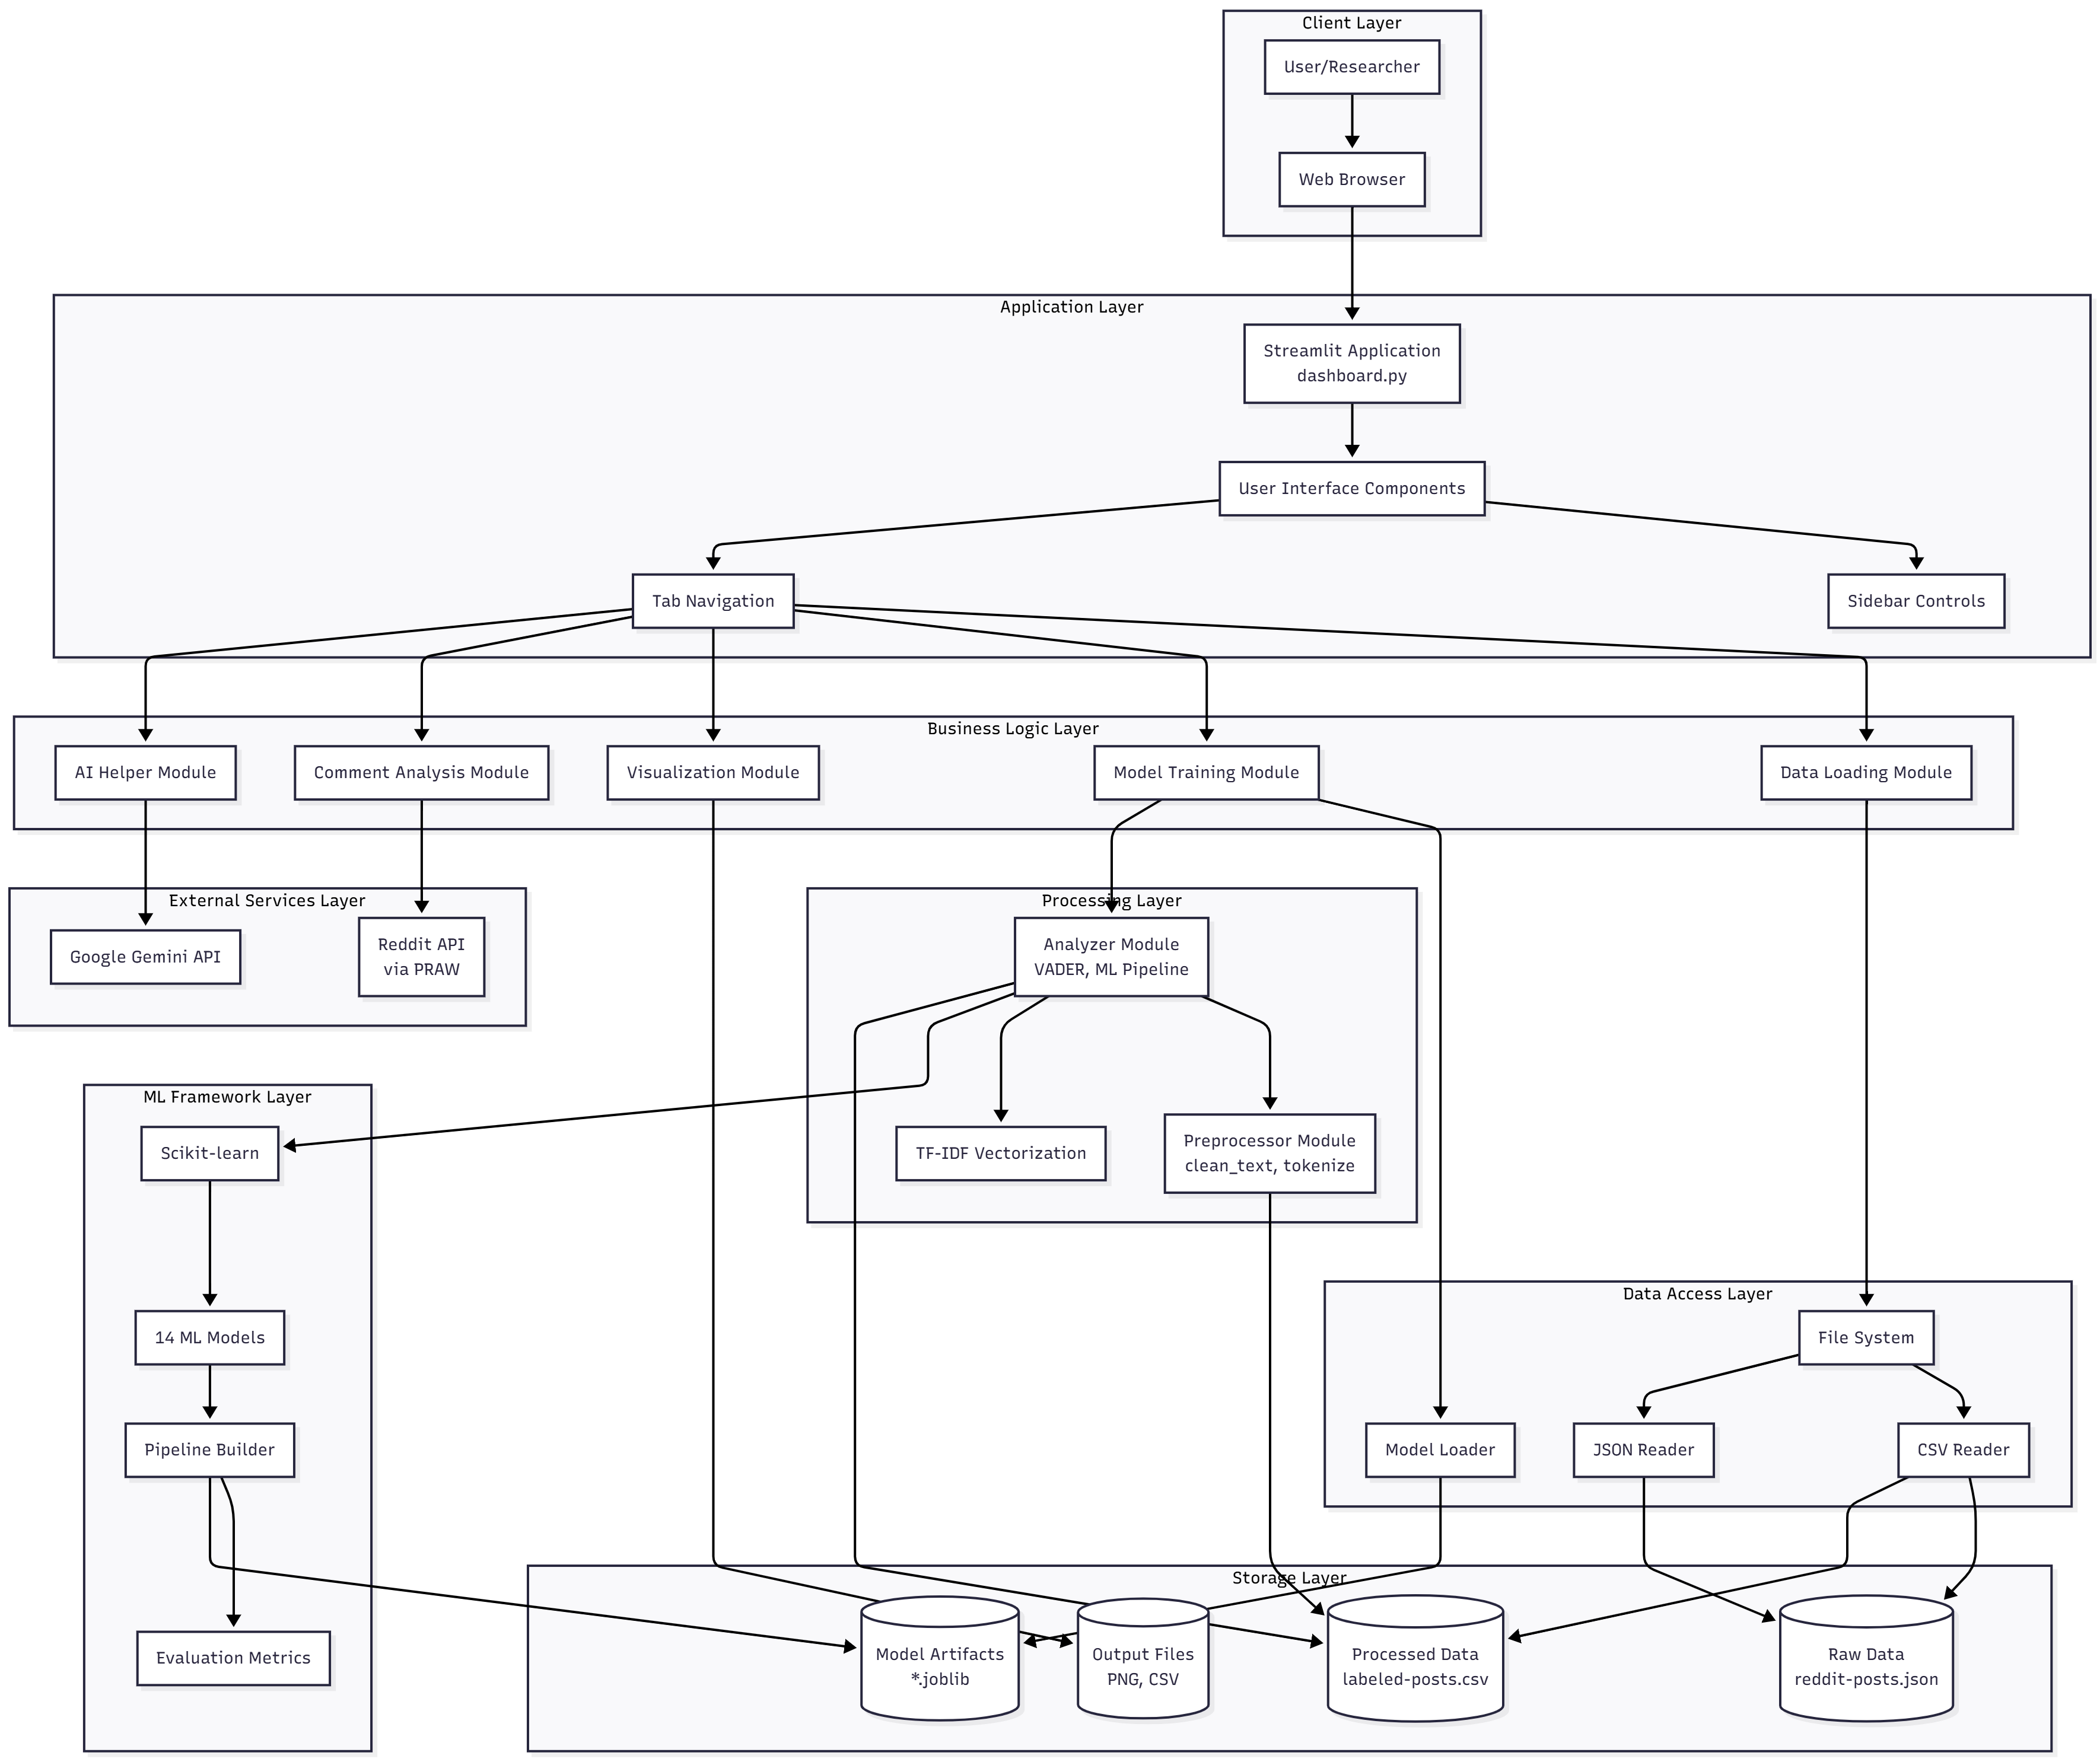.

This project aims to address these challenges by developing an end-to-end sentiment analysis system that integrates data collection, preprocessing, machine learning models, and an interactive dashboard to deliver meaningful insights into public attitudes toward AI influencers.

2.2 Features
The proposed sentiment analysis system incorporates a set of key features designed to ensure efficient data processing, accurate sentiment classification, and intuitive user interaction. The major features include:
1. Automated Reddit Data Collection
The system retrieves Reddit posts related to specified keywords using the PRAW API. It supports incremental data collection, automatically avoiding duplicates and storing newly fetched records in a structured JSON format.
2. Robust Text Preprocessing
Comprehensive cleaning operations—including lowercasing, URL removal, punctuation stripping, number removal, and tokenization—prepare raw text for accurate sentiment analysis and model training.
3. Rule-Based Sentiment Labeling (VADER)
The system uses the VADER sentiment analyzer to generate baseline sentiment labels, enabling quick classification of text into positive, negative, and neutral categories.
4. Machine Learning Model Training
Multiple ML models (e.g., Logistic Regression, Naive Bayes, SVM, Random Forest, Gradient Boosting) can be trained using TF-IDF features. The system offers model evaluation metrics such as accuracy, F1-score, and classification reports.
5. Interactive Streamlit Dashboard
A user-friendly dashboard displays key insights, sentiment distributions, KPIs, and visualizations. Users can train models, compare performance, and interact with the dataset in real time.
6. Real-Time Comment Sentiment Analysis
The system allows users to analyze comments from any Reddit post URL instantly, providing immediate sentiment insights.
7. Multi-Format Data Export
Users can download datasets in multiple formats including CSV, JSON, Excel, Parquet, HTML, XML, and SQL for further research or external processing.

2.3 Scope
The scope of this project encompasses the end-to-end development of an automated sentiment analysis system focused on Reddit discussions related to AI-generated influencers. The system covers the complete workflow, beginning with data acquisition and extending through preprocessing, sentiment classification, and interactive visualization. It is designed to analyze large volumes of text data efficiently and provide meaningful insights into public perception.
The project specifically includes:
- Data Collection: Retrieval of Reddit posts using keyword-based search and incremental updates to ensure comprehensive coverage without duplication.
- Text Processing: Implementation of standardized cleaning, tokenization, and preparation of unstructured text for sentiment analysis.
- Sentiment Classification: Use of both rule-based methods (VADER) and machine-learning models to classify text into sentiment categories.
- Model Training and Evaluation: Training multiple ML algorithms, assessing performance metrics, and enabling model selection within the dashboard.
- Dashboard Development: Creation of an interactive Streamlit interface for real-time sentiment analysis, visual exploration, and model comparison.
- Data Export: Support for exporting processed data into multiple formats for further usage or academic research.
The project does not include advanced deep learning architectures, social media engagement prediction, or cross-platform data integration. Its primary focus is sentiment analysis of Reddit posts within the defined keyword scope.

2.4 Methodology
The methodology adopted in this project follows a systematic, modular approach to ensure accurate sentiment extraction and efficient processing of Reddit data. The workflow is divided into sequential stages, each addressing a specific analytical requirement.
1. Data Collection
Reddit posts related to AI influencers are gathered using the PRAW API. A keyword-based search retrieves relevant submissions, while an incremental fetching mechanism prevents duplicate entries. The collected data is stored in JSON format for flexibility and scalability.
2. Data Preprocessing
Raw text is cleaned using standardized preprocessing techniques. This includes lowercasing, removing URLs, removing punctuation and numeric characters, eliminating extra whitespace, and tokenizing text. Preprocessing ensures uniformity and prepares the dataset for effective modeling.
3. Sentiment Labeling (Rule-Based)
The VADER sentiment analyzer is applied to generate baseline sentiment labels (positive, negative, neutral). These labels serve as ground truth for initial exploratory analysis and are used to filter data for ML model training.
4. Feature Extraction
Text is transformed into numerical representations using TF-IDF vectorization. This method captures both term frequency and contextual importance, enabling better model performance in sentiment classification tasks.
5. Machine Learning Model Training
Multiple ML classifiers—including Logistic Regression, Naive Bayes, SVM, Random Forest, Gradient Boosting, Extra Trees, and Passive Aggressive models—are trained on the TF-IDF features. Each model is evaluated using accuracy, F1-score, and classification reports to determine performance.
6. Dashboard Development
An interactive Streamlit dashboard is created to visualize sentiment distributions, KPIs, trends, top subreddits, and model comparisons. The dashboard also includes real-time Reddit comment analysis and multi-format dataset export options.
7. Deployment & Output Generation
The final processed results, model outputs, and visual insights are presented through the dashboard, allowing users to interactively explore public sentiment toward AI influencers.

2.4 Objective
The primary objective of this project is to develop an automated, end-to-end sentiment analysis system capable of extracting, processing, and interpreting public opinion on AI-generated influencers using Reddit data. To achieve this overarching goal, the project focuses on the following specific objectives:
1. To collect relevant Reddit posts
Implement a robust data collection pipeline using the PRAW API to gather posts related to AI influencers, ensuring incremental updates and duplicate avoidance.
2. To preprocess and standardize textual data
Apply systematic text cleaning, tokenization, and normalization techniques to convert unstructured Reddit content into a machine-readable format.
3. To perform sentiment analysis using hybrid techniques
Utilize both rule-based (VADER) and machine-learning approaches to classify posts into positive, negative, and neutral categories.
4. To train and evaluate multiple ML models
Develop TF-IDF-based pipelines and compare the performance of various classifiers using metrics such as accuracy, F1-score, and classification reports.
5. To design an interactive visualization dashboard
Create a Streamlit-based interface that enables users to explore sentiment trends, visualize insights, compare model outputs, and analyze live Reddit comments.
6. To support multi-format data export
Allow users to download processed datasets and analysis results in various formats for research and reporting.

Chapter 3: SPECIFICATIONS

3.1 Requirement Specification
A well-defined requirements specification ensures the smooth development and implementation of the sentiment analysis system. The system requirements are categorized into functional, non-functional, performance, and safety requirements to ensure optimal operation.

3.1.1 Functional Requirements
- Data Collection Module
  - The system shall fetch Reddit posts using the PRAW API based on predefined keywords.
  - The system shall support incremental data collection and prevent duplicates.
  - The system shall store all collected posts in JSON format.
- Preprocessing Module
  - The system shall clean text by removing URLs, punctuation, numbers, and extra whitespace.
  - The system shall tokenize text and prepare it for analysis.
- Sentiment Analysis Module
  - The system shall apply VADER to generate sentiment labels (positive, negative, neutral).
  - The system shall train machine-learning models using TF-IDF features.
  - The system shall classify sentiment using selected ML models.
- Dashboard Module
- The system shall display KPIs, sentiment distribution, time-series trends, and model comparisons.
  - The system shall provide real-time comment analysis for any Reddit post URL.
  - The system shall allow users to export data in multiple formats (CSV, JSON, Excel, SQL, etc.).

3.1.2 Non-Functional Requirements
- Usability
- The dashboard interface shall be intuitive, easy to navigate, and accessible for non-technical users.
- Reliability
- The system shall handle API errors gracefully and continue processing where possible.
- Data integrity shall be maintained during collection and preprocessing.
- Scalability
- The system shall support analysis of large datasets without performance degradation.
- Maintainability
- The codebase shall follow modular programming practices to enable easy updates and feature expansion.
- Security
- Sensitive information such as API keys shall be stored securely in environment variables.

3.1.3 Performance Requirements
- Data Processing Speed
- The system shall preprocess and clean large batches of text within acceptable response times.
- Model Training Efficiency
- Machine-learning models shall be trained within reasonable computational limits using optimized pipelines.
- Dashboard Responsiveness
- Visualizations shall load within a few seconds to ensure smooth user interaction.
- Real-Time Analysis
- The comment analyzer shall fetch and classify comments from a Reddit post without noticeable delays.

3.2 Software and Hardware Requirements
3.2.1 Software Requirements
The system requires the following software components for development, processing, and dashboard deployment:
Operating System
- Windows 10/11, macOS, or any modern Linux distribution.
Programming Language
- Python 3.9+, chosen for its extensive machine-learning and data-processing libraries.
Required Libraries
- pandas, numpy – data manipulation and numerical processing
- scikit-learn – machine-learning model development
- nltk , vaderSentiment – text preprocessing and rule-based sentiment analysis
- Streamlit – interactive dashboard development
- Plotly – data visualization
- praw, python-dotenv – Reddit API integration and environment configuration
- joblib, pyarrow, openpyxl, lxml – model saving and multi-format file export
External Dependencies
- Reddit API credentials for data collection
- Gemini API (optional) for AI-generated model comparison

3.2.2 Hardware Requirements
To run the sentiment analysis system smoothly, the following hardware setup is required:
Minimum Requirements
- Processor: Dual-core CPU (Intel i3 or equivalent) capable of handling basic data processing and script execution.
- RAM: At least 8 GB to support dataset loading, preprocessing, and model training without frequent slowdowns.
- Storage: Minimum 3 GB free space for storing raw Reddit posts, processed datasets, model files, and project dependencies.
- Graphics: Integrated graphics are sufficient, as no GPU-based computations are required for this project.
Recommended Requirements
- Processor: Quad-core CPU (Intel i5/i7 or AMD Ryzen 5/7) for faster training and smoother multitasking.
- RAM: 16 GB or higher to handle larger datasets and perform model experiments efficiently.
- Storage: SSD storage (6 GB) for faster file access and improved performance of data-heavy tasks.

Chapter 4: SYSTEM ARCHITECTURE

The system architecture defines the overall structure and operational flow of the sentiment analysis application. It outlines how data is collected, processed, analyzed, and delivered to end users through an interactive dashboard. The architecture is modular, allowing each component to function independently while contributing to the complete workflow.

4.1 Proposed System Architecture
The proposed system architecture is designed to automate the complete process of sentiment analysis on Reddit posts related to AI influencers. The system begins with the user accessing a web interface, which serves as the interaction layer for uploading data, triggering analysis, and viewing results. The backend handles preprocessing tasks such as text cleaning, tokenization, and normalization. After preprocessing, the data flows into the sentiment analysis module, where both rule-based methods (like VADER) and machine-learning models assess the sentiment. The machine-learning component is responsible for training, prediction, and storing model outputs in the database. Finally, the processed results are delivered to the user through intuitive visualizations and dashboards, enabling real-time exploration and interpretation of sentiment trends.

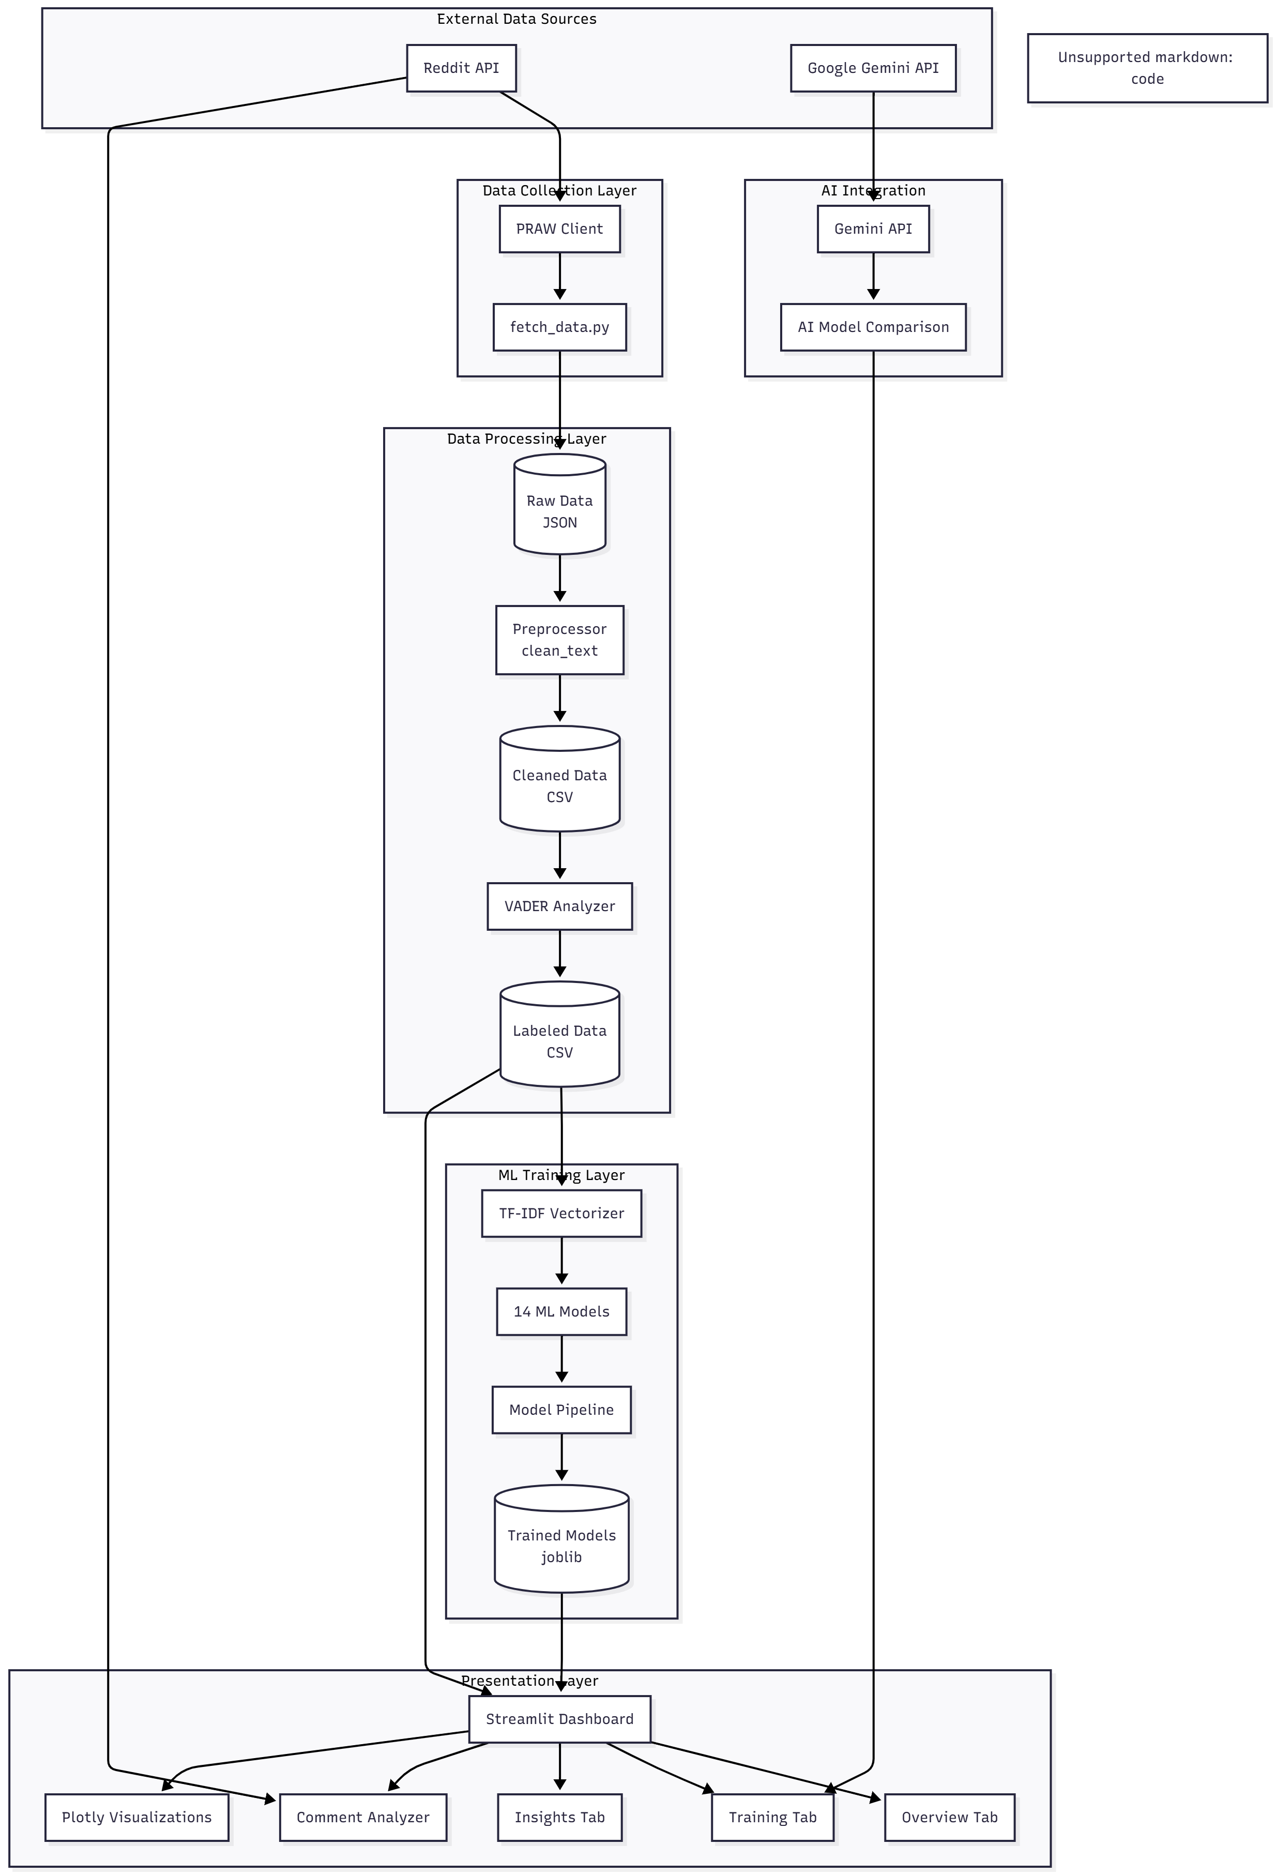

4.2 Modules
4.2.1 Data Flow Diagram (DFD)
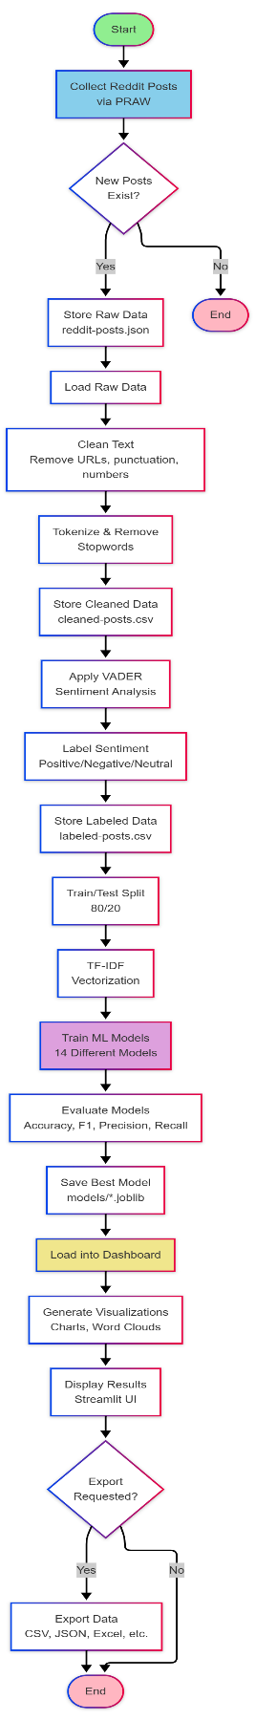
The Data Flow Diagram (DFD) represents the flow of data between different system components.

UML Diagram
UML diagrams are visual representations used in software engineering to model system architecture, design, and behavior. They help developers, designers, and stakeholders understand and communicate the structure and functionality of a system.
• Use case Diagram.

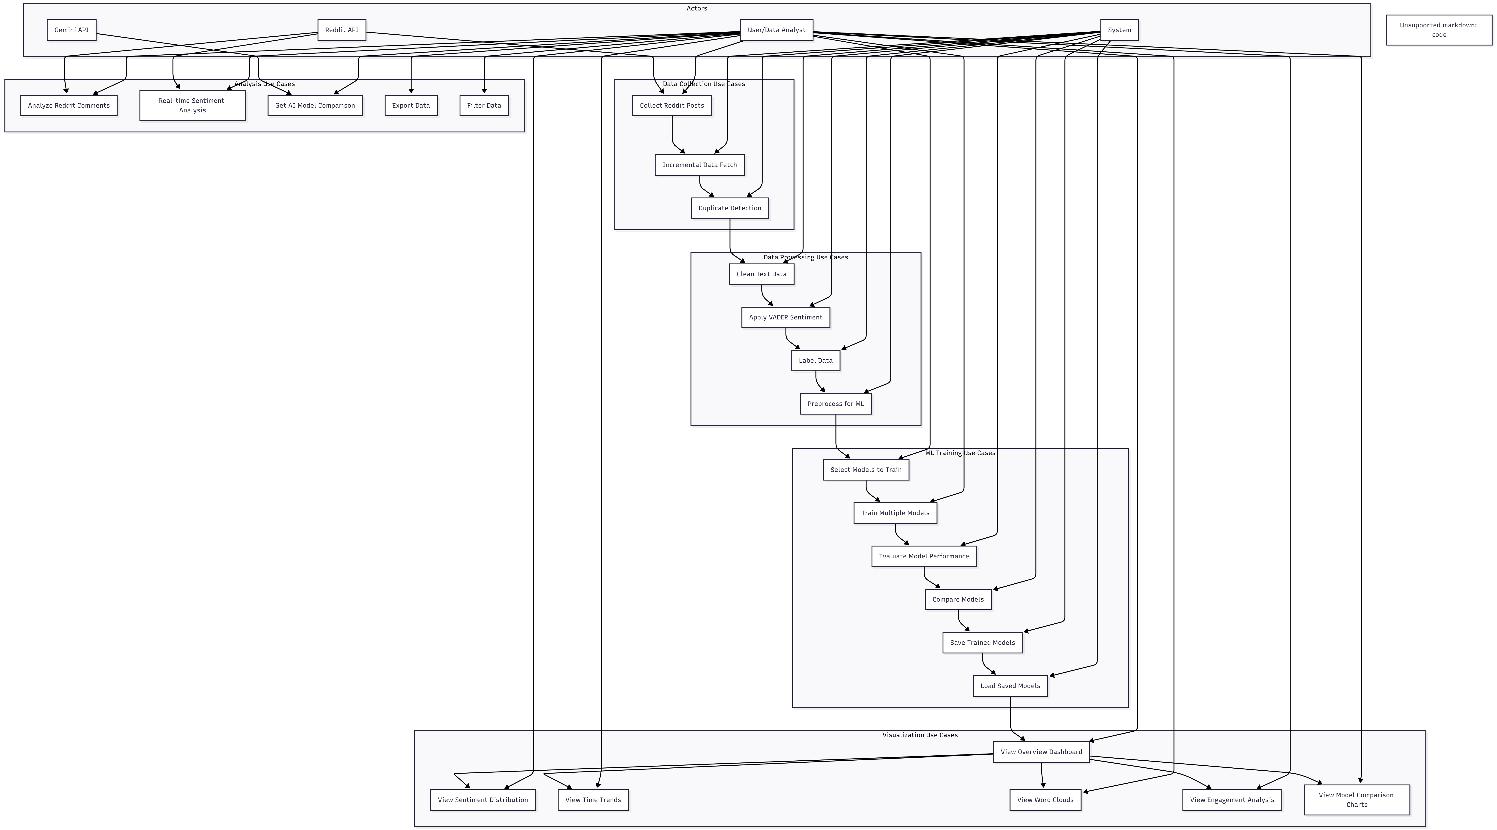

- Activity Diagram.

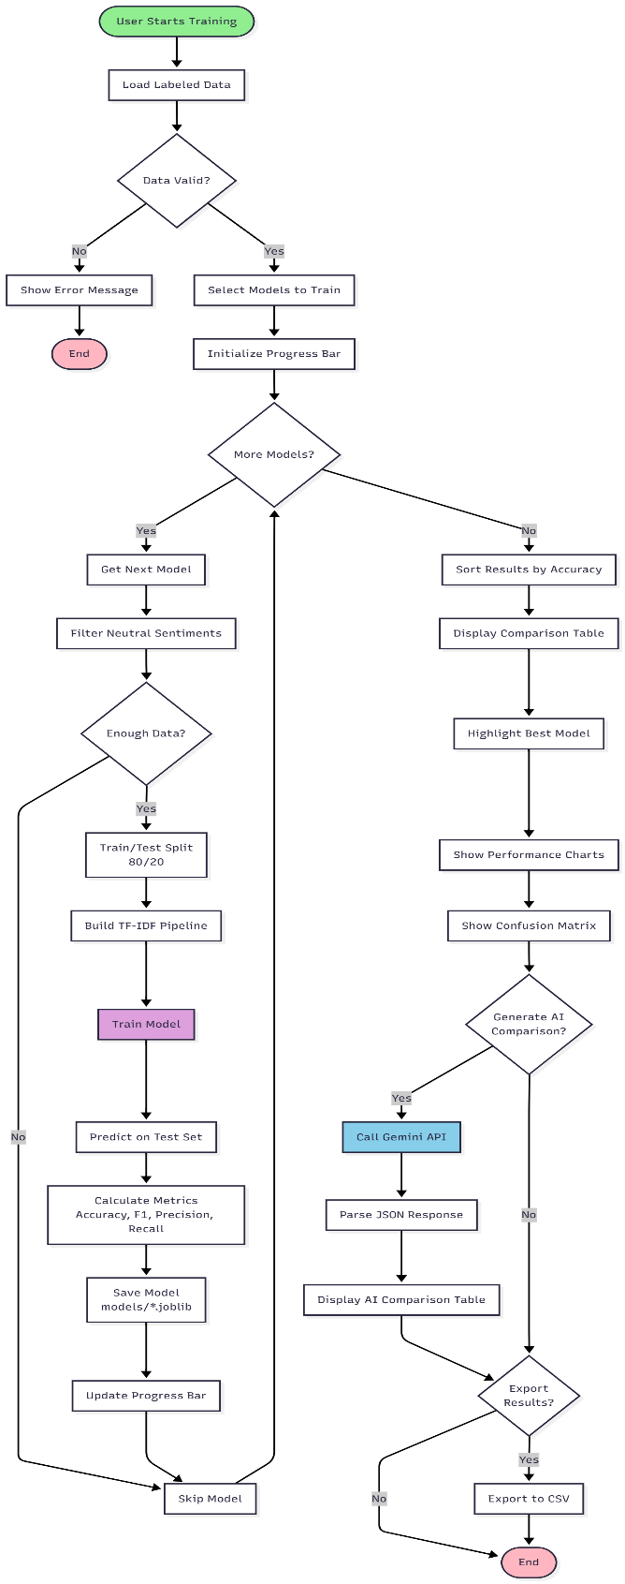

Chapter 5: IMPLEMENTATIONS
The system implementation phase focuses on translating the proposed architecture into a fully functional sentiment analysis application. Each module is developed using a modular, step-by-step approach to ensure maintainability, scalability, and smooth integration across all components.

5.1 Data Collection Implementation
The Reddit data is collected using the PRAW API, with secure authentication through environment variables. A Python script automates the search, retrieval, and storage of posts related to AI influencers. An incremental update mechanism prevents duplication by checking post IDs before saving.

5.2 Preprocessing Implementation
Text preprocessing is implemented using Python’s nltk, re, and custom helper functions. The system performs cleaning operations such as lowercasing, punctuation removal, URL stripping, digit removal, tokenization, and stopword filtering. The cleaned text is stored for further analysis.

5.3 Sentiment Analysis Implementation
VADER is used as the rule-based classifier to assign initial sentiment labels. These labels are included in the dataset to support exploratory analysis and serve as ground truth for ML model training.

5.4 Machine Learning Model Implementation
A TF-IDF vectorization pipeline is constructed using scikit-learn. Several machine-learning algorithms—such as Logistic Regression, Naive Bayes, SVM, Random Forest, Gradient Boosting, and Passive Aggressive Classifier—are trained and evaluated. Metrics such as accuracy, F1-score, and classification reports are generated for comparison. Trained models are stored using joblib.

5.5 Dashboard Implementation
The Streamlit-based dashboard integrates all components, displaying sentiment distribution, KPIs, visualizations, model performance, and real-time comment analysis. Users can train models inside the UI, upload data, or generate on-demand sentiment predictions. The dashboard also provides data export options in multiple formats.

5.6 Output Generation
The system produces sentiment results, visual charts, downloadable datasets, and model comparison reports. Real-time sentiment analysis of Reddit comments is displayed instantly to support quick insights.
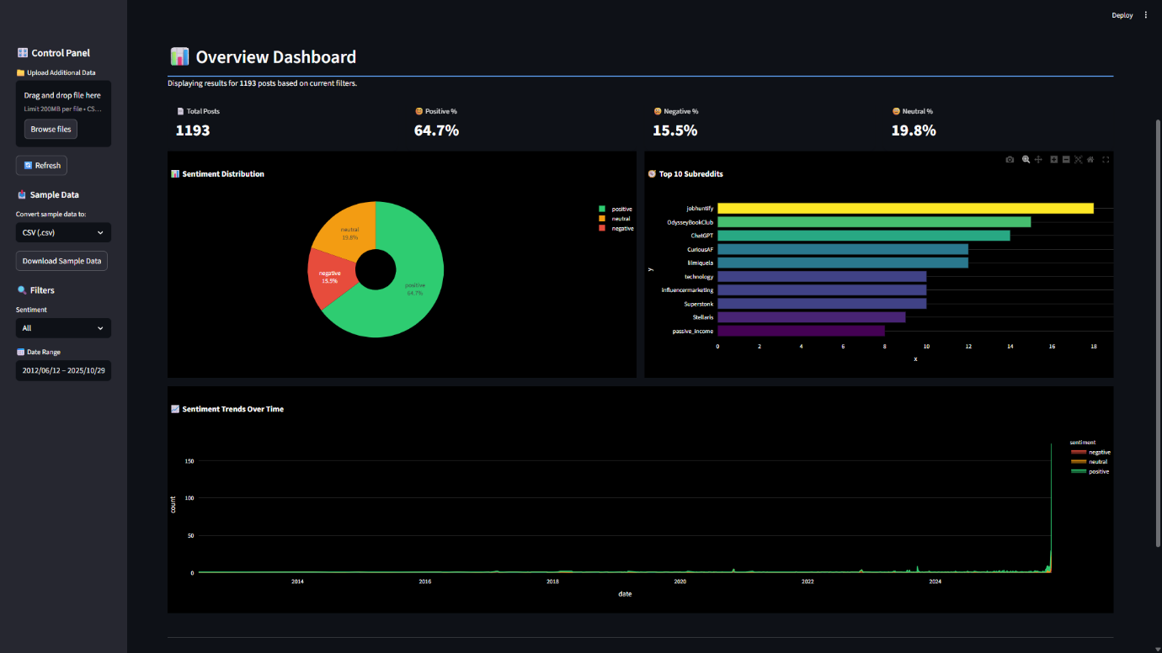

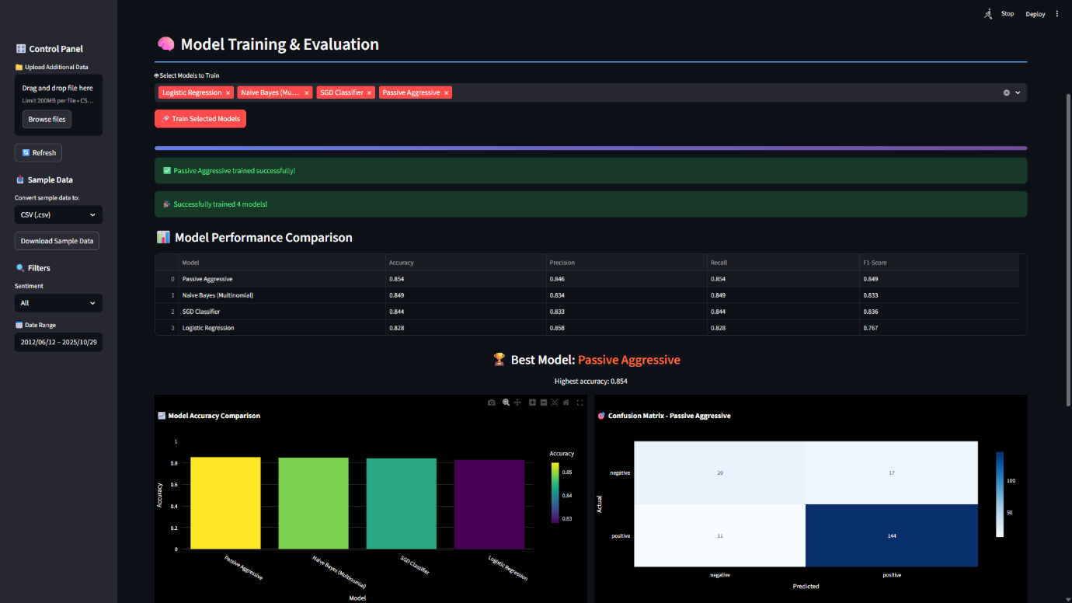

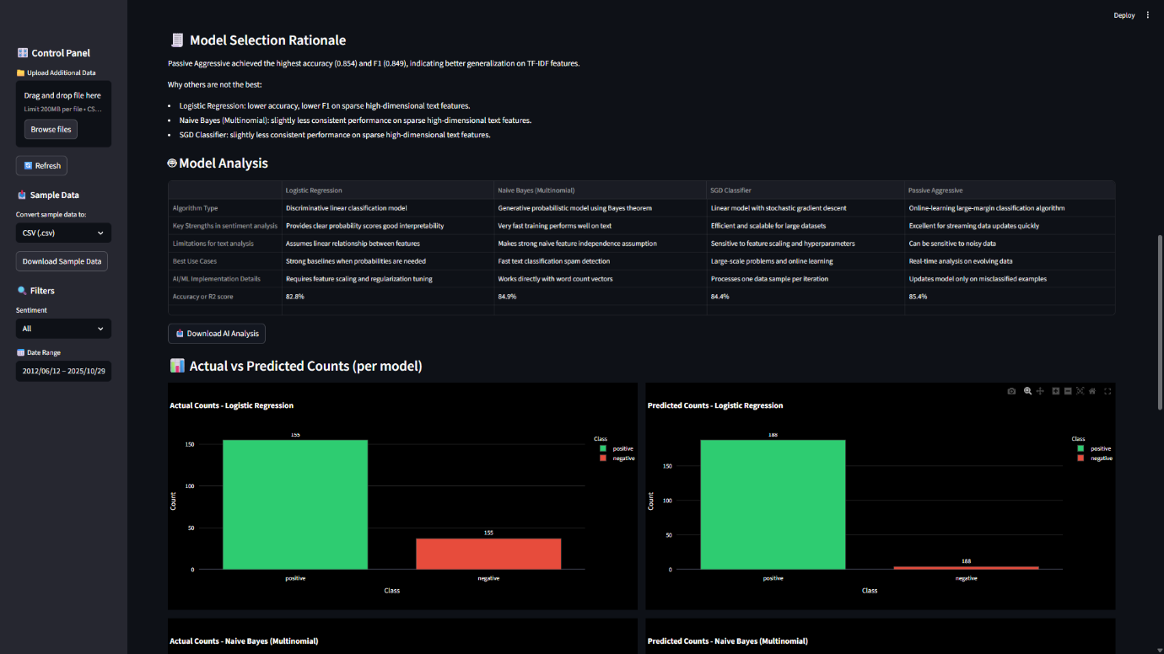

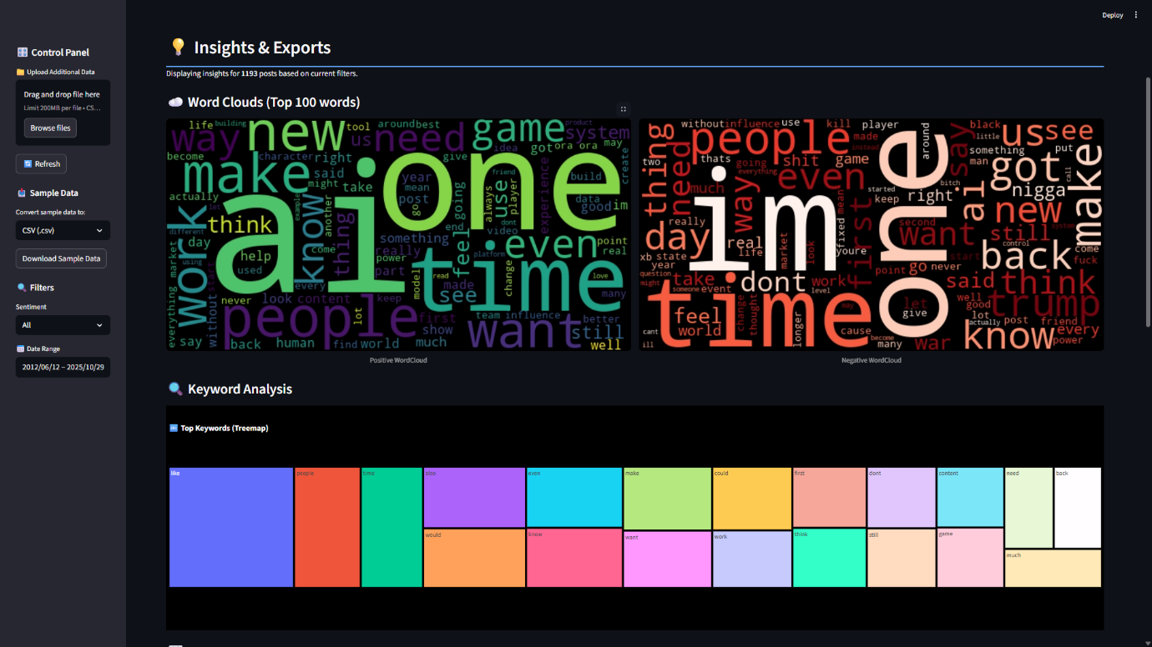

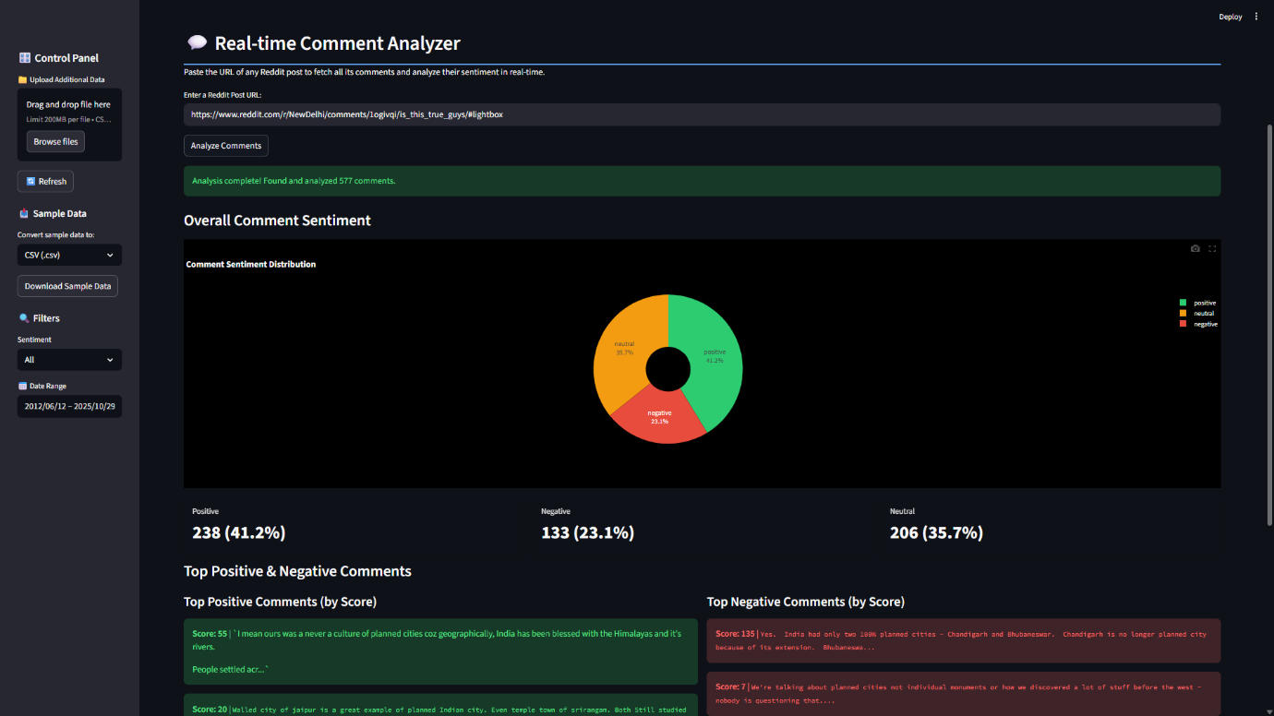

Chapter 6: CONCLUSION AND FUTURE SCOPE

6.1 Conclusion
This project successfully developed an end-to-end sentiment analysis system capable of collecting, preprocessing, analyzing, and visualizing Reddit discussions related to AI-generated influencers. By integrating rule-based methods such as VADER with multiple machine-learning models, the system provides a comprehensive understanding of public sentiment across large volumes of user-generated content. The Streamlit dashboard enhances accessibility by offering real-time insights, interactive visualizations, and multi-format data export options.
Through a modular architecture, the system ensures scalability, maintainability, and efficient performance, enabling researchers and users to explore sentiment trends with ease. Overall, the project demonstrates the effectiveness of combining natural language processing, machine learning, and interactive visualization to derive meaningful insights from social media data.

6.2 Challenges and Solutions in Future Implementations
While the current system performs effectively for sentiment analysis on Reddit data, several challenges may arise during future enhancements. Addressing these challenges will improve scalability, accuracy, and overall system reliability.
1. Challenge: Handling Larger and Diverse Datasets
As the system expands to include data from multiple platforms, the volume and diversity of text will significantly increase.
Solution:
Implement distributed data processing frameworks such as Apache Spark, along with optimized storage formats like Parquet to handle large-scale datasets efficiently.
2. Challenge: Limited Accuracy of Classical Machine-Learning Models
Traditional classifiers may struggle with highly contextual or sarcastic text, which is common in social media.
Solution:
Integrate transformer-based deep learning models (e.g., BERT, RoBERTa) that understand contextual semantics and provide more accurate sentiment classification.
3. Challenge: Real-Time Processing and Latency
Real-time sentiment analysis of comments may cause delays due to API response time and heavy preprocessing.
Solution:
Use caching mechanisms, asynchronous API calls, and lightweight preprocessing pipelines to reduce latency.
4. Challenge: Dashboard Scalability and Multi-User Access
Local Streamlit deployment may not support multiple users or heavy traffic.
Solution:
Deploy the system on cloud platforms (AWS, Azure, GCP) with load balancing, containerization (Docker), and scalable backend services.
5. Challenge: Managing Noisy or Unstructured Text
Social media data often contains slang, emojis, abbreviations, and multilingual content.
Solution:
Integrate advanced text normalization techniques, emoji sentiment mapping, and multilingual NLP models.

6.3 Future Scope
The system presents a solid foundation for sentiment analysis on Reddit data, yet several opportunities exist to enhance its capabilities in future implementations. One major direction is the integration of advanced deep learning models such as BERT, RoBERTa, or GPT-based architectures, which can significantly improve sentiment accuracy by capturing deeper contextual meaning. Expanding the data sources to other social media platforms—such as Twitter, Instagram, or YouTube—would also provide a more comprehensive representation of public opinion.
Automating the data ingestion process using scheduled pipelines can enable continuous, real-time monitoring of sentiment trends. Deploying the system on cloud platforms will further enhance scalability, support multi-user access, and improve response speed. Additional analytical features such as topic modeling, keyword extraction, and trend forecasting can provide richer insights into user discussions.
Incorporating multilingual support, emoji interpretation, and sarcasm detection will allow the system to handle the diverse and evolving nature of online communication more effectively. These improvements can transform the system into a more robust, flexible, and widely applicable sentiment analysis platform.

