Reverse Engineering Memoranda
Table of Contents
Dependencies 2
Main Structure 2
ui/EventsPanel.java 3
UML 3
Screenshot - Events Panel 4
Source Code for New Event button and tooltip text 5
Screenshot – New event pop-up 6
private void saveEvents(); 7
ui/EventDialog.java 8
UML 8
ui/EventsManager.java 9
UML 9
util/CurrentStorage.java 10
UML 10
Dependencies 10
util/FileStorage.java 11
UML 11
Overview: Events Read/Write to Disk 11
openEventsMangaer() - Screenshot code snippet 12
storeEventsManager() – Screenshot code snippet 12

Dependencies

Main Structure
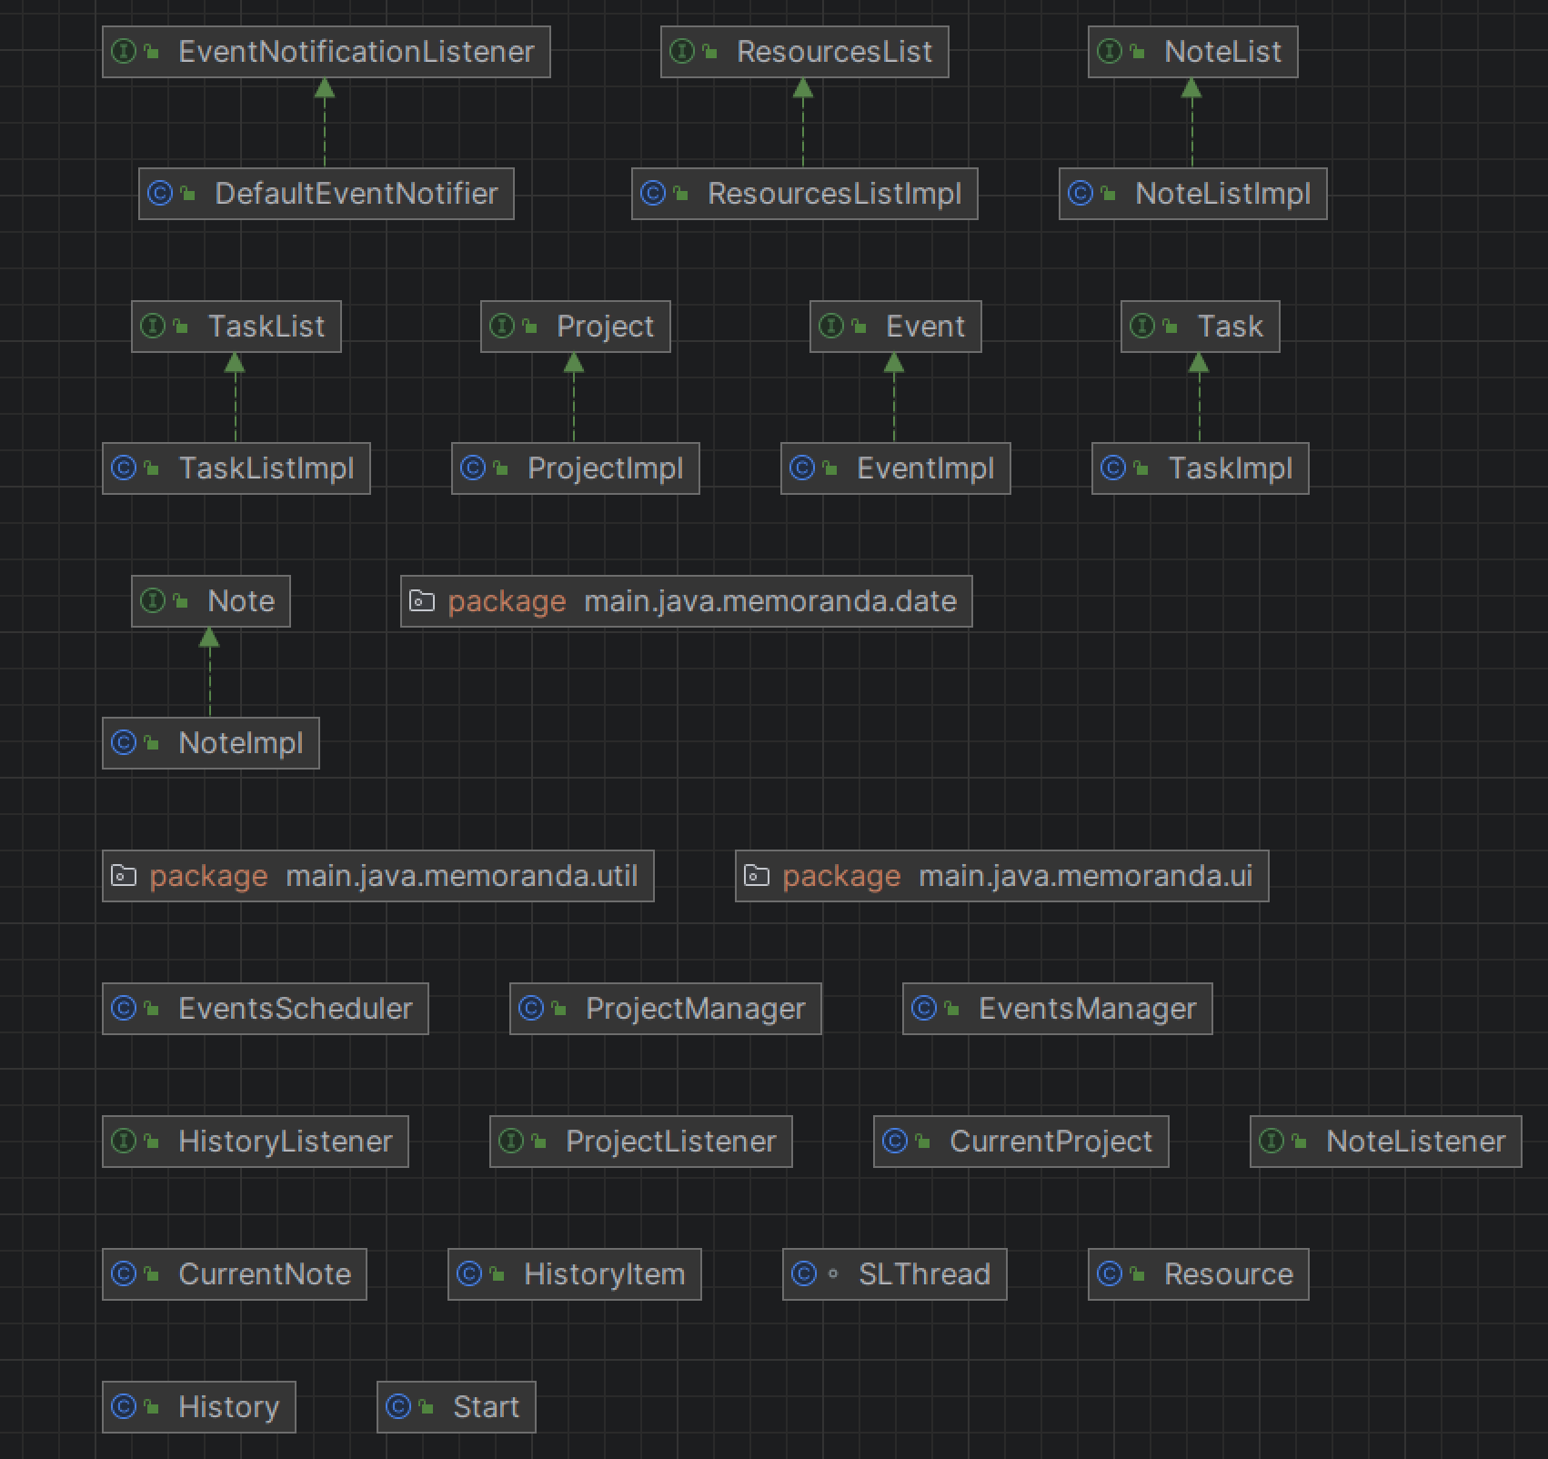

ui/EventsPanel.java

UML
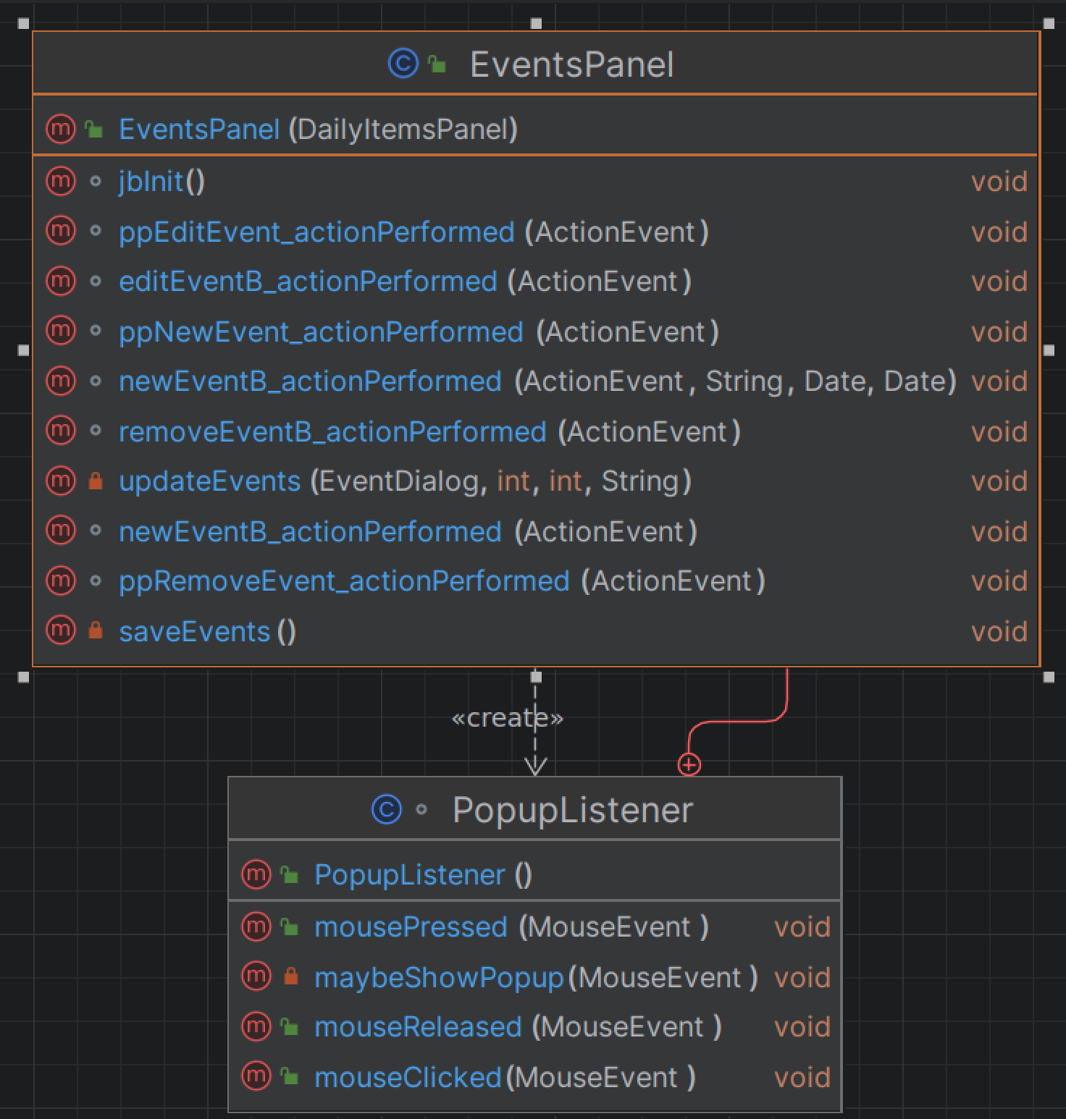

Screenshot - Events Panel

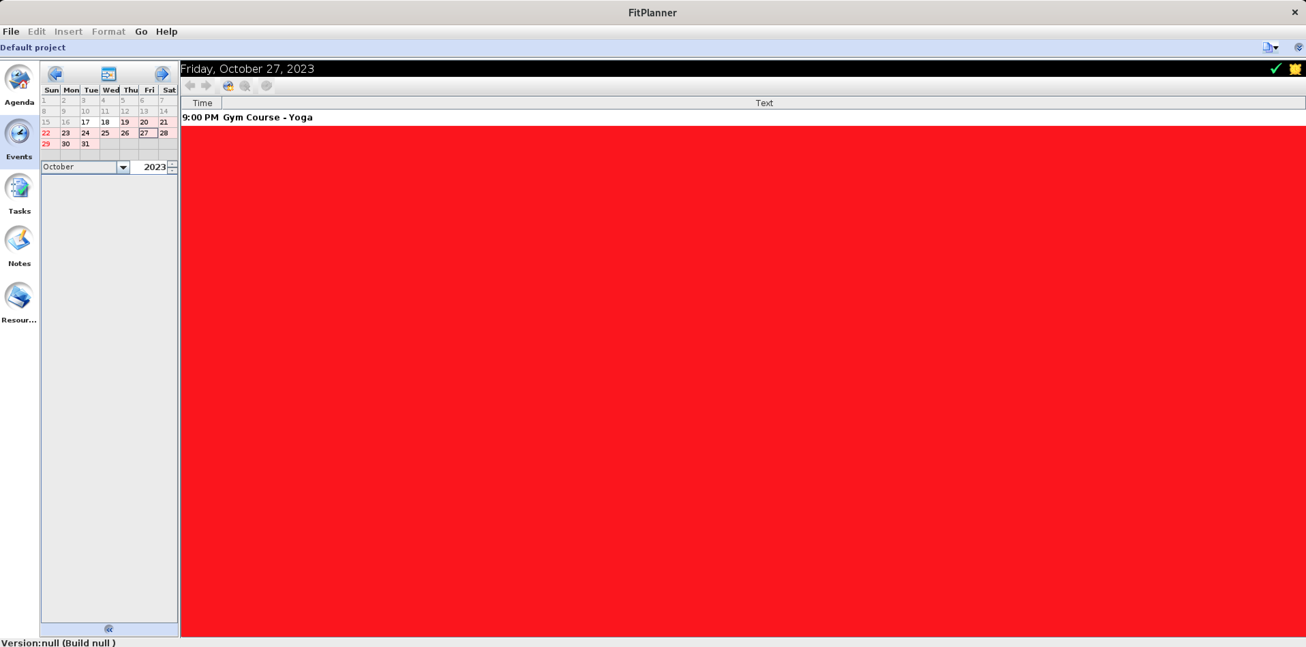

Source Code for New Event button and tooltip text

When “New event” is clicked, the ActionListener calls newEventB_actionPerformed.

This passes the current date to the next which creates the pop-up EventDialog

newEventB_actionPerformed(ActionEvent e) 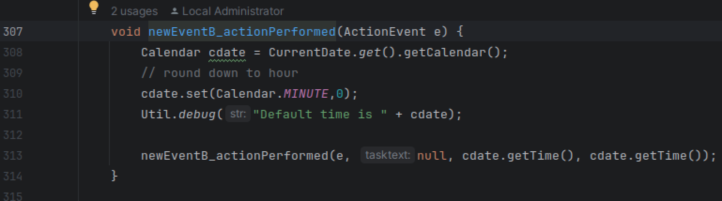

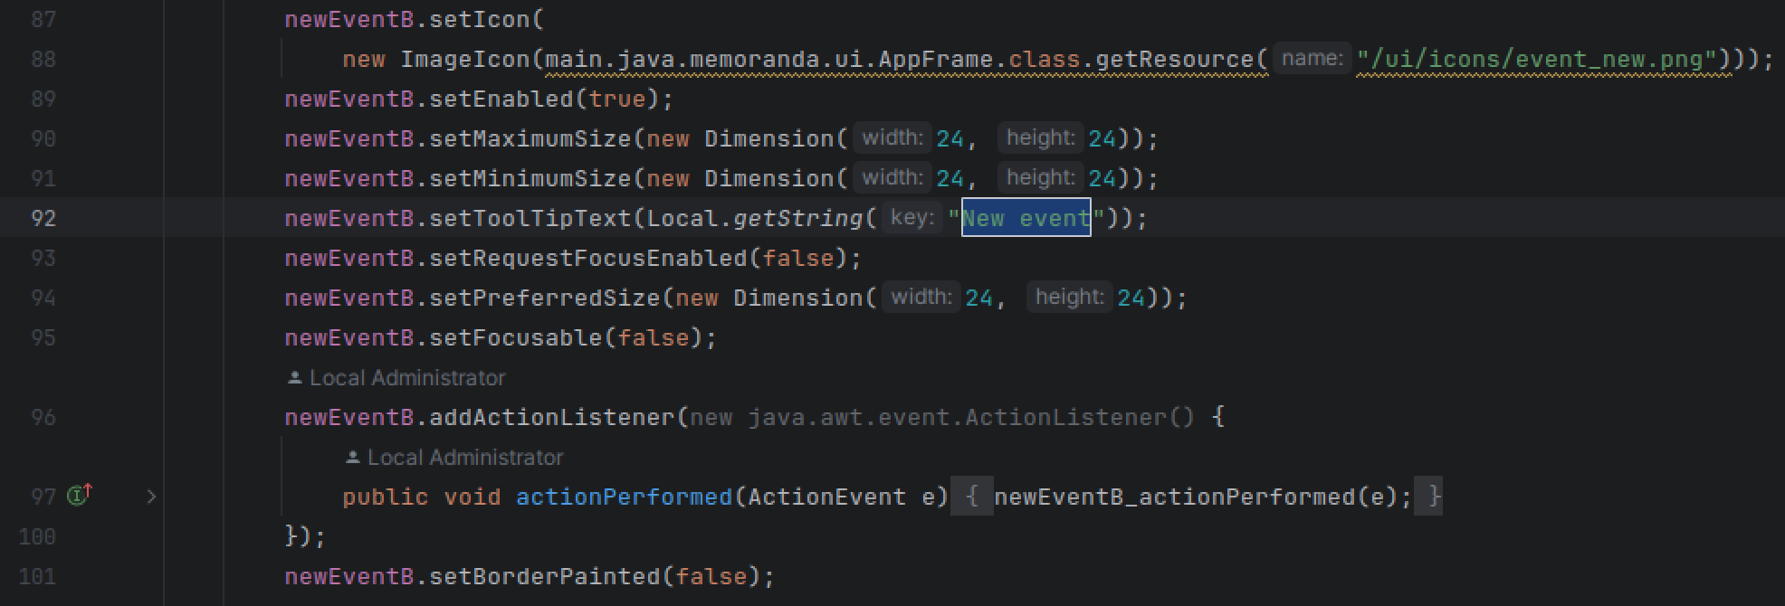

newEventB_actionPerformed(ActionEvent e, String tasktext, Date startDate, Date endDate)
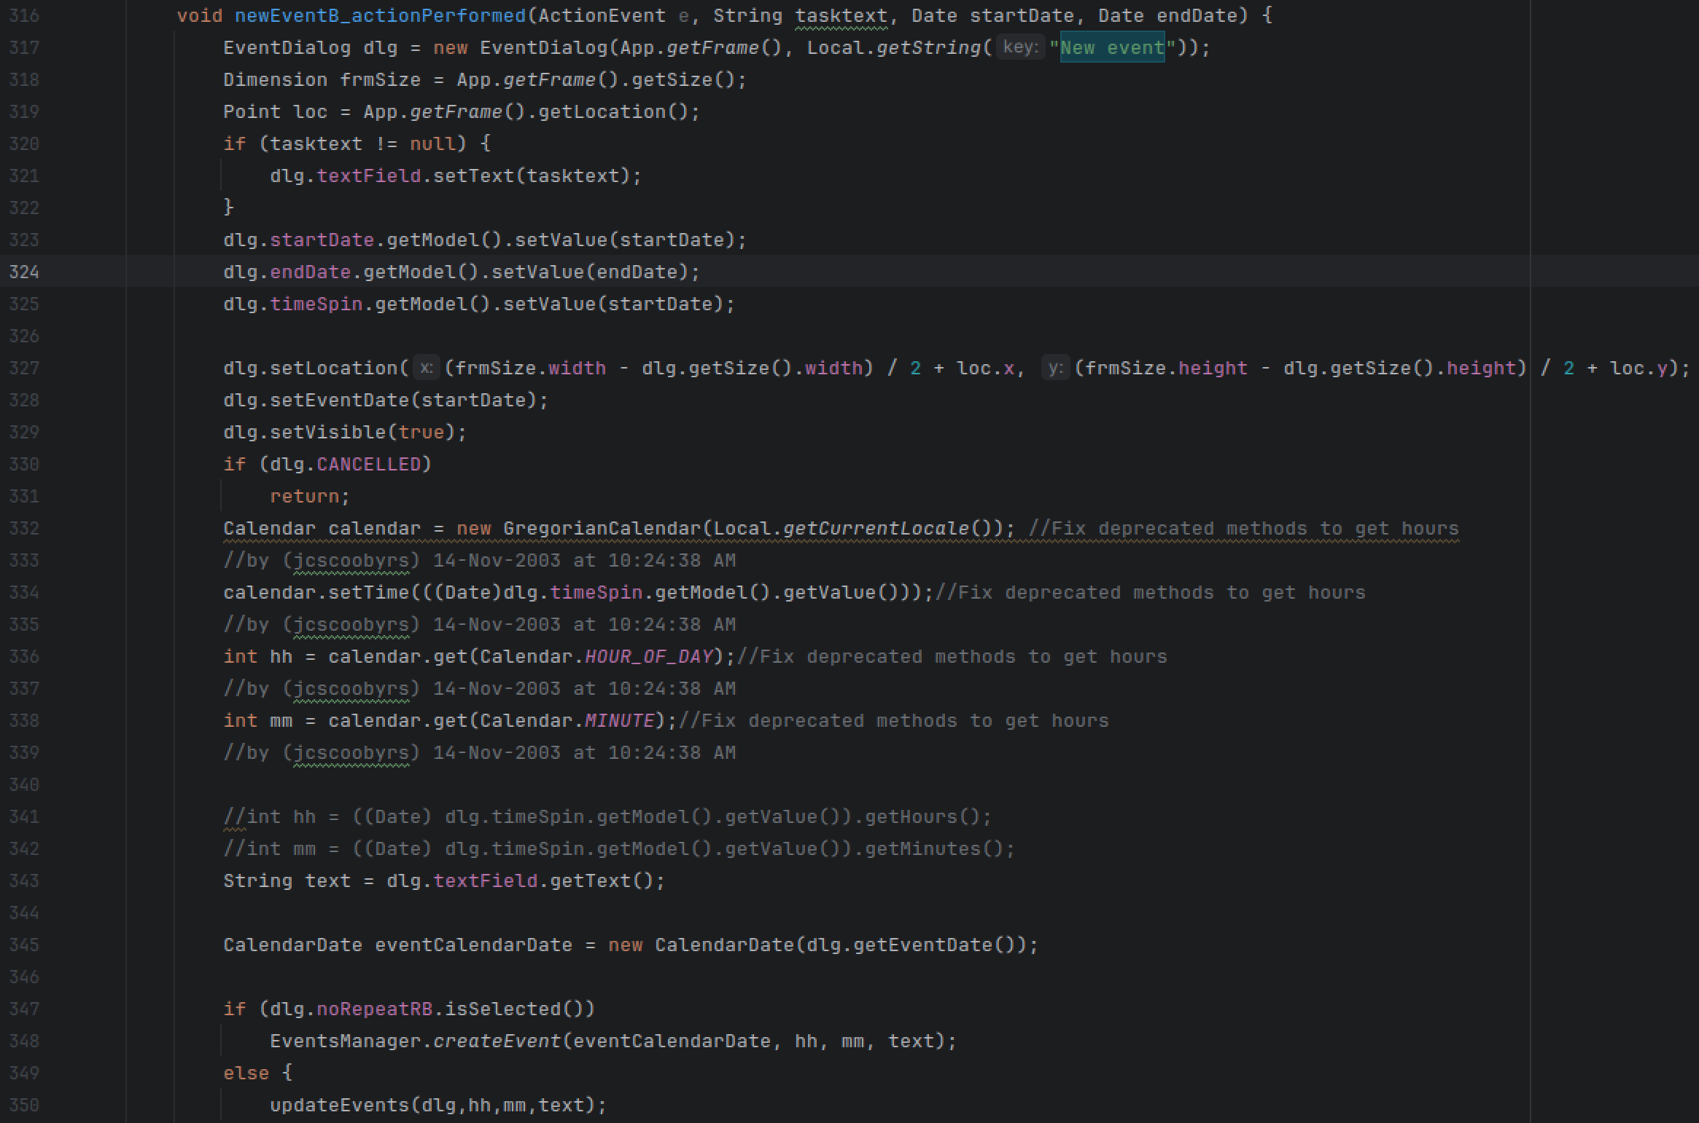

Screenshot – New event pop-up
See ui/EventDialog.java
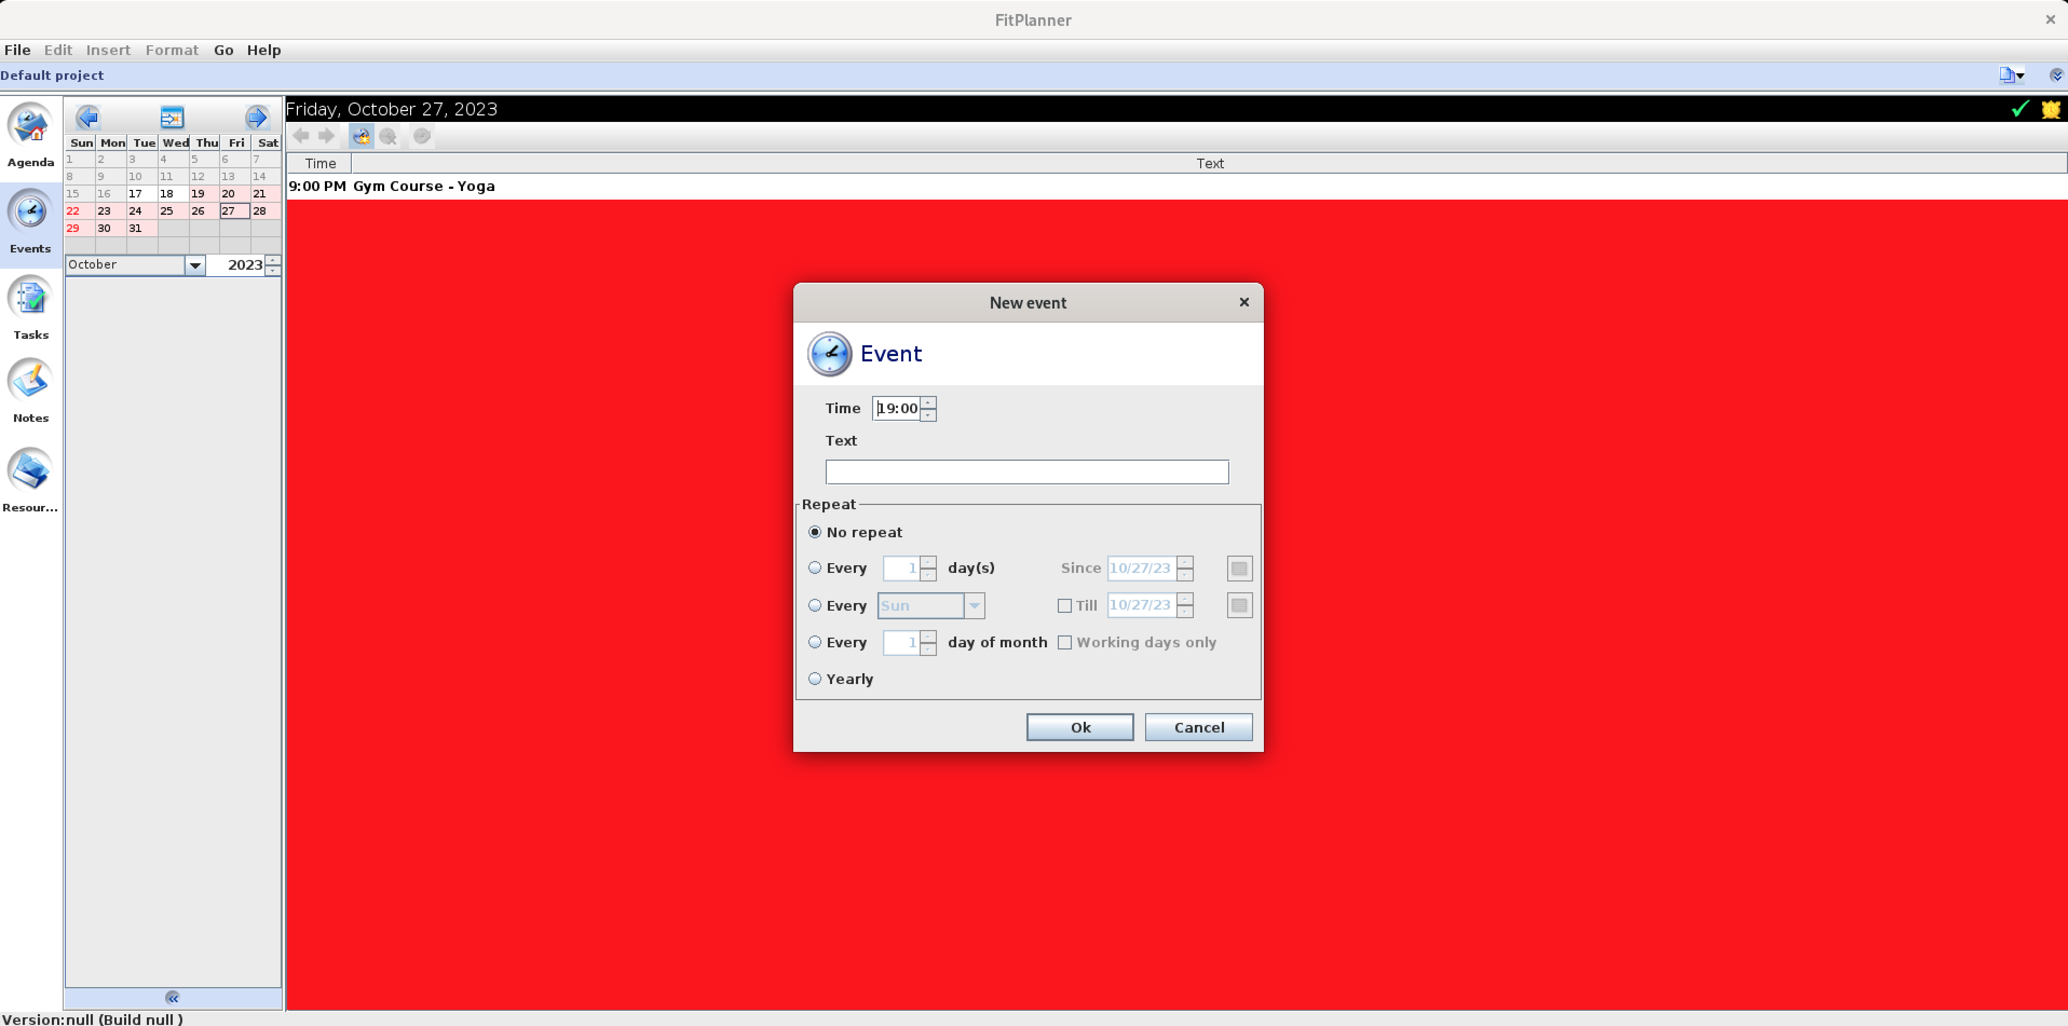

EventsManager.createEvent(eventCalendarDate, hh, mm, text);
See ui/EventsManager.java

private void saveEvents();
- See CurrentStorage
- EventsScheduler
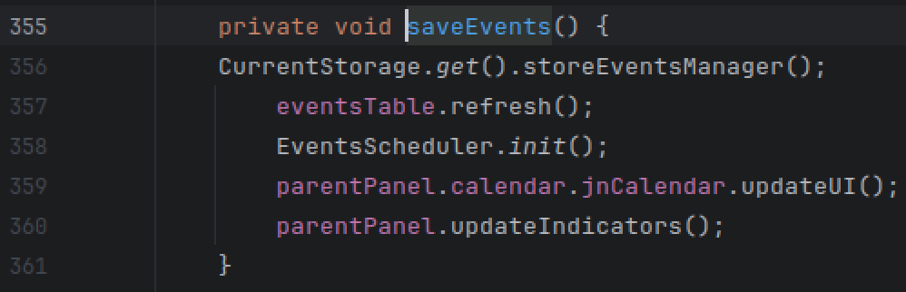

ui/EventDialog.java

UML

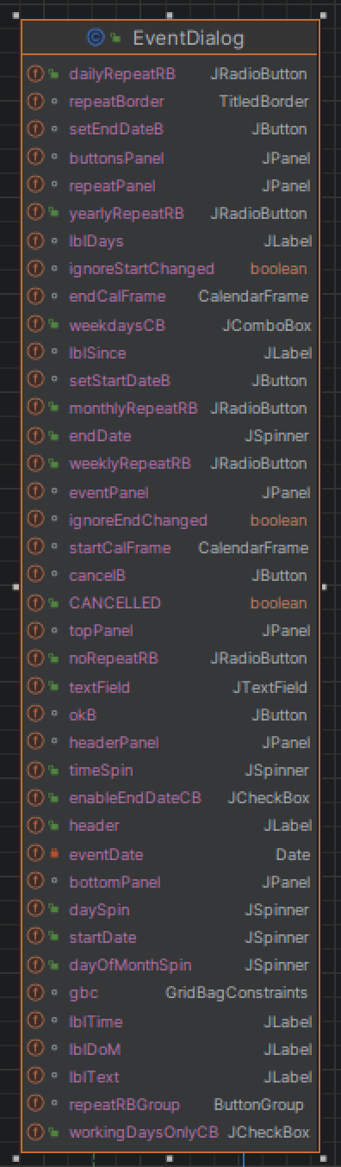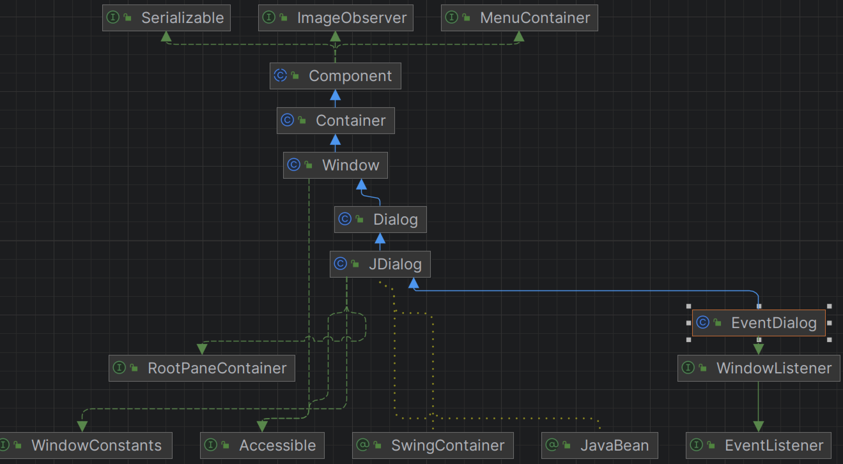

ui/EventsManager.java

UML
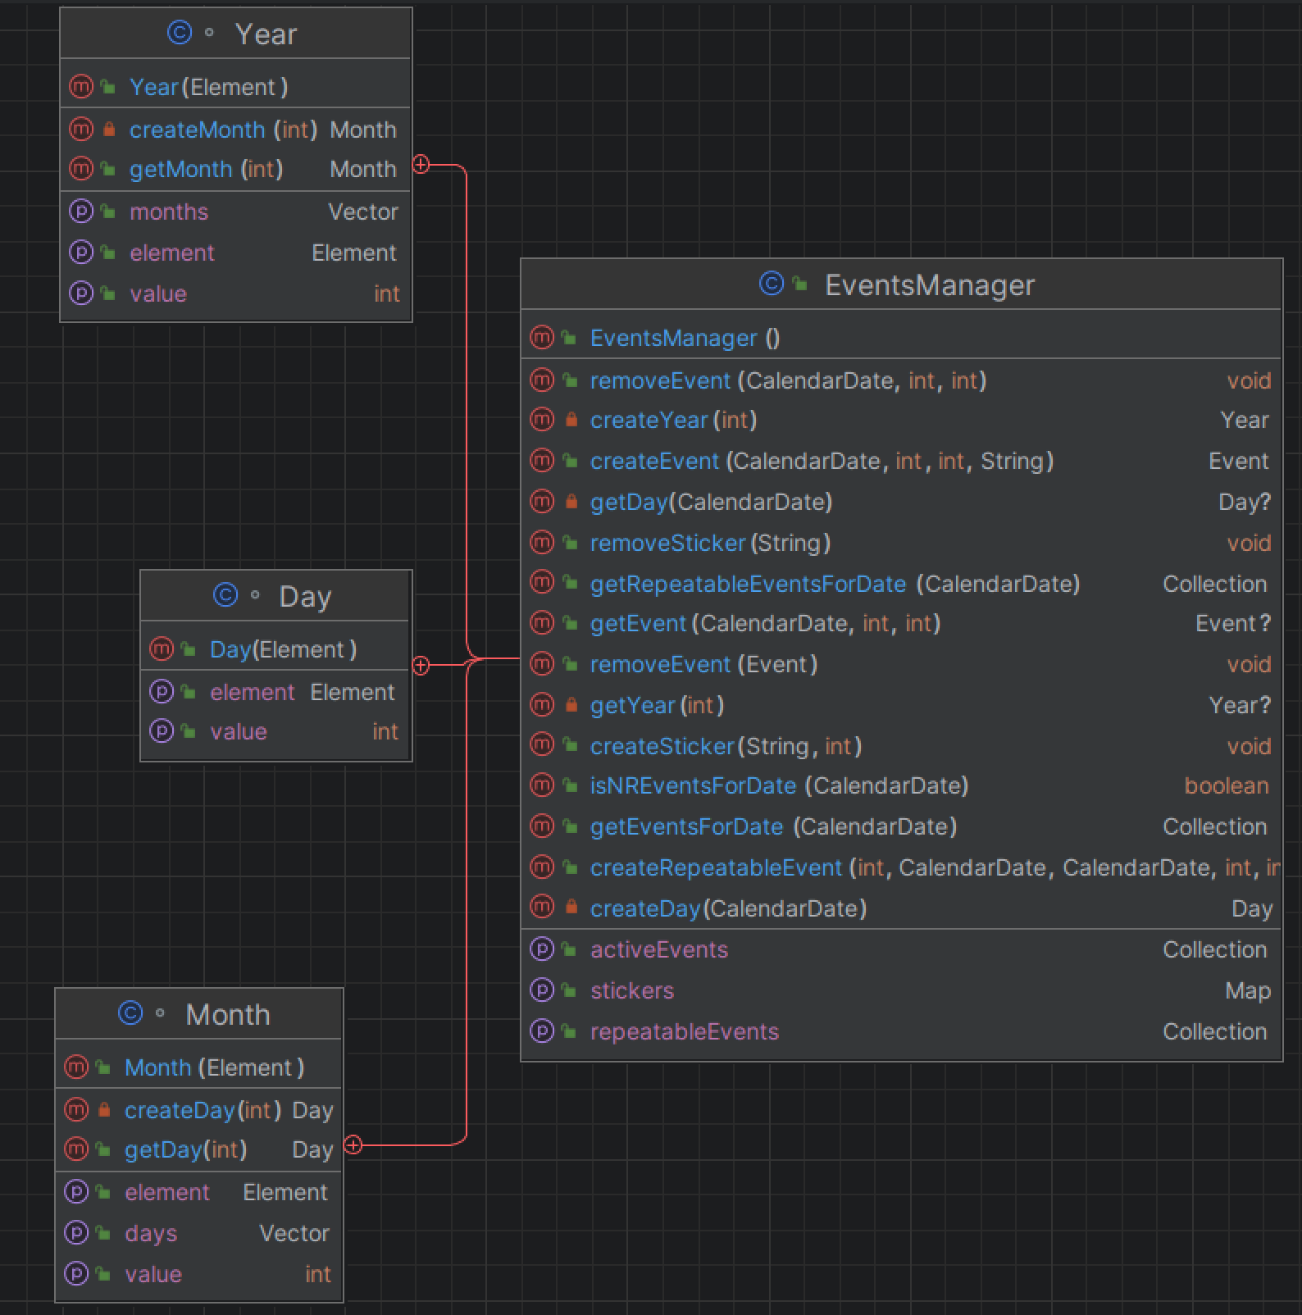

util/CurrentStorage.java

UML
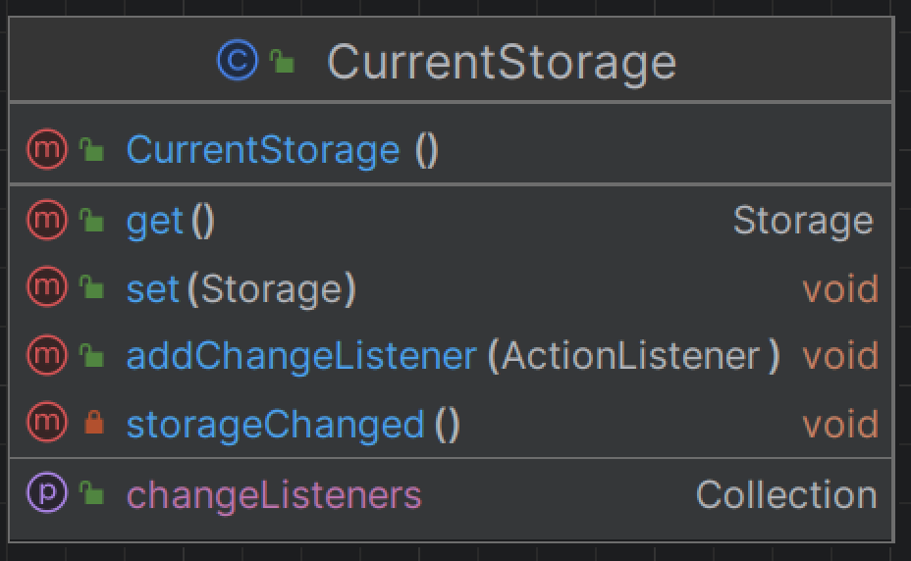

Dependencies
FileStorage

util/FileStorage.java

UML
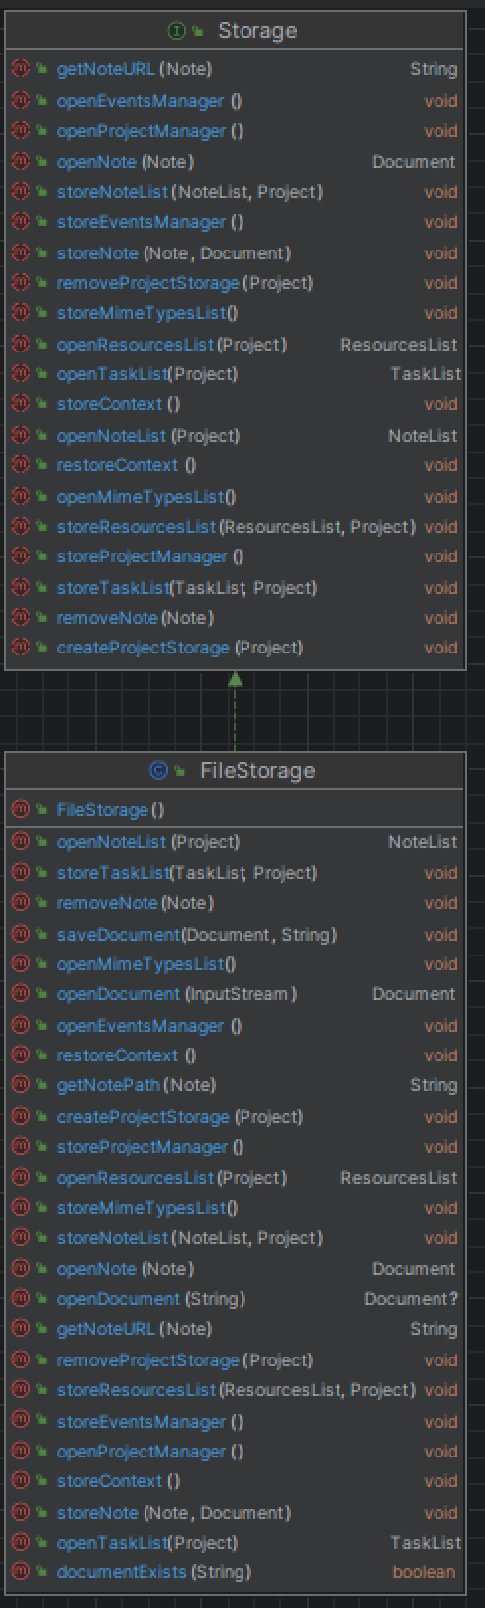

Overview: Events Read/Write to Disk
This is where files are transferred to and from disk

openEventsMangaer() - Screenshot code snippet
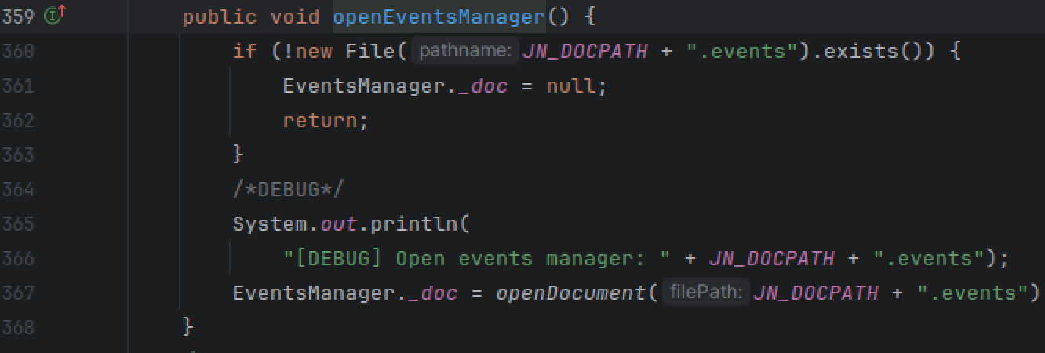

storeEventsManager() – Screenshot code snippet

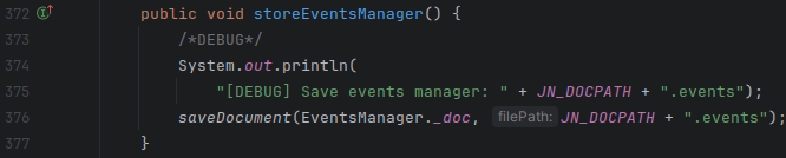

Screenshot: Debug: Save events manager

