CS4341 Project 6: Bayesian Parameter Learning

This project seeks to explore the Bayes Net Toolbox feature of MATLAB. We use it in a simple sense to generate a random network and attempt to use the algorithm to learn various parameters using the EM-Method.

# 1.

The script uses initially random values for each parameter to attempt to see if it can learn. After 3 Iterations, this is what our answers became:

intial params: prior: 0.631, learn: 0.355, forget: 0.000, guess: 0.997, slip: 0.224

learned params: prior: 0.300, learn: 0.141, forget: 0.000, guess: 0.162, slip: 0.083

true params: prior: 0.300, learn: 0.140, forget: 0.000, guess: 0.200, slip: 0.080

Mean Absolute Error of parameter learning: 0.0083

## 2.

The script had to be modified only to look at the observed nodes. (Nodes 6-10 in this specific case.) Using initially random parameters, but now only looking at observable state values, our answers became.

intial params: prior: 0.631, learn: 0.355, forget: 0.000, guess: 0.997, slip: 0.224

learned params: prior: 0.289, learn: 0.000, forget: 0.000, guess: 0.870, slip: 0.800

true params: prior: 0.500, learn: 0.140, forget: 0.000, guess: 0.200, slip: 0.080

Mean Absolute Error of parameter learning: 0.3481

This seems to be correct. Since the program ignores hidden states, we have some questionable values being returned. Additionally, our parameter learning error is high, so we can assume that this is not a good fit for the network.

# 3.

Example output: (since it happened 35 additional times.)

intial params: prior: 0.300, learn: 0.140, forget: 0.000, guess: 0.000, slip: 0.000

learned params: prior: 0.621, learn: 0.179, forget: 0.000, guess: 0.000, slip: 0.000

true params: prior: 0.500, learn: 0.140, forget: 0.000, guess: 0.200, slip: 0.080

Mean Absolute Error of parameter learning: 0.0880

Figure with Axes labeled:

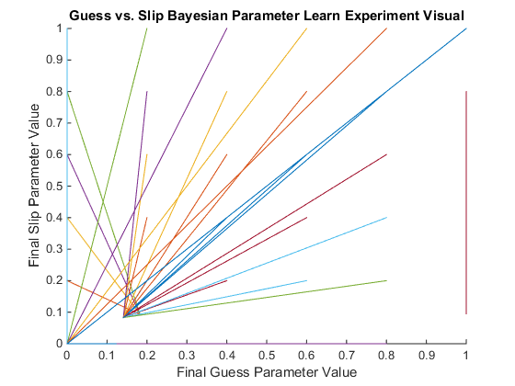

## Responses to follow-up questions on Question 3:

1. The x-axis of the figure refers to the the learned guess parameter changing over each EM iteration.
2. The y-axis of the figure pertains to the slip parameter changing over each EM iteration.
3. I see two distinct convergence points at (0,0) and then at (0.09,0.13). Which is indeed near our learned parameter values for each iteration.
4. The character of the initial paramters that will converge based on the diagram is any initial guess parameter in (0.13-1) paired with a initial slip value in (0.1-0.8).
5. With a larger number of samples there would only be more data to support the assertion of this figure. That is, the learned parameters would converge to the actual values for those parameters.
   1. In fact this assertion is correct, this figure was generated using 1000 samples per net:
   2. 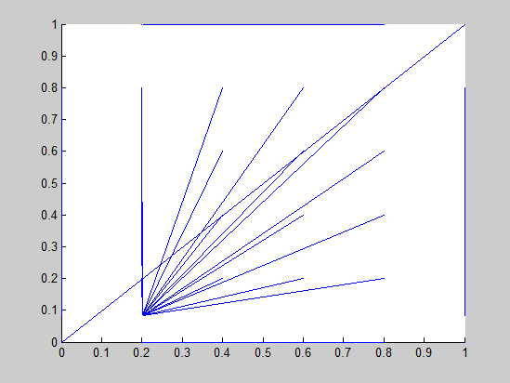
   3. As you can see there is a convergence at (0.20,0.09) like the true parameters suggest.