Zoe Pesce

MISM 3403

Database Lab Work

**Database Requirements:**

The DLZHP LLC Property Management Database will capture data about the following:

For each **building** owned: a building ID (unique), building address, building number of floors, price building was purchased at, year building was purchased, year building was built, building age (derived from year built and current date)

For each **Apartment**: a AptNo (partially unique, i.e., unique within a building), apartment number of bedrooms, apartment total rooms, rent amount

For each **Tenant**: a Tenant ID (unique), Tenant Full Name (composed of Tenant First Name and Tenant Last Name), multiple Tenant phone numbers, Tenant birthday, Tenant age (derived from tenant birthday and current date)

For each **Building Manager**: a Manager ID (unique), Manager Full Name (composed of Manager First Name and Manager Last Name), Manager Birthday, Manager Age (derived from manager birthday and current date), Manager salary, Manager bonus (optional), multiple manager phone numbers

For each **building inspector**: an Inspector ID (unique), Inspector full name (composed of inspector first name and inspector last name)

Each building has one or more apartments.

Each apartment is located in exactly one building.

Each apartment is leased to one or many tenants or it can be leased to none.

Each tenant leases one or many apartments.

Each building is managed by exactly one manager.

Each manager manages one or many buildings.

Each manager resides in exactly one building.

Each building has one manager residing in it or no managers residing in it.

Each inspector inspects one or many buildings.

Each building is inspected by one or many inspectors.

For each building that a particular inspector inspects, the dates of the last inspection and the date of the next future inspection by the inspector are recorded.

For each apartment a tenant leases, the Tenant's move in date and the Tenant's lease term date are recorded.

**ER Diagram:**

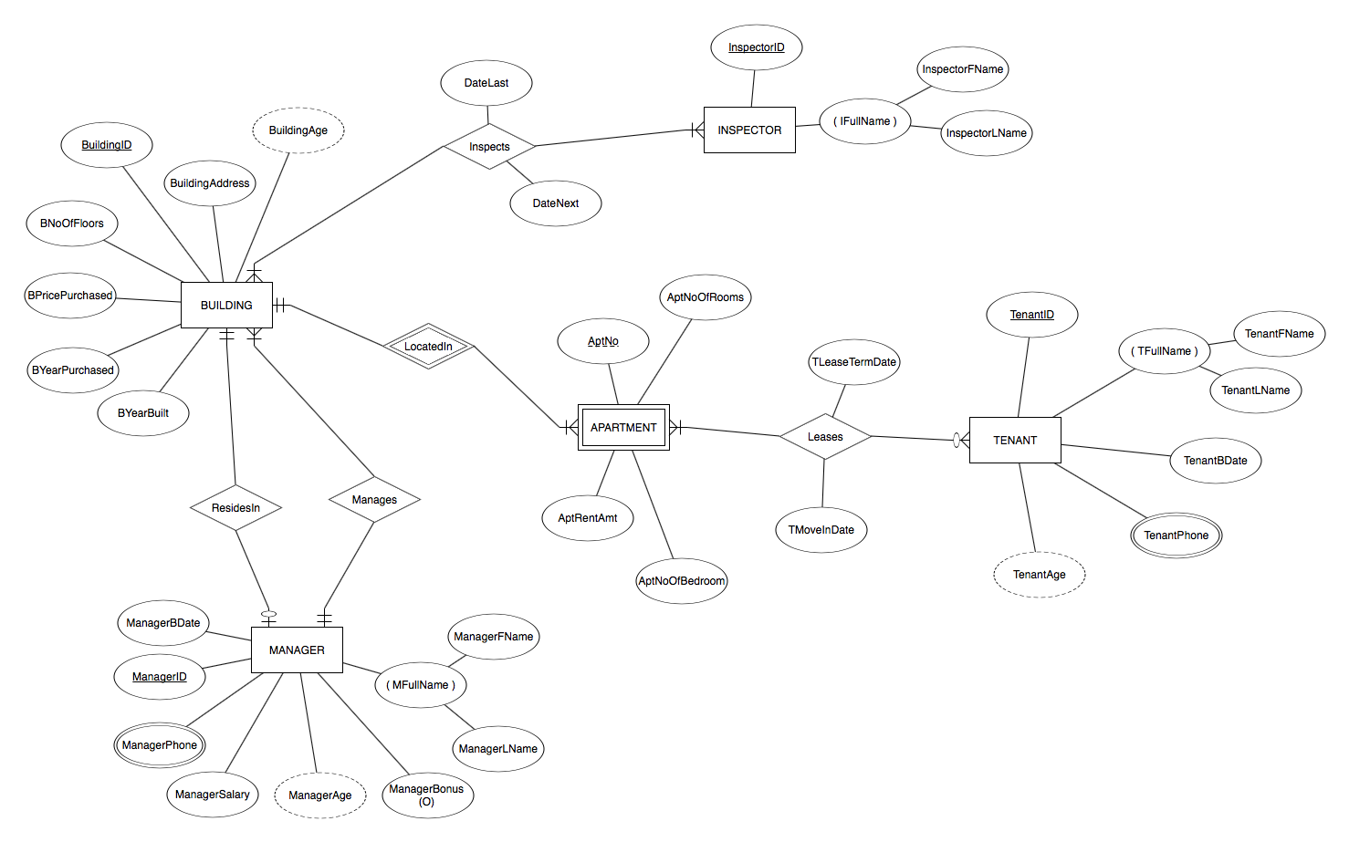

**Relational Schema:**

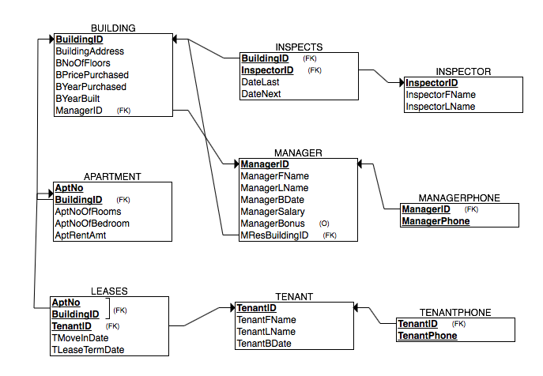

**After creation of the database I created a new table to further categorize Phone type (mobile or home). You can see this in my code, along with alterations of the managerphone and tenantphone tables, and updates to the values of these tables. After the addition of this table I updated my database requirements and the relational schema, as shown below. For my jupyter notebook because I wanted it to be able to run everything in one run (implementation, deployment, and use) so my queries could be included at the end, I repeated the code to create my database and included the phonetype table during initial creation of the whole database.**

**Updated Requirements:**

The DLZHP LLC Property Management Database will capture data about the following:

For each **building** owned: a building ID (unique), building address, building number of floors, price building was purchased at, year building was purchased, year building was built, building age (derived from year built and current date)

For each **Apartment**: a AptNo (partially unique, i.e., unique within a building), apartment number of bedrooms, apartment total rooms, rent amount

For each **Tenant**: a Tenant ID (unique), Tenant Full Name (composed of Tenant First Name and Tenant Last Name), multiple Tenant phone numbers, Tenant birthday, Tenant age (derived from tenant birthday and current date)

For each **Building Manager**: a Manager ID (unique), Manager Full Name (composed of Manager First Name and Manager Last Name), Manager Birthday, Manager Age (derived from manager birthday and current date), Manager salary, Manager bonus (optional), multiple manager phone numbers

For each **building inspector**: an Inspector ID (unique), Inspector full name (composed of inspector first name and inspector last name)

For each **phone type**: a phone type ID (unique) and phone type

Each building has one or more apartments.

Each apartment is located in exactly one building.

Each apartment is leased to one or many tenants or it can be leased to none.

Each tenant leases one or many apartments.

Each building is managed by exactly one manager.

Each manager manages one or many buildings.

Each manager resides in exactly one building.

Each building has one manager residing in it or no managers residing in it.

Each inspector inspects one or many buildings.

Each building is inspected by one or many inspectors.

For each building that a particular inspector inspects, the dates of the last inspection and the date of the next future inspection by the inspector are recorded.

For each apartment a tenant leases, the Tenant's move in date and the Tenant's lease term date are recorded.

**Updated Relational Schema:**

