The Signaling Cascade Challenge

The concentration of four intracellular proteins or phospho-proteins (X1, X2, X3 and X4) participating in a signaling cascade were measured in about 10⁴ cells by antibody staining and flow cytometry. The idea of this challenge is to explore what key aspects of the dynamics and topology of interactions of a signaling cascade can be inferred from incomplete flow cytometry data.

The challenge

We measured the concentration of four components in a portion of a signal transduction cascade in primary cells of undisclosed nature as shown in the Figure.

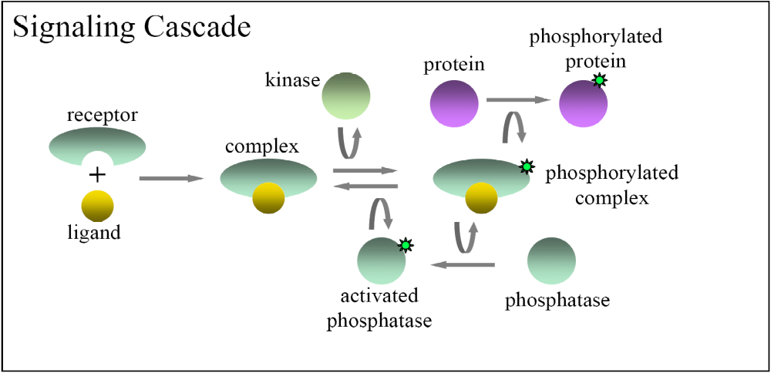
Figure. Schematics of the signaling cascade. A ligand binds to the membrane bound receptor creating a complex. A kinase catalyzes the phosphorylation of complex into phosphorylated complex. The latter is a catalyst of both the phosphorylation of protein into phosphorylated protein, and of phosphatase into activated phosphatase. The activated phosphatase catalyzes the dephosphorylation of phosphorylated complex into complex.

These cells were activated with ligands for one of their membrane-bound receptors. Two types of ligands: weak and strong (i.e., with different potency), and in different quantities, have been used. The data sets explained in the next section describe measurements on individual cells by antibody staining and flow cytometry for different proteins. The challenge is as follows: given the measurements of components X1, X2, X3 and X4 determine which of the following functions: kinase, protein, phosphorylated protein, phosphatase, activated phosphatase and phosphorylated complex in the signaling cascade of the figure correspond to the measured molecular species X1, …, X4. In other words: is X1 the activated phosphatase? Is X2 the kinase? And so on.

The datasets

We obtained a series of measurements of the signal transduction in primary cells of undisclosed nature. The data sets offered to the participants compile measurements on individual cells by antibody staining and flow cytometry for 4 different proteins or phopshoproteins. Depending on the availability of reagents, each file contains measurements on 10⁴ to 10⁵ cells for the levels of protein Xi (i=1…4) at 5min of activation for one strong ligand and seven quantities and one weak ligand and five quantites. Each row represents an individual cell, and each entry indicates the fluorescence level in arbitrary units. The measurements were taken in the range in which fluorescence is linear with concentration.

The names and contents of the files are as follows.

The files

StrongLigand_j_Xi_X4.csv

(where the extension csv stands for comma separated values) contain the values for the proteins Xi (first column) and X4 (second column), which were labeled in the same cell and measured simultaneously, but independently of the other proteins. It corresponds to the activation by 10^{7-j} strong ligands (for 0<j<7) or no ligand (for j =7).

The files

WeakLigand_j_Xi_X4.csv

(where the extension csv stands for comma separated values) contain the values for the proteins Xi (first column) and X4 (second column), which were labeled in the same cell and measured simultaneously, but independently of the other proteins. It corresponds to the activation by 10^{5-j} strong ligands (for 0<j<5) or no ligand (for j=5).

Submission of predictions

Download the file DREAM3_SignalingCascadeChallenge.xls. This file contains a header line and four rows corresponding to each of the four measured proteins X1, …, X4, as follows:

 | Kinase | Protein | Phosphorylated Protein | Phosphatase | Activated Phosphatase | Complex | Phosphorylated Complex
X1
X2
X3
X4

Complete the table by inserting a 1 in the box for the assignments considered correct and a 0 otherwise. For example, if Xi is deemed to be an activated phosphatase, then add a 1 in the corresponding box (intersection of row Xi and “activated phosphatase” column). Each row has to have exactly one 1 and five 0s. Each column can have either all zeros, or exactly one 1 and three 0s. After completing the table, save it in text format as:

TeamName_SignalingCascadeChallenge.txt,

where TeamName is the name of the team with which you registered for the challenge. Unfilled boxes in the table will be considered to have a zero)

Scoring metrics

We will score the results based on the probability that a random assignment would result in the same number of correct assignments achieved in the actual prediction.

