1. Given the provided data, what are three conclusions we can draw about Kickstarter campaigns?
   * The majority of campaigns are related to entertainment (music, theater, film/TV). As such, these types of campaigns have a higher success rate compared to other types.
     + Of the entertainment category, plays are the most common sub-category type of campaign.
   * Donations to campaigns decrease around the holidays (Nov-Jan). Campaigns started in spring (Apr-May) have the best chance of success.
   * Campaigns in the food category are more likely to fail than to succeed. The opposite is true of music: music related campaigns are more likely to succeed than to fail.
2. What are some limitations of the dataset?
   * Currency isn’t standardized. If donations for all campaigns were in/converted to the same currency/exchange rate, comparisons of donation totals and averages could be done across countries.
   * The hierarchy of categories could be expanded to allow for even more in depth analysis of successful vs. unsuccessful campaigns. For example, my conclusion that entertainment related campaigns make up the majority of the dataset is a bit of a jump since “entertainment” is not an official parent category in the existing dataset. We also have no way of breaking down subcategories even further. Using television as an example, are sitcoms more successful than cooking shows or dramas? Using television as an example again, an expanded dataset could have a category hierarchy of: entertainment > film & video > television > sitcoms. This would allow us to drill down even further into the more and less successful types of campaigns.
3. What are some other possible tables and/or graphs that we could create?
   * Pie charts showing the breakdown of sub-categories within their broader categories
     + We can already do this visualization in a different way using the second pivot table created, which has the bonus of also showing rate of success versus failure per sub-category. However, I believe a pie chart is a clearer visualization of sub-category distribution on its own.

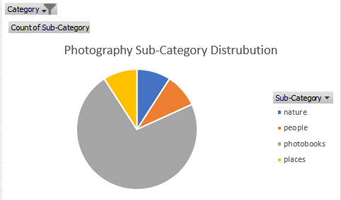

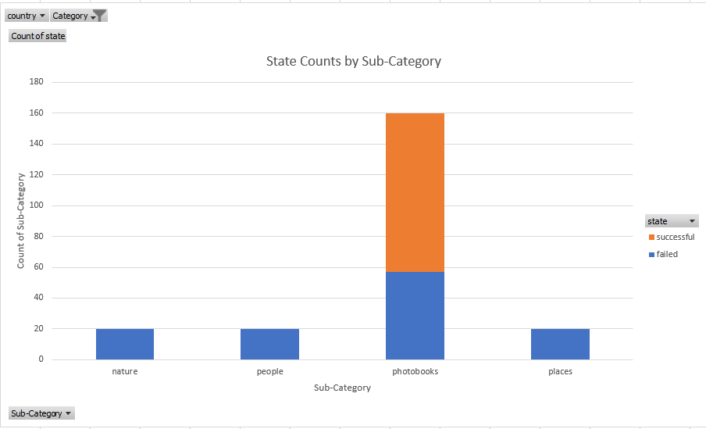

* + Using the date created and date ended, we could calculate the length of each campaign and compare it to success rates. Did campaigns with a longer run time have a better chance of success? (Answer: no. Successful campaigns were shorter on average).

