6.7 Consider the following grammar for simple Pascal-style declarations:

decl→ var-list：type

var-list→ var-list，id | id

type->integer | real

Write an attribute grammar for the type of a variable.

|  |  |
| --- | --- |
| grammar | semantic |
| decl→ var-list：type | var-list.dtype = type.dtype |
| var-list1→ var-list2，id | id.dtype = var-list1.dtype  var-list2.dtype = var-list1.dtype |
| var-list→ id | id.dtype = var-list.dtype |
| type->integer | type.dtype = integer |
| type->real | type.dtype = real |

6.8 Consider the grammar of Exercise 6.7.Rewrite the grammar so that the type of a variable can be defined as a purely synthesized attribute，and give a new attribute grammar for the type that has this property.

decl→ ***id*** var-list

var-list→ ，***id*** var-list | ：type

type->***integer*** | ***real***

|  |  |
| --- | --- |
| grammar | semantic |
| decl→ ***id*** var-list | ***id***.dtype = var-list.dtype |
| var-list1→ ，***id*** var-list2 | ***id***.dtype = var-list2.dtype  var-list1.dtype = var-list2.dtype |
| var-list→ ：type | var-list.dtype = type.dtype |
| type->***integer*** | type.dtype = ***integer*** |
| type->***real*** | type.dtype = ***real*** |

6.13 Consider the following attribute grammar:

Grammar Rule Semantic Rules

S→ ABC *B.u=S.u*

*A.u=B.v+C.v*

*S.v=A.v*

A→ a *A.v=2*A.u*

B→ b *B.v=B.u*

C→c *C.v=1*

1. Draw the parse tree for the string ***abc*** (the only string in the language),and draw the dependency graph for the associated attributes. Describe a correct order for the evaluation of the attributes.

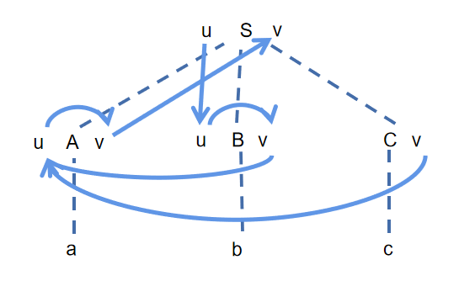

order: C.v → S.u → B.u → B.v → A.u → A.v → S.v

1. Suppose that *S.u*  is assigned the value 3 before attribute evaluation begins. What is the value of *S.v* when evaluation has finished?

B.u = 3

B.v = 3

A.u = 4

A.v = 8

S.v = 8

c. Suppose the attribute equations are modified as follows:

Grammar Rule Semantic Rules

S→ ABC *B.u=S.u*

*C.u=A.v*

*A.u = B.v + C.v*

*S.v=A.v*

A→a *A.v=2*A.u*

B →b *B.v=B.u*

C→c  *C.v → C.u-2*

What value does *S.v* have after attribute evaluation, if *S.u = 3* before evaluation begins?

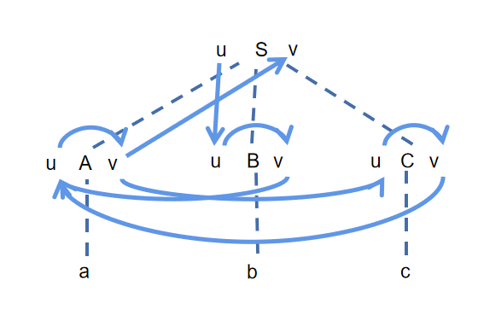

There is no meaningful value since the dependency is cyclic.