Class: CSE320 Digital Design and Synthesis

Time: T-TH 4:30PM

Semester: Spring 2014

Lab 1 Report

The purpose of this assignment is two-fold. First, it is to gain experience in writing Verilog behavioral and structural descriptions of a most common component in digital systems, namely, combinational adders, and to perform functional and (abstract) timing simulation. Second is to learn some remarkably simple ways of increasing the performance of adders.

**Part 1**

**Answers:**

a)

module a_full_adder(sum,c_out,a,b,c_in);

input a,b,c_in;

output sum, c_out;

wire g,p,pc;

// Internal nets

wire s1, c1, c2;

// Logic gates

xor #2 (s1, a, b);

and #1 (c1, a, b);

xor #2 (sum, s1, c_in);

and #1 (c2, s1, c_in);

or #1 (c_out, c2, c1);

endmodule

b)

module a_n_rca(sum, c_out, a, b, c_in);

parameter n = 4;

input [n-1:0] a,b;

input c_in;

output [n-1:0] sum;

output c_out;

wire [n-1:0] gen, prop;

wire [n:0] cc; // internal carry bits

assign cc[0] = c_in;

assign c_out = cc[n];

genvar j;

generate

for(j=0 ; j<n ; j=j+1) begin

a_full_adder FA(sum[j],cc[j+1],a[j],b[j],cc[j]);

end

endgenerate

endmodule

c)

|  |  |
| --- | --- |
| n-bit rca | ns |
| 4 | 10 |
| 8 | 18 |
| 16 | 34 |
| 32 | 66 |
| 64 | 130 |
| 128 | 258 |

Explanation: The delay time (in nanosecond) equals nearly the double of the n-bits of the RCA. As shown in the plot, when the RCA bit capacity increases, the delay times increases.

**Wave forms:**

**N=4** 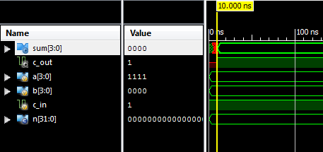

**N=8** 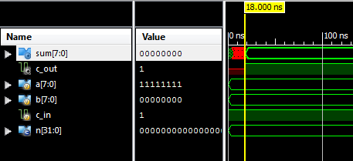

**N=16** 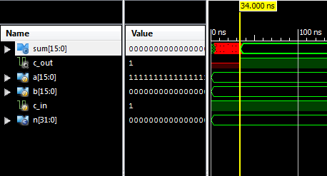

**N=32** 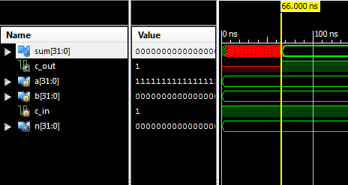

**N=64** 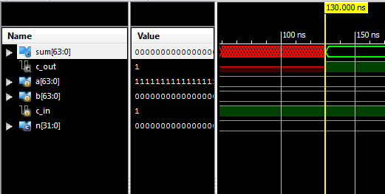

**N=128** 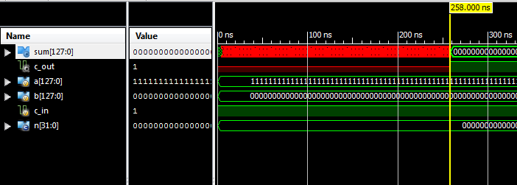

**Code:**

module a_full_adder(sum,c_out,a,b,c_in);

input a,b,c_in;

output sum, c_out;

// Internal nets

wire s1, c1, c2;

// Logic gates

xor #2 (s1, a, b);

and #1 (c1, a, b);

xor #2 (sum, s1, c_in);

and #1 (c2, s1, c_in);

or #1 (c_out, c2, c1);

endmodule

module a_n_rca(sum, c_out, a, b, c_in);

parameter n = 4;

input [n-1:0] a,b;

input c_in;

output [n-1:0] sum;

output c_out;

wire [n-1:0] gen, prop;

wire [n:0] cc; // internal carry bits

assign cc[0] = c_in;

assign c_out = cc[n];

genvar j;

generate

for(j=0 ; j<n ; j=j+1) begin

a_full_adder FA(sum[j],cc[j+1],a[j],b[j],cc[j]);

end

endgenerate

endmodule

module a_n_rca_tb;

parameter n=4;

// Inputs

reg [n-1:0] a;

reg [n-1:0] b;

reg c_in;

// Outputs

wire [n-1:0] sum;

wire c_out;

// Instantiate the Unit Under Test (UUT)

a_n_rca #(n) uut (

.sum(sum),

.c_out(c_out),

.a(a),

.b(b),

.c_in(c_in)

);

initial begin

// Add stimulus here

a=4'hF;b=4'h0;c_in=1;

#700 $finish;

End

endmodule

**Part 2**

**Answers:**

a)

|  |  |  |
| --- | --- | --- |
| K | N-bit cba | ns |
| 1 | 4 | 8 |
| 2 | 8 | 16 |
| 4 | 16 | 32 |
| 8 | 32 | 64 |
| 16 | 64 | 128 |
| 32 | 128 | 256 |

Explanation: The delay time (in nanosecond) M (4 in this case) multiplied with the half value of N (bits). As shown in the plot, when the RCA bit capacity increases, the delay times increases by the double.

b)

delay = M * (N/2) (M=4 in this example)

**Wave forms:**

**K=1, N=4** 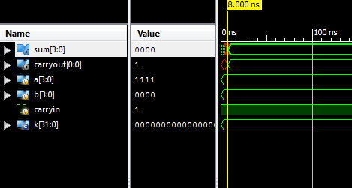

**K=2, N=8** 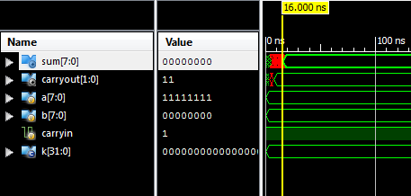

**K=4, N=16** 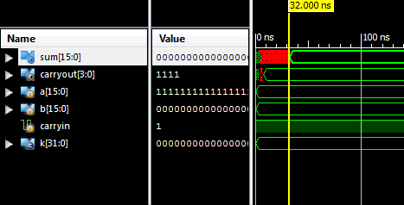

**K=8, N=32** 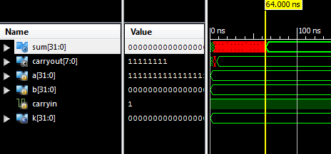

**K=16, N=64** 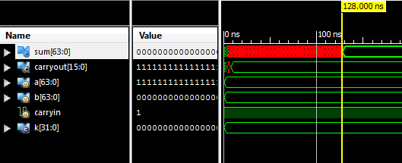

**K=32, N=128** 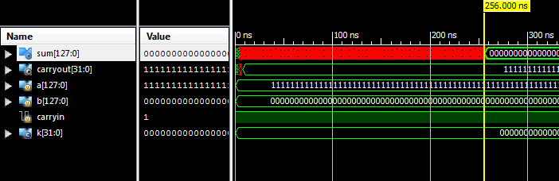

**Code:**

// CARRY-SKIP ADDER

module a_n_cba(a,b,carryin,sum,carryout);

parameter m = 4;

parameter k = 2;

parameter n = k*m;

input [n-1:0] a, b; /* add these bits */

input carryin; /* carry in*/

output [n-1:0] sum; /* result */

output [k-1:0] carryout;

wire [n:0] carry; /* transfers the carry between bits */

wire [n-1:0] p; /* propagate for each bit */

assign carry[0] = carryin;

genvar i,j;

generate

for(i=1 ; i<=k ; i=i+1) begin

for(j=0 ; j<i*m ; j=j+1) begin

a_skip_fulladder A(a[j],b[j],carry[j],sum[j],carry[j+1],p[j]);

end

assign #2 carryout[i-1] = carry[j] | ((p[j-4] & p[j-3] & p[j-2] & p[j-1] & carryin));

end

endgenerate

endmodule

module a_skip_fulladder(a,b,carryin,sum,carryout,p);

input a,b,carryin;

output sum,carryout,p;

assign #2 {carryout,sum}=a+b+carryin;

assign #2 p=a^b;

endmodule

module a_n_cba_tb;

parameter k=1;

// Inputs

reg [4*k-1:0] a;

reg [4*k-1:0] b;

reg carryin;

// Outputs

wire [4*k-1:0] sum;

wire [k-1:0] carryout;

// Instantiate the Unit Under Test (UUT)

a_n_cba #(.k(k)) uut (

.a(a),

.b(b),

.carryin(carryin),

.sum(sum),

.carryout(carryout)

);

initial begin

// Add stimulus here

a=8'hFF;b=8'h00;carryin=1;

#700 $finish;

end

endmodule

**Part 3**

**Answers:**

a)

|  |  |  |
| --- | --- | --- |
| k | N-bit CSA | ns |
| 1 | 4 | 6 |
| 2 | 8 | 10 |
| 4 | 16 | 18 |
| 8 | 32 | 34 |
| 16 | 64 | 66 |
| 32 | 128 | 130 |

1. delay = (k*M)+2 (M=4 In Examples)

**Wave forms:**

**K=1, N=4**

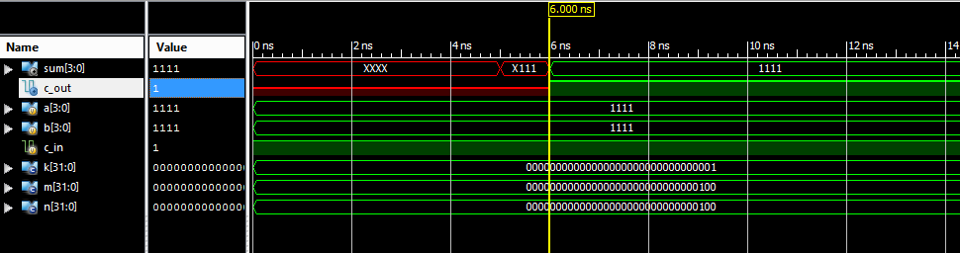

**K=2, N=8**

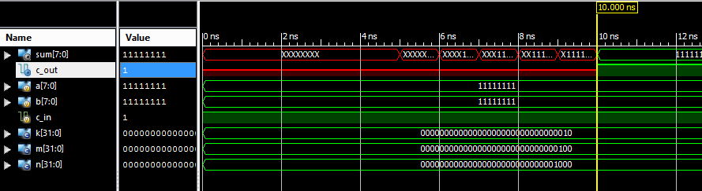

**K=4, N=16**

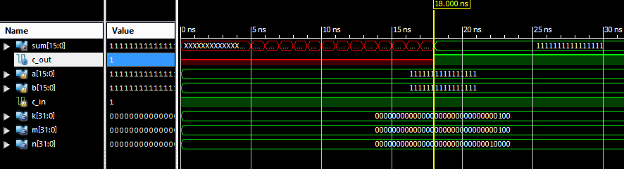

**K=8, N=32**

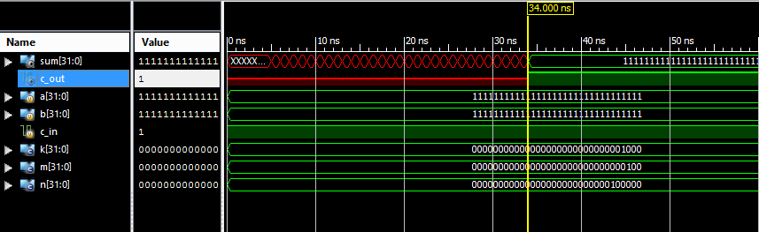

**K=16, N=64**

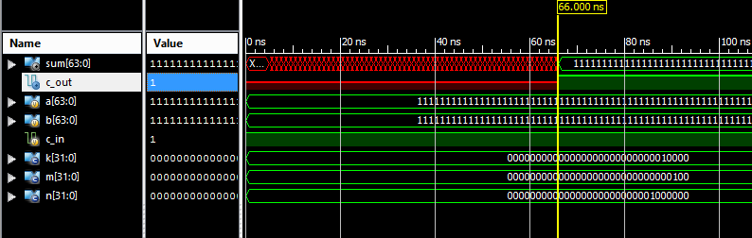

**K=32, N=128**

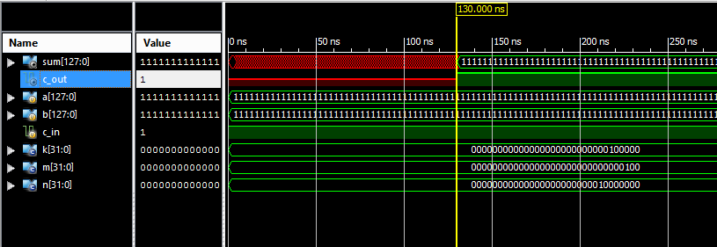

**Code:**

module z_n_csa(sum,c_out,a,b,c_in);

parameter k = 8;

parameter m = 4;

parameter n = k*m;

input [n-1:0] a, b;

input c_in;

output [n-1:0] sum;

output c_out;

wire [n:0] carry;

wire [n-1:0] sum_w;

assign carry[0] = c_in;

assign c_out = carry[n];

genvar j;

generate

for(j=0 ; j<k ; j=j+1) begin

z_m_sca_stage CSAM(sum[j*m+3:j*m],carry[j*m+4],a[j*m+3:j*m],b[j*m+3:j*m],carry[j*m]);

defparam CSAM[j].m=m;

end

endgenerate

endmodule

module z_m_sca_stage(sum,c_out,a,b,c_in);

parameter m = 4;

input [m-1:0] a, b;

input c_in;

output [m-1:0] sum;

output c_out;

wire [m:0] carry;

wire [m-1:0] sum_w;

assign carry[0] = c_in;

assign c_out = carry[m];

genvar j;

generate

for(j=0 ; j<m ; j=j+1) begin

z_csa_stage CSA(sum[j],carry[j+1],a[j],b[j],carry[j]);

end

endgenerate

endmodule

module z_csa_stage(sum,c_out,a,b,c_in);

input a,b,c_in;

output sum,c_out;

wire [1:0] sum_r, c_out_r;

// Full Adders for both c_in = 0 & 1

a_full_adder FA1(sum_r[0],c_out_r[0],a,b,0);

a_full_adder FA2(sum_r[1],c_out_r[1],a,b,1);

// MUX - Starts at the same time as the FA so no delay

z_2_1_mux M1(sum,sum_r[0],sum_r[1],c_in);

z_2_1_mux M2(c_out,c_out_r[0],c_out_r[1],c_in);

Endmodule

module a_full_adder(sum,c_out,a,b,c_in);

input a,b,c_in;

output sum, c_out;

wire g,p,pc;

// Internal nets

wire s1, c1, c2;

// Logic gates

xor #2 (s1, a, b);

and #1 (c1, a, b);

xor #2 (sum, s1, c_in);

and #1 (c2, s1, c_in);

or #1 (c_out, c2, c1);

endmodule

module z_2_1_mux(out,a,b,sel);

output out;

input a,b,sel;

wire sel_,a1,b1,out;

not not1(sel_,sel);

and #1 and1(a1,a,sel_);

and #1 and2(b1,b,sel);

or or1(out,a1,b1);

endmodule

**Part 4**

**Answers:**

a)

|  |  |  |
| --- | --- | --- |
| k | N-bit CSA | ns |
| 3 | 9 | 11 |
| 5 | 20 | 22 |
| 7 | 35 | 37 |
| 10 | 65 | 67 |
| 15 | 135 | 137 |

b) delay = ((k+1)(k+2)/2)+1

This result is because by the time that the carry out has left section n-1 the inputs for the mux of section 2 are then ready for the carry in. This cycle continues up to the end and all of the delay is generated by the MUX.

**Wave forms:**

**K=3, N=9**

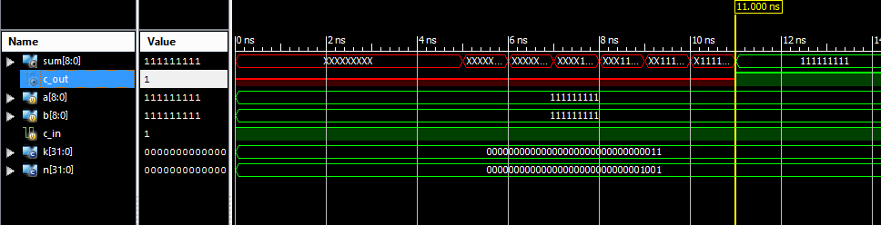

**K=5, N=20**

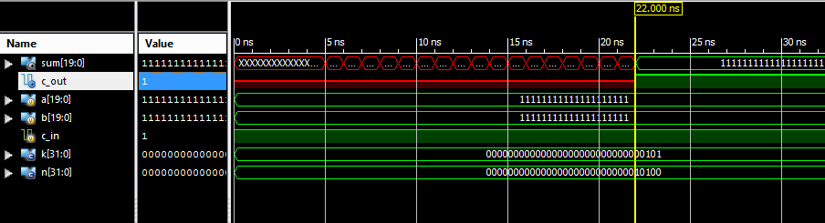

**K=7, N=35**

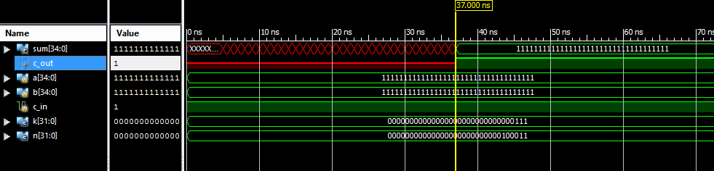

**K=10, N=65**

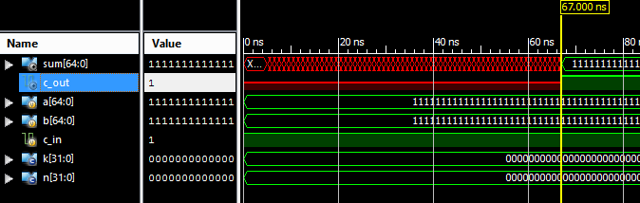

**K=15, N=135**

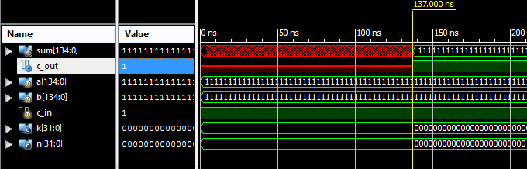

**Code:**

module z_sqcsa(sum,c_out,a,b,c_in);

parameter k = 15;

parameter n = ((k+1)*(k+2)/2)-1;

input [n-1:0] a, b;

input c_in;

output [n-1:0] sum;

output c_out;

wire [n:0] carry;

wire [n-1:0] sum_w;

assign carry[0] = c_in;

assign c_out = carry[k];

genvar j;

generate

for(j=0 ; j<k ; j=j+1) begin

parameter m = ((j+2)*(j+3)/2)-2;

parameter m_last = ((j+1)*(j+2)/2)-1;

z_m_sca_stage CSAM(sum[m:m_last],carry[j+1],a[m:m_last],b[m:m_last],carry[j]);

defparam CSAM[j].m=m+1-m_last;

end

endgenerate

endmodule

module z_m_sca_stage(sum,c_out,a,b,c_in);

parameter m = 4;

input [m-1:0] a, b;

input c_in;

output [m-1:0] sum;

output c_out;

wire [m:0] carry;

wire [m-1:0] sum_w;

assign carry[0] = c_in;

assign c_out = carry[m];

genvar j;

generate

for(j=0 ; j<m ; j=j+1) begin

z_csa_stage CSA(sum[j],carry[j+1],a[j],b[j],carry[j]);

end

endgenerate

endmodule

module z_csa_stage(sum,c_out,a,b,c_in);

input a,b,c_in;

output sum,c_out;

wire [1:0] sum_r, c_out_r;

// Full Adders for both c_in = 0 & 1

a_full_adder FA1(sum_r[0],c_out_r[0],a,b,0);

a_full_adder FA2(sum_r[1],c_out_r[1],a,b,1);

// MUX - Starts at the same time as the FA so no delay

z_2_1_mux M1(sum,sum_r[0],sum_r[1],c_in);

z_2_1_mux M2(c_out,c_out_r[0],c_out_r[1],c_in);

endmodule

module a_full_adder(sum,c_out,a,b,c_in);

input a,b,c_in;

output sum, c_out;

wire g,p,pc;

// Internal nets

wire s1, c1, c2;

// Logic gates

xor #2 (s1, a, b);

and #1 (c1, a, b);

xor #2 (sum, s1, c_in);

and #1 (c2, s1, c_in);

or #1 (c_out, c2, c1);

endmodule

module z_2_1_mux(out,a,b,sel);

output out;

input a,b,sel;

wire sel_,a1,b1,out;

not not1(sel_,sel);

and #1 and1(a1,a,sel_);

and #1 and2(b1,b,sel);

or or1(out,a1,b1);

endmodule

Last Page:

This is entirely our work and we have not received assistance in any form whatsoever.

Signatures:

Zachary Priddy Abdulla Al Braiki

------------------- ----------------------