Class: CSE320 Digital Design and Synthesis

Time: T-TH 4:30PM

Semester: Spring 2014

Lab 3 Report

The purpose of this assignment is to design the control logic of the MIPS processor. We incorporate the ALU that was designed in the lab 2. This module contains: PC Selector, Instruction Decoder, and ALU modules, with some extra logic.

**Code: ALU.v code**

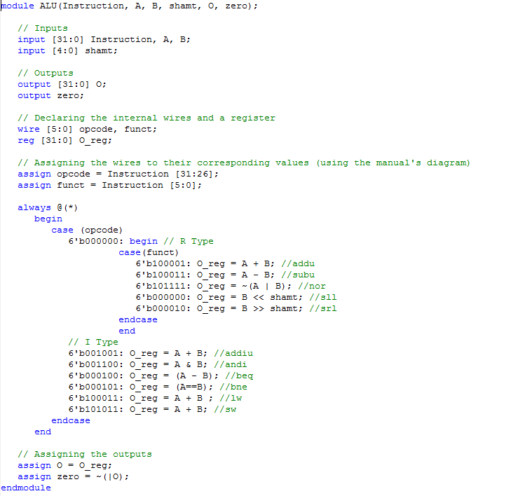

**ALU test bench code**

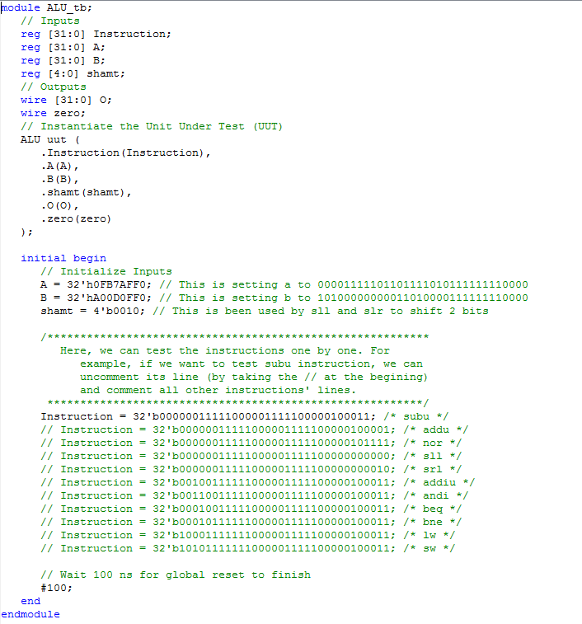

**PC.v code** 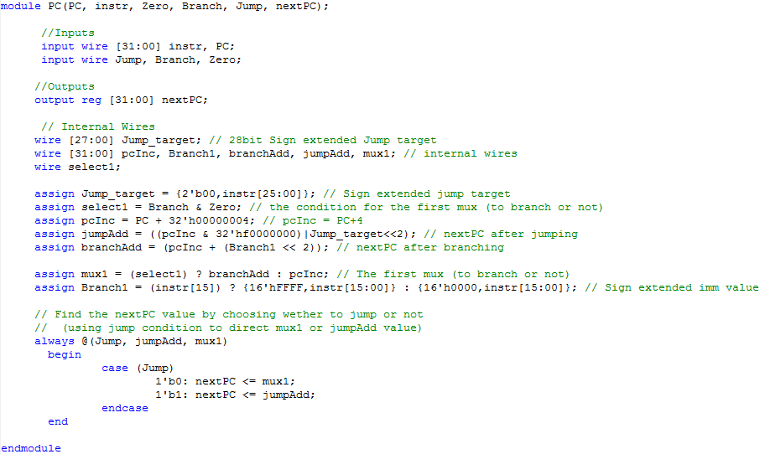

**PC test bench code**

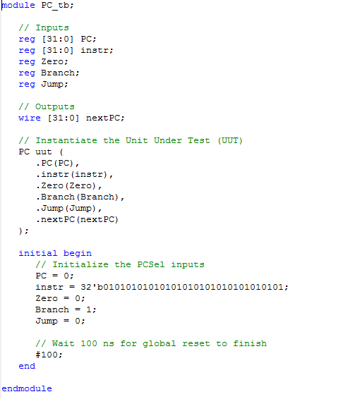

**instructionDecoder.v code** 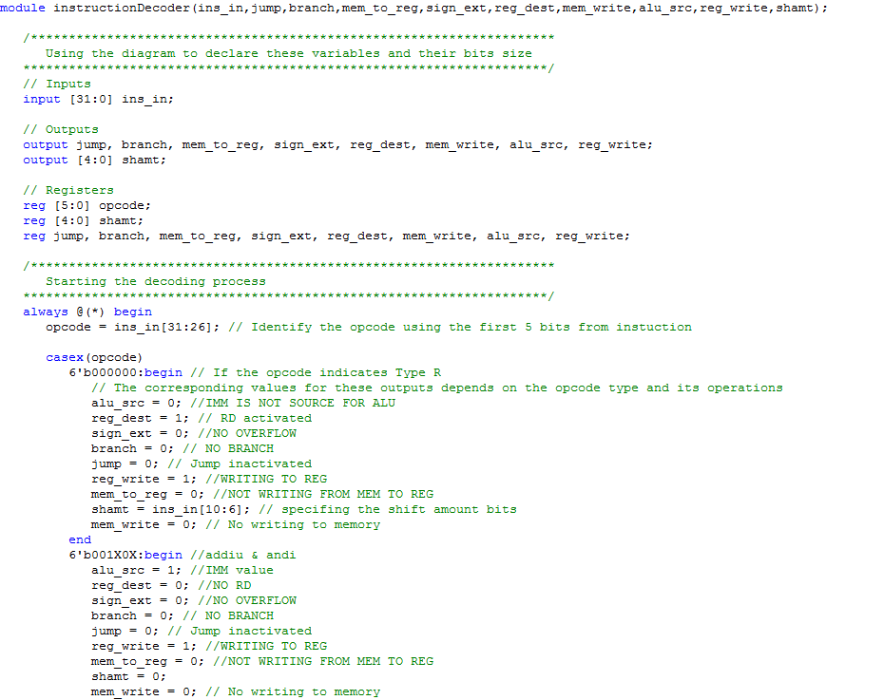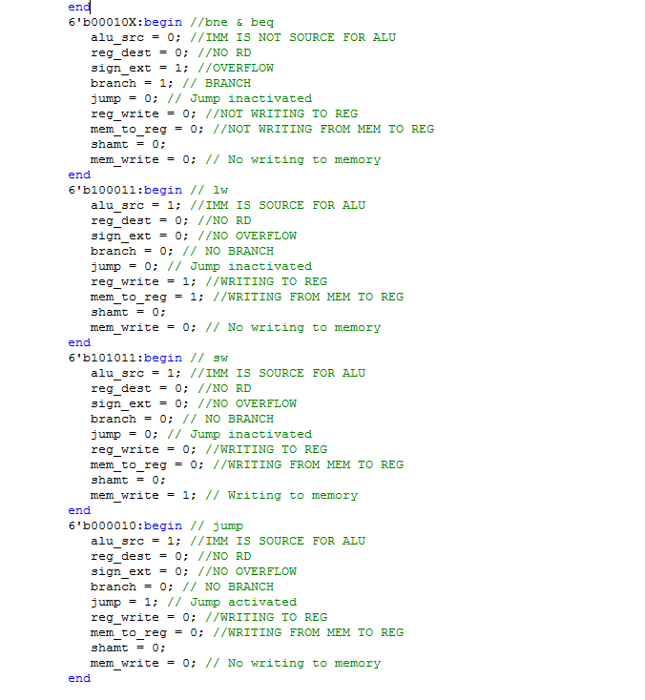

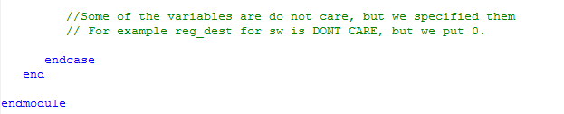

**instructionDecoder test bench code**

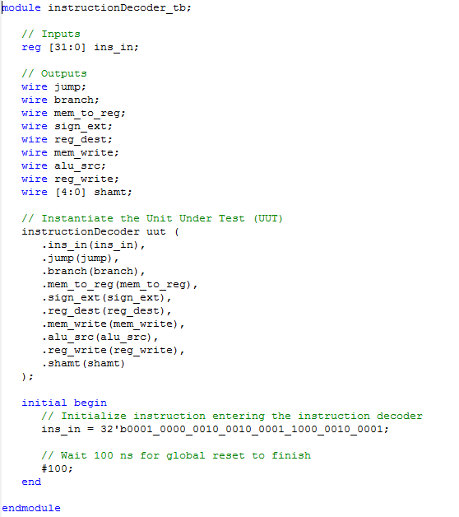

**controlLogic.v code**

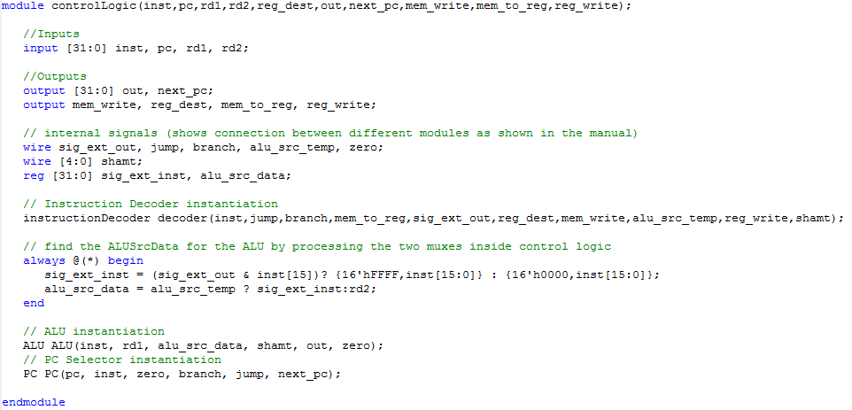

**controlLogic test bench code**

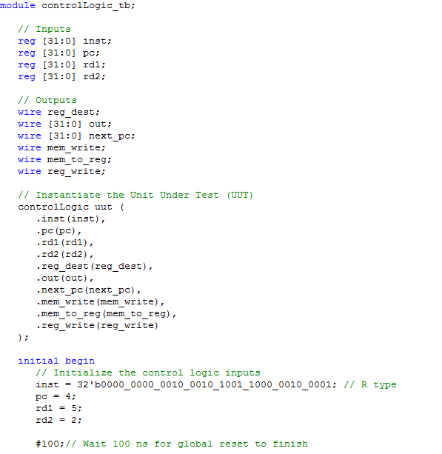

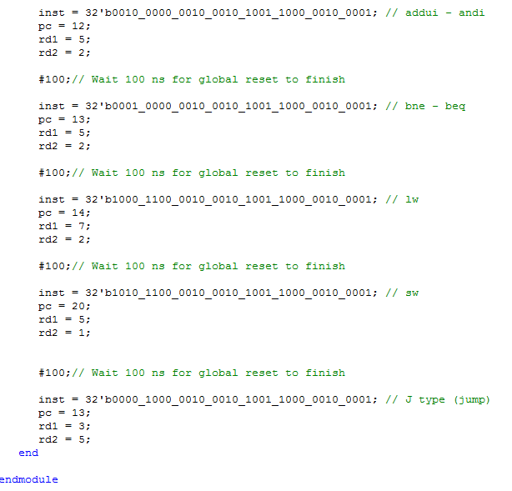

**Wave forms:**

**ALU Module**

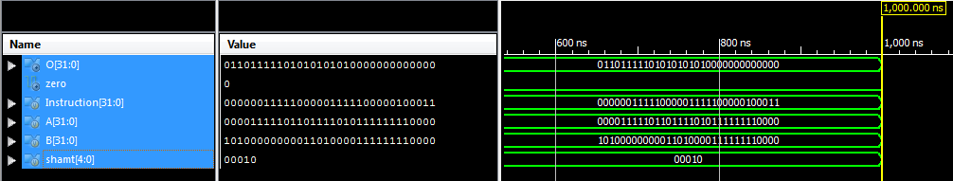

**PC Module**

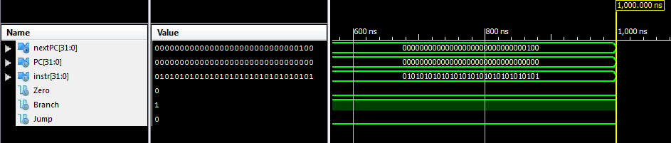

**instructionDecoder Module**

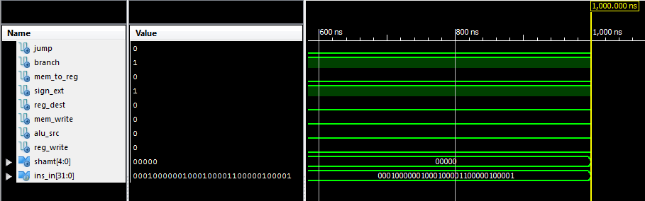

**ControlLogic Module**

**R type (addu)**

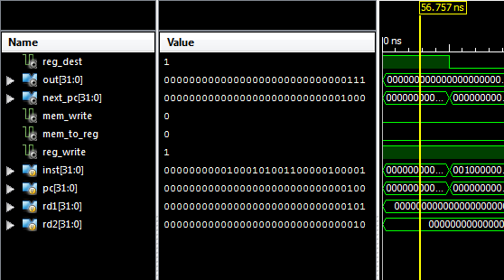

**Addui – andi**

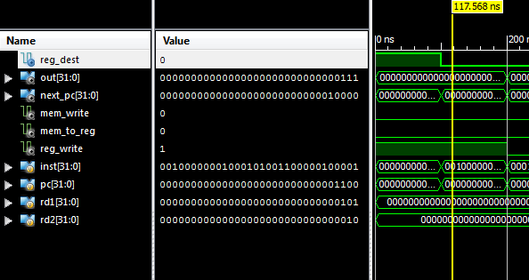

**bne – beq**

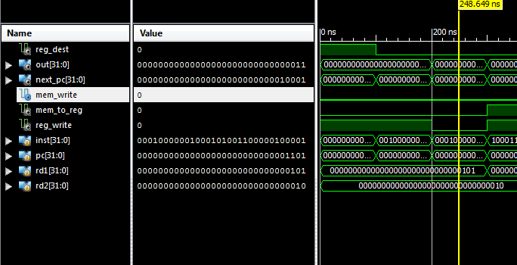

**Lw**

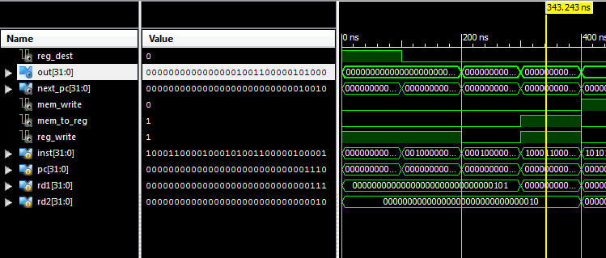

**Sw**

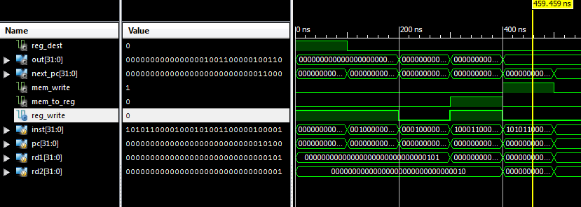

**J type (jump)**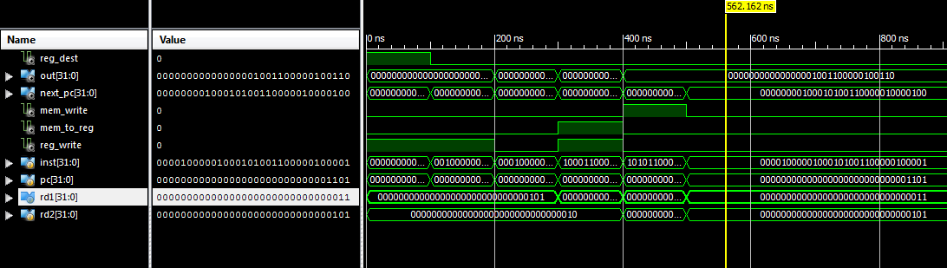

Last Page:

This is entirely our work and we have not received assistance in any form whatsoever.

Signatures:

Zachary Priddy Abdulla Al Braiki

------------------- ----------------------