CSCI204

Assignment one

Joshua Tan Jun Jie | 6096839 | 21 April, 2018

Contents

Interpreted Requirements of 2D StarFleet Program 2

General Asumptions 2

Illustration of Program 3

Implementation Summary 4

addData 4

updateCivIdx 4

displayTopDestinations 4

displayAll 4

calculateTotalDist 4

Reflections on Program Development 5

# Interpreted Requirements of 2D StarFleet Program

## General Asumptions

* Total distance between nodes include a return to the home base (0,0) before starting a journey towards the next node.
* Compiled using C++11 (g++ -std=c++11 PointTwoD.cpp LocationData.cpp MissionPlan.cpp –o <file.exe>)

# Illustration of Program

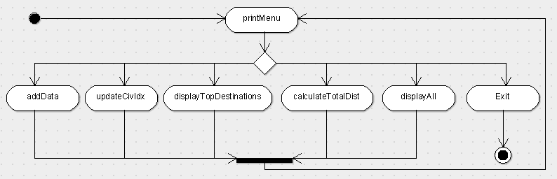

# Implementation Summary

## addData

Adds new data for nodes into a LocationData object array. Sets values to a default value if the input is blank.

## updateCivIdx

Searches for entries which are not updated and updates them using the LocationData functions. If there is nothing to be updated, system will display a message to inform the user that there is no entry in need of update.

## displayTopDestinations

Checks if all entries are updated before cloning the LocationData array and sorting it according to the civilization index values of the objects. The highest five objects are then displayed in the terminal.

## displayAll

Displays all entries in the order they were added into the program.

## calculateTotalDist

Checks if all entries are updated before cloning the object array and sorting it to pick out the top five and calculate the total distance required to travel to all nodes with inclusion of a return trip for each node.

# Reflections on Program Development

Learning how to create objects helped streamline a lot of the processes involving the storing of data. This assessment certainly helped clear up any uncertainty on how would classes work and interact with each other even if they were in separate files.