**Computational Fluid Dynamics**

**HW3 – Passion Project**

**Proposal Submission**  
Group 5:

José Maria Carvalho 87940

Tiago Sá 89690

José Pedro Teles 89689

Rodrigo Cruz 89712

**Formula 1 - Drag Reduction System (DRS)**

The DRS is a driver-adjustable bodywork introduced in Formula 1 in 2011 in order to promote overtaking by increasing top speed. It consists in an adjustable rear wing which moves in response to driver commands, affecting the aerodynamics of the car.

When, in race mode, the two cars are less than a second apart or in qualifying, the driver can send a signal from the steering wheel to the ECU (Engine Control Unit), a McLaren Electronics unit used in F1 cars since 2008. The latter orders an actuator connected to the endplate that decreases its angle of attack (AoA) by a certain value and is disables either when the driver presses the same button or touches the brakes returning the wing flap to its ‘closed’ position (figure 1).

Figure 1: DRS example.

We will conduct a 2D analysis of the effects that changing the AoA of the rear wing endplate, the choice airfoil camber according to F1 car regulations of 2022 [1, 2], as well as the vertical distance between the two plates and Gurney flap have on aerodynamic forces (Drag and Downforce (Lift)) influencing performance of the car [3].

The F1 restrictions for the rear wing bodywork for 2022 are the following:

* Airfoil camber – Radius of curvature greater than 100mm;
* Rear wing endplate chord smaller than adjacent wing;
* The two airfoils must lie in a 540mm x 600mm rectangle;
* Vertical distance limitation – distance between two closest points of the two plates must lie between 10 and 85mm when open and between 10 and 15mm when closed;
* Gurney flap at trailing edge – up to 20mm.

A 2D section (figure 2) will be selected and we define a strategy to analyse the above variables influence on performance of the system by considering different meshes and run a mesh convergence study and gather information on the mesh zones that need more refinement so that the solver may converge to more reliable solutions, while assuming uniform inlet velocity field conditions in the Control Volume at 350km/h. The outputs of interest to be optimized are the Drag Reduction when DRS is enabled (endplate open) and Downforce (maximum when closed and minimum when open) [4,5].

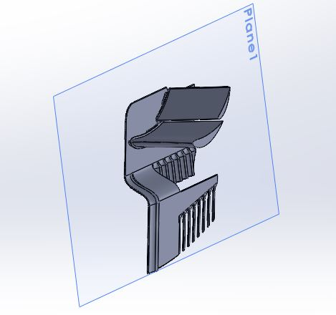

Figure 2: Section view example.

[1] FIA, *2022 Formula 1 Techical Regulations*, 19 february 2021.

[2] Racecar Engineering, <https://www.racecar-engineering.com/articles/f1/drs-the-drag-reduction-system/>, visited in 11/12/2021.

[3] Simon McBeath, *Competition Car Downforce*, 1998*.*

[4] Frankie F. Jackson, *Aerodynamic Optimization of Formula SAE Vehicle using Computational Fluid Dynamics*, 2018, the University of Huddersfield.

[5] S. Wordley, D. McArthur, L. Phersson, D. Tudball Smith and D. Burton, *Development of a Drag Reduction System (DRS) For Multi-Element Race Car Wings*, 2014, Monash University Clayton.