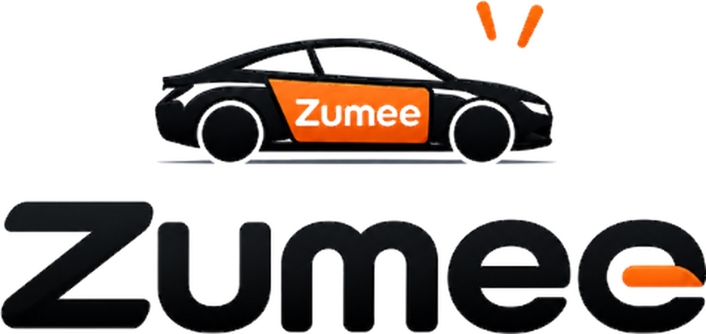
About Zumee
Local drivers. Local businesses.
Vancouver · Vehicle advertising · zumee.org
September 2026
This document introduces how Zumee works for businesses and drivers. Pricing, campaign details and the rights and obligations of each party are set out in a written quote and a separately signed agreement.

Who we are
Zumee is a vehicle advertising platform for Metro Vancouver. We connect everyday drivers with local businesses that want to be seen more, turning space on cars into moving advertisements that carry a local shop's name through neighbourhoods, shopping districts and daily life.
We started in Vancouver and grow one neighbourhood at a time: drivers live here, businesses are based here. Most of what a business pays goes straight to a local driver, so the money stays in the community.

How it works
Drivers | Businesses
01 Register your car: share your neighbourhood, car make and year, monthly mileage and one photo of the car.  02 Match a campaign: agree on the campaign, pay and display requirements.  03 Drive as usual: keep your normal routes, send one photo a week and odometer photos at the start and end of each month, get paid monthly. | 01 Tell us your needs: your business, address, number of vehicles and duration.  02 Confirm the plan: approve vehicles, artwork and the full quote.  03 Launch: pay and arrange installation, then receive weekly street photos and monthly mileage.

For businesses: why Zumee

Why local
- Drivers are neighbours: every car belongs to someone who lives in Metro Vancouver and tells us their neighbourhood when they sign up. No outsourced fleets.
- Money stays local: most of what you pay goes straight to a local driver, not to a big company.
- Proof you can see: a time-stamped photo of the car every week and odometer photos at the start and end of each month.

Who it suits
- Real estate and mortgage agents who already buy bench and shelter ads and need their name seen repeatedly.
- Home services with a clear service area: plumbing, roofing, landscaping, cleaning, moving.
- Restaurants, bakeries and cafés during openings and peak seasons.
- Clinics, gyms, tutoring and early-learning centres that grow through neighbourhood recognition.
- Any other business that serves a local community.

What you get
- One time-stamped photo of the car every week.
- A monthly mileage record from odometer photos at the start and end of the month.
- The driver's home neighbourhood, so you can judge coverage.
- If a car can no longer display the ad during the campaign, a comparable replacement or a pro-rated fee adjustment.
- The magnetic panels are yours to keep after the campaign.

What we do not promise
- No guaranteed impressions, clicks, foot traffic, enquiries or sales.
- No promise that the ad stays inside one area, and no tracking of where drivers go.
- "A coffee a day" describes our budget goal, not a fixed price; actual fees follow the full quote.

Process and fees
- Submit a request at zumee.org; we contact you within 24 hours.
- Confirm vehicles, artwork, campaign length and the full quote, including production, installation and applicable taxes.
- Pay, then we schedule production and installation; the campaign period starts on the first day the ad is actually displayed.
- Changes or cancellation can be requested before production; refund rules follow the agreement.

For drivers: drive as usual, earn on the way

What you get
- Monthly pay, with the amount, placement and campaign days written into the agreement.
- Free installation and removal, arranged by us.
- No tracking app required.
- You decide which campaigns to accept.

What we ask of you
- Live in Metro Vancouver.
- A car in good condition with no visible damage, generally 10 years old or newer.
- One time-stamped photo of the car each week and odometer photos at the start and end of each month.
- Keep the ad intact and visible as agreed; tell us promptly if display stops or the ad is removed early.
- Drive normally; never drive dangerously or break traffic rules to gain exposure.
- Ads are never placed on windows and never obstruct the driver's view.

Good to know
- Registration is free, but it does not guarantee a campaign or income.
- Check with ICBC or your insurance broker about declaring advertising use.
- We record the paint condition before installation; old, repainted or worn paint increases removal risk and we cannot promise zero paint damage.
- Your details and photos are used only for contact, matching and verification.

Concept renderings
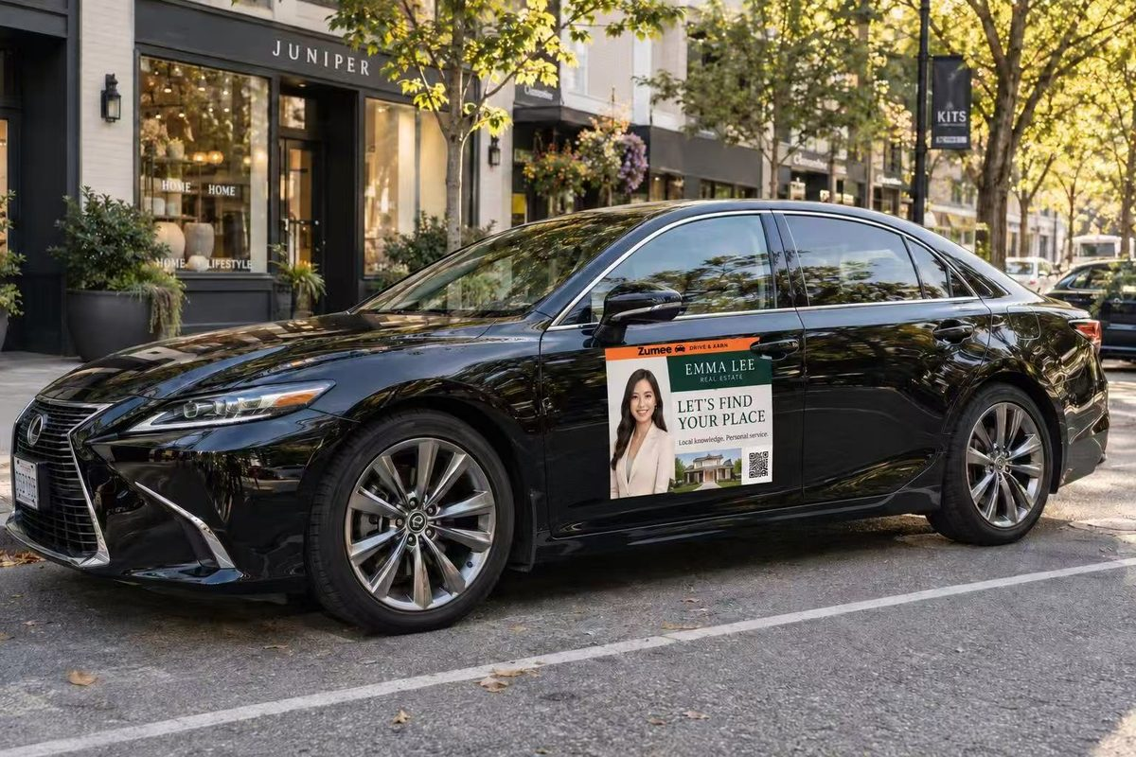  Real estate agent · Kitsilano | 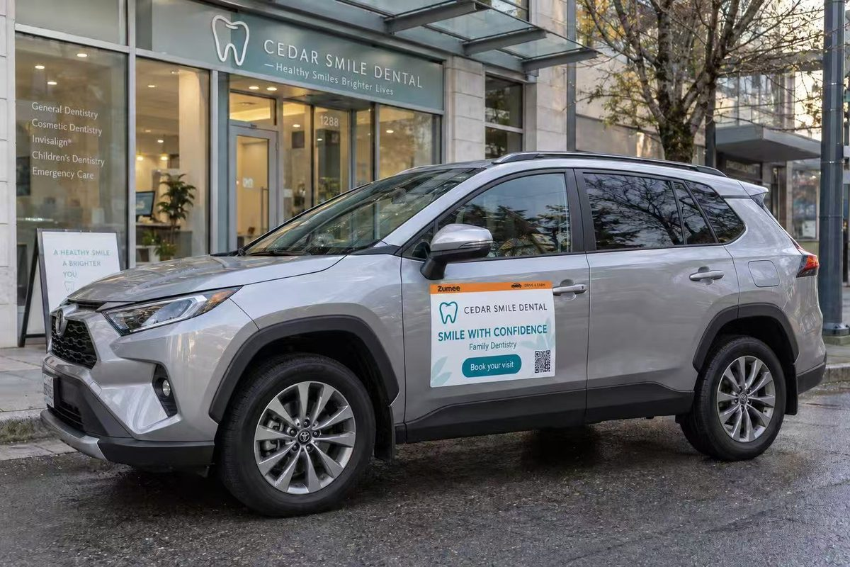  Dental clinic · Vancouver West
Concept renderings only. Actual size, artwork and placement depend on the agreed plan and may differ from what is shown.

Compliance and privacy
- We review all artwork and may refuse or pause ads that appear unlawful, infringing or unsuitable; cannabis, alcohol and election advertising must meet the relevant rules.
- Registration details are used only for contact, vehicle matching and order management, and shared only with people or providers needed to deliver the service.
- Driver photos are used only for campaign verification and are not published; public case studies require separate consent.

Contact
Website: zumee.org
Driver registration: zumee.org/#driver
Campaign requests: zumee.org/#business
Phone / email: ______________________

