Running simulations on Cloud
cloud.sdu.dk allows you to run various software on a small cluster via a web browser. Below you should use the Large Atomic Molecular Massively Parallel Simulation (LAMMPS) simulator for running some simulations to visualize soft-matter physics.

0) Log into https://cloud.sdu.dk/ to get access to FY552 project ressources. You should send me your user name (mine is CarstenSvaneborg#7381) and I can add you to the project.

1) Create folder for simulations.

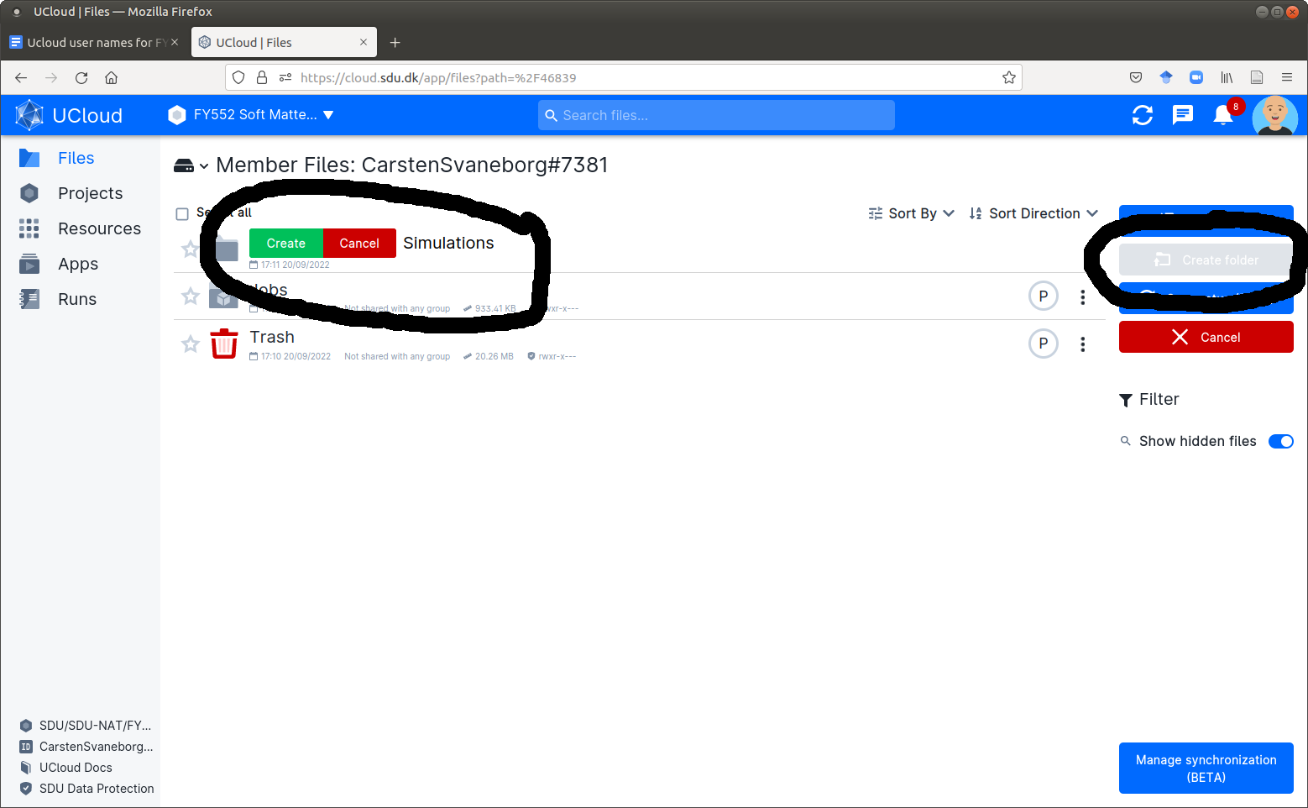

2) Create a folder for each simulation you run, its a good idea to write the key parameters in the sub-directory name, so later you can easily compare data for different simulations. Here we aim to run a simulation of a binary blend with composition phi=0.5 and chi parameter 3, hence I make a folder BinaryBlend_phi0.5_chi3:

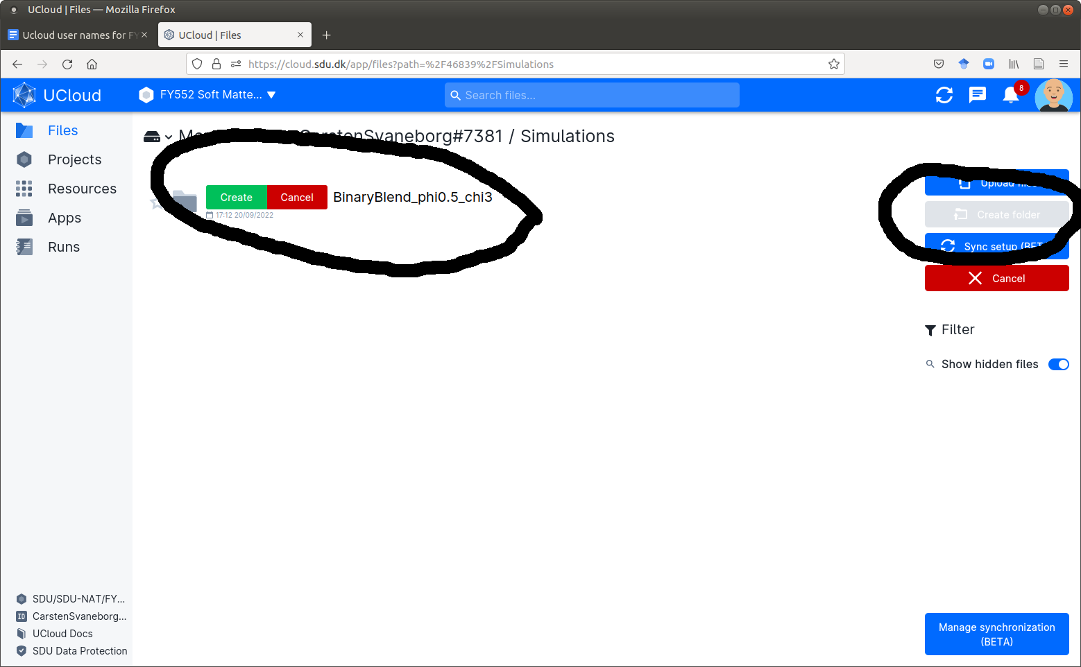

2) Upload the simulation script. From SDU Its learning you should have downloaded ”dpd_binary_mixtures.lam”. Press ”Upload Files” → Choose the file. Press ESC key to close the upload window when you have uploaded the file.

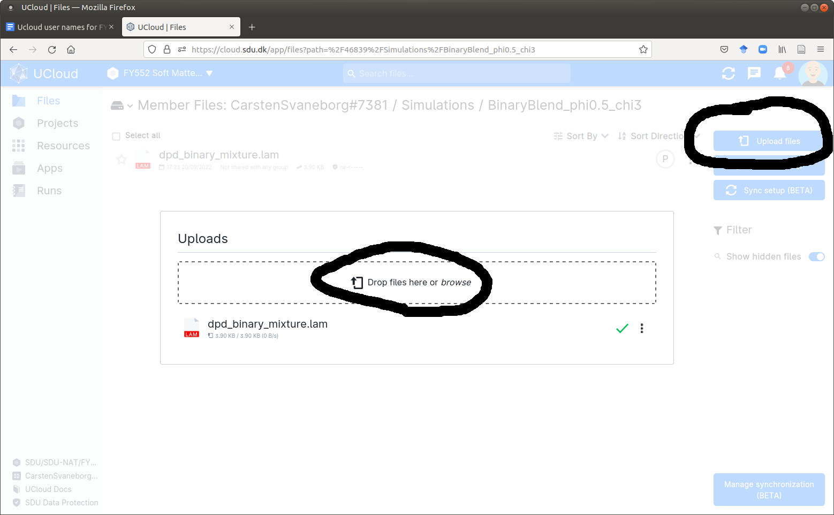

3) To run a simulation you should ensure that you are using the right project by choosing ”FY552” in the top blue menu bar. Then click on Apps, and choose LAMMPS. I have previously chosen to star it, hence its the first app in my list below. You can also use the link to find it: https://cloud.sdu.dk/app/jobs/create?app=lammps&version=3Mar2020-3b

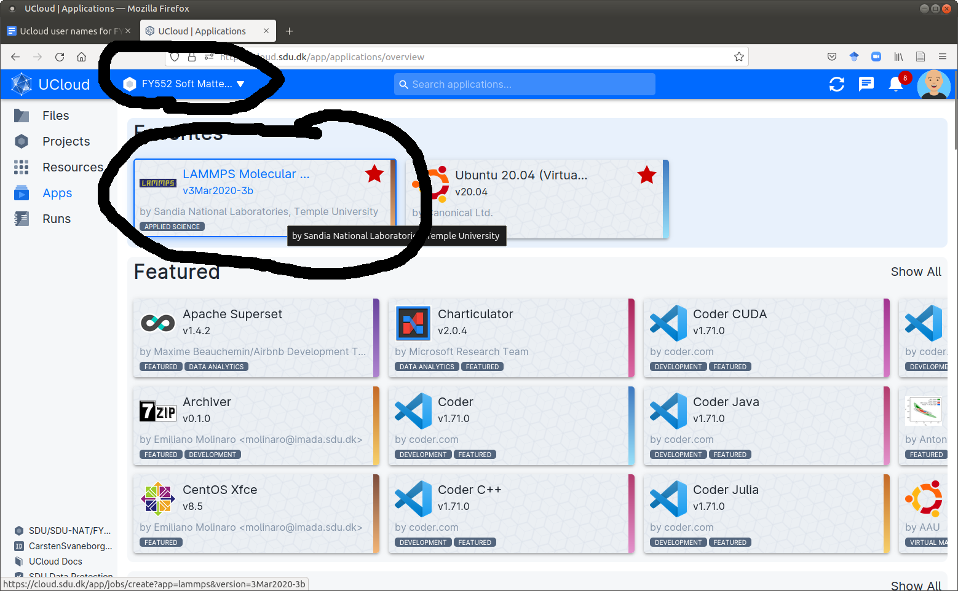

4) Click LAMMPS, then you get to the page below, which asks for various input options.
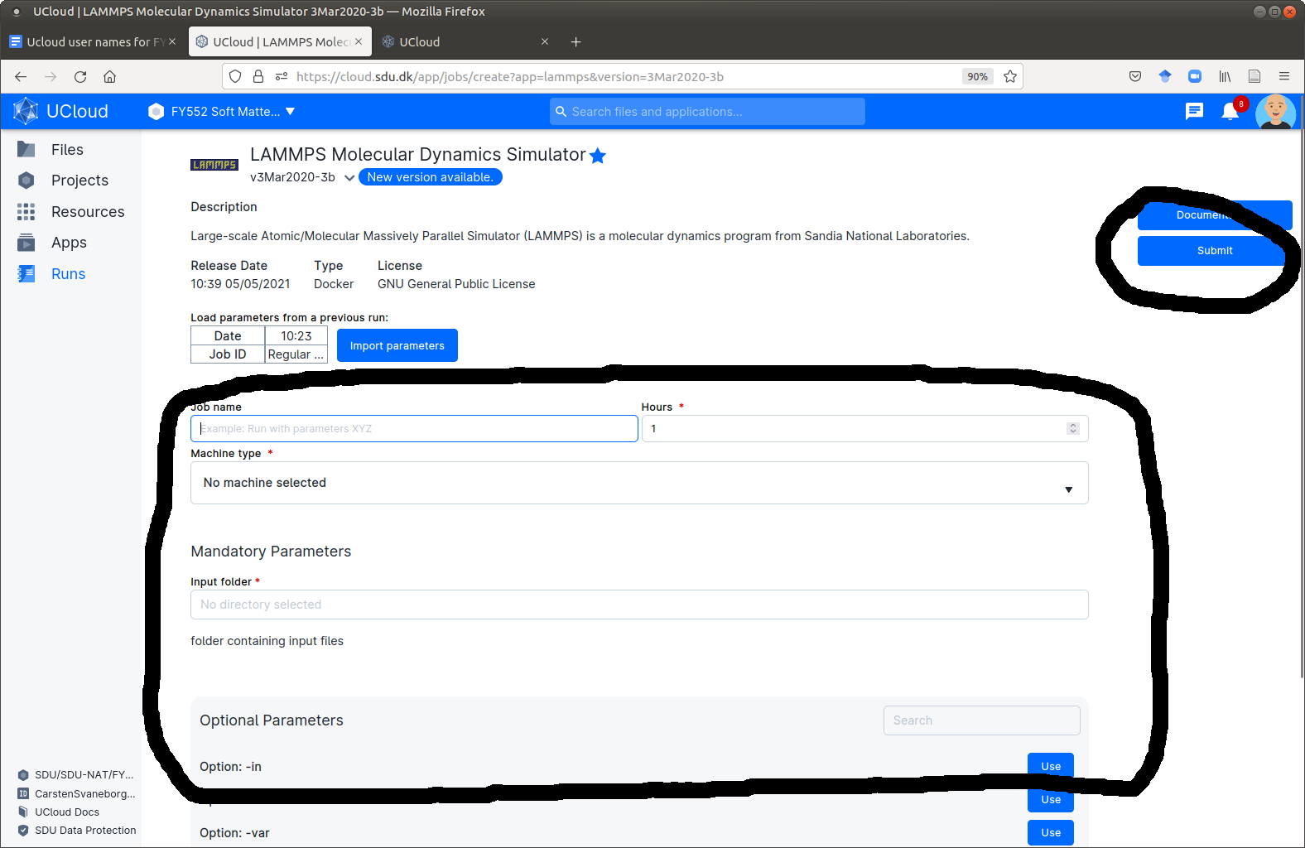

You need to fill in the information in the black box and then press submit.

Job name: ”BinaryBlendPhi0_5chi3_0”
Hours: 1 hour is fine.
Machine type: u1-standard-8
Input folder: Navigate to the folder you made for this run.
Finally you need the optional -in argument. Navigate to the folder and choose the file you uploaded.

Comments: Jobname is not allowed to contain space or period. The simulations takes less than 5 minutes, so 1 hour is fine. Machine type uses 8 cores for the simulation which is fine.

5) You should now have a page looking like the one below, and you can press Submit to submit the job to the queue.

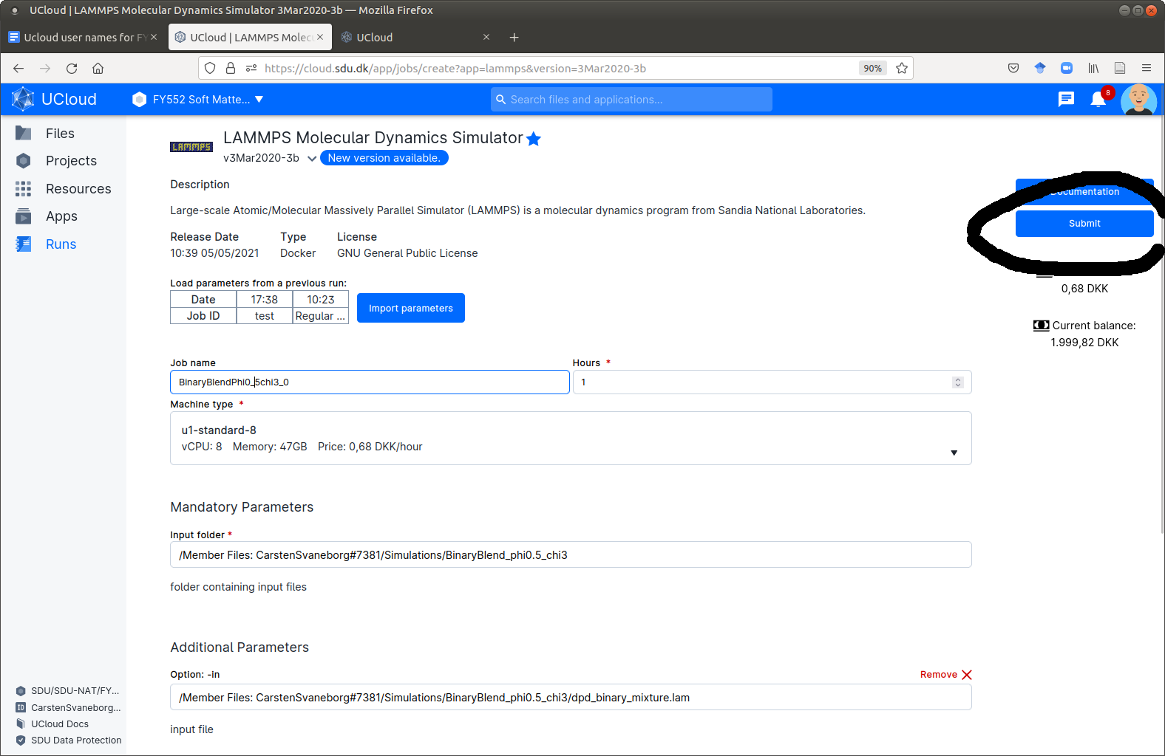

6) When the simulation is competed. It looks like the window below.
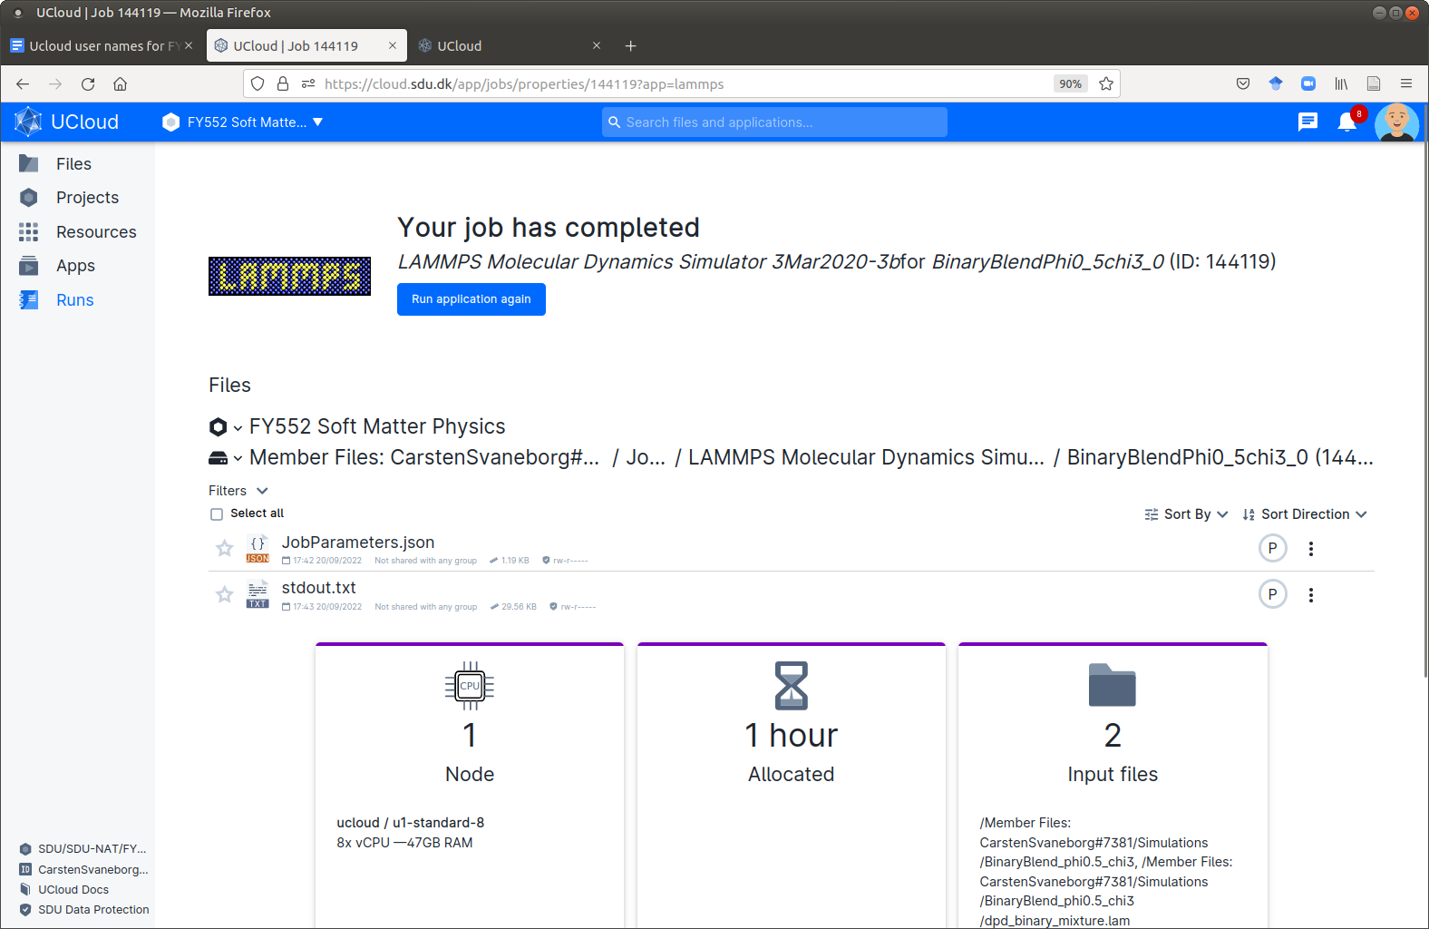

7) Navigating to the simulation folder, you can now look at the output files, e.g. download and view the movie, or click on one of the snapshots.

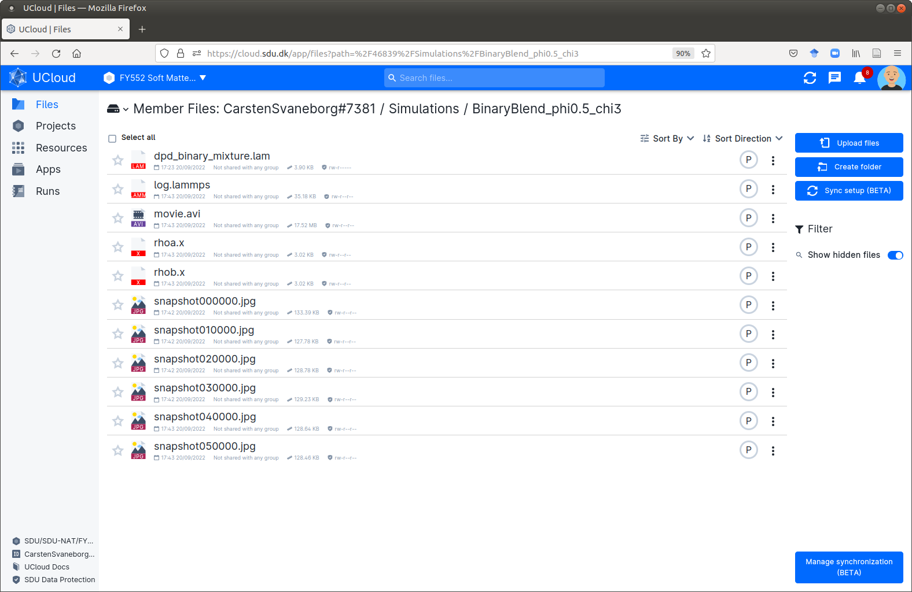

For instance the final conformation looks like this:

