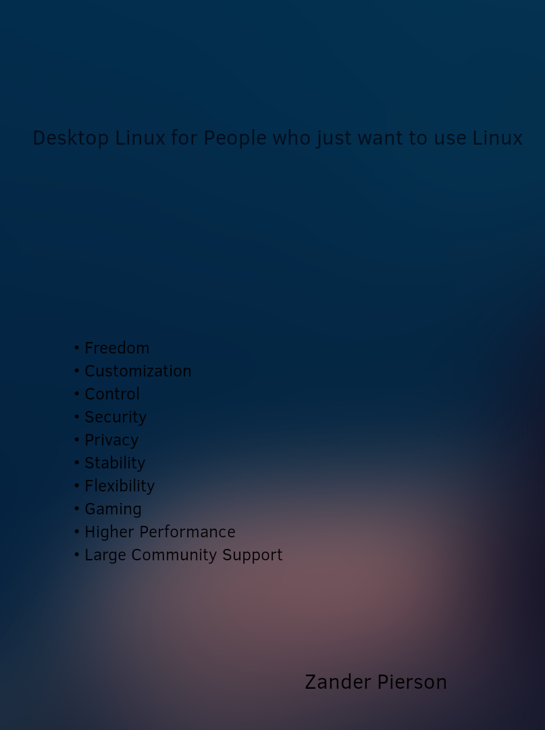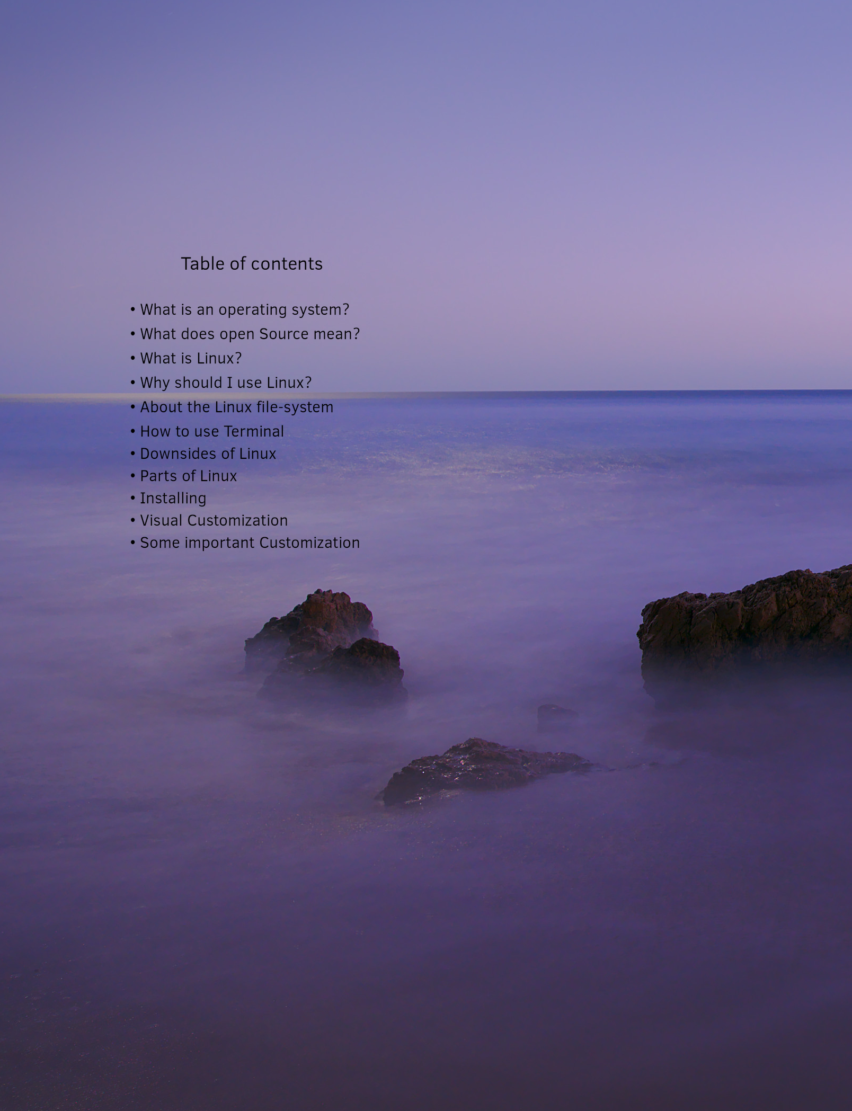

Thanks to

Chris Titus

I thank you for lots of what I know

Linus Torvolds

none of this would exist if it was not for you

Manjaro project

thank you for making one of my favorite distributions

Best of luck

Zander

What is a operating system?

(you can skip if you want)

When you buy a PC you may think ‘this is a windows PC’ this is not completely true. A PC (not mac) has a boot menu that allows you to change and install an operating system.

When you thing of an operating system you may think of windows. This is one, but there are many examples. If something is a computer and you can control it, it has a operating system. This is because, a computer is useless without a operating system. So your calculator has a operating system. Fundamentally, an operating system is Software that allows you to speak and transmit data to a computer without speaking its language. On your desktop computer, you have a central processing unit(CPU), storage (HDD or SAD) and memory, these all speak there own language. The operating system turns your inputs to the language that these chips can understand.

What does Open Source mean?

Open source is put simply code that is publicly accessible. Anyone can review it, distribute the code and modify it. Open source fuels innovation for free. If implemented well, and done correctly. Open Source Software will always be much more secure that any Closed Source Software. As we will talk about later, Closed source software follows a system of Security-by-obscurity, this is where bugs cannot be exploited by hackers because they cannot review the code. Open source will always have less bugs. Think of it as a wall. Open source walls are clear and you can see the weak spots. Remember that all walls have weak spots. but with open source there are so many more people that are able to fix the weak spots. And if a hacker keeps hitting the wall everywhere eventually they will hit a weak spot because there are so many more of them.

Closed Source Software would not be nearly as bad if this were the whole story. Unfortunately there is more. In the world that we live in. We are so dependent on so much Software, lots of this, many people could not live without. IPhones, Alexa, and Google for example. We are so dependent that they can do quite a bit of shady stuff before we stop using them. So most Closed Source software from big companies contains spy-ware. This is because we cannot see the code and see what they are doing. These companies collect as much data about you that they can. As Richard Stallman once said, “With software there are only two possibilities: either the users control the program or the program controls the users. If the program controls the users, and the developer controls the program, then the program is an instrument of unjust power.”

What is Linux?

* Linux runs 96.3 percent of the worlds internet servers.
* 90 percent of all cloud infrastructure runs Linux.
* all of the top 500 super computers run on Linux.

Information found at hostingtribunal.com

Linux, was created in the 1990s by Linux Torvalds. Linus Torvalds has been programming computers since he was a child. By the time he was around 20, he wanted to buy a UNIX computer. He did not have enough money for one. So he created his own operating system from scratch.

Once the project started gaining traction in the form of people contributing code to his project, he never realized just how big this software would become. In a ted interview. Torvalds states that a friend of his at the university of Helsinki, introduced him to free software licenses. This is one of the big steps that eventually led to the success of his software. You see with closed source software like in windows. The code cannot be reviewed and tweaked by anyone but staff at Microsoft. This is one reason that windows is so unsecured compared to Linux. They follow whats called security-by-obscurity. This system works by hackers not being able to see the bugs. They cannot find them because only staff at Microsoft can see the code. In open source code, anyone in the whole world can review the code and submit corrections. All code has bugs but open source allows there to be thousands of times more people to fix the code. Anyone can review the code and submit corrections. Or if they like it they can take the code and change it and re distribute it (this is the reason we have thousands of distributions)

one large reason that Linux is so much more secure than windows is that Linux. does not have “administrators” on windows if you want to run a .exe file you just click it and if your a “administrator” you get a yes/no prompt. On Linux. some users can have “sudo” permissions. This means that if you want to install a program the user will put in there password if they have sudo permissions. But the user with highest power is the “root” user. There is never a moment that you can install a program without a password.

Why should I use Linux?

There are kind of two main pools of reasons to use Linux, practical, and ethical. The first one is easier to communicate in a book, here are some examples of practical reasons:

* Linux is much more secure that windows or mac
* Linux is free. Unlike windows and Linux.
* All software updates on its own. So no out of date software
* No need for additional drivers
* It wont slow down over time
* Freedom of choice.

But, the second category of reasons, Ethical, is all to do with it being open source. Linux is does not take from its users freedom or privacy. Unlike windows and mac.

In my opinion all of these reasons should easily be enough to bring anyone over to Linux, even if you have to sacrifice a few programs.

About the Linux file system

The Linux. file system is a bit different than that of windows. You may or not be familiar with the windows file-system, but the windows file-system works like this. Your drive is assigned a letter. The drive containing windows is usually C:\ than you have things like Program Files and Than Users, inside users are the users than inside those is your Home Directory. A Home Directory is the one containing the Pictures, Documents, Music, Videos and Download folders. If you plug in a flash drive, or have a second Drive your computer will give it another letter.

Linux is much different. All drives are in one Directory. This starts at the root. This is represented with the the backslash / than inside the root directory are the following:

boot,dev,etc,home,lib,lib64,media,mnt,opt,crop,root,run,srv,sys,tmp,usr,var

you do not need to know or understand all of these, but you should know a few. The home directory holds the users home directory. For example, if you want to find your image.jpg in your Pictures folder this is the path:

/home/username/Pictures/image.jpg

the root users home directory is under /root

/root/Pictures/image.jpg

the other one you should know is /usr folder. But mainly the /usr/share This folder holds user configuration files used by the system and all users. Here are some examples

the applications icons are stored in /usr/share/icons

the default wallpapers are under /usr/share/backgrounds

How to use the terminal?

The terminal may seem intimidating at first glance, but it is really quite simple. You may ask why should I want to learn how to use the terminal? Here is the reason. The terminal is the fastest way to get something done. If you know exactly what you need to do you can just tell the computer in just a few words instead of clicking around for a while.

Here is the basic structure of terminal commands:

<program> <operation> <target>

occasionally one is taken or given. But this is the basic structure. Now here are a few good commands to know.

Cp . . . . . . . . . . . copy and paste

ls . . . . . . . . . . . list

cat . . . . . . . . . . .displays file output

nano . . . . . . . . . . simple text editor

mkdir . . . . . . . . . .make a directory (folder)

rmdir . . . . . . . . . .remove a directory (folder)

shutdown . . . . . . . . powers off the system

apt . . . . . . . . . . .debain package manager

dnf……………..red hat package manager

dnf . . . . . . . . . . .modern red hat package manager

once you have gotten comfortable with the terminal, you will realize that it often is the fastest and essayist way to get things done.

For example, if you want to copy Image.jpg from your pictures folder to /usr/share/backgrounds/wallpapers/ you can use the command:

sudo cp ~/username/Pictures/image.jpg /usr/share/backgrounds/wallpapers

^

the Tilde is short for your home folder, /home/username/

if you want to download Firefox, nautilus file manager, vlc, steam , and brave browser. You can simple type:

sudo apt install firefox nautilus vlc steam brave

(remember apt is only used on debain systems)

and Finally if you want to run a python file you can type:

python3 my-python-file.py

Downsides of Linux

there are a few Downsides of Linux, at least for now. In this book we will discus three:

* Software compatibility
* too much customization (The paradox of Choice)
* does not prevent users from doing stupid things

1: Due to windows being the most used desktop operating system for so long, most software is created with it in mind. So some of your favorite software may not be made to work on Linux. But with Linux desktop usage on the rise, at least from my experience just about all your software will work on Linux.

2: a story by thedecisionlab.com explains this the best:

Imagine that you need milk, so you go to the grocery store to pick some up. When you get to the dairy aisle you see that there are dozens of options. These days, not only do you have to make a decision on the percentage of fat you want (1%, 2%, skim, etc.), but also what source you want your milk to be coming from: cows, almonds, soybeans, oats…the list goes on. Almost dumbfounded, you stand in front of the aisle and have no idea what milk to pick. There are so many choices that you are overwhelmed.

This may seam like a dumb or stupid worry but with Linux there are thousands of distributions and each needs a desktop environment. Because of this Linux creates a indecisive property to its users. And a term “Distro-hoping” was made. This term refers to rapidly switching distribution to find the right one.

3: Linux dose not prevent its users from doing stupid things. For example the command :

sudo rm -rf /\*

will completely erase the root directory, including the software to do the erasing, and the software to display what is happening on the screen.

But don’t worry, it is not often that you will break your system. In fact it will almost never happen. Especially if you don't do anything without thinking. For example, the command above, reads

super user remove root directory, force it

sudo rm / \*

(a trick to not kill your system, is to not mess with the root directory)

(also, if worst comes to worst you can press ctrl+alt+f4 to go to a tty terminal. This is a terminal that does not need a graphic driver)

What makes up Linux

This topic is not needed for general use, but it is good to know if you want to understand Linux thoroughly. If you want to really customize your computer you want to understand all the pieces that make up the system. Just know that this will be a simple understanding. So the pieces we will go over in this book will be:

* Grub
* Package Manger
* And how to use a package manager
* Desktop Environment

1: First we will discus the Grub menu. The grub menu will go unnoticed unless two things happen. If you have a dual boot system (a System that has multiple operating systems) Or you have a operating system that installs multiple kernels. In simple terms the grub menu directs the computer to a operating system. If you have multiple operating systems, the grub menu will show them and you can select witch you want (this is a great way to get into Linux because you can keep windows around in case you want to use it)

2: Now this is a important one, A Package Manager. Now in windows if you want to install a program, you would go to a web browser and find a .exe or a .msi file. This risks you getting a virus. On Linux you install programs more like you would on your phone. You have a app store also known as a package manager.

On each Distribution you have a different package manager. These are the main Distributions and the package manager they use:

Debian ==> apt

Arch ==> pacman and pamac

Red hat ==> dnf or yum

Solus ==> eopkg

this is the main thing that separates distributions from each other.

2b: Using a package manager to install programs

lets assume we are on windows. And you want to download vlc media player to watch a movie. You would probably find a .exe or a .msi file, and you would click on the file to install the program. On Linux it is different. There are two ways to install programs. They both have the same end effect.

1. simply open a terminal window and type

sudo <package manager> <install command> vlc

this above method is the essayist if you know the exact name of the program. Replace

<package manager>

with yours witch may be apt, dnf, or pacman depending on distribution. And replace

<install command>

with your install command, Apt and dnf use the word install while pacman uses -S. you can read the manual for your package manager with

man <package manager>

(the command ‘man’ is good to know because it pulls up a manual for any command in the terminal)

2: the second way to install programs is with the app store, most major distributions have a Graphical user interface (GUI) app store. Simply open it from the apps menu and search for the program. In this case vlc media player.

3: a Desktop Environment is one of the important things you should know. A Desktop Environment is the look and feel of a distribution. You can have completely different distributions but if they have the same Desktop Environment they will look and feel the same. Here are the main Desktop Environments:

Gnome………………Modern and touch friendly UI

Kde……………………Highly customization, modern and polished UI

Xfce…………………Most lightweight. Windows like UI

Mate…………………Lightweight and simple

Cinnamon………Familiar interface that is Sleek and polished

Budgie……………Mid-weight Distro that is made to be Modern and elegant

What is a Distribution?

With open source software anyone is allowed to redistribute it if they want to. So, there are thousands of distributions of Linux. These form from people modifying existing distributions. Each distribution is a little different and some are better for some things. Take Ubuntu for example. This distribution is the most used one. There also is Lubuntu witch is made to be light weight for older computers. And there is Kubuntu that is using Kde as a desktop environment.

Fedora is a distribution that is 100 percent open source, while most distributions have a little bit of closed software, often to communicate with closed source chips like NVIDIA Graphics card. One important thing to remember is that most of the Thousands of distributions, lots of them are only a little bit customized from each other and the are not worth your time. You can make any distribution look like any other distribution. That is what is great about Linux. You can customize anything you want.

Here is a list of the more reverent distributions, and what they are based on.

(as of 2021, according to distrowatch.com)

Mx Linux……………………………………...Debian

Manjaro………………………..……………...Arch

Mint……………………………………………Debain/Ubuntu

Pop! OS………………………………………..Ubuntu

Ubuntu………………………………………...Debian

Fedora…………………………………………Red Hat

Zorin…………………………………………...Ubuntu

Arch…………………………………….……...Not based on anything

OpenSUSE……………………………..……...SUSE

Solus…………………………………………..Not based on anything

How to install Linux

Over all Linux is very simple to use. And the internet is a great resource if you have any issues. Due to These resources online I will not be making a through install manual. This manual will be very simple and broad. On a modern computer, a Linux distribution needs three partitions. A partition is basically a split in your hard drive. You can view your drives partition scheme on windows by opening Disk Management.

First step to installing Linux, is picking the Linux distribution you want to install. Above you can see all the distros. You go onto the website for the distribution and you download operating system.

Next you need to put the operating system onto a flash drive. You can use a tool called balena etcher, or any other image flasher. (a .iso or .img also called a disk image) Next you plug the flash drive into your computer and enter the boot menu (often entered by pressing f12 during startup, the specific button is determined by the computer manufacture)

Select the flash drive in the boot menu and you should boot into a “live environment” this is basically a sample of the Linux distribution. This way you can use the Linux distro without installing it. You can mess around in here without changing your current operating system. You should see a installer somewhere.

The installers are very easy to use but if you need help the internet is a great place to find help. Remember you can dual boot so you can keep windows and pick the operating system when you turn on your computer.

A modern Linux system requires a

boot partition (for UEFI systems, modern computers are all UEFI)

root partition (this contains the / directory)

Optional:

swap partition (use a HDD as ram. your computer uses swap space if your ram becomes full)

If you want to ‘clean install’ witch is when the installer will wipe all the partitions and install the distribution, then the installer wont be very complicated. You should just have to select your disk and press clean install.

But, if you plan on dual booting, the installer may be a bit more complicated. The internet is your friend and it should be able to walk you through the complex bits.

Removing Linux from a dual boot

If for whatever reason you decided that Linux is not for you, and you want to remove Linux from a dual boot. Even though I love it, I will walk you through removing it.

* First you should boot into windows.
* Inside windows you should open a command prompt with administrative access.
* Next, run diskpart by typing ‘diskpart’ and pressing enter
* type ‘list disk’
* look at the disks shown and determine witch is the main disk that holds your efi partition (if you don’t know you can skip to the list vol step)
* type ‘select disk <disk number>’ (replace with the number of the disk)
* and then type list vol
* there should only be one fat32 partition, it should be around 100-500 MB
* look at the number of the fat32 partition, and type ‘select vol <number>’
* now, type ‘assign letter=A:’
* type ‘exit’
* type ‘cd /d A:’
* type ‘cd EFI’
* type ‘dir’
* you should now see a list of the efi boot entries on your system, the name of your distribution should be one of them,
* type ‘rmdir /s <distro>’

now, the boot entire is deleted, now we need to reclaim the space that Linux took up. Simply enter disk management and right click the Linux partition and press delete. Now right click the windows partition (probably C) and select extent partition, click through the menu to reclaim the space.

If your distrobution created a separate boot entry and you can see it in disk management, you will need to enter a live environment and open gparted to delete that partition.

Customization

Now that you have installed Linux, you may not like the look or feel of the install. If you want to make it more your own this is the right section for you. Linux allows for total control of the system. If you are smart enough and comfortable enough with the system, you can make it look and act however you want it to.

Some desktop environments make it easier to customize. This area of knowledge is not timeless like other things such as package managers, What I mean by this is, a guide for customizing gnome 10 years ago would be much different than it is now. Because of this I can not make a in-depth guide while also making it timeless. It is best if you want to truly make your computer your own, to do research on a much more relevant platform. Called the internet. I believe that I will be updating this book and releasing it on my GitHub page. If you want to get a more up to date version of this book you can visit

https://github.com/zqpie/Desktop-Linux-for-people-who-just-want-to-use-linux

Desktop environments are made for all different kinds of workflows. If you don’t want to go to deep into customization, you can try a new desktop environment. Similar to dual booting, you can have multiple desktop environments installed on one single system.

Here is an example. Say you have a Pop! OS system. This system runs Gnome/Cosmic as a Desktop Environment. But what if you want it to look and feel more like Windows 7. you can simply install the cinnamon desktop environment. You can do this by typing this command:

Sudo apt install cinnamon (apt is used in debain based systems)

Than once the install is done. You can logout. In the login screen you can look around for a session drop down menu. All login screens(Display managers) will have one. Switch the desktop environment to cinnamon. And then you will be able to login to the new desktop environment.

Now it will look like a new computer, but it is still the same computer. All your files and apps will be the exact same. You can also change your login interface, also known as a display manager. I like the lightdm display manager. This is probably the most customization display manager. To change to lightdm you can follow these steps,:

(don’t reboot your computer during this process)

1) first disable your current display manager with:

sudo systemctl disable <current display manager>

if you are running gnome your display manager is probably gdm

you can do a bit of research to figure out what your current display manager is.

2) next you need to install the new Display manager:

sudo <package manager> <install command> <display manager>

if we were on manjaro installing lightdm:

sudo pacman -S lightdm

3) now we need to enable the new display manager:

sudo systemctl enable lightdm

4)(Optional) if you want to customize the login screen a bit more you can install the login screen settings menu:

sudo <package manager> <install command> lightdm-settings

Now you should have set lightdm to be your display manager. You can follow more instructions online to further customize the login screen.

Some Miscellaneous Customization

one downside of the fabulous hardware support, and freedom that Linux brings is that there are a few things you will need to do to get your system up and running. Here I will be giving explanations to some important things you may need to do so you don’t have to run into issues down the road.

* Multiple Drives

if you have multiple drives on your PC, as we discussed earlier, your drive will not be assigned with a letter like [D:\](../../../../D:/) Instead, on Linux you will need to mount the drive. This is not a difficult process so follow these steps bellow.

Firstly, although Linux can read all windows file-systems, like ntfs and fat32. It is recommended that you should use a Linux file-systems(Linux file-systems are much better than windows) especially if you want to game on your computer, you cannot run games of a ntfs partition. So lets get to switching it.

You will need to use a partition tool, I like gparted. So first step is to install gparted. Now this tool is easy enough to use but if you have difficulty the internet is your friend. You should use the drive switcher tab, and go to your second drive. Than delete all the existing partitions(this will destroy any existing data present) now right click the unallocated space and create a new ext4 or btfs partition (I recommend ext4).once you are done, you can press the green check and complete the drive formatting. now right click the ext4 partition and look for a code called a UUID. Copy the code and you can exit gparted.

Second you need to make a folder for your drive to be in. as we talked about earlier, in Linux, your drives are all in one file system. If you want your drive to be accessed by all users you should make a folder in a space all users can access, like the /media directory(if it is not present you can create it, using the mkdir command) alternatively, if you want the drive to be only accessed by one user, you can put the folder in their home directory. Name the folder what ever you want. I will name it Hardrive in this example, and place it in user Lukas directory:

mkdir /home/luka/Hardrive

next you will need sudo permissions to edit the /etc/fstab text document. You will use the command:

nano /etc/fstab

this will open an editor. Now go to the bottom of the document and type the following:

UUID=<enter the UUID of your drive> <file system> <location> defaults 0 0

in our example it would look like this:

UUID=123785483427 ext4 /home/luka/Hardrive defaults 0 0

now press control and o to save the document, and then press control and x to exit the document.

Now you should check to see if you did everything right. Type:

sudo mount -A

if you have no errors than you should be done! Now you can go to the folder you made and that folder is your hardrive.

* Add a new user

to add a new user in Linux, use the useradd command, if you want them to have a home directory:

sudo useradd -m <username>

this does not give the user a password, so the user is disables until you give them a password

* Changing/adding a user password

to change or add a password to a user you can just type:

sudo passwd <username>

* Adding non-free media codecs

if you want to watch movies or listen to music you may need extra media codecs. To do this:

on ubuntu: sudo add-apt-repository multiverse

(three separate commands) sudo apt update

sudo apt-get install ubuntu-restricted-extras

on arch/manjaro: sudo pacman -S a52dec faac faad2 flac jasper lame

(one long list) libdca libdv libmad libmpeg2 libtheora libvorbis libxv opus wavpack x264 xvidcore

this should install all the things you may need.

Software

As of now, Linux is not the most popular desktop operating system. So Software developers are not as quick to make there software for Linux. But, there are plenty of alternatives, and you can run windows software on Linux Using WINE, sometimes this is not the best experience but often it works just like on windows. For software that that is not available on Linux, here are some alternatives that wont require WINE.

Microsoft Office……………………………………………………...Libre office Writer

Excel……………………………………………………………….....Libre office Calc

Photo-shop………………………………………………..………...Gimp

Using wine

Wine, stands for ‘wine is not a emulator’ it is a software package that allows windows software to run on Linux. If you cant find a alternative for a windows program on Linux, you can use wine to run them. If you want to install wine it can be installed with:

sudo <package manager> <install command> wine winetricks

for example, on fedora

sudo dnf install wine winetricks

now, you need to configure wine, simply type:

sudo winecfg

now you need to download the windows program. Go to the website and download the windows file, .exe for example. Than, you need to navigate to the directory that contains the window file.

Cd ~/Downloads (this will bring you to your downloads folder)

Next you simply run the file with wine

sudo wine <windows file>

(sometimes you might have to run it without sudo permissions)

Using Winetricks

winetricks is a branch of wine that makes it a bit simpler to install software, it basically is a windows/mac app store. Just type

winetricks

(again, you may need to run with/without sudo permissions)

you can also run it from your application menu

from here it is very intuitive. Just select what option you would like, press “install an application” to open the windows/mac app store