Press Keyboard R, the camera will stop.

Press P, a small window will show the blur effect:

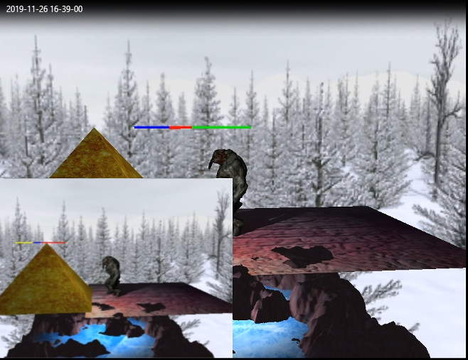

Press I, a small window will show the inverse effect:

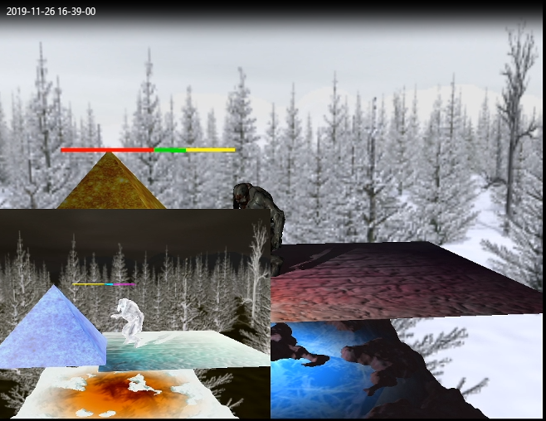

Press G, a small window will show the grey effect:

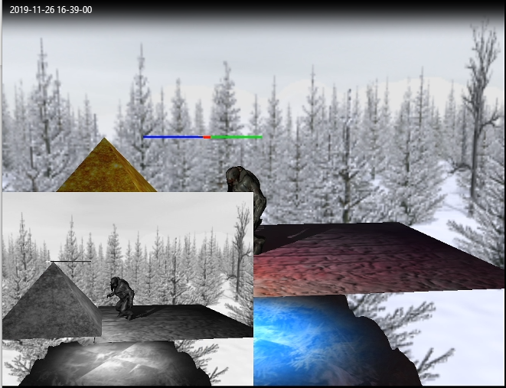

Press H, a small window will show the sharp effect:

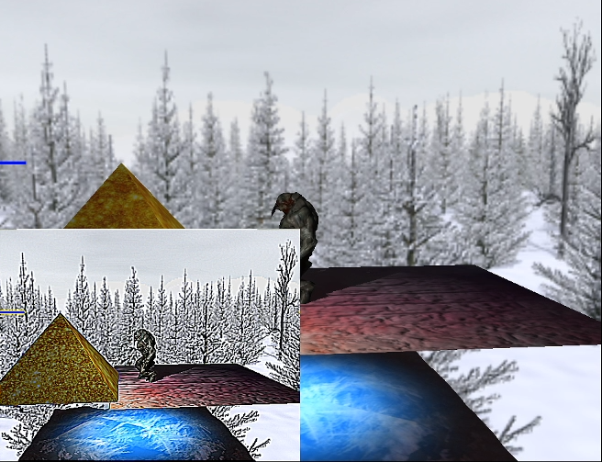

YouTube address:

https://youtu.be/rwk2GSBv6A0