HW3

Qingying zong

1

(i)

Let Zi be the treatment indicator for subject i (in the variable Treat), Si be the variable

lnPfs, the potential surrogate, and let Ti be lnSurv, the true clinical endpoint of interest.

(a)

The estimated coefficient of is 0.22356, p value is .00277<0.05, so it is significantly different from 0. Therefore, Z is predictive of S.

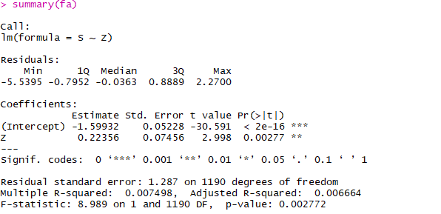

(b)

The estimated coefficient of β is 0.13305, p value is .054>0.05, so it is significantly not different from 0. Therefore, Z is not predictive of T, i.e. the treatment is not predictive of the true endpoint.

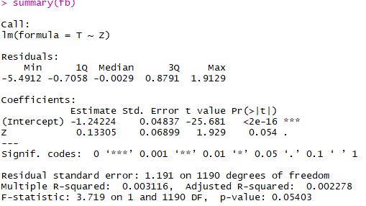

(c)

The estimated coefficient of γ is 0.869695, p value is <2e-16, so it is significantly different from 0. Therefore, S is predictive of T, i.e. the surrogate is predictive of the true endpoint.

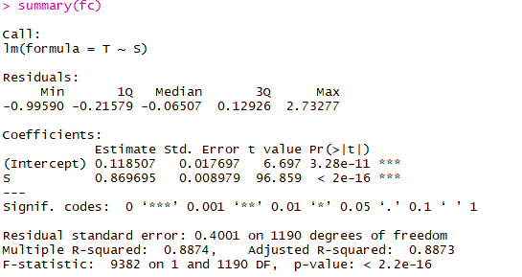

(d)

The estimated coefficient β is -0.06185, p value is 0.0078; γ is 0.87177, p value is 2e-16. Since both β and γ are nonzero, so S does fully capture the effect of Z on T.

f (T | S; Z) f(T|S), i.e., treatment variable provides additional information about true endpoint after surrogate is known.

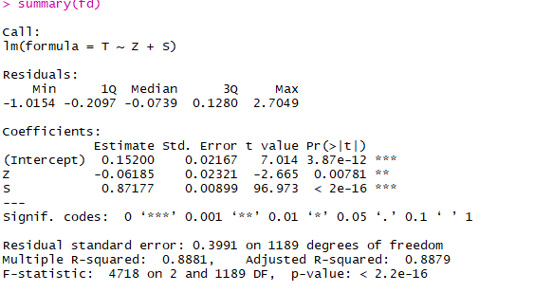

(ii)



PE =1.464847. The transformed progression-free survival appears to explain part of the effect of treatment on the transformed overall survival, and it also changes the direction of the effect.

(iii)



RE =0.5951268, this means that treatment on overall survival relative to treatment on surrogate is 0.5951268.

2





3



**#codes:**

#

setwd("C:/Users/Lenovo/Desktop/clinical trials")

df <- read.csv("OvarianSample.csv")

head(df)

Z <- df$Treat

S <- df$lnPfs

T <- df$lnSurv

#1

fa <- lm(S ~ Z)

summary(fa)

fb <- lm(T ~ Z)

summary(fb)

fc <- lm(T ~ S)

summary(fc)

fd <- lm(T ~ Z+S)

summary(fd)

#

PE <- 1-as.numeric(coef(fd)[2]/coef(fb)[2])

PE

#

RE <- as.numeric(coef(fb)[2]/coef(fa)[2])

RE

#

#3

qbeta(0.9, 3, 3, ncp = 0, lower.tail = TRUE, log.p = FALSE)

1. pbeta(1/3,3,3)