OUM
DS.140 Design Specification
<Company Long Name>
<Subject>

When this template is completed, delete all the yellow notes as follows:
1. With your document open, open the Find and Replace window.
2. Expand the Find and Replace window using the More>> button.
3. Place the cursor in the Find what: field.
4. Choose Format > Style.
5. When the Find Style box opens, scroll through the list and select Note and click OK.
6. Leave the Replace with: field blank.
7. Select Replace, Replace All or Find Next to remove the yellow notes.
8. Repeat using the Note Wide style if there are any landscape sections that contain wide yellow notes.
Please refer to the OUM Template User’s Guide for detailed instructions for working with OUM templates.

Author: <Author>
Creation Date: May 6, 2014
Last Updated: June 26, 2014
Document Ref: <Document Reference Number>
Version: DRAFT 1A

Title, Subject, Last Updated Date, Reference Number, and Version are marked by a Word Bookmark so that they can be easily reproduced in the header and footer of documents. When you change any of these values, be careful not to accidentally delete the bookmark. You can make bookmarks visible by selecting the Office Button>Word Options>Advanced> and checking the Show bookmarks option in the Show document content region.

Approvals:
<Approver 1>
<Approver 2>
To add additional approval lines, press [Tab] from the last cell in the table above.
You can delete any elements of this cover page that you do not need for your document.

Document Control

Change Record
5
Date | Author | Version | Change Reference
28-Nov-05 | <Author> | Draft 1a | No Previous Document

Reviewers

Name | Position

Contents
1 Document Control iii
1.1 Change Record iii
1.2 Reviewers iii
2 Technical Overview 1
2.1 Building Blocks 1
2.2 Block Relationship Diagram 1
3 <Screen Title> - Screen Design 3
3.1 Navigation Logic 3
4 <Report Name> - Report Design 4
5 Data Design 5
5.1 Data Design Table 5
5.2 Data Sources 5
5.3 Validation Logic 6
6 SQL Design 7
6.1 SQL Statements 7
6.2 Performance Considerations 7
7 Behavior Design 8
7.1 Function (Operation) Design 8
7.2 Business Rule Design 8
8 Interface Design 9
8.1 Service Design 9
8.2 External Interface Design 9
8.3 Performance Considerations 10
9 Quality of Service Design Considerations 11
9.1 Restart Strategy 11
9.2 Crash Recovery 11
9.3 Security 11
9.4 Performance 11
10 Database Design 12
10.1 Database Diagram 12
10.2 Desired Table Changes 12
10.3 Tables, Indexes, Sequences 12
10.4 Archiving 12
11 Installation Considerations 13
12 Open and Closed Issues 14
12.1 Open Issues 14
12.2 Closed Issues 14

To update the table of contents, put the cursor anywhere in the table and press [F9]. To change the number of levels displayed, select the menu option Insert->Index and Tables, make sure the Table of Contents tab is active, and change the Number of Levels to a new value.

Technical Overview
The purpose of this task is to assemble all the information that is required to describe the design of a software component into a complete Design Specification. This task is not a substitute for executing the individual design tasks. This specification work product can serve as a structure for completing the design for each component by providing pointers back into the Design Tasks:
- DS.040 Develop Design Architecture Description
- DS.080 Design Software Components
- DS.090 Design Data
- DS.100 Design Behavior
- DS.130 Design User Interface
This Design Specification documents the detailed design for <Component Name> that is part of <Use Case Package Name/Number>. This specification, the design specifications for the other components that are part of this use-case package (package), along with the Analysis Specification for the package constitute the complete detailed design for this use case package.

Building Blocks
The intent of this section is to list the building blocks that are required to design the designated component. This includes classes, objects, modules, etc. Reference the Module View of the Architecture Description (RD.130) and appropriate Software Component Design (DS.080) to derive the list of classes and their relationships.

Building Blocks

Block Relationship Diagram
The intent of this section is to graphically depict how the component under consideration interfaces to related components, external systems, and other actors that interact with the use-case package. Reference the Conceptual View and Module View of the Architecture Description (RD.130) and the class diagram prepared in the Software Component Design (DS.080) and Component Behavior Design (DS.100).
The diagram below represents the base tables of each block or zone of the form (vertical) and tables referenced for validation or lookups (horizontal).
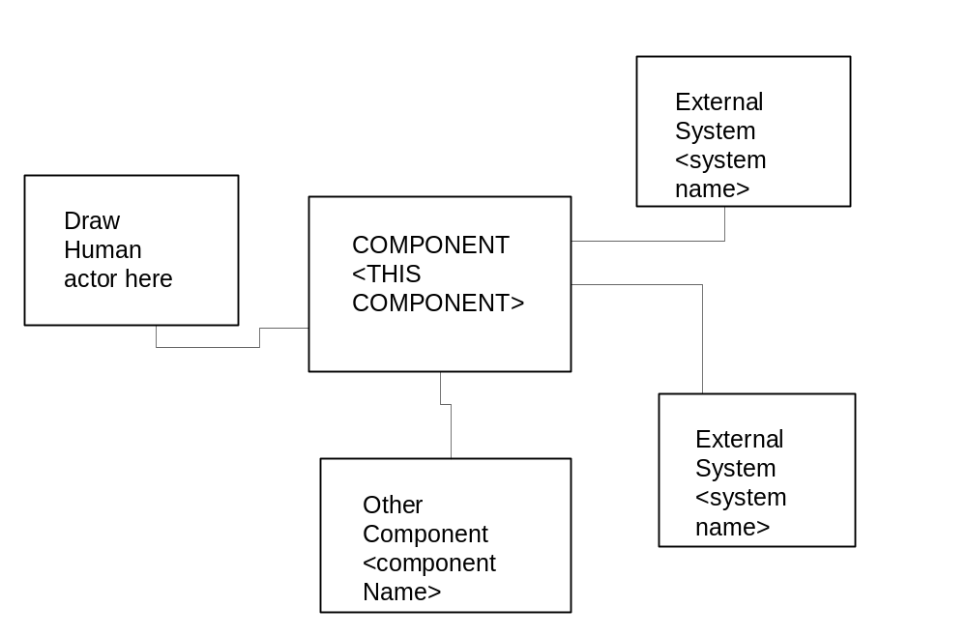
The diagram above is just an example—Double click on it to edit it as an embedded object. Select it and choose Edit->VISIO Object->Open to open it in the full Visio application.
You can also use other tools to draw your diagram and define most of the information in this section. So you may then want to refer to the repository for a specific diagram.

<Screen Title> - Screen Design
The intent of this section is to document the design for the screens for each Use Case supported by the component. Reference or include the User Interface Design (DS.130) for the component.
Use Case 1
- Screen Design A
- Screen Design B

Use Case 2
- Screen Design C
- Screen Design D

Navigation Logic
The intent of this section is to identify the screen navigation sequences for each Use Case supported by the component. Reference or include the User Interface Design (DS.130) for the component.

Use Case 1
Scenario 1.
Screen A
Screen B
Screen C
Scenario 2.
Screen D
Screen E
Screen F

Use Case 2
Scenario 1.
Screen A
Screen D
Screen E
Scenario 2.
Screen A
Screen C
Screen G

<Report Name> - Report Design
The intent of this section is to document the report format designs for the reports provided by the component. Reference or include the report specification from the User Interface Design (DS.130) for the component.
Use Case 1
- Report A
- Report B
Use Case 2
- Report C
- Report D

Data Design
The intent of this section is to define the design details of each attribute – format, length, accessibility, visibility, validation rules, mandatory or optional, etc. – that is required for each entity or class within the component. If available, reference or include the class diagram (or other data design model) from the Component Data Design (DS.090) for this component. If not available, use the table below.

Data Design Table

Entity (Class) | Attribute (Data Field) | Format | Length | Accessibility | Validation Rules | Required?
Person | Name | Alphanumeric | 25 | All | Must exist in HR Database | Yes

Data Sources
The intent of this section is to identify the table, columns, and source values that are required to support the above data elements. Refer to the Physical Database Design (IM.040), to identify the existing tables where the above attributes are located.

Table | Column | Source Value
<table name> | <column name | <table>.<column>
 | <column 2> | 'Literal string'
 | <column 3> | (Description of derived value)

Validation Logic

The intent is to design the rules that are necessary to verify the format, length, relationships etc. of the attributes listed above.

Table Name

Attribute Name | Validation logic | Warning Conditions | Error Conditions
Attribute 1
Attribute 2

SQL Design

The intent of this section is to define the tables, the attributes and the SQL statements that are necessary to create, read, update, and/or delete the attributes for each use case from the database. Include applicable portions of the Software Component Design (DS.080). The focus is on creating the SQL documents for the CRUD (Create, Read, Update, Delete) processes. If the DS.080 is not available, provide the SQL for your module here.

SQL Statements

Use Case Scenario 1 - Data Selection

SELECT <data>
FROM <tables>
WHERE <select criteria>
AND <join conditions>

Use Case Scenario 1 - Data Deletion

DELETE <data>
FROM <table>

Performance Considerations
The intent of this section is to define the design considerations necessary to achieve the data retrieval and storage requirements for performance. Include performance requirements as specified in the Supplemental Requirements (RD.055) for service level requirements (i.e., 1-minute response time, etc.)

Behavior Design
The intent of this section is to define the details of each operation (to include pseudo code) required for each entity, module, or class within the component. Refer to Behavior Design (DS.100) and the Design class diagram, with a focus specifically on the Operations section for the Class. In the event that you do not have a class diagram use the table below.

Function (Operation) Design

Function (operation) Name | Arguments | Default Values | Return Values | Pseudo code | Comments
Person:ComputePay | HoursWorked, PayRate | Hours worked =40 | GrossPay | GrossPay = HoursWorked * PayRate | Only Used for Exempt Employees

Business Rule Design
The intent of this section is to define the implementation strategy for each business rule within this component. Refer to the DS.110 Business Rules Design to capture the Business Rules for this component.

Interface Design
The intent of this section is to design the services between the components and the interfaces with external systems for each Use Case. Refer to DS.080 Software Component Design and focus on calling arguments (i.e., service signature) and logic definition.
<Overview description>

Service Design
The intent of this section is to document the services that are provided by this component, for each Use Case. Refer to the Services Design (DS.120).

<Use Case1 name/number>
<Service Name> is published for this component with the following arguments:
Argument | Prompt | Value Set | Default Value
ORG_ID | Organization id | Generic | :$PROFILE$.mfg_organization_id
USER_ID | Application User ID | Generic | :$PROFILE$.user_id
DATE | Selection Date | FND_Date4_required | :$$DATE$$

<Use Case2 name/number>
<Service Name> is published for this component with the following arguments:
Argument | Prompt | Value Set | Default Value
ORG_ID | Organization id | Generic | :$PROFILE$.mfg_organization_id
USER_ID | Application User ID | Generic | :$PROFILE$.user_id
DATE | Selection Date | FND_Date4_required | :$$DATE$$

External Interface Design
The intent of this section is to document the External interface messages (i.e., name, arguments etc.) that are sent or received by this component for all external systems for each Use Case.

<Use Case1 name/number>
<Message Name> is sent or received by this component with the following arguments:
Argument | Prompt | Value Set | Default Value
ORG_ID | Organization id | Generic | :$PROFILE$.mfg_organization_id
USER_ID | Application User ID | Generic | :$PROFILE$.user_id
DATE | Selection Date | FND_Date4_required | :$$DATE$$

<Use Case2 name/number>
<Message Name> is sent or received by this component with the following arguments:
Argument | Prompt | Value Set | Default Value
ORG_ID | Organization id | Generic | :$PROFILE$.mfg_organization_id
USER_ID | Application User ID | Generic | :$PROFILE$.user_id
DATE | Selection Date | FND_Date4_required | :$$DATE$$

Performance Considerations
The intent of this section is to define the design considerations necessary to achieve the performance requirements for each interface. Include performance supplemental requirements as specified in the Supplemental Requirements (RD.055) work product for service level requirements include the Software Component Design (DS.080) with focus on the interface performance Design.

Quality of Service Design Considerations
The intent of this section is to document the design considerations for the component regarding the non-functional requirements. Refer to the Supplemental Requirements (RD.055). If the Software Component Design (DS.080) is not available, use the sections below. Add additional sections for various Supplemental Requirement types.
Based on the requirements stated in the Supplemental Requirements (RD.055)

Restart Strategy
- Strategy Consideration 1
- Strategy Consideration 2

Crash Recovery
- Strategy Consideration 1
- Strategy Consideration 2

Security
- Strategy Consideration 1
- Strategy Consideration 2

Performance
- Strategy Consideration 1
- Strategy Consideration 2

Database Design
The intent of this section is to design the physical schema of the database, or changes to the database for this component. Refer to the Logical Database Design (DS.150).
This section summarizes new and/or changing database objects and data required to support <Component Name>. However, the complete database design is documented in the Develop Database Design work product.

Database Diagram
The intent of this section is to graphically depict the ER diagram that represents how the database will be designed for this component. Refer to the Logical Database Design (DS.150) with a focus only on the portion of the diagram needed to support this component.

Desired Table Changes
The intent of this section is to document the design changes necessary for existing or new tables required to support this component. Refer to the Logical Database Design (DS.150).

Tables, Indexes, Sequences

Archiving
The intent of this section is to document the design changes necessary to provide archiving required to support this component. Refer to the Logical Database Design (DS.150).

Installation Considerations
Add to or modify this list as appropriate. Provide additional details where necessary to facilitate the creation of the installation routines.
Installation scripts must be prepared to perform the following actions in an automated way:
- Create new tables.
- Insert seed data into <App Prefix>_LOOKUPS as described above.
- Run grant/synonym script.
- Define Value Sets and Validation Tables.
- Define Descriptive Flexfields.
- Define Help text.
- Define Message text.
- Register Forms.
- Register Concurrent Programs.
- Register Standard Report Submission parameters.
- Create Menus.

Open and Closed Issues

Add open issues that you identify while writing or reviewing this document to the open issues section. As you resolve issues, move them to the closed issues section and keep the issue ID the same. Include an explanation of the resolution.
When this work product is complete, any open issues should be transferred to the project- or process-level Issue Log (Manage focus area) and managed using a project level Issue Form (Manage focus area). In addition, the open items should remain in the open issues section of this work product, but flagged in the resolution column as being transferred.

Open Issues

ID | Issue | Resolution | Responsibility | Target Date | Impact Date

Closed Issues

ID | Issue | Resolution | Responsibility | Target Date | Impact Date

