Sketch for 5.4 c), with $x_{*}=10$

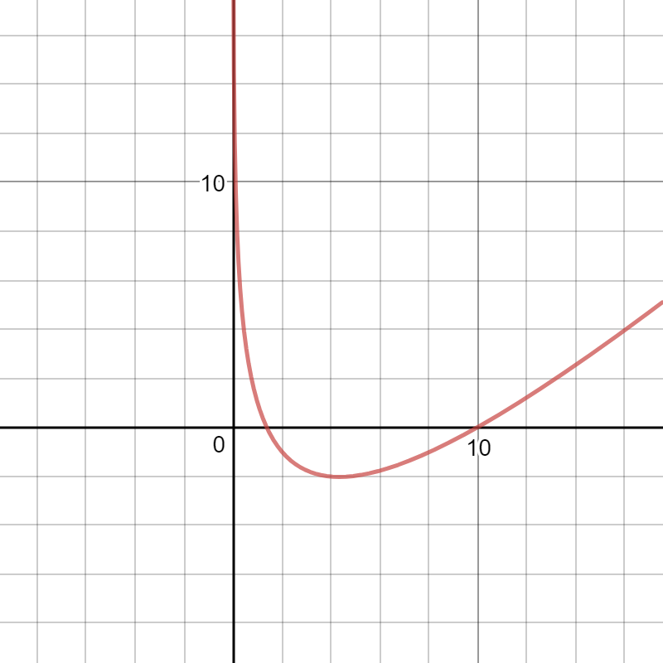

5.5 a) Weight vector after 5000 iterations of gradient ascent

[-0.04463628 -0.97498106 -0.92022903 -0.80146152 -0.83443097 -0.23026157 1.17676876 1.03431253]

[ 0.38297012 0.60925647 -0.02341717 0.04993536 0.14068977 0.33020503 -0.18489513 -0.63290761]

[ 0.74535214 0.77329123 1.12649351 0.49673133 0.13540154 -1.38629371 -2.12860503 -1.54516822]

[ 1.5072573 0.55116443 0.64480069 -0.27950827 -0.86792879 0.02172161 -0.4151613 -0.38789878]

[ 0.07448928 0.13411829 -0.02628987 -0.33303769 -0.00635626 -0.63043722 0.09017963 0.08982505]

[ 0.79421352 -0.1595946 0.5905914 0.21659534 0.61885643 0.17879049 0.18384859 -0.94245134]

[ 0.33917139 -0.00522386 0.2361696 0.09467432 -0.37409572 0.13008587 -0.1617381 -0.72116554]

[-0.10583036 0.05010946 0.70883605 0.79547788 -0.22922072 0.75598052 -0.25818735 -0.19671396]