Chapter 2*
Methanol economy:
Definition:
Methanol economy is a suggested future way to solve the problem of oil and gas energy, in which methanol and dimethyl ether replace fossil fuels as a means of energy storage, ground transportation fuel, and raw material for synthetic hydrocarbons and their products.
Why does its practice development contribute to a sustainable carbon cycle:
The key factor that it can contribute to carbon cycle is the conversion of carbon dioxide to methanol. The chemical recycling of CO₂ to new fuels and materials makes them renewable on the human timescale......
Chemical equation:
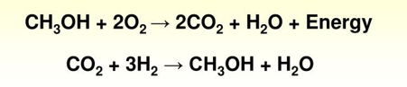
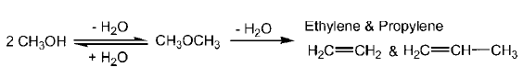
Starting materials:
Fuel storage:
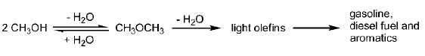
Industrial process of synthesizing CH₃OH:
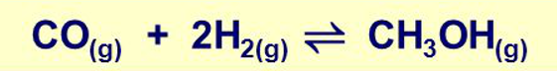
A mixture of copper, zinc oxide and aluminum oxide are used as a catalyst.
Preparation of synthesis gas (steam reforming):
CO₂ reforming of CH₄:

Chapter 3 Supercritical fluid:
Definition:
A supercritical fluid is any substance at a temperature and pressure above its critical point, where distinct liquid and gas phases do not exist. It can effuse through solids like a gas, and dissolve materials like a liquid.
Critical temperature:
The critical temperature of a substance is the temperature at and above which vapor of the substance cannot be liquefied, no matter how much pressure is applied.
Critical pressure:
The critical pressure of a substance is the pressure required to liquefy a gas at its critical temperature.
Characteristics:
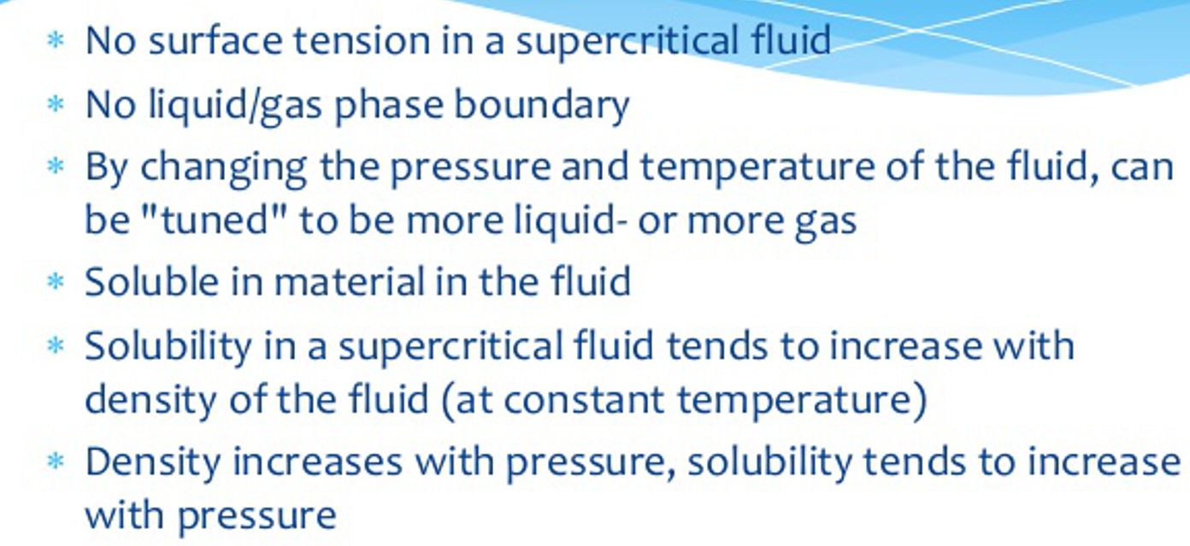
Advantages:
- High diffusion rates offer potential for increased reaction rates.
- Potential for homogeneous catalytic processes.
High solubility of light gases, some catalysts and substrates; bring all together in single homogeneous phase
- Inert to oxidation; resistant to reduction
Excellent medium for oxidation and reduction reactions.
- Small amounts of co-solvents can further modify solvent properties
- High compressibility
Large change in solvent properties for relatively small change in pressure – infinite range of solvent properties available.
Ability to tune solvent to favor a particular reaction pathway simply by optimizing temperature or pressure.
should be handled in standard high-pressure equipment on lab or industrial scale.
- Non-toxic, non-flammable, and inexpensive.
- Non-protic and generally unreactive.
- Product isolation to total dryness is achieved by simple decompression.
- CO₂ can be recovered and reused
Application:
Supercritical fluid extraction; Supercritical fluid decomposition; Dry-cleaning; Supercritical fluid chromatography; Chemical reactions; Impregnation and dyeing; Nano and micro particle formation; Generation of pharmaceutical cocrystals; Supercritical drying; Supercritical water oxidation; Supercritical water hydrolysis; Supercritical water gasification; Supercritical water gasification; Biodiesel production; Enhanced oil recovery and carbon capture and storage
Chapter 5 synthetic techniques *（一道题）
Highly efficient synthetic techniques to achieve green process：
- Photochemical reactions
- Chemistry with microwaves
- Sonochemistry (ultrasound in synthetic chemistry)
- Electrochemical synthesis
Photochemical reactions:
Definition:
A chemical reaction initiated by the absorption of energy in the form of light. The consequence of molecules’ absorbing light is the creation of transient excited states whose chemical and physical properties differ greatly from the original molecules.
Photochemical paths access high energy intermediates that cannot be generated thermally, thereby overcoming large activation barriers in a short period of time, and allowing reactions otherwise inaccessible by thermal processes.
Grotthuss–Draper law (First law of photochemistry):
Light must be absorbed by a chemical substance in order for a photochemical reaction to take place.
Stark-Einstein law:
Each photon of light absorbed by a chemical system, no more than one molecule is activated for a photochemical reaction, as defined by the quantum yield.
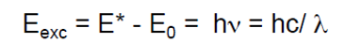
Chromophore:
Electronic transitions involve a shift of one electron from a lower to a higher energy molecular orbital. In most cases these molecular orbitals are associated with a specific part (e. g. functional group) of the molecule. This part , that mainly absorbs the photon is termed the chromophore.
Photophysical processes:
- Relaxation processes: Dissipation of energy and change of electronic configuration after excitation. Vibrational relaxation, internal conversion, intersystem crossing
- Decay processes: return of ground state with release of energy.
Quenching-energy transfer, fluorescence, phosphorescence, luminescence
Photochemical processes:
Chemical reactions of the excited state fragmentations: cis/trans isomerization, rearrangements, addition/cyclization reactions, photo oxidations
Important Compound Classes
Alkenes, dienes & polyenes, aromatic compounds, carbonyl compounds, nitrogen-containing compounds (R-N₃, RR’C=N₂, R-NO₂, R-N=N-R, R-ONO) singlet oxygen, halogen-containing compounds.
Photocatalyst:
In chemistry, photocatalysis is the acceleration of a photoreaction in the presence of a catalyst (e.g., TiO₂). The photocatalytic activity depends on the ability of the catalyst to create electron–hole pairs.
Advantages:
Clean process: Photons are very clean reagents, leaving no residues. A photo-initiated process therefore has potential advantages even when compared to reactions initiated by the use of catalysts.
Energy efficient: Since the energy is more directed, reaction temperatures are generally low. This may give higher selectivity, by reducing by-product formation from competing reactions.
A unique way to prepare products that would be difficult to make by other routes.
Challenges:
- Reactor fouling
Small amounts of fouling on the photochemical window or reactor wall through which the light has to pass can completely prevent reaction occurring.
- Light sources are polychromatic
Common mercury arc lamps emit around of their energy in the 405 nm to 578 nm range.
- Light sources are expensive
Thick-walled quartz as in high-pressure mercury lamps, and delicate,
- The power of transmitted light drops off easily
The power of transmitted light drops off as the square of the distance from the light
Microwaves:
Definition:
Microwaves are a form of electromagnetic radiation with wavelengths ranging from 1 meter to 1 millimeter; with frequencies between 300 MHz and 300 GHz. Its frequency can affect the behaviors of rotations of molecules.
It may be considered a more efficient source of heating than conventional steam- or oil heated vessels since the energy is directly imparted to the reaction medium rather than through the walls of a reaction vessel.
Mechanisms:
Microwave heating occurs when the molecules become polarized by a alternating electromagnetic field. Rapid rotational movement of the molecules inside the materials cause collisions with neighboring molecules. The ensuing results is frictional heat.
Chemistry (Parameter):
The heating characteristics of a particular material (for example, a solvent) are dependent on its dielectric properties.
The ability of a substance to convert electromagnetic energy into heat is determined by the so-called energy dissipation factor (tanδ).
A reaction medium with a high tanδ value is required for efficient absorption and for rapid heating.
Advantage:
- Rapid reactions
- High purity of products
- Less side-products
- Improved yields
- Simplified and improved synthetic procedure
- Wider usable range of temperature
- Higher energy efficiency
- Sophisticated measurement and safety technology
- Modular systems enable changing from mg to kg scale.
Shortcomings:
- Heat force control is difficult
- Water evaporation
- Closed container is dangerous because it could be burst
Owing to their high polarity and non-volatility, ionic liquids might be ideal for carrying out high temperature reactions efficiently.
Ultrasound:
Definition:
A sound wave is propagated by a series of compression and rarefaction cycles. When it passes through a liquid medium, it causes the molecules to oscillate around their mean position, the average distance between molecules is reduced and, conversely, it is increased during rarefaction.
Under appropriate conditions in the rarefaction cycle, the attractive forces of the molecules of the liquid may be overcome, causing bubbles to form. If the internal forces are great enough to cause collapse of these bubbles very high local temperatures (around 5000 oC) and pressures (over 1000 bar) may be created.
Applications in Organic Synthesis
- Homogeneous Sonochemistry: Aqueous medium; Non-aqueous media
- Heterogeneous Sonochemistry: Phase Transfer Catalysis; Reactions with metals; Heterogeneous Catalysis
- Enzyme reactions
Organic Electrochemistry:
Electrochemistry:
Electrochemistry is the branch of physical chemistry that studies the relationship between electricity and identifiable chemical change.
Organic electrochemistry:
Organic electrochemistry is concerned with the exchange of electrons between a substrate and an electrode and the chemical reactions that result from such electron transfer processes.
Green benefits:
Often water-based processes;
- Usually mild operating conditions (relatively energy efficient);
- Atom efficient - replacement of reagents by electrons.
Organic electrochemistry: Why?
Reaction economy:
Direct control of electron energy via over potential
Electrons/protons are (typically) sole reagents
Synthetic utility:
Umpolung chemistry
High typically predictable, tolerance of functional groups

Chapter 6*（一道题）
Design of ‘greener’ processes and products:
- chemistry aspects
- engineering aspects

- Conventional Reactors
- Inherently Safer Design
- Process Intensification
- In-process Monitoring
Conventional Reactors：
Batch reactor: is filled with reactants in a single stirred tank at time zero and the reaction proceeds. It is mainly used in multi-purpose plants for fine chemicals and pharmaceuticals.
Semi-batch reactor: allows partial filling of reactants with the flexibility of adding more as time progresses.
Continuous reactor: Reactants are continuously fed into the reactor and emerge as continuous stream of product. It is used in dedicated plant for bulk chemicals.
The design of an appropriate reactor system can：
- minimal by-product formation and downstream processing requirements
- optimal energy usage and costs reduction
- minimal hazards and waste.
Heat and mass transfer of batch reactors: #
Batch reactors are not just large versions of laboratory equipment laboratory: differences in heat transfer and mass transfer.
Problems with mass transfer: the delay and subsequent generation of large and dangerous exothermic reactions.
- The laboratory reaction rate can be monitored by varying agitator speed
- The reaction rate is independent of speed.

Problems with heat transfer: the safety and efficiency of a process, the economics.
The adverse effects of thermal lag:
Probably reducing the yield and selectivity, and making purification more difficult, thus leading to more waste, increased energy usage and higher costs.

More by-products by further reaction of the product.
Additional solvent can be used as a heat sink to control the temperature of exothermic processes in batch reactors, which cannot be recommended to the green chemist.
The adverse effects of poor mass transfer:
Resulting in the delay and subsequent generation of large and dangerous exothermic reactions.

Allowing relatively high concentrations to build up which then start to react rapidly.
Resulting in excessive hydrolysis when neutralizing agents were used.

Methods to improve the heat-transfer rate:
To increase the temperature differential by using higher-pressure steam or a hot oil supply. (adverse effects: fouling and unwanted reactions)
To increase the heat exchange area by the heating/cooling coils inside the reactor. (additional advantages: increasing the turbulence in the reactor; adverse effects: difficult cleaning and ‘dead spots’ or localized areas of poor mixing)
Buss loop reactor
Advantages and disadvantages of batch reactor:
An important advantage of a batch reactor is traceability. The product from a particular batch will have a uniform consistency, and can be uniquely labeled and readily traced.
Batch reactors are, however, rarely the most efficient in terms of throughput and energy use when the reaction kinetics is fast.
In contrast, the product from a continuous process may change gradually over time, and it is therefore more difficult to trace a particular impurity or fault in the material.
Categories of continuous Reactors:
Plug flow: tube-in-tube and fixed-bed reactors
Mixed flow: a Continuous Stirred Tank Reactor (CSTRs)
Advantages of plug flow:
- Low pressure drops.
- Tubes are easy to clean.
- Disadvantages of plug flow:
Reactor temperature difficult to control.
- Hot spots may occur within reactor when used for exothermic reactions.
- Difficult to control due to temperature and composition variations.

- Easily maintained since there are no moving parts.
- High conversion rate per reactor volume.
- Mechanically simple.
- Unvarying product quality.
- Good for studying rapid reactions.
- Efficient use of reactor volume.
- Good for large capacity processes.
Comparison between CSTRs and batch reactors:
Similarities:
large stainless steel vessels with an agitator, possibly baffles
A jacket or internal coils for heating and cooling.
Differences:
A constant in and out flow of materials, the constant concentrations of all the components and the constant reaction conditions for the CSTR.
Inherently Safer Design
How to prevent hazardous occurrences in designing chemical plants?
Minimization, Simplification, Substitution, Moderation and Limitation
Process Intensification
Definition:
Process intensification 'Technologies and strategies that enable the physical sizes of conventional process engineering unit operations to be significantly reduced.'

Improving mass-transfer rates to match that of the reaction.

Improving heat-transfer rates to match the exothermicity of a reaction.
Having an appropriate residence time for the reaction.
In-process Monitoring
In-line vs on-line process monitoring:
In-line analysis: no removal of the sample from the reaction vessel. E.g. titration, chromatography, spectroscopy and sensor based methods
On-line analysis: does involve removing a sample, usually as a side stream

Chpater 7（一道题）
- Non-renewable resources
- Renewable resources
- Chemicals from feedstock
Non-renewable resources:
Definition: A nonrenewable resource is a natural resource that cannot be re-made or re-grown at a time-scale comparable to its consumption. E.g., petroleum, coal, natural gas and nuclear power.
Issues with reliance on nonrenewable energy:
Dwindling supplies, environmental pollution.
Advantages and disadvantages with coal
Advantages and disadvantages of natural gas
Advantages and disadvantages of petroleum
Advantages and disadvantages of neclear energy
Renewable resource:
Definition:
A renewable resource is a natural resource which has the ability to revitalise itself naturally over an extended period of time. These resources are used to convert into energy and aid in helping provide alternatives to the current usage of oil, gas and coal which are finite.
Solar energy: Solar energy is radiant light and heat from the Sun, originating with the thermonuclear fusion reactions occurring in the sun.
Heating water, active system
Efficiency of solar heating system is always less than 100% because:
- % transmitted depends on angle of incidence,
- Number of glass sheets (single glass sheet transmits 90-95%), and
- Composition of the glass ( high borosilicate glass)
Heating Living Spaces, Solar cell
Photovoltaics: By joining n- and p-type semiconductors together, a junction is set which in simple terms enables electrons to move to fill the holes.
Advantages and disadvantages of solar energy
Geothermal energy: Geothermal energy is heat energy generated and stored in the Earth
Geyser, Hot Water Reservoirs, Natural Steam Reservoirs, Geopressured Reservoirs, normal Geothermal Gradient, Hot Dry Rock and Molten Magma
Advantages and disadvantages of geothermal energy
Tidal power: Tide energy comes from the gravitational attraction of the moon and sun on the earth’s oceans.
Wave power: Wave power is caused by a number of forces, i.e. wind, gravitational pull from the sun and moon, changes in atmospheric pressure, earthquakes etc.
Hydropower: Hydropower is power derived from the energy of falling water or fast running water, which may be harnessed for useful purposes.
Advantages and disadvantages of Hydroelectricity
Wind power: Wind power is the use of air flow through wind turbines to mechanically power generators for electric power.
Advantages and disadvantages of Wind power
Categories: Vertical axis, Horizontal axis
Biomass: Biomass refers to organic matter derived from living organisms that has stored energy through the process of photosynthesis (plants and woods).
Gasification, Thermolysis, Pyrolysis, Hydrothermolysis and Anaerobic Digestion
Bioethanol: by fermentation of glucose-based crops such as sugar cane and corn starch using Saccharomyces yeasts.
Chemicals from Feedstocks
Feedstock is a general term for the plant matter used to make fuel. E.g., Agricultural wastes, trees, grasses, corn, wood wastes and residues, aquatic plants, animal wastes and municipal wastes.

