# Target journal: *Nature Behavior*

Target length; *title through end of article text: 4,000 – 5,000 words (not including methods, data, references)*

*[EXAMPLES: title through end of text, not including methods, data, references*

*Josephson 2021= 6,000 words Ma et. al. 2022 = 3428 words Kroeger 2023 = 4170 words]*

Our 8-21-24 draft is 5282 words from title up to “methods”.

# **timeline of drafts:** ZRS adapted to article format from thesis chapter 6-5-24 …

BC editing 6-25. Accepting most ZRS changes, BC not using track Changes.

ZRS edited evening 6-25.

BC editing mid-August. Sent to ZRS 8-16.

ZRS updates with track changes and sent to BC 8-20.

8-21 BC accepts ZRS edits. BGC edits (without using Track Changes) through 8-25-24 and sends back to ZRS.

# **Environmental Justice in the Colorado River Basin**

Water access and water quality in areas receiving water from the Colorado River Basin (CRB) are constrained by pollution, competition for limited supplies and lack of delivery and treatment infrastructure. These constraints adversely affect those relying on the basin’s waters, with disproportionate effects on low-income areas and communities of color. In this article, we analyze differential exposure among racial and ethnic groups to four specific water-related environmental burdens: dust particles in the air, leaky underground storage tanks, lack of green space, and incomplete household water access. We examine differential exposure by analyzing data from the U.S Council on Environmental Quality, combined with U.S. census data for nearly 7,800 census tracts. These tracts are located within the CRB itself, or receive water exported from the CRB. We find that Hispanic, Black and American Indian populations are disproportionately exposed to three of the environmental burdens examined in this study. Dust pollution is pervasive throughout all groups, but is lower on average in census tracts with a higher proportion of American Indian populations; which tend to be rural. These findings encompass a large region that depends on the waters of the CRB, much of the southwestern U.S. Identifying systemic patterns of differential exposure linked to water policy is a first step in motivating and shaping measures to mitigate disproportional adverse effects on vulnerable populations.

**Introduction** Worldwide, there is increasing recognition that low income and minority populations are disproportionately exposed to water shortages, impaired water quality and other water-related environmental hazards. Further, these communities have lower access to money, infrastructure and other resources that support recovery (Deria et. al., 2020; Viniece et. al., 2021; Mueller and Gasteyer, 2023; Bandala et. al., 2022; Sanchez et. al., 2023). This article focuses on water-related environmental justice issues in the U.S. Southwest.

The waters of the Colorado River Basin (CRB) are vital to the southwestern U.S. Over 40 million people in the U.S. depend upon these waters, residing in the geographic basin itself and in the areas outside the basin that receive its water. The CRB provides water for over 5 million acres of irrigated cropland, hundreds of national parks, monuments and other recreation and cultural sites, dozens of federally listed species and vast natural areas of forest, canyons, grasslands and desert (Richter et. al., 2024). The Basin is in crisis, with multiple high-level federal-state-tribal negotiations underway to identify a sustainable path forward. Within this context of urgency, this article highlights environmental justice concerns related to the management of the waters of the CRB, concerns that could readily be overlooked in the efforts to secure water for farms, cities and industry. We draw upon new sources of data to examine patterns of water-related environmental burdens across racial and ethnic groups at the U.S. census tract spatial scale.

The term *Areas Receiving Colorado River Water* (ARCRW) denotes the geographic CRB plus the areas outside that basin that receive Colorado River water deliveries, shown in Figure 1. The population of the *ARCRW* is 36.7% Hispanic, 5.2% Black, 1.5% Native American and 44.3% White (U.S. Census Bureau, 2019)[1].

Figure 1 is shaded to indicate % of non-white population (Hispanic non-white plus Black plus Native American) in the 7,764 census tracts of the ARCRW. Figure 1 demonstrates that some census tracts in rural areas are predominantly populated by people of color. Figures 2 and 3 show finer detail of race and ethnicity in urban census tracts, using the Phoenix and Denver metropolitan areas as examples. Figures 2 and 3 indicate high concentrations of people of color in specific urban census tracts, reinforcing the uneven distribution by race and ethnicity found in more rural census tracts and highlighting a notably segregated population pattern in parts of the ARCRW.

Figure 1. % Non-White Population in 2019 by U.S. Census Tracts in ARCRW

Figure 2. % Non-White Population in 2019 in Phoenix and Surrounding Areas

Figure 3. % Non-White Population in 2019 in Denver, Colorado and Surrounding Areas

Given the diverse racial and ethnic groups of the ARCRW and the uneven spatial distribution of people of color, it is natural to examine how access to amenities and exposure to hazards is distributed around the ARCRW and among different populations. Given the ongoing urgent dialogue about managing the waters of the CRB, it also is timely to consider how management of the region’s water affects environmental justice (EJ). Environmental justice is defined by the US Environmental Protection Agency (EPA) as “the just treatment and meaningful involvement of all people, regardless of income, race, color, national origin, Tribal affiliation, or disability, in agency decision-making and other Federal activities that affect human health and the environment … so that people are fully protected from disproportionate and adverse human health and environmental effects (including risks) and hazards; and have equitable access to a healthy, sustainable, and resilient environment …” (U.S. Environmental Protection Agency, n.d.).

**Related Environmental Justice Studies**

This research is informed by the broader EJ literature’s examination of patterns in U.S. environmental burdens. EJ issues have been prevalent and discussed for many decades in the U.S., exacerbated by environmental policies that adversely affected specific groups based on race or skin color (Bullard, 1994, Banzhaf et. al., 2019). Disproportional impacts occurring around the globe have become more broadly communicated, drawing attention to environmental justice issues worldwide (Mohai et. al., 2009).

Although policies have been adopted in the U.S. to mitigate pollution, disproportional negative impacts persist for low-income individuals and racial and ethnic minorities (Kodros et. al., 2022; Kathuria and Khan, 2007; Jorgenson et. al., 2020; Dell et. al., 2009; Bell and Ebisu, 2012). Lower income and minority communities are exposed to higher levels of air pollution (Miranda et. al., 2011; Kathuria and Khan, 2007; Jorgenson et. al., 2020; Kodros et. al., 2022; Bell and Ebisu, 2012). Positive effects from water infrastructure expenditures on economic development outcomes (measured as changes in poverty, per capita income and unemployment) are smaller in counties with higher proportions of Hispanic and Indigenous populations (Mueller and Gasteyer, 2023). High air pollution levels, increased natural disaster occurrences, higher temperatures and lack of environmental amenities lead to poor health outcomes, hindering productivity and exacerbating income equality (Oyedele and Tella, 2023; Oliveira et. al., 2023; Johar et. al., 2022; González et. al., 2021; Jorgenson et. al., 2020; Spotswood et. al., 2021; Zaveri et. al., 2020; Dell et. al., 2009).

Substandard infrastructure contributes to disproportionate effects on health and income. Hispanic populations are more likely to be exposed to lead water service pipes in New York City (Nigra et. al., 2023). Lower income communities are more vulnerable to flooding (Deria et. al., 2020). Across the United States, 489,836 households (.41% of all U.S. households) lacked complete indoor plumbing, on average across 2014-2018 (Mueller and Gasteyer, 2021). Native American communities have a higher incidence of housing with incomplete kitchens or plumbing (Mueller and Gasteyer, 2021; Bandala et. al., 2022). Forty percent of households in the Navajo Nation haul their water due to lack of household water infrastructure (Tanana et. al., 2021). Tribal communities also forgo income that could be earned from utilizing senior water rights, due to the lack of infrastructure investments (Sanchez et. al., 2023).

Some policies that aim to reduce exposure to hazards and improve access to amenities have disproportional benefits for higher income, non-minority populations (Zhang et. al., 2022; Williams et. al., 2020; Spotswood et. al., 2021; Neier, 2021; Mueller and Gasteyer, 2023; Miranda et. al., 2011; Liu et. al, 2021; Bae and Lynch, 2023). Access to green space and tree canopy, especially in urban areas, can have positive benefits on mental and physical health and improve home values (Zhang et. al., 2022; Williams et. al., 2020; Liu et. al, 2021; Li, 2022). However, some groups benefit disproportionately from green space provision. Access to safe parks and tree canopy in cities is less prevalent for low-income or racial and ethnic minorities (Williams et. al., 2020; Zhang et. al., 2022). Where programs exist to plant more trees, minorities face higher risk of gentrification as housing values increase with tree planting, as Li finds in New York city (Li, 2023).

Portion of the CEJST data used in this study have been used in a few other published studies. Mullen et. Al. (2023). analyze tribal economies, highlighting the role of cultural considerations and energy extraction to accurately represent tribal nations’ economies. Shrestha et. al. (2022) used an earlier version of the CEJST data to show that nearly one-third of the U.S. population lives in an area considered disadvantaged by CEJST metrics. Shrestha et. al. (2023) highlight higher proportions of racial and ethnic minorities residing in disadvantaged communities. Contributing to the EJ literature, this study analyzes environmental burdens linked to water quality, allocation and infrastructure in ARCRW, using recently released CEJST data (released November, 2022). We identify highly disproportionate impacts across race and ethnic groups of specific water-related environmental burdens.

**Context of Environmental Justice and Water Policy in the ARCRW**

The ARCRW in the U.S. comprises portions of seven states that lie within the geographic CRB and additional areas within these states that receive water from the basin[2]. The states, tribal nations, cities, farms and natural habitat of the ARCRW are bound together by complex layers of legislation, administrative decisions and court rulings extending back over a century. The ongoing multi-year drought and shifting climate and hydrology of the basin increases the complexity and urgency of efforts to address allocation of water, protection of water quality and water equity among the ARCRW’s diverse populations and jurisdictions.

**Water Policymaking**

ARCRW state and federal policymakers, including Congress and state legislatures, courts and administrative agencies historically have decided how to allocate and manage water supplies and water quality. Some senior water rights held by tribal nations remain largely unquantified, leaving those tribal communities vulnerable amidst intense competition for water (Schutz, 2013). More recently, tribal nations and environmental NGOS have gained more prominent influence. These diverse parties seek to meet demand for agricultural and municipal sectors, while ensuring suitable water quality, maintaining water supply and conserving natural habitat. Multiple water disputes have been litigated and agreements negotiated to quantify water rights and build infrastructure for tribal communities to utilize their rights (Colby et al., 2005). Water supply constraints are likely to be exacerbated in some areas of the ARCRW by agreements among states to cut back use of a portion of their Colorado river water entitlements (Ciccarillo, 2024).

Along with surface water from the Colorado River and its many tributaries, groundwater is an important component of water supply. Groundwater and surface water supplies and quality are inextricably interconnected. Groundwater depletion negatively impacts surface water flows, which is needed to support recreational activities and natural wetlands in the ARCRW. Surface water depletion affects groundwater recharge (Condon, 2019). Water quality is impacted by many aspects of human activity in the ARCRW and worldwide. Figure 4 from the Groundwater Foundation (n.d.) portrays common sources of surface and groundwater contamination, several of which we analyze in our study[3].

Figure 4. Sources of Water Contamination[4]

**Water-Related Environmental Burdens**

Many aspects of water management and policy impact communities in the ARCRW. These aspects include multi-layered decision processes that seek to 1) decide how much water goes where, when, to whom and for what purposes, 2) ensure sufficient water quality, and 3) invest in infrastructure to protect supply reliability and water quality. Limited and uncertain water supplies constrain allocation decisions. Many factors affect water quality, as Figure 4 illustrates. Infrastructure investments entail large amounts of money and lengthy political processes. These three broad aspects of water policy affect severity and distribution of environmental burdens in the ARCRW, and these burdens have significant implications for health and productivity (Oyedele and Tella, 2023; Oliveira et. al., 2023; Johar et. al., 2022; González et. al., 2021; Jorgenson et. al., 2020; Spotswood et. al., 2021; Zaveri et. al., 2020; Dell et. al., 2009).

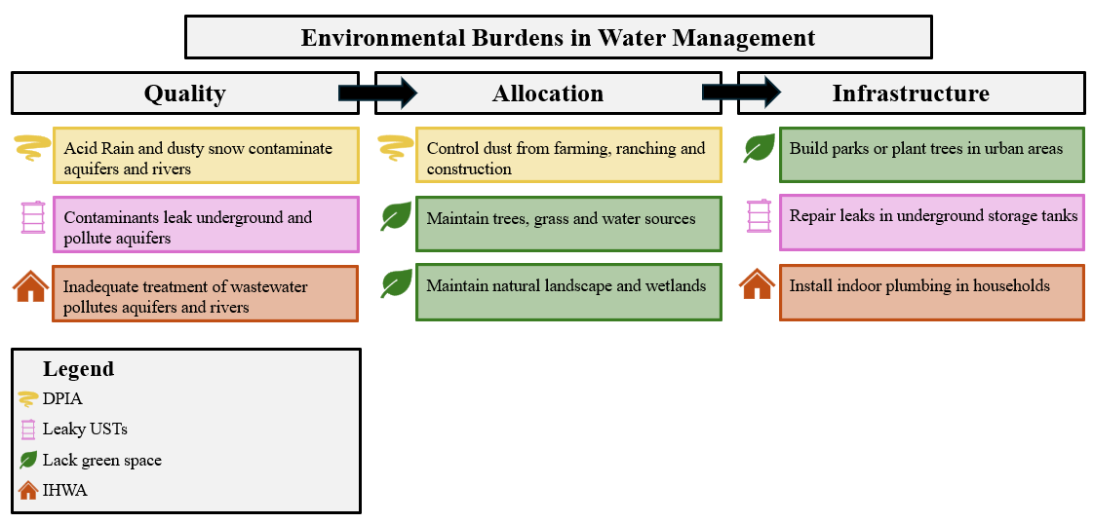

Figure 5. Environmental Burdens in Water Management

Figure 5 links the four environmental burdens analyzed in this paper to aspects of water management. Dust particles in the air (DPIA) impact human, animal and plant health, as well as contaminating water (Groundwater Foundation, n.d.). Moreover, dust control for farming, ranching and construction requires water to be allocated for this purpose. Leaky underground storage tanks (USTs) release toxic materials that contaminate soil and water. Maintaining and monitoring storage tank infrastructure impacts the amount of contaminants released into water sources and populations exposed to those contaminants. Green space requires reliable water allocation to maintain trees, turf, lakes, wetlands and riparian habitat in this arid region. Infrastructure choices that increase impervious surfaces and cropland reduce natural habitat, diminish green space, increase temperature, contribute to air and water pollution and adversely affect mental health (Aram, et al., 2019; Hoge and Wulf, 2023). Incomplete household water access (IHWA) inhibits residents’ access to safe drinking water and threaten health. Having to haul water for household use decreases productivity and income. Inadequate household water infrastructure also contributes to tribal nations’ inability to fully use their water rights (Sanchez, 2023).

Table 1 defines the four environmental burdens analyzed.

Table 1. Environmental Burden Definitions

To summarize, many types of water management and policy decisions in the ARCRW affect the four environmental burdens analyzed in this article. Water quality policies and infrastructure investment and maintenance decisions affect leaky USTs and inadequate household water access. Allocating water for dust control, urban green space and natural habitat affect DPIA and lack of green space. To mitigate environmental justice impacts of water-related environmental burdens, water management and policymaking must deliberately account for these four environmental burdens stemming from water contamination, constrained resources and poor infrastructure.

### Results

### We apply an Ordinary Least Squares (OLS) regression model to examine relationships between four environmental burdens (lack of green space, DPIA, leaky USTs, and IHWA) and race, income, and education characteristics. We utilize a newly released data set from the Council on Environmental Quality (CEQ) in 2022 that compiles environmental burdens, race, ethnicity, income, education, and health variables at the census tract level. We spatially match census tract data to the ARCRW and apply econometric analysis to the cross-sectional data.

Figure 6 shows correlations[5] at the census tract spatial scale between the four environmental burdens, race and ethnicity, income, education, and population density. A positive correlation means higher exposure to an environmental burden, while a negative correlation means lower exposure to an environmental burden. White non-Hispanic populations are less exposed to all four burdens, with small to moderate negative correlations. American Indian is the only racial group that is strongly exposed to IHWA, with strong positive correlation. Hispanic and Black non-Hispanic populations show disproportionate exposure (positive correlations) with three of the environmental burdens, excluding IHWA.

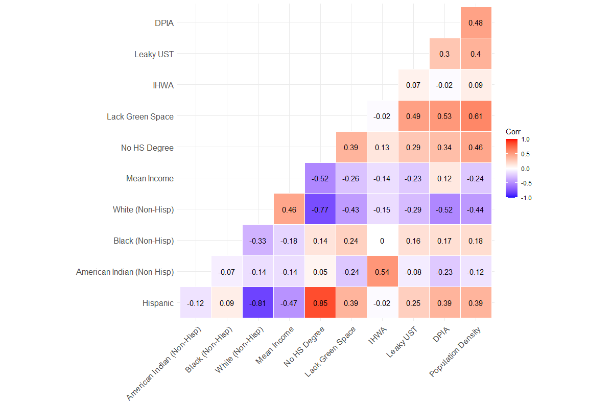

Figure 7. Correlation Matrix of Environmental Burdens and Demographics

Table 2 presents summary statistics for each variable discussed in this section as a summary of all the census tracts in the study area. The average share of impervious surface or cropland in ARCRW census tracts is roughly 50%. While most census tracts have zero households with IHWA, there is a tract located within tribal reservation lands where 67% of households lack water access infrastructure. While only 0.94% of households in the ARCRW have IHWA, this corresponds to about 130,621 households unevenly spread across the basin, raising cause for concern. Households with IHWA are concentrated in specific areas of tribal lands (Deitz and Meehan, 2019). The average income for all tracts in the ARCRW is $91,406.88. Population density varies across tracts, with the lowest density tracts having zero residents (there are eight of these - typically tracts consisting only of an airport or body of water). The highest density tract has 148.09 people per acre and is located in Los Angeles.

|  |  |  |  |  |  |
| --- | --- | --- | --- | --- | --- |
| **Variable** | **Min** | **Mean** | **Median** | **Max** | **Stand. Dev.** |
| % Lack ofgreen space acreage | 0.03% | 49.5% | 53.0% | 97.3% | 21.8% |
| % Households with IHWA | 0.00% | 0.97% | 0.00% | 62.00% | 2.57% |
| Leaky USTs | 0.00 | 3.44 | 2.24 | 42.16 | 3.98 |
| DPIA | 4.01 | 9.54 | 9.29 | 13.86 | 2.65 |
| % Hispanic | 0.0% | 36.2% | 28.6% | 100.0% | 26.5% |
| % American Indian | 0.0% | 1.7% | 0.0% | 100.0% | 9.3% |
| % Black | 0.0% | 5.1% | 2.4% | 84.7% | 8.2% |
| % Without high school degree | 0.0% | 15.2% | 10.0% | 75.0% | 14.0% |
| Mean Income (Scaled $1000) | $0.0 | $91.4 | $81.4 | $434.7 | $45.3 |
| Population Density | 0.00 | 11.79 | 8.62 | 148.09 | 12.76 |

Table 2. Summary Statistics

## Statistical Modeling Results

Table 3 shows the results of four statistical models, each examining one of the four environmental burdens as dependent variables[6]. Figure 7 visualizes these models as Forest Plots (Fagerland, 2015). To check for linear dependencies between explanatory variables, a Variance Inflation Factor (VIF) is calculated for each variable in each model. For all the parameters, the variance is not inflated enough to cause concern for collinearity. Table 3 reports VIF values, which each are less than 5.0. This lies well below the threshold for indicating collinearity as a concern (O’Brien, 2007).

The F-statistics are significant for all models, which indicates that the independent variables in each model have good explanatory power[7]. The model for air pollution shows that much of the variation for this environmental burden is accounted for.

**Water quality, DPIA and leaky USTs**

Model (1) shows interesting results related to air quality. Tracts with higher DPIA are positively correlated with tracts that are home to higher percentages of Hispanic and Black populations. Tracts with higher income, on average, and those that are more densely populated are also likely to be tracts with higher levels of DPIA. Tracts with a higher percentage of American Indian populations are the only group negatively correlated with DPIA.

Model (2) indicates that Black and less educated populations live in areas with higher density of leaky USTs. Hispanic and American Indian populations are less exposed to leaky UST. Moreover, tracts with higher income on average are also those with less leaky USTs.

**Allocating water and lack of green space**

Policies that decide how scarce water is allocated affect cropland acreage, new construction (impervious surfaces) and water to support green space and natural habitat (model 3). Census tracts with higher percentages of Hispanic and Black populations are also those with higher percentages of a lack of green space. American Indian and lower educated populations reside in areas with higher percentages of green space, likely linked to being rural instead of urban. Tracts with higher average income have higher percentages of green space. Lastly, more densely populated tracts have higher percentages of a lack of green space.

**Water infrastructure and households with incomplete plumbing**

The role of infrastructure that provides potable tap water in the home is represented in model (4). On average, Hispanics live in tracts in which a lower percent of households have IHWA. In contrast, American Indian populations and those with less education live in tracts with higher percentages of households with IHWA. Higher income census tracts, on average, have a smaller percentage of homes with full household water. Population density is positively correlated with higher percentages of households with IHWA.

|  |  |  |  |  |  |  |  |  |
| --- | --- | --- | --- | --- | --- | --- | --- | --- |
| Dependent Variable: | (1) DPIA | | (2) Leaky USTs | | (3) Lack Green Space | | (4) IHWA | |
| Variable | Estimate |  | Estimate |  | Estimate |  | Estimate |  |
| (Intercept) | 5.96 | *** | 2.16 | *** | 40.66 | *** | 0.89 | *** |
|  | *(0.066)* |  | *(0.15)* |  | *(0.98)* |  | *(0.09)* |  |
| % Hispanic | 1.68 | *** | -0.81 | ** | 9.51 | *** | -1.81 | *** |
|  | *(0.14)* |  | *(0.36)* |  | *(1.66)* |  | *(0.34)* |  |
| % American Indian (Non-Hisp) | -0.95 | *** | -2.46 | *** | -33.48 | *** | 14.74 | *** |
|  | *(0.20)* |  | *(0.34)* |  | *(2.16)* |  | *(1.43)* |  |
| % Black (Non-Hisp) | 3.06 | *** | 2.80 | *** | 21.67 | *** | -0.41 |  |
|  | *(0.12)* |  | *(0.65)* |  | *(1.99)* |  | *(0.46)* |  |
| % No HS Degree | 0.0029 |  | 0.031 | *** | -0.064 | ** | 0.027 | *** |
|  | *(0.0025)* |  | *(0.0077)* |  | *(0.032)* |  | *(0.007)* |  |
| Mean Income (scaled $10,000) | 0.0001 | *** | -0.0001 | *** | -0.0007 | *** | -0.00005 | *** |
|  | *(0.000004)* |  | *(0.00001)* |  | *(0.0001)* |  | *(0.000007)* |  |
| Population Density (scaled 1000) | 28.80 | *** | 87.79 | *** | 769.51 | *** | 20.30 | *** |
|  | *(1.84)* |  | *(7.52)* |  | *(36.52)* |  | *(3.47)* |  |
| State Effects | Yes |  | Yes |  | Yes |  | Yes |  |
| Observations | 7756 |  | 7756 |  | 7756 |  | 7756 |  |
| R2 | 0.7881 |  | 0.2106 |  | 0.4859 |  | 0.3286 |  |
| Adj. R2 | 0.7878 |  | 0.2094 |  | 0.4851 |  | 0.3275 |  |
| F Stat (12; df = 7743) | 2400 | *** | 172.1 | *** | 609.7 | *** | 315.8 | *** |
| Breusch-Pagan Statistic | 969.36 | *** | 467.44 | *** | 329.36 | *** | 793.02 | *** |
| Variable | VIF | Df |  |  |  |  |  |  |
| Hispanic | 4.91 | 1 |  |  |  |  |  |  |
| American Indian (Non-Hisp) | 1.34 | 1 |  |  |  |  |  |  |
| Black (Non-Hisp) | 1.14 | 1 |  |  |  |  |  |  |
| % No HS Degree | 4.93 | 1 |  |  |  |  |  |  |
| Mean Income (scaled $10,000) | 1.73 | 1 |  |  |  |  |  |  |
| Population Density (scaled 1000) | 1.50 | 1 |  |  |  |  |  |  |
| State Effects | 1.95 | 6 |  |  |  |  |  |  |
| *p<0.1;**p<0.05;***p<0.01 |  |  |  |  |  |  |  |  |

Table 3. Econometric Results

Figure 7 utilizes Forest Plots (Fagerland, 2015) to visualize the results in Table 3. The y-axis denotes the independent variables explored in our models and the x-axis is the domain that contains the estimated relationship values between the regressors and the environmental burdens. The horizontal lines in Figure 7 for each variable represent the 95% confidence interval around the point estimate. The estimates, labeled to the top right of each point, are denoted as significant if their p-value is less than 0.05. In other words, the likelihood of the models falsely indicating a significant relationship between the regressors and environmental burdens is less than 5%. These plots highlight the significant size difference between the population density relationship and the other explanatory variables’ relationship with the four environmental burdens. Also of note is the size of the relationship between census tracts with higher proportion of American Indians and tracts with IHWA.

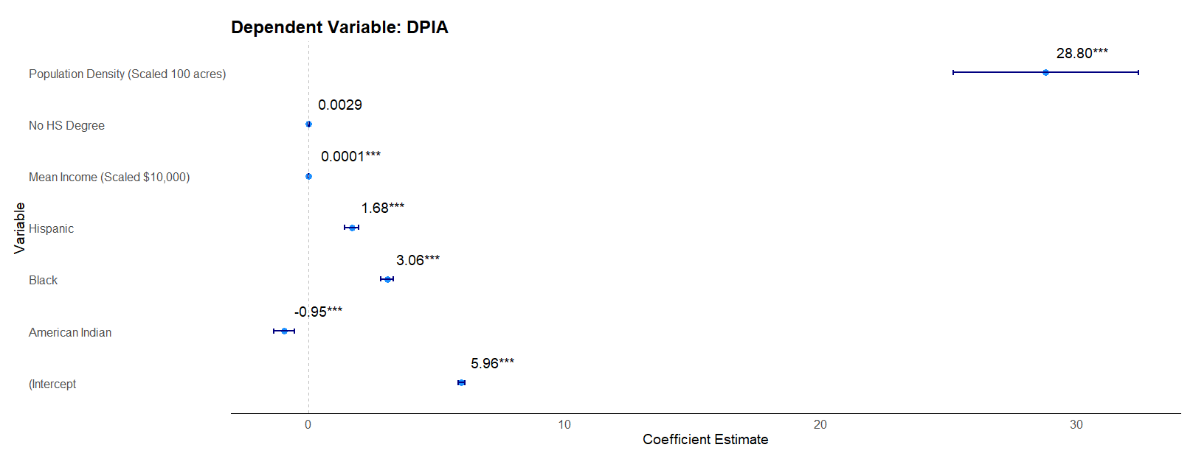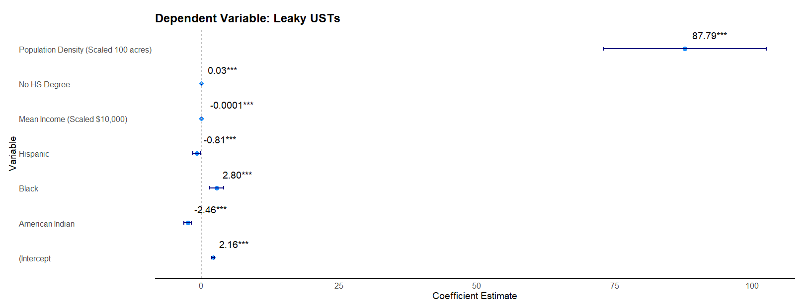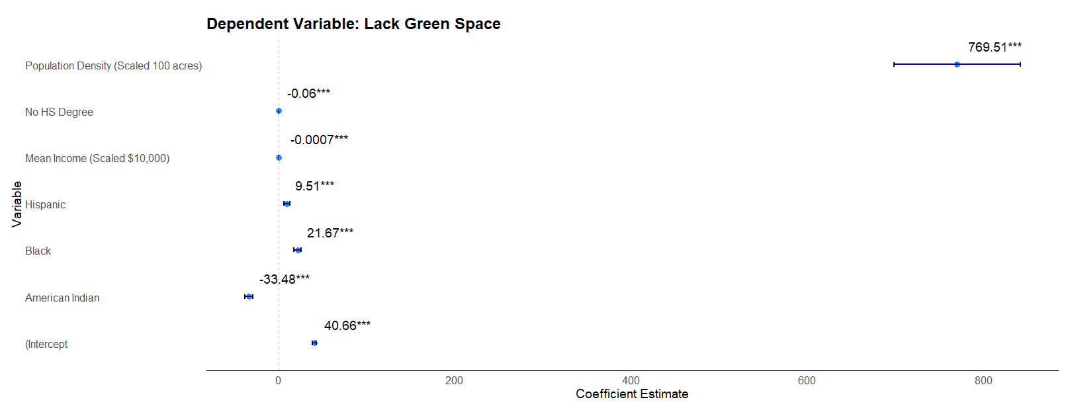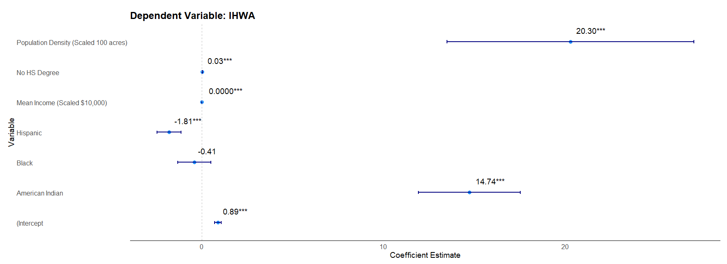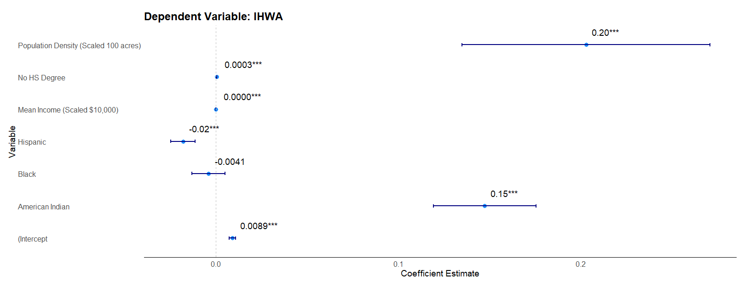

We find, on average, census tracts with a 1% increase in Hispanic populations also increase in DPIA and lack of green space by 1.68 particles and 9.51 acres. Census tracts where there is a 1% increase in American Indian populations also increase in percentage of households with IHWA by 15%, on average. Census tracts where there is a 1% increase in Black populations also increase in DPIA, leaky USTs and lack of green space by 3.06 particles, 2.8 leaky UST’s and 21.67 acres, on average. To summarize the statistical findings, Hispanic, Black and American Indian populations are disproportionately exposed to three of the environmental burdens examined in this study. Dust pollution (DPIA) is pervasive throughout all groups.

## Discussion

### Moved from earlier location: Our results align with past literature finding disproportional relationships between minority groups and environmental burdens. Findings highlight the need for increased diversity, equity, and inclusion (DEI) in policy discussions regarding water supply and access in the ARCRW, as lack of DEI in water dialogues leads to environmental injustice (Williams et. al., 2023).

Moved from earlier location: Water policy in the ARCRW is formulated at multiple levels, by federal, tribal, state and local agencies and elected officials. Especially during extended drought, the focus is on stretching a scarce water supply among competing water locations and users. Incorporating multiple aspects that influence water quality, water access and infrastructure decisions to explore disproportional exposure to environmental burdens can help in guiding further water policy in the ARCRW in an EJ context. The race and ethnicity variables follow the expected relationships as seen in past EJ literature. Hispanic populations, regardless of race, show negative correlations with IHWA and leaky UST’s and a positive correlation with DPIA and lack of green space. One aspect to consider is the Hispanic variable includes the white Hispanic population. This categorization could impact the relationship between Hispanic populations with environmental burdens in opposing ways if race is a greater determining factor.

Moved from earlier location: Income and population density also have expected signs. One could infer that those with higher income can choose to live in areas surrounded by green space. DPIA, on the other hand, seems to be less avoidable, even for those with a greater ability to choose where they live. Moreover, the positive correlation between population density and each environmental burden suggests where there are more people there is also higher incidence of DPIA, leaky USTs, lack of green space and IHWA.

### Motivation for Study

We explore several types of environmental burdens related to water quality, allocation and infrastructure to further identify whether certain groups in the ARCRW are disproportionately exposed. These burdens include air pollution, leaky USTs, lack of green space and households with incomplete plumbing. Environmental burdens around the world have disproportional effects on racial and ethnic minorities, as well as on low-income and less educated individuals (Kodros et. al., 2022; Kathuria and Khan, 2007; Jorgenson et. al., 2020; Dell et. al., 2009; Bell and Ebisu, 2012). Moreover, environmental burdens lead to adverse health outcomes (Oyedele and Tella, 2023; Oliveira et. al., 2023; Johar et. al., 2022; González et. al., 2021; Jorgenson et. al., 2020; Spotswood et. al., 2021; Dell et. al., 2009). Understanding whether there are disproportional exposure to environmental burdens in the ARCRW can help inform policy decisions ensuring equitable protection while improving the quality and quantity of the Colorado River water supply.

### Race, Income, and Education Relationships with Environmental Burdens in the ARCRW

The econometric models utilize four different environmental burdens as the dependent variable: air pollution prevalence, leaky USTs, lack of green space and households with incomplete plumbing. Race, ethnicity, income, education, and population density are included as explanatory variables. A cross-sectional data set is analyzed in four separate OLS models, each with the same explanatory variables but different environmental burdens as the dependent variable. The models are run with robust standard errors.

The percentage of those who identify as Hispanic, regardless of race, in a census tract shows positive relationships with air pollution and impervious surface or cropland, and negative relationships with leaky UST’s and percentage of households with incomplete plumbing. American Indians and low educated populations are the most likely to live in areas with more households with incomplete plumbing while Black population size is positively correlated with each of the other environmental burdens. Those with higher income tend to live in places with more access to green space, less households with incomplete plumbing, less USTs, and higher air pollution.

### Water Policy Implications for Considering Disproportionate Impacts

BGC – a “guardrail” approach – don’t make EJ problems worse – is necessary. Then propose some proactive approaches, tying them to what currently is underway with Infrastructure Bill implementation as it relates to water

While decisions have been made to mitigate pollution (i.e. the Clean Air and Clean Water Acts in 1970 and 1972), allocate ample amounts of water (i.e. through projects like the Central Arizona Project), and improve household plumbing, environmental burdens persist in the ARCRW (U.S. Executive Office of the President Council on Environmental Quality, 2022). Understanding which groups are likely vulnerable to the four environmental burdens examined can help inform policy regarding where to target water allocations, water pollution mitigation strategies, and investments in household infrastructure. Our findings present evidence of positive correlations between minority, less educated and low-income communities and environmental burdens. Much of the literature finds similar results regarding relationships between environmental burdens and race, ethnicity, income, and education. These findings suggest environmental injustice surrounding water users in the ARCRW is present.

Air pollution directly negatively impacts human and environmental health, and adversely affects water quality. Findings for air pollution prevalence suggest this burden is pervasive among all groups, regardless of race, ethnicity, income, or education level, excluding American Indian populations who are found negatively correlated with air pollution. Higher leaky UST densities are more likely to impact Black and less educated populations. These results highlight the need for further policy focus on mitigating contaminants from point sources.

Water allocations do not just pertain to satisfying base level agricultural and municipal demand. Policy makers also decide how to allocate Colorado River water towards maintaining natural habitat, by ensuring sufficient flow levels, and investing in green landscapes, such as planting trees or building parks in cities, which require enough water to do so. Some cities, like Los Angeles, have programs that incentivize tree planting. One drawback to this beautification effect trees have on cities is that these programs lead to increases in home values, potentially leading to gentrification, like the scenario seen in New York City’s Million Trees Program (Li, 2022). Finding ways to maintain green spaces while avoiding gentrification impacts can be useful for creating equitable policy regarding water allocations in the ARCRW.

Households with incomplete plumbing exist within the ARCRW boundaries, inhibiting those residing in such households from utilizing access to their full water right. This problem seems most likely experienced by American Indian populations. Aiming household water infrastructure investments towards Reservations could help lessen the burden in the ARCRW.

We find that relationships between racial and ethnic minorities as well as low income and less educated populations and environmental burdens corroborate the need for increased DEI in water dialogue, as discussed in Williams et. al. (2023). The more representation that takes part in water policy decisions, the broader perspectives there are to find an optimal solution for water quality and quantity issues in the ARCRW while ensuring the well-being of all water users regardless of race, ethnicity, income, or education level.

### Future Research Directions

There is much room for future research to improve upon the analyses regarding water and environmental burdens. Much of the data has only recently become attainable through technological advancements. As more remote sensing data collection and analysis tools are developed, one can also explore the relationships with environmental burdens and demographics over time with panel data.

Modeling further the relationships between the environmental burdens and Hispanic populations split between White and non-White races can be useful in disentangling potentially opposing correlations. It would be interesting to know whether race alone is a larger driver for determining whether a particular group is disproportionately exposed to an environmental burden.

Many census tracts in the study area are very sparsely populated. 30% of the census tracts have less than or equal to about 5 people per acre. It could be interesting to see if these correlations hold when looking at highly rural and urban tracts separately. This separation could also help capture a potential nonlinear relationship between income and population density, since both highly urban and rural areas have both high and low-income individuals. Population density may also have a non-linear relationship with impervious surface or cropland area. Those in less densely populated tracts are more likely to be surrounded by cropland, or just natural space. Those in more densely populated tracts are certainly surrounded by a higher portion of impervious surface. This suggests the relationship between population density and lack of natural or green landscape could be logarithmic and should be further explored.

One might want to further explore models for leaky USTs as more data becomes available to see how much this environmental burden varies over time. This could provide further insight into why the model’s explanatory power is not high. Finally, looking into areas concentrated with households with incomplete plumbing to analyze differences between those with and without household water use infrastructure can be useful.

### Summary

Our analysis on environmental burdens relating to water quality, allocations and infrastructure shows evidence that further policy may be needed in the ARCRW to address impacts on communities which are particularly vulnerable. While mitigation strategies are becoming more common, it is important to work toward more equitable access to water sources and less exposure to environmental burdens in ARCRW, regardless of race and ethnicity or income and education level.

## Methods

This section introduces the Climate and Economic Justice Screening Tool (CEJST) data, defines specific variables used in the econometric analysis, and discusses some potential data limitations.

**Data.** The newest version of the CEJST data set was released by the CEQ in 2022 (U.S. Executive Office of the President Council on Environmental Quality, 2022). This data set compiles demographic, housing, income, and environmental information and provides indicators for different environmental burdens at the U.S. Census Bureau census tract level (White House Council on Environmental Quality’s Climate and Economic Justice Screening Tool (CEJST), 2022). Census tracts included in this analysis lie wholly or partially within the ARCRW boundary and adjacent areas receiving Colorado River water, such as tracts in Los Angeles. At the edges of the ARCRW, census tracts with less than 50% of their human activity (defined as impervious surface and cropland) occurring within the ARCRW boundary intersection are excluded from the analysis.

**Environmental Burdens.** We focus upon four environmental burdens of significant concern in the ARCRW and linked in differing ways to how water is managed in the ARCRW. This section begins with definitions of the environmental burdens, which are elaborated below. Table 3 provides brief definitions and measurement units.

|  |  |  |
| --- | --- | --- |
| Environmental Burden | Definition | Measurement Units |
| Lack of Green Space | The percent of census tract that is artificial surface (i.e. cement, roads, etc.) or cropland. | Percent |
| IHWA | The percent of households with incomplete kitchens or plumbing. | Percent |
| Leaky Underground Storage Tanks (USTs) | The density of leaky USTs and all active USTs within 1500 feet of each census tract. | Density |
| DPIA | The amount of inhalable particles, less than 2.5 micrometers, in the air. | Micrograms per cubic meter of air |

Table 4. Summary of Environmental Burden Variables

Lack of green space is measured by CEJST is the percent of a census tract’s land that is impervious surface (i.e. concrete, pavement, or other artificial surfaces) or cropland. This data is sourced by the CEQ from the Multi-Resolution land Characteristics Consortium which compiles remote sensing land cover data including the National Land Cover Data (NLCD) 2019 Percent Developed Imperviousness. The NLCD provides information on the percent of pixels that are imperious surface, and The Trust for Public Lands converts that into an area at the census tract level (Multi-Resolution Land Characteristics Consortium (MRLC), 2019).

IHWA, called lack of indoor plumbing in the CEJST data, measures the percentage of homes with incomplete indoor kitchens or plumbing. The Department of Housing and Urban Development (HUD) receives detailed data from the American Community Survey (ACS) on the number of households that lack indoor kitchens or plumbing. The ACS reports households that have incomplete plumbing and those with incomplete kitchens separately, and HUD combines them as a part of their Comprehensive Housing Affordability Strategy (CHAS) Data (Department of Housing and Urban Development, n.d.). The ACS data is a five-year moving average from 2014-2018 at the census tract level. According to the U.S. Census Bureau, households with incomplete plumbing are those that lack at least one of the following characteristics: hot and cold piped water, bathtub or shower, and flushable toilet; whereas households with incomplete kitchens are those that lack a sink with a faucet, stove or gas range, and/or a refrigerator (U.S. Department of Commerce, 2015). These criteria are combined by the ACS so that if a household is missing any of these characteristics, they are identified as lacking complete kitchen or plumbing. CEQ then uses the percentage of households in each census tract with incomplete kitchen or plumbing from HUD’s CHAS. For simplicity, this study refers to households with incomplete indoor kitchens or indoor plumbing as households with IHWA.

Leaky UST’s are calculated as the density of leaking UST’s to the number of active UST’s within 1500 feet of each census tract. Leaking UST’s can cause water contamination, potentially presenting health risks through impacting drinking water quality and environmental risks creating fire and explosion hazard (U.S. Environmental Protection Agency, 2024). This data is from the Environmental Protection Agency’s (EPA) UST Finder in 2021 and then compiled by EPA’s EJScreen (White House Council on Environmental Quality’s Climate and Economic Justice Screening Tool (CEJST, 2022).

DPIA is the level of inhalable particles, which are less than or equal to 2.5 micrometers. These particles can be made up of various chemicals or heavy metals, which may cause cancer (U.S. Environmental Protection Agency, 2020). This data comes from the EPA’s Office of Air and Radiation’s (OAR) fusion of model and monitor data in 2017. The EPA National Air Toxics Assessment (NATA) and the U.S. Department of Transportation’s (DOT) traffic data sources the PM2.5 data, which is then compiled by EPA’s EJScreen and included in the CEJST data. There are about 4000 State and Local Air Monitoring Stations (SLAMS) across the United States that track air pollution levels. Limitations include spatial gaps, filled by the EPA’s modeling techniques. Gaps occur especially in rural areas where the SLAMS are less likely to be located (U.S. Environmental Protection Agency, 2020).

**Race, Ethnicity, Income, Education, and Population.** Race and ethnicity data come from the U.S. Census American Community Survey (ACS) as a five-year moving average in 2019 at the census tract level (U.S. Census Bureau, 2019). Races analyzed include American Indian, Black, and White non-Hispanic population counts. Also used is the population in each tract that identify as Hispanic, regardless of race. The ACS provides data that splits racial groups by ethnicity (Hispanic or non-Hispanic). These are used to ensure no overlap occurs within the race and ethnicity populations in the models. For further elaboration on how the ACS categorizes race and ethnicity population counts, see figure 8 below. Population percentages by race and ethnicity are discussed in Appendix A.

Figure 9. U.S. Census Bureau’s Categorization of Race and Ethnicity Categories

Mean household income comes from the U.S. Census Bureau’s ACS as a five-year moving average in 2019 at the census tract level. The education variable measures the percentage of the population in each tract at or over the age of 25 that has obtained a high school degree. This education indicator is from the CEJST data and is a five-year moving average estimate in 2019 (averaged value from 2015 to 2019).

**Population Density.** To control whether a tract is rural, we include population density in the analysis, calculated as the population divided by the area (in acres) in each census tract. This variable is incorporated in the model to reduce endogeneity issues as greater population density shows positive correlations with many of the environmental burdens data (as seen in Figure 6).

**Data Limitations.** The cross-sectional data is measured in somewhat different time periods. For example, the leaky UST data is based on measurements for 2021 and the incomplete plumbing data for 2018, while the demographic data uses 2019 values. These variables are reasonably comparable due to lack of variability of the observations from year to year.

**Econometrics.** We explore relationships between environmental burdens and income, race and ethnicity, and education in the Colorado River Basin at the census tract level.

We use a linear regression model to analyze the relationship between each environmental burden and demographics, income, and education characteristics. This model produces the most efficient, consistent, unbiased, and linear estimate. The OLS estimator assumes the following: (1) the environmental burdens are linearly dependent on the explanatory variables, (2) the explanatory variables are linearly independent from each other, and (3) the error terms are not correlated with the explanatory variables , they are homoscedastic , and there is no autocorrelation .

Because race and ethnicity characteristics are correlated with income and education (Chetty et. al., 2020; Povich et. al., 2015), we conduct further tests to ensure that variance is not overinflated due to collinearity between the explanatory variables (Michler and Wu, 2020). To check for this, the variance inflation factor (VIF) is calculated (O’Brien, 2007).

The data analyzed is cross-sectional with 7,756 observations. We present four models, each with the same explanatory variables including race, ethnicity, income, and education. Each dependent variable is a different environmental burden. Those identifying as non-Hispanic White, Hawaiian or Pacific Islander, two or more races or another race not accounted for in the ACS are excluded from the models as the comparison group (for race/ethnicity). (White population accounts for 78.7% of these excluded categories).

To avoid endogeneity issues due to unobserved heterogeneity, we include state control variables as dummy variables to account for differences in each tract due to the state in which it belongs. These unobserved characteristics could be attitudes and preferences towards these environmental burdens, political beliefs related to social and environmental policies, and environmental amenities that differ across states. Population density is incorporated into the model to account for urban versus rural tracts.

The OLS model is specified below:

Model components are as follows:

pertains to the four environmental burdens of interest including lack of green space, IHWA, leaky USTs, and DPIA in tract .

is the intercept.

are variable coefficients.

is the number of those who identify as Hispanic, regardless of race, in tract .

is the number of those who identify as American Indian, non-Hispanic, in tract .

is the number of those who identify as Black, non-Hispanic, in tract .

is the percentage of those, 25 or older, without a high school degree in tract .

is mean income in tract .

is the population density in tract .

, , , , , and represent dummy variables for each state.

# Data Availability

Data is freely available for download from the CEJST and U.S. Census Bureau. All data used in this study can be found through sources cited throughout the paper.

# Code Availability

The code used for this analysis can be found…

## References

Aram F, EH Garcia, E Solgi, and S Mansournia. 2019. “Urban green space cooling effect in

cities.” Heliyon, 5(4): e01339. <https://doi.org/10.1016%2Fj.heliyon.2019.e01339>

Bae J and MJ Lynch. 2023. “Ethnicity, Poverty, Race, and the Unequal Distribution of U.S.

Safe Drinking Water Act Violations, 2016-2018.” The Sociological Quarterly, 64(2),

274–295. DOI: 10.1080/00380253.2022.2096148

Bandala ER, MI McCarthy, and N Brune. 2022. “Water security in native American

communities of Nevada.” Environmental Science & Policy, 136, 520-529. DOI:

10.1016/j.envsci.2022.07.009

Banzhaf S, L Ma, and C Timmins. 2019. “Environmental Justice: The Economics of Race, Place,

and Pollution.” Journal of Economic Perspectives, 33(1): 185-208.

https://doi.org/10.1257/jep.33.1.185

Bell ML and K Ebisu. 2012. “Environmental Inequality in Exposures to Airborne Particulate

Matter Components in the United States.” Environmental Health Perspectives, 120(12),

1699-1704. DOI: 10.1289/ehp.1205201

Berggren J. 2018. “Utilizing sustainability criteria to evaluate river basin decision-making: the

case of the Colorado River Basin.” Regional Environmental Change, 18(6), 1621-1632.

DOI: 10.1007/s10113-018-1354-2

Bullard R. 1994. “Environmental Racism and Invisible Communities.” West Virginia Law

Review, 96. https://researchrepository.wvu.edu/wvlr/vol96/iss4/9

Chetty R, JN Friedman, N Hendren, MR Jones, and SR Porter. 2018. “The Opportunity Atlas: Mapping the Childhood Roots of Social Mobility.” NBER Working Paper, no. 25147. http://www.nber.org/papers/w25147

Chetty R, N Hendren, MR Jones, and SR Porter. 2020. “Race and Economic Opportunity in the United States: an Intergenerational Perspective.” The Quarterly Journal of Economics, 135(2): 711-783. DOI: 10.1093/qje/qjz042

Ciccarillo S. 2024. “Till the Rivers All Run Dry: Equal Sovereignty and the Western Water

Crisis.” Washington and Lee Law, 81(3): 196-257.

<https://scholarlycommons.law.wlu.edu/cgi/viewcontent.cgi?article=1170&context=wlulr->

online

Colby B, J Thorson, and S Britton. 2005. Negotiating Tribal Water Rights. University of

Arizona Press.

Condon L and RM Maxwell. 2019. “Simulating the sensitivity of evapotranspiration and

streamflow to large-scale groundwater depletion.” Science Advances, 5(6): eaav4574.

DOI:10.1126/sciadv.aav4574

Deitz S and K Meehan. 2019. “Plumbing Poverty: Mapping Hot Spots of Racial and Geographic

Inequality in U.S. Household Water Insecurity.” Annals of the American Association of

Geographers, 109(4), 1092–1109. https://doi.org/10.1080/24694452.2018.1530587

Dell M, BF Jones, and BA Olken. 2009. “Temperature and Income: Reconciling New Cross

Sectional and Panel Estimates.” American Economic Review, 99(2), 198-204. DOI:

10.1257/aer.99.2.198

Department of Housing and Urban Development. n.d. “Consolidated Planning/Chas Data.”

https://www.huduser.gov/portal/datasets/cp.html

Deria A, P Ghannad, and YC Lee. 2020. “Evaluating implications of flood vulnerability factors

with respect to income levels for building long-term disaster resilience of low-income

communities.” International Journal of Disaster Risk Reduction, 48, 101608. DOI:

10.1016/j.ijdrr.2020.101608

Fagerland MW. 2015. Research in Medical and Biological Sciences - Chapter 12 – Evidence

Based Medicine and Systematic Reviews.Academic Press, p. 431-461.

González FAI, ME Santos, and S London. 2021. “Persistent effects of natural disasters on human

development: quasi-experimental evidence for Argentina.” Environment, Development

and Sustainability, 23(7), 10432-10454. DOI: 10.1007/s10668-020-01064-7

Groundwater Foundation. n.d. “Groundwater Contamination.” Accessed May 2024.

https://groundwater.org/threats/contamination/#:~:text=Atmospheric%20Contaminants.,t

ansferred%20into%20our%20groundwater%20supplies

Hoge E and C Wulf. 2023. “The Case for Green Space: A Cost-Effective Mental Health

Resource.” Anxiety & Depression Association of America. <https://adaa.org/learn-from->us/from-the-experts/blog-posts/consumer-professional/case-green-space-cost-effective#:~:text=Unfortunately%2C%20as%20we%20migrate%20to,to%20develop%20a%20mood%20disorder

Johar M, DW Johnston, MA Shields, P Siminski, and O Stavrunova. 2022. “The economic

impacts of direct natural disaster exposure.” Journal of Economic Behavior &

Organization, 196, 26-39. DOI: 10.1016/j.jebo.2022.01.023

Jorgenson AK, TD Hill, B Clark, RP Thombs, P Ore, KS Balistreri, and JE Givens. 2020.

“Power, proximity, and physiology: does income inequality and racial composition

amplify the impacts of air pollution on life expectancy in the United States?”

Environmental Research Letters, 15(2), 024013. DOI: 10.1088/1748-9326/ab6789

Kathuria V and NA Khan. 2007. “Vulnerability to Air Pollution: Is There Any Inequity in

Exposure?” Economic and Political Weekly, 42(30), 3158-3165.

https://www.jstor.org/stable/4419846

Kodros JK, ML Bell, F Dominici, C L'Orange, KJ Godri Pollitt, S Weichenthal, X Wu, and J

Volckens. 2022. “Unequal airborne exposure to toxic metals associated with race,

ethnicity, and segregation in the USA.” Nature Communications, 13(1), 6329. DOI:

10.1038/s41467-022-33372-z

Li L. 2023. “Environmental goods provision and gentrification: Evidence from

MillionTreesNYC.” Journal of Environmental Economics and Management, 120,

102828. DOI: 10.1016/j.jeem.2023.102828

Liu D, MP Kwan, and Z Kan. 2021. “Analysis of urban green space accessibility and distribution

inequity in the City of Chicago.” Urban Forestry & Urban Greening, 59, 127029. DOI:

10.1016/j.ufug.2021.127029

Mohai P, D Pellow, and JT Roberts. 2009. “Environmental Justice.” Annual Review of

Environment and Resources, 34: 405-430. DOI: 10.1146/annurev-environ-082508-

094348

Michler JD and SY Wu. 2020. “Governance and contract choice: Theory and evidence from

groundwater irrigation markets.” Journal of Economic Behavior and Organization, 180,

129-147. https://doi.org/10.1016/j.jebo.2020.09.031

Miranda ML, SE Edwards, MH Keating, and CJ Paul. 2011. “Making the EJ

Grade: The Relative Burden of Air Pollution Exposure in the United States.”

International Journal of Environmental Research and Public Health, 8(6), 1755-1771.

Mueller JT and S Gasteyer. 2021. “The widespread and unjust drinking water and clean water

crisis in the United States.” Nature Communications, 12(1): 3544. DOI: 10.1038/s41467

021-23898-z

Mueller JT and S Gasteyer. 2023. “The ethnically and racially uneven role of water infrastructure

spending in rural economic development.” Nature Water, 1(1), 74-82. DOI:

10.1038/s44221-022-00007-y

Mullen H, K Whyte, and R Holifield. 2023. “Indigenous Peoples and the Justice40 Screening

Tool: Lessons from EJSCREEN.” Environmental Justice, 16(5).

<https://doi.org/10.1089/env.2022.0045>

Multi-Resolution Land Characteristics Consortium (MRLC). 2019. “NLCD 2019 Percent

Developed Imperviousness (CONUS).” <https://www.mrlc.gov/data/nlcd-2019-percent->

developed-imperviousness-conus

Neier T. 2021. “Austrian Air – Just Clean for Locals: A Nationwide Analysis of Environmental

Inequality.” Ecological Economics, 187, 107100. DOI: 10.1016/j.ecolecon.2021.107100

Nigra AE, W Lieberman-Cribbin, BC Bostick, ST Chillrud, and D Carrion. 2023. “Geospatial

Assessment of Racial/Ethnic Composition, Social Vulnerability, and Lead Water Service

Lines in New York City.” Environmental Health Perspectives, 131(8), 087015. DOI:

10.1289/EHP12276

O’Brien RM. 2007. “A Caution Regarding Rules of Thumb for Variance Inflation Factors.” Qual

Quant 41, 673–690. https://doi.org/10.1007/s11135-006-9018-6

Oliveira VH, I Lee, and C Quintana-Domeque. 2023. “Natural Disasters and Early Human

Development: Hurricane Catarina and Infant Health in Brazil.” Journal of Human

Resources, 58(3), 819-851. DOI: 10.3368/jhr.59.1.0816-8144R1

Oyedele O and SA Tella. 2023. “Environmental quality and health outcomes in sub-Saharan

Africa- A panel econometric approach on the role of forest investment.” Cogent

Economics & Finance, 11(2), 2269806. DOI: 10.1080/23322039.2023.2269806

Povich D, B Roberts, and M Mather. 2015. “Low-Income Working Families: The Racial/Ethnic

Divide.” The Working Poor Families Project. <https://www.prb.org/wp->

content/uploads/2020/11/WPFP-2015-Report-Racial-Ethnic-Divide.pdf

Richter BD, G Lamsal, L Marston, S Dhakal, LS Sangha, RR Rushforth, D Wei, BL Ruddell, KF

Davis, A Hernandez-Cruz, S Sandoval-Solis, and JC Schmidt. 2024. “New water

accounting reveals why the Colorado River no longer reaches the sea.” Communications

Earth & Environment, 5(1), 1-12. DOI: 10.1038/s43247-024-01291-0

Sanchez L, B Leonard, and EC Edwards. 2023. “Paper Water, Wet Water, and the Recognition

of Indigenous Property Rights.” Journal of the Association of Environmental and

Resource Economists, 10(6), 1545-1579. DOI: 10.1086/725400

Schutz JR. 2013. “Present Perfected Rights: The Most Senior Undefined Water Rights on the

Colorado River.” Water Law Review, 16(2): 382-388.

https://digitalcommons.du.edu/cgi/viewcontent.cgi?article=1364&context=wlr

Shrestha R, J Neuberger, S Rajpurohit, and D Saha. 2022. “6 Takeaways from the CEQ Climate

and Economic Justice Screening Tool.” World Resources Institute.

<https://www.wri.org/technical-perspectives/6-takeaways-ceq-climate-and-economic->

justice-screening-tool

Shrestha R, S Rajpurohit, and D Saha. 2023. “CEQ’s Climate and Economic Justice Screening

Tool Needs to Consider How Burdens Add Up.” World Resources Institute.

<https://www.wri.org/technical-perspectives/ceq-climate-and-economic-justice-screening->

tool-cumulative-burdens

Spotswood EN, M Benjamin, L Stoneburner, MM Wheeler, EE Beller, D Balk, T McPhearson,

M Kuo, and RI McDonald. 2021. “Nature inequity and higher COVID-19 case rates in

less-green neighbourhoods in the United States.” Nature Sustainability, 4(12), 1092-

1098. DOI: 10.1038/s41893-021-00781-9

Tanana H, J Garcia, A Olaya, C Colwyn, H Larsen, R Williams, and J King. 2021. “Universal

Access to Clean Water for Tribes in the Colorado River Basin.” Water & Tribes

Initiative. <https://www.naturalresourcespolicy.org/docs/water-tribes/wti-full-report->

4.21.pdf

Timmins C and A Vissing. 2022. “Environmental justice and Coasian bargaining: The role of

race, ethnicity, and income in lease negotiations for shale gas.” Journal of Environmental

Economics and Management, 114, 102657. DOI: 10.1016/j.jeem.2022.10265

U.S. Census Bureau. 2019. 2010-2020 American Community Survey 5-year Estimates Detailed

Tables. Retrieved from

<https://data.census.gov/table/ACSDT5Y2022.B25048?q=United%20States&amp;t=Wate>

r,%20Sewage,%20and%20Plumbing%20Facilities&amp;g=040XX00US04$1400000,06

$1400000,35$1400000

U.S. Executive Office of the President Council on Environmental Quality. 2022. “Climate and

Economic Justice Screening Tool (CEJST).”

https://screeningtool.geoplatform.gov/en/downloads.

U.S. Department of Commerce. 2015. “Plumbing and Kitchen Facilities in Housing Units –

American Community Survey Research and Evaluation Program.”

<https://www.census.gov/content/dam/Census/library/working->

papers/2015/acs/2015_Raglin_01.pdf

U.S. Environmental Protection Agency. 2020. “Bayesian Space-time Downscaling Fusion

Model (Downscaler) - Derived Estimates of Air Quality for 2017.” Office of Air Quality

Planning and Standards Air Quality Assessment Division.

U.S. Environmental Protection Agency. 2024. “Learn About Underground Storage Tanks.”

<https://www.epa.gov/ust/learn-about-underground-storage-tanks#why>

U.S. Environmental Protection Agency. n.d. “Environmental Justice.” Accessed June 2024.

https://www.epa.gov/environmentaljustice

U.S.White House Council on Environmental Quality’s Climate and Economic Justice Screening Tool

(CEJST). 2022. “1.0 list of disadvantaged communities.” <https://static-data->

screeningtool.geoplatform.gov/data-versions/1.0/data/score/downloadable/1.0-

communities-list.pdf

Williams SA, S Eden, SB Megdal, and V Joe-Gaddy. 2023. “Diversity, Equity, Inclusion, and

Justice in Water Dialogues: A Review and Conceptualization.” Journal of Contemporary

Water Research & Education, 177: 113-139. <https://ucowr.org/wp->

content/uploads/2023/04/177_Williams_et_al.pdf

Williams TG, TM Logan, CT Zuo, KD Liberman, and SD Guikema. 2020. “Parks and safety: a

comparative study of green space access and inequity in five U.S. cities.” Landscape

and Urban Planning, 201, 103841. DOI: 10.1016/j.landurbplan.2020.103841

Zaveri ED, JD Russ, SG Desbureaux, R Damania, AS Rodella, and G Ribeiro Paiva De Souza.

2020. “The Nitrogen Legacy: The Long-Term Effects of Water Pollution on Human

Capital.” World Bank Policy Research Working Paper No. 9143.

https://papers.ssrn.com/sol3/papers.cfm?abstract_id=3533562

Zhang Z, KL Martin, KT Stevenson, and Y Yao. 2022. “Equally green? Understanding the

distribution of urban green infrastructure across student demographics in four public

school districts in North Carolina, USA.” Urban Forestry & Urban Greening, 67, 127434.

DOI: 10.1016/j.ufug.2021.12743

# Acknowledgements

Place acknowledgements here

# Author Contributions

Place contributions here

# Competing Interests

Authors declare no competing interests

# Additional Information

Extended data, supplementary information, corresponding author, peer review info, reprints and permissions, publisher’s not

[8]Appendix A, B, & C

1. The United States, by way of comparison, is 34.8% Hispanic, 5.0% Black, 1.2% Native American and 45.2% White (U.S. Census Bureau, 2019).
2. Waters from the basin also are important to northwestern Mexico. That area is not included in this analysis focused on EJ in the southwestern U.S. and using spatial demographic and environmental data not currently available in Mexico.
3. Many other such burdens relating to water exist in the ARCRW, including drinking water quality violations, wells going dry, etc. These are not included in this study due to lack of data at the census tract spatial scale.
4. This material was reproduced from groundwater.org with the permission of The Groundwater Foundation. © The Groundwater Foundation. All Rights Reserved. <https://groundwater.org/terms-of-use/>
5. The correlation coefficients are calculated using the Pearson correlation formula. The formula is where and are the means of the x and y variables. This method assumes linear relationships between the variables. The correlation coefficient of 0.25 between Hispanic and Leaky UST contrasted with -0.29 for White (Non-Hispanic) means that census tracts with a higher proportion of Hispanic populations are more likely to have a higher leaky UST density compared to census tracts with a higher proportion of White (Non-Hispanic) populations.
6. The Breusch-Pagan test statistics indicate heteroskedasticity is found likely present in all the models. To correct for this, all models in table 2 are run with White’s standard errors.
7. The incomplete plumbing model has a relatively low R^2, unsurprising as only 0.94% of all households in the ARCRW have incomplete indoor plumbing. The low R^2 for the Leaky UST model suggests there are unobservable factors contributing to the density of leaky USTs.
8. ## Appendix A Race and Ethnicity Population Breakdown in the ARCRW

   Figure A1 shows the percentage of each race and ethnicity residing in the ARCRW in 2019. These groups are mutually exclusive. All races (White, Black, American Indian, and Other) identify as non-Hispanic. Moreover, the Hispanic group represents anyone who identifies regardless of race. The Hispanic population makes up the largest proportion of the population in the ARCRW followed by the White non-Hispanic population. Among the lowest percentages are Black and American Indian non-Hispanic populations.

   Figure A1. ARCRW Race and Ethnicity Population Breakdown

   ## Appendix B Nonlinear relationship among population density, income, and environmental burdens

   There is reason to suggest population density has nonlinear relationships with income and environmental burdens. This section discusses each and describes how one might model these relationships in future research.

   The relationship between population density and income is interesting. Low-income and high-income households are both likely to live in more dense and less dense areas. Figure B1 below shows a scatter plot between income and population density, which highlights the denseness of census tracts in which those with different income levels live in the ARCRW. Each point represents a census tract. There is a large spread of high-income and low-income tracts in sparsely populated areas. The more densely populated tracts have a much smaller income range. The shape suggests tracts with lower population density are more segregated by income. Whereas highly densely populated tracts have a greater mix between high and low-income households.

   A graph of a scatter plot of pop density and income

   Description automatically generated

   Figure B1. Scatter Plot of Population Density and Mean Income

   The relationship between income and each environmental burden when population density is held constant, as seen in Table 3 suggests lower-income tracts face higher environmental burden incidence, except air pollution. Let’s look further into the lack of green space burden as an example. This dependent variable highlights which tracts have higher amounts of impervious surface or cropland. Because of how it is defined, tracts that have low population density can have large amounts of cropland while tracts with high population density likely have high amounts of impervious surface. Figure B2 shows a scatter plot of the relationship between population density and lack of green space. Each point represents a census tract. The figure shows there is a large spread of low population density tracts that have high and low amounts of impervious surface or cropland. On the other hand, tracts with a high population density show high percentages of impervious surface or cropland (more likely to be the former than the latter).

   A diagram of a scatter plot

   Description automatically generated

   Figure B2. Scatter Plot of Population Density and Lack of Green Space

   To isolate the different spreads of population density at each end of the lack of green space and income variables, one could split the data into low and high population density subsets and compare results between the two groups. An interaction between population density and income may also be useful to determine whether low-income individuals are more exposed in rural versus urban areas and vice versa. Because of the distribution shape between population density and lack of natural or green landscape, it may be useful to explore taking the log of population density in the model.

   ## Appendix C Lack of Natural or Green Landscape Error and Solution

   This section describes an issue with the CEJST’s lack of green space variable and how this paper addresses ed the error. The data set used in this study is Version 1.0 released on November 22, 2022. This version uses 2010 census tract boundaries to align with the 2019 census data and lack of green space. The lack of green space variable in the CEJST data is defined by the Multi Resolution Land Characteristics (MRLC) consortium to be the percent of a tract that is impervious surface or cropland (MRLC, 2019). However, in the CEJST’s “How to use the list of communities” document, the table with variable definitions describes the lack of green space variable as excluding cropland. The latter definition has been confirmed incorrect after conferring with the CEJST through their support email (U.S. Executive Office of the President Council on Environmental Quality, 2022). Thus, the original definition from the MRLC is correct and was confirmed by the CEJST team as well as staff at the Trust for Public Land.

   Additionally, the lack of green space variable in the CEJST Version 1.0 data is formatted incorrectly. The variable is labeled as a percent, but has many four and three digit values with no decimals. This led us to question whether the data on lack of green space actually is a percentage of census tract land area. After consulting with the CEJST team and Dale Watt, GIS project manager at the Trust for Public Land, we conclude there is a decimal missing in each observation. To correct for this, we add zeros at the front of each observation to format all observations as four digits long. Then, we add a decimal between the first two and last two digits. We then compare a number of actual census tract observations with CEJST data and find our corrected formatting and observations to be consistent.