ASSIGNMENT 3

CB.EN.U4CSE20263

SRINATH PALANIAPPAN

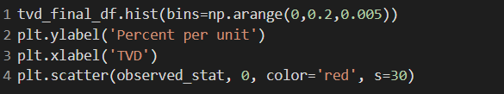

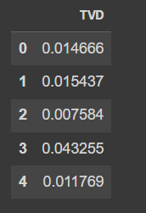

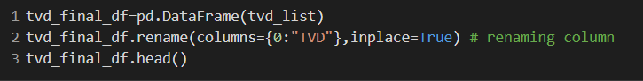

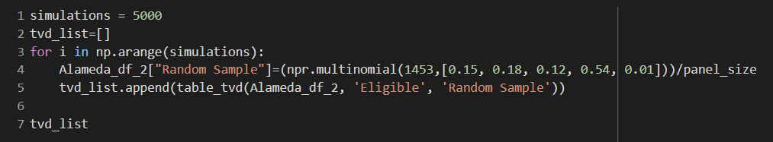



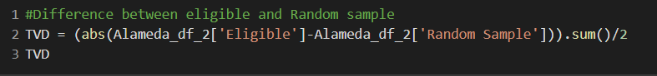

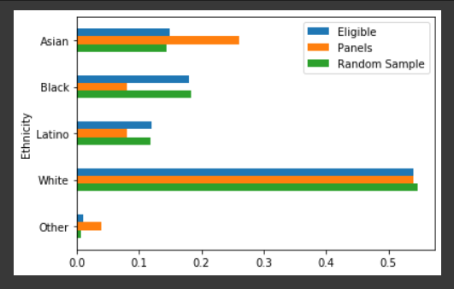

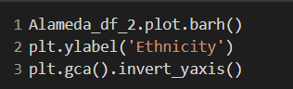

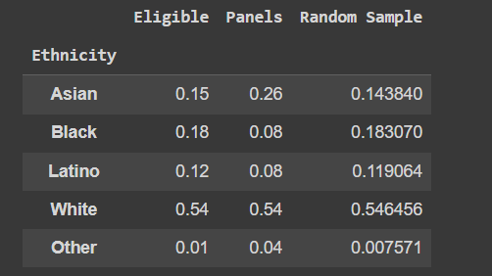

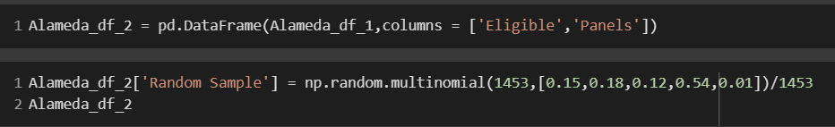



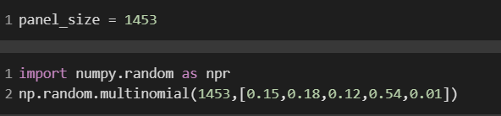



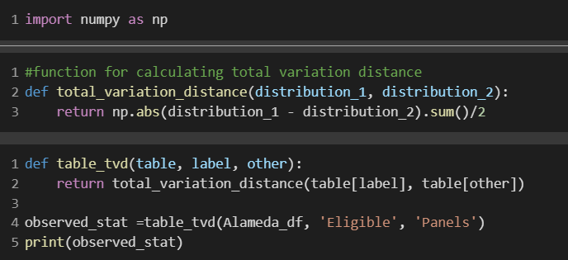

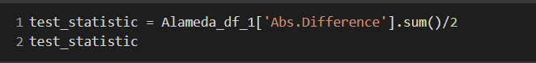

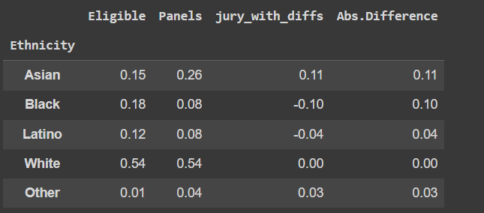

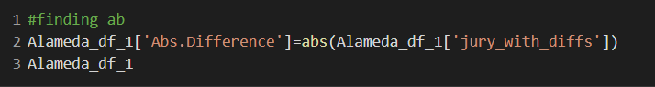

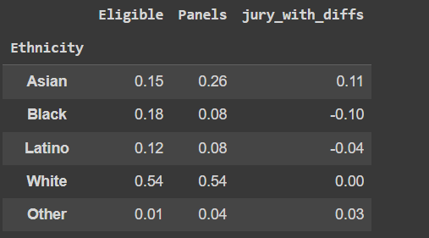

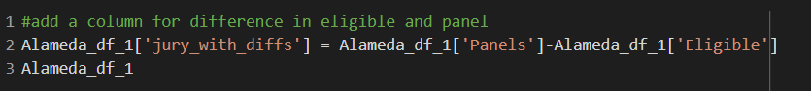

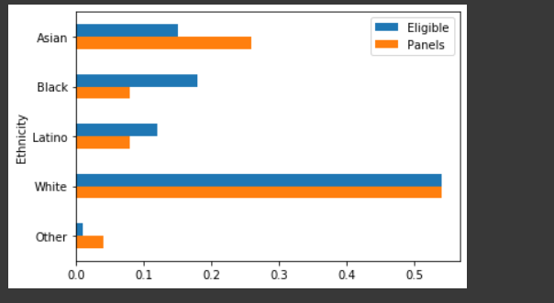

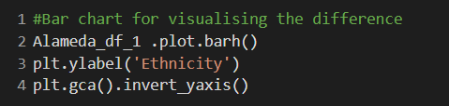

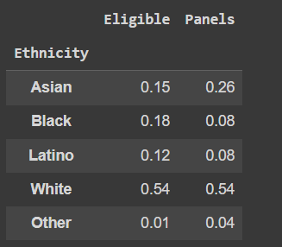

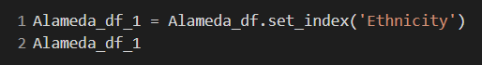

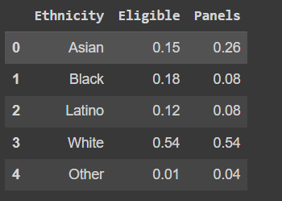

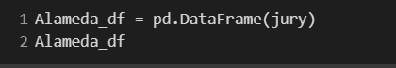

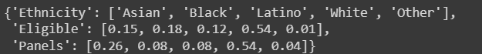

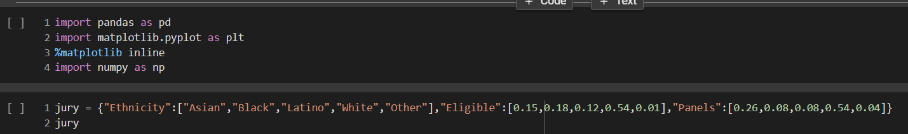

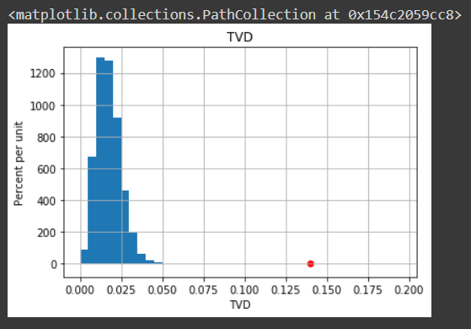

My understanding of this assignment problem:

There are 2 hypothesis:

Null Hypothesis:-panels were selected at random

panels were not selected at random

Next we calculate the distance between Two Distributions

sum of its entries is 0

the positive entries add up to 0.14

total of the negative entries which is -0.14, they cancel each other out.

The TVD is 0.14

Also, The green panels representative of the population.

NOTE:In our graph the randomsample resembles only the eligble and NOT the random population.

The TVD of population of eligible juniors is 0.14, so it is farawaay from the distribution.

Therefore, Alternative hypothesis has more proof, so we side with it and reject the null hypothesis.

MORE QUESTIONS ABOUT THE DATA

Eligible Jurors. First, it is important to remember that not everyone is eligible to serve on a jury.

The Census doesn't maintain records of the populations in all these categories.

Panels. In addition, panels aren't selected from the entire eligible population.

All of this raises complex questions about how to accurately estimate the ethnic composition of eligible jurors in Alameda County.

It is not clear exactly how the 1453 panelists were classified into the different ethnic categories

Thus, while we have a clear conclusion about the data in our table – the panels do not look like a random sample from the distribution provided for eligible jurors – questions about the nature of the data prevent us from concluding anything broader.