**19CSE304 Data Science**

**Assignment – 1**

Srinath Palaniappan

CB.EN.U4CSE20263

1. data = {"srinath", "222", 111, 400.4}

tup = tuple(data)

print(tup)

print(type(tup))



1. dic = dict({'Roll_No': 'CB.EN.U4CSE20263', 'Last_Name': 'Srinath', 'First_Name': 'Palaniappan', 'DOB': '22-06-2001'})

print(dic)



1. import numpy as np

np.random.seed(100)

array = np.random.randn(3,3)

array



1. import random

x= random.uniform(0.0, 1.0)

print(x)

print(abs(-1234))



1. import random

x= random.randint(20,90)

print(x)



1. (a) import random

list = [11,12,13,14,15]

list2= random.sample(list,3)

print(list2)



(b) from random import shuffle

x= [11,12,13,14,15]

shuffle(x)

print(x)



(c) rand= random.choice(list)

print(rand)



1. file = open("C:\Users\Harshith\New\help.txt","r")

print(file.read())

1. theory = 40

practical = 20

if(theory > 50):

print("Please check the input score for 'Theory'.")

elif(practical > 50):

print("Please check the input score for 'Practical'.")

else:

print("Score validated. Your total is: ",theory + practical)

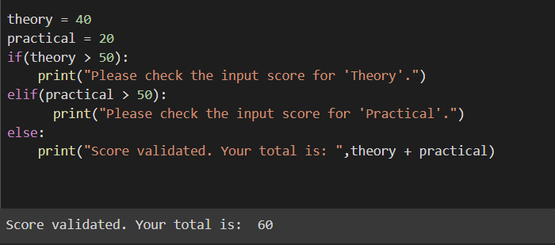

1. string = "The King is Dead, Long Live The King"

print(string)

print(string[0])

print(string[2:5])

print(string[2:])

split= string.split()

print(split)

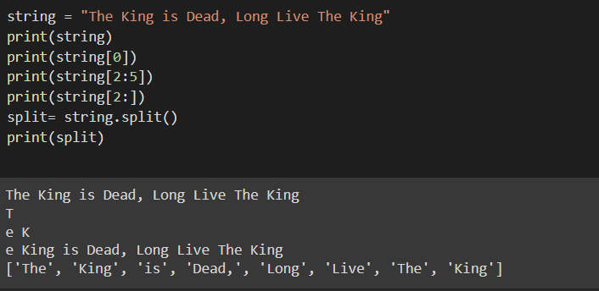

1. import numpy as np

list = [1,4,5,8]

A = [float(x) for x in num_list]

array= np.array(A)

array

print(array[0:2])

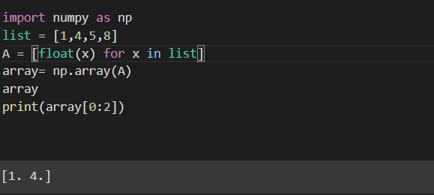

1. import numpy as np

a = np.array([[1, 2, 3], [4,5, 6]])

for i in range(len(a)):

for j in range(len(a[i])):

print(a[i][j], end=' ')

print()

print(a.ndim)

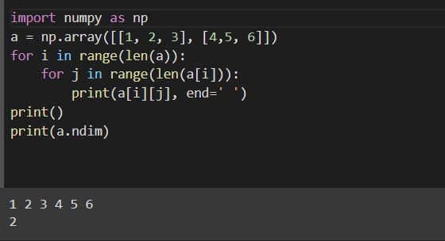

1. import numpy as np

a = np.array([[1,2,3], [4,5,6]])

slice= a[1:]

print(slice)

b = a.astype(np.float64)

k = np.array([b[0][1], b[1][1]])

print(k)

length = sum(len(l) for l in a)

print(length)

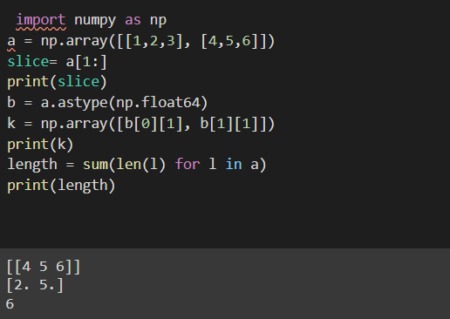

13 import numpy as np

Arr1 = np.array([1,2,3,4,5,6,7,8,9,10])

arr = np.reshape(array, (5,2))

print(arr)

tran= arr.transpose()

print(tran)

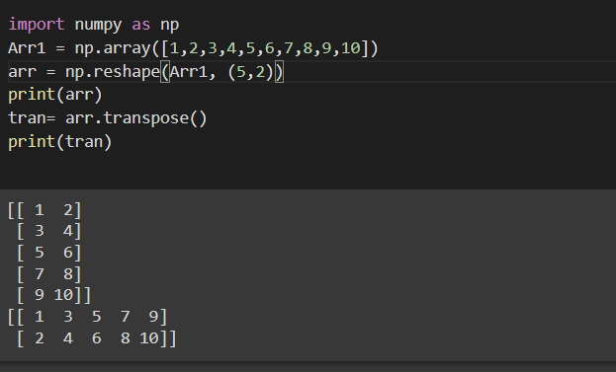

14 import numpy as np

list = [1,2,3]

array = np.array(list)

print(array)

print(type(array))

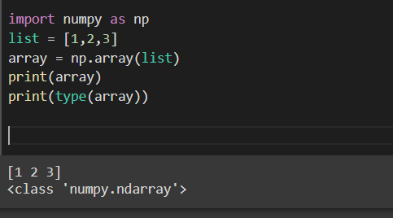

15 import numpy as np

array= np.array([1,2,3])

array.fill(9)

print(array)

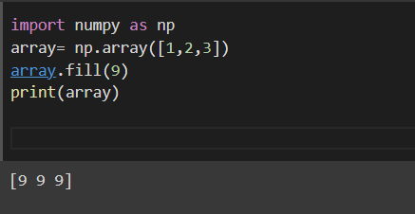

16 import numpy as np

array= np.array([2,4,5])

total = sum(array)

print(total)

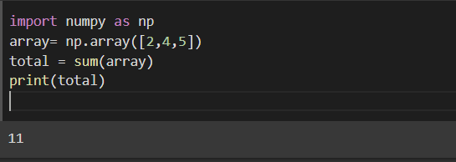

17 import numpy as np

array= np.array([77,74,75])

total = np.prod(array)

print(total)

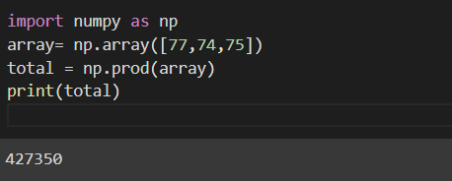

18 import numpy as np

array = np.array([2,1,9,1,2,22,1,1,4,55,6,2,56])

mean= np.mean(array)

variance= np.var(array)

mini= min(array)

maxi= max(array)

argmin= np.argmin(array)

argmax= np.argmax(array)

std= np.std(array)

print(mean)

print(variance)

print(mini)

print(maxi)

print(argmin)

print(argmax)

print(std)

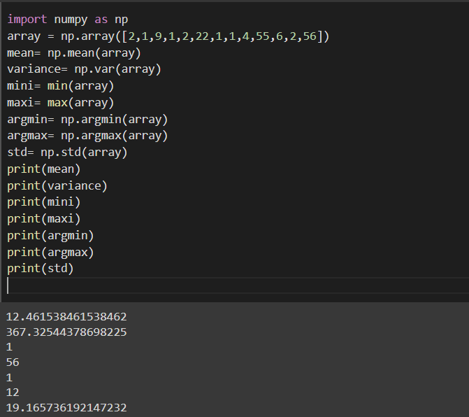

19 import numpy as np

array = np.array([1, 1, 4, 5, 5, 5, 7])

lis= array.tolist()

uniq= np.unique(lis)

uniq.sort()

print(uniq)

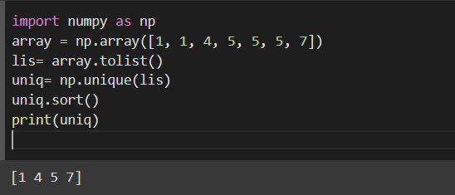

20 import numpy as np

a= np.array([1,2,3])

b= np.array([0,1,1])

dot= np.dot(a,b)

print(dot)

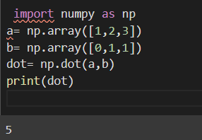

21 import numpy as np

from numpy.linalg import eig

matrix = np.array([[2,-12],[1,-5]])

w,v= eig(matrix)

print('Eig-value: ',w)

print('Eig-vector: ',v)

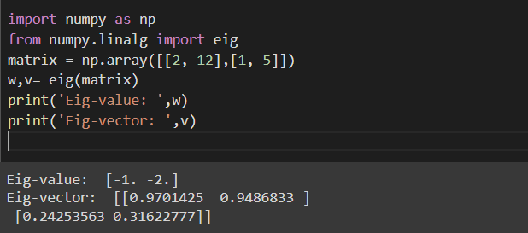

22 import numpy as np

a= np.array([11, 22, 11, 31])

b= np.array([25, 33, 31, 28])

arr1= a.astype(np.float64)

arr2= b.astype(np.float64)

corrcoef= np.corrcoef(arr1, arr2)

print(corrcoef)

