*In attachment you will find* *Task Project. Unzip that project somewhere on your PC.  
To successfully run project you will must have installed on your PC   
1. Visual studio community edition as minimum (Download link:* [*https://www.visualstudio.com/vs/community/*](https://www.visualstudio.com/vs/community/) *)  
2. MSSQL express (Download link:* [*https://www.microsoft.com/en-us/sql-server/sql-server-editions-express*](https://www.microsoft.com/en-us/sql-server/sql-server-editions-express) *)  
3. .NET Core 2.1 (v2.1.300) SDK (Download link:* [*https://www.microsoft.com/net/download/windows*](https://www.microsoft.com/net/download/windows) *)*

*After you setup environment for test project, go to project folder and open TestProject.sln with Visual studio.  
When open, in solution explorer check if TestProject.Client is set as startup project (right click on TestProject.Client->Set as startup project*

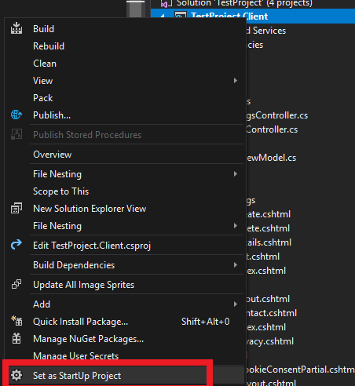

*After that, Open Package manager console And choose TestProject.Infrastructure as Default project:*  
  
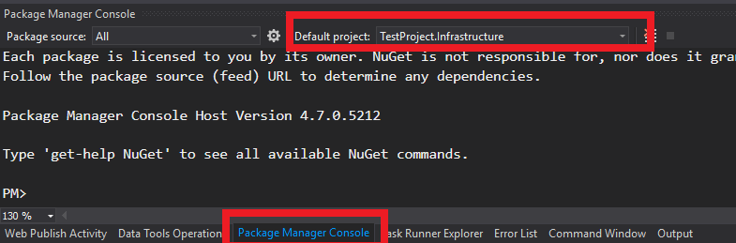

*Run update database command:*

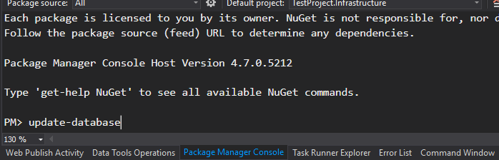

*When that is done check in server explorer if database is created.*

