General Information
📆 Deadline
15 May 2026 (Friday Week 11), 11:59
Late submissions are allowed up until 3 days after the deadline. A penalty of 5% per day late will apply. Assignments more than 3 days late will not be accepted (i.e. will receive 0 marks). The cut-off time for a day is 11:59pm.
🎯 Overarching Goal
In this assignment, your goal is to implement and compare machine learning classifiers on a prediction task, reporting on your findings and drawing insights from these findings. In particular, you will need to:
Implement two classifiers from scratch - K-Nearest Neighbor (KNN) and Decision Tree (DT)
Implement your own variation of these classifiers -KNN+ and DT+
Implement 10-fold stratified cross-validation to evaluate your classifiers
Evaluate your classifiers' performances on a real dataset - predicting survival of patients with heart failure
Evaluate additional classifiers on the same dataset using Weka (ZeroR, OneR, kNN, Random Forest, Bagging, Boosting, Support Vector Machine and Neural Network) along with Weka's versions of the classifiers you implemented
Write a report in the style of a scientific paper, which critically discusses your findings
✏️ Marking
The assignment is worth 24 marks, and counts for 24% of your final course mark. It consists of two parts: code (10 marks) and report (14 marks).
The code part is submitted through Ed (right here). It will be automarked against testcases. There is no manual marking.
The report part is submitted through Canvas and it will be manually marked. The marking rubric is provided on Canvas.
The report is worth 58% - we recommend you leave plenty of time to complete it.
👥 Groups
The assignment must be completed in groups of 2 or 3 students (updated 24 April 2026). The students in the group do not have to be from the same tutorial, but must be from the same stream - COMP3308.
You need to register a group in Canvas->People under 3308 A2 , so that the code marks are correctly exported from Ed to Canvas and the report marks are correctly recorded in Canvas. There is a separate group registration for Assignment 1 and Assignment 2. Even if you work with the same partner as in Assignment 1, you need to register your group again, under 3308 A2. You will not be able to submit your report under the group registration for Assignment 1.
Everyone needs to form a group, you cannot submit individually. All students in the group will receive the same mark.
💻 Language
Your implementation must be written in Python
📄 Submission
The code part must be submitted through Ed. It consists of several parts, each with its own testcases. Submit your solution for each part to the relevant page. You can submit multiple times, each time you will receive feedback about the passed and failed testcases. If you pass all testcases, you will obtain the full marks.
This assignment page is not shared - each student has their own workspace. You can however collaborate with your group members in real time through the workspaces page. To do so, create a new workspace:
From there, invite your group members through the share tab:
The invited users can then access the workspace from the Shared with Me section on the workspaces page.
When the assignment is finished, all students from the group should submit the whole assignment (all parts) in their own assignment page. The marks are based on the latest submission - this is the latest code submitted for marking, not just tested against the test cases, so don't forget to press the “Submit” button at the top right of your screen to submit your code for marking.
Important: You must press "Submit", otherwise your mark may not be recorded correctly even if you have a working submission before the deadline.
In the report part, you need to discuss your findings. The report should be submitted to the Assignments page in Canvas, not in Ed.
🎓 Academic honesty
Please read the University policy on Academic Honesty carefully.
Plagiarism (copying from another student, website or other sources), making your work available to another student to copy, engaging another person to complete the assignments instead of you (for payment or not) are all examples of academic dishonesty.
Do not confuse legitimate co-operation and cheating! You can discuss the assignment with other students, this is a legitimate collaboration, but every group must write their own code.
Acknowledging and referencing the use of AI - to be done in Canvas (Part 2 of this assignment)
You are permitted to use AI tools in the assignments for this course but you will need to include a statement explaining:
that you have used AI tools in completing the work
what automated writing or generative AI tools you have used
how you have used them.
Visit the Current Students website for more information on AI in assessments, including details on how to acknowledge its use. Additional information about generative AI use is provided on the AI in Education Canvas site. It includes additional guidance on how to acknowledge and reference the use of generative AI.

Datasets
🎉 Well done!!
You now know a lot of general information about the assignment!
📊 Next Step: Data
The next two slides will provide you with important information about the data you'll be using for this assignment (relating to heart failure), along with workspaces to explore the data!
We hope you're data-set on learning more! 🤩

Heart Failure Dataset
The dataset for this assignment is the Heart Failure dataset, available from the UCI repository and described in the following paper:
Davide Chicco and Giuseppe Jurman: "Machine learning can predict survival of patients with heart failure from serum creatinine and ejection fraction alone". BMC Medical Informatics and Decision Making 20, 16 (2020). https://doi.org/10.1186/s12911-020-1023-5
It contains data from electronic medical records of patients who had heart failure. The goal is to predict if the patient will die or survive in the follow up period.
The data file is heart-failure.csv. Each row corresponds to a patient’s record. There are 11 nominal features corresponding to personal characteristics and clinical tests. The last column is the class value: died or survived.
Note that this is a modified version of the original dataset. You need to use the dataset provided here. The original dataset contains both numeric and nominal features. For this assignment, the numeric features have been discretised based on clinical guidelines. Some other changes have been made - one feature has been removed and the identical rows after the discretisation have been removed too. This resulted in a dataset containing 273 examples described with 11 features. More details about the features and class are given in the table below:

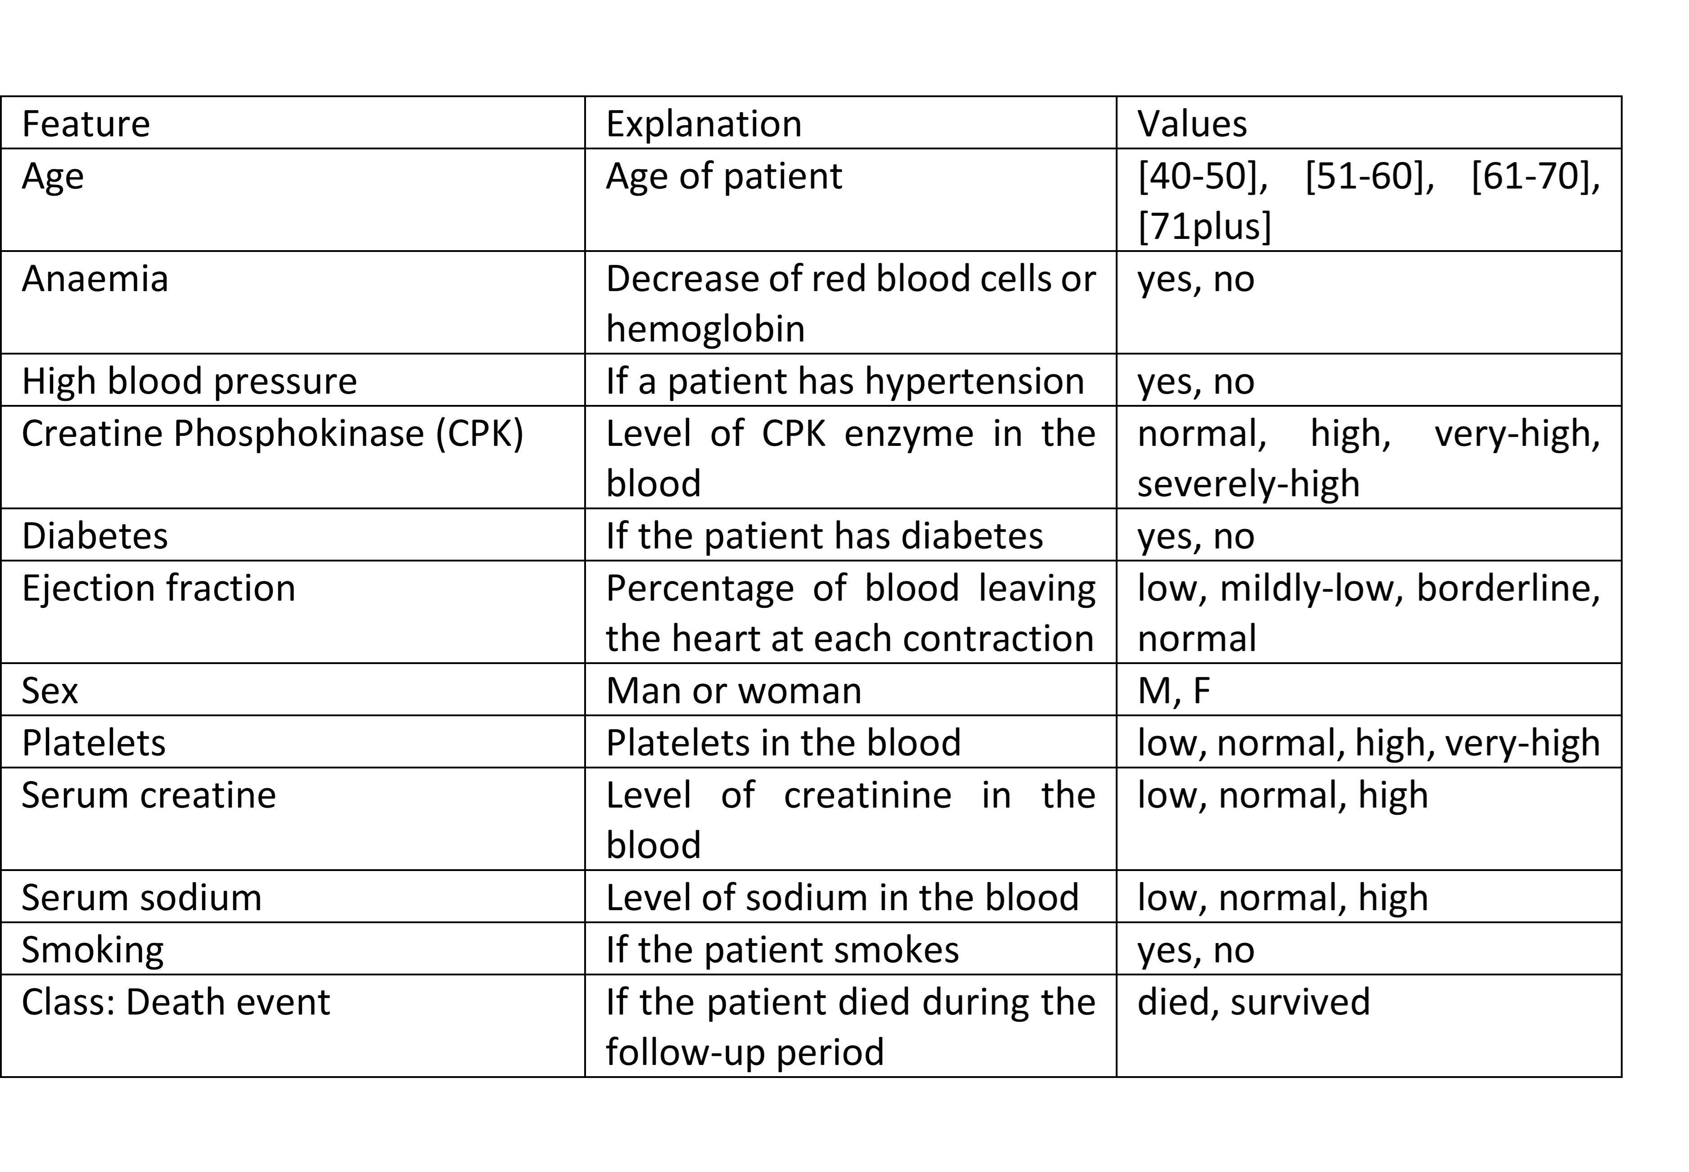
Your Task
To the right, we've provided you with a workspace to explore this dataset. The workspace is unmarked, but you will need to use the dataset later, and to also discuss it in your report, so it's a good idea to play around with it!

heart-failure.csv：
age,anaemia,CPK,diabetes,ejection_fraction,high_blood_pressure,platelets,serum_creatinine,serum_sodium,sex,smoking,class
[61-70],yes,normal,yes,low,no,normal,high,normal,M,no,died
[61-70],yes,normal,no,normal,no,normal,normal,normal,F,no,died
[61-70],no,normal,no,low,no,normal,normal,normal,F,no,died
[61-70],no,high,yes,low,no,normal,normal,normal,M,yes,died
[61-70],no,high,no,low,no,normal,normal,low,M,yes,died
[61-70],no,high,no,low,yes,normal,normal,normal,M,yes,survived
[61-70],yes,normal,no,low,yes,normal,normal,normal,F,no,survived
[61-70],no,normal,no,low,no,normal,normal,low,M,yes,survived
[40-50],yes,high,yes,low,yes,normal,normal,low,F,no,survived
[40-50],yes,very-high,yes,low,no,low,normal,normal,F,no,died
[40-50],yes,high,yes,normal,no,low,high,low,F,no,died
[40-50],no,high,no,low,yes,low,high,normal,M,no,died
[40-50],yes,high,no,low,no,low,normal,normal,M,no,died
[40-50],no,normal,yes,low,yes,normal,normal,normal,F,yes,died
[40-50],no,high,no,borderline,no,normal,normal,low,F,no,died
[40-50],no,high,no,low,no,normal,normal,low,M,no,died
[40-50],yes,normal,no,low,no,normal,high,normal,M,no,died
[40-50],yes,high,yes,low,no,normal,normal,normal,F,no,died
[40-50],no,high,no,mildly-low,yes,normal,high,low,F,no,died
[40-50],yes,normal,yes,low,yes,normal,high,low,F,no,died
[40-50],no,normal,yes,low,yes,normal,high,low,F,no,died
[40-50],yes,normal,no,low,yes,normal,normal,normal,M,no,died
[40-50],no,high,yes,low,no,normal,high,normal,M,yes,died
[40-50],no,high,no,low,yes,normal,normal,normal,M,yes,died
[40-50],no,very-high,yes,low,no,normal,normal,normal,M,no,died
[40-50],no,high,no,low,no,normal,normal,normal,M,no,died
[40-50],no,severely-high,yes,low,yes,normal,normal,normal,M,no,died
[51-60],no,normal,no,low,no,low,high,low,F,no,died
[51-60],no,normal,yes,low,no,low,high,low,M,no,died
[51-60],no,normal,no,low,no,low,high,low,M,yes,died
[51-60],yes,high,no,normal,yes,normal,high,normal,F,no,died
[51-60],yes,normal,no,low,no,normal,high,low,M,no,died
[51-60],yes,high,yes,normal,no,normal,normal,normal,F,no,died
[51-60],yes,normal,yes,low,no,normal,high,low,F,no,died
[51-60],yes,normal,no,low,no,normal,normal,normal,M,yes,died
[51-60],yes,normal,no,low,no,normal,high,normal,M,no,died
[51-60],no,high,no,mildly-low,no,normal,high,low,M,no,died
[51-60],yes,normal,yes,low,no,normal,normal,normal,M,yes,died
[51-60],yes,high,yes,low,no,normal,high,low,F,yes,died
[51-60],no,very-high,no,low,no,normal,high,low,M,yes,died
[51-60],no,severely-high,no,low,no,normal,normal,normal,M,no,died
[51-60],no,very-high,yes,normal,no,normal,high,high,F,no,died
[51-60],no,very-high,no,low,yes,normal,normal,low,M,no,died
[51-60],yes,high,yes,low,yes,normal,normal,normal,F,no,died
[51-60],no,very-high,no,low,no,normal,normal,normal,M,no,died
[51-60],no,high,yes,low,no,normal,high,normal,F,no,died
[51-60],no,very-high,yes,low,no,normal,high,normal,F,no,died
[51-60],yes,normal,no,low,no,normal,normal,normal,F,no,died
[51-60],yes,normal,no,low,yes,high,high,normal,F,no,died
[51-60],no,high,yes,low,yes,high,normal,normal,M,yes,died
[51-60],yes,high,yes,normal,no,very-high,normal,low,M,yes,died
[61-70],yes,high,no,low,yes,normal,normal,normal,M,no,died
[61-70],no,high,yes,mildly-low,yes,normal,normal,normal,M,yes,died
[61-70],no,normal,yes,borderline,yes,normal,normal,normal,M,no,died
[61-70],yes,high,yes,low,no,normal,high,low,M,no,died
[61-70],no,high,yes,low,no,normal,high,low,M,no,died
[61-70],no,high,no,low,yes,normal,high,low,M,yes,died
[61-70],no,normal,no,normal,no,normal,high,normal,F,no,died
[61-70],no,normal,yes,mildly-low,yes,normal,normal,normal,M,yes,died
[61-70],yes,high,no,low,yes,normal,normal,normal,M,yes,died
[61-70],yes,normal,yes,low,yes,normal,high,normal,F,no,died
[61-70],yes,normal,yes,low,no,normal,high,low,F,no,died
[61-70],yes,normal,yes,borderline,yes,normal,normal,low,F,no,died
[61-70],no,normal,yes,low,no,very-high,high,normal,M,no,died
70plus,yes,high,no,borderline,no,low,normal,normal,M,no,died
70plus,yes,high,no,low,no,low,normal,normal,M,no,died
70plus,yes,high,no,low,yes,low,high,low,M,no,died
70plus,no,normal,yes,low,no,low,high,normal,M,yes,died
70plus,no,high,yes,low,yes,normal,normal,normal,F,no,died
70plus,yes,normal,no,mildly-low,yes,normal,normal,normal,F,no,died
70plus,no,normal,yes,low,no,normal,normal,low,M,yes,died
70plus,yes,normal,no,mildly-low,yes,normal,high,low,M,yes,died
70plus,yes,high,no,mildly-low,no,normal,high,normal,M,no,died
70plus,no,normal,no,low,yes,normal,high,low,M,no,died
70plus,yes,high,no,low,no,normal,high,low,M,no,died
70plus,yes,normal,yes,borderline,no,normal,normal,low,M,no,died
70plus,no,high,no,mildly-low,yes,normal,high,normal,F,no,died
70plus,no,severely-high,no,low,no,normal,normal,low,M,yes,died
70plus,no,high,yes,low,yes,normal,normal,normal,M,yes,died
70plus,yes,normal,no,low,no,normal,normal,normal,M,no,died
70plus,no,high,no,low,no,normal,high,low,M,no,died
70plus,no,high,yes,low,yes,normal,high,low,F,no,died
70plus,no,high,no,low,no,normal,high,low,F,no,died
70plus,no,high,yes,low,yes,normal,high,low,M,no,died
70plus,no,high,no,low,no,normal,normal,low,M,no,died
70plus,no,high,no,low,yes,normal,high,low,M,no,died
70plus,yes,normal,no,low,no,normal,normal,normal,M,yes,died
70plus,no,normal,no,normal,no,normal,normal,low,M,yes,died
70plus,yes,high,yes,borderline,yes,normal,normal,normal,F,no,died
70plus,yes,high,no,low,yes,normal,high,normal,M,yes,died
70plus,no,normal,no,mildly-low,no,normal,high,low,M,no,died
70plus,yes,normal,no,low,yes,normal,high,low,M,yes,died
70plus,yes,high,no,low,no,very-high,high,low,M,no,died
70plus,yes,high,no,low,yes,very-high,high,normal,F,yes,died
[40-50],no,high,no,low,no,low,normal,low,M,no,survived
[40-50],yes,normal,no,borderline,no,low,normal,normal,F,no,survived
[40-50],no,very-high,no,low,no,low,high,normal,M,yes,survived
[40-50],no,high,no,normal,yes,low,normal,normal,M,yes,survived
[40-50],yes,normal,no,low,no,normal,normal,normal,M,yes,survived
[40-50],no,normal,no,mildly-low,yes,normal,normal,low,M,yes,survived
[40-50],yes,normal,no,low,no,normal,normal,normal,M,no,survived
[40-50],no,normal,no,mildly-low,no,normal,normal,normal,M,no,survived
[40-50],no,very-high,no,low,yes,normal,normal,normal,M,no,survived
[40-50],no,normal,no,low,no,normal,high,low,M,yes,survived
[40-50],no,high,yes,low,no,normal,normal,low,M,no,survived
[40-50],no,high,yes,normal,no,normal,normal,normal,F,no,survived
[40-50],no,severely-high,no,low,no,normal,normal,normal,M,yes,survived
[40-50],yes,very-high,yes,low,no,normal,normal,normal,M,no,survived
[40-50],yes,normal,no,mildly-low,no,normal,normal,normal,F,no,survived
[40-50],yes,very-high,yes,low,no,normal,normal,normal,F,no,survived
[40-50],yes,normal,yes,low,no,normal,normal,normal,M,no,survived
[40-50],no,normal,yes,mildly-low,yes,normal,normal,normal,M,no,survived
[40-50],no,normal,yes,mildly-low,no,normal,normal,normal,M,no,survived
[40-50],yes,high,no,borderline,no,normal,normal,normal,F,no,survived
[40-50],no,high,yes,low,no,normal,high,normal,M,no,survived
[40-50],no,normal,no,low,no,normal,normal,normal,M,yes,survived
[40-50],yes,normal,yes,mildly-low,no,normal,normal,low,M,no,survived
[40-50],no,high,no,low,no,normal,normal,normal,M,yes,survived
[40-50],no,high,yes,low,yes,normal,high,low,M,yes,survived
[40-50],no,very-high,yes,low,no,normal,normal,normal,M,yes,survived
[40-50],no,high,yes,low,yes,normal,normal,normal,F,no,survived
[40-50],no,high,no,mildly-low,yes,normal,normal,normal,F,no,survived
[40-50],no,high,no,normal,no,normal,normal,normal,F,no,survived
[40-50],no,high,yes,low,yes,normal,normal,low,F,no,survived
[40-50],no,high,no,mildly-low,yes,normal,normal,low,M,no,survived
[40-50],yes,normal,no,mildly-low,no,normal,normal,normal,M,no,survived
[40-50],yes,normal,yes,low,no,normal,normal,normal,F,no,survived
[40-50],no,high,yes,low,no,normal,normal,normal,F,no,survived
[40-50],no,high,yes,low,no,normal,normal,normal,M,no,survived
[40-50],no,high,yes,low,no,normal,normal,low,F,no,survived
[40-50],yes,high,no,low,no,normal,normal,normal,F,no,survived
[40-50],yes,high,no,low,no,normal,normal,normal,M,yes,survived
[40-50],yes,normal,yes,mildly-low,no,normal,normal,normal,F,no,survived
[40-50],no,normal,no,mildly-low,no,normal,normal,normal,M,yes,survived
[40-50],no,high,yes,normal,yes,normal,normal,normal,M,no,survived
[40-50],no,normal,no,mildly-low,no,normal,high,normal,M,yes,survived
[40-50],no,very-high,no,low,yes,normal,low,normal,F,no,survived
[40-50],no,high,no,low,yes,high,normal,normal,F,no,survived
[40-50],yes,normal,no,low,yes,high,normal,normal,F,no,survived
[40-50],no,high,yes,normal,no,very-high,normal,low,F,no,survived
[40-50],no,very-high,yes,normal,no,very-high,normal,normal,F,no,survived
[40-50],no,high,yes,low,no,very-high,normal,normal,M,yes,survived
[51-60],no,high,yes,low,no,low,normal,normal,M,yes,survived
[51-60],yes,high,no,low,yes,low,normal,normal,F,no,survived
[51-60],no,high,no,low,no,low,high,normal,M,no,survived
[51-60],yes,normal,yes,low,no,low,high,normal,M,no,survived
[51-60],yes,very-high,no,low,yes,low,normal,normal,M,no,survived
[51-60],yes,high,yes,low,no,low,normal,normal,M,yes,survived
[51-60],yes,high,no,mildly-low,no,normal,normal,normal,F,no,survived
[51-60],no,normal,no,low,yes,normal,normal,normal,M,no,survived
[51-60],yes,normal,no,low,yes,normal,normal,normal,M,no,survived
[51-60],yes,normal,no,low,no,normal,normal,low,M,yes,survived
[51-60],yes,high,yes,low,no,normal,high,normal,M,no,survived
[51-60],no,normal,no,mildly-low,no,normal,normal,normal,M,no,survived
[51-60],yes,high,no,normal,yes,normal,high,normal,M,yes,survived
[51-60],no,normal,no,low,yes,normal,high,normal,M,yes,survived
[51-60],yes,high,no,mildly-low,no,normal,normal,normal,M,yes,survived
[51-60],no,normal,no,low,no,normal,normal,normal,M,yes,survived
[51-60],yes,normal,no,normal,yes,normal,normal,normal,M,no,survived
[51-60],no,normal,no,normal,no,normal,normal,low,M,yes,survived
[51-60],no,high,yes,mildly-low,no,normal,normal,low,F,no,survived
[51-60],no,very-high,no,low,yes,normal,normal,normal,M,no,survived
[51-60],no,normal,yes,low,no,normal,normal,normal,F,no,survived
[51-60],no,high,yes,low,no,normal,normal,normal,F,no,survived
[51-60],yes,very-high,no,normal,yes,normal,normal,normal,M,yes,survived
[51-60],yes,very-high,yes,mildly-low,no,normal,high,low,M,no,survived
[51-60],no,normal,yes,low,yes,normal,normal,normal,M,no,survived
[51-60],no,high,no,mildly-low,no,normal,normal,normal,M,no,survived
[51-60],yes,high,yes,low,no,normal,high,normal,M,yes,survived
[51-60],no,very-high,yes,low,no,normal,high,low,M,yes,survived
[51-60],yes,normal,no,mildly-low,no,normal,normal,normal,M,yes,survived
[51-60],yes,high,no,normal,yes,normal,normal,normal,M,no,survived
[51-60],no,high,yes,low,no,normal,high,low,M,no,survived
[51-60],no,very-high,no,low,no,normal,normal,normal,F,no,survived
[51-60],yes,normal,yes,normal,yes,normal,normal,normal,F,no,survived
[51-60],yes,normal,no,low,no,normal,high,normal,F,no,survived
[51-60],no,high,no,low,no,normal,high,normal,M,no,survived
[51-60],no,high,no,mildly-low,no,normal,normal,normal,M,yes,survived
[51-60],yes,very-high,yes,mildly-low,no,normal,normal,normal,F,no,survived
[51-60],no,normal,no,borderline,yes,normal,high,normal,F,no,survived
[51-60],no,high,yes,mildly-low,no,normal,normal,low,M,no,survived
[51-60],yes,normal,yes,normal,no,normal,normal,normal,F,no,survived
[51-60],no,very-high,yes,low,no,normal,high,normal,M,no,survived
[51-60],no,normal,no,borderline,no,normal,normal,normal,M,yes,survived
[51-60],yes,normal,yes,low,yes,normal,normal,normal,F,no,survived
[51-60],no,high,no,mildly-low,yes,normal,normal,normal,F,no,survived
[51-60],no,very-high,no,mildly-low,no,normal,normal,normal,M,yes,survived
[51-60],no,normal,yes,low,yes,normal,normal,normal,F,no,survived
[51-60],yes,high,yes,mildly-low,yes,normal,normal,low,M,no,survived
[51-60],yes,high,no,low,no,normal,high,normal,M,yes,survived
[51-60],yes,normal,yes,low,yes,normal,normal,normal,M,yes,survived
[51-60],yes,normal,yes,mildly-low,no,normal,normal,normal,M,no,survived
[51-60],yes,normal,no,normal,no,normal,normal,normal,M,yes,survived
[51-60],yes,normal,no,mildly-low,yes,normal,normal,normal,M,yes,survived
[51-60],no,normal,yes,normal,no,normal,normal,normal,M,no,survived
[51-60],no,high,yes,low,yes,normal,normal,normal,F,no,survived
[51-60],no,normal,yes,low,no,normal,normal,normal,M,yes,survived
[51-60],no,normal,no,borderline,no,high,normal,normal,M,no,survived
[51-60],no,normal,yes,low,no,high,normal,normal,F,no,survived
[51-60],no,high,yes,low,no,very-high,normal,normal,M,no,survived
[61-70],no,high,yes,low,no,low,normal,normal,M,no,survived
[61-70],no,high,no,mildly-low,no,low,high,normal,M,yes,survived
[61-70],yes,very-high,no,mildly-low,no,low,normal,normal,M,no,survived
[61-70],no,very-high,no,mildly-low,no,low,normal,normal,M,yes,survived
[61-70],no,high,yes,borderline,no,low,normal,normal,M,yes,survived
[61-70],no,normal,yes,low,yes,normal,normal,normal,M,yes,survived
[61-70],yes,normal,yes,low,yes,normal,normal,normal,F,no,survived
[61-70],yes,normal,yes,normal,no,normal,normal,normal,F,no,survived
[61-70],no,high,no,low,no,normal,normal,low,M,no,survived
[61-70],yes,normal,no,normal,yes,normal,normal,normal,M,yes,survived
[61-70],yes,normal,yes,low,no,normal,normal,normal,M,yes,survived
[61-70],no,normal,no,borderline,no,normal,normal,normal,M,yes,survived
[61-70],yes,normal,yes,mildly-low,yes,normal,normal,normal,F,no,survived
[61-70],yes,normal,yes,normal,yes,normal,normal,normal,F,no,survived
[61-70],no,high,no,low,no,normal,normal,low,F,no,survived
[61-70],no,normal,no,normal,yes,normal,normal,normal,M,no,survived
[61-70],no,high,yes,low,no,normal,normal,normal,F,no,survived
[61-70],yes,normal,yes,mildly-low,no,normal,normal,normal,F,no,survived
[61-70],yes,normal,no,low,no,normal,high,normal,M,yes,survived
[61-70],yes,normal,no,mildly-low,yes,normal,normal,normal,F,no,survived
[61-70],yes,high,no,low,yes,normal,normal,normal,F,no,survived
[61-70],no,normal,yes,low,yes,normal,normal,low,F,no,survived
[61-70],no,normal,no,low,no,normal,high,low,F,no,survived
[61-70],no,very-high,yes,mildly-low,no,normal,normal,normal,M,no,survived
[61-70],yes,normal,no,mildly-low,yes,normal,normal,low,M,no,survived
[61-70],no,very-high,no,normal,no,normal,normal,normal,M,no,survived
[61-70],no,normal,yes,normal,yes,normal,normal,normal,M,no,survived
[61-70],no,normal,no,low,no,normal,high,normal,M,no,survived
[61-70],no,normal,yes,mildly-low,no,normal,normal,normal,M,yes,survived
[61-70],yes,high,yes,low,yes,normal,normal,low,M,no,survived
[61-70],yes,high,yes,mildly-low,no,normal,normal,normal,F,no,survived
[61-70],no,very-high,no,low,no,normal,normal,normal,M,yes,survived
[61-70],no,high,no,borderline,no,normal,normal,normal,M,yes,survived
[61-70],yes,normal,yes,normal,no,normal,normal,normal,M,no,survived
[61-70],no,high,yes,mildly-low,no,normal,normal,normal,F,no,survived
[61-70],yes,very-high,yes,low,no,normal,normal,low,M,no,survived
[61-70],yes,high,no,mildly-low,no,normal,normal,low,F,no,survived
[61-70],yes,normal,no,low,yes,normal,normal,low,M,no,survived
[61-70],no,normal,no,mildly-low,no,normal,high,normal,F,no,survived
[61-70],no,high,no,low,no,normal,high,normal,F,no,survived
[61-70],no,normal,no,normal,yes,normal,normal,normal,M,yes,survived
[61-70],yes,high,no,low,no,normal,normal,normal,M,no,survived
[61-70],yes,normal,yes,normal,yes,normal,normal,normal,M,no,survived
[61-70],yes,high,no,low,no,normal,high,low,M,no,survived
[61-70],no,high,no,low,yes,normal,normal,low,F,no,survived
[61-70],yes,normal,no,normal,no,normal,high,normal,F,no,survived
[61-70],no,normal,no,normal,yes,normal,normal,normal,F,yes,survived
[61-70],no,high,no,low,no,normal,normal,normal,F,no,survived
[61-70],no,very-high,no,borderline,yes,normal,normal,normal,F,no,survived
[61-70],no,high,yes,low,yes,normal,normal,normal,M,yes,survived
[61-70],yes,high,no,mildly-low,no,high,normal,normal,M,yes,survived
[61-70],no,normal,yes,low,yes,very-high,normal,normal,F,no,survived
70plus,no,high,no,low,no,low,normal,normal,M,yes,survived
70plus,yes,high,yes,low,no,normal,normal,normal,M,yes,survived
70plus,yes,normal,no,borderline,yes,normal,high,low,M,no,survived
70plus,no,high,no,low,no,normal,normal,normal,M,no,survived
70plus,no,high,no,low,yes,normal,normal,low,M,no,survived
70plus,no,normal,yes,borderline,yes,normal,normal,low,M,no,survived
70plus,yes,very-high,no,mildly-low,yes,normal,normal,normal,F,no,survived
70plus,no,very-high,no,low,no,normal,normal,normal,M,yes,survived
70plus,yes,high,no,borderline,no,normal,normal,low,M,no,survived
70plus,no,normal,no,borderline,yes,normal,normal,high,M,no,survived
70plus,no,high,no,mildly-low,no,normal,normal,normal,M,no,survived
70plus,no,high,no,mildly-low,yes,normal,normal,normal,M,no,survived
70plus,no,high,yes,normal,no,normal,high,low,F,no,survived
70plus,no,high,no,low,no,normal,normal,low,F,no,survived
70plus,yes,normal,no,mildly-low,no,normal,normal,normal,M,yes,survived
70plus,yes,high,yes,low,yes,normal,normal,low,M,yes,survived
70plus,no,high,yes,low,no,normal,high,low,M,no,survived
70plus,yes,high,no,low,no,normal,normal,normal,F,no,survived
70plus,yes,normal,no,borderline,yes,high,normal,normal,M,no,survived
70plus,no,high,no,borderline,no,very-high,high,normal,M,yes,survived
70plus,yes,normal,no,normal,no,very-high,high,normal,F,no,survived

Data Processing
Data Preprocessing
Nice work! Now that you've explored the data, you’ll need to perform some simple pre-processing on the heart-failure.csv dataset before you start implementing your own classifiers.
After downloading the data file from the the previous slide, remove the first row (i.e., the column names), save the file as heart.csv and also paste the file contents into this workspace into the heart.csv section.
Note: All further activities will be performed using this submitted file.

Classifiers
Excellent work!! You've explored the data and performed some preprocessing! It's now time to implement two core classifiers from class:
- KNN
- Decision Tree
🖊️ Function Signatures
You will write functions with the following signatures:
classify_knn(training_file, testing_file, k)
classify_dt(training_file, testing_file)
The first function will perform classification using KNN, the second will use Decision Trees.
The functions will accept two filenames, given as strings. The first contains a dataset to be used to train the classifier; the second contains a dataset without class values for testing. The classifier functions must return their classifications for each example in the testing file.
The k parameter for the first function specifies how many nearest neighbours to use when classifying an example. It will be an integer.
🏋️ Training data file
The training file will consist of several rows of data, each with n attributes plus a single class value (died or survived). The file will not have a header row, will have one example per line, with the feature values separated by commas, followed by a class value. The training data might look like this:
[61-70],no,high,no,low,yes,normal,normal,normal,M,yes,survived
[40-50],yes,very-high,yes,low,no,low,normal,normal,F,no,died
[40-50],yes,normal,no,borderline,no,low,normal,normal,F,no,survived

📚 Testing Data File
The testing data file will consist of several new examples to test your data on. It will have the same format as the training file, except there will be no class value at the end. An example testing file could look as follows:
[51-60],yes,high,no,low,no,normal,high,normal,M,yes
[61-70],yes,normal,yes,mildly-low,yes,normal,normal,normal,F,no
70plus,no,high,no,low,no,normal,normal,normal,M,no

Note: Your functions should be able to handle any number of attributes. You can assume that if the input training file has n attributes + a class column, then the testing file will also have n attributes. You can also assume that your functions will only be given discrete (nominal) data.
🖨️ Output
Your functions will return a list. Each element of the list, in order, corresponds to one of the examples in the given testing data file. The elements of the list should be strings representing the classification your function chose (i.e., "died" or "survived") for the corresponding line in the testing data file. An example return value could be as follows:
["died", "survived", "died"]
Note: These outputs are in no way related to the sample inputs given above. If you have any questions or need any clarifications about program input or output, ask a question on Ed or ask your tutor. Since your program will be automatically tested by Ed, it is important that you follow the instructions exactly.
You will need to be able to output the decision tree that is built when running the decision tree classifier. This output will NOT be tested automatically, so it should only be outputted when requested (for example, you could write a second dt function with a different name that outputs the tree in addition to classification, or you could use a variable set inside the function to control whether or not the tree will be printed). DO NOT make your program output this diagram every time, as it will interfere with the testing system's ability to process your output. You will require this output for your report.
Warning: These implementations must be your own work - the use of libraries to perform ML tasks is not permitted.

Next step：
KNN
The K-Nearest Neighbor should be implemented for nominal attributes using the Euclidean distance function. To ensure consistent results, please adhere to the following tie-breaking rules:
- Distance Ties: If instances have the same distance, priority is given to those with a lower row index in the training csv file.
- Voting Ties: If there is a tie in the majority vote (e.g., k is even), predict class died.

Knn与DT代码

Evaluating Classifiers
Brilliant Job!!! You've just finished implementing your own classifiers! It's now time to evaluate your classifiers; i.e. find out how well they actually perform as classifiers.
📈 Evaluation Overview
This evaluation will consist of two steps:
- Dividing the datasets into 10 folds (automatically marked, see the next slide)
- Implementing 10-fold cross-validation using those folds to determine the performance of your classifiers, including the algorithm's average accuracy over the 10 folds (not automatically marked, but needed for the report)
- Extending the evaluation to include Weka's implementations of the same classifiers (NB and DT), as well as many additional classifiers.

Stratified Folds
To show that you understand how 10-fold stratified cross-validation works, you will need to generate a file called heart-folds.csv from the original heart.csv. This file can be generated in any manner you choose (manually or using code). heart-folds.csv should contain 10 folds, each containing the approximately the same number of examples, and the ratio of yes examples to no examples should be approximately the same for each fold. Each fold should be in the following format:
- Name of the fold, fold1 to fold10.
- Contents of the fold, with each entry on a new line.
- A single blank line to separate the folds from each other.
An example of the heart-folds.csv file would look as follows (made up data):

fold1
[61-70],no,high,yes,borderline,no,low,normal,normal,M,yes,survived
[40-50],yes,normal,yes,low,yes,normal,high,low,F,no,died

fold2
[51-60],no,high,yes,low,no,very-high,normal,normal,M,no,survived
70plus,no,high,yes,low,yes,normal,normal,normal,F,no,died

...
fold10
[40-50],yes,normal,no,borderline,no,low,normal,normal,F,no,survived
70plus,yes,normal,no,mildly-low,yes,normal,normal,normal,F,no,died

Note: The number of instances per fold should not vary by more than one. If the total number of instances is not divisible by ten, the remaining items should be distributed amongst the folds rather than being placed in one fold.
Copy your stratified folded data from heart-folds.csv into the corresponding file in this Ed problem and submit, and Ed will check that you have correctly created the folds and applied stratification.
For more information on cross validation and stratification, see the following diagrams.

Cross Validation:
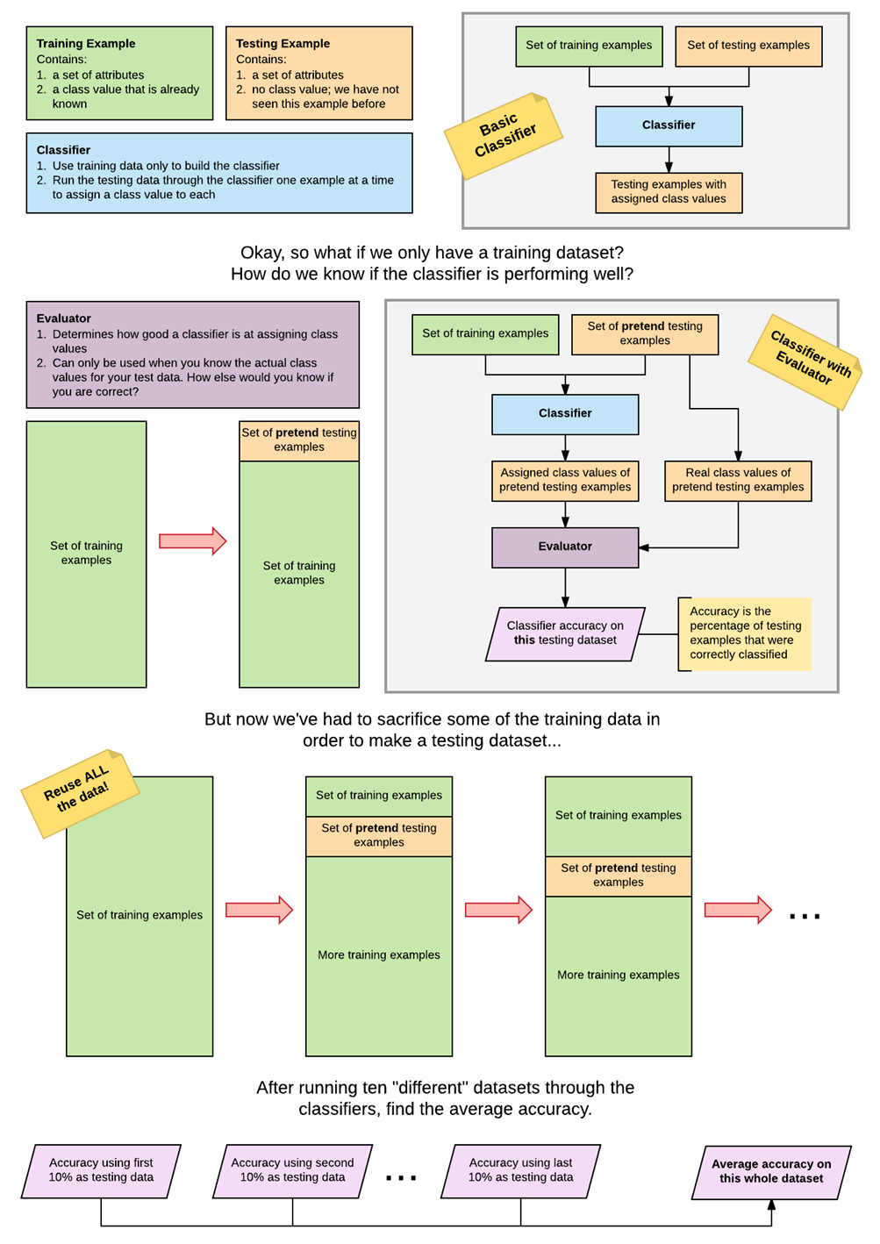
Cross Validation
Now that you've created your folds, write a program to evaluate your classifiers on the dataset using those folds. In particular, you should perform 10-fold cross-validation to evaluate accuracy and any other performance measures you consider important.
Note: This code will not be automatically tested, but will be required to complete the report; you need to know the average accuracy and other performance measure of your KNN, KNN+, DT and DT* algorithms.

Create folds和cross validation代码

Further Results - Weka
🎉 Congratulations!!
You've just finished all the programming tasks for this assignment! It's now time to use Weka to collect more results, so you'll be ready to write your final report.
🦜 Further Results with Weka
In Weka, select 10-fold cross validation (it is actually 10-fold stratified cross validation) and run the following algorithms: ZeroR, 1R, k-Nearest Neighbor (k-NN; IBk in Weka, with k=1 and 5), Naive Bayes (NB), Decision Tree (DT; J48 in Weka), Multi-Layer Perceptron (MLP), Support Vector Machine (SVM; SMO in Weka), Bagging (Bagg), Boosting (Boost, AdaBoostM1 in Weka) and Random Forest (RF). For Bagging and Boosting, combine decision trees (J48) not the default REPtrees or decision stumps. For the DT classifier, run the algorithm with and without pruning (using the default pruning option).
Compare the performance of the Weka’s classifiers with your KNN and Decision Tree classifiers – the core (KNN and DT) and the extended (KNN+ and DT+) versions.
In addition to accuracy, what other performance measure will be useful? Include them in the report.

