《软件体系结构与设计模式》大作业报告

姓名 | 职务 | 学号 | 组内成绩 | 小组成绩 | 个人成绩
 | 组长
 | 组员
 | 组员
 | 组员
 | 组员
 | 组员

哈尔滨工业大学（威海）计算机科学与技术学院
2021年秋季学期
前 言
一、本课程的主要任务
本课程主要讲述典型的软件设计模式与体系结构的特点及其典型应用。本课程还讨论了如何在软件体系结构的设计中应用具体的设计模式。通过对于软件设计模式与软件体系结构的学习，可以给学生提供大型软件设计的完整的新观点与新技术。通过本课程的学习，学生能够应用基本的软件设计模式与体系结构设计与编写Java程序，从而加深对面向对象设计原则的理解，为成为一名高水平的软件工程师打下基础。

二、本课程的要求
本课程涵盖10个设计模式与11个软件体系结构。课程的重点：讲清楚各个软件设计模式的结构与典型的交互；讲清楚各个软件体系结构的架构与各个组成组件之间的交互情况。课程的难点：设计模式的典型交互与实现，软件体系结构的各个层的典型交互与实现。教学内容与教学要求如下所述：工厂方法模式，抽象工厂模式，适配器模式，桥接模式，策略模式与状态模式，访问者模式，中介者模式，观察者模式；MVC架构与层次架构，主程序-子程序架构与面向对象架构，数据流系统，数据流体系结构-案例分析与程序设计，事件驱动体系结构-理论，客户端/服务器体系结构，P2P风格的体系结构与网格计算体系结构，SOA架构与云计算架构。

三、作业的验收内容（以小组为单位）
- Java程序源代码（电子稿形式）；要求使用Eclipes, Idea或者其它的Java集成开发环境(IDE)开发；你的程序要合理地分成若干个package以体现软件设计模式或软件体系结构。然后提交的时候，对于每个程序都要有一份可执行的xxx.jar文件与一个你的程序的源代码文件包（需要压缩）。
- 作业报告（电子稿形式）；
- 每个小组提交一份纸质作业报告（即2）所述报告的打印稿）。

2021年9月

Homework 1: 工厂方法模式(Factory Method Pattern)
作业描述：The following class diagram represents a design in factory method pattern to query about the features of different types of auto insurances. See the source code for the implementation of the following class diagram.
- Firstly in the following design, in the class hierarchy named AutoInsurance, add a class LuxuryInsur, meaning the insurance for luxury cars.
<<interface>>
PolicyProducer
getAutoObj(): AutoInsurance
<<create>>
<<create>>
<<create>>
<<create>>
BodyPolicy
getAutoObj():
AutoInsurance
CollPolicy
getAutoObj():
AutoInsurance
<<interface>>
AutoInsurance
+getInfo(): String
BodyInjur
Collision
+getInfo():String
ComCover
+getInfo():String
PersonInjur
+getInfo():String
+getInfo():String
ClientGUI
main()
ComPolicy
getAutoObj():
AutoInsurance
PersonPolicy
getAutoObj():
AutoInsurance
Fig 1 Design of the auto insurance information system in the factory method pattern

- The class LuxuryInsur has the same interface as every class in this class hierarchy
- You write a word description of the new insurance
- Then you need to add a sub class in the class hierarchy PolicyProducer to create object of class LuxuryInsur
- Finally you need to modify the client class ClientGUI to allow the newly added Luxury Car Insurance to be displayed as other insurance policies.

作业报告部分
- Describe your finished homework, including
- What classes have been added to the existing class hierarchy?
- The relationship between the existing classes and the newly added classes.
- What code has been added to what class?

- Draw your new class diagram here

- 运行逻辑. Run the ClientGUI class and you choose “Body Injur Liability”, and then click on “show Info” button. List all the methods called in correct order here.

- After you add the new class LuxuryInsur, what other classes have you changed? Does this design follow the open-closed principle? Why?

- In the class ClientGUI, the ButtonListener class contains the code below:
if (type.equals(BODYINJURE)) {
pp=new BodyPolicy();
}
else if (type.equals(COLLISION)) {
pp=new CollPolicy();
}
else if (type.equals(PERSONINJURE)) {
pp= new PersonPolicy();
}
else if (type.equals(COMPREHENSIVE)) {
pp= new ComPolicy();
}

The code above is to choose factory subclass according to the
user’s choice (i.e., type). NOW, on a second thought, if you don’t
like this and want to assign this task to the factory class
hierarchy, then what would you do? Describe your idea.

Homework 2: 抽象工厂模式(Abstract Factory Pattern)
作业描述：The following class diagram represents a design in abstract factory pattern to query about the features of different types of buildings. See the source code for the implementation of the following class diagram.
- Run the AbstractFactoryGUI first to be familiar with the program
BuildingFactory
+getFactory(type: String): BuildingFactory
+getHouse(): House
+getCondo(): Condo
<<Interface>>
House
+getHouseInfo()
<<create>>
<<create>>
SuperFactory
+getHouse(): House
+getCondo(): Condo
<<create>>
<<interface>>
Condo
+getCondoInfo()
MediumFactory

+getHouse(): House
+getCondo(): Condo
ClientGUI
main()
<<create>>
SupCondo
+getCondoInfo()
MedCondo
+getCondoInfo()
SupHouse
+getHouseInfo()
MedHouse
+getHouseInfo()
Fig 1 Design of building information system in the abstract factory pattern

- In the avove design, add a class hierarchy named SemiDetacher with 2 subclasses named SupSemiDe and MedSemiDe and similar interface and methods as class hierarchy House and class hierarchy Condo do.
- Then you need to modify the corresponding part in the class BuildingFactory and its subclass to allow the objects of subclasses of SemiDetacher be created
- Implement the modified class diagram, adding possible code as needed.
- Run object of the class AbstractFactoryGUI to test the program with new function.

作业报告部分
1. Describe your finished homework.
  - Tell me what classes have you added to the existing class hierarchy?
  - Explain the relationship between the existing classes and the newly added classes.

2. Draw your new class diagram here

3. When a user chooses semi-detatcher and click on search, what methods will be called? List all of them in correct order.

4. After you add the required class SemiDetacher hierarchy,
  - What classes in the BuildingFactory class hierarchy have been affected?
  - What methods have you added to the class hierarchy?

5. Discuss the similarity and differences between factory method pattern and the abstract factory pattern in no more that 120 words.

6. Discuss about the method getFactory(String type) in the class
BuildingFactory.
- What is the functionality of this class?
- If we cancel this method from class BuildingFactory, then what do we need to do in the class AbstractFactoryGUI?
- Point out advantages of the method getFactory(String type).

Homework 3 适配器模式(Adapter Pattern)
作业描述：(注意：本作业要用到Java API中的String类的功能，例如charAt(int m)和Character类中的功能，例如Character.isLetter(char c)等)
- Run the ClientGUI class in the the following design in class adapter pattern.
+isValidName( ): boolean
+isValidAddress(): boolean
+isValidZipCode(): boolean +isValidCellPhoneNum(): boolean
+isValidSSNNum(): boolean
<<interface>>
CusInfoValidator
+isValidSSNNum(): boolean
InformationAdapter
Inherits
implements
ClientGUI
InfoValidation
+isValidName( ): boolean
+isValidAddress(): boolean
+isValidZipCode(): boolean +isValidCellPhoneNum(): boolean
You will see a graphical user interface as below.
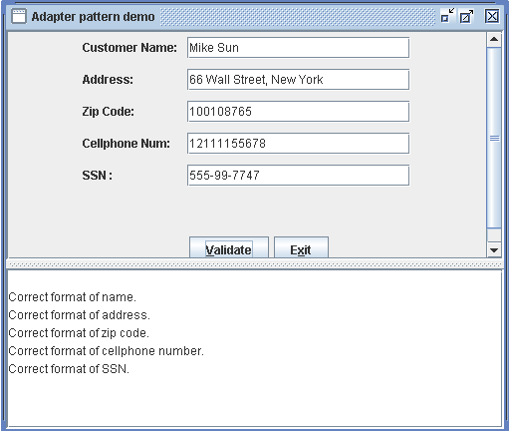

- In the interface CusInfoValidator, add a method “isValidEmailAddr”
- In class InformationAdapter, add and implement the isValidEmailAddr method according to the following requirement:
  - The email address should be formed by English characters from the 26 English alphabets mixed with digits from 0, 1, 2, 3, 4, 5, 6, 7, 8, 9, exactly one“@”, and at least one period mark “.”
  - The leading character should be one of the 26 English letters
  - The length of the whole email address should be at least 5
- Modify user interface ClientGUI to add a row for users to input email address

作业报告部分
1. Describe your finished homework, including
  - Which method has been added to what class?
  - In this design, to implement all the methods in the interface CusInfoValidator, why we only need to claim and implement the methods isValidSSNNum() and isValidEmailAddr in class InformationAdapter?
  - This program is designed and implemented by using the class adapter pattern. If the design is changed so that the object adapter pattern is used, then in class InformationAdapter, do we need to claim all the methods that are inside the interface CusInfoValidator and then implement all of them? Why?

2. Draw your modified class diagram here

3. Summarize the similarity and difference of the Class Adapter Design Pattern and the Object Adapter Design Pattern.

4. (Program Testing) List your typical input and output from running your program in validating an email address.

Homework 4: 桥接模式(Bridge Pattern)

作业描述（特工信息保密系统）：
The following design represents an agent information system. Agents’information should be encrypted and then saved into a text file or a database. There are two ways to encrypt agent’s name and code number, represented by classes EncryptedInfo1 and EncryptedInfo2.
EncryptedInfo1的加密算法：折叠算法
- 将26个英文字母按照顺序排列，加密的时候，以折叠的方式进行：
a←→z, b←→y, ...,m←→n
- 大写字母也是如此。大写字母加密为大写字母。
- 数字加密也以此方式进行0←→9,1←→8,2←→7,3←→6, 4←→5
a b c d e f g h i j k l m n o p q r s t u v w x y z
0 1 2 3 4 5 6 7 8 9
EncryptedInfo2的加密算法：分组互换算法
- 将26个英文字母按照顺序排列，按照如下方式两两分成一组，本组内部加密的时候互换： a←→b, c←→d，…, w←→x, y←→z。
- 大写字母的加密方式也是如此，大写字母加密为大写字母。
- 数字加密：0←→1, 2←→3,4←→5, 6←→7, 8←→9
a b c d e f g h i j k l m n o p q r s t u v w x y z
0 1 2 3 4 5 6 7 8 9

程序运行界面如下

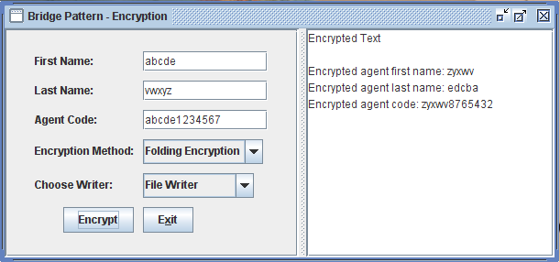

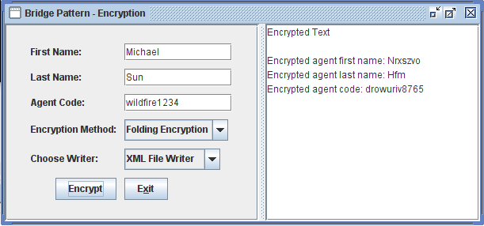

设计类图如下
<<interface>>
AgentInfo
+log(lNm: String, fNm: String, cd: String)
EncryptedInfo1
+encryptName(name: String)
+encryptCode(code: String)
+log(lNm: String, fNm: String,
cd: String)
-writer: MessageWriter
EncryptedInfo2
+encryptName(name: String)
+encryptCode(code: String)
+log(lNm: String, fNm: String,
cd: String)
-writer: MessageWriter
<<interface>>
MessageWriter

+logMsg(lNm: String, fNm: String, cd: String)
TxtFileWriter
+logMsg(lNm: String,
fNm: String,
code: String)
ClientGUI
Encrypted.txt
Database
XmlFileWriter
+logMsg(lNm: String,
fNm: String,
code: String)
DBWriter
+logMsg(lNm: String,
fNm: String,
code: String)
AgentInfo.xml
Fig. 1 Design class diagram for agent information system
Your task:
You are required to write a class EncryptedInfo3 to encrypt agent’s last name, first name and code number.
- The class should be in the same format as EncryptedInfo1 and EncryptedInfo2, and provide a different encryption method
- EncryptedInfo3 should encrypt the last name, first name and code number as described below as CaesarCypher: To encrypt a word, we replace the letter a with b, b with c, and so on, up to z, which is replaced by a. This is called the rotate-1 Caesar cipher. When a digital number between 0 and 9 is encountered, the rule to rotate is 0→1, 1→2,…,8→9 and 9→0. For example:
Plain text: Mike
Encrypted text: Njlf
Plain text: Sun
Encrypted text: Tvo
Plain text: Shanben56
Encrypted text: Tibocfo67
c) Modify the class ClientGUI to allow choice EncryptedInfo3 to be shown in the GUI.

- Note: 特工密码长度为12位，由英文字母与0，1，…，9阿拉伯数字组成。
- The length for a code is exactly 12, formed by mixed characters and digital numbers.

作业报告部分
1. Describe your finished homework, including
  - What classes have been added to the existing class hierarchy?
  - Explain the relationship between the existing classes and the newly added classes.

2. Draw your new class diagram here

3. Answer questions as below: after you add class EncryptedInfo3,
- Do you need to recompile class EncryptedInfo1 and EncryptedInfo2?
- Do you need to recompile class AgentInfo?
- Do you need to recompile class FileWriter or DBWriter?

4. In class EncryptedInfo1, there is a constructor
public EncryptedInfo1(MessageWriter l){
writer = l;
}
Why do we use type MessageWriter as the parameter type and why don’t we use type FileWriter or DBWriter as the parameter type?

5. In class ClientGUI , we have the source code
MessageWriter writer;
…
if( logWay.compareTo(ClientGUI.DBWRITER)==0 )
writer = new DBWriter();
if( logWay.compareTo(ClientGUI.FILEWRITER)==0 )
writer = new FileWriter();
What is the advantage of writing code above?

6. If we add a class named ConsolWriter parallel to DBWriter, do we need to recompile any classes?

7. Test your finished program. List your test input and output from running your program.

Homework 5: 外观模式(Façade pattern)

Description of the Homework:

Now we have some classes for image processing as below:
- BufferedImgOperation
- ImageBluring (图像平滑)
- ImageSharpening (图像锐化)

The BufferedImgOperations is an interface class, which has 2 implementing classes, ImageBluring, and ImageSharpening.
- An object of imageBluring class represents a smooth filter to smooth an input image and produce an output image.
- An object of ImageSharpening class represents a sharpening filter to sharpen an input image and produce an output image.
- Both input images and output images are of type BufferedImage, which is difficult to understand.

The class diagram is as below.

<<Interface>>
BufferedImgOperation
+filter(src: BufferedImage, dst: BufferedImage): BufferedImage
ImageBlurring
+ filter(src: BufferedImage,
dst: BufferedImage):
BufferedImage
ImageSharpening

+ filter(src: BufferedImage,
dst: BufferedImage):
BufferedImage

Fig 1 Image processing system class hierarchy

We need to write an application program to do image bluring, and image sharpening, and display the original image and processed image in an graphical user interface and also save the processed image into a folder.

When the program runs, it produces a GUI as below, on which a user firstly selected an image file flower.jpg, selected Blur filter and sharpening filter, and then clicked on button process.

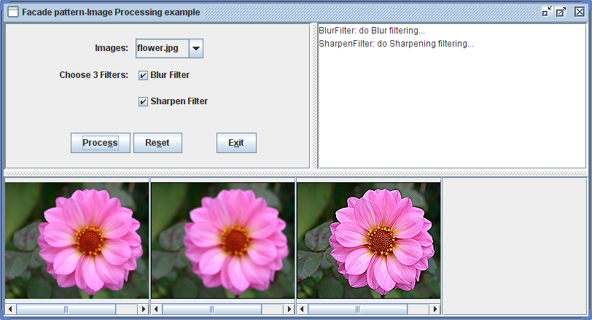
Fig 2 The GUI from the program-Image processing system

Difficult part （困难之处）:
- Need to convert .jpg file format into BufferedImage type, in order to do image processing, which is difficult to understand
- .jpg file is for displaying image
- BufferedImage type is for image processing
- A lot of efforts are needed to display an image
- Need to save the processed image into a folder

The working mechanism of the program is as following
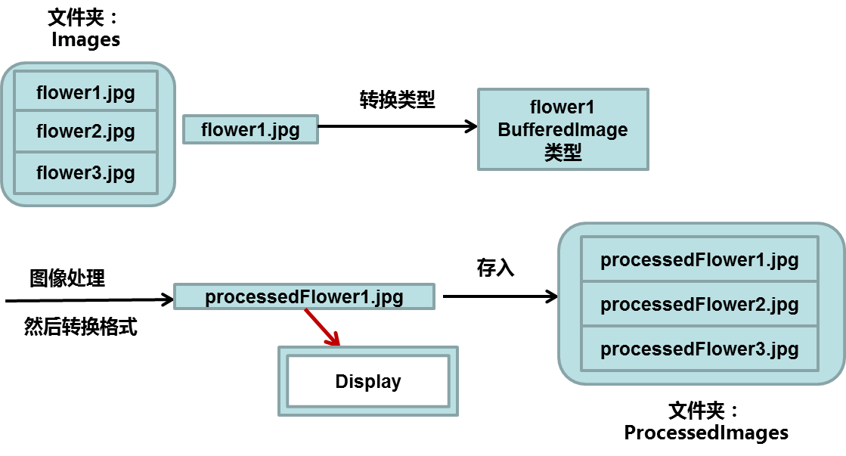

Fig 3 The working mechanism of the program

Therefore, we asked a senior software developer to write a façade class ImageProcFacade, that is, we use the façade pattern to design the program. The design class diagram is as below.
ImageProcFacade
processImage(String chosenImg): void
produceImIcon(Image img): ImageIcon
displayImage(JLabel imgLabel,ImageIcon imgIcon))
showFilterInfo(JTextArea filterInfoTxt, String filterInfo )
getFilterDescription(String filtor )
<<Interface>>
BufferedImgOperation
+filter(src: BufferedImage, dst: BufferedImage): BufferedImage
ImageBluring
+ filter(src: BufferedImage,
dst: BufferedImage):
BufferedImage
ClientGUI
main()
ImageSharpening

+ filter(src: BufferedImage,
dst: BufferedImage):
BufferedImage
外观类

Fig 4 Image processing system designed by using the façade pattern

What you need to do:
- In the design in Fig 4, add a class named ImageEdgeDetection (图像边界检测), which has already been included in this file directory. You also need to add the class ImageEdgeDetection to the class hierarchy in Fig 1 and Fig 2
- You need to modify ImageProcFacade to add Image Edge Detection functionality (增加图像边界检测功能)
- You need to change ClientGUI a little bit in order to add Image Edge Detection functionality

作业报告部分
1. Describe your finished homework, including
  - What classes have been added to the existing class hierarchy?
  - State the relationship between the existing classes and the newly added classes.
  - What classes have you modified?

2. Explain the ImageProcFacade class
- In the constructor ImageProcFacade(ArrayList ftrStr, JLabel[] imLbl, JTextArea infoTxt), explain the parameters
- Use your own words to explain how the method processImage(String chosenImg) works.

3. Answer questions from the class ImageProcFacade
  - In this program, why we use a BufferedImage file and a .jpg file?
  - How to get the original BufferedImage file img[0]?
  - What specific method actually does image processing of img[0]?
  - What specific code write the processed image file img[i+1] to a JPEG file, which then be saved into folder ProcessedImages?

4. Read class ImageProcFacade, and then answer questions
  - Why we need a “JLabel imgLabel” object?
  - Why we need an “ImageIcon imgIcon” object?

5. In class ImageProcFacade, what code is for saving the processed image file to the ProcessedImages folder?

Homework 6: 策略模式(Strategy Pattern)
作业描述(This Homework needs only a little bit coding)：The following class diagram represents a design in strategy pattern to sort integer arrays using different algorithms. This homework requires you
- Run the program ClientGUI first to see how an integer array is sorted.
- Add a strategy sub class to implement SortAlgorithm to do Bidirectional bubbleSort. Thus you can name this class BidirBubbleSort. Note that the BidirBubbleSort.java file is already in the same package and what you need to do is just add it to the strategy class hierarchy.
- In ClientGUI, modify the JcomboBox part to add an option to allow bidirectional bubble Sort.

<<interface>>
SortAlgorithm
+sort(a: int [ ], c: Context)
BubbleSort
+sort(a:int[],c:Context)
ClientGUI
HeapSort
+sort(a:int[],c:Context)
Context
+Context(s: SortAlgorithm)
+sortIntArray(): int[]
+startExecution(): void
+endExecution(): void
+getExeTime(): long
context
sort
InsertionSort
+sort(a:int[],c:Context)
QuickSort
+sort(a:int[],c:Context)
Fig 1. The Design of the Sorting Integer Array Problem in example 7.2 of the book

作业报告部分
1. Describe your finished homework, including
  - What classes have been added to the existing class hierarchy?
  - Specify the relationship between the existing classes and the newly added classes.
  - What code has been added to what class?

2. Draw your new class diagram here

3. Describe the typical interactions of the design in Fig 1 above in details

4. Discussions of the extensibility issues.
1) After you add your new class BidirBubbleSort in the strategy class hierarchy,
  - Do you have to change the Context class?
  - Do you have to change the Client class ClientGUI?
2) If you have changed the code for a sort(a:int[],c:Context) method in a sub-strategy class in the strategy class hierarchy,
  - Do you have to change or recompile the Context class?
  - Do you have to change or recompile the Client class ClientGUI?

5. Test your program by outputing typical input and output from running your new program

Homework 7: 状态模式(State Pattern)
作业描述：See the following class diagram for the State pattern implementation of Banking.
State
#context: BankContext
#changeState()：void
+passStateObjToContext()：void
+getAcctNum()：String
+getState()：String
+setContext(con: BankContext)：void
+deposit(amt: double)：void
+withdraw(amt: double): void
+isOverDrawnLimitReached(): void
BankContext
balance: double
objState: State
+getState()：String
+setStateObj(objState:State):void
+deposit(amt: double): void
+withdraw(amt: double): void
+getBalance(): double
+updateBalance(bal: double)
+isOverDrawnLimitHit(): Boolean
+createCusNewAcct(n1:String, n2: String, a: String)
+getAcctNum(fName: String, lName: String)
ClientGUI
objState
context
NoTransactionFeeState
+deposit(amt:double)
+withdraw(amt:double)
+isOverDrawnLimitReached()
TransactionFeeState
+deposit(amt:double)
+withdraw(amt:double)
+isOverDrawnLimitReached()
OverDrawnState
+deposit(amt:double)
+withdraw(amt:double)
+isOverDrawnLimitReached()
BankAcct.txt
Fig 1. class diagram of Bank account in the State pattern

NoTransactionFeeState
TransactionFeeState
OverDrawnState
Fig 2. the state transition diagram for the Banking problem

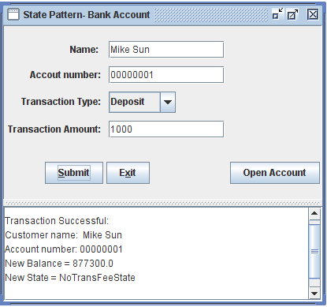
Fig 3. the graphical user interface produced when class AccountManager is run

Functionality of the program:
- 开新账号：开新账号的时候，只需要在用户图形界面上填上名、姓与存款数额，例如在Name栏，填写 “Rose Black”，在Transaction Amount栏，填写100，然后点击按钮Open Account，即可。不要填写账号栏，因为系统将随机生成你的新账号。
- 银行业务(存款、取款)：在进行银行业务的时候，必须（牢记账号）提供（可以查询数据文件BankAcct.txt获得真实的姓名与账号）名、姓，账号，并且选择存款deposit。例如，在Name栏填写“Mike Sun”，在Account Number一栏，填写00000001，然后在Transaction type, 选择deposit，在Transaction Amount栏填写1000最后点击安娜Submit即完成存款。

你的作业要求（Your Job）:
The class BankContext acts as the Context class in the State Pattern and class ClientGUI is the client class. Read the source code carefully and then do the following:
- Add a new class called TaxState to inherit the State class. Use the algorithm as below: When balance >= 100000, the program runs into TaxState.
- Under this state, every newly deposited amount of money will be charged 5% for the tax (the tax will be paid to the government, however, we ignore this part and just deduct 5% for newly deposit amount of money ) .

作业报告部分

1. Describe your finished homework, including
  - What classes have been added to the existing class hierarchy?
  - Specify the relationship between the existing classes and the newly added classes.

2. Draw your new state diagram here

3. When you fill in “Tom White”, “00000003”, choose “deposit” as transaction type, and when you fill in the transaction amount as 10000, and click on the button “submit”, what statements in the class ClientGUI will be invoked. Also trace back all the statements called in class BankContext, class State and its subclasses, CustomerAcctAccess, and FileUtil classes. Print out Tom White’s data in the BankAcct.txt file before and after the deposit.

4. What methods in what classes are used to keep the communication between the State class hierarchy and the context class BankContext

5. When you add the new required class TaxState, what methods in what existing classes will also have to be modified?

Homework 8: 访问者模式(Visitor pattern)

作业描述：This homework is about a program for selling sport shoes in a store. Study the following Fig 1, Fig 2 and Fig 3 about the visitor solution of the sport-shoe store problem.
Fig 1. The sportShoes hierarchy
SportShoes
+getPrice:double
+getDescription
Nike
NorthFace
Adidas
Salomon
GlobeBlitz
DCShoesRover
+getPrice:double
+getDescription
+getPrice:double
+getDescription
+getPrice:double
+getDescription
+getPrice:double
+getDescription
+getPrice:double
+getDescription
+getPrice:double
+getDescription
RunningShoes
SkatingShoes
WalkingShoes
+getPrice():double
+getDescription()
+getPrice():double
+getDescription()
+getPric()e:double
+getDescription()
Mephisto
+getPrice:double
+getDescription
Pony-Mexico
+getPrice:double
+getDescription
GlobeAppleyard
+getPrice:double
+getDescription
Fig 1 is a class hierarchy about popular sport shoes, which can be classified into 3 categories: WalkingShoes, RunningShoes and SkatingShoes, and each category also have some brands.

Fig 2 is a visitor class hierarchy for visiting the class hierarchy in fig 1. The class hierarchy has 2 sub classes: PriceVisitor and ShoeInfoVisitor, for getting the prices and descriptions for each brand of shoes respectively.

Visitor
+visitAdidas(Adidas e);
+visitSalomon(Salomon e);
+visitPonyMexico(PonyMexico e);
+visitNorthFace (NorthFace e);
+visitNike(Nike e);
+visitMephisto(Mephisto e);
+visitGlobeBlitz (GlobeBlitz e);
+visitGlobeAppleyard(GlobeAppleyard e);
+visitDCShoesRover(DCShoesRover e);
PriceVisitor
+visitAdidas(Adidas e);
+visitSalomon(Salomon e);
+visitPonyMexico(PonyMexico e);
+visitNorthFace (NorthFace e);
+visitNike(Nike e);
+visitMephisto(Mephisto e);
+visitGlobeBlitz (GlobeBlitz e);
+visitGlobeAppleyard(GlobeAppleyard e);
+visitDCShoesRover(DCShoesRover e);
ShoeInfoVisitor
+visitAdidas(Adidas e);
+visitSalomon(Salomon e);
+visitPonyMexico(PonyMexico e);
+visitNorthFace (NorthFace e);
+visitNike(Nike e);
+visitMephisto(Mephisto e);
+visitGlobeBlitz (GlobeBlitz e);
+visitGlobeAppleyard(GlobeAppleyard e);
+visitDCShoesRover(DCShoesRover e);
Fig 2. The visitor hierarchy

Fig 3 is the design of the program by using the visitor pattern. ClientGUI is the user interface class that displays the choices of all the shoes selling by a store. This class creates an object s of a subclass of SportShoes and an object v of the subclass of the visitor class, and then let s accept v.
SportShoes
+accept:void
+getPrice:double
+getDescription
RunningShoes
WalkingShoes
+accept:void
+getPrice:double
+getDescription
Nike
Mephisto
+accept:void
+getPrice:double
+getDescription

NorthFace
Adidas
Pony-Mexico
+accept:void
+getPrice:double
+getDescription

Salomon
GlobeBlitz
GlobeAppleyard
+accept:void
+getPrice:double
+getDescription

DCShoesRover
+accept:void
+getPrice:double
+getDescription
+accept:void
+getPrice:double
+getDescription
+accept:void
+getPrice:double
+getDescription
+accept:void
+getPrice:double
+getDescription
+accept:void
+getPrice:double
+getDescription
+accept:void
+getPrice:double
+getDescription
+accept:void
+getPrice:double
+getDescription
+accept:void
+getPrice:double
+getDescription
Visitor
PriceVisitor
ShoeInfoVisitor
ClientGUI
SkatingShoes
Fig 3 the design of the program by using the visitor pattern

作业描述(Homework requirement)
- Run the ClientGUI to be be familiar with the structure of the program
- Write code for ShoeInfoVisitor to implement all the methods in this class to get descriptions of all the kind of shoes
- Also in the client class ClientGUI, add necessary methods to get the information about the selected shoes (from calling object ShoeInfoVisitor), and display the information on the upper right panel of the graphic user interface

作业报告部分
1. Answer the following
  - Which class have you written code for?
  - What code have you added to what class to show the shoe information to the screen?

2. Do the following
- Explain how method accept(Visitor v) works.
- How a node class is visited?

3. Which class is responsible for creating objects of the SportShoes and
objects of the visitor? How to make the 2 kinds of objects work together?

4. (测试) Typical input and output from running your finished program

Homework 9: 中介者模式(Mediator Pattern)

Homework Description：See the following class diagram for the Mediator pattern implementation of collaboration program for Hotel, Airline and Tour.
HotelGUI
-m: BusinessMediator
+addCustomer(String c);
+addPossibleCustomer(String c)
+displayInfo(String txt)
+writeCusToXmlFile(String[] c)
+writeCandidateCusToXmlFile(c)
TourGUI
-m: BusinessMediator

BusinessMediator
companyList: ArrayList <ParticipantGUI>
+register(c: CompanyGUI)
+addPossibleCus(p: ParticipantGUI ,
text String)
+updateAllGuis(p: ParticipantGUI,
text String)
+writePossibleCusToXmlFile(p: ParticipantGUI ,
cusData: String[])
AirlineGUI
-m: BusinessMediator

<<interface>>
ParticipantGUI
+addCustomer(String c);
+addPossibleCustomer(String c)
+displayInfo(String txt)
+writeCusToXmlFile(String[] c)
+writeCandidateCusToXmlFile(c)

Client
+main()

+addCustomer(String c);
+addPossibleCustomer(String c)
+displayInfo(String txt)
+writeCusToXmlFile(String[] c)
+writeCandidateCusToXmlFile(c)
+addCustomer(String c);
+addPossibleCustomer(String c)
+displayInfo(String txt)
+writeCusToXmlFile(String[] c)
+writeCandidateCusToXmlFile(c)
HotelCustomer.xml
HotelPossibleCustomer.xml
AirportCustomer.xml
AirportPossibleCustomer.xml
TourCustomer.xml
TourPossibleCustomer.xml
图1 利用中介者模式设计的信息共享程序

The three graphical user interfaces for the Hotel, Airline and Tour are as below.

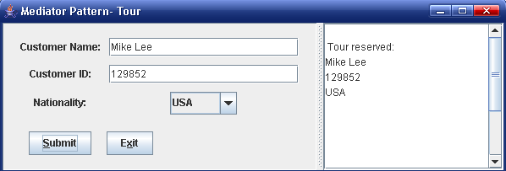
图2 旅游公司输入客户信息
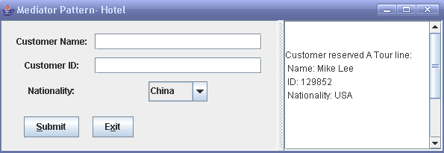
图3 宾馆界面同步获得旅游公司输入的客户信息
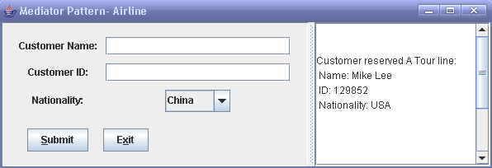
图4 机场界面同步获得旅游公司输入的客户信息

当在一个用户图形界面，例如Tour，中输入Mike Lee，1239852，选择USA然后点击按钮“Submit”，则程序会通过BusinessMediator对象，将这些客户信息转发给Hotel和Airline对象，并且显示在相应的用户图形界面上。这些客户数据也被写到了以下的数据文件TourCustomer.xml，HotelPossibleCustomer.xml和AirportPossibleCustomer.xml中。

Homework requirement:
- Run the program before you go any further
- (Coding) Add another class named TouriststoreGUI （旅游商店）such that the 4 classes HotelGUI, AirflightGUI, TourGUI and TouriststoreGUI will interact though the BusinessMediator in the same way as before (use the mediator pattern). Note that you need to create files TourStoreCustomer.xml and TourStorePossibleCustomer.xml and relavent customer information needs to be added to the above files.

项目报告部分
1. Describe your finished homework, including
  - What class has been added to the existing class hierarchy?
  - The relationship between the existing classes and the newly added class

2. Draw your new complete class diagram here

3. In HotelGUI object, when you enter name entry as “Rose Black”, id number entry as “555888999”, and choose the nationality as “USA”, and then click on button “Submit” to save the customer information into file HotelCustomer.xml, what methods in what class will have been invoked, list all of them in correct order.

4. Discussion
- Describe the functionality of the BusinessMediator class.
- Explain how the mediator pattern works?
- How the method updateAllGuis(ParticipantGUI p, String text) in the BusinessMediator class works?

5. [Extendibility Issue] Discussion:
- After you add the new class TouriststoreGUI, do you have to modify class ParticipantGUI?
- After you add the new class TouriststoreGUI, do you have to modify class HotelGUI?
- After you add the new class TouriststoreGUI, do you have to modify class AirlineGUI?
- After you add the new class TouriststoreGUI, do you have to modify class TourGUI?
- After you add the new class TouriststoreGUI, do you have to modify class BusinessMediator?

Homework 10: 观察者模式(Observer Pattern)

1. Requirements of the homework：
Run the Client before you actually do any coding. After you run the program, 4 graphical user interfaces will appear,
- TemperatureGUI, the observable and the other 3 guis,
- CelsiusGUI, and FahrenheitGUI, KelvinGUI, the observers.
In the interface TemperatureGUI, When you select one temperature measure from the 3 measures: Celsius or Fahrenheit or Kelvin and input the degree for temperature, then the CelsiusGUI, FahrenheitGUI and KelvinGUI will actually show the degrees of the temperatures, in Celsius, Fahrenheit, and Kelvin respectively.

The design is as below.
Note: This design is based on the Java observable/observer strategy of handling events. Here, Observable is a java class and Observer is an interface (Java API, J2sdk1.4.2, and later).
Observable
TemperatureGUI
+addObserver(observer:Observer)
+setChanged()
+notifyObservers(event: Object)
+setTemperature(String tem): void
+getSelectedTemExpression(): String
<<interface>>
Observer
CelsiusGUI
FahrenheitGUI
+update(o: Observable, e: Object)
notify
Update(o, e)
Update(o, e)
KelvinGUI

update(o, e)
Client
+main()

你的任务：
Part I: Coding: Use the class CelsiusGUI.java as an example to write 2 additional Java classes, named RankineGUI.java, and ReaumurGUI.java to show the 2 different measures of the temperature.
Part II: coding: Finish the remaining 2 methods in the class TemperatureConvertor.java. They are:
public float getRankineTemperature(String opt,String t)
public float getReaumurTemperature(String opt,String t)
Part III: coding: In class TemperatureGUI.java, add necessary code to allow the Jcombox to show the "Rankine", and "Reaumur" for users to choose from.

Note: the formulas for conversions among different temperature measures can be found in the file Temperature Conversions.doc in this folder.

项目报告部分(Report):
- Describe your finished homework, including
  - What classes have been added to the class hierarchy
  - Explain the relationship between the existing classes and the newly added classes.
  - What code has been added to what class?

- Draw your new design diagram here

3. Answer questions
- Explain the parameters in this method update(o: Observable, e: Object) in the design for this homework?
- How the update method update(o: Observable, e: Object) in the observer works?

4. What is the functionality of the Client class in this design?

5. Display the typical input and output from running your program as below.

Project 1: Encryption by Using Layered Architecture
问题描述：The purpose of this project is to design an agent information system by using three-layer layered architecture. The agent information is encrypted and then saved into some specific text files. In the design below, the graphical user interface includes a class nemed ClientGUI for sending user’s request. The application layer contains a class hierarchy named Encryption to actually encrypt agent info and calls class TxtFileWriter, which saves the encrypted data into files Folding.txt, and Group-swap.txt. The agent information to be encrypted includes agent’s last name, first name, and agent code. The agent code can be mixed characters with digital numbers. The length of the code is 12.

ClientGUI

TxtFileWriter
Encryption
EncryptedInfo1
EncryptedInfo2
Folding.txt
Group-swap.txt
表示层
应用层
永久数据存储层
EncryContext
Fig 1. Software architecture for the agent information system

算法描述：
Class EncryptedInfo1 encrypts agent information using Encryption Algorithm1 (折叠算法) as below.
Precondition: a text file to be encrypted contains only English characters and digital numbers. The algorithm is:
a→z, b→y, ...m→n, y→b, z→a
0→9, 1→8, 2→7, 3→6, 4→5, 5→4, 6→3, 7→2, 8→1, 9→0
Upper case letters are also encrypted the same way (Upper case letters are encrypted into Upper case letters).

Class EncryptedInfo2 encrypts agent information using Encryption Algorithm2 (分组互换算法).
Precondition: a text file to be encrypted contains only English characters and digital numbers. The algorithm is:
a→b, b→a; c→d, d→c; e→f, f→e;, ..., y→z, z→y
0→1, 1→0; 2→3, 3→2; ...8→9, 9→8
Upper case letters are also encrypted the same way (Upper case letters are encrypted into Upper case letters) .
Class diagram is as Fig 2.

The source code for the above class diagram has been written in Java. The encrypted agent information from EncryptedInfo1 is saved into a file named Folding.txt and encrypted agent information from EncryptedInfo2 is saved into a file named Group-swap.txt. Both text files are in the same folder as the Java source files.

The class diagram is as below.
<<interface>>
Encryption
+encryptName(inputStr: String): String
+encryptCode(inputSt: Stringr): String
+log(lNm: String, fNm: String, cd:String): void

EncryptedInfo1
+encryptName(inputStr: String): String
+encryptCode(inputSt: Stringr): String
+log(lNm: String, fNm: String, cd:String)
-writer: TxtFileWriter
-writer: TxtFileWriter
+encryptName(inputStr: String): String
+encryptCode(inputSt: Stringr): String
+log(lNm: String, fNm: String, cd:String)
ClientGUI
EncryptedInfo2
TxtFileWriter
+logMsg(encryptOption: String, lNm: String, fNm: String, cd:String)
Folding.txt
Group-swap.txt
EncryContext
+doEncryption(lastNm:String, firstNm: String, code: String, txt: JTextArea)
-en: Encryption
Fig 2. The class diagram for the agent information system

你的任务：
1) 在以上已经存在的设计中，新增加第三种加密算法. Now you are required to write a class EncryptedInfo3 to encrypt agent’s last name, first name and code number.
a) The class should be in the same format as EncryptedInfo1 and EncryptedInfo2, and provides a different encryption method
b) EncryptedInfo3 should encrypt the last name, first name and code number as described below as CaesarCypher: To encrypt a word, we replace the letter a with b, b with c, and so on, up to z, which is replaced by a. This is called the rotate-1 Caesar cipher. When a digital number between 0 and 9 is encountered, the rule to rotate is 0→1, 1→2,…,8→9 and 9→0. For example:
Agent first name: Mike
Encrypted agent first name: Njlf
Agent last name: Sun
Encrypted agent last name: Tvo
Agent code: WildWolf7489
Encrypted agent code: XjmeXpmg8590
c) Modify the class ClientGUI to allow choice EncryptedInfo3 to be shown in the GUI.
d) The encrypted agent information should be saved into a text file Caesar.txt.

2) 在应用层，增加相应的解密算法层次类Decryption，该类带有三个相应的解密子类。分别从三个加密文件中读出的agent加密信息，可以通过此层次类解密，然后显示在用户图形界面上。
3) 在用户图形界面上增加解密按钮，以便对各个加密文件所存的内容进行解密，然后显示的用户图形界面上。

【注】为了方便起见，你也可以使用另外一个文件夹包含全部的解密程序和text文档。

项目报告部分
- Draw your software architecture for your new agent information encryption system

- Draw class diagram for your new agent information encryption system

- To implement all the required functionalities, what classes have you added to the application layer?

- Which design pattern has been used in the application layer?

- Answer question: When you add a new class in the application layer, will the data file access layer be affected or not?

- Answer question: When you add a new class in the application layer, will the user interface layer be affected or not?

- Answer question: When you add a new method in the TxtFileWriter class, will the user interface layer or the application layer be affected or not?

- If you want the user interface layer to initialize a request to save some data into the data files, what classes need to call?

- In your program,
  - Does the application layer call the user interface layer?
  - Does the data files access layer call the application layer or the user interface layer?

10. 测试与验证部分: List at least 3 group of typical input and output from running your program, corresponding to 3 ways to encrypt and decrypt agent information

Project 2: Population File Processing in Batch Sequential Architecture

项目需求：实现一个人口信息处理程序
This project is about processing population files to get men whose ages are above 18 and under 25, for candidates to be soldiers. In addition to this, this project also classifies the population by man, woan, and ages. Batch sequential architecture is used to process the files. The design is as below.

ForkInputProcessor

WomanProcessor1

WomanProcessor2

ManProcessor1

ManProcessor2

Man.txt
Woman.txt
Beijing.txt
Woman18+.txt
Woman18-.txt
Woman18-25.txt
Woman25+.txt
Man18-.txt
Man18+.txt
Man25+.txt
Man18-25.txt

人口信息处理程序软件体系结构图

In this design, there are 5 batch sequential processors
- ForkInputProcessor: Read input file line by line, and write each line read to one of the two output files, one is a file containing woman data and the other is a file containing man information.
- WomanProcessor1: read input file (Woman) line by line, and write each line read to one of the two output files, one is a file containing women whose age are under 18, i.e., file Woman18-.txt, and the other is a file containing women whose ages satisfy: age>= 18, file Woman18+.txt.
- WomanProcessor2: read input file (Woman18+) line by line, and write each line read to one of the two output files, one is a file containing women whose ages satisfy: 18<=age<=25, i.e., file Woman18-25.txt, and the other is a file containing women whose ages are above 25, i.e., file Woman25+.txt.
- ManProcessor1: Read input file (Man) line by line, and write each line read to one of the two output files, one is a file containing men whose ages are below 18, i.e., file Man18-.txt, and the other is a file containing men whose ages satisfy: age >= 18, i.e., file Man18+.txt.
- ManProcessor2: Read input file (Man18+) line by line, and write each line read to one of the two output files, one is a file containing men whose ages are above 25, i.e., Man25+, and the other is a file containing men whose ages satisfy: 18<=age<= 25, file Man18-25.txt.

The class diagram design is as below.

你的任务：
- 在以上设计中，ClientGUI类，AssemblyOfPipeLines 类，BatchProcessing类, ForkInputProcessor类和WomanProcessor1类已经实现（写完代码）。你的任务是写代码实现WomanProcessor2类，ManProcessor1类和ManProcessor2类（提示：在写代码之前，运行程序，会对你的理解有所帮助）。
- 要求你产生架构图中的所有的txt文件。

<<interface>>
BatchProcessing
+processData()
ForkInputProcessor
+process()
WomanProcessor1
+process()
WomanProcessor2
+process()
ManProcessor2
+process()
ManProcessor1
+process()
AssemblyOfPipeLines
ClientGUI
人口信息处理程序设计类图

项目报告部分(Project Report Part)
- Answer question: Do the classes WomanProcessor1, WomanProcessor2，ManProcessor1 and ManProcessor2 have any dependent relationships (they call each other or not)?

- When you add a new processor (for example, a children processor) to the class hierarchy BatchProcessing, what class needs to be modified in order for using the new sub class?

- Answer question: what is the order of program execution? Can the 5 processors be executed simultaneously or not?

4. What is the reason for using class AssemblyOfPipeLines?

5. 验证部分: List typical input and output from running your program.

Project 3: Text File Encryption in Pipes-and-filters Architecture

项目需求部分：实现一个多次加密程序
Do text file encryption by using the pipes and filters architecture. Suppose that we have 3 encryption algorithms as following:
Encryption Algorithm 1 (折叠算法). Precondition: a text file to be encrypted contains only English characters and digital numbers. The algorithm is:
a→z, b→y, ...m→n, y→b, z→a
0→9, 1→8, 2→7, 3→6, 4→5, 5→4, 6→3, 7→2, 8→1, 9→0
Upper case letters are also encrypted the same way (Upper case letters are encrypted into Upper case letters).
Encryption Algorithm 2(分组互换算法). Precondition: a text file to be encrypted contains only English characters and digital numbers. The algorithm is:
a→b, b→a; c→d, d→c; e→f, f→e;, ..., y→z, z→y
0→1, 1→0; 2→3, 3→2; ...8→9, 9→8
Upper case letters are also encrypted the same way (Upper case letters are encrypted into Upper case letters) .
Encryption Algorithm 3 (Caesar cipher, rotation 1): Precondition: a text file to be encrypted contains only English characters and digital numbers. The algorithm is: for the 26 English characters, you replace the letter a with b, b with c, and so on, up to z, which is replaced by a. When a digital number between 0 and 9 is encountered, the rule to rotate is 0→1, 1→2,…,8→9 and 9→0.
a→b, b→c; c→d, d→e; e→f, …,y→z, z→a
0→1, 1→2; 2→3, 3→4; 4→5, 5→6,6→7,7→8, 8→9, 9→0
Upper case letters are also encrypted the same way (Upper case letters are encrypted into Upper case letters)
The program should be designed using pipes and filters architecture, which contains filters as below:
- InFilter reads the file to be encrypted in character stream format and parses the file. The parsed data is written to the output pipe as char stream;
- EncrFilter1 reads character stream from its source pipe, use Encryption algorithm 1 to encrypt the incoming characters and numbers, and then write the resultant data into sink pipe as character stream;
- EncrFilter2 reads character stream from its source pipe, use Encryption algorithm 2 to encrypt the incoming characters and numbers, and then write the resultant data into sink pipe as character stream;
- EncrFilter3 reads character stream from its source pipe, use Encryption algorithm 3 to encrypt the incoming characters and numbers, and then write the resultant data into sink pipe as character stream;
- OutFilter reads character stream from the source stream (through source pipe), and then write the resultant data into a file named Updated.txt in directory “EncryptedFiles” and onto the right textArea on the GUI (the original file content will be shown on the left textArea)
The logic design of the pipeline is as the following.

Sale1.txt
EncryptedSale1.txt
Screen
EncrFilter1
EncrFilter2
OutFilter
InFilter
EncrFilter3
Fig 1. The logical design of the encryption system

The class diagram design is as below.

Pipe
-reader_: PipedReader
-writer_: PipedWriter
+read()
+write(c: int)
+closeReader()
+closeWriter()
<<Interface>>
Runnable
+run()
Filter
#input: Pipe
#output:Pipe
-isStarted:boolean
+Filter(input:Pipe,output:Pipe)
+start()
+stop()
+run()
#process()
InFilter
+process()
EncrFilter1

+process()
EncrFilter2

+process()
OutFilter
+process()
EncrFilter3

+process()
AssemblyOfPipeLines
PipeFilterTestGui
Fig 2. The design of encryption program using pipes and filters architecture

你的任务：
- 在以上设计中，InFilter类，EncrFilter1类，和OutFilter类已经实现。你的任务是写代码实现EncrFilter2类和EncrFilter3类（提示：在写代码之前，运行程序，会对你的理解有所帮助）。
- 要求你的经过3次复合加密过滤器处理的文件，显示在图形界面右端的文本框中和相应的文件夹EncryptedFiles中的相应的文件EncryptedSalesman1, EncryptedSalesman2,或者EncryptedSalesman3之中。
- 与加密类似地，按照以上类似的管道-过滤器架构设计并且实现一个针对以上算法的解密系统，可以将以上的整个加密程序，包括用户图形界面类，复制为另外一个文件夹，然后少许修改代码，而成为一个解密系统。注意，解密系统的过滤器的顺序与加密系统过滤器的顺序相反。
- 对解密系统进行测试：使用已经被三次加密的数据，进行解密运算，如果最后得到未加密之前的原始数据，则说明你的加密系统是正确的（目的是验证你的加密算法的正确性）。

项目报告部分(Report Part)
- Answer question: When you add a new sub class of Filter, what class needs to be modified in order for using the new sub class?

- Answer question: What makes the data flow through the pipeline?

- Answer question: What “all the filters can work simultaneously” mean?

4. 验证部分
  - List typical input and output from running your encryption program
  - use your decryption system to decrypt the output file from encryption to get the original file (如果你解密以后得到了原始文件，则证明你的加/解密算法的实现是正确的).

