Title: Automated road and footpath extraction in Ugandan Refugee Settlements using a lightweight CNN and VHR multispectral imagery.
Authors: Zachary Mondschein, X, Y, Z, James Watson, Jamon Van Den Hoek, et al.
Keywords: “remote sensing”, “road extraction”, “classification”, “machine learning”, “refugee settlements”, “rural”, “Uganda"
Target Journals: Remote Sensing of Environment, Environmental Research Letters

Introduction:
The United Nations High Commissioner for Refugees (UNHCR) estimates that in 2024 122.6M people were forcibly displaced worldwide (Global-Report-2024, n.d.). As displacement increases, the populations of refugee settlements are expanding rapidly, and new camps continue to be established (Van Den Hoek & Friedrich, 2021). Although camps are often thought of as temporary solutions constructed utilizing cheap building materials and basic design configurations (Gupta et al., n.d.), many refugee camps have persisted for decades, transitioning into more permanent settlements (Alqub & Matar, 2025). Two thirds of refugees live in protracted refugee scenarios, and the average stay in a refugee camp in more than 10 years (Peters & Van Den Hoek, 2021).
Despite the growing number of people living in refugee settlements, they are among the most under-documented human landscapes globally. Geographies of displacement are poorly accounted for in existing global settlement datasets, which fail to detect refugee settlements due to their rapid evolution, and unique material conditions (Van Den Hoek & Friedrich, 2021). From the perspective of urbanization science, refugee camps share characteristics of both urban and informal settlements. Slater (2014) argues that refugee camps embody the “extreme city” revealing tension between the impermanent and the permanent (Slater, n.d.).
Among the least documented components of these landscapes are roads and footpaths. These infrastructure features mediate many aspects of daily life, including access to water, markets, and agricultural fields. Yet, in many humanitarian landscapes, maps of roads are incomplete and inconsistently updated. Current maps rely heavily on manual digitization, in which planners trace roads from very high–resolution (VHR) imagery using platforms such as OpenStreetMap (OSM), or use GPS trackers in the field (Haklay & Weber, 2008). However, this approach is labor intensive and time consuming, and ill suited to landscapes in which infrastructure can change rapidly. Van Den Hoek et al. (2021) found that most data was created three years after refugee arrival, and 81% of OSM data in refugee settlements were never edited, highlighting a significant lag in infrastructure mapping (Van Den Hoek et al., 2021).
In the past decade, advances in AI driven approaches have produced a new class of deep learning models designed for road extraction from earth observation imagery. Methods such as CoANet (Mei et al., 2021), which introduces connectivity-aware attention mechanisms, AGD-LinkNet (Jiang et al., 2023), which introduces dilated convolutions, and CE-RoadNet (Cheng et al., 2025), which uses a cascaded network design, improve performance in urban contexts by modeling the topology and linear geometry of road networks. While these models have performed well in urban and peri-urban environments, there are significant challenges in applying these models to humanitarian or rural contexts. In contrast to the clearly defined roads that characterize urban and suburban settings, roads in humanitarian landscapes tend to be diverse, and poorly defined.
In this project I aim to assess whether deep learning methods can address these challenges. My research questions are threefold:
(1) Can a lightweight CNN architecture, originally developed and benchmarked on urban road systems, be adapted to humanitarian settings where infrastructure is informal and sometimes ephemeral?
(2) Can we train a model using annotations for roads and footpaths that are adapted from OpenStreetMap data, despite incomplete and uneven coverage in the training dataset?
(3) Does supplementing OSM data with a relatively small quantity of high-quality, hand drawn annotations meaningfully improve model accuracy?
To examine these questions, we construct a segmentation workflow using 0.5 m Maxar multispectral imagery in the Nakivale Refugee Settlement in Southwestern Region, Uganda. We fine tune the CE-RoadNet model trained on the “Massachusetts Roads” dataset using both OSM-derived road masks and new high-quality manual annotations of missing footpaths (Cheng et al., 2025).
This work will meaningfully support future humanitarian mapping projects in the Conflict Ecology Lab at Oregon State University. An updated road and footpath map in Ugandan refugee settlements will enable travel time estimation, which is a key factor in understanding exposure to risk associate with resource collection, including gender-based violence.

2. Methods:
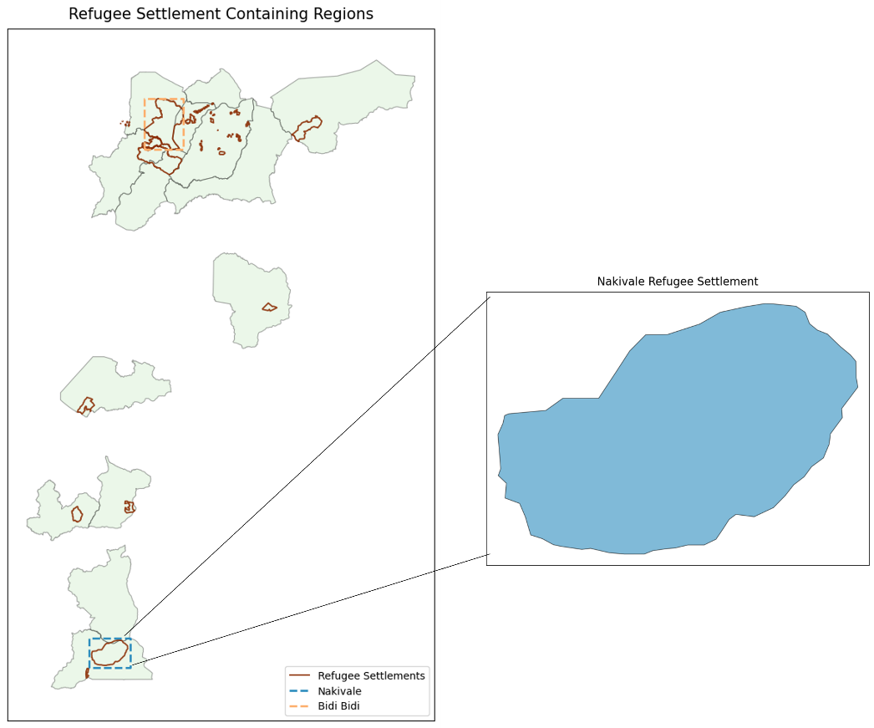
Figure 1. Displays the boundaries of Nakivale Refugee Settlement in southwestern Uganda.

2.1 Study Site
As of 2021, Uganda was host to 1.4 million refugees, which represents ~3% of its total population (Van Den Hoek & Friedrich, 2021b). In 2020 this was the largest refugee population in Africa, and the second largest in the world (Friedrich & Van Den Hoek, 2020). The refugee population increased by ten-fold between 2012 and 2017 as a result of humanitarian crises in Sudan and Democratic Republic of Congo. 92% of refugees in the country reside inside UNHCR refugee settlements, and the remaining 8% are in Kampala. In 1998 Uganda codified its Self Reliance Strategy (SRS), a refugee policy that allocates land and grants refugees access to food, aid, health, and education. The policy also grants refugees the ability to freely travel outside the borders of refugee settlements for work (Bjørkhaug, 2020). As a result, Uganda is unique among refugee hosting countries in how refugee populations are integrated into surrounding host country communities (Bohnet & Schmitz-Pranghe, 2019). Additionally, as a result of the SRS policy, refugee settlements are understood as long term structures, as opposed to temporary staging area. Nakivale is one of the largest refugee settlements in the country by population and land mass. Nakivale is a 185 km^2 refugee settlement located in Southwestern Uganda. It is one of the oldest refugee settlements in the country, having been established in 1958. As of 2020, it sheltered 132,000 refugees (Bjørkhaug, 2020).

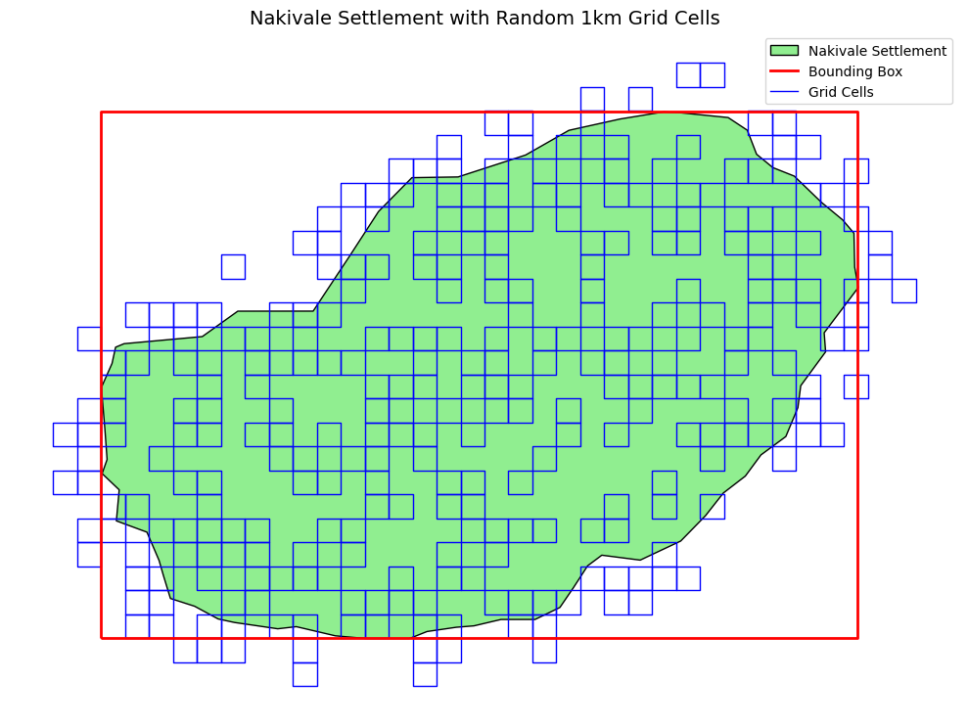
Figure 2. Nakivale Refugee Settlement with 300 randomly selected 1km x 1km grid cells. The bounding box for the buffered settlement region is shown in red.

2.2 OSM Data
OpenStreetMap (OSM) road and footpath data were used as the primary source of annotations for model development. Data were acquired using the OSMnx Python library, which queries the Overpass API to retrieve all available roadway geometries within the study area (Boeing, 2025). We selected for roadways in the study region using the following tags: [‘primary’, ‘secondary’, ‘tertiary’, ‘undefined’, 'service', 'give way', 'crossing', 'secondary link', 'platform', 'path', 'footway', 'track', 'pedestrian', 'steps', 'residential']. We then filtered the resulting dataset to include only polyline geometries, removing point “node” features.

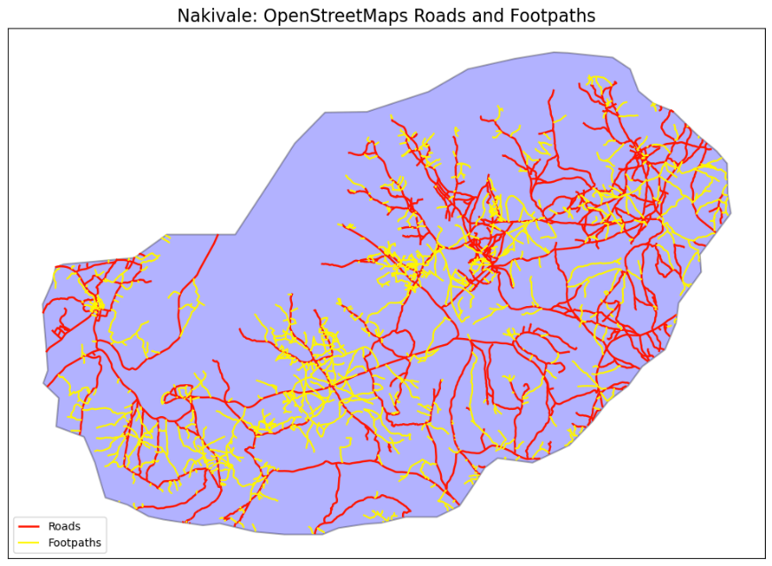
Figure 3. Roads and Footpaths acquired via OSMnx library. Roads are displayed in red, footpaths are displayed in yellow.

2.3 Maxar Imagery
Very high-resolution (VHR) 0.5 m multispectral and panchromatic Maxar imagery was accessed via the Conflict Ecology Lab Maxar archive housed on the Oregon State University High Performance Computer (HPC). To sample our settlement, we generated a 1km x 1km grid mesh over our AOI. From the mesh, we randomly sampled 300 grid cells. The selected cell boundaries were exported as a GeoJSON and transferred to the HPC environment. On the HPC, Maxar scenes that intersected with each selected grid cell were identified and clipped with GDALWARP. Each clipped image subset was then tiled into 256 x 256-pixel patches and partitioned into a 70/20/10 train/test/validation split. Splitting was performed at the grid-cell level to reduce spatial autocorrelation in the feature space.

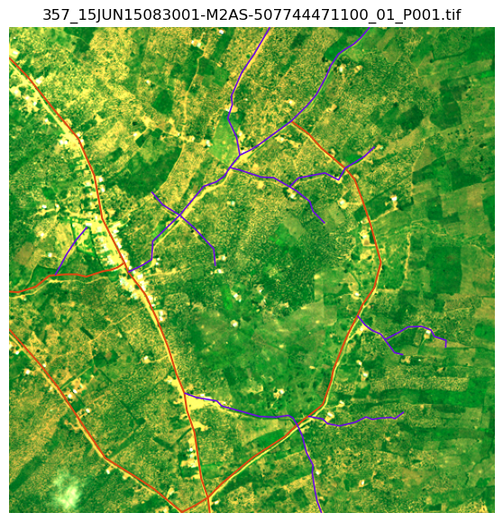
Figure 4. A randomly selected 1km x 1km Maxar chip. Displayed using natural color band combination. OSM roads are shown in red, footpaths are shown in yellow.

2.4 Model Development
This study utilizes a lightweight convolutional neural network (CNN) architecture for adapted from CE-RoadNet, a cascaded semantic segmentation model designed to improve the extraction of curvilinear, topologically connected features such as roads. CE-RoadNet introduces three key innovations in convolutional neural network architectures for automated road extraction, including the use of smoothed dilated convolutional residual blocks, an attention guided feature fusion (AGFF) module, and a cascaded network design. We examine how training data quality influences model performance in refugee settlements by implementing and comparing four increasingly sophisticated training regimes:
- Fine-tuning CE-RoadNet using OSM-derived training data
OSM polyline geometries were rasterized into binary road masks aligned with the Maxar imagery.
- Fine-tuning CE-RoadNet using high-quality OSM-derived training data
OSM polyline geometries were manually inspected. New, high quality binary masks were generated through manual digitization of OSM features. This drastically reduces the noise in the annotations, especially at road edges.
- Fine-tuning CE-RoadNet using high-quality OSM-derived training data and hand-digitized ‘missing’ roads and footpaths.
Unmapped roads and footpaths were manually digitized within the Maxar image patches, supplementing the manually digitized, OSM-derived training data.
- Training a custom CE-RoadNet model from scratch.
Using the combined high quality training dataset from the last iteration, we trained a model from scratch instead of fine-tuning a pre-trained model. Here we test whether domain-specific models perform better than more generalizable models in humanitarian landscapes.
2.5 Model Evaluation
We replicated parts of the evaluation schema from Cheng et al. (2025) to evaluate the model performance. We reported on several standard pixel level metrics for semantic segmentation including:
- Precision (P): P = TP / (TP + FP)
The proportion of predicted road pixels that are correct
- Recall (R): R = TP / (TP + FN)
The proportion of true road pixels that were correctly identified
- F1: F1 = 2 × (P × R) / (P + R)
The harmonic mean of Precision and Recall
Where TP is the number of true positives, FP is the number of false positives, and FN is the number of false negatives.

Additionally, because it is important to assess the connectivity of the predicted road networks, we also report on two structural metrics:
- clDice: calculates the similarity score between the binary segmentation mask and the morphological skeleton of the true road network. This metric penalizes topological fragmentation and rewards connectivity.
  - 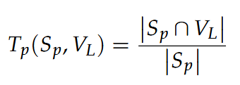
  - 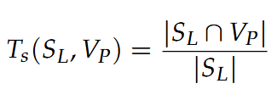
  - 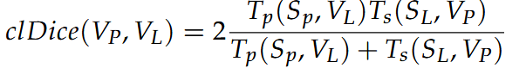
Where V_{P} is the segmentation mask, V_{L} is the observed mask, the skeletons S_{P} and S_{L} are extracted from V_{P} and V_{L}. Therefore T_{p}(S_{P}, V_{L}) represents topology precision, and T_{s}(S_{L}, V_{P}) represents topological recall, and clDice(V_{p},V_{L}) is the harmonic mean of these two.
- Average Path Length Similarity (APLS): A measure of the similarity of predicted and observed road networks in terms of traversable path distance.
  - 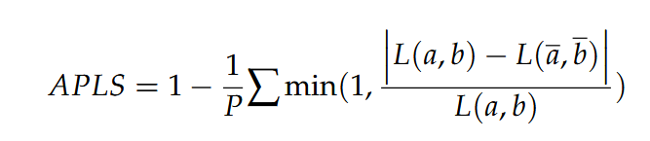
Where P denotes to the quantity of unique paths in the ground truth network G. L(a, b) represents the path length connecting the nodes a and b, And where a(hat) and b(hat) are the nodes in G(hat) that are closest in location to nodes a and b.

Results + Discussion:
At the time of writing, model training and inference have yet to be completed. The work conducted during this course instead comprised the projects formulation, the foundational data processing, the exploration of the literature, and various exploratory data analyses. There were several components of this process that were meaningful capacity building exercises for the researcher (me), but are not appropriately reflected in the level of output. For example, one large component of this effort involved retrieving and processing VHR earth observation imagery using OSU’s HPC environment. In the course of this task, I have learned a lot about setting up environments, using the terminal, using command line tools, implementing parallelization, and managing computing resources. The steps required to complete this task are an important part of the technical overhead required for training modern CNN models. And although we have still not transitioned to the modelling phase of this project, we have produced a nearly-ready data pipeline.
A major bottleneck arose from the task of constructing a high-quality training dataset. This is a task that required far more time than I initially anticipated, and underscored the reality that the quality of your model is limited by the quality of your data. In parallel with development of this analytical workflow, I collaborated with my lab throughout the term to design a protocol for undergraduate research assistants tasked with manually digitizing the roads in humanitarian landscapes throughout Uganda. The datasets that will emerge from this effort will contribute to my “highest quality” training dataset in my modelling approach, and will also enable me to evaluate the model’s ability to generalize outside of Nakivale refugee settlement to other Ugandan refugee landscapes.
The first iteration of our modelling approach will rely on OSM-derived masks as road labels. Given the noise, imprecise labels, and missing road labels, I anticipate modest performance for this baseline model. However the initial results will enable us to evaluate subsequent iterations which incorporate progressively more sophisticated annotations. I anticipate the ability to progress rapidly through this model prototyping stage in the coming weeks, while we building the high-quality annotation dataset for subsequent model iterations.
Conclusion:
Over the course of this project, I fortified the skills required for large scale research in computational geography and remote sensing. I gained practical experience in several critical areas in the design and execution of analytical workflows. I anticipate relying on these skills again and again throughout my graduate research. And while modelling has not yet begun, I have positioned myself well to make rapid progress in the coming weeks.

References:
Alqub, H., & Matar, O. (2025). Refugees’ home-making practices as assemblages: Material & symbolic features of housing settlements in the camp. World Development Perspectives, 39, 100714. https://doi.org/10.1016/j.wdp.2025.100714
Boeing, G. (2025). Modeling and Analyzing Urban Networks and Amenities With OSMnx. Geographical Analysis, 57(4), 567–577. https://doi.org/10.1111/gean.70009
Cheng, K.-N., Ni, W., Zhang, H., Wu, J., Xiao, X., & Yang, Z. (2025). CE-RoadNet: A Cascaded Efficient Road Network for Road Extraction from High-Resolution Satellite Images. Remote Sensing, 17(5), 831. https://doi.org/10.3390/rs17050831
Global-report-2024. (n.d.).
Gupta, A., Ortiz, A., Fobi, S., Kebut, D., Iyer, S., Dodhia, R., & Lavista-Ferres, J. (n.d.). Mapping Refugee Camps with AI: A Benchmark Dataset and Baseline Models for Humanitarian Applications.
Haklay, M., & Weber, P. (2008). OpenStreetMap: User-Generated Street Maps. IEEE Pervasive Computing, 7(4), 12–18. https://doi.org/10.1109/MPRV.2008.80
Jiang, Y., Zhong, C., & Zhang, B. (2023). AGD-Linknet: A Road Semantic Segmentation Model for High Resolution Remote Sensing Images Integrating Attention Mechanism, Gated Decoding Block and Dilated Convolution. IEEE Access, 11, 22585–22595. https://doi.org/10.1109/ACCESS.2023.3253289
Mei, J., Li, R.-J., Gao, W., & Cheng, M.-M. (2021). CoANet: Connectivity Attention Network for Road Extraction From Satellite Imagery. IEEE Transactions on Image Processing, 30, 8540–8552. https://doi.org/10.1109/TIP.2021.3117076
Peters, L. E. R., & Van Den Hoek, J. (2021). Charting a justice-based approach to planned climate relocation for the world’s refugees. In I. J. Ajibade & A. R. Siders, Global Views on Climate Relocation and Social Justice (1st ed., pp. 48–61). Routledge. https://doi.org/10.4324/9781003141457-4
Slater, J. (n.d.). Urban Systems of the Refugee Camp.
Van Den Hoek, J., & Friedrich, H. K. (2021). Satellite-Based Human Settlement Datasets Inadequately Detect Refugee Settlements: A Critical Assessment at Thirty Refugee Settlements in Uganda. Remote Sensing, 13(18), 3574. https://doi.org/10.3390/rs13183574
Van Den Hoek, J., Friedrich, H. K., Ballasiotes, A., Peters, L. E. R., & Wrathall, D. (2021). Development after Displacement: Evaluating the Utility of OpenStreetMap Data for Monitoring Sustainable Development Goal Progress in Refugee Settlements. ISPRS International Journal of Geo-Information, 10(3), 153. https://doi.org/10.3390/ijgi10030153

