Title: Detecting Morphological Change and Permanence in Refugee Camps
Abstract: Millions of people around the world have been forcibly displaced as a result of crises such as conflict and natural disaster. Between 2009 and 2018, the number of people living in refugee camps increased from 43 million to nearly 71 million (Van Den Hoek & Friedrich, 2021a). However, despite eclipsing the population of many European countries, the refugee camp space is only loosely defined (Slater, n.d.). Refugee camps are generally constructed with economic considerations mind, using cheap building materials and basic design configuration (Gupta et al., n.d.). The quality of ephemerality is embedded in this conception of a refugee camp; however, many refugee camps have persisted for decades, transitioning into more permanent settlements (Alqub & Matar, 2025). In the study of urbanization, scientists have increasingly employed earth observation and computer vision techniques to characterize urban morphologies and how they change over time (Debray et al., 2025; Jin et al., 2022; Kuffer & Barrosb, 2011). LiDAR, high-resolution optical imagery, and SAR are increasingly being used to train supervised machine learning models to classify urban land use and expansion. Unsupervised models are used to characterize trends of urban densification, and uncover changing patterns in urban assemblage. In this study we examine two refugee settlements in Uganda, Bidi Bidi and Nakivale as case studies to study changes in refugee camp morphology over time. We implement a two-step analytical framework: (1) deep-learning feature extraction and (2) object based change detection pipeline, in which semantic segmentation models are employed to extract building footprints at various time steps, these maps of built up areas are vectorized, and changes to building footprints across timesteps are quantified (Δ area, Δ orientation, Δ material).
Key Words: ‘Refugee Settlements’, ‘Displacement’, ‘Machine Learning’, ‘Rural’, ’Urban Morphology’, ‘Change detection’
Hypothesis: We hypothesize that Refugee settlements undergo rapid morphological changes during their establishment and organization, with changes slowing as settlements become more established. We also expect changes to be heterogenous throughout settlements, with hinterlands developing differently than urban cores.
Research Questions:
- How do intra-settlement morphologies evolve during the initial establishment period of a refugee settlement? How do settlements continue to change once they are established? Can we classify a refugee settlements level of establishment using morphological signatures?
- How do the rates and types of morphological changes differ between different parts of a refugee settlement?
- To what extent can remote sensing and deep learning derived building footprints capture evolving settlement morphologies?
Introduction:
The United Nations High Commissioner for Refugees (UNHCR) estimates that in 2024 122.6M people were forcibly displaced worldwide (Global-Report-2024, n.d.). As a result, the populations of refugee settlements are growing rapidly, and new camps continue to be established (Van Den Hoek & Friedrich, 2021b). Camps are often thought of as temporary solutions to forced displacement, however two thirds of refugees live in protracted refugee scenarios, and the average stay in a refugee camp in more than 10 years (Peters & Van Den Hoek, 2021). Nonetheless, the spatial organization and evolution of refugee settlements is poorly understood. Geographies of displacement are poorly accounted for in existing global settlement datasets, which fail to detect refugee settlements due to their rapid emergences, and unique material conditions (Van Den Hoek & Friedrich, 2021b).
From the perspective of urbanization science, refugee camps share characteristics of both urban and informal settlements. Slater (2014) argues that refugee camps embody the “extreme city” revealing tension between the impermanent and the permanent (Slater, n.d.). The humanitarian planning that guides refugee settlement construction is characterized by rigid design principles and strict top-down control. However, refugee camp inhabitants reorganize and reproduce these spaces through home-making practices and social interactions (Alqub & Matar, 2025). Refugee camps thus continue to evolve as a result of both top-down and bottom-up processes.
Urbanization scientists are increasingly applying remote sensing techniques to characterize urban growth patterns and trajectories. In particular, spatial metrics have been used to characterize urban typologies (Debray et al., 2025), and the typologies of informal and unplanned settings (Kuffer & Barrosb, 2011). However, there have been few attempts to apply such techniques to humanitarian or displacement contexts. Characterizing how refugee settlements change over time may be important for humanitarian design and increasing resilience to natural hazards. In this study, we combine remote sensing, spatial metrics, and deep-learning building extraction to characterize changes in the internal morphologies of two refugee settlements in Uganda, Bidi Bidi and Nakivale. We aim to build a quantitative understanding of how settlements evolve and change through different stages of permanence.

Study Site:
As of 2021, Uganda was host to 1.4 million refugees, which represents ~3% of its total population (Van Den Hoek & Friedrich, 2021b). In 2020 this was the largest refugee population in Africa, and the second largest in the world (Friedrich & Van Den Hoek, 2020). The refugee population increased by ten-fold between 2012 and 2017 as a result of humanitarian crises in Sudan and Democratic Republic of Congo. 92% of refugees in the country reside inside UNHCR refugee settlements, and the remaining 8% are in Kampala. In 1998 Uganda codified its Self Reliance Strategy (SRS), a refugee policy that allocates land and grants refugees access to food, aid, health, and education. The policy also grants refugees the ability to freely travel outside the borders of refugee settlements for work (Bjørkhaug, 2020). As a result, Uganda is unique among refugee hosting countries in how refugee populations are integrated into surrounding host country communities (Bohnet & Schmitz-Pranghe, 2019). Additionally, as a result of the SRS policy, refugee settlements are understood as long term structures, as opposed to temporary staging area. Bidi Bidi and Nakivale are two of the largest refugee settlement in the country by population and land mass. Nakivale is a 185 km^2 refugee settlement located in southwestern Uganda. It is one of the oldest refugee settlements in the country, having been established in 1958. As of 2020, it sheltered 132,000 refugees (Bjørkhaug, 2020). As of 2021, Bidi Bidi is the second largest refugee settlement in the world, sheltering 232,743 refugees in 42,754 households across roughly 250km^2 (Logie et al., 2021). The settlement was established shortly after violent conflict broke out in Juba, South Sudan in 2016 (Nakalembe et al., 2022).
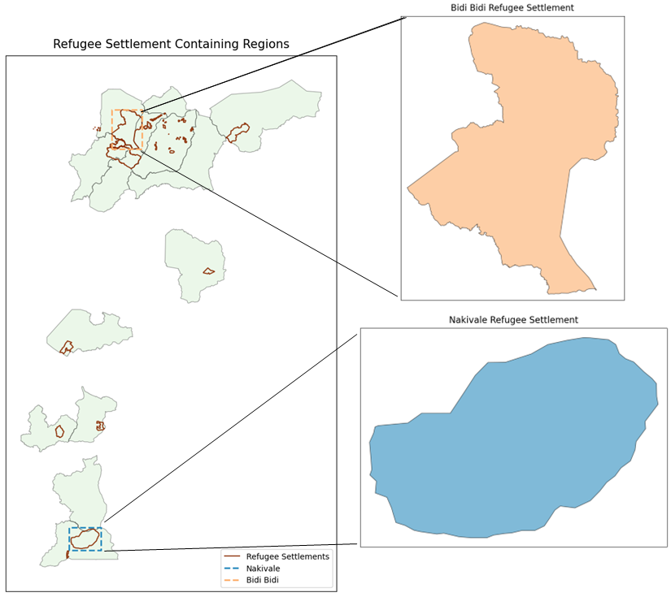

Methods:
- We use satellite remote sensing and spatial analysis to quantify morphological change in Nakivale and Bidi Bidi refugee settlements. For our analysis we will rely on 0.5m multispectral Maxar imagery from 2015-2025. This comprises dates from before the establishment of Bidi Bidi to present. Maxar scenes will be orthorectified, and Sentinel-1 scenes will be processed with a lee speckle filter. All imagery will be clipped to settlement boundaries (buffered by 500m) using the Ugandan planning boundaries dataset (laboratory product). We will extract building footprints from Maxar imagery using a semantic segmentation model utilizing a lightweight CNN architecture. The model will be trained on the HPC. Ground truth data (training labels) will be provided from a mix of OSM building footprints and manually digitized building footprints. We will apply the trained model to multitemporal Maxar imagery to create annual footprint raster maps. These maps will then be vectorized and various spatial metrics will be calculated such as building density, mean and standard deviation of building size, and orientation entropy. Validation of our approach is limited due to lack of ground data. We are also limited by the somewhat course temporal resolution of the very high-resolution imagery. Future research might attempt to supplement this approach with qualitative spatial analysis or participatory methods to gain a better understanding of the typologies of refugee settlements. Future research might also seek to answer the question of if optical remote sensing detect changes in building materials over time and if changes in building materials occur at specific stages in refugee settlement development.

Timeline:
Project Tasks | Month #1 | Month #2 | Month #3 | Month #4 | Month #5 | Month #6 | Month #7 | Month #8
Digitize and acquire ground truth data
Access and process satellite imagery
Build and train model workflow
Validate model
Apply model to multi-temporal Maxar imagery
Perform cluster analysis and calculate spatial metrics
Write and edit manuscript

Budget:
Funding Sources:
  - LC/LUC, Research Opportunities in Space and Earth Sciences (ROSES)
    - Agency: NASA – National Aeronautics and Space Administration
    - Description: The Land Cover/Land Use Change (LCLUC) Program advances earth science by funding projects that use satellite data to understand how land cover and use change over time. Projects map change and investigate how changes affect human, natural and climatic systems. LCLUC is a subcall of ROSES, the Research Opportunities in Space and Earth Sciences, NASA’s omnibus funding call.
  - Confronting Hazards, Impacts, and Risks for a Resilient Planet (CHIRRP)
    - Agency: National Science Foundation (NSF)
    - Description: CHIRRP funds research focused on understanding and forecasting hazards and developing strategies that strengthen community resilience. CHIRRP projects engage community partners, and support the development of Earth System Science approaches that advance knowledge of hazards impact and risk.
References:
- Alqub, H., & Matar, O. (2025). Refugees’ home-making practices as assemblages: Material & symbolic features of housing settlements in the camp. World Development Perspectives, 39, 100714. https://doi.org/10.1016/j.wdp.2025.100714
- Arcaute, E., Hatna, E., Ferguson, P., Youn, H., Johansson, A., & Batty, M. (2015). Constructing cities, deconstructing scaling laws. Journal of The Royal Society Interface, 12(102), 20140745. https://doi.org/10.1098/rsif.2014.0745
- Bjørkhaug, I. (2020). Revisiting the Refugee–Host Relationship in Nakivale Refugee Settlement: A Dialogue with the Oxford Refugee Studies Centre. Journal on Migration and Human Security, 8(3), 266–281. https://doi.org/10.1177/2331502420948465
- Bohnet, H., & Schmitz-Pranghe, C. (2019). Uganda: A role model for refugee integration?
- Debray, H., Gassilloud, M., Lemoine-Rodríguez, R., Wurm, M., Zhu, X., & Taubenböck, H. (2025). Universal patterns of intra-urban morphology: Defining a global typology of the urban fabric using unsupervised clustering. International Journal of Applied Earth Observation and Geoinformation, 141, 104610. https://doi.org/10.1016/j.jag.2025.104610
- Friedrich, H. K., & Van Den Hoek, J. (2020). Breaking ground: Automated disturbance detection with Landsat time series captures rapid refugee settlement establishment and growth in North Uganda. Computers, Environment and Urban Systems, 82, 101499. https://doi.org/10.1016/j.compenvurbsys.2020.101499
- Ghorbanzadeh, O., Crivellari, A., Tiede, D., Ghamisi, P., & Lang, S. (2022). Mapping Dwellings in IDP/Refugee Settlements Using Deep Learning. Remote Sensing, 14(24), 6382. https://doi.org/10.3390/rs14246382
- Global-report-2024. (n.d.).
- Gupta, A., Ortiz, A., Fobi, S., Kebut, D., Iyer, S., Dodhia, R., & Lavista-Ferres, J. (n.d.). Mapping Refugee Camps with AI: A Benchmark Dataset and Baseline Models for Humanitarian Applications.
- Jiang, H., Peng, M., Zhong, Y., Xie, H., Hao, Z., Lin, J., Ma, X., & Hu, X. (2022). A Survey on Deep Learning-Based Change Detection from High-Resolution Remote Sensing Images. Remote Sensing, 14(7), 1552. https://doi.org/10.3390/rs14071552
- Jin, M., Sun, R., Yang, X., Yan, M., & Chen, L. (2022). Remote sensing-based morphological analysis of core city growth across the globe. Cities, 131, 103982. https://doi.org/10.1016/j.cities.2022.103982
- Kuffer, M., & Barrosb, J. (2011). Urban Morphology of Unplanned Settlements: The Use of Spatial Metrics in VHR Remotely Sensed Images. Procedia Environmental Sciences, 7, 152–157. https://doi.org/10.1016/j.proenv.2011.07.027
- Liu, C., Cao, Y., Yang, C., Zhou, Y., & Ai, M. (2020). Pattern identification and analysis for the traditional village using low altitude UAV-borne remote sensing: Multifeatured geospatial data to support rural landscape investigation, documentation and management. Journal of Cultural Heritage, 44, 185–195. https://doi.org/10.1016/j.culher.2019.12.013
- Logie, C. H., Okumu, M., Latif, M., Musoke, D. K., Odong Lukone, S., Mwima, S., & Kyambadde, P. (2021). Exploring resource scarcity and contextual influences on wellbeing among young refugees in Bidi Bidi refugee settlement, Uganda: Findings from a qualitative study. Conflict and Health, 15(1), 3. https://doi.org/10.1186/s13031-020-00336-3
- Lu, Y., Koperski, K., Kwan, C., & Li, J. (2021). Deep Learning for Effective Refugee Tent Extraction Near Syria–Jordan Border. IEEE Geoscience and Remote Sensing Letters, 18(8), 1342–1346. https://doi.org/10.1109/LGRS.2020.2999354
- Nakalembe, C., Zubkova, M., Hall, J. V., Argueta, F., & Giglio, L. (2022). Impacts of large-scale refugee resettlement on LCLUC: Bidi Bidi refugee settlement, Uganda case study. Environmental Research Letters, 17(6), 064019. https://doi.org/10.1088/1748-9326/ac6e48
- Peters, L. E. R., & Van Den Hoek, J. (2021). Charting a justice-based approach to planned climate relocation for the world’s refugees. In I. J. Ajibade & A. R. Siders, Global Views on Climate Relocation and Social Justice (1st ed., pp. 48–61). Routledge. https://doi.org/10.4324/9781003141457-4
- Ramadan, A. (2013). Spatialising the refugee camp. Transactions of the Institute of British Geographers, 38(1), 65–77. https://doi.org/10.1111/j.1475-5661.2012.00509.x
- Slater, J. (n.d.). Urban Systems of the Refugee Camp.
- Van Den Hoek, J., & Friedrich, H. K. (2021a). Satellite-Based Human Settlement Datasets Inadequately Detect Refugee Settlements: A Critical Assessment at Thirty Refugee Settlements in Uganda. Remote Sensing, 13(18), 3574. https://doi.org/10.3390/rs13183574
- Van Den Hoek, J., & Friedrich, H. K. (2021b). Satellite-Based Human Settlement Datasets Inadequately Detect Refugee Settlements: A Critical Assessment at Thirty Refugee Settlements in Uganda. Remote Sensing, 13(18), 3574. https://doi.org/10.3390/rs13183574

